Supplementary Material-figures

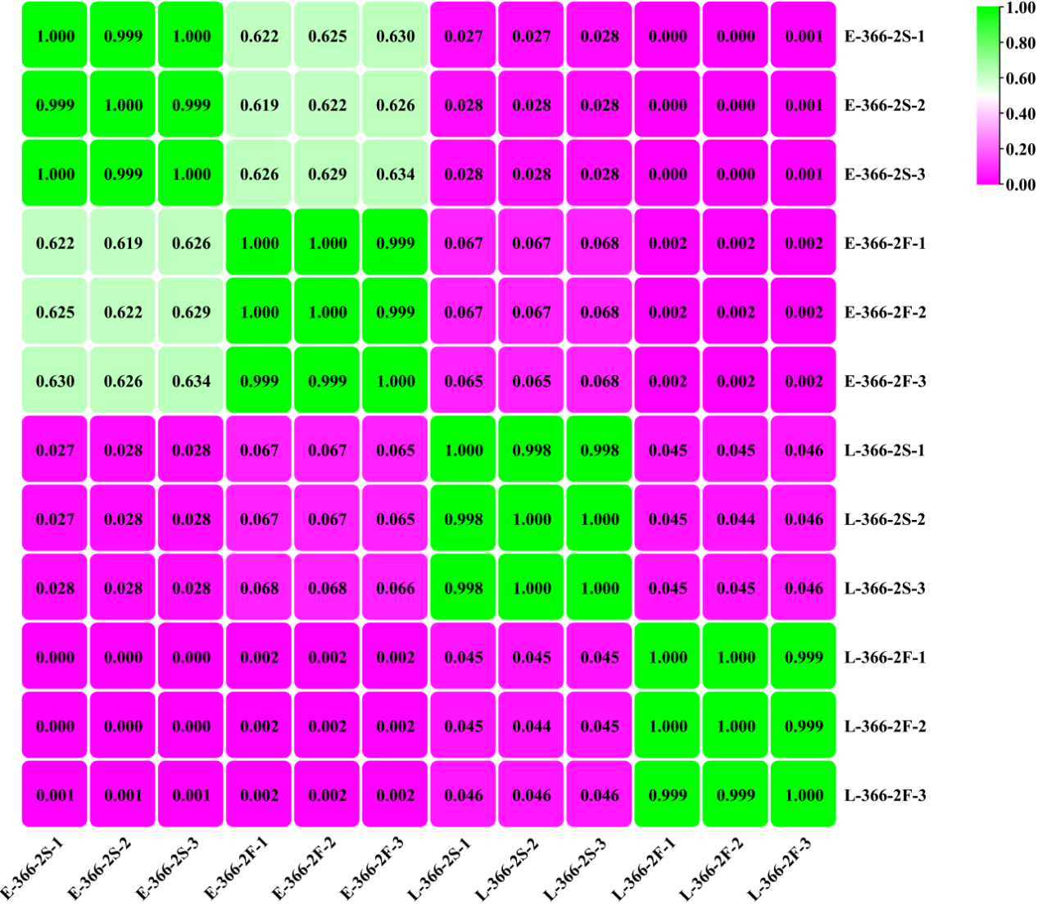
Fig. S1 Expression correlation heat map of samples.

