Supplementary data
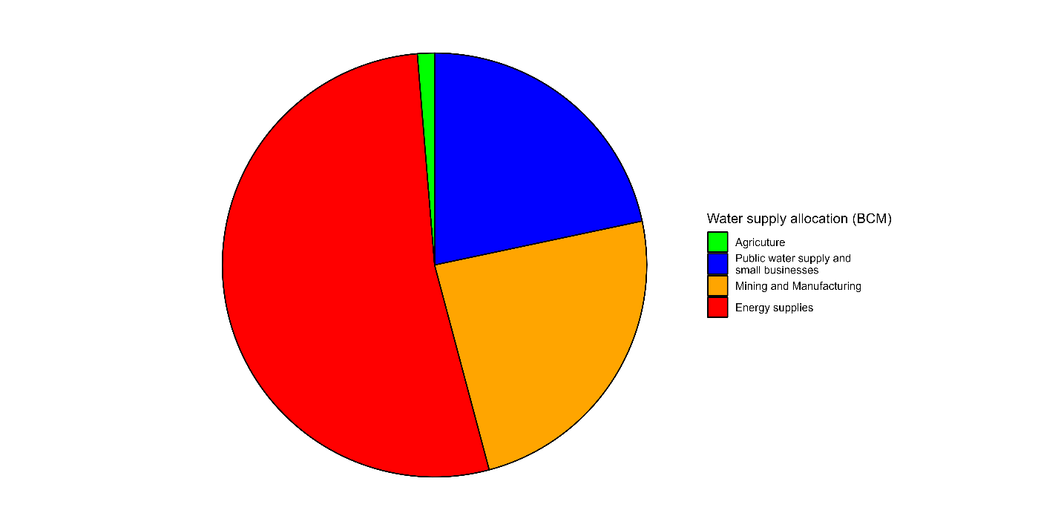
Fig. S1. Water supply allocation in Germany, 2016 (source: https://www.umweltbundesamt.de/en/topics/water/water-resource-management#undefined; Date accessed: 01.06.2022)
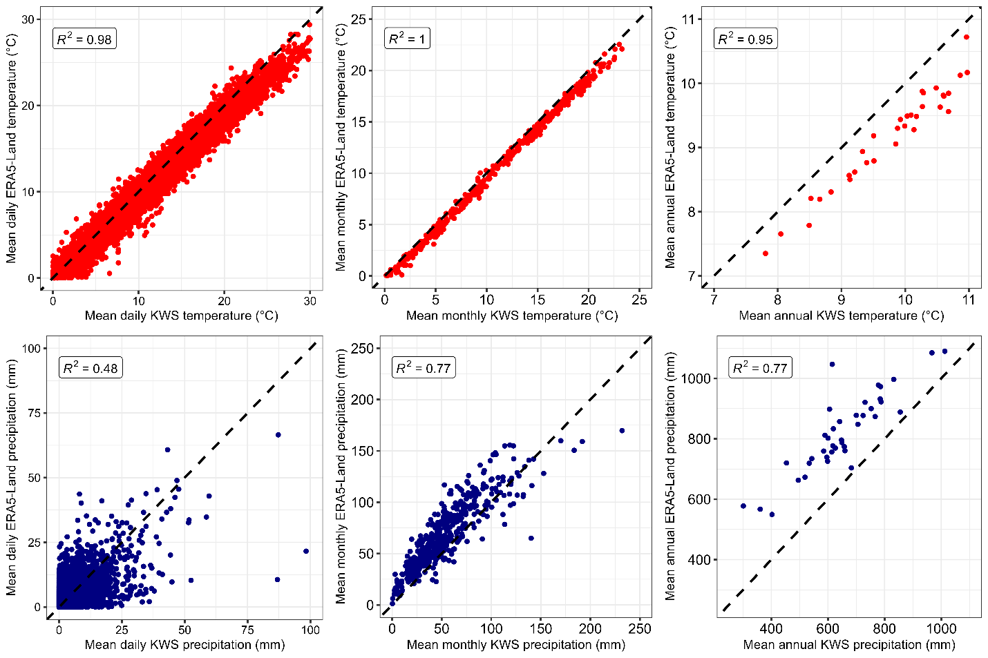
(A)
(B)
Fig. S2. The one-to-one plot of daily, monthly, and annual KWS against ELR mean temperature (A) and precipitation (B) from 1981 to 2020 (1998 and 2018 records were excluded due to missing values in the KWS record)
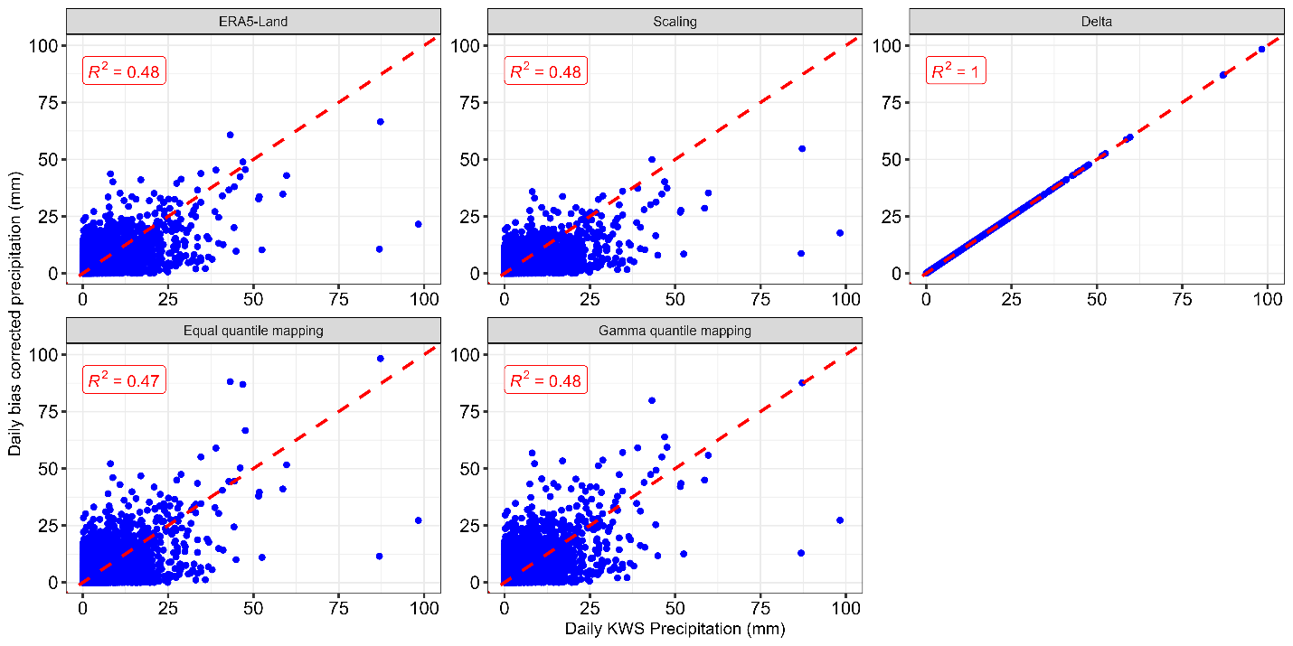
Fig. S3. The one-to-one plot of daily KWS against ERA5-Land precipitation from 1981 to 2020
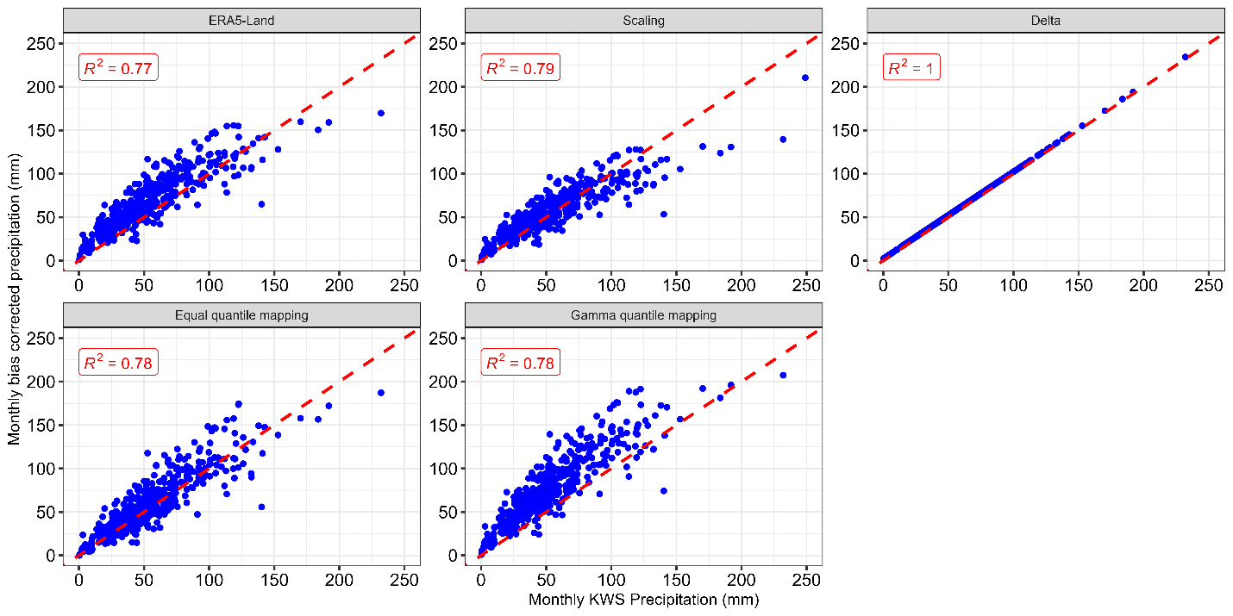
Fig. S4. The one-to-one plot of monthly KWS against ERA5-Land precipitation from 1981 to 2020
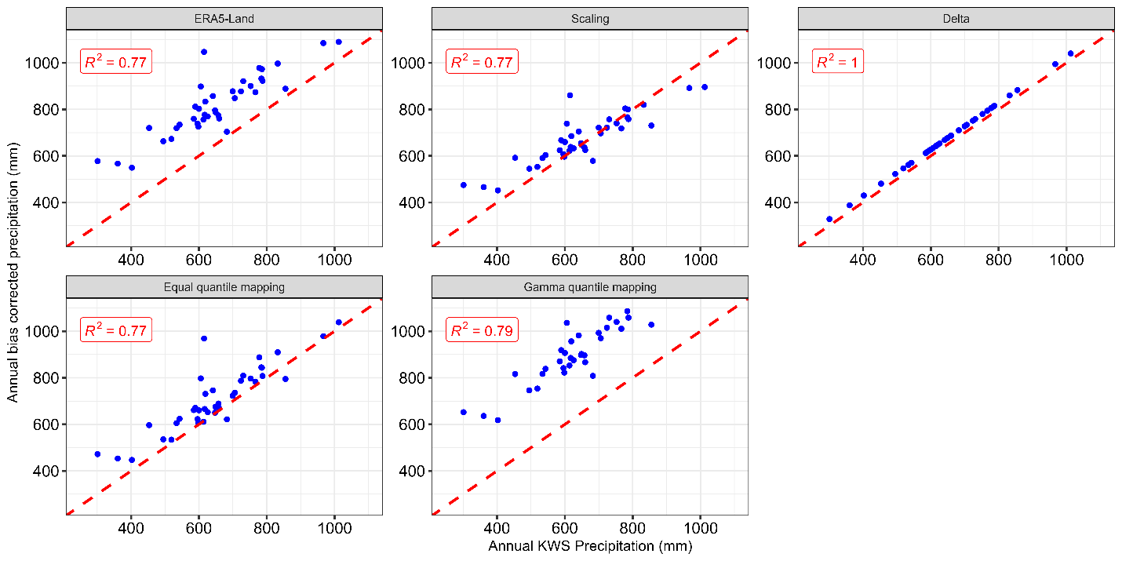
Fig. S5. The one-to-one plot of annual KWS against ERA5-Land precipitation from 1981 to 2020
Table S1. Conservative parameters of AquaCrop of maize and potato
Default parameter | Maize | Potato
Fruit/grain-producing crop and root/tuber crop | 2 | 3
Base temperature (°C) below which crop development does not progress | 6 | 2
Upper temperature (°C) above which crop development no longer increases with an increase in temperature | 30 | 26
Total length of crop cycle in growing degree-days | 1700 | 1276
Considered soil fertility stress for calibration of the stress response (%) | 50 | 50
Minimum air temperature below which pollination starts to fail (cold stress) (°C) | 10 | -9
Maximum air temperature above which pollination starts to fail (heat stress) (°C) | 40 | -9
Minimum growing degrees required for full crop transpiration (°C - day) | 12 | 7
Minimum effective rooting depth (m) | 0.3 | 0.3
Maximum effective rooting depth (m) | 2.3 | 1.5
Number of crops per hectare | 75000 | 40000
GDDays from sowing to emergence | 80 | 200
GDDays from sowing to maximum rooting depth | 1409 | 1079
GDDays to start senescence | 1400 | 984
GDDays from sowing to maturity (length of crop cycle) | 1700 | 1276
GDDays from sowing to flowering | 880 | 550
Length of the flowering stage (growing degree days) | 180 | 0
GDDays building up of Harvest Index during yield formation | 750 | 700
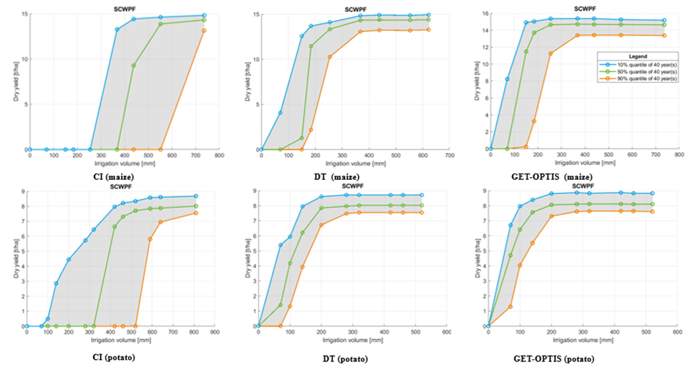
Fig. S6. Representative figures of some generated SCWPF of deficit irrigation management strategy depicting perfect information about irrigation
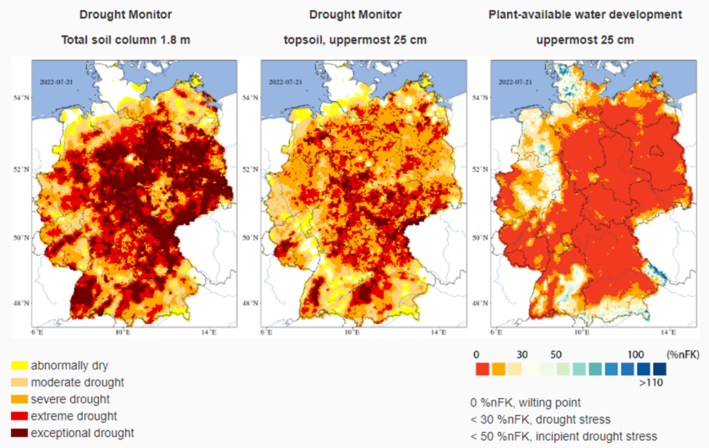
Fig. S7. Helmholtz Research Institute's fourteenth-day drought monitor for soil moisture and plant available water (https://www.ufz.de/index.php?en=37937; Date accessed: 29.07.2022)
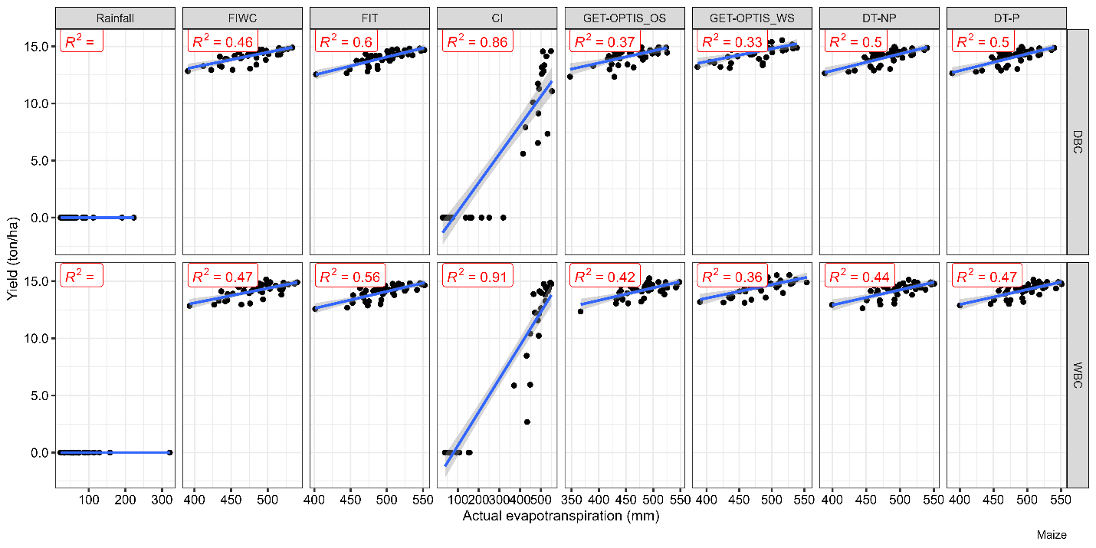
Fig. S8. ETa relationship against the yield of maize from 1981 to 2020 for the summer growing season
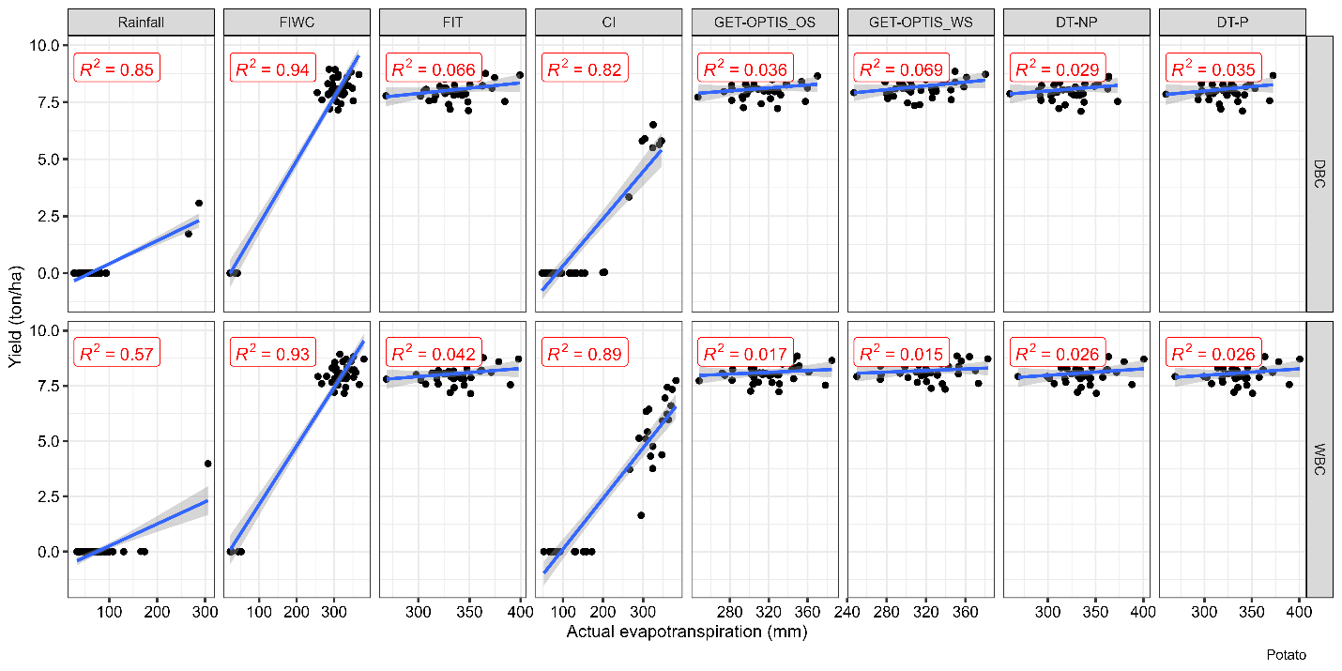
Fig. S9. ETa relationship against the yield of potato from 1981 to 2020 for the summer growing season
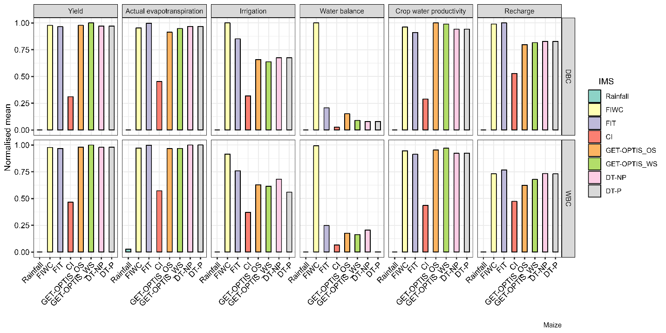
Fig. S10. The normalized mean of agriculture assessment performance of maize
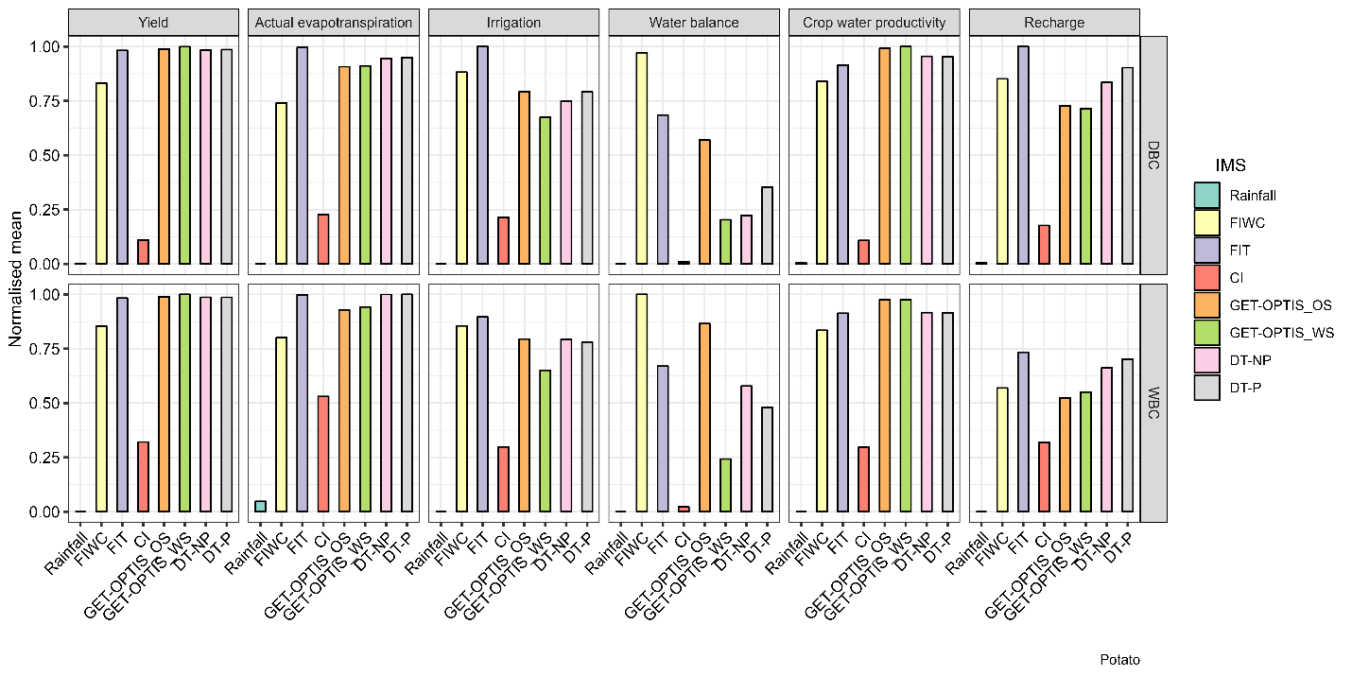
Fig. S11. The normalized mean of agriculture assessment performance of potato

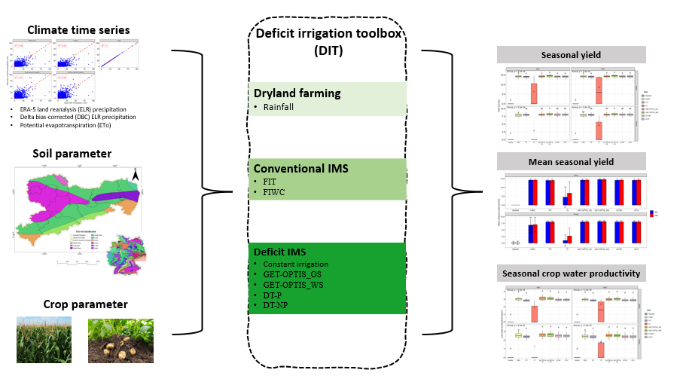
Fig. S12. Graphical abstract of the study

