Machine Learning-driven models for predicting CO₂ Uptake in Metal-Organic Frameworks (MOFs)

Sofiene Achourª, Zied Hosni^{b}
ª Research Unity of Modeling in Fundamental Sciences and Didactics, University of Tunis El Manar, BP 254, El Manar 2, 2096, Tunisia
^{b} Institute for Materials Discovery, University College London, 40 Roberts Building, London, WC1E 7 JE, United Kingdom

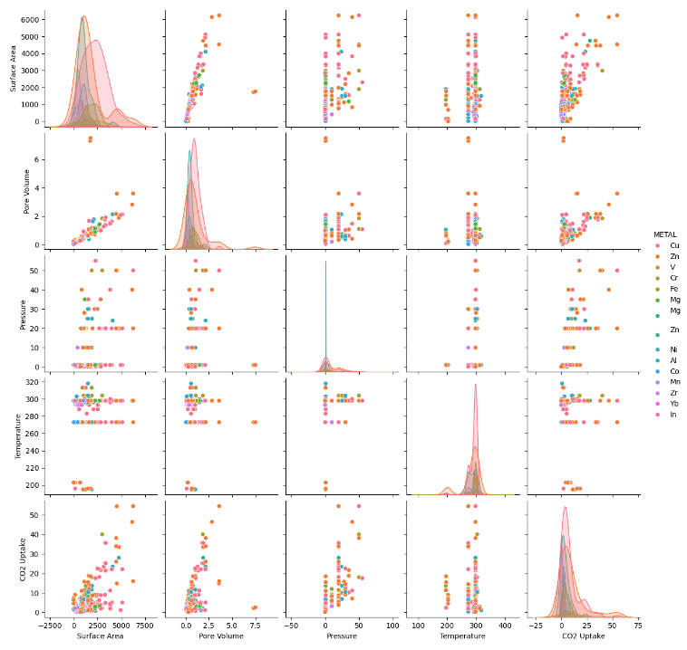
Figure S1: Pairwise Relationships Between MOF Descriptors - Pairplot visualizing the relationships and distributions between different structural and functional descriptors of MOFs.
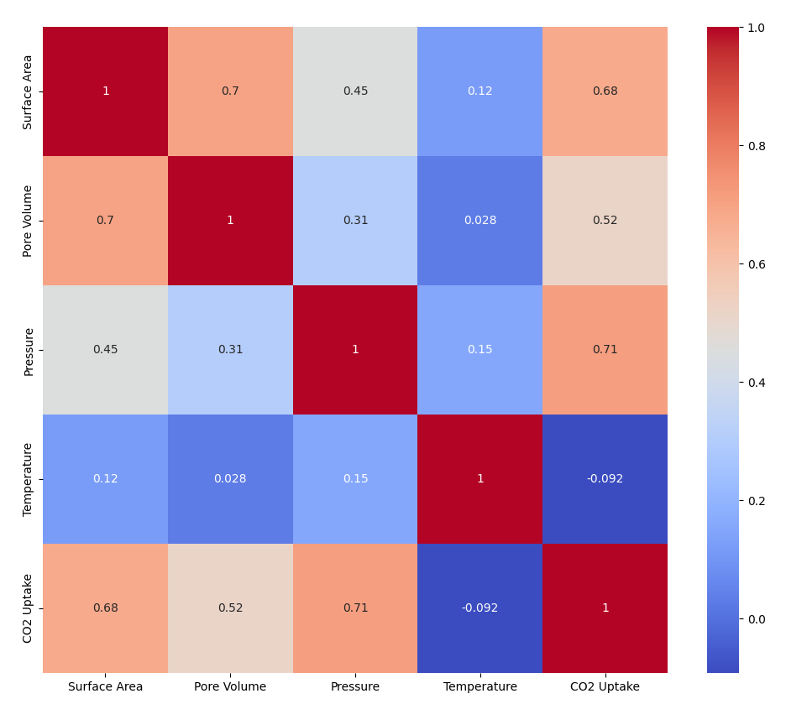
Figure S2: "Correlation Heatmap of MOF Features" - A heatmap showcasing the correlation coefficients between various MOF properties, such as surface area, pore volume, and CO₂ uptake, facilitating the identification of the most influential features for gas adsorption.
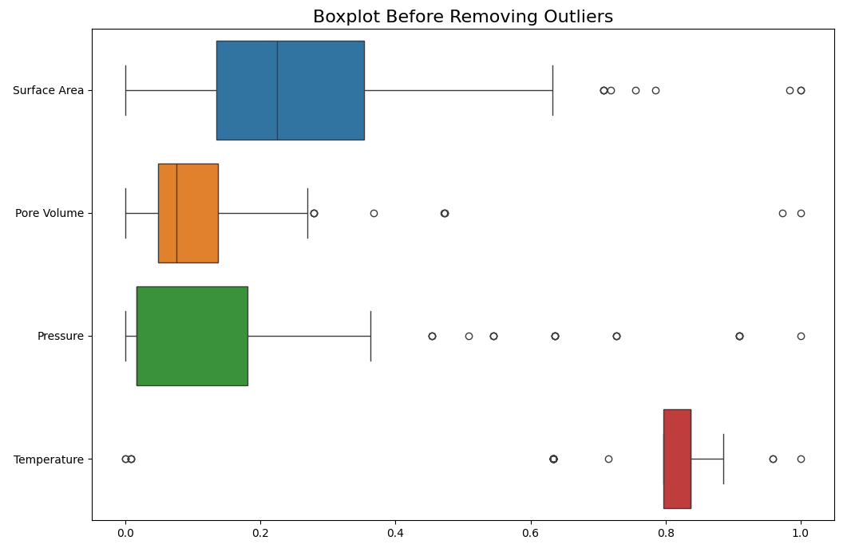
Figure S3: Boxplot illustrating the distribution of Surface Area, Pore Volume, Pressure, and Temperature before outlier removal. Outliers are represented as individual points outside of the boxplot whiskers.
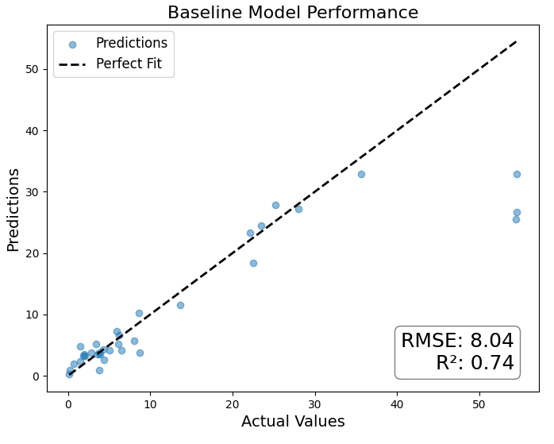
Figure S4: Scatter plot before preprocessing of actual vs. predicted CO₂ uptake values for the baseline model, with a line of perfect fit for reference, indicating the model's performance before data preprocessing.
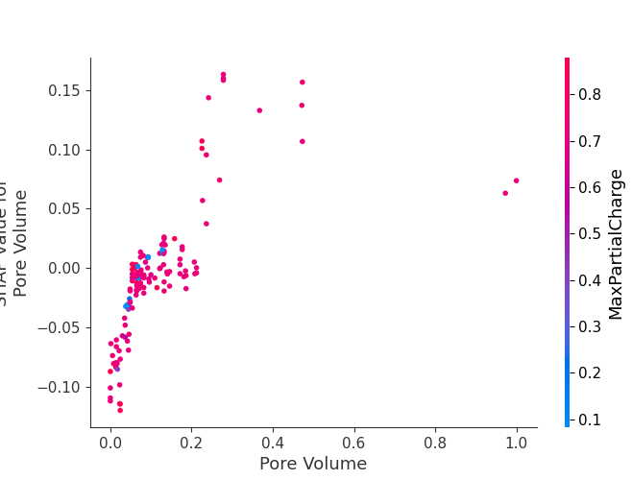
Figure S5: Scatter plot depicting the SHAP values for pore volume against the actual pore volume values, colored by the value of a secondary feature to show interaction effects.
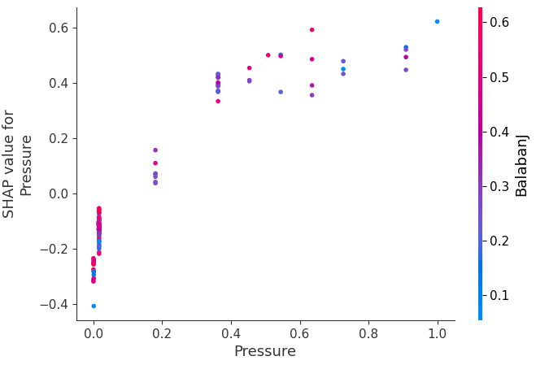
Figure S6: Visualization of the SHAP values for pressure, illustrating the model’s dependence on pressure for predicting CO₂ uptake, with point color representing an interaction with another feature.
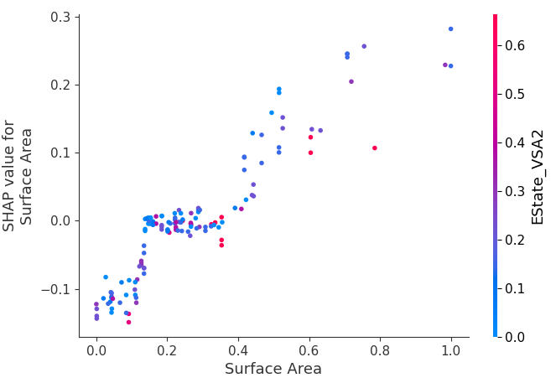
Figure S7: SHAP Dependence Plot for Surface Area illustrating the impact of surface area on the model output, with SHAP values indicating the contribution of surface area to the prediction. The color gradient represents the EState_VSA2 feature value, highlighting its interaction with surface area.

