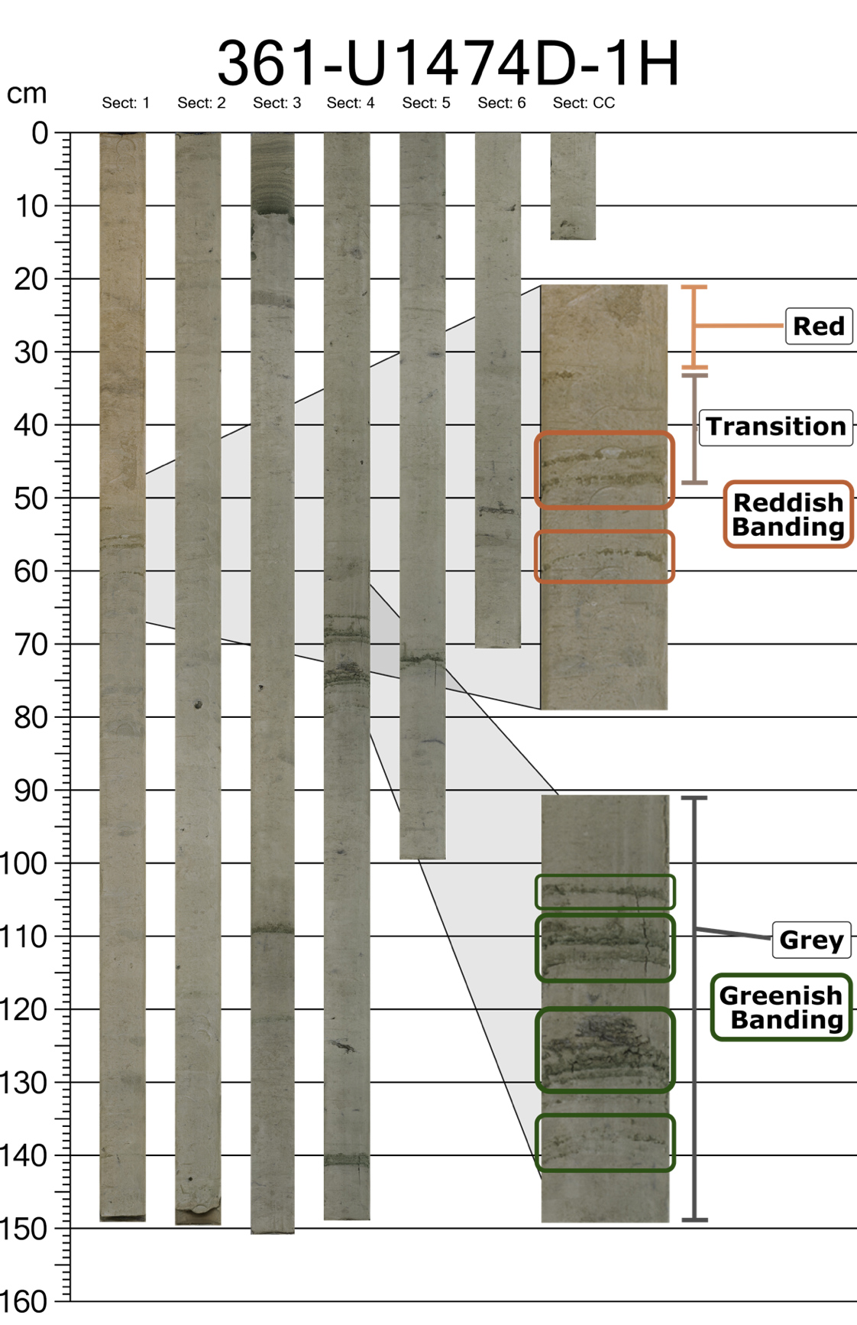
Extended Data Figure 1: Active vs relic diagenetic fronts. At the oxidative color transition in section 1 around 50 cm, banding is reddish in color. Beneath that (sections 2-6), banding appears greenish in color.
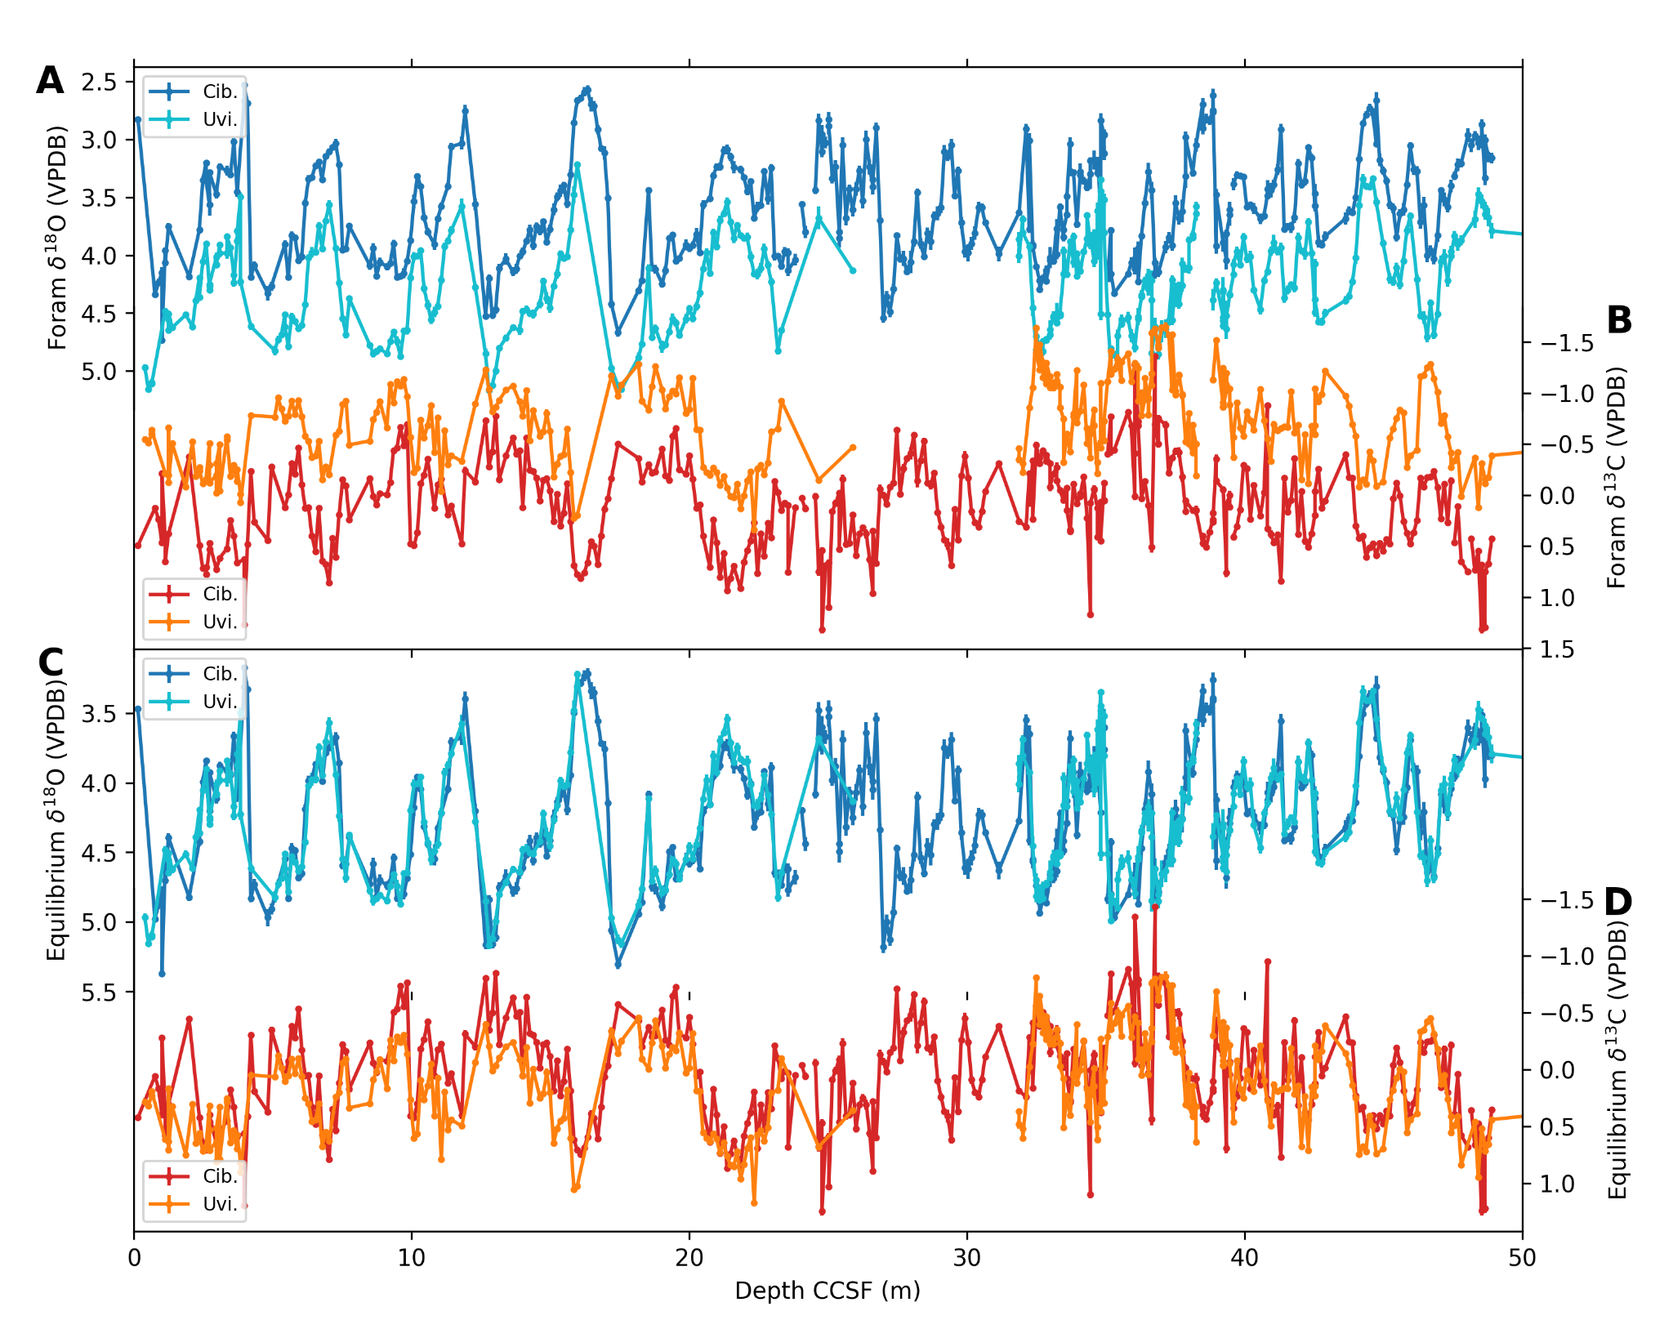
Extended Data Figure 2: U1474 Stable Isotope Data. A, B) stable isotope data on foraminiferal tests, C, D) foraminiferal test data with vital effects removed. These records were averaged to make our 𝛿¹⁸O and 𝛿¹³C records.
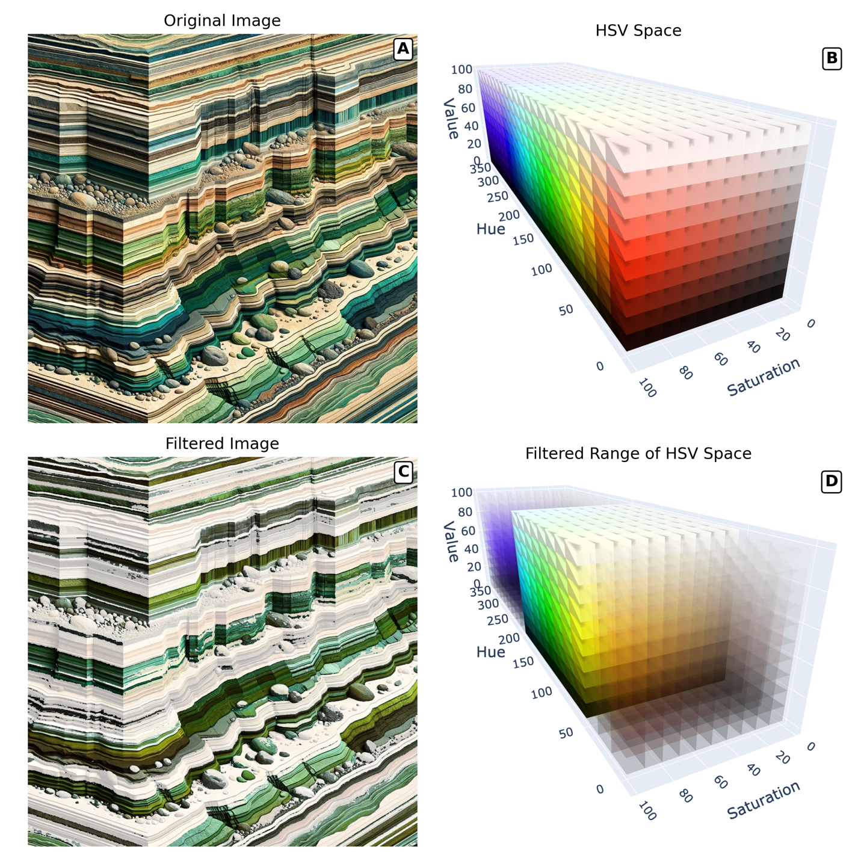
Extended Data Figure 3: OpenCV inRange function demo. A) Image generated using DALL-E 3 with the prompt “An image that shows horizontal stripes that look like layers of sediment. Some of the layers should be green.” B) Hue-saturation-value (HSV) space divided up into 18x10x10 blocks. C) Image from panel A filtered for green colors. Pixels outside of the filter are more transparent. D) Selected blocks of HSV space used to filter image in panel C.
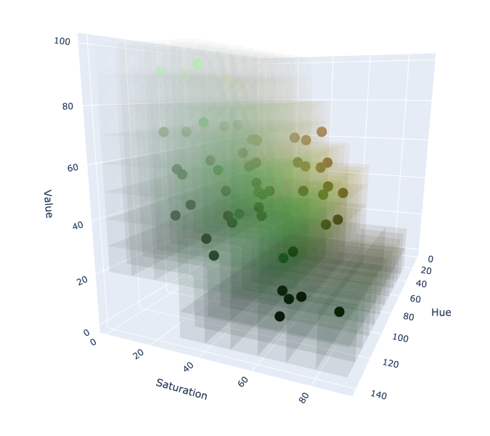
Extended Data Figure 4: The 627 10x10x10 cubes of HSV space we tested in order to find the range of colors represented in the greening of sediments at U1474. The coordinates of the Munsell Soil Colors acted as a rough guide to limit our search, creating a range for realistic colors in sediment.

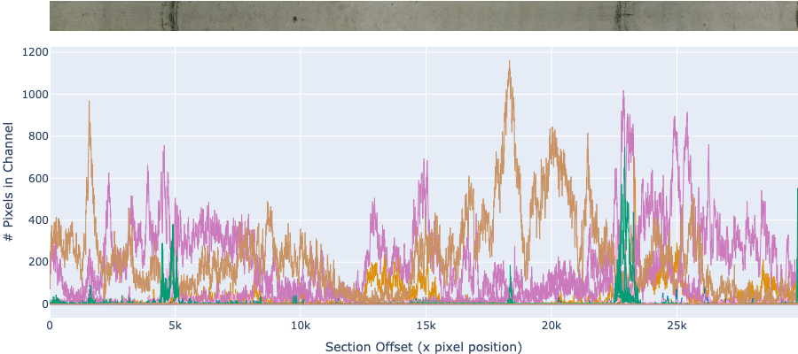
Extended Data Figure 4: Testing channels for green sensitivity. A demonstration of the intensity of a number of color channels across section U1474 F 2H3. The x-axis is shown in the full resolution provided by the width of the image in pixels. Channels that were determined to be sensitive to only green layers are colored green in this figure. In the GitHub Repository for this paper, this figure is available in interactive form.
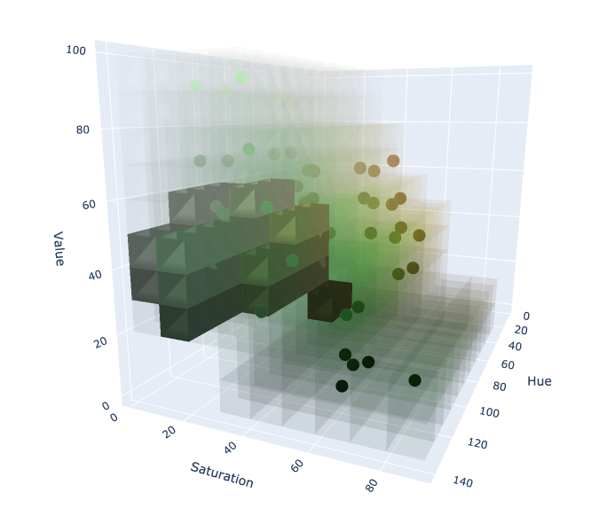
Extended Data Figure 6A: Tested and selected channels for Site U1474. Munsell colors are plotted as dots over the tested channels (low opacity). The channels determined to most exclusively represent green layers are the blocks with high opacity.
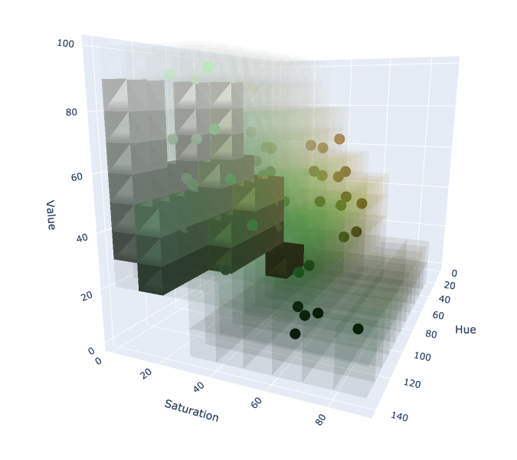
Extended Data Figure 6B: Tested and selected channels for Site U1313. Munsell colors are plotted as dots over the tested channels (low opacity). The channels determined to most exclusively represent green layers are the blocks with high opacity.
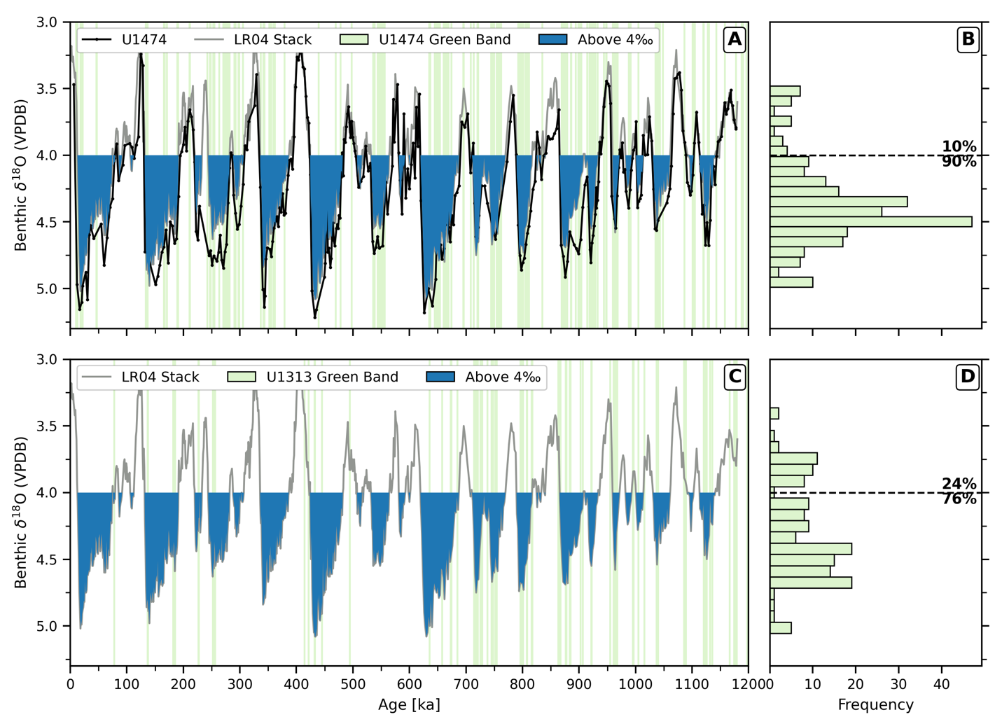
Extended Data Figure 7: The co-occurence of banding with glacial conditions. LR04 (grey) and our benthic oxygen isotope stack from Site U1474 (black) plotted alongside the depositional ages of green bands in the record, demarcated by vertical green lines. The blue shaded area glacial periods, times 𝛿¹⁸O is heavier than 4 per mil. The probability distribution of green bands with respect to 𝛿¹⁸O is plotted as a histogram in the right panel. The horizontal line represents 𝛿¹⁸O = 4 per mil.
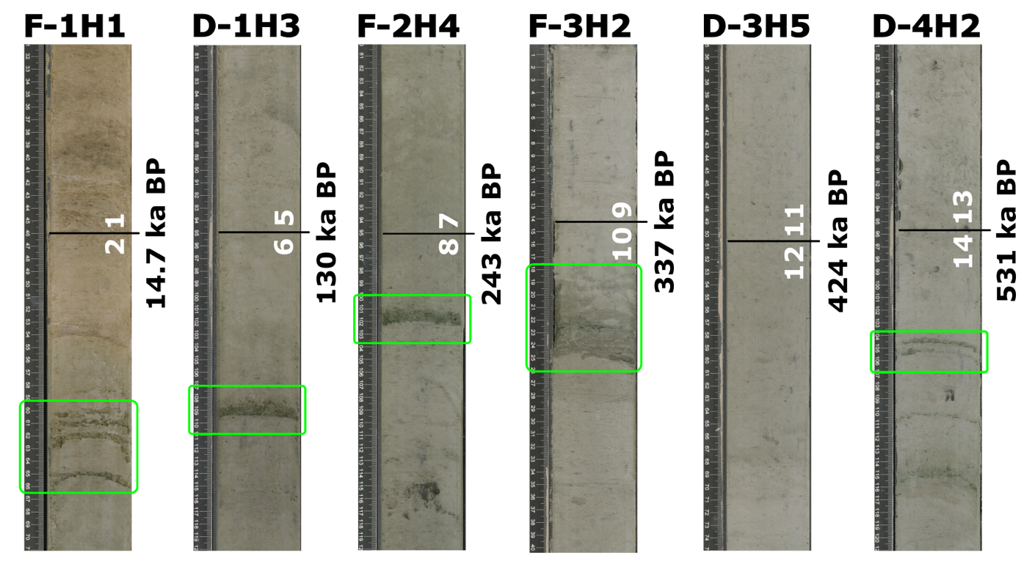
Extended Data Figure 8: Green banding at glacial terminations at IODP Site U1474. Hole, core, indicated for splice section above. Dated using radiocarbon for glacial termination 1, and alignment to benthic 𝛿¹⁸O for earlier terminations. Age (in thousands of years before present) for Marine Isotope Stage boundary indicated with horizontal black line. Marine Isotope Stage indicated by white number.
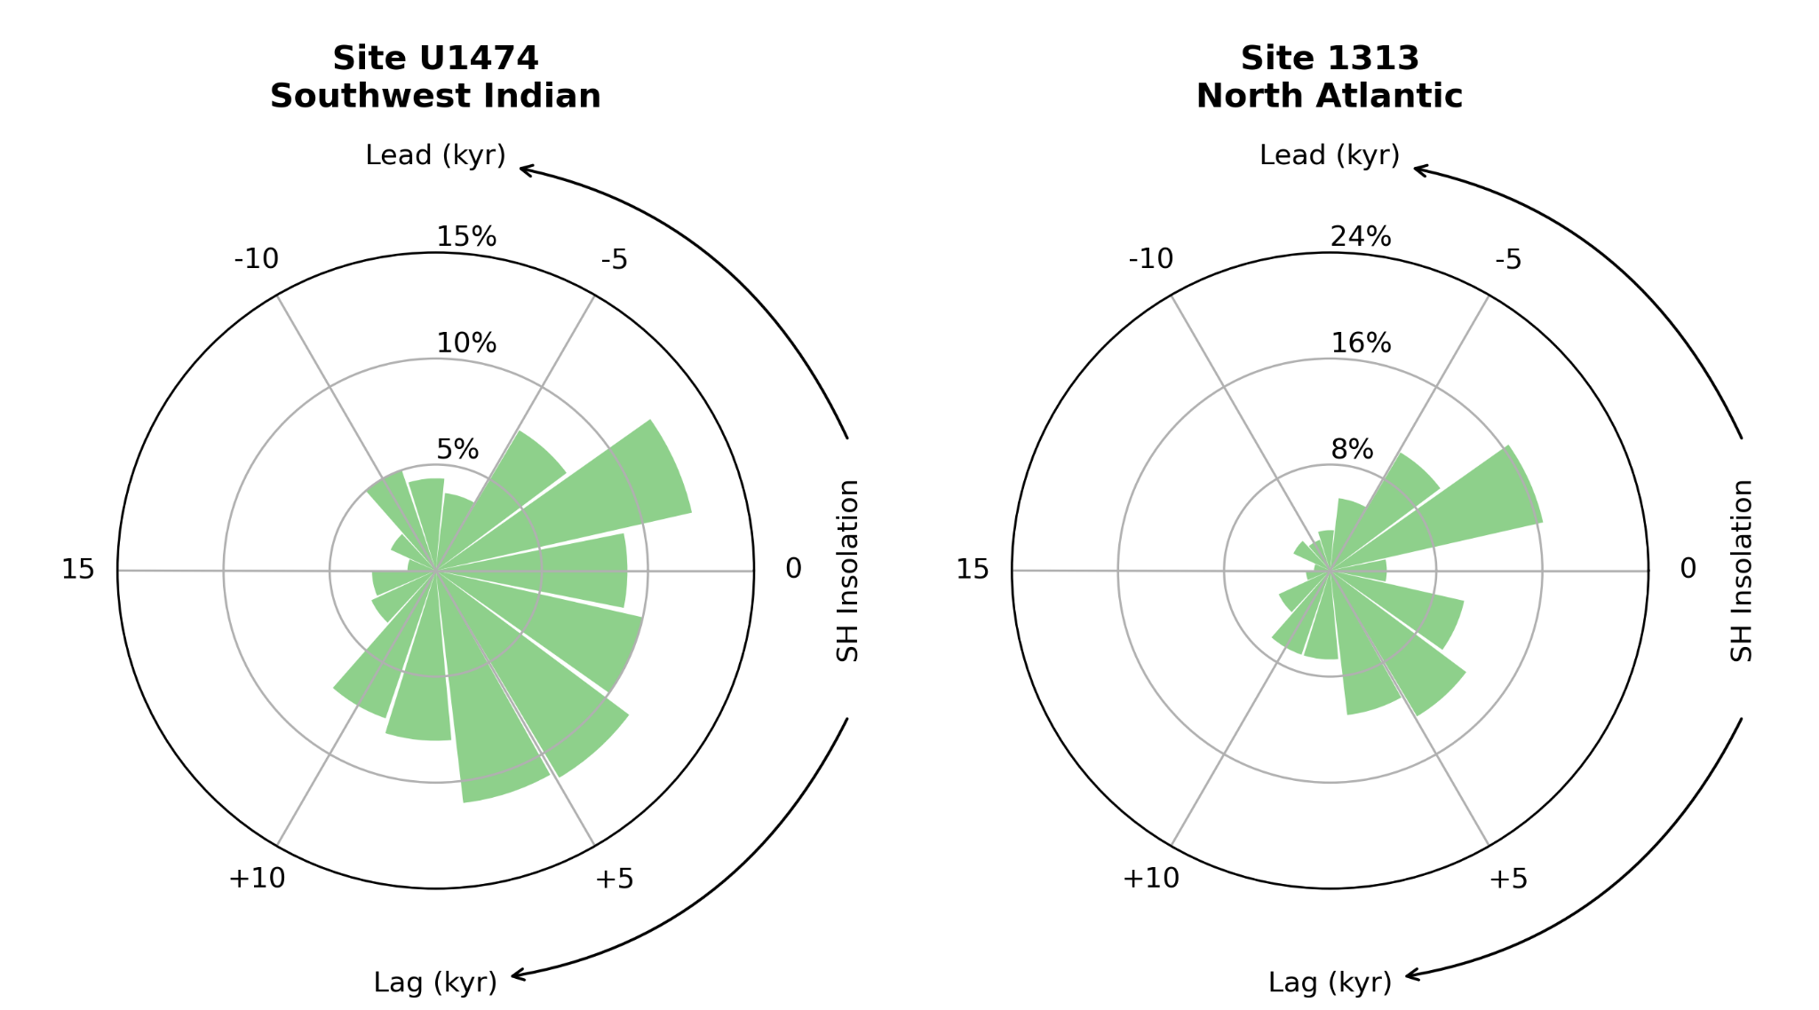
Extended Data Figure 9: Phasing of green layer formation with respect to insolation. Phase diagrams of the depositional ages with respect to high latitude southern hemisphere (65 S) insolation maxima. U1474 lags insolation maxima. 1313 layers cluster tightly leading insolation maxima.
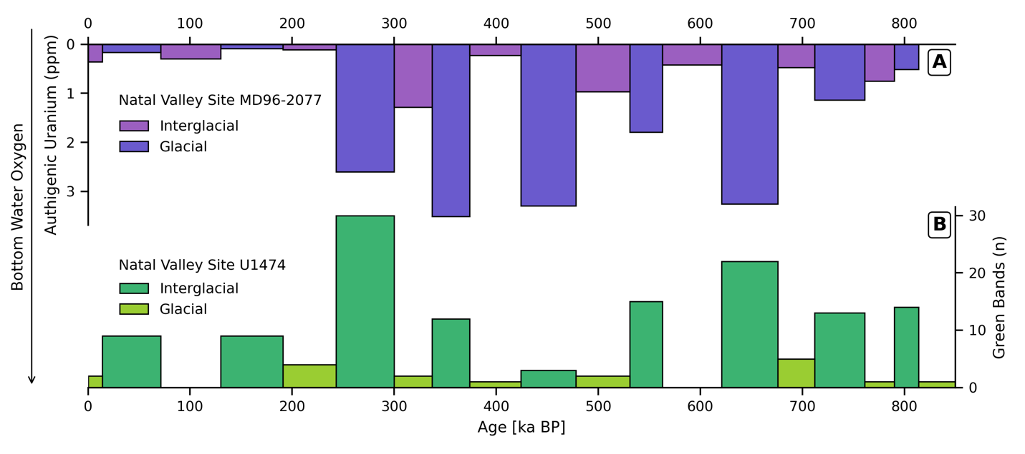
Extended Data Figure 10: Proxy evidence for oxygen variability in the Natal Valley. (A) Authigenic uranium concentrations from sediment core site MD96-2077⁹⁸. The values are averaged by marine isotope stage. High uranium concentrations indicate reducing conditions. (B) Green band abundance at Site U1474 binned by marine isotope stage.
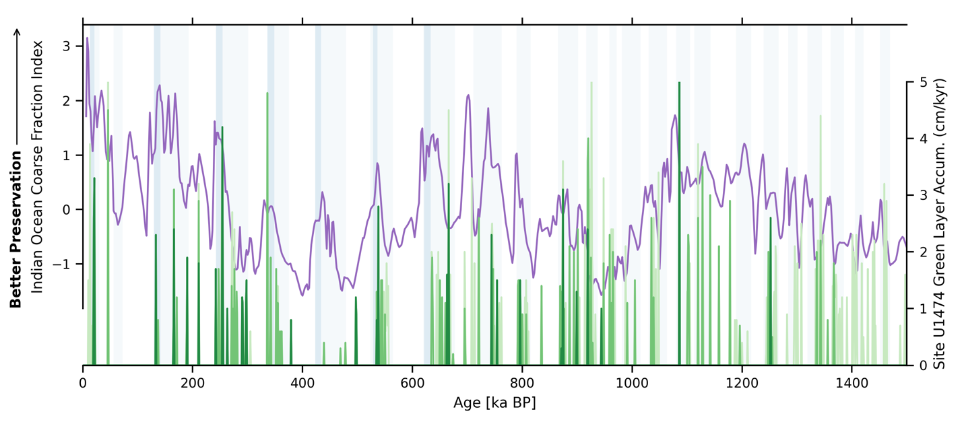
Extended Data Figure 11: Indian Ocean carbonate preservation and green band abundances at Site U1474. Carbonate preservation indicated by the coarse fraction index of Bassinot et al.¹⁰¹(purple). Vertical bars represent glacial marine isotope stages.
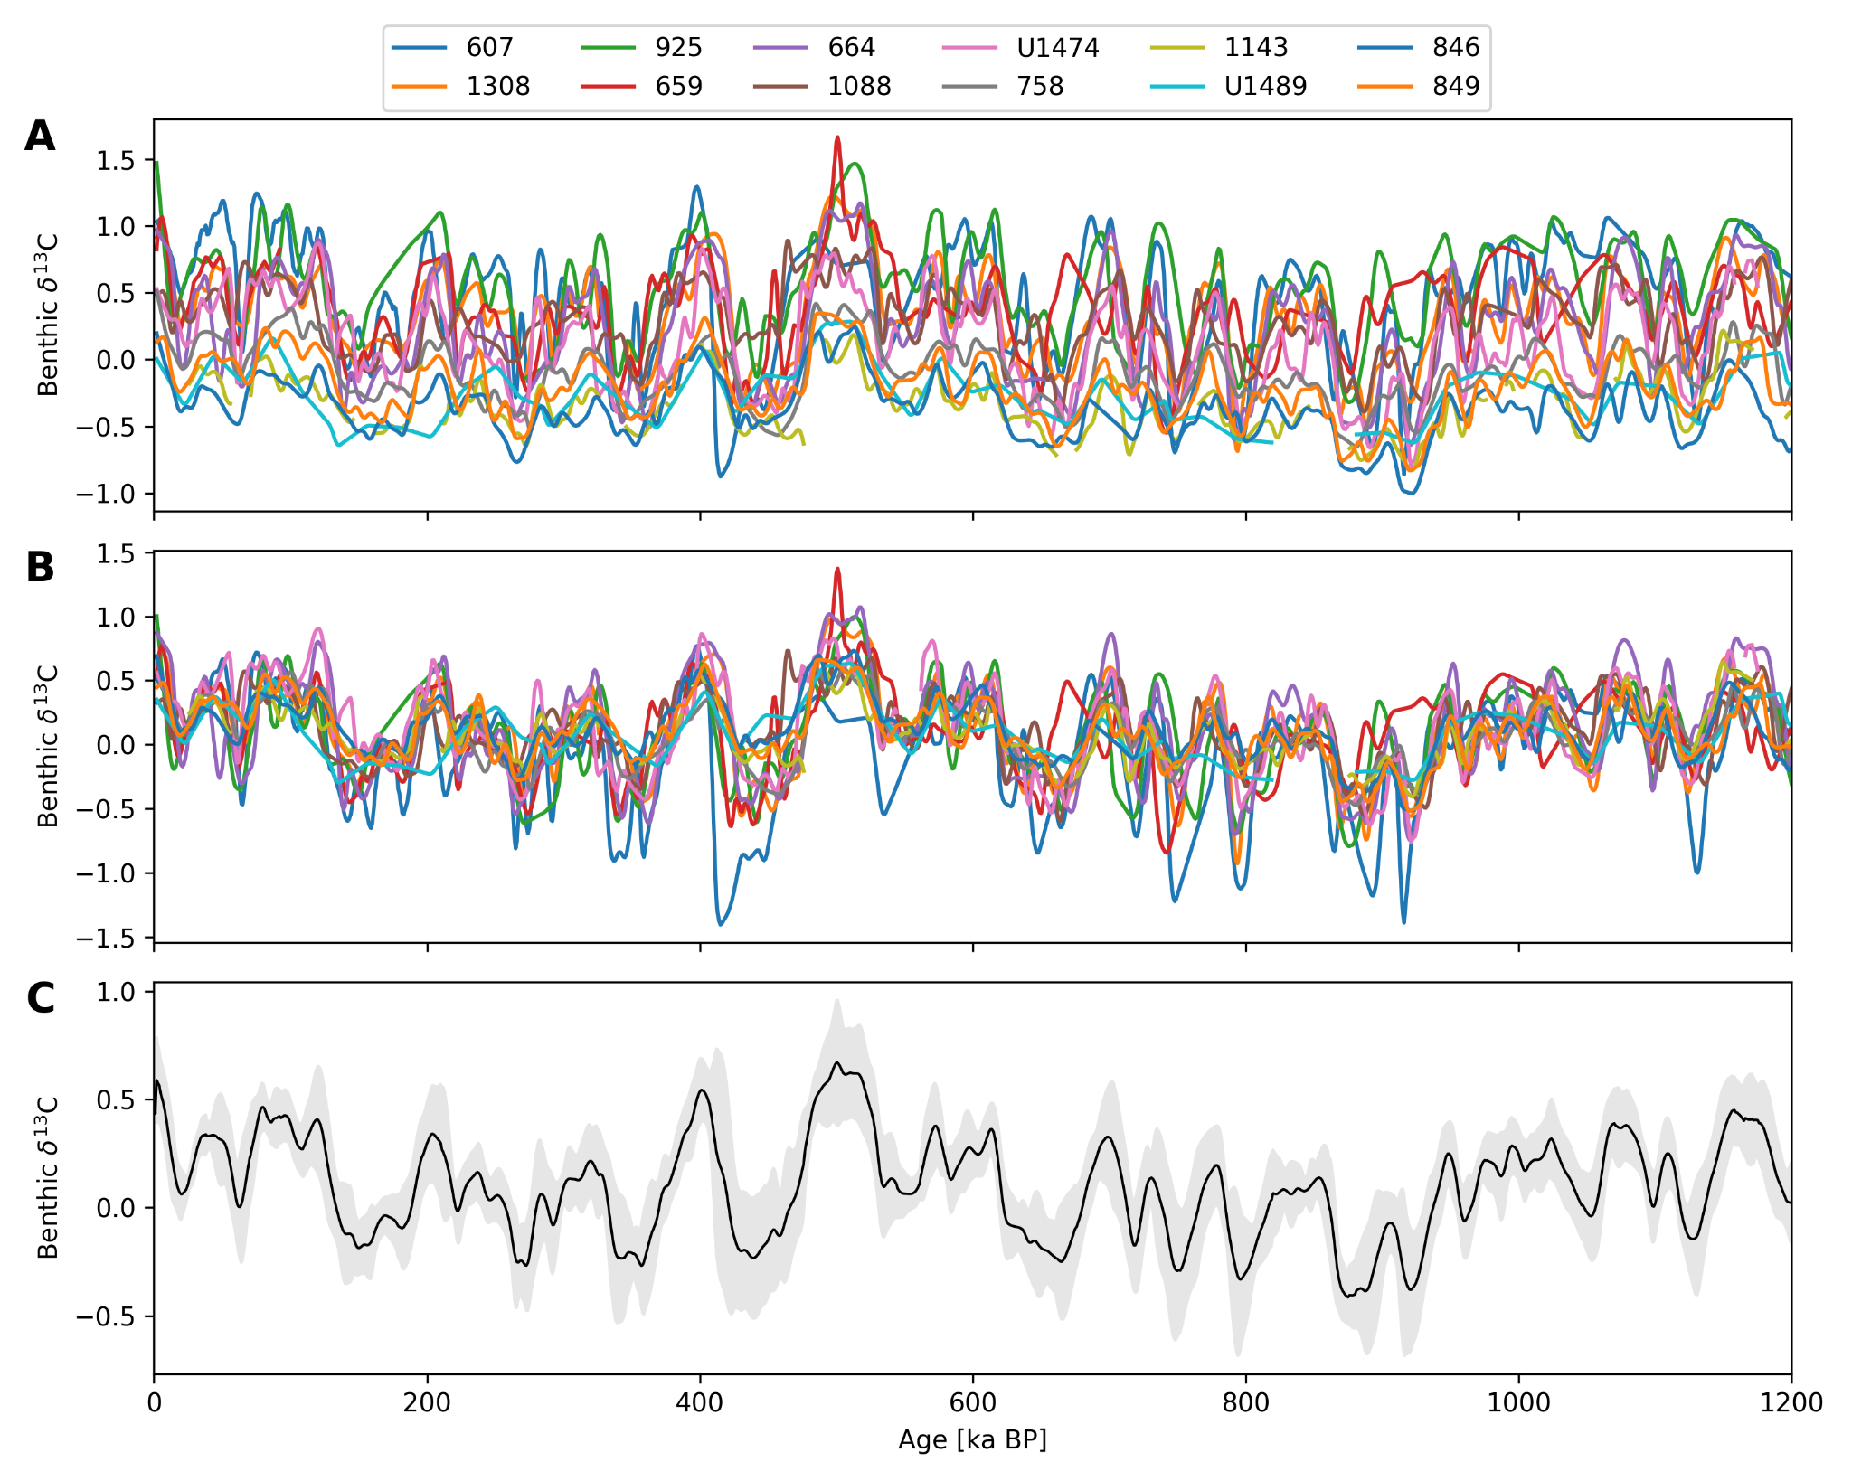
Extended Data Figure 12: Constructing a global stack of carbon isotopes. A) Smoothed benthic carbon isotope records B) Mean removed C) Averaged and mean returned

