Table 1. Dynamo Plugins Used
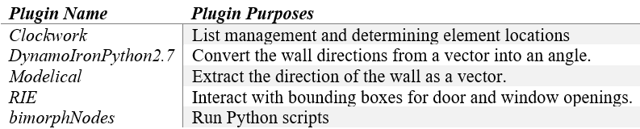

Table 2. Extracted Location and Material Information for Room Configuration
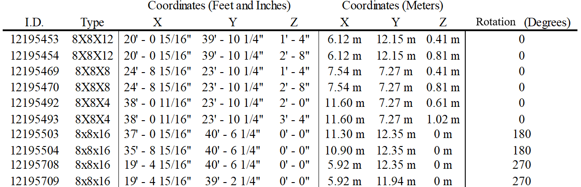

Table 3. Generated Content for Each Room Configuration
