Supplementary material

Contents
Supplementary Methods
Supplementary Results
Supplementary Tables
Supplemental Figures
Supplementary References
Supplementary Appendix (Study Data)

Supplementary Methods
- PET Analysis quality control protocol (data exclusions)
A FEP participant with marked deviation in our QC was excluded from the final analysis. The automatic blood sampling system (ABSS) could not withdraw samples after 5 minutes & was aborted at 15 minutes. Further, there was significant difficulty withdrawing 3- and 5-minute manual metabolite samples (high fatty content in samples) and thus, there were no manual metabolite samples post 7 minutes. It was also difficult to perform saline rinses (anti-coagulation measures). This significantly compromised the necessary data required for the generation of a reliable input function for the kinetic analysis of this participant. Thus, our results are not driven by methodological issues.
- Measures
Competency to fully comprehend the purpose of the study to make rational decision whether to participate was determined using the MacCAT (1) in all patient participants. Further, the following measures were used to examine the symptom severity and other behavioural measures in the clinical cohorts (FEP and CHR): Positive and Negative Syndrome Scale (PANSS) [FEP] (2), Structured Interview for Psychosis-Risk Syndromes (SIPS) and the Scale of Psychosis-Risk Symptoms (SOPS) [CHR] (3), Repeatable Battery for the Assessment of Neuropsychological Status (RBANS) (4), Global Assessment of Functioning scale (GAF) (5), Beck-anxiety inventory (BAI) (anxiety scale) (6), Snaith-Hamilton Pleasure Scale (SHAPS) (pleasure scale) (7), Apathy Evaluation Scale (apathy scale) (8) and Hamilton Depression Rating Scale (HAM-D) (depression scale) (9).
- MAO-B expression pattern in different brain cell types (Single cell type transcriptomic analysis)
Single-nucleus RNA-sequencing (snRNA-seq) provides cell type specific transcriptomic data relevant to specific targets in post-mortem samples.
For the DLPFC dataset (10) (34 healthy controls; 16 M, 18 F), briefly, pre-processing methods employed included sequencing, alignment, and generation of count matrices followed by optimization of Seurat clustering parameters resulting in the generation of nuclei clusters. Clusters were annotated to one of 7 major brain cell types in the DLPFC dataset - excitatory neurons (48% of nuclei), inhibitory neurons (18% of nuclei), oligodendrocytes (14% of nuclei), astrocytes (8% of nuclei), oligodendrocyte precursor cells (OPCs) (5% of nuclei), endothelial cells (2.5% of nuclei), microglia (2% of nuclei) and one unassigned cluster showed a mixed expression profile of neuronal and glial marker genes (2% of nuclei).
For the ACC dataset (Dehestani M., unpublished data, 2023 https://www.biorxiv.org/content/10.1101/2023.05.11.540329v3), snRNA-seq on the 2 healthy controls in the ACC region was done to identify neuronal and non-neuronal cell-type differences. After data cleaning and quality control, 88,876 high-quality single nuclei were retained. The clustering of these high-quality nuclei identified 13 clusters covering major broad cell types in the brain, i.e. excitatory neurons (ExN), inhibitory neurons (InN), oligodendrocytes (Oligo), oligodendrocyte precursor cells (OPCs), microglia (mic), astrocytes (Astro) and vascular cells (Vas). On average, 7406 high-quality nuclei were obtained per sample ranging from 3.6% to 16.5% of the total nuclei. Further, the clusters were annotated based on the expression of cell-type marker, MAO-B.
For the striatum (11), striatal snRNA-seq data was derived exclusively from WT mice, comprising a cohort of four 14- to 15-month-old male mice. The snRNA-seq dataset encompassed 1314 high-quality cells after quality control and normalization processes. Louvain clustering and annotation of these cells delineated well-defined clusters corresponding to major cell populations in the striatum, including medium spiny neurons (MSNs), interneurons, oligodendrocytes, astrocytes, endothelial cells, and microglia. Further sub-clustering of MSNs unveiled distinct subtypes, such as D1 and D2 MSNs, along with an "eccentric" subtype.
In our brief analysis, dot plots were created using Seurat's Dot Plot function with default parameters, incorporating MAO-B as the inputted feature (12).
Supplementary Results
No association between MAO-B V_{T}, Clinical and Neuropsychological measures
In FEP, we found no significant associations between MAO-B V_{T} and duration of illness (F_{(1,14)} = 2.97, p = 0.11, f = 0.46) or duration of untreated psychosis (F_{(1,14)} = 0.28, p = 0.61, f = 0.14), controlling for tobacco use and ROI, possibly due to the younger study cohort.
Additionally, no significant correlations were found between MAO-B V_{T} and PANSS symptom severity within the FEP group (Table S2), nor were there any significant correlations with the severity of psychosis-risk symptoms in CHR individuals (Table S3). Across the combined patient cohort (including both CHR individuals and FEP patients), we found no association between cognitive function and MAO-B V_{T} (Table S4) except for a positive correlation between decreased DLPFC MAO-B V_{T} and RBANS visuospatial memory (r = 0.48, p uncorrected = 0.04) and a trending correlation in the mPFC (r = 0.45, p uncorrected = 0.051). Other clinical or behavioural measures such as Global Assessment of Functioning, anxiety (BAI), anhedonia (SHAPS), apathy (AES) and depression (HAM-D) scores were not associated with MAO-B V_{T} in any brain regions (Table S5).
Supplementary Tables
Supplementary Table 1. Comparison of MAO-B V_{T} among healthy volunteer datasets.
ROI | Study data | Mean | SD | t Test¹ | p² | % mean difference
 |  |  |  |  |  | Current study et al vs. Moruguchi S et al. 2019 | Current study et al vs. Gill et al. 2022 | Current study et al vs. Koshimori Y et al. Brain. 2023
DLPFC | Moruguchi S et al. JAMA Psychiatry. 2019 | 28.2 | 5.4 | 0.12 | 0.90 | -0.7 | N/A | 3.4
DLPFC | Gill T et al. Eur Neuropsychopharmacol. 2022 | NA | NA | N/A | N/A | -0.7 | N/A | 3.4
DLPFC | Koshimori Y et al. Brain. 2023 | 29.37 | 3.64 | 0.77 | 0.45 | -0.7 | N/A | 3.4
DLPFC | Current study et al | 28.4 | 4.41
mPFC | M Moruguchi S et al. JAMA Psychiatry. 2019 | 32.6 | 4.8 | 0.27 | 0.87 | 0.9 | 1.6 | 4.2
mPFC | Gill et al. Eur Neuropsychopharmacol. 2022 | 32.8 | 4.71³ | 0.30 | 0.77 | 0.9 | 1.6 | 4.2
mPFC | Koshimori Y et al. Brain. 2023 | 33.67 | 4.36 | 0.94 | 0.35 | 0.9 | 1.6 | 4.2
mPFC | Current study et al | 32.3 | 4.96
ACC | Moruguchi S et al. JAMA Psychiatry. 2019 | 36.3 | 5.9 | 1.05 | 0.30 | 5.9 | 5.0 | 7.5
ACC | Gill et al. Eur Neuropsychopharmacol. 2022 | 35.98 | 5.62³ | 0.87 | 0.39 | 5.9 | 5.0 | 7.5
ACC | Koshimori Y et al. Brain. 2023 | 36.82 | 5.12 | 1.50 | 0.14 | 5.9 | 5.0 | 7.5
ACC | Current study et al | 34.26 | 5.85
HIP | Moruguchi S et al. JAMA Psychiatry. 2019 | NA | NA | N/A | N/A | N/A | 2.6 | 0.3
HIP | Gill et al. Eur Neuropsychopharmacol. 2022 | 32.96 | 5.02⁴ | 0.51 | 0.62 | N/A | 2.6 | 0.3
HIP | Koshimori Y et al. Brain. 2023 | 32.24 | 5.64 | 0.07 | 0.95 | N/A | 2.6 | 0.3
HIP | Current study et al | 32.14 | 4.39
Ventral Striatum | Moruguchi S et al. JAMA Psychiatry. 2019 | 53.2 | 11.8 | 0.98 | 0.33 | -5.8 | 3.2 | -0.05
Ventral Striatum | Gill et al. Eur Neuropsychopharmacol. 2022 | 58.30 | 10.65³ | 0.54 | 0.59 | -5.8 | 3.2 | -0.05
Ventral Striatum | Koshimori Y et al. Brain. 2023 | 56.47 | 11.59 | 0.01 | 0.99 | -5.8 | 3.2 | -0.05
Ventral Striatum | Current study et al | 56.50 | 8.55
Dorsal Striatum | Moruguchi S et al. JAMA Psychiatry. 2019 | NA | NA | N/A | N/A | N/A | -2.2 | N/A
Dorsal Striatum | Gill et al. Eur Neuropsychopharmacol. 2022 | 44.26 | 6.57⁴ | 0.44 | 0.66 | N/A | -2.2 | N/A
Dorsal Striatum | Koshimori Y et al. Brain. 2023 | NA | NA | N/A | N/A | N/A | -2.2 | N/A
Dorsal Striatum | Current study et al | 45.26 | 6.57
¹Independent samples T-test comparing means of MAO-B V_{T} between healthy volunteer datasets (published vs. current study data).
²p<0.05

³Average SD calculated using the available standard deviations of the HV datasets for the respective ROIs.
⁴Assumed SD based on the available standard deviation or average of the available SDs of the HV datasets for the respective ROIs.
Abbreviations: ACC, anterior cingulate cortex; DLPFC, dorsolateral prefrontal cortex; HIP, Hippocampus; mPFC, medial prefrontal cortex; N/A, Not applicable; NA, Not available; %, Percentage; ROI, Region of interest; SD, Standard deviation.

Supplementary Table 2: No association between MAO-B V_{T} and PANSS scores in FEP, adjusted for tobacco use.
V_{T} | Positive |  | Negative |  | General |  | Total
ROI | r | p | r | p | r | p | r | p
DLPFC | 0.34 | 0.26 | 0.34 | 0.26 | 0.06 | 0.85 | 0.26 | 0.39
mPFC | 0.003 | 0.99 | -0.19 | 0.53 | -0.34 | 0.25 | -0.23 | 0.45
ACC | 0.11 | 0.73 | 0.09 | 0.78 | -0.12 | 0.71 | 0.006 | 0.98
HIP | 0.11 | 0.71 | 0.28 | 0.36 | 0.11 | 0.71 | 0.18 | 0.55
AST | 0.03 | 0.92 | 0.09 | 0.77 | -0.05 | 0.86 | 0.008 | 0.98
LST | -0.08 | 0.79 | 0.22 | 0.47 | -0.01 | 0.97 | 0.02 | 0.95
SMST | 0.18 | 0.56 | 0.32 | 0.29 | 0.26 | 0.39 | 0.30 | 0.33
Abbreviations: ACC, Anterior cingulate cortex; AST, Associative striatum; DLPFC, Dorsolateral prefrontal cortex; mPFC, Medial prefrontal cortex; LST, Limbic striatum; PANSS, Positive and Negative Syndrome Scale; SMST, Sensorimotor striatum; V_{T,} Total distribution volume

Supplementary Table 3: No association between MAO-B V_{T} and SOPS scores in CHR, adjusted for tobacco use.
V_{T} | Positive |  | Negative |  | Disorganization |  | General |  | Total
ROI | r | p | r | p | r | p | r | p | r | p
DLPFC | -0.09 | 0.87 | -0.33 | 0.52 | -0.21 | 0.69 | -0.53 | 0.28 | -0.37 | 0.47
mPFC | -0.10 | 0.85 | -0.33 | 0.52 | -0.22 | 0.67 | -0.53 | 0.28 | -0.38 | 0.46
ACC | 0.04 | 0.95 | -0.30 | 0.56 | -0.19 | 0.71 | -0.56 | 0.25 | -0.35 | 0.49
HIP | -0.09 | 0.86 | -0.26 | 0.63 | -0.16 | 0.76 | -0.47 | 0.35 | -0.31 | 0.55
AST | -0.13 | 0.81 | -0.25 | 0.63 | -0.17 | 0.75 | -0.46 | 0.36 | -0.31 | 0.55
LST | -0.15 | 0.78 | -0.34 | 0.51 | -0.24 | 0.65 | -0.53 | 0.28 | -0.39 | 0.45
SMST | -0.04 | 0.94 | -0.24 | 0.65 | -0.15 | 0.78 | -0.48 | 0.33 | -0.30 | 0.57
Abbreviations: ACC, Anterior cingulate cortex; AST, Associative striatum; DLPFC, Dorsolateral prefrontal cortex; mPFC, Medial prefrontal cortex; LST, Limbic striatum; SOPS, Scale of Prodromal Symptoms; SMST, Sensorimotor striatum; V_{T,} Total distribution volume

Supplementary Table 4. Association between MAO-B V_{T} and RBANS scores in patient sample, adjusted for tobacco use and group effect.
V_{T} | Immediate memory |  | Visuospatial |  | Language |  | Attention |  | Delayed memory |  | Total
ROI | r | p | r | p | r | p | r | p | r | p | r | p
DLPFC | 0.06 | 0.82 | 0.48 | 0.04¹ | 0.15 | 0.53 | 0.05 | 0.84 | -0.07 | 0.79 | 0.15 | 0.54
mPFC | 0.21 | 0.38 | 0.45 | 0.051 | 0.12 | 0.62 | 0.19 | 0.43 | 0.06 | 0.81 | 0.24 | 0.33
ACC | 0.17 | 0.48 | 0.40 | 0.09 | 0.08 | 0.74 | 0.03 | 0.92 | -0.07 | 0.77 | 0.13 | 0.59
HIP | 0.15 | 0.54 | 0.36 | 0.13 | 0.08 | 0.76 | -0.08 | 0.74 | -0.17 | 0.49 | 0.07 | 0.78
AST | 0.17 | 0.50 | 0.29 | 0.22 | 0.05 | 0.84 | -0.07 | 0.76 | -0.12 | 0.62 | 0.06 | 0.80
LST | 0.34 | 0.15 | 0.37 | 0.12 | 0.15 | 0.54 | 0.02 | 0.93 | -0.07 | 0.79 | 0.19 | 0.43
SMST | 0.11 | 0.65 | 0.37 | 0.12 | -0.02 | 0.94 | -0.03 | 0.92 | -0.08 | 0.74 | 0.06 | 0.82
DLPFC MAO-B V_{T} was associated with visuospatial RBANS scores in the patient sample (r = 0.48, p = 0.04). Sub-analysis revealed that this correlation was driven by the FEP group (r = 0.66, p= 0.02) in comparison to CHR group (r = 0.30, p= 0.56).
¹p < 0.05
Abbreviations: ACC, anterior cingulate cortex; AST, Associative striatum; DLPFC, Dorsolateral prefrontal cortex; mPFC, Medial prefrontal cortex; LST, Limbic striatum; RBANS, Repeatable Battery for the Assessment of Neuropsychological Status; SMST, Sensorimotor striatum; V_{T,} Total distribution volume

Supplementary Table 5: No association between MAO-B V_{T} and clinical symptom and behavioural measures in patient sample, adjusted for tobacco use and group effect.
V_{T} | Global Assessment of Functioning (GAF) |  | Anxiety score (BAI)¹ |  | Apathy  (AES)² |  | Pleasure scale (SHAPS) |  | Depression scale  (HAM-D)
ROI | r | p | r | p | r | p | r | p | r | p
DLPFC | -0.23 | 0.34 | -0.01 | 0.96 | -0.05 | 0.87 | 0.17 | 0.48 | -0.02 | 0.95
mPFC | -0.45 | 0.06 | 0.18 | 0.49 | 0.19 | 0.49 | 0.28 | 0.24 | 0.14 | 0.59
ACC | -0.32 | 0.18 | 0.11 | 0.65 | -0.01 | 0.97 | 0.20 | 0.41 | 0.06 | 0.80
HIP | -0.38 | 0.11 | 0.17 | 0.50 | -0.03 | 0.93 | 0.22 | 0.37 | 0.12 | 0.65
AST | -0.33 | 0.17 | 0.09 | 0.73 | 0.01 | 0.96 | 0.15 | 0.54 | 0.05 | 0.84
LST | -0.25 | 0.30 | 0.13 | 0.60 | 0.14 | 0.62 | 0.19 | 0.44 | 0.005 | 0.98
SMST | -0.33 | 0.17 | -0.01 | 0.96 | -0.04 | 0.89 | 0.28 | 0.26 | 0.11 | 0.65
¹BAI and HAM-D scores were not available for one FEP.
²AES scores were not available for one FEP and two CHRs.
Abbreviations: ACC, Anterior cingulate cortex; AES, Apathy evaluation scale; AST, Associative striatum; BAI, Beck Anxiety Inventory; DLPFC, Dorsolateral prefrontal cortex; HAM-D, Hamilton Depression Rating; MPFC, Medial prefrontal cortex; LST, Limbic striatum; SHAPS, Snaith-Hamilton Pleasure Scale; SMST, Sensorimotor striatum; V_{T,} Total distribution volume

Supplemental Figures
Supplementary Figure 1. The schematic participant flow diagram
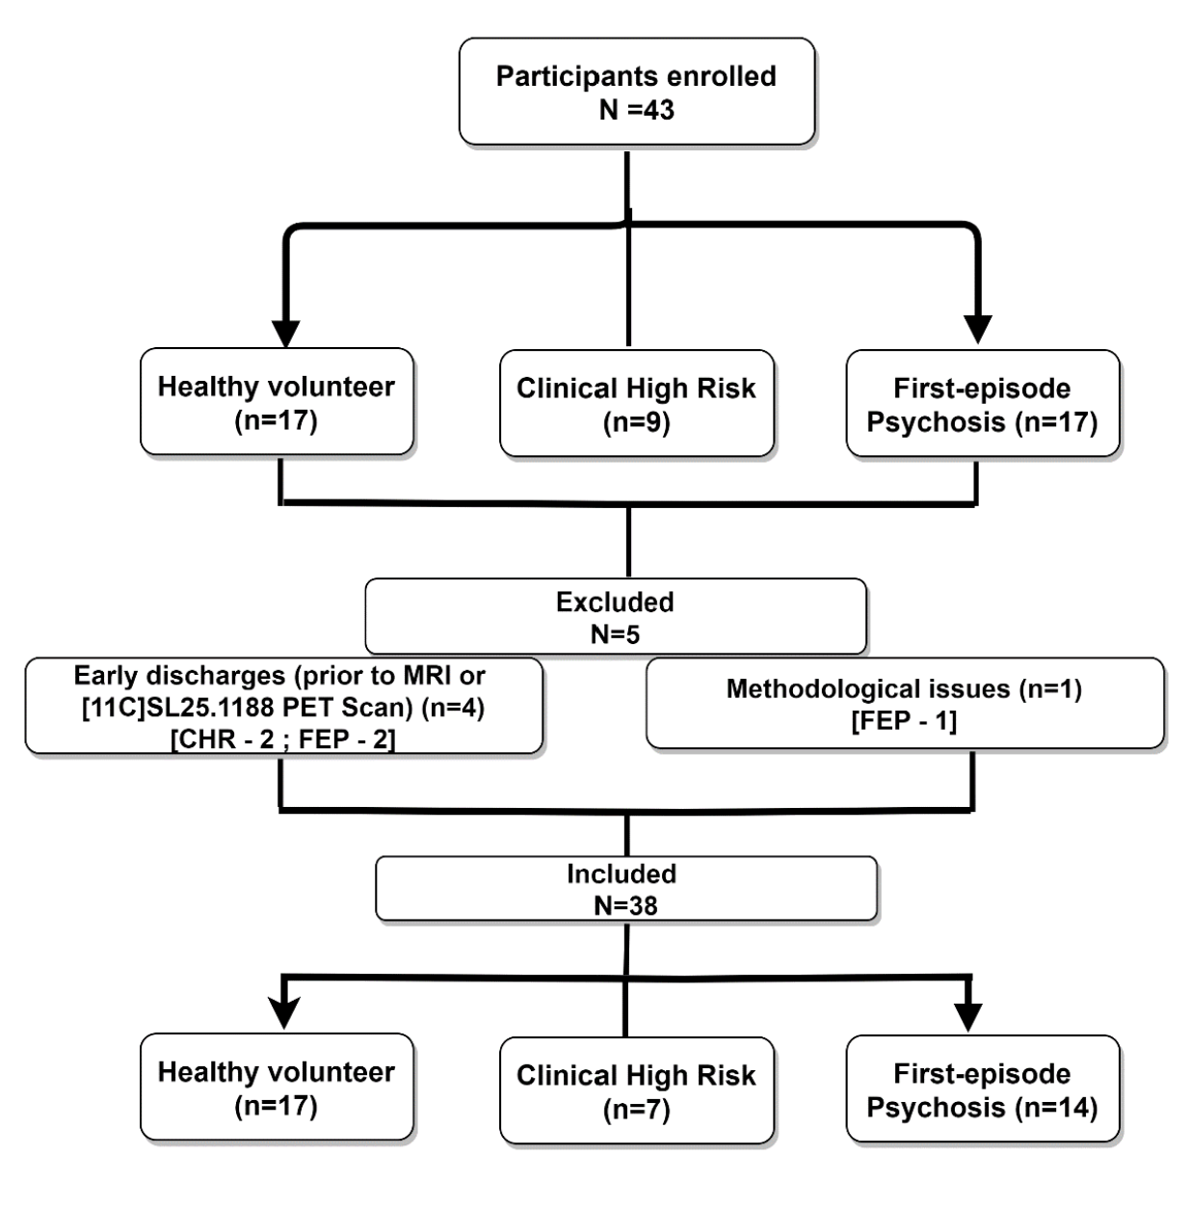
Figure S1. The healthy volunteers for the current study were obtained from a collaborator’s PET study (13) that met the inclusion/exclusion criteria of the current study and used the same radioligand, [¹¹C]SL25.1188.
Abbreviations: CHR, Clinical High Risk; HV, Health Volunteer; FEP, First-episode Psychosis; N, sample size; PET, Positron emission tomography
Supplementary Figure 2. MAO-B V_{T} with cannabis use (cannabis vs no-cannabis) across prioritized ROIs
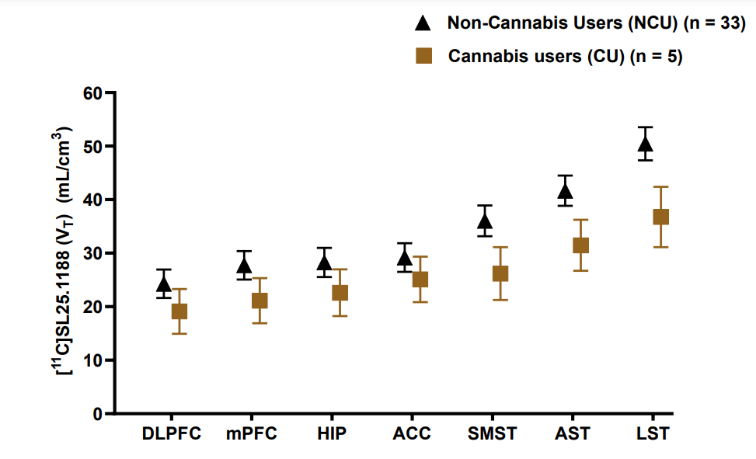
Figure S2. The error bar graph reflects the model estimated marginal means and 95% confidence intervals in MAO-B V_{T} compared between cannabis users (n = 5) vs. non-cannabis users (n = 33) plotted across cortical and sub-cortical ROIs. The graph depicts lower MAO-B V_{T} in cannabis users with a larger effect observed in striatal ROIs (SMST, AST, LST) as opposed to cortical ROIs (Cohen’s f = 0.89).
Abbreviations: ACC, Anterior cingulate cortex; AST, Associative striatum; DLPFC, Dorsolateral prefrontal cortex; MPFC, Medial prefrontal cortex; LST, Limbic striatum; SMST, Sensorimotor striatum
Supplementary Figure 3. Single nucleus analysis of MAO-B expression grouped by broad cell type clusters.
- DLPFC
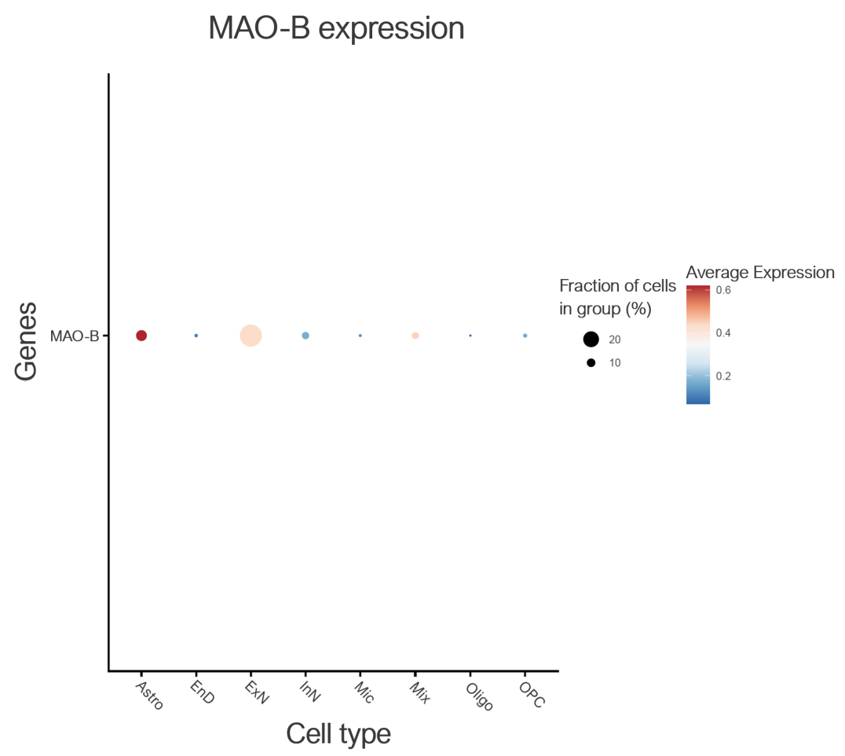
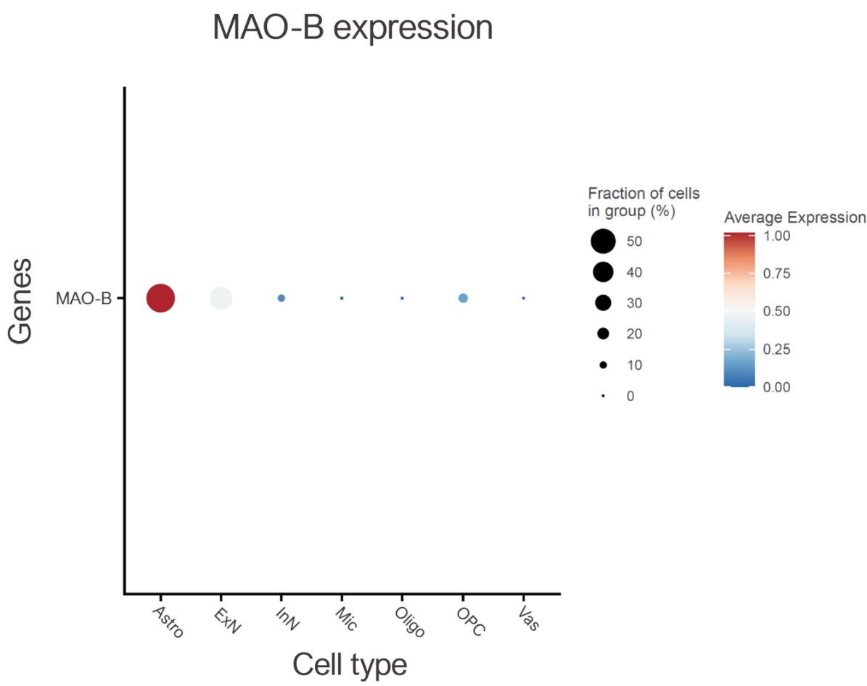
- ACC

- Striatum
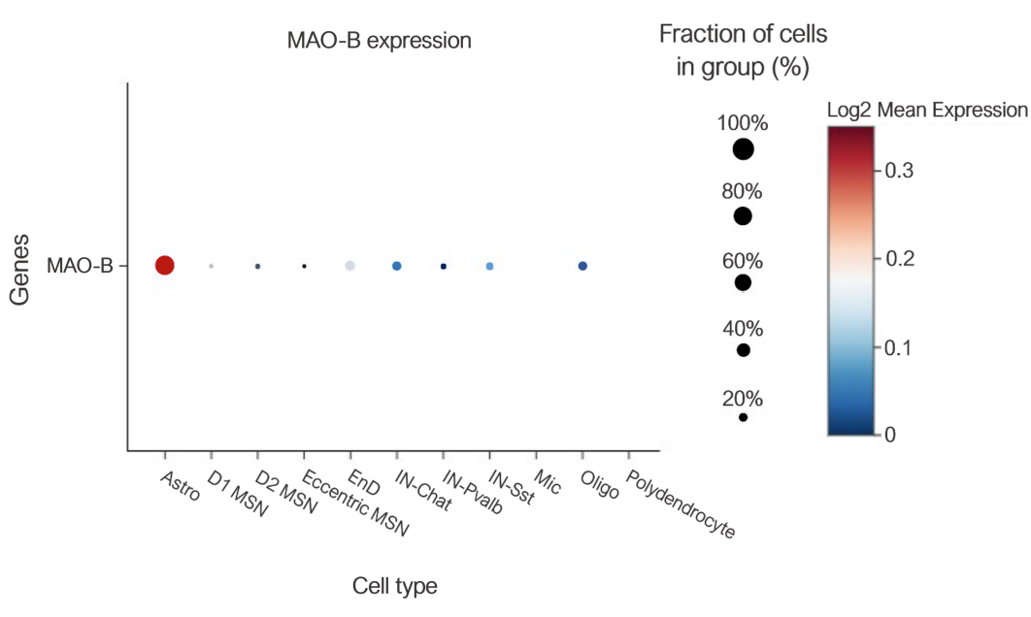
Figure S3. Dot plot corresponding to the expression levels of MAO-B grouped by broad cell type clusters in the A) DLPFC, B) ACC, and C) Striatum. The size of the dots corresponds to the percentage of MAO-B expressing cells within a cluster (cell type) expressing a feature (MAO-B), whereas the color of the dots corresponds to the average expression or concentration level of feature (MAO-B marker) within that cell type. The sizes of the dots are not comparable between regions as the numbers are semi-quantitatively calculated by Seurat's Dot Plot function software. In DLPFC (HC, n=34), MAO-B expression is approximately 28% in excitatory neurons and around 13% in astrocytes. In ACC (neurotypical subjects, n=2), 58% of astrocytes and approximately 44% of excitatory neurons express MAO-B. In the striatum (wild-type control mice, n=4), 72% of astrocytes express MAO-B. Overall, the average MAO-B expression i.e., the concentration of MAO-B within each cell, indicated by the brighter color (dark red), is higher in the astrocyte cluster compared to other cell types.
Abbreviations: Astro, Astrocytes; D1 MSN, D1-type medium spiny neurons; D2 MSN, D2-type medium spiny neurons; Eccentric MSN, Eccentric medium spiny neurons; End, Endothelial cells; ExN, Excitatory neurons; IN-Chat, Cholinergic interneurons; InN, Inhibitory neurons; IN-Pvalb, Parvalbumin interneurons; IN-Sst, Somatostatin interneurons; Mic, Microglia; Mix, Mixed expression profile; Oligo, oligodendrocytes; OPCs, Oligodendrocyte precursor cells; Vas, Vascular cells
Supplementary References
1. WONG J. MacCAT-CR: MacArthur Competence Tool for Clinical Research. By P. S. Appelbaum and T. Grisso. (Pp. 84; $22.00.) Professional Resource Press: Sarasota, FL. 2001. -. Psychological Medicine. 2002 Jul 1;32:943–8.
2. Kay SR, Fiszbein A, Opler LA. The positive and negative syndrome scale (PANSS) for schizophrenia. Schizophr Bull. 1987;13(2):261–76.
3. Miller TJ, McGlashan TH, Rosen JL, Somjee L, Markovich PJ, Stein K, et al. Prospective diagnosis of the initial prodrome for schizophrenia based on the Structured Interview for Prodromal Syndromes: preliminary evidence of interrater reliability and predictive validity. Am J Psychiatry. 2002 May 1;159(5):863–5.
4. Randolph C, Tierney M, Mohr E, Chase T. Randolph C, Tierney MC, Mohr E, Chase TN. The Repeatable Battery for the Assessment of Neuropsychological Status (RBANS): preliminary clinical validity. J Clin Exp Neuropsychol 20: 310-319. Journal of clinical and experimental neuropsychology. 1998 Jul 1;20:310–9.
5. Aas IHM. Global Assessment of Functioning (GAF): properties and frontier of current knowledge. Ann Gen Psychiatry. 2010 May 7;9:20.
6. Beck AT, Epstein N, Brown G, Steer RA. An inventory for measuring clinical anxiety: psychometric properties. J Consult Clin Psychol. 1988 Dec;56(6):893–7.
7. Snaith RP, Hamilton M, Morley S, Humayan A, Hargreaves D, Trigwell P. A scale for the assessment of hedonic tone the Snaith-Hamilton Pleasure Scale. Br J Psychiatry. 1995 Jul;167(1):99–103.
8. Marin RS, Biedrzycki RC, Firinciogullari S. Reliability and validity of the Apathy Evaluation Scale. Psychiatry Res. 1991 Aug;38(2):143–62.
9. Hamilton M. A rating scale for depression. J Neurol Neurosurg Psychiatry. 1960 Feb;23(1):56–62.
10. Maitra M, Mitsuhashi H, Rahimian R, Chawla A, Yang J, Fiori LM, et al. Cell type specific transcriptomic differences in depression show similar patterns between males and females but implicate distinct cell types and genes. Nat Commun. 2023 May 22;14(1):2912.
11. Malaiya S, Cortes-Gutierrez M, Herb BR, Coffey SR, Legg SRW, Cantle JP, et al. Single-Nucleus RNA-Seq Reveals Dysregulation of Striatal Cell Identity Due to Huntington’s Disease Mutations. J Neurosci. 2021 Jun 23;41(25):5534–52.
12. Hao Y, Hao S, Andersen-Nissen E, Mauck WM, Zheng S, Butler A, et al. Integrated analysis of multimodal single-cell data. Cell. 2021 Jun 24;184(13):3573-3587.e29.
13. Gill T, Watling SE, Richardson JD, McCluskey T, Tong J, Meyer JH, et al. Imaging of astrocytes in posttraumatic stress disorder: A PET study with the monoamine oxidase B radioligand [11C]SL25.1188. European Neuropsychopharmacology. 2022 Jan 1;54:54–61.

Supplementary Appendix (Study Data)
Study ID | Diagnosis | Tobacco use (P/A) | Cannabis urine drug screen positive (P/A) | DLPFC V_{T} | MPFC  V_{T} | ACC V_{T} | HIP  V_{T} | AST V_{T} | LST V_{T} | SMST V_{T}
1 | FEP | A | A | 26.71 | 31.62 | 32.10 | 31.76 | 44.12 | 55.73 | 39.53
2 | FEP | A | A | 23.15 | 27.77 | 28.85 | 28.62 | 40.02 | 51.92 | 35.83
3 | FEP | A | A | 35.42 | 29.92 | 37.32 | 38.52 | 52.23 | 63.00 | 48.83
4 | FEP | A | A | 26.65 | 31.28 | 34.13 | 35.61 | 50.37 | 65.59 | 40.61
5 | FEP | A | A | 27.00 | 30.18 | 29.98 | 30.26 | 42.40 | 51.26 | 42.16
6 | FEP | A | A | 25.91 | 30.14 | 32.12 | 29.29 | 44.95 | 53.21 | 38.06
7 | FEP | P | P | 14.69 | 16.98 | 19.23 | 19.38 | 23.54 | 32.58 | 20.29
8 | FEP | P | A | 23.58 | 27.22 | 29.95 | 25.32 | 40.43 | 52.55 | 33.92
9 | FEP | A | A | 31.79 | 37.30 | 36.58 | 32.95 | 49.76 | 54.56 | 45.51
10 | FEP | A | A | 24.24 | 28.48 | 30.67 | 30.33 | 42.91 | 47.03 | 36.29
11 | FEP | P | A | 20.98 | 24.83 | 26.76 | 28.29 | 38.71 | 47.13 | 23.98
12 | FEP | A | A | 21.63 | 24.67 | 26.03 | 24.17 | 38.00 | 39.55 | 34.01
13 | FEP | A | A | 29.95 | 30.12 | 33.33 | 26.20 | 42.77 | 44.92 | 33.35
14 | FEP | A | A | 34.21 | 38.49 | 41.66 | 41.12 | 57.60 | 64.41 | 52.92
15 | CHR | A | P | 12.73 | 14.26 | 15.26 | 16.77 | 16.15 | 21.70 | 13.08
16 | CHR | A | A | 19.06 | 21.69 | 23.75 | 25.02 | 31.25 | 37.90 | 27.23
17 | CHR | A | A | 25.84 | 29.50 | 32.67 | 31.09 | 45.90 | 53.28 | 40.74
18 | CHR | A | P | 18.58 | 20.89 | 22.73 | 23.55 | 31.99 | 34.32 | 27.58
19 | CHR | A | A | 25.75 | 28.76 | 28.77 | 30.09 | 44.28 | 52.09 | 36.73
20 | CHR | P | A | 19.57 | 23.16 | 23.25 | 21.47 | 34.36 | 38.30 | 30.49
21 | CHR | A | A | 29.20 | 31.30 | 33.94 | 30.94 | 44.05 | 54.28 | 39.59
22 | HV | A | P | 32.54 | 35.38 | 46.19 | 34.46 | 49.94 | 53.20 | 39.66
23 | HV | A | A | 31.04 | 35.03 | 38.28 | 34.72 | 51.70 | 60.74 | 43.52
24 | HV | A | A | 15.23 | 18.65 | 20.85 | 19.82 | 29.62 | 38.92 | 24.72
25 | HV | A | A | 28.88 | 35.46 | 34.51 | 35.15 | 49.94 | 64.96 | 43.61
26 | HV | A | A | 32.00 | 35.51 | 37.59 | 34.31 | 53.15 | 62.24 | 41.85
27 | HV | A | A | 27.96 | 32.24 | 33.85 | 30.40 | 45.20 | 55.94 | 40.33
28 | HV | A | A | 30.69 | 34.56 | 36.65 | 38.04 | 49.81 | 63.39 | 47.28
29 | HV | A | A | 31.45 | 37.15 | 36.09 | 33.18 | 54.05 | 66.04 | 52.23
30 | HV | A | A | 33.55 | 38.58 | 38.59 | 37.61 | 55.45 | 70.07 | 47.99
31 | HV | A | A | 27.64 | 30.89 | 31.31 | 31.99 | 46.61 | 51.67 | 37.02
32 | HV | A | A | 24.25 | 26.73 | 27.56 | 27.95 | 36.34 | 48.50 | 32.89
33 | HV | A | A | 31.91 | 37.28 | 40.85 | 34.37 | 57.18 | 68.11 | 43.35
34 | HV | A | A | 29.67 | 33.79 | 35.61 | 32.49 | 46.90 | 61.11 | 44.02
35 | HV | A | A | 28.65 | 32.03 | 35.06 | 34.40 | 48.77 | 56.50 | 43.93
36 | HV | A | P | 27.33 | 28.71 | 32.27 | 29.16 | 45.81 | 52.33 | 40.64
37 | HV | A | A | 26.66 | 30.33 | 29.62 | 31.23 | 42.69 | 56.66 | 36.04
38 | HV | A | A | 23.64 | 27.35 | 27.51 | 27.13 | 36.28 | 41.41 | 35.09
Abbreviations: A, Absent; ACC, Anterior cingulate cortex; AST, Associative striatum; DLPFC, Dorsolateral prefrontal cortex; HIP, Hippocampus; ID, Identification; LST, Limbic striatum; MPFC, Medial prefrontal cortex; P, Present; SMST, Sensorimotor striatum; V_{T}, Total distribution volume

Main Analysis. Study group differences in regional MAO-B V_{T} levels
MIXED VT BY Diagnosis Tobacco_use Cannabis_urine_drug_screen_positive ROI
/CRITERIA=DFMETHOD(SATTERTHWAITE) CIN(95) MXITER(100) MXSTEP(10) SCORING(1)
SINGULAR(0.000000000001) HCONVERGE(0.00000001, ABSOLUTE) LCONVERGE(0, ABSOLUTE) PCONVERGE(0,
ABSOLUTE)
/FIXED=Diagnosis Tobacco_use Cannabis_urine_drug_screen_positive ROI | SSTYPE(3)
/METHOD=ML
/PRINT=DESCRIPTIVES SOLUTION
/RANDOM=INTERCEPT | SUBJECT(Study_ID) COVTYPE(VC)
/REPEATED=ROI | SUBJECT(Study_ID) COVTYPE(DIAG)
/EMMEANS=TABLES(OVERALL)
/EMMEANS=TABLES(Diagnosis) COMPARE ADJ(BONFERRONI)
/EMMEANS=TABLES(Tobacco_use) COMPARE ADJ(BONFERRONI)
/EMMEANS=TABLES(Cannabis_urine_drug_screen_positive) COMPARE ADJ(BONFERRONI)
/EMMEANS=TABLES(ROI) COMPARE ADJ(BONFERRONI).

Secondary Analysis 1. Effect of cannabis use on MAO-B V_{T} and more pronounced effects in striatal regions
MIXED VT BY Diagnosis Tobacco_use Cannabis_urine_drug_screen_positive ROI
/CRITERIA=DFMETHOD(SATTERTHWAITE) CIN(95) MXITER(100) MXSTEP(10) SCORING(1)
SINGULAR(0.000000000001) HCONVERGE(0.00000001, RELATIVE) LCONVERGE(0, ABSOLUTE) PCONVERGE(0,
ABSOLUTE)
/FIXED=Diagnosis Tobacco_use Cannabis_urine_drug_screen_positive ROI
Diagnosis* Cannabis_urine_drug_screen_positive Diagnosis*ROI Cannabis_urine_drug_screen_positive *ROI |
SSTYPE(3)
/METHOD=ML
/PRINT=DESCRIPTIVES SOLUTION
/RANDOM=INTERCEPT | SUBJECT(Study_ID) COVTYPE(VC)
/REPEATED=ROI | SUBJECT(Study_ID) COVTYPE(DIAG)
/EMMEANS=TABLES(OVERALL)
/EMMEANS=TABLES(Diagnosis)
/EMMEANS=TABLES(Tobacco_use)
/EMMEANS=TABLES(Cannabis_urine_drug_screen_positive)
/EMMEANS=TABLES(ROI)
/EMMEANS=TABLES(Diagnosis* Cannabis_urine_drug_screen_positive)
/EMMEANS=TABLES(Diagnosis*ROI)
/EMMEANS=TABLES(Cannabis_urine_drug_screen_positive *ROI) .

