Supporting Information
Facile Universal Strategy of Presenting Multifunctional Short Peptides for Customizing Desired Surfaces
Ruofei Lu, ^{¶, ♀, Ʈ, #} Bingyang Zhao, ^{Ѱ, #} Kaiyuan Huo, ^{Ӈ} Hao Liu, ^{ф} Yang Wang, ♀, *
Xingjie Zan, ^{¶, ♀, Ӈ,} * Siwang Hu ¶, ♀, *
¶ Department of Arthroplasty, The First People’s Hospital of Wenling, Affiliated Wenling Hospital, Wenzhou Medical University, Taizhou, Zhejiang, 317500, China
♀ Wenzhou Institute, University of Chinese Academy of Sciences, Wenzhou Key Laboratory of Perioperative Medicine, Wenzhou 325001, China
^{Ʈ} South China Normal University, South China Academy of Advanced Optoelectronics, Guangdong Provincial Key Laboratory of Optical Information Materials and Technology & Institute of Electronic Paper Displays, Guangzhou 510006, China
^{Ѱ} School & Hospital of Stomatology, Wenzhou Medical University, Wenzhou, 325035, China
^{Ӈ} School of Pharmaceutical Sciences, Wenzhou Medical University, Wenzhou 325000, China
^{ф} School of Materials Science and Engineering, Zhengzhou University, Zhengzhou 450001, China
# These authors contributed equally.
*Corresponding author. E-mail: wangy0727@ucas.ac.cn (Y. Wang); zanxj@ucas.ac.cn (X. Zan); siwang_h@wmu.edu.cn (S. Hu)

Experimental Section
Chemicals and Materials.
Tannic acid (95%), proanthocyanidin (PC, 95%), epigallocatechin gallate (EGCG, 95%), catechin (Cat, 95%), gallic acid (GA, 95%), polystyrene sphere (PS, 3μm), tetrahydrofuran (THF, 99%), ammonia (NH₃·H₂O, 25%), sulfuric acid (H₂SO₄, 98%), hydrogen peroxide (H₂O₂, 30%), tris(hydroxymethyl)aminomethane (Tris, 99%), hydrochloric acid (HCl, 38%), disodium hydrogen phosphate dodecahydrate (Na₂HPO₄·12H₂O, 99%), sodium dihydrogen phosphate dihydrate (NaH₂PO₄·2H₂O, 99%), sodium chloride (NaCl, 99.5%), 2,2ʹ-azino-bis(3-ethylbenzothiazoline-6-sulfonic acid) (ABTS, 99%), and potassium persulfate (K₂S₂O₈, 99%) were purchased from Sigma. Enhanced green fluorescent protein (EGFP), bovine serum albumin (BSA), lysozyme (Lyz), Dulbecco’s modified eagle medium (DMEM), α-minimum essential medium (α-MEM), rhodamine phalloidin (phalloidin–TRITC), 4′,6-diamidino-2-phenylindole (DAPI), phosphate-buffered saline (PBS), paraformaldehyde (4%), TritonTM X-100, sodium β-glycerophosphate (β-GP), and alizarin red were purchased from Solarbio Life Science. Vitamin C, a BCIP/NBT alkaline phosphatase kit, and a cell counting kit-8 (CCK-8) were purchased from Beyotime Institute of Biotechnology.
Design and synthesis of peptides.
The following peptides bearing different properties were designed and synthesized: Negatively charged peptides: hexaaspartic acid (Asp₆); positively charged peptides: hexaarginine (Arg₆), hexahistidine (His₆), and hexalysine (Lys₆); uncharged peptides: hexaproline (Pro₆); hydrophobic peptides: hexatyrosine (Tyr₆); peptides containing different amino-acid contents: trihistidine (His₃), nonahistidine (His₉), and dodecahistidine (His₁₂); negative–positively charged peptides: di-(lysine–aspartic acid–lysine) ((Lys–Asp–Lys)₂); uncharged–positively charged peptides: di-(lysine–glycine–lysine) ((Lys–Gly–Lys)₂); hydrophobic–positively charged peptides: di-(lysine–isoleucine–lysine) ((Lys–Ile–Lys)₂) and di-(lysine–phenylalanine–lysine) ((Lys–phe–Lys)₂); cell adhesion functional peptide: Lys₆–Acp–Arg–Gly–Asp–Acp–Arg–Gly–Asp–Acp–Arg–Gly–Asp (K₆/RGD); antibacterial functional peptide: Lys₆–Acp–Lys–Trp–Lys–Leu–Phe–Lys–Lys–Ile–Gly–Ala–Val–Leu–Lys–Val–Leu–NH₂ (Cecropin A–melittin hybrid peptide, K₆/CM15); and antifouling functional peptide: Lys₆–(PEG2000–MAL)–Cys (K₆/PEG). Peptides were synthesized by Hangzhou All Peptide Biotechnology Co., Ltd.
Preparation of polyphenol–peptide coatings.
Polyphenols (1 mg/mL) and peptides (1 mg/mL) were dissolved in the required buffer. Wafers (1 cm × 1 cm) were cleaned using piranha solution (70% H₂SO₄ and 30% H₂O₂, V/V, Caution: strong oxidizer!) at 98°C for 2 h and then washed with deionized water and dried with a nitrogen gas stream. Pretreated fresh silicon wafers were used as substrates for LbL assembly. Substrates were alternately immersed in polyphenol and a peptide solution for 5 min until the desired number of layers (n) was obtained. Each deposited layer had to be washed with either deionized water or the buffer solution and dried with nitrogen gas.
Characterization.
The coating thickness was measured using a multiangle ellipsometric polarization spectrometer (Woollam M2000UI, J. A. Woollam Co., Inc., Lincoln, NE) at incidences of 65 and 70° and analyzed using WVASE32 software. A quartz crystal microbalance with dissipation (QCM-D, Biolin Scientific, Sweden) was used to monitor the LbL growth of the TA- and peptide-assembled coatings. The instrument’s software (Dfind, Biolin Scientific) was employed for modeling and analyzing data obtained using QCM-D. The coatings were analyzed using Fourier-transform infrared (FTIR) spectroscopy (Tensor II spectrometer, Bruker, Germany). Samples were scanned in the wavenumber range 400–3600 cm⁻¹ in the attenuated total reflection mode, and data were baseline corrected using the instrument’s companion software. Assembled TA–peptide coatings were characterized using X-ray photoelectron spectroscopy (XPS, ESCALAB 250), and peak data were obtained starting at 90° and at an energy of 20 eV. The surface morphology, Young’s modulus, and adhesion work of the coatings under physiological conditions were measured using liquid-phase atomic force microscopy (LP–AFM, ForceRobot 300, JPK, Berlin, Germany) in PBS at room temperature (25±3℃). The surface morphology of the multilayered capsules was characterized using field-emission scanning electron microscopy (FESEM, SU8010, HITACHI). The surface zeta potential and particle size of multilayered particles and capsules were obtained using a nanoparticle size analyzer (ZEN3600, Malvern). Water contact angles were analyzed using the static sessile drop method, a KRUSS DSA1 version 1.80 drop shape analyzer, and water as the probe liquid.
Stability of TA–peptide coatings.
As-prepared TA–peptide coatings were immersed in DMEM or 100 mM or 4 M NaCl solutions for the required time, and the change in thickness with increasing immersion time was monitored to investigate the coating stability.
TA–peptide coating fabrication factors.
The pH, salt concentration, and peptide chain length or type were changed during LbL assembly, and the thicknesses of the obtained coatings were compared to investigate the effect of different influencing factors on the assembled TA–peptide coatings.
Isothermal titration calorimetry measurements.
Isothermal titration calorimetry (ITC) analysis was performed using a MicroCal PEAQ-ITC instrument (Malvern). The sample cell was loaded with the peptide solution, and the reference cell contained double-distilled water. In a typical experiment, a peptide solution (0.33 mg mL⁻¹) was introduced to the sample cell (~300 µL) of the calorimeter, and TA solution was loaded into the injection syringe. TA (3 mM) was titrated into the sample cell using syringes via 19 individual injections, including an initial injection of 0.4 µL and 18 subsequent injections of 2 µL. Throughout the experiment, the sample cell contents were stirred at 750 rpm and 298 K to ensure thorough mixing. Raw enthalpy-change data (µW) were plotted as functions of the injection time and featured a series of peaks for each injection.
Simulation systems and Molecular dynamics simulation.
The all-atom force field parameter of the TA molecule was generated by CHARMM Force Field Generation of Small Molecules¹. The structure of peptides that are composed of six identical residues was predicted by AlphaFold2², respectively. The simulation systems are listed in Table S1. The TA molecules and the predicted structure of peptides composed of six identical residues were solvated in a water box of 12.7×12.7×12.7 nm³. The CHARMM-GUI server was used to generate the configuration, topology, and parameter files with the CHARMM36m force field³⁻⁵. For the system, in addition to the 3 mM TA molecules and peptides, the simulation system included about 155,449 water molecules, 119 sodium, and 119 chloride ions (mimicking the 10 mM NaCl present in TA molecules and peptide buffer), totaling about 190,000 atoms for each system. The cubic periodic boundary condition was used during the simulations and the van der Waals interaction was switched off from 1 to 1.2 nm. The Particle Mesh Ewald (PME) method calculated the long-range electrostatic interactions. Energy minimization was done using the steepest descent algorithm, followed by a 0.4 ns NVT (constant particle number, volume, and temperature) and a 20 ns NPT (constant particle number, pressure, and temperature) equilibration simulation by gradually decreasing force restraints from 1000 kJ mol⁻¹ nm⁻² to 400 mol⁻¹ nm⁻² (for NVT stage) and 400 kJ mol⁻¹ nm⁻² to 40 mol⁻¹ nm⁻² (for NPT stage). All force restraints were removed after the equilibration steps, and the MD simulation was performed in the NPT ensemble. The 500 ns all-atom MD simulation trajectory was performed on the simulation systems by using GROMACS 2021⁶ at 300 K using a time step 2 fs.
Free radical–scavenging assay.
The antioxidant activity of the TA/peptide coatings was investigated using a free radical–scavenging assay and ABTS⁺ radical cationic aqueous solutions. The ABTS⁺ stock solution was prepared by mixing 10 mL of 7 mM ABTS and 10 mL of 2.45 mM aqueous potassium persulfate, incubated at room temperature, and protected from light for 24 h to produce ABTS⁺ radical cations. The stock solution was then diluted with deionized water until the absorbance was reduced to 1–2 units, as measured using a NANO-3 microspectrophotometer (operating in ultraviolet–visible (UV–vis) mode) at 732 nm. The diluted solution was purged with nitrogen for 1 h and then immediately used for the free radical–scavenging assay. The free radical–scavenging efficiency of the TA/peptide coating was expressed based on the decrease in absorbance at 732 nm of the diluted ABTS⁺ solution. Experiments were performed on coatings deposited on 1 cm² silicon wafers. The TA/peptide coating deposited on the substrate and control blank silicon wafer were placed in a 24-well plate filled with 1 mL of 0.08 mM ABTS⁺ solution and sealed. The plate was placed on a shaker and shaken slowly, and the absorbance at 732 nm was recorded at different times. After the reaction, the decreased absorbance was translated to the ABTS⁺ concentration as (A₀ − A)/ε, where A₀ and A are the absorbances of the control ABTS⁺ and experimental ABTS⁺ solutions, respectively, and ε is the extinction coefficient of the ABTS⁺ solution at 732 nm (ε = 25 400 M⁻¹ cm⁻¹). After the reaction, ABTS⁺ data were normalized to the consumption over an area of 1 cm².
Cell proliferation.
Dental pulp stem cells were cultured on blank and coated slides at a density of 2 × 10⁴ cells/cm². At 1, 2, and 3 d, cellular activity was measured using CCK-8. Briefly, after the dental pulp stem cells were cultured for a different number of days and incubated with 10% of the culture-medium volume of CCK-8 solution for 2 h, 100 μL of the solution was transferred to a 96-well plate, and the absorbance was measured at 450 nm. After 3 d of culture, cells were fluorescence stained, washed with PBS, and fixed in a cell fixative. Actin filaments were stained using phalloidin–TRITC (red), and nuclei were stained using DAPI (blue), and the stained specimens were imaged using fluorescence microscopy. Three images were randomly selected for cell counting and statistical analysis.
Cellular antioxidant assay.
Dental pulp stem cells were cultured on blank and coated slides at a density of 2 × 10⁴ cells/cm². After 24 h of incubation, cell culturing was continued using α-MEM with/without 30 μM H₂O₂ instead of the medium. After 12 h of culture, cells were washed with PBS and fixed in a cell fixative. Actin filaments were stained using phalloidin–TRITC (red), and nuclei were stained using DAPI (blue), and the stained specimens were imaged using confocal laser scanning microscopy (CLSM, A1 Nikon). Three images were randomly selected for cell counting and statistical analysis.
Intracellular ROS level.
Dental pulp stem cells were cultured on blank and coated slides at a density of 2 × 10⁴ cells/cm². After 24 h of incubation, cell culturing was continued using α-MEM with/without 300 μM H₂O₂ instead of the medium. After 12 h of culture, a ROS detector DCFH–DA was added (to a final concentration of 10 μM). After incubation for 30 min at 37°C, cells were washed with PBS and fixed in a cell fixative. Nuclei were stained using DAPI (blue) and imaged using CLSM. Three images were randomly selected for cell counting and statistical analysis.
Preparation of multilayered capsules.
First, 50 μL of 3 μm diameter PS was withdrawn, uniformly dispersed in 1 mL of deionized water, and washed three times by centrifugation at 5000 rpm in a high-velocity centrifuge. Washed PS precipitates were successively and uniformly dispersed in 1 mL of TA and Lys₆ solution and alternately ultrasonicated and vortexed for 5 min to enable the LbL assembly of molecules, and each assembled layer needed to be washed three times by centrifugation with deionized water at 5000 rpm. This process was repeated to obtain the desired number of layers of multilayered particles and then the multilayered particles were uniformly dispersed in 1 mL of THF solution, left undisturbed for 15 min to remove the PS template, and washed three times by centrifugation at 7000 rpm to obtain multilayered capsules.
Early cell adhesion and spreading.
First, 4 × 10⁴ MC3T3-E1 cells were inoculated on blank slides in 24-well plates and on material-coated circular slides. After 2 and 4 h of culture, the cells were fixed with 4% paraformaldehyde. Then, 0.1% TritonTM X-100 was added to open the cell membrane, and the cytoskeleton and nucleus were stained with cyclopeptide-labeled rhodamine (red) and DAPI (blue). Changes in the cell number and morphology were observed using CLSM, and the cell adhesion and spreading area were evaluated using imageJ software.
Cell adhesion test.
First, 2.5 × 10⁴ MC3T3-E1 cells were inoculated in 24-well plates and grouped as a blank, positive control, (TA–Lys₆)₆, and (TA–K₆/RGD)₆, wherein the positive control was a collagen-solution-coated glass slide. After incubation for 12 h and subsequent horizontal shaking for 30 min at 150 rpm, the cell viability of each group was detected using CCK-8. The relative cell viability was calculated based on the cell viability (test)/cell viability (blank group) ratio.
Osteogenic staining analysis.
Early osteogenic differentiation is marked by alkaline phosphatase, and alizarin red is an indicator of calcium deposition. MC3T3-E1 cells were inoculated at a density of 2 × 10⁴ cells/well. After the 7th and 14th days, the cells were fixed with 4% paraformaldehyde. Then, the ALP activity was detected using a BCIP/NBT kit, and the cells were imaged under a microscope. On the 14th and 21st days, the cells were fixed, and 0.1% alizarin red solution was added for staining for 30 min (pH 4). Then, the stained cells were washed three times with PBS, 10% cetylpyridinium chloride solution was added for 1 h, and the absorbance value quantification of calcium nodules was detected at 593 nm.
Osteogenic gene expression.
MC3T3-E1 cells were seeded on (TA–K₆/RGD)₆ coatings at a density of 2 × 10⁴ cells/well. Expressions of osteogenic genes, including runt-related transcription factor 2 (RUNX2), human type I collagen (COL-1), and osteocalcin (OCN), were detected using real-time polymerase chain reaction (RT-PCR). After 14 days of culture, the RNA of the MC3T3-E1 cells was extracted using the TRIzol reagent and reverse-transcribed to complementary DNA (cDNA) using a PrimeScript RT reagent kit. β-Actin was used as the housekeeping gene, and all the forward and reverse primers applied for osteogenesis-related genes are listed in Table S2. All the data were analyzed using the 2−△△ct method, and the data normalized to the mean values of the control group are displayed.
Antibacterial test.
The in vitro bacteriostatic effects of blank silicon wafers (control), (TA–Lys₆)₆ coatings, and (TA–K₆/CM15)₆ coatings were studied using Staphylococcus aureus (S. aureus) and Escherichia coli (E. coli). First, different samples were immersed in 1 mL of bacterial suspensions (10⁷ colony-forming units (CFU)/mL) and incubated for 4 h at 37°C. Subsequently, the samples were sonicated to resuspend the bacteria, and plates were coated in 10 cm diameter Petri dishes to observe changes in the number of colonies. After the material was coincubated with bacteria (10⁷ CFU/mL) for 24 h, on the other hand, the bacterial dilution was removed, and the silicon wafers were washed three times with PBS to remove any loosely bound bacteria. Then, all the silicon wafers were fixed with glutaraldehyde (2.5 vol%) at 4°C overnight, dehydrated using an ethanol gradient, vacuum dried, and observed using scanning electron microscopy.
Antifouling test.
The antifouling effects of the blank glass sheet (control) and (TA–Lys₆)₆ and (TA–K₆/PEG)₆ coatings for resisting protein adsorption were investigated using EGFP proteins. First, blank and peptide-coated glass sheets were soaked in 1 mL of EGFP solution (0.5 mg/mL) overnight. Then, all the sheets were washed with PBS solution to remove any physisorbed EGFP. Finally, the sheets were observed using CLSM. Five points per sheet were selected to obtain fluorescence images, and ImageJ software was used to quantify the fluorescence intensity. In addition, the antiadsorption capacities of different coatings against BSA and Lyz proteins were monitored using QCM-D. The desired coatings (control, (TA–Lys₆)₆, and (TA–K₆/PEG)₆) were deposited on clean quartz crystals following the same procedure as described in Section 2.3, mounted in the flow chamber of an E4 QCM-D instrument (Q-Sense), and passed through a buffer for equilibration and then through 1 mg/mL of the protein (BSA or Lyz) solution at 50 μL/min, and the frequency change was observed at an overtone of three.
Data processing and statistical analysis.
For the obtained data, statistical analysis was performed using two-sample t-tests, for which “*” (p < 0.05), “**” (p < 0.01), “***” (p < 0.001), and “****” (p < 0.0001) indicated statistically significant differences, and “ns” indicated not a statistically significant difference.
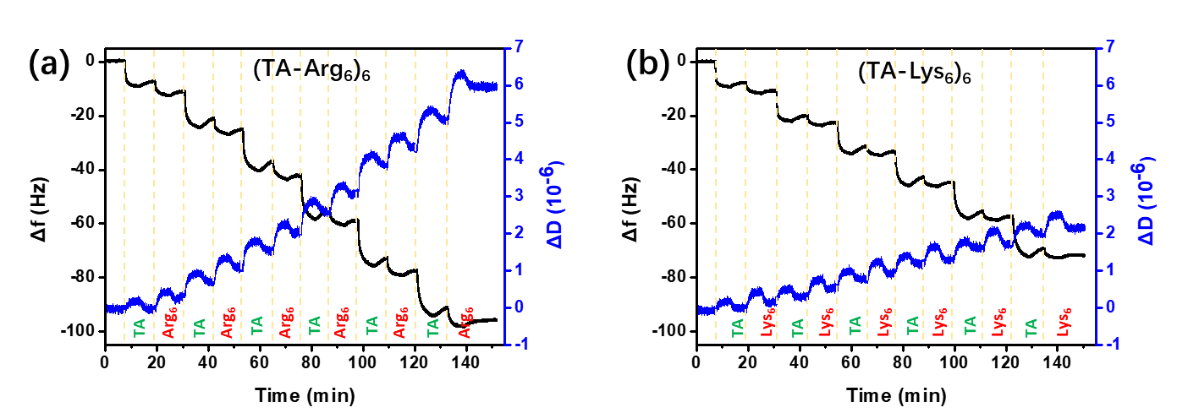
Figure S1. In real time shifts of Δf and ΔD during fabrication (a) (TA/Arg₆)₆ and (b) (TA/Lys₆)₆ coatings.
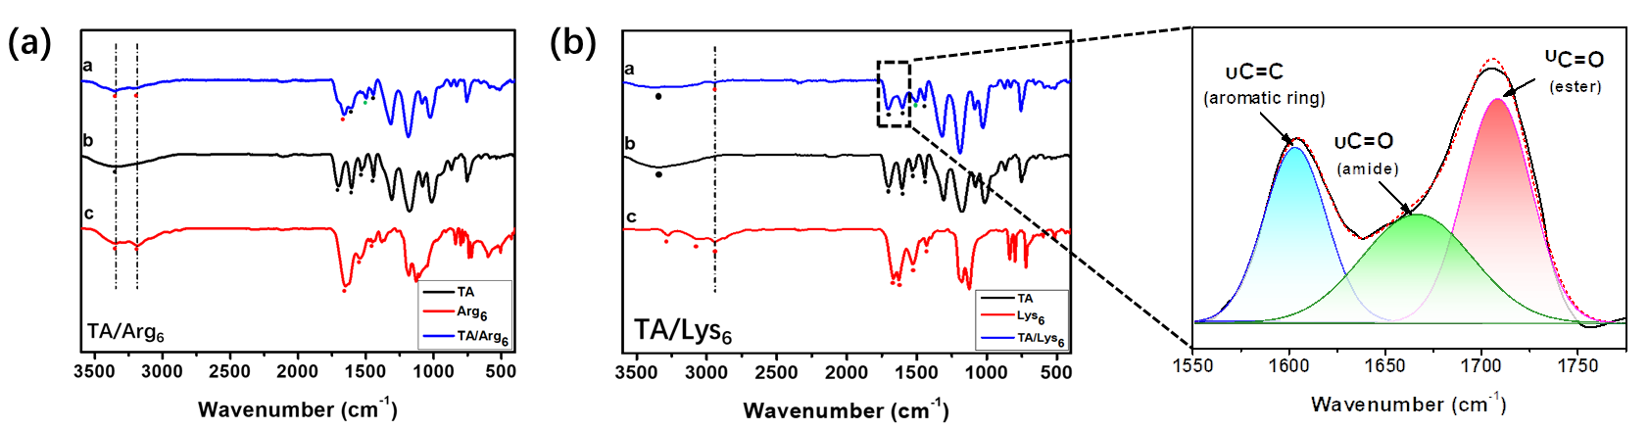
Figure S2. FTIR analysis of chemical structures of (a) TA/Arg₆, TA, Arg₆ and (b) TA/Lys₆, TA, Lys₆.
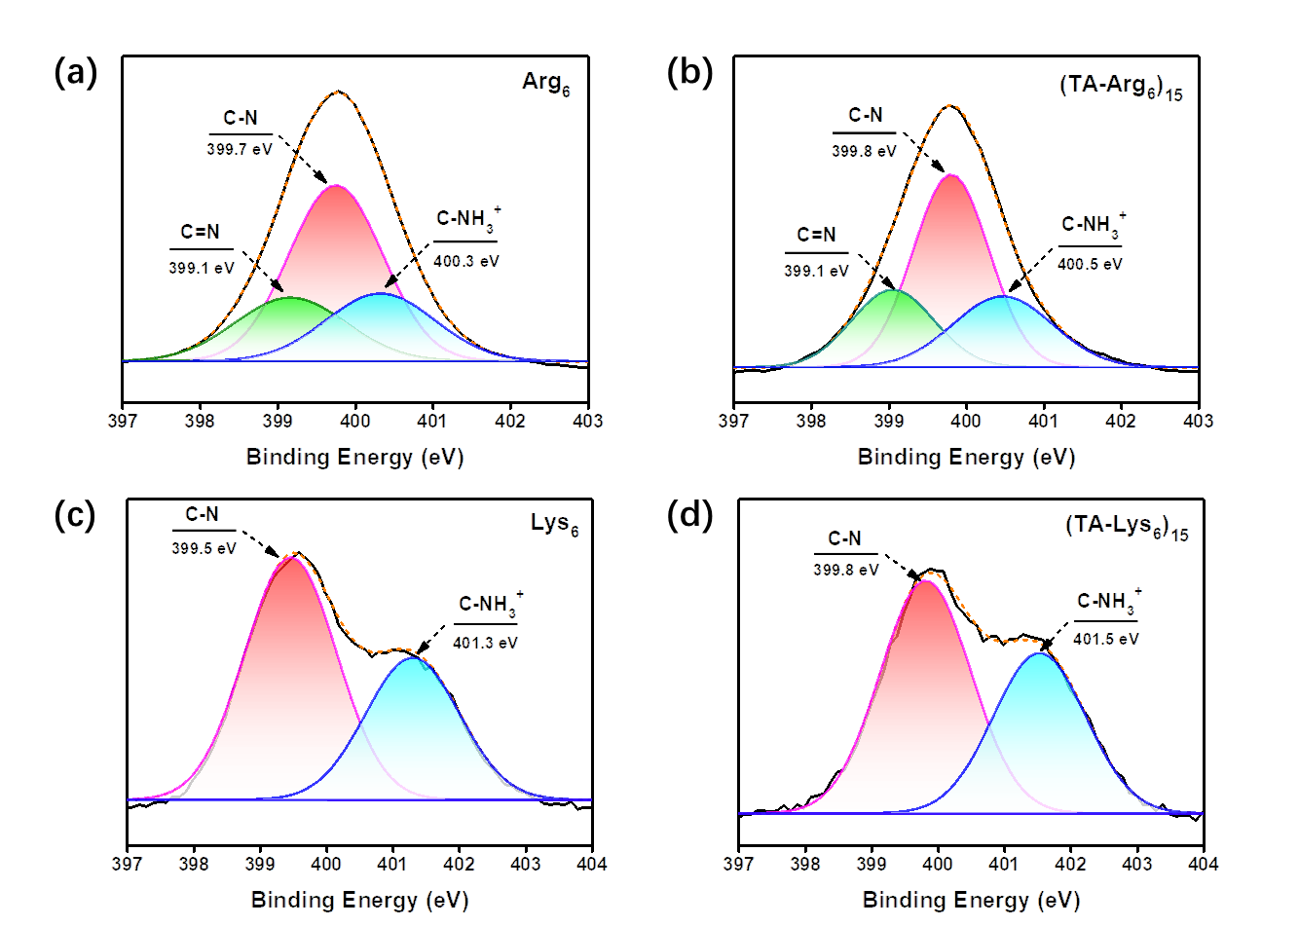
Figure S3. XPS analysis of the coatings: Detailed N 1s XPS spectrum of (a) Arg₆, (c) Lys₆ powder and (b) (TA-Arg₆)₁₅, (d) (TA-Lys₆)₁₅ coating on silicon wafers.
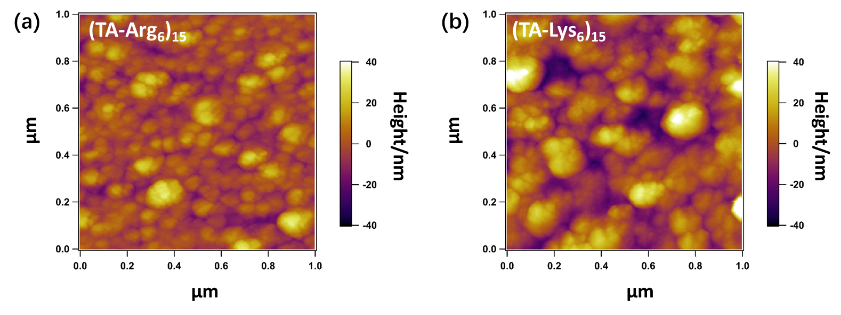
Figure S4. LP-AFM images of (a) (TA-Arg₆)₁₅ and (b) (TA-Lys₆)₁₅ coatings.
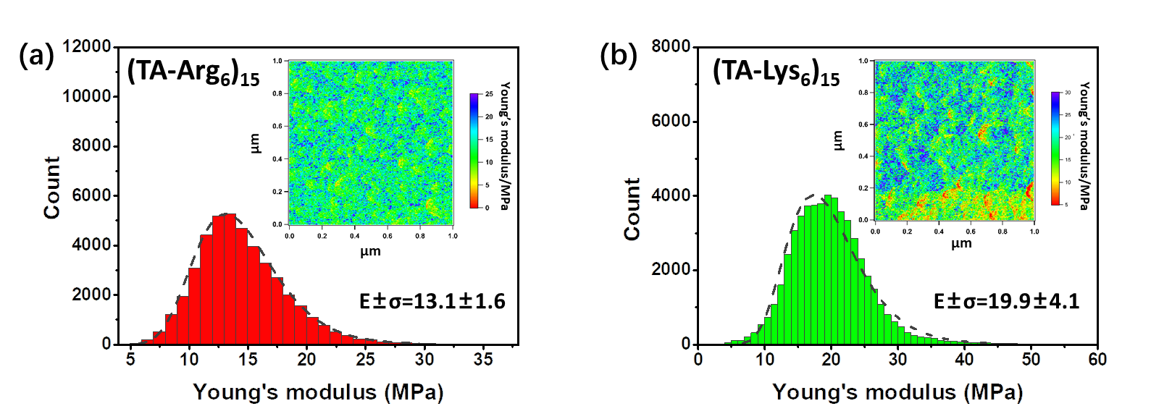
Figure S5. Images and frequency distribution of Young’s modulus of (a) (TA-Arg₆)₁₅ and (b) (TA-Lys₆)₁₅ coatings in liquid environment.
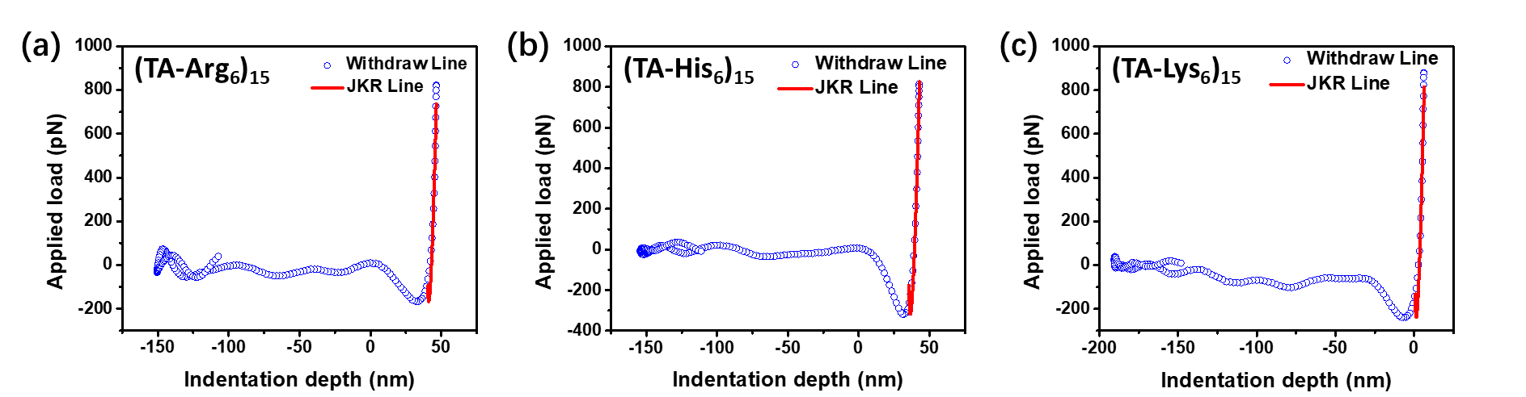
Figure S6. Typical test force curves and JKR curves on the (a) (TA-Arg₆)₁₅, (b) (TA-His₆)₁₅ and (c) (TA-Lys₆)₁₅ coatings in liquid environment.
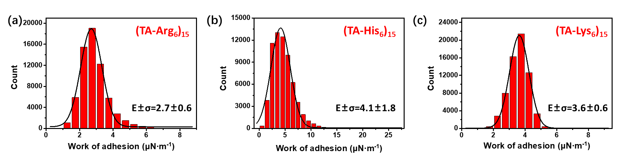
Figure S7. The work of adhesion on (a) (TA-Arg₆)₁₅, (b) (TA-His₆)₁₅ and (c) (TA-Lys₆)₁₅ coatings in liquid environment.
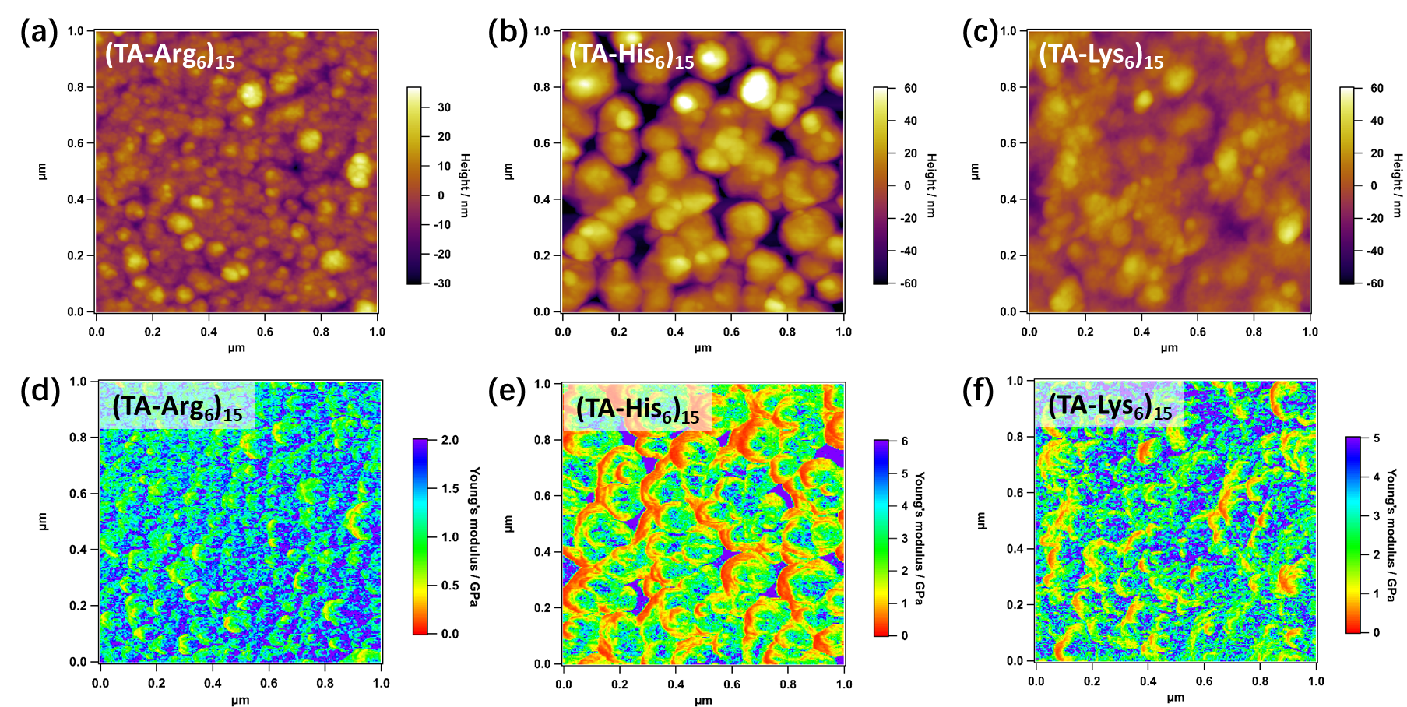
Figure S8. AFM images of (a) (TA-Arg₆)₁₅, (b) (TA-His₆)₁₅ and (c) (TA-Lys₆)₁₅ coatings in air environment. Young’s modulus images of (d) (TA-Arg₆)₁₅, (e) (TA-His₆)₁₅ and (f) (TA-Lys₆)₁₅ coatings in air environment.
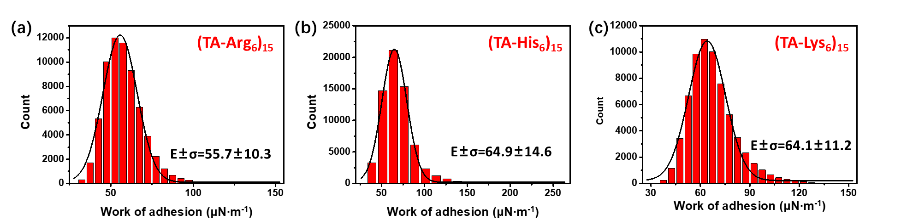
Figure S9. The work of adhesion on (a) (TA-Arg₆)₁₅, (b) (TA-His₆)₁₅ and (c) (TA-Lys₆)₁₅ coatings in air environment.
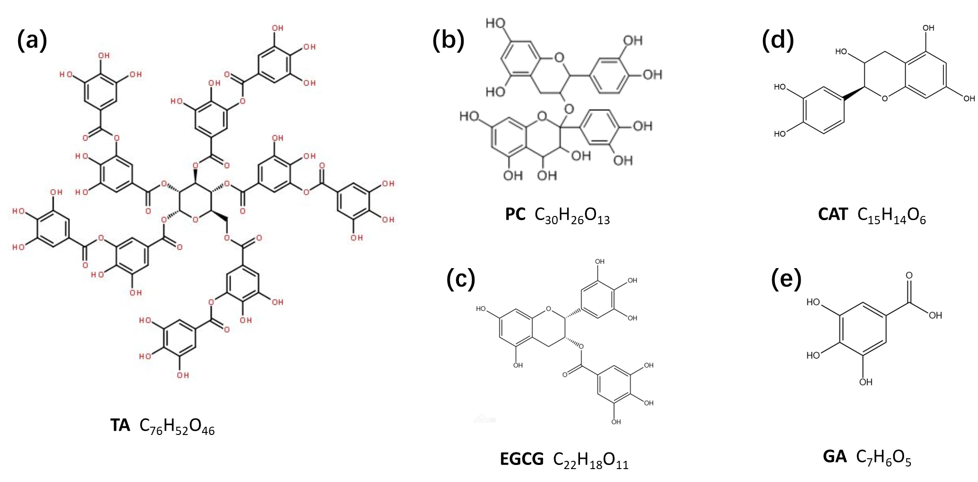
Figure S10. The structures and molecular formulas of (a) TA, (b) PC, (c) EGCG, (d) CAT and (e) GA.
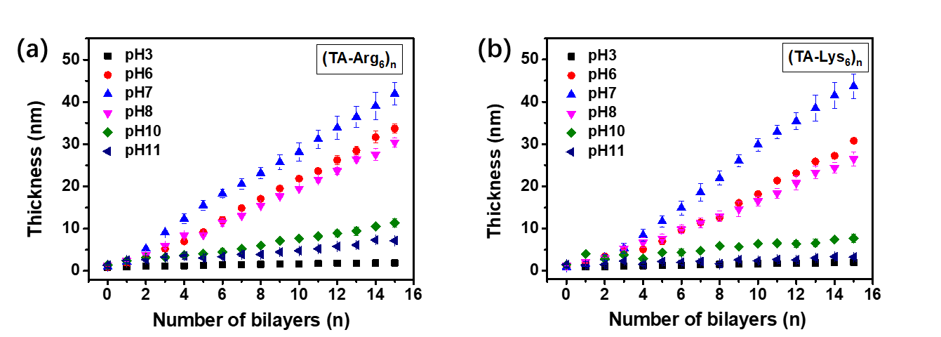
Figure S11. Effects of pH on (a) (TA/Arg₆)₆ and (b) (TA/Lys₆)₆ coatings growth.
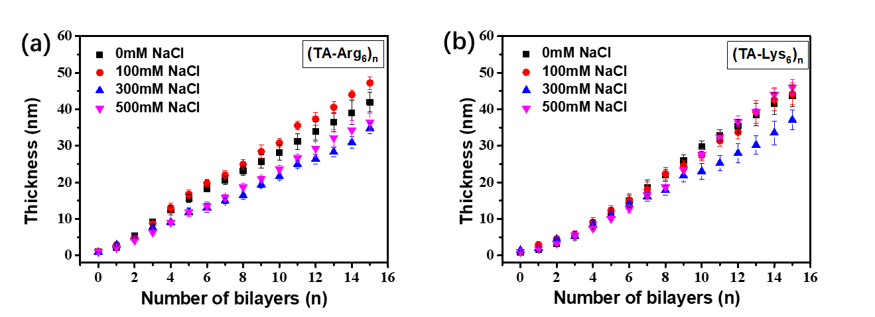
Figure S12. Effects of salt concentration on (a) (TA/Arg₆)₆ and (b) (TA/Lys₆)₆ coatings growth.
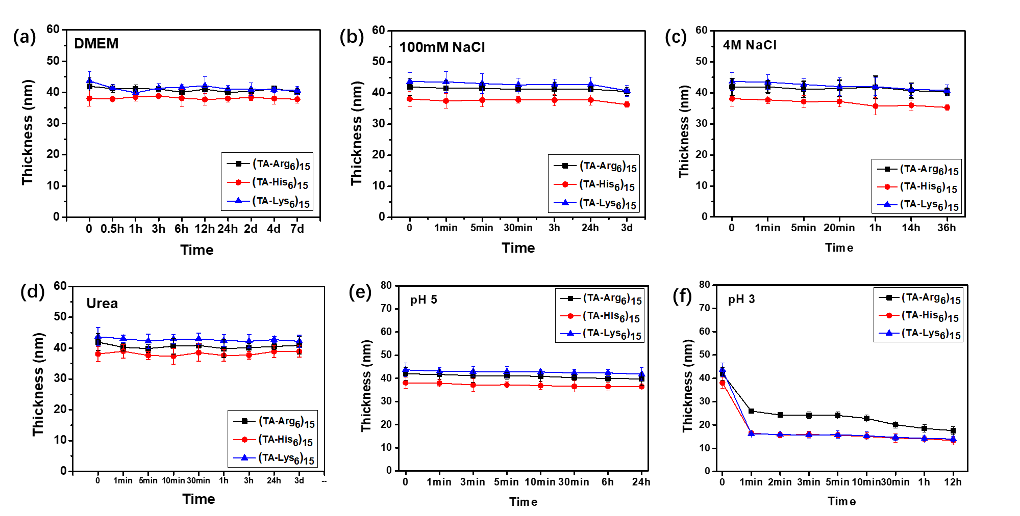
Figure S13. Stability analysis of coatings in (a) DMEM, (b) 100 mM NaCl, (c) 4M NaCl, (d) Urea, (e) pH 5 buffer and (f) pH 3 buffer.
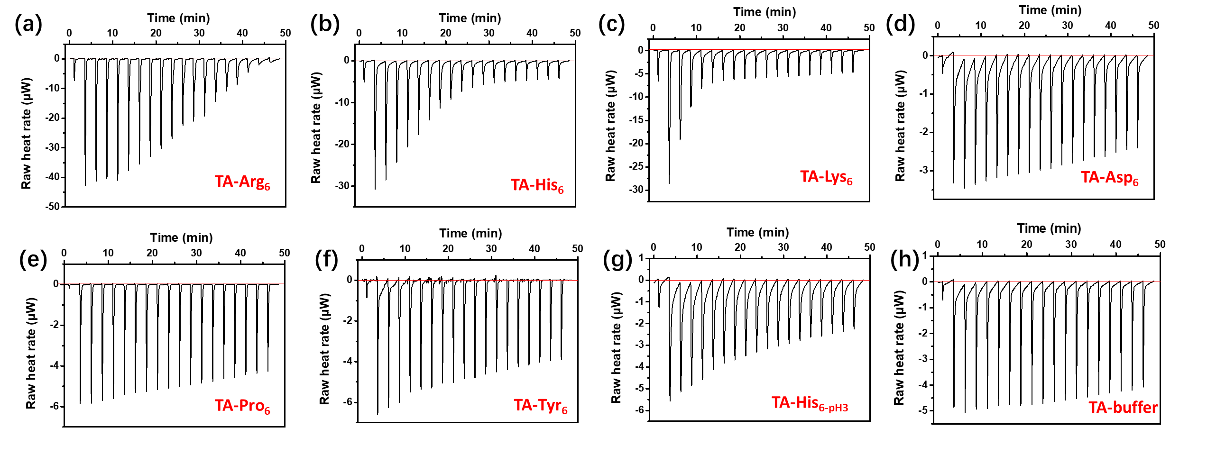
Figure S14. Thermodynamic ITC curves obtained by titration of (a) Arg₆, (b) His₆, (c) Lys₆, (d) Asp₆, (e) Pro₆, (f) Tyr₆ or (g) His_{6-pH3} in TA at 25 °C. (h) Dilution heat release curve of TA solution.
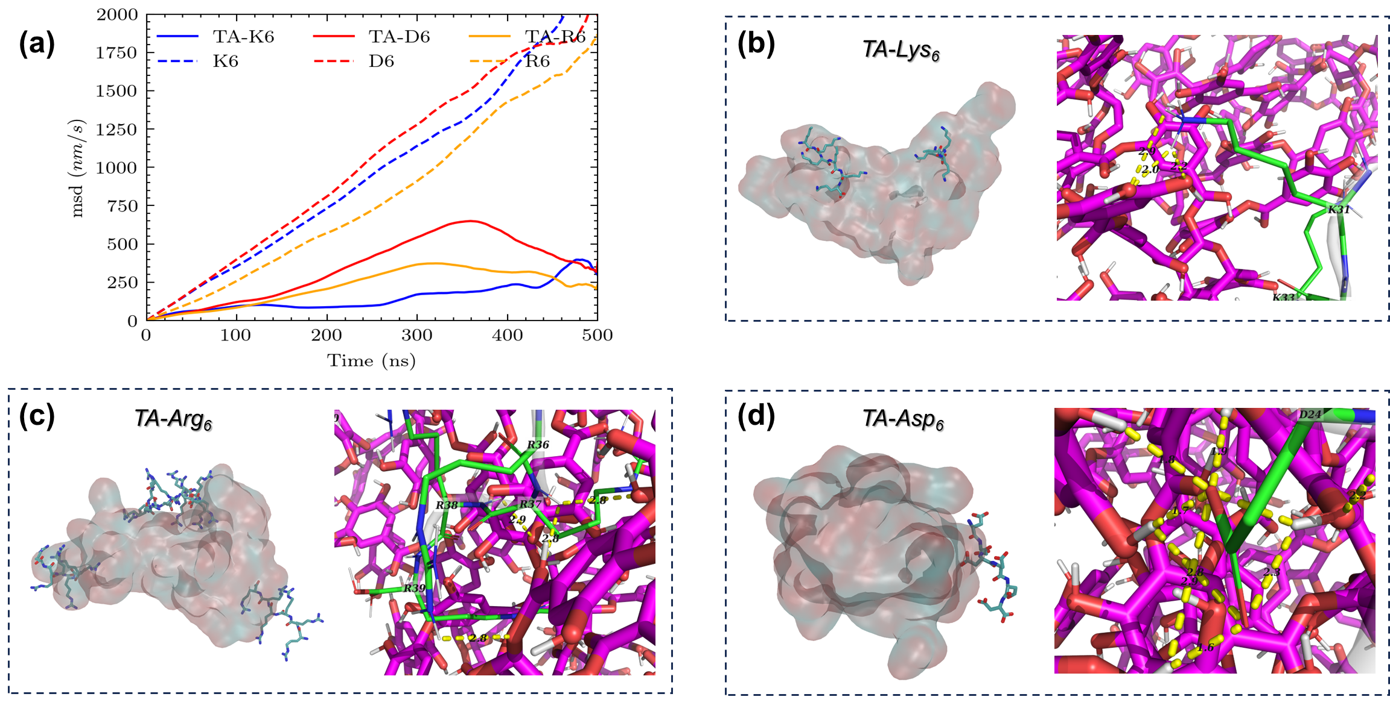
Figure S15. The effects of the neutral solution environment (pH=7) on the interaction between peptide with six identical charged residues and TA molecules in the neutral (pH=7) solution environment. (a) The MSD time evolution of Lys₆ (K6, blue, dashed), Asp₆ (D6, red, dashed), and Arg₆ (R6, orange, dashed) peptide and TA (solid) molecules. (b) The interaction between Lys₆ peptide (green) and TA molecules (magenta). (c) The interaction between Arg₆ peptide (green) and TA molecules (magenta). (d) The interaction between Asp₆ peptide (green) and TA molecules (magenta). The atoms that may formed hydrogen bonds were shown in the yellow dashed line.

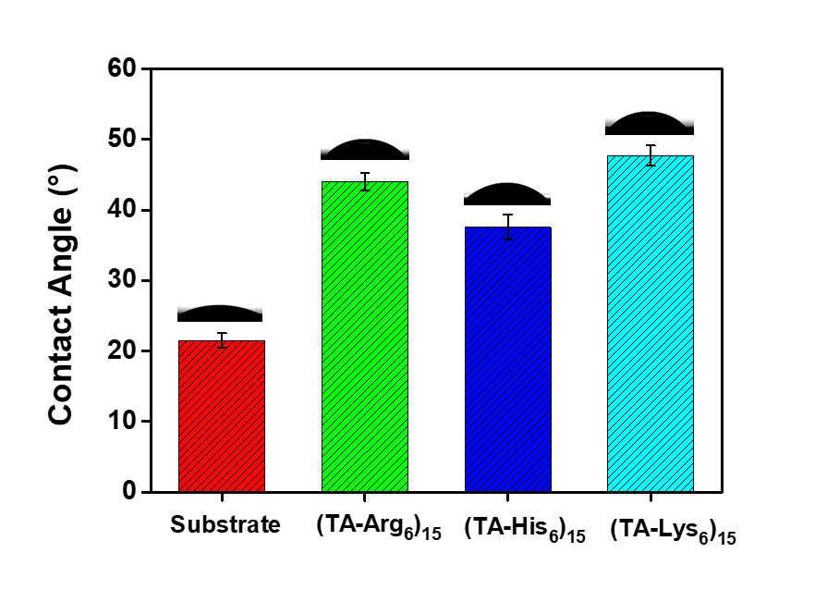
Figure S16. Quiescent contact angle of (TA-Arg₆)₁₅, (TA-His₆)₁₅ and (TA-Lys₆)₁₅ coatings.
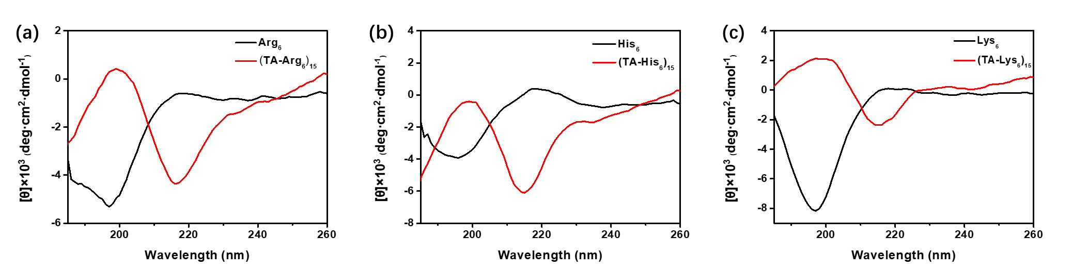
Figure S17. CD spectra of (a) Arg₆, (TA/Arg₆)₁₅, (b) His₆, (TA/His₆)₁₅ and (c) Lys₆, (TA/Lys₆)₁₅.

Table S1. The all-atom MD simulation systems

System | Solute | Temperature | Sequence | pH
System 1 | 10 mM NaCl, 3 mM TA | 300K | RRRRRR | 7.0
System 2 | 10 mM NaCl, 3 mM TA | 300K | KKKKKK | 7.0
System 3 | 10 mM NaCl, 3 mM TA | 300K | DDDDDD | 7.0
System 4 | 10 mM NaCl, 3 mM TA | 300K | HHHHHH | 7.0
System 5 | 10 mM NaCl, 3 mM TA | 300K | HHHHHH | 3.0

Table S2. The forward and reverse primers for osteogenesis related genes
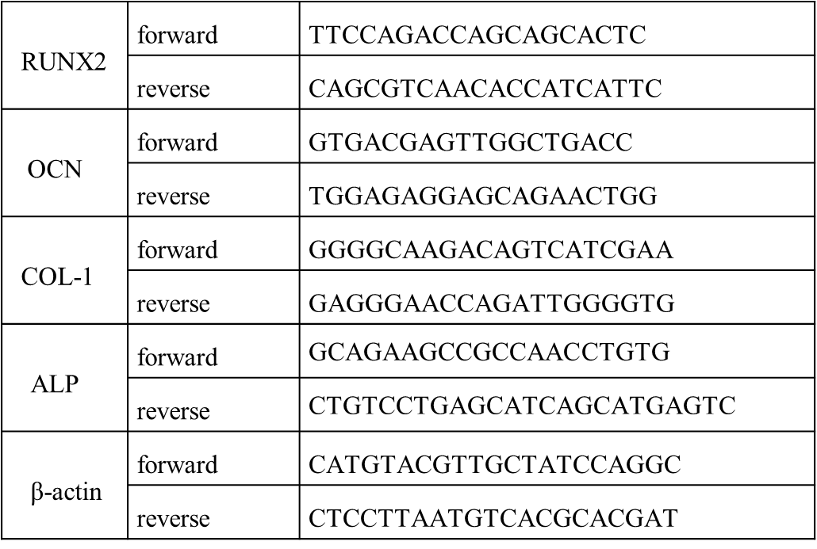
Table S3. Analyze composition of N 1s by XPS
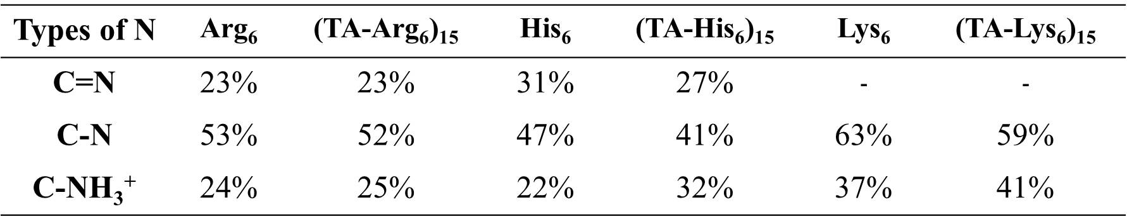
Table S4. Analyze composition content of coating by XPS
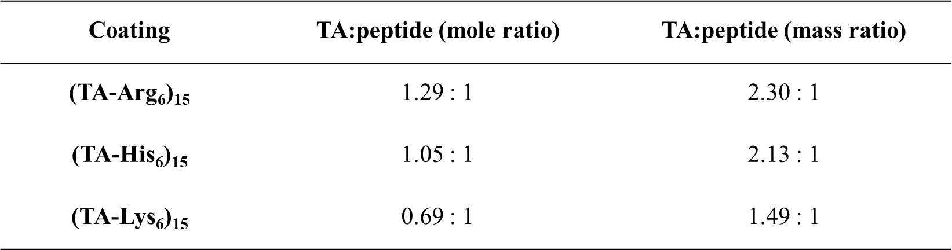

REFERENCES
1. Kim, S.; Lee, J.; Jo, S.; Brooks, C. L., III; Lee, H. S.; Im, W., CHARMM-GUI ligand reader and modeler for CHARMM force field generation of small molecules. J. Comput. Chem. 2017, 38 (21), 1879-1886.
2. Jumper, J.; Evans, R.; Pritzel, A.; Green, T.; Figurnov, M.; Ronneberger, O.; Tunyasuvunakool, K.; Bates, R.; Zidek, A.; Potapenko, A.; Bridgland, A.; Meyer, C.; Kohl, S. A. A.; Ballard, A. J.; Cowie, A.; Romera-Paredes, B.; Nikolov, S.; Jain, R.; Adler, J.; Back, T.; Petersen, S.; Reiman, D.; Clancy, E.; Zielinski, M.; Steinegger, M.; Pacholska, M.; Berghammer, T.; Bodenstein, S.; Silver, D.; Vinyals, O.; Senior, A. W.; Kavukcuoglu, K.; Kohli, P.; Hassabis, D., Highly accurate protein structure prediction with AlphaFold. Nature 2021, 596 (7873), 583-+.
3. Huang, J.; Rauscher, S.; Nawrocki, G.; Ran, T.; Feig, M.; de Groot, B. L.; Grubmueller, H.; MacKerell, A. D., Jr., CHARMM36m: an improved force field for folded and intrinsically disordered proteins. Nat. Methods 2017, 14 (1), 71-73.
4. Lee, J.; Cheng, X.; Swails, J. M.; Yeom, M. S.; Eastman, P. K.; Lemkul, J. A.; Wei, S.; Buckner, J.; Jeong, J. C.; Qi, Y.; Jo, S.; Pande, V. S.; Case, D. A.; Brooks, C. L., III; MacKerell, A. D., Jr.; Klauda, J. B.; Im, W., CHARMM-GUI Input Generator for NAMD, GROMACS, AMBER, OpenMM, and CHARMM/OpenMM Simulations Using the CHARMM36 Additive Force Field. Journal of Chemical Theory and Computation 2016, 12 (1), 405-413.
5. Jo, S.; Kim, T.; Iyer, V. G.; Im, W., Software news and updates - CHARNIM-GUI: A web-based grraphical user interface for CHARMM. J. Comput. Chem. 2008, 29 (11), 1859-1865.
6. Abraham, M. J.; Murtola, T.; Schulz, R.; Pall, S.; Smith, J. C.; Hess, B.; Lindahl, E., GROMACS: high performance molecular simulations through multi-level parallelism from laptops to supercomputers. SoftwareX 2015, 1-2, 19-25.

