Supplementary document

S1 Fig. 1
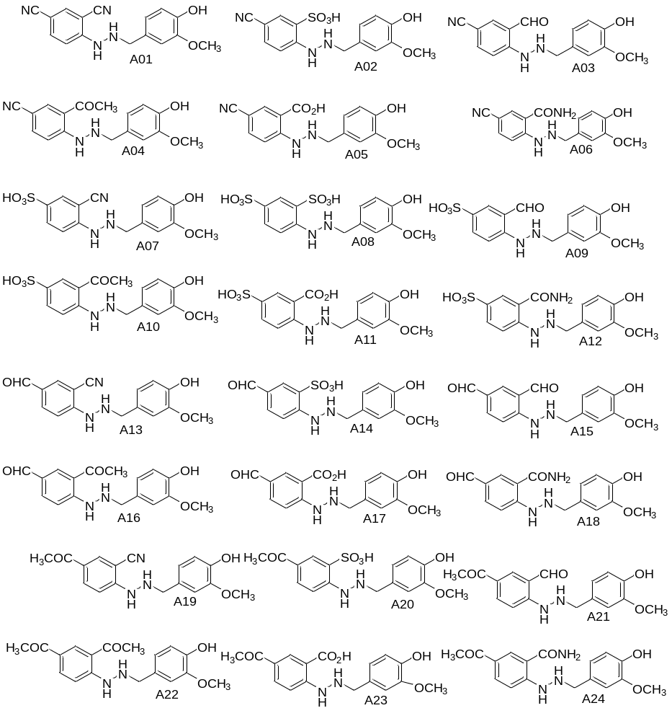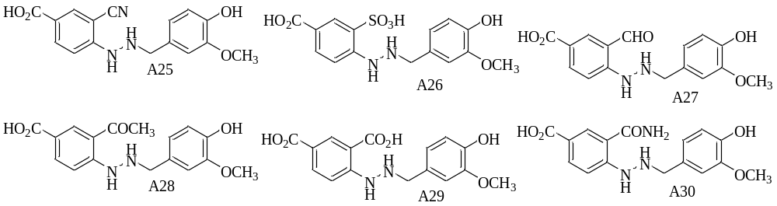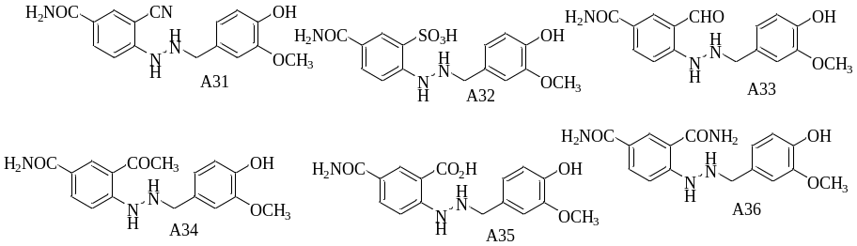
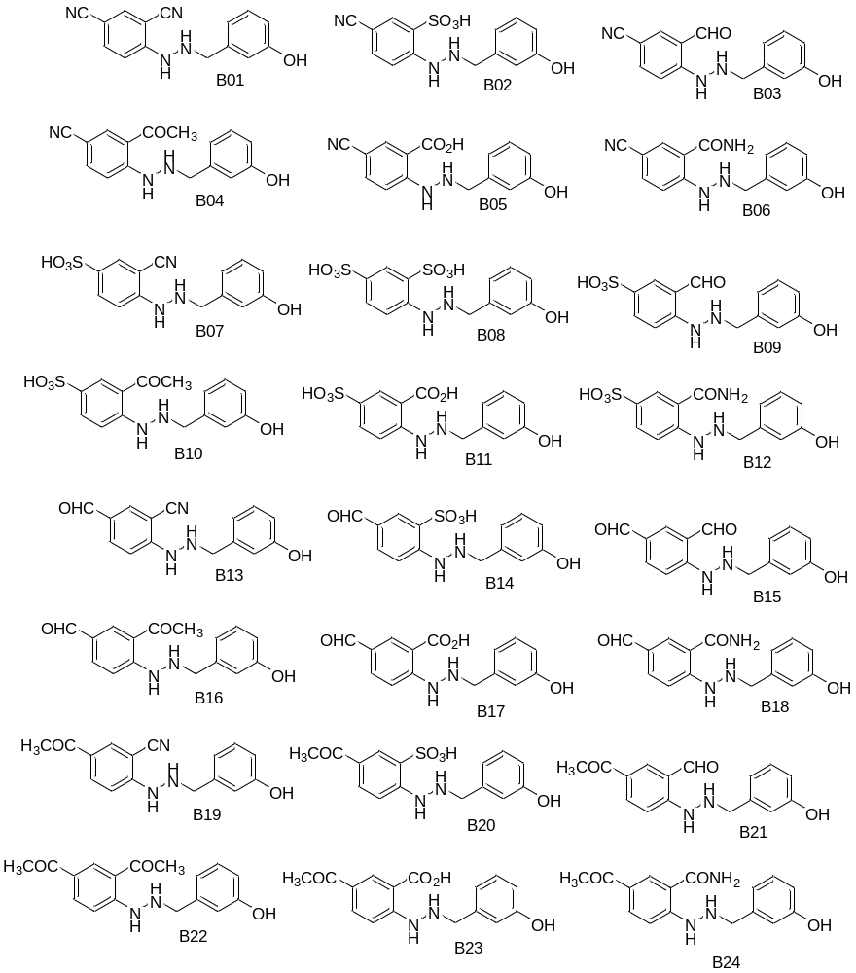
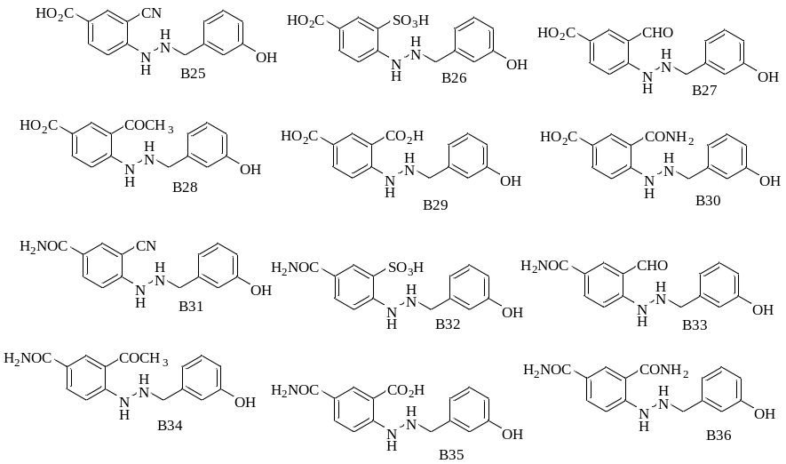
2D structure of the designed compounds [A01-A036 for PHN3 analogues and B01-B036 for PHN6 analogues]

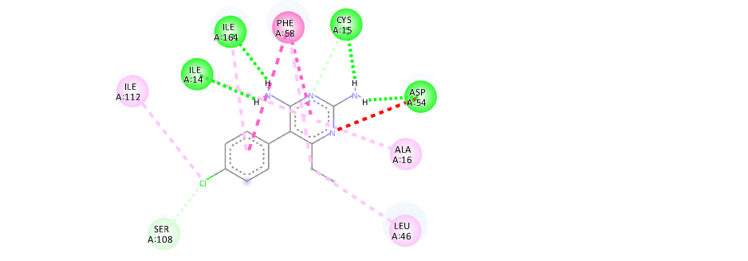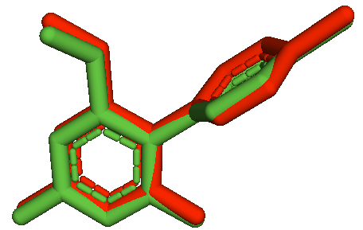
A B
S2 Fig. 2D image showing the superimposed amino acid residues (A) and Ligand superimposition (B).

S3 Fig. Ramachandran plot of the studied proteins: wt-PfATP6(a), L263E(b), 3QGT(c), 1J3K(d)
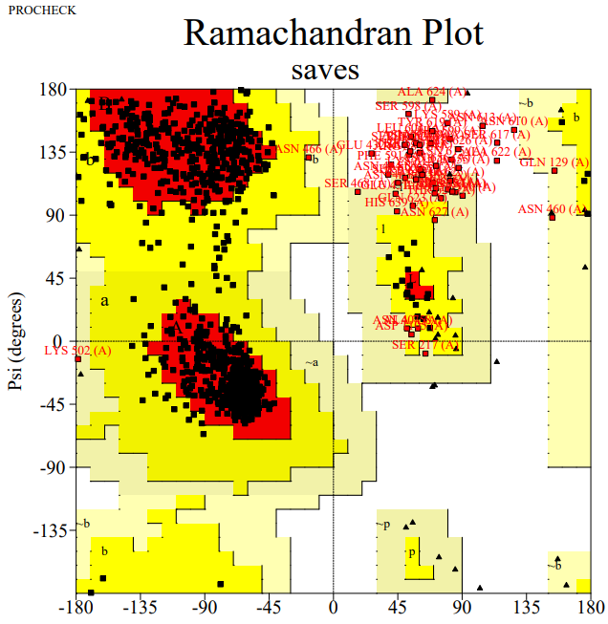
Fig(a) Fig(b)
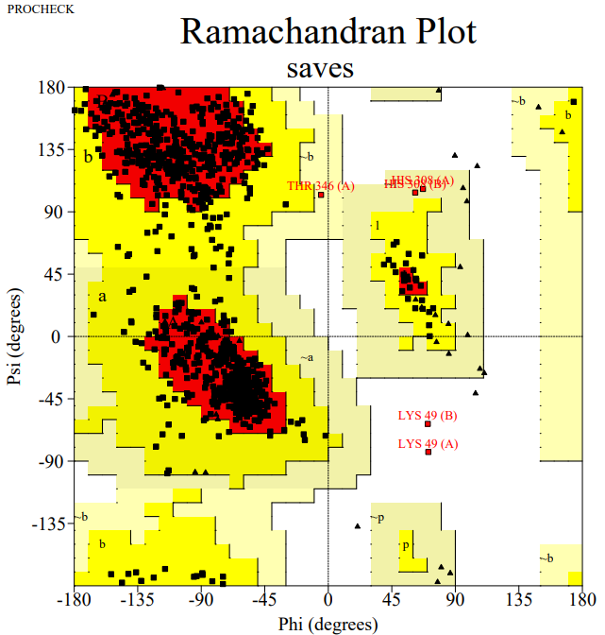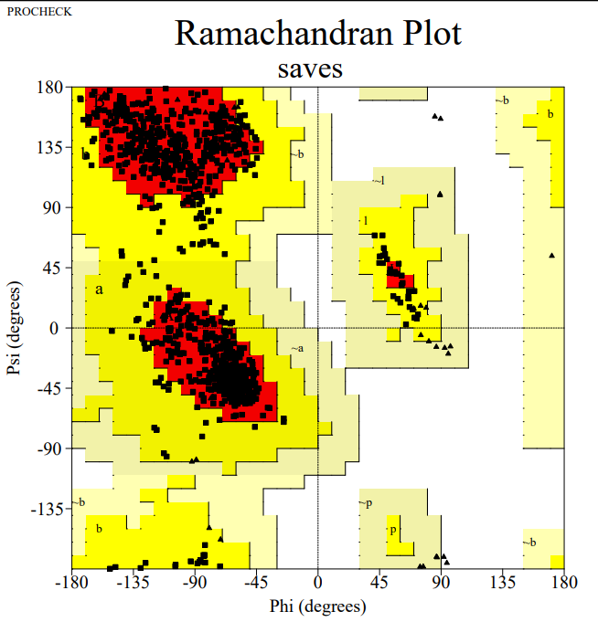
Fig(c) Fig(d)

S1 Table. Summary of of docking of compounds with target proteins showing regional residues
Protein | Residues in most favoured region | Residues in allowed region | Residues in generously allowed regions | Residues in disallowed regions
Wt-PfATP | 84.6% | 10.0% | 2.6% | 2.8%
L263E | 84.5% | 10.0% | 2.6% | 2.8%
PfDHFR | 86.8% | 12.6% | 0.4% | 0.2%
qm-PfDHFR | 88.3% | 11.7% | 0.0% | 0.0%

S4 Fig. Backbone Root Mean Square Deviation (RMSD) of wild type malarial PfATP6 (red) and mutant protein (black) in complex with artemisinin (control drug). S5 Fig. Backbone Root Mean Square Deviation (RMSD) of wild type PfDHFR (blue) and quadruple mutant protein (green) in complex with pyrimethamine (control drug).

S4 Fig S5 Fig

S6 Fig. Analysis of hydrogen bonds formed between pyrimethamine and PfDHFR (blue) and qm-PfDHFR (green). S7 Fig. Analysis of hydrogen bonds formed between artemisinin and wild type PfATP6 (red) and mutant protein (black).

S6 Fig. S7 Fig.

S2 Table. Results of docking of compounds with target proteins
Compound | Estimated Free Energy of Binding
 | PfATP6 | L263E | PfDHFR | qm-PfDHFR
A23 | -7.57 | -7.12 | -8.47 | -8.61
A28 | -7.58 | -7.21 | -8.43 | -8.66
A29 | -7.66 | -7.34 | -8.56 | -8.96
B06 | -7.32 | -7,20 | -8.31 | -8.10
B23 | -7.60 | -7.47 | -8.61 | -8.56
B24 | -7.73 | -7.44 | -8.97 | -8.94
B28 | -7.45 | -7.89 | -8.50 | -9.12
B29 | -7.44 | -7.34 | -8.39 | -8.58
B30 | -7.80 | -7.47 | -8.53 | -9.40
B34 | -7.82 | -7.72 | -8.34 | -8.91
B35 | -7.12 | -7.55 | -8.58 | -8.42
B36 | -7.77 | -7.75 | -8.80 | -9.22
Artemisinin | -8.45 | -7.15
Pyrimethamine |  |  | -7.96 | -7.81

S3 Table. Physicochemical parameters of the optimized compounds from SwissADME
Molecule | MW | nRB | nHBA | nHBD | MR | TPSA
A23 | 330.34 | 7 | 6 | 4 | 88.71 | 107.89
A28 | 330.34 | 7 | 6 | 4 | 88.71 | 107.89
A29 | 332.31 | 7 | 7 | 5 | 85.47 | 128.12
B06 | 282.3 | 5 | 4 | 4 | 77.87 | 111.17
B23 | 300.31 | 6 | 5 | 4 | 82.21 | 98.66
B24 | 299.32 | 6 | 4 | 4 | 83.35 | 104.45
B28 | 300.31 | 6 | 5 | 4 | 82.21 | 98.66
B29 | 302.28 | 6 | 6 | 5 | 78.98 | 118.89
B30 | 301.3 | 6 | 5 | 5 | 80.11 | 124.68
B34 | 299.32 | 6 | 4 | 4 | 83.35 | 104.45
B35 | 301.3 | 6 | 5 | 5 | 80.11 | 124.68
B36 | 300.31 | 6 | 4 | 5 | 81.25 | 130.47

S4 Table. Toxicity profile of the optimized compounds
 | Hepatotoxicity |  | Oral toxicity class |  | hERG inhibition
Molecule | OSIRINS | ProTox II | ProTox II | Admetsar | Admesar
A23 | Inactive | Inactive | IV | III | No
A28 | Inactive | Inactive | IV | III | No
A29 | Inactive | Inactive | IV | III | No
B06 | Inactive | Inactive | IV | III | No
B23 | Inactive | Inactive | IV | III | No
B24 | Inactive | Inactive | IV | III | No
B28 | Inactive | Inactive | IV | III | No
B29 | Inactive | Inactive | IV | III | No
B30 | Inactive | Inactive | IV | III | No
B34 | Inactive | Inactive | IV | III | No
B35 | Inactive | Inactive | IV | III | No
B36 | Inactive | Inactive | IV | III | No

S5 Table. Toxicity profile of the optimized compounds
 | Carcinogenicity |  | Immunotoxicity | Ames toxicity | Plasma binding protein
Molecule | ProTox II | Admetsar | Pro Tox II | Admetsar | Admetsar
A23 | Inactive | Inactive | Inactive | No | 0.69
A28 | Inactive | Inactive | Inactive | No | 0.699
A29 | Active | Inactive | Inactive | No | 0.618
B06 | Inactive | Inactive | Inactive | No | 0.624
B23 | Inactive | Inactive | Inactive | No | 0.72
B24 | Active | Inactive | Inactive | No | 0.70
B28 | Active | Inactive | Inactive | No | 0.636
B29 | Inactive | Inactive | Inactive | No | 0.598
B30 | Inactive | Inactive | inactive | No | 0.589
B34 | Active | Inactive | Inactive | No | o.63
B35 | Inactive | Inactive | Inactive | No | 0.61
B36 | Active | Inactive | Inactive | No | 0.53

S6 Table. Pharmacokinetic parameters of the optimized compounds
Molecule | GI absorption | BBB permeant | Pgp substrate | Lipinski rule of 5 number of violation
A23 | High | No | No | 0
A28 | High | No | No | 0
A29 | High | No | No | 0
B06 | High | No | No | 0
B23 | High | No | No | 0
B24 | High | No | No | 0
B28 | High | No | No | 0
B29 | High | No | No | 0
B30 | High | No | No | 0
B34 | High | No | No | 0
B35 | High | No | No | 0
B36 | High | No | No | 0

