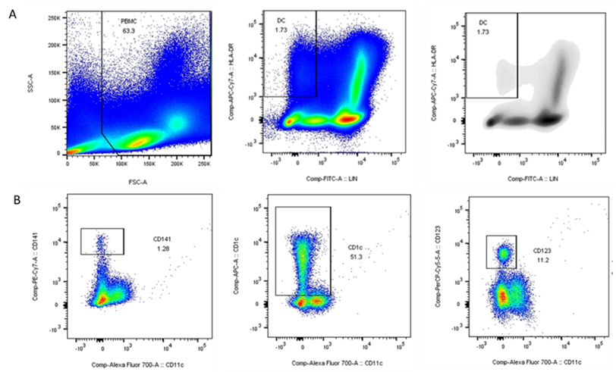
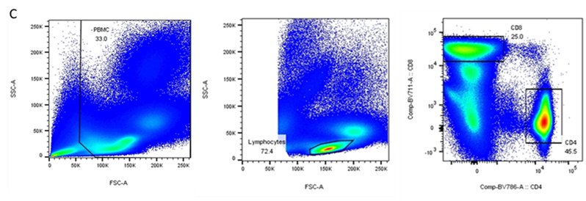
Figure S1. Gating strategies of blood dendritic cells and T lymphocytes
(A) Peripheral blood mononuclear cells (PBMCs) were gated in the FSC/SCC plot (left). Dendritic cells were gated by lineage-negative (lin⁻) and HLA-DR-positive (HLA-DR⁺) PBMCs (center). Density plots then further confirmed a unique homogeneous group of Lin-HLA⁻DR⁺ cells (right). (B) Among dendritic cells, CD11c⁺CD141⁺ was identified as conventional type 1 dendritic cells (cDC1) (left), CD11c⁺CD1c⁺ was identified as conventional type 2 dendritic cells (cDC2) (middle), and CD11c⁺CD123⁺ was identified are plasmacytoid dendritic cells (pDC) (right). (C) Lymphocytes were gated in the FSC/SSC plot (middle). CD4 and CD8 T cells were gated from lymphocytes as shown (right).

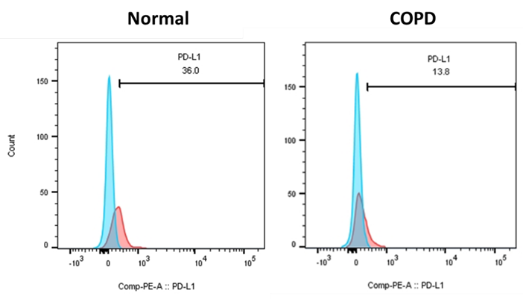
Figure S2 Representative histograms of PD-L1⁺ cDC1 in the blood of normal and COPD participants
Flow cytometric analysis of PD-L1 on cDC1 in PBMCs, representative results from normal and COPD participants. PBMCs were analyzed directly by staining with the indicated antibodies. The percentage of PD-L1⁺ cells was shown in pink. All histograms were gated according to their respective isotype controls (blue).

