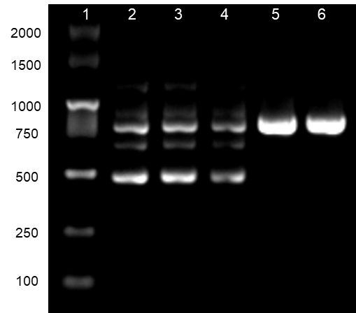

Supplementary figure Breakpoint-specific PCR products for CYP11B1:c.954+78_980delinsACAG. Lane1: DNA marker, Lane 2-6: CYP11B1 deletion-insertion fragment in the proband, the brother, the mother, the father, and the control, respectively.

Supplementary table Primers used for PCR Assay of CYP11B2/CYP11B1 chimeric gene and CYP11B1 gene.

Supplementary table 1 Primers Used for PCR Assay of CYP11B2/CYP11B1 chimeric gene
Primer | Sequence
CYP11B1F | ACCCCCAATGAGTCCCTGCCTCCA
CYP11B1R | GGATGCTCTAAGAAAACGCCATAGACTGG
CYP11B2F | GGTGAGATAAAAGGATTTGGGCTGAA
CYP11B2R | AGAACAGTCTTCAAAACAGGAAATGGA

Supplementary table 2 Primers Used for PCR Assay of CYP11B1 Gene

Primer | Sequence
CYP11B1-intron 6 | AGAGCAGGTGCAGGGGAAT
CYP11B1-exon 5 | CCCTCAACAGTACACCAGCA

