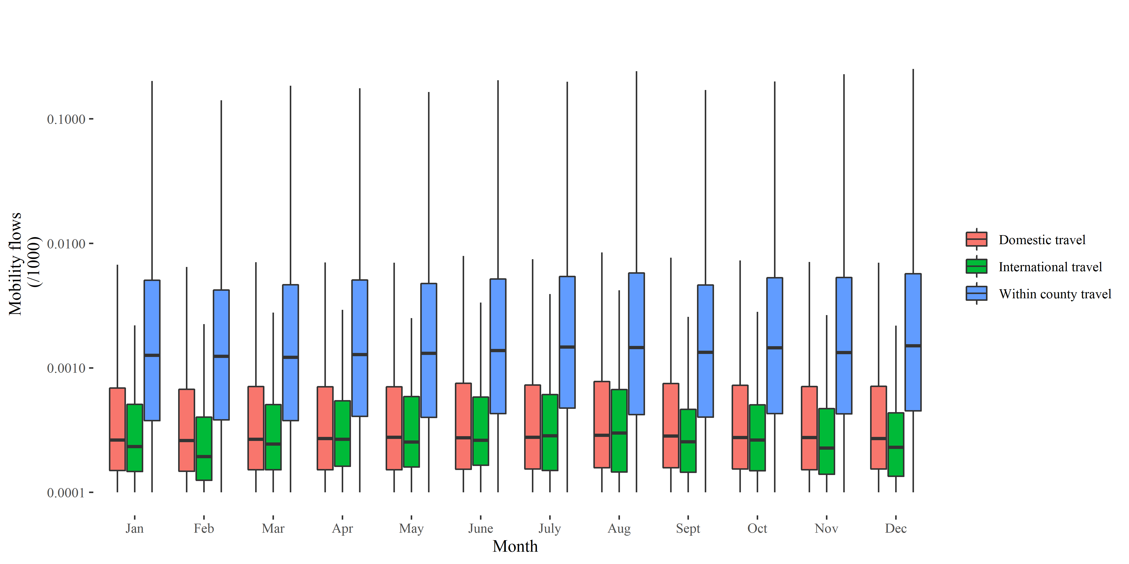Figure S1. Box plots of monthly relative population flows by type of travel, as determined by origin/destination pairs. Red represents domestic travel within Kenya, green represents international travel from Kenya, and blue represents within-county travel. Months represent average population flows over 2018 and 2019.

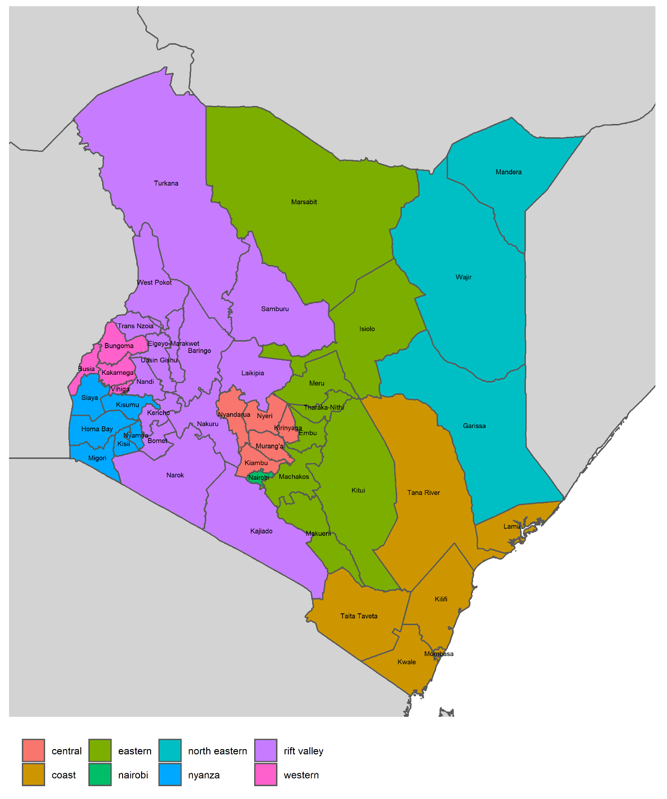
Figure S2. Counties in Kenya by province.
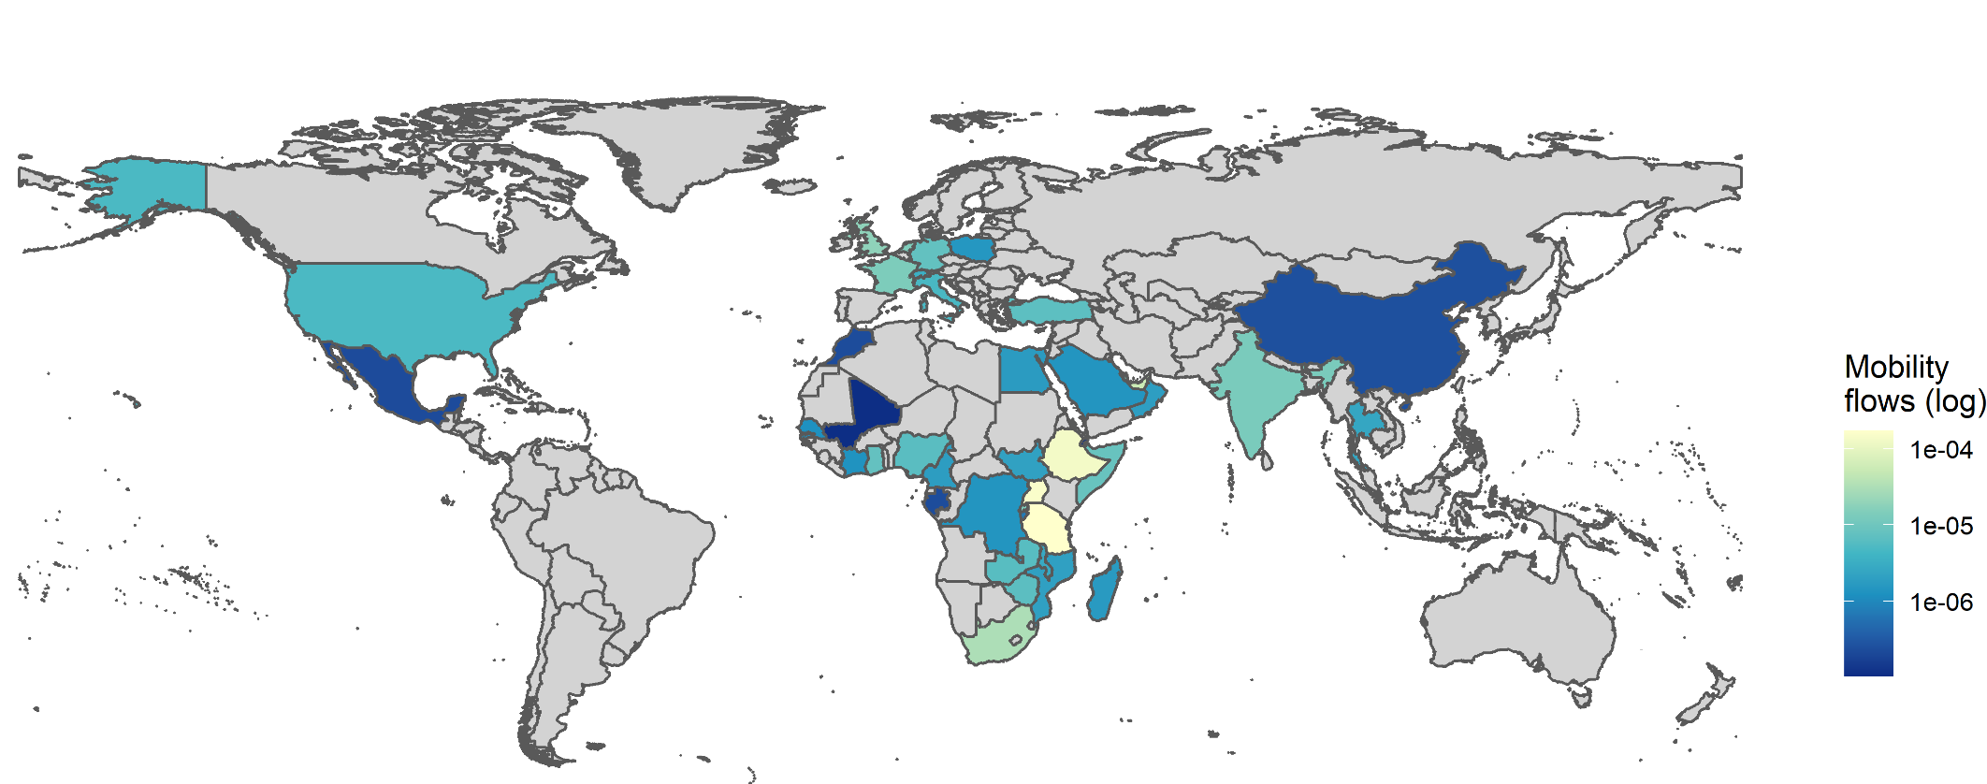
Figure S3. Total international mobility flows from Kenya over 2018 and 2019. Flows were log transformed to highlight spatial heterogeneity.
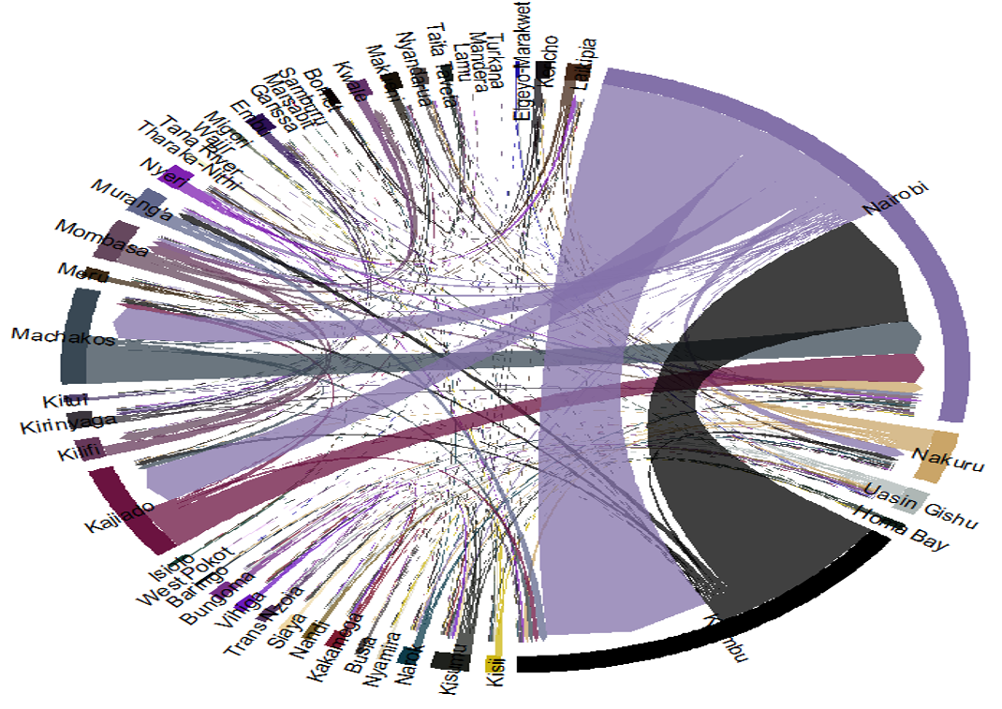
Figure S4. Bidirectional domestic mobility patterns between Kenya counties. Arrows indicate directionality of movement.

