Table 6. Structures of samples for 0.1 % foaming agent dosage and various mixing durations and mixing speeds
 |  | Mixing Time (Mn)
 |  | 2 | 5 | 8 | 12
Mixing Speed (rpm) | 400 | 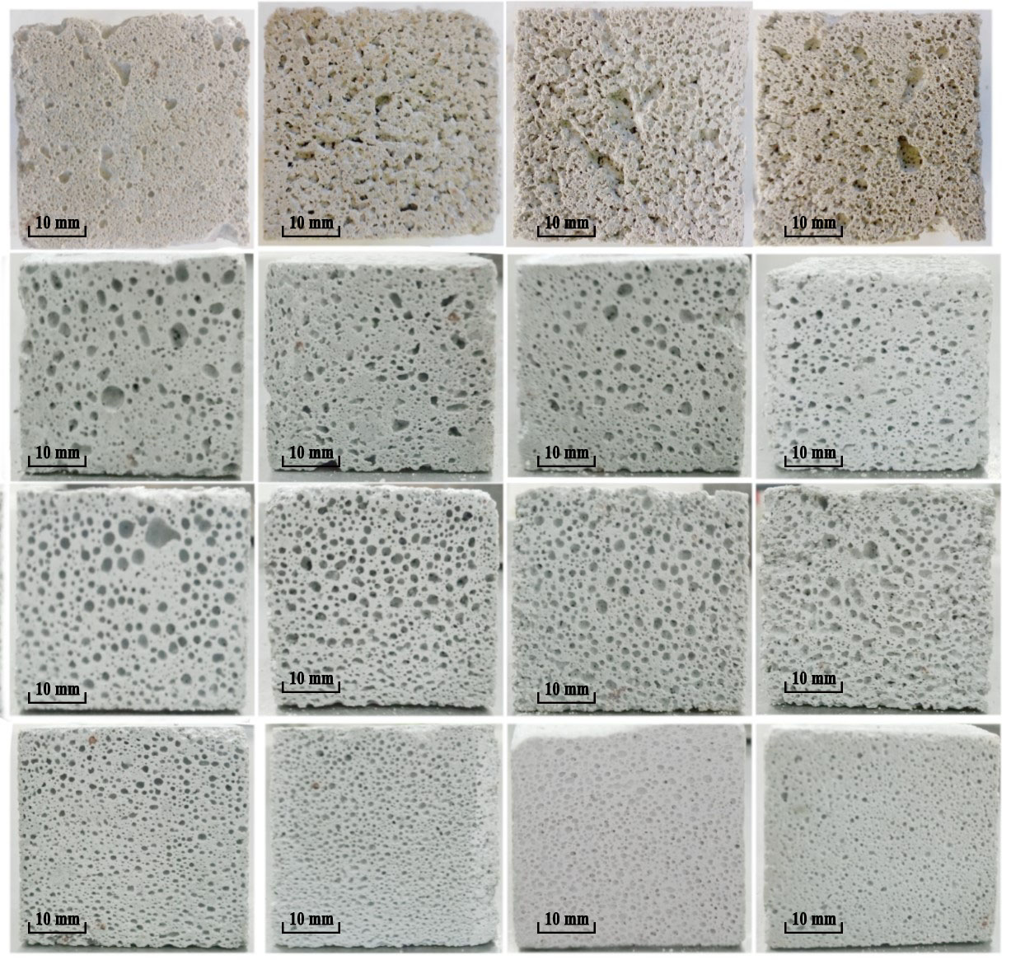
Mixing Speed (rpm) | 600
Mixing Speed (rpm) | 800
Mixing Speed (rpm) | 1000

Table 7. The Effect of Foaming Agent Dosage on the Structure of Samples for a Mixing Speed of 800 rpm
 |  | Foaming Agent Dosage (%)
 |  | 0.05 | 0.1 | 0.15
Mixing time (Mn) | 2 | 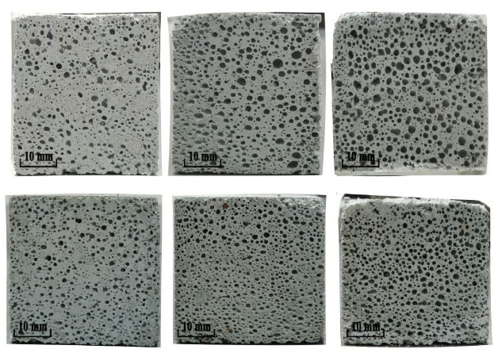
Mixing time (Mn) | 5

Table 8. Structures of samples for a mixing speed of 1000 rpm with various mixing durations and various foaming agent dosages.
 |  | Mixing Time (Mn)
 |  | 2 | 5 | 8 | 12
Foaming Agent Dosage (%) | 0.05 |  | 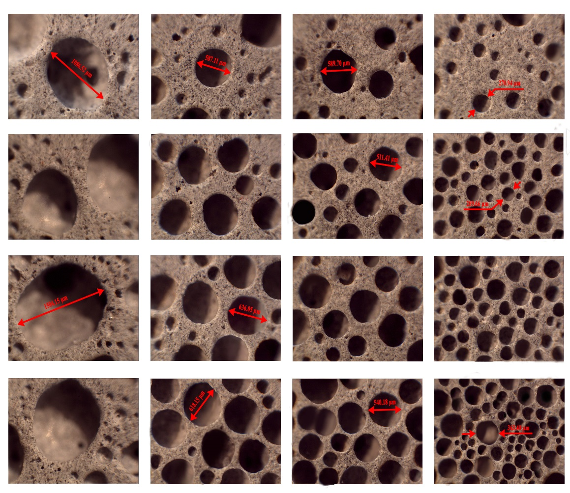
Foaming Agent Dosage (%) | 0.1
Foaming Agent Dosage (%) | 0.15
Foaming Agent Dosage (%) | 0.2

