Supplementary Information for:

Analysis of Reconfigurable Multi-Passband Metasurface Filters Designed by Deep Neural Networks for 6G Applications
Vahid Jamshidiha¹, Abdolali Abdipour¹, Amir Nader Askarpour^{1,*}
¹Amirkabir University of Technology, Electrical Engineering Department, Tehran, 1591634311, Iran.
*Corresponding Authors: Amir Nader Askarpour, E-mail: askarpour@aut.ac.ir

Contents

Details of Auto-encoder Neural Network

Surface Current distribution in Resonant Frequencies

1. Details of Auto-encoder Neural Network
As shown in Fig. S1, we first randomly generate structural parameters for 20,000 different metasurfaces based on our desired multi-layer metasurface. This multi-layer metasurface consists of three metal scatterers that are located in equal distances from each other in a double height dielectric in comparison with the single layer scatterer. Next, we simulate all 20,000 metasurfaces by linking MATLAB with CST MWS to calculate and save the magnitude of S₁₂ parameter. In the process of making the dataset, we have changed the length of the unit cell, the dielectric thickness, the metal width, and the radii of both the outer and inner rings. It is crucial to note that the changes in all layers are identical. Then, we have normalized the data to increase the convergence speed of the models and distributed the dataset into train, test, and cross-validation sets. Finally, the desired neural networks have been trained in the Google Colab environment with the model of Tesla T4.
Figure S1. Sketch representation of the deep neural network-based approach for forward and inverse design.
Details of forward and full auto-encoder architecture is illustrated in Figs. S2(a) and S2(b). As it is shown, inverse design model and forward design model are not similar in number of units in each hidden layer. This is due to improve networks performance to make the best prediction for both spectrum and structural parameters. For all hidden layers in the network, the Rectified Linear Unit (ReLU) activation function is employed. Both the forward and inverse design models the learning rate is set 0.001 and decay rate of 0.1 for each 200 epochs, employ Adam optimization method and Mean Square Error as the loss function, given as follows:
$MSE=\frac{1}{N}\sum_{i=1}^{N}{{\left(S_{12}^{desired}-S_{12}^{predicted}\right)}^{2}}$ (1)
(a)
(b)
Figure S2. (a) forward design model and (b) full auto-encoder model based on cascading of inverse design part (green box) and forward model (red-dotted box).

2. Surface Current distribution in Resonant Frequencies
Each of determined resonant frequencies in Figure 5 are attributed to a mode based on the surface current distribution. We have calculated surface currents in resonant frequencies and listed them in Table S1. This table is valid for the y-polarization, and for the x-polarization, all of the currents should be rotated by 90 degrees. As it can be seen, all modes have different surface current distributions in comparison with one another.

Table S1. Surface current distribution calculated at central frequency of each mode.
Resonance ID | Upper layer | Middle layer | Lower layer
(1) | 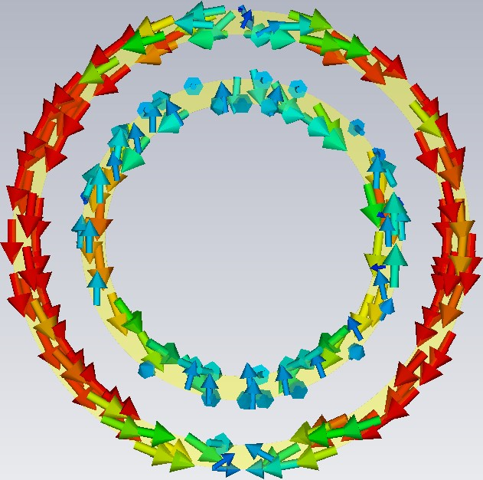 | 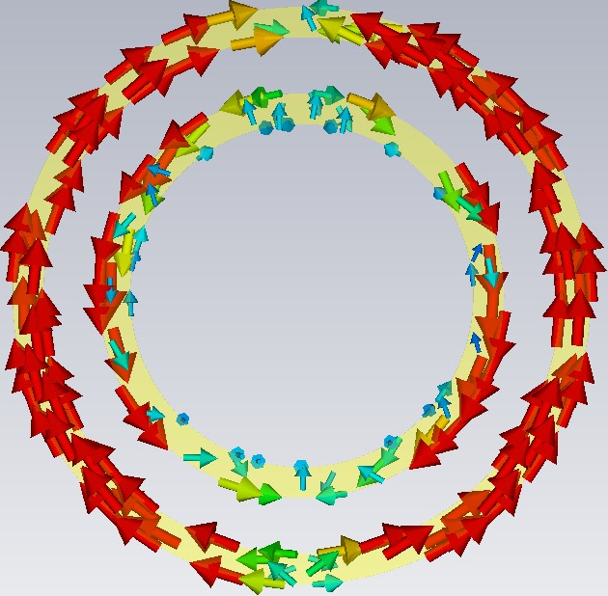 | 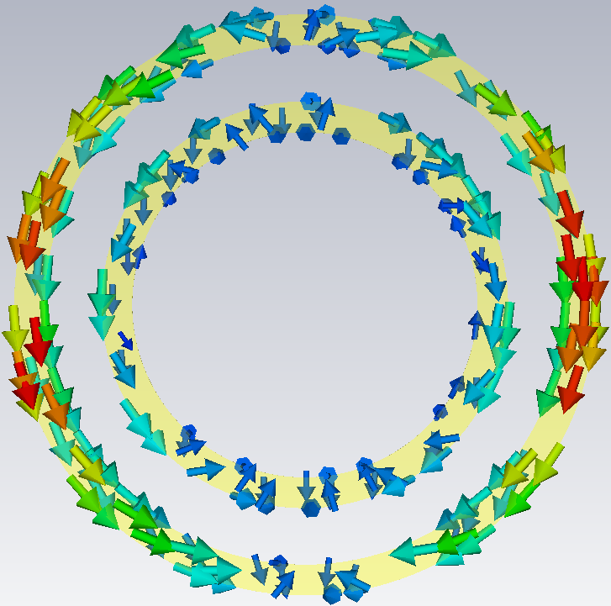
(2) | 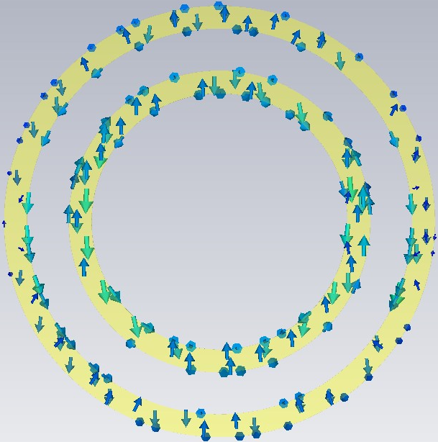 | 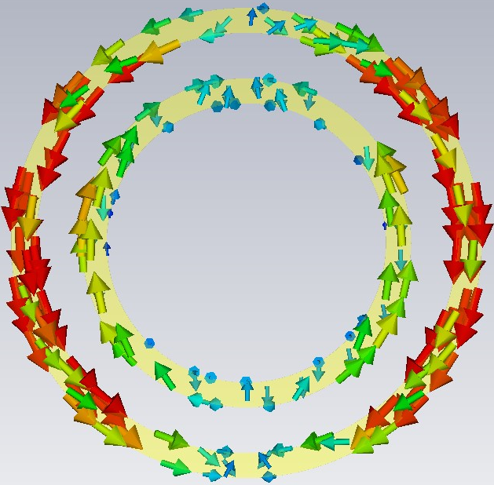 | 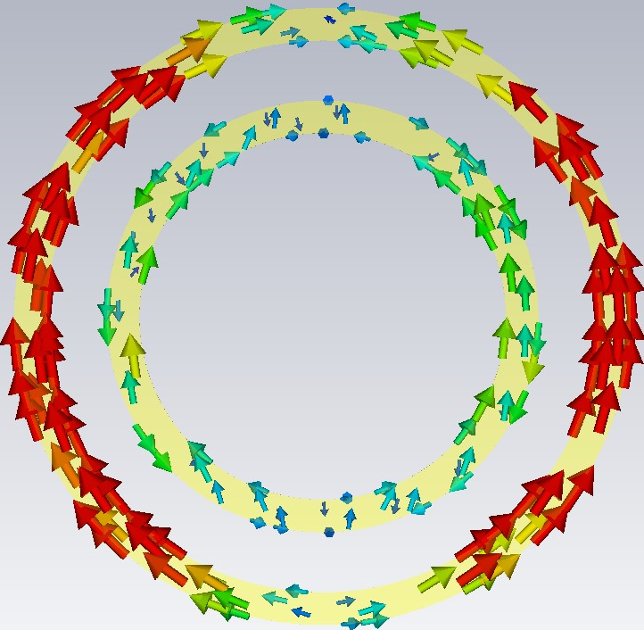
(3) | 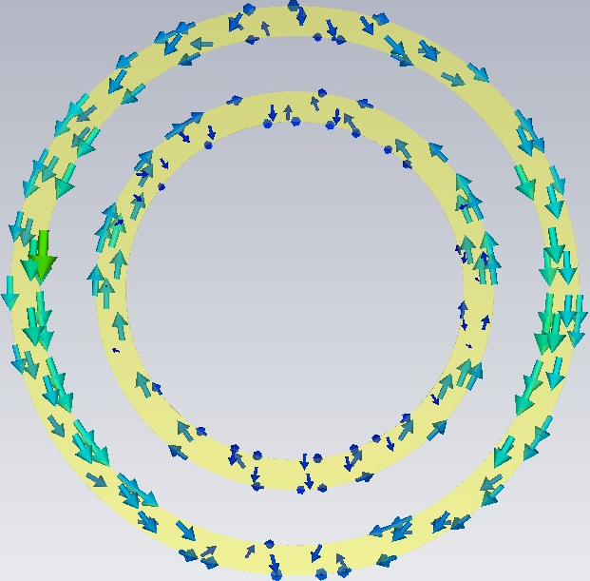 | 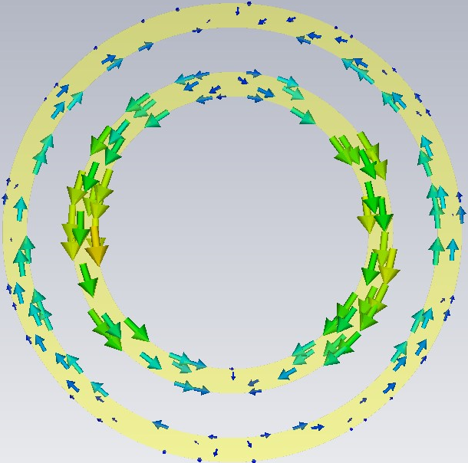 | 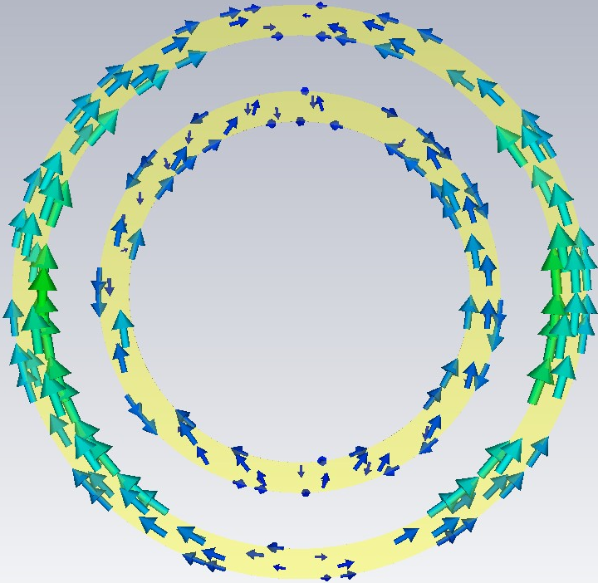
(4) | 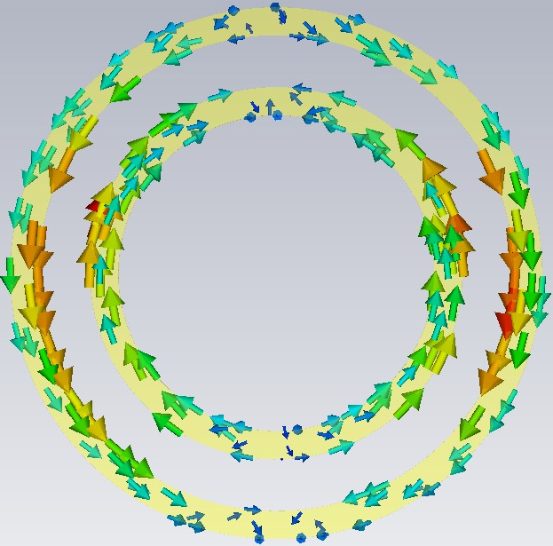 | 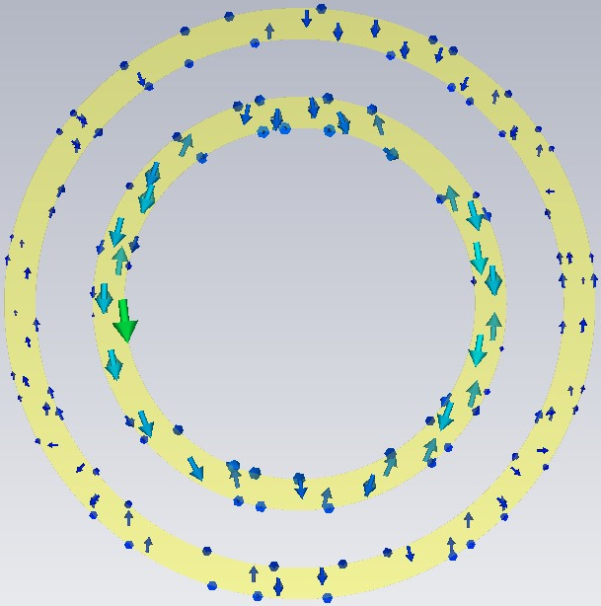 | 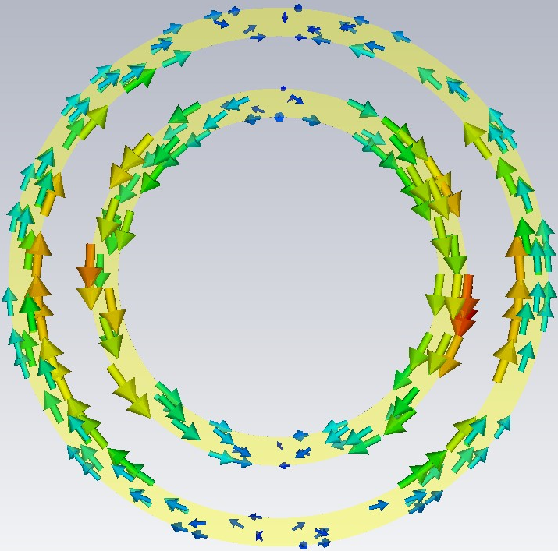
(5) | 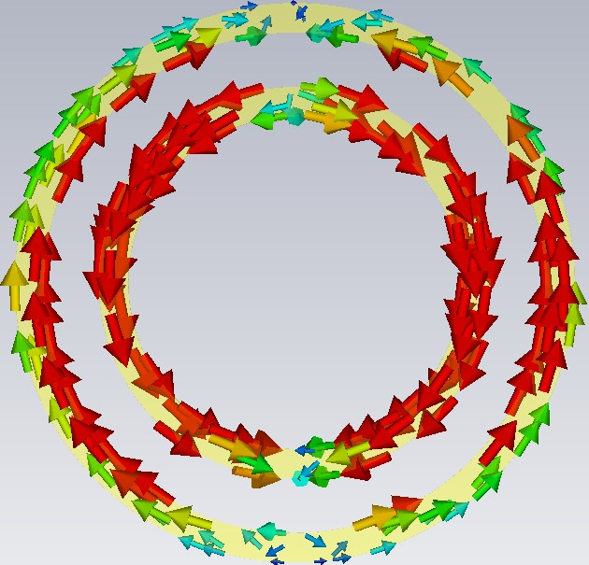 | 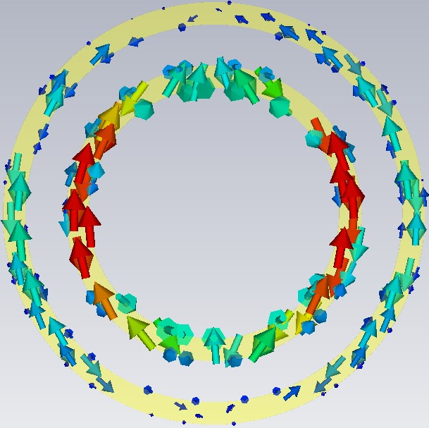 | 