Table 1: Patients’ Demographic Data Presentation.
n |  | Age/ Sex | Resection aetiology | Defect Classification  (Brown) | Reconstruction | Bone Source | Plate | Thickness | Virtual Resection
Directional Guidance Slot Guide. | 1 | 17/F | Osteomyelitis | II | Secondary | -------- | PAP | 2.4 | 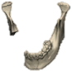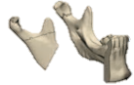
Directional Guidance Slot Guide. | 2 | 18/M | Ameloblastoma | III | Primary | Fibula | PSP | 2.4 | 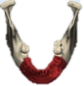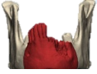
Directional Guidance Slot Guide. | 3 | 39/M | Osteomyelitis | III | Secondary | -------- | PSP | 2.7 | 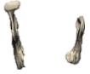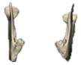
Directional Guidance Slot Guide. | 4 | 47/F | Ossifying Fibroma | II | Primary | Fibula | PSP | 2.4 | 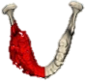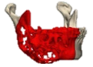
Directional Guidance Slot Guide. | 5 | 34/F | Ameloblastoma | I | Primary | AIC | PAP | 2.4 | 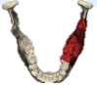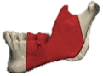
Directional Guidance Slot Guide. | 6 | 41/F | Myxoma | I | Primary | AIC | PAP | 2.4 | 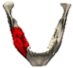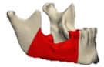
Directional Guidance Slot Guide. | 7 | 46/M | Squamous Cell Carcinoma | II | Secondary | -------- | PSP | 2.4 | 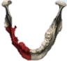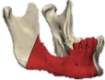
Directional Guidance Slot Guide. | 8 | 56/M | Ameloblastoma | I | Primary | AIC | PAP | 2.4 | 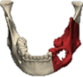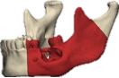
Directional Guidance Slot Guide. | 9 | 49/F | Ameloblastoma | I | Primary | AIC | PAP | 2.4 | 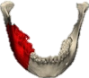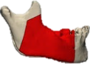
Directional Guidance Slot Guide. | 10 | 33/F | Osteomyelitis | II | Secondary | -------- | PSP | 2.4
Directional Guidance Slot Guide. | 11 | 39/F | Myxoma | II | Primary | Fibula | PSP | 2.4 | 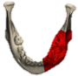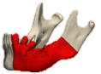
Directional Guidance Slot Guide. | 12 | 28/M | Ameloblastoma | I | Primary | AIC | PAP | 2.4 | 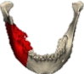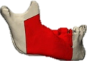
Directional Guidance Slot Guide. | 13 | 27/M | Osteomyelitis | I | Primary | AIC | PAP | 2.4 | 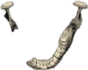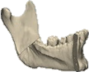
Conventional Edge Cutting Guide. | 1 | 35/M | Ameloblastoma | II | Primary | AIC | PAP | 2.7 | 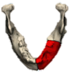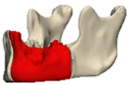
Conventional Edge Cutting Guide. | 2 | 47/F | Ameloblastoma | I | Primary | AIC | PAP | 2.7 | 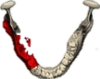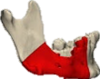
Conventional Edge Cutting Guide. | 3 | 28/F | Ameloblastoma | II | Primary | AIC | PAP | 2.7 | 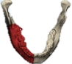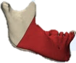
Conventional Edge Cutting Guide. | 4 | 51/M | Ameloblastic  Carcinoma | II | Primary | Fibula | PAP | 2.7 | 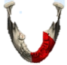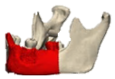
Conventional Edge Cutting Guide. | 5 | 54/F | Myxoma | II | Secondary | -------- | PAP | 2.4 | 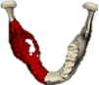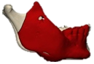
Conventional Edge Cutting Guide. | 6 | 28/F | Ameloblastoma | I | Primary | AIC | PAP | 2.4 | 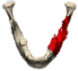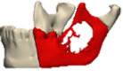
Conventional Edge Cutting Guide. | 7 | 38/F | Myxoma | I | Primary | AIC | PAP | 2.4 | 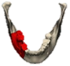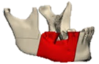
Conventional Edge Cutting Guide. | 8 | 19/M | Ameloblastic  Fibroma | II | Primary | AIC | PSP | 2.4 | 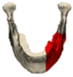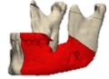
Conventional Edge Cutting Guide. | 9 | 27/M | Ameloblastoma | II | Primary | Fibula | PSP | 2.4 | 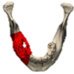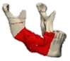
Conventional Edge Cutting Guide. | 10 | 39/M | Ameloblastoma | II | Primary | AIC | PAP | 2.4
Conventional Edge Cutting Guide. | 11 | 39/M | Squamous Cell Carcinoma | II | Primary | AIC | PSP | 2.4
Conventional Edge Cutting Guide. | 12 | 39/M | Osteomyelitis | I | Primary | AIC | PAP | 2.4 | 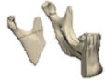
Conventional Edge Cutting Guide. | 13 | 39/M | Osteomyelitis | I | Secondary | -------- | PAP | 2.4 | 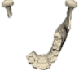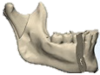
Total n = 26  37.7 ± 12.6 YRs.  0.73:1 M:F |  |  | 11 Ameloblastoma.  6 Osteomyelitis.  4 Myxoma.  2 Sq. Carcinoma.  1 Ab Carcinoma.  1 Ab Fibroma.  1 Ossify. Fibroma. | 11 Class I.  13 Class II.  2 Class III. | 20 Primary.  6 Secondary. | 6 Fibula  14 AIC | 9 PSP.  17 PAP. | 21 (2.4).  5 (2.7).
n, Number; M, Male; F, Female; AICG, SS; PSP, Patient Specific Plate; PAP, Preoperatively Adapted Plate.

Table 2: Analysis of the positional accuracy of the resection planes from different resection guide forms (n=26).
 |  | Proximal Osteotomy |  |  |  |  | Distal Osteotomy
 |  | Distance (mm) | Pitch  (º) | Yaw  (º) |  |  |  | Distance (mm) | Pitch  (º) | Yaw  (º)
Directional Guidance Slot Guide (n=13). | Δ ± SD. | 0.49 ± 0.19 | 1.1 ± 0.61 | 2 ± 0.58 |  |  |  | 0.30 ± 0.19 | 1.3 ± 0.50 | 2.4 ± 0.33
Directional Guidance Slot Guide (n=13). | Range. | 0.21 – 0.81 | 0.16 – 1.8 | 1.4 – 3.1 |  |  |  | 0.11 – 0.65 | 0.54 – 2 | 1.9 – 3
Conventional Edge Cutting Guide (n=13). | Δ ± SD. | 2.1 ± 1.2 | 2.2 ± 0.55 | 5.1 ± 3.1 |  |  |  | 2 ± 1.2 | 4.7 ± 4 | 9.1 ± 9
Conventional Edge Cutting Guide (n=13). | Range. | 0.67 – 4.2 | 1.5 – 3.1 | 2.2 – 13.3 |  |  |  | 1.2 – 4.8 | 0.56 – 12.7 | 2.7 – 33.5
Test (P) |  | U=4.0*  (<0.001*) | t=5.104*  (<0.001*) | U=10.0*  (<0.001*) |  |  |  | U=0.0*  (<0.001*) | U=22.0*  (<0.001*) | U=4.0  (<0.001*)
Δ , Absolute mean; SD, Standard deviation; t, Student t-test; U, Mann Whitney test.
P, p value for comparing between the studied groups; *, Statistically significant at p ≤ 0.05.

Table 3: Analysis of the flap/graft positional accuracy (n=20).
 |  | Proximal Osteotomy |  |  | Distal Osteotomy
 |  | Lateral Shift (mm) | Vertical Shift  (mm) |  | Lateral Shift (mm) | Vertical Shift  (mm)
Directional Guidance Slot Guide (n=13). | Δ ± SD. | 0.74 ± 0.28 | 0.62 ± 0.24 |  | 0.72 ± 0.23 | 0.63 ± 0.33
Directional Guidance Slot Guide (n=13). | Range. | 0.24 – 1.2 | 0.34 – 0.93 |  | 0.22 – 1 | 0.20 – 1.2
Conventional Edge Cutting Guide (n=13). | Δ ± SD. | 2 ± 1.5 | 1.2 ± 0.68 |  | 2.4 ± 1.3 | 1.3 ± 0.43
Conventional Edge Cutting Guide (n=13). | Range. | 0.69 – 5.2 | 0.19 – 2.8 |  | 0.69 – 4.8 | 0.76 – 2
Test (P) |  | U=24.50*  (<0.009*) | U=34.00*  (<0.001*) |  | U=13.00*  (<0.001*) | U=20.50*  (<0.001*)
Δ , Absolute mean; SD, Standard deviation; t, Student t-test; U, Mann Whitney test.
P, p value for comparing between the studied groups; *, Statistically significant at p ≤ 0.05.

Table 4: Analysis of the defect span accuracy (n=26).
Segment L  (mm) | Directional Guidance Slot Guide (n=13). | Edge cutting conventional Guide (n = 13).
VPM
Δ ± SD. | 69.64 ± 22.54 | 64.7 ± 13.4
Range | 48.6 – 120.5 | 43.7 – 86
APM
Δ ± SD. | 69.55 ± 22.58 | 65 ± 13.1
Range | 48.7 – 120.3 | 44.1 – 85.1
Difference
Δ ± SD. | -0.09 ± 0.37 | 0.59 ± 1.27
Range | -0.69 – 0.80 | -1.1 – 2
Level of agreement
ICC coefficient | 1.000 | 0.995
95%C.I | 1.000 – 1.000 | 0.982 – 0.998
P | <0.0001* | <0.0001*
VPM, Virtual Preoperative Model; APM, Actual Postoperative Model; Δ , Absolute mean; SD, Standard deviation: ICC, Interclass Correlation Coefficient; CI, Confidence interval.
ICC Outcome Values: <0.5 Poor agreement, 0.5 to <0.75 Moderate agreement, 0.75 to <0.9 Good agreement, 0.9 - 1.0 Excellent agreement.
P, p value for comparing between the studied groups; *, Statistically significant at p ≤ 0.05.

