Scheme 1. Synthesis of SQCOF under optimum conditions.
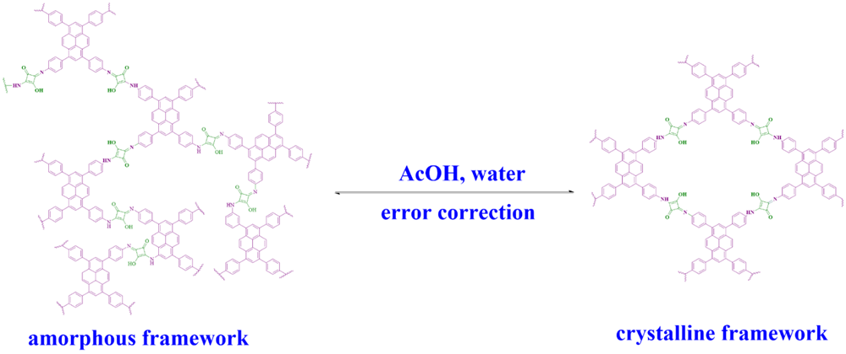
Scheme 2. Error correction in the amorphous framework by acid catalyst.

.
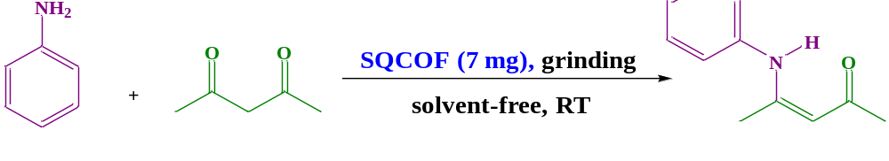
Scheme 3. Condensation of aniline and acetylacetone as the model reaction.

Scheme 4. Reaction of raw materials with Model-SQ.

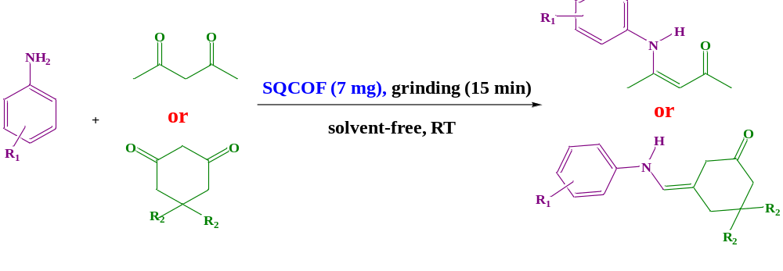
Scheme 5. Synthesis of different derivatives of enaminones under optimal conditions.

Scheme 6. Proposed mechanism of enaminone production by SQCOF.

