Supporting information

Synthesis and Improving the Crystallinity of a Squaranine Covalent Organic Framework by Investigating the Co-Catalyst Effect and Using It as a Green and Metal-Free Catalyst for the Synthesis of Enaminones.
M. Sadegh Ramezani*, Sadegh Safaei, Zahra Goodarzi and Mahsa Moradi
Department of Chemistry, University of Isfahan, Isfahan 81746-73441, Iran.
*Corresponding author: M. Sadegh Ramezani
Email: m.sadeghramezani1995@sci.ui.ac.ir
msrchm9592@yahoo.com

- Materials and instruments:
4,4′,4″,4‴-(pyrene-1,3,6,8-tetrayl)tetraanilinewas (TAPP) synthesized according to the references [S1,S2]. Squaric acid (SQ), Pyrene, 4-Aminophenylboronic acid pinacol ester, potassium carbonate, Tetrakis(triphenylphosphine)palladium (0), 1,3-dicarbonyl compounds, aniline derivatives, dichloromethane (DCM), acetonitrile, N, N-dimethylformamide (DMF), 1,4-dioxin, 1,2-dichlorobenzene (DCB), n-butanol, acetone, tetrahydrofuran (THF), acetic acid, hydrochloric acid (37%), sodium hydroxide, bromine, mesitylene and nitro benzene, all were purchased from Merck (Darmstadt, Germany). High-purity Milli-Q water (18.2 MΩ·cm) was prepared in the laboratory using a ZU101 water purification system from Zolalan Sharif Pars (Iran) during the examinations.
Powder X-ray diffraction (PXRD) was collected by Bruker D8 ADVANCE (Germany). Nitrogen gas sorption experiments were carried out on a BELSORP MINI 2 (Japan). Before measurement, the samples were degassed in a vacuum at 120 °C for 24 h. Fourier transform infrared spectroscopy (FT-IR) spectra were recorded on JASCO FT-IR 6300 (Japan). Field-emission scanning electron microscopy (FE-SEM) and energy dispersive X-ray spectrometry (EDX) were performed on an FEI quanta FEG450 (USA) operating at an accelerating voltage of 20.0Kv (USA). FEI Titan 80-300 Transmission Electron Microscope (USA) was used for TEM images. Solid-state UV-Vis was performed on UV-VEs-670 (Japan). NMR spectra were recorded on a Bruker Avance 400 MHz spectrometer (Germany).
- Figures
Figure S1. FTIR spectra of SQCOF.

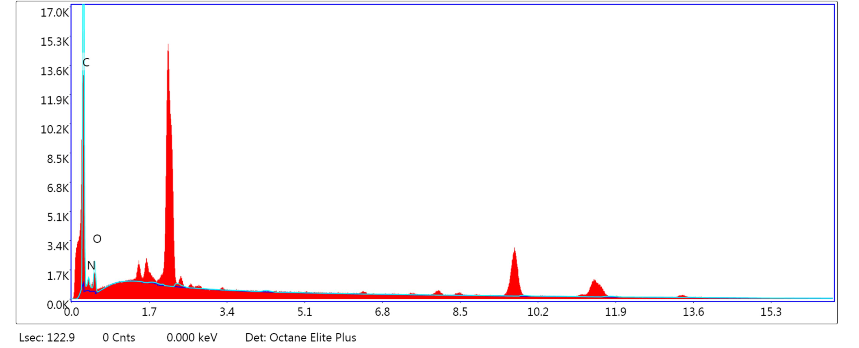
Figure S2. Energy-dispersive X-ray spectroscopy (EDS) of SQCOF.

Figure S3. PXRD pattern of SQCOF under acidic and alkaline solutions and organic solvents.

Figure S4. N₂ adsorption−desorption curves and pore size distribution graphs of SQCOF.
Figure S5. Solid-state UV-Vis spectra of SQCOF.
- NMR data

3-oxo-2-(p-tolylamino)-4-(p-tolyliminio)cyclobut-1-en-1-olate (Model-SQ).
Yellow solid. ¹H- NMR (400 MHz; DMSO-d₆) δ= 2.28 (s, 6H, CH3), 7.19 (d, J=8 Hz, 4H, Ar-H), 7.38 (d, J=8 Hz, 2H, Ar-H), 7.68 (s, 2H, Ar-H), 9.78 (s, 1H,N-H), 11.30 (s, 1H, N-H).

Figure S6. ¹H-NMR spectrum of Model-SQ

(Z)-4-(phenylamino)pent-3-en-2-one
Light yellow solid; ¹H- NMR (400 MHz; CDCl₃) δ=2.01 (s, 3H, CH3), 2.12 (s, 3H, CH3), 5.20 (s, 1H, CH), 7.12 (d, J=8 Hz, 2H, Ar-H), 7.20 (t, J=8 Hz, 1H, Ar-H), 7.33-7.37 (m, 2H, Ar-H), 12.50 (s, 1H, NH).
Figure S7. ¹H-NMR spectra of (Z)-4-(phenylamino)pent-3-en-2-one

(Z)-4-(p-tolylamino)pent-3-en-2-one
Cream color solid; ¹H- NMR (400 MHz; CDCl₃) δ=1.96 (s, 3H, CH3), 2.10 (s, 3H, CH3), 2.34 (s, 3H) 5.17 (s, 1H, CH), 7.00 (d, J=8, 2H, Ar-H), 7.14 (d, J=8, 2H, Ar-H), 12.42 (s, 1H, NH).

Figure S8. ¹H-NMR spectra of (Z)-4-(p-tolylamino)pent-3-en-2-one .

(Z)-4-((4-Hydroxyphenyl)amino)pent-3-en-2-one
Yellow solid; ¹H- NMR (400 MHz; CDCl₃) δ=1.93 (s, 3H, CH3), 2.12 (s, 3H, CH3), 5.18 (s, 1H, CH), 6.15 (s, 1H, OH), 6.83-6.86 (m, 2H, Ar-H), 6.94-6.98 (m, 2H, Ar-H), 12.26 (s, 1H, NH).

Figure S9. ¹H-NMR spectra of (Z)-4-((4-Hydroxyphenyl)amino)pent-3-en-2-one.

(Z)-4-(Naphtalen-1-ylamino)pent-3-en-2-one
White solid. ¹H- NMR (400 MHz; CDCl₃) δ=1.931.81 (s, 3H, CH3), 2.10 (s, 3H, CH3), 5.24 (s, 1H, CH), 7.21 (d, J = 8, 1H, Ar-H), 7.38 (t, J = 8, 1H, Ar-H), 7.44-7.49 (m, 2H, Ar-H), 7.70 (d, J = 8, 1H, Ar-H), 7.80-7.82 (m, 1H, Ar-H), 7.94-7.97 (m, 1H, Ar-H), 12.68 (s, 1H, NH).

Figure S10. ¹H-NMR spectra of (Z)-4-(Naphtalen-1-ylamino)pent-3-en-2-one.

(Z)-4-((4-Fluorophenyl)amino)pent-3-en-2-one
Yellow solid. ¹H- NMR (400 MHz; CDCl₃) δ=1.91 (s, 3H, CH3), 2.08 (s, 3H, CH3), 5.18 (s, 1H, CH), 6.99-7.08 (m, 4H, Ar-H), 12.35 (s, 1H, NH).

Figure S11. ¹H-NMR spectra of (Z)-4-((4-Fluorophenyl)amino)pent-3-en-2-one.

(Z)-4-((4-Chlorophenyl)amino)pent-3-en-2-one
Yellow solid. ¹H- NMR (400 MHz; CDCl₃) δ=1.99 (s, 3H, CH3), 2.11 (s, 3H, CH3), 5.21 (s, 1H, CH), 7.03-7.06 (m, 2H, Ar-H), 7.29-7.33 (m, 2H, Ar-H), 12.44 (s, 1H, NH).

Figure S12. ¹H-NMR spectra of (Z)-4-((4-Chlorophenyl)amino)pent-3-en-2-one.

(Z)-4-((3-Chlorophenyl)amino)pent-3-en-2-one
Yellow solid. ¹H- NMR (400 MHz; CDCl₃) δ= 2.03 (s, 3H, CH3), 2.12 (s, 3H, CH3), 5.23 (s, 1H, CH), 6.99-7.30 (m, 4H, Ar-H).

Figure S13. ¹H-NMR spectra of (Z)-4-((3-Chlorophenyl)amino)pent-3-en-2-one.

(Z)-4-((4-Bromophenyl)amino)pent-3-en-2-one
Yellow solid. ¹H- NMR (400 MHz; CDCl₃) δ= 1.94 (s, 3H, CH3), 2.06 (s, 3H, CH3), 5.17 (s, 1H, CH), 6.93 (d, J = 8, 2H, Ar-H), 7.40 (d, J = 8, 2H, Ar-H), 12.41 (s, 1H, NH).

Figure S14. ¹H-NMR spectra of (Z)-4-((4-Bromophenyl)amino)pent-3-en-2-one.

3-(Phenylamino)cyclohex-2-enone
Yellow solid. ¹H- NMR (400 MHz; CDCl₃) δ= 2.04 (m, 2H, CH2), 2.37-2.50 (m, 4H, CH2), 5.59 (s, 1H, CH), 6.02 (s, 1H, NH), 7.15-7.36 (m, 5H, Ar-H).

Figure S15. ¹H-NMR spectra of 3-(Phenylamino)cyclohex-2-enone.

3-(Naphtalen-1-ylamino)cyclohex-2-enone
White Crystal. ¹H- NMR (400 MHz; CDCl₃) δ=2.10-2.13 (m, 2H, CH2), 2.39 (t, J = 6.4, 2H, CH2), 2.65 (t, J = 6.4, 2H, CH2), 5.17 (s, 1H, CH), 6.22 (s, 1H, NH), 7.42 (m, 1H, Ar-H), 7.45-7.49 (m, 1H, Ar-H),7.53-7.55 (m, 2H, Ar-H), 7.81 (d, J = 8, 1H, Ar-H), 7.87-7.92 (m, 2H, Ar-H).

Figure S16. ¹H-NMR spectra of 3-(Naphtalen-1-ylamino)cyclohex-2-enone.

5,5-Dimethyl-3-(phenylamino)cyclohex-2-enone
Pale pink Crystal. ¹H- NMR (400 MHz; CDCl₃) δ=1.13 (s, 6H, CH3), 2.24 (s, 2H, CH2), 2.36 (s, 2H, CH2), 5.60 (s, 1H, CH), 6.29 (s, 1H, NH), 7.16-7.20 (m, 3H, Ar-H), 7.33-7.37 (m, 2H, Ar-H).

Figure S17. ¹H-NMR spectra of 5,5-Dimethyl-3-(phenylamino)cyclohex-2-enone.

(3Z,3'Z)-4,4'-(1,4-Phenylenebis(azanediyl))bis(pent-3-en-2-one)
Gray solid. ¹H- NMR (400 MHz; CDCl₃) δ=2.02 (s, 6H, CH3), 2.12 (s, 6H, CH3), 5.22 (s, 2H, CH), 7.09 (s, 4H, Ar-H), 12.48 (s, 2H, NH).

Figure S18. ¹H-NMR spectra of (3Z,3'Z)-4,4'-(1,4-Phenylenebis(azanediyl))bis(pent-3-en-2-one) .

References:
S1. G. Venkataramana and S. Sankararaman, (Wiley Online Library, 2005)
S2. F. Auras, L. Ascherl, A.H. Hakimioun, J.T. Margraf, F.C. Hanusch, S. Reuter, D. Bessinger, M. Döblinger, C. Hettstedt and K. Karaghiosoff Journal of the American Chemical Society 138, 51 (2016)

