6.- Supplementary information

Table S1. References to the fire events that are used in the paper. Those references include detailed information on the events that support our findings.
Australia
Australia, (Canberra), 2003 | 1. Fromm, M., Tupper, A., Rosenfeld, D., Servranckx, R. & McRae, R. Violent pyro-convective storm devastates Australia’s capital and pollutes the stratosphere. Geophysical Research Letters 33, (2006).
Australia, (SE), 2009 | 2. Cruz, M. G. et al. Anatomy of a catastrophic wildfire: The Black Saturday Kilmore East fire in Victoria, Australia. Forest Ecology and Management 284, 269–285 (2012).  3. Toivanen, J. et al. Coupled Atmosphere-Fire Simulations of the Black Saturday Kilmore East Wildfires with the Unified Model. Journal of Advances in Modeling Earth Systems 11, 210–230 (2019).
Australia, (SE), 2019-2020 | 4. Boer, M. M., Resco de Dios, V. & Bradstock, R. A. Unprecedented burn area of Australian mega forest fires. Nat. Clim. Chang. 10, 171–172 (2020).  5. Peterson, D. A. et al. Australia’s Black Summer pyrocumulonimbus super outbreak reveals potential for increasingly extreme stratospheric smoke events. npj Clim Atmos Sci 4, 1–16 (2021).
North America
USA, (California, Dude fire), 1990 | 6. Goens, D. W. & Andrews, P. L. WEATHER AND FIRE BEHAVIOR FACTORS RELATED TO THE 1990 DUDE FIRE NEAR PAYSON, AZ. NWCG Wildland Fire Leadership Development Program, (1998).
USA, 2002 | 7. Fromm, M. et al. The Untold Story of Pyrocumulonimbus. Bulletin of the American Meteorological Society 91, 1193–1210 (2010).
Western North America (SW Canada, W USA, NW Mexico), 2013 | 8. Peterson, D. A., Hyer, E. J., Campbell, J. R., Solbrig, J. E. & Fromm, M. D. A Conceptual Model for Development of Intense Pyrocumulonimbus in Western North America. Monthly Weather Review 145, 2235–2255 (2017).  9. Peterson, D. A. et al. The 2013 Rim Fire: Implications for Predicting Extreme Fire Spread, Pyroconvection, and Smoke Emissions. Bulletin of the American Meteorological Society 96, 229–247 (2015).
USA, (California, Camp fire), 2018 | 10. Lareau, N. P., Donohoe, A., Roberts, M. & Ebrahimian, H. Tracking Wildfires with Weather Radars. Journal of Geophysical Research: Atmospheres 127, e2021JD036158 (2022).
USA, (California), 2020 | 11. Safford, H. D., Paulson, A. K., Steel, Z. L., Young, D. J. N. & Wayman, R. B. The 2020 California fire season: A year like no other, a return to the past or a harbinger of the future? Global Ecology and Biogeography 31, 2005–2025 (2022).  12. Lareau, N. P. et al. Fire-Generated Tornadic Vortices. Bulletin of the American Meteorological Society 103, E1296–E1320 (2022).
South America
Chile, 2017 | 13. CONAF. Descripción y efecteos <<Tormenta de fuego>> 18 de enero al 5 de febrero de 2017 Regiones O’Higgins, el Maule y Biobio. 32p.
Amazonia, (Brazil, Bolivia, Paraguay, Peru), 2019 | 14. Artes, T., Oom, D & n Migueal-Ayanz, J. Wildfires in the Amazon Region 2019. (EU JRC, LU, 2020).
Europe
Greece, (S), 2007 | 15. Gouveia, C. M. et al. The outstanding synergy between drought, heatwaves and fuel on the 2007 Southern Greece exceptional fire season. Agricultural and Forest Meteorology 218–219, 135–145 (2016).
Portugal, 2017 | 16. Guerreiro, J. et al. Análise e Apuramento Dos Factos Relativos Aos Incêndios Que Ocorreram Em Pedrógão Grande, Castanheira de Pêra, Ansião, Alvaiázere, Figueiró Dos Vinhos, Arganil, Góis, Penela, Pampilhosa Da Serra, Oleiros e Sertã Entre 17 e 24 de Junho de 2017. (2017).  17. Guerreiro, J. et al. Avaliaçao Dos Incendios Ocorridos Entre 14 e 16 de Otubro 2017 Em Portugal Continental. Relatoria Final. 274 https://www.parlamento.pt/Documents/2018/Marco/RelatorioCTI190318N.pdf (2018).  18. Castellnou, M., Guiomar, N., Rego, F. & Fernandes, P. Fire Growth Patterns in the 2017 Mega Fire Episode of October 15, Central Portugal. (2018). doi:10.14195/978-989-26-16-506_48.
Greece, 2021 | 19. Giannaros, T. M. et al. Meteorological Analysis of the 2021 Extreme Wildfires in Greece: Lessons Learned and Implications for Early Warning of the Potential for Pyroconvection. Atmosphere 13, 475 (2022).
Europe, (Portugal, Spain, France), 2022 | 20. Rodrigues, M. et al. Drivers and implications of the extreme 2022 wildfire season in Southwest Europe. Science of The Total Environment 859, 160320 (2023).
Siberia
Siberia, 2003 | 21. Youn, D. et al. Impacts of aerosols on regional meteorology due to Siberian Forest fires in May 2003. Atmospheric Environment 45, 1407–1412 (2011).
Siberia 2019 | 22. Ohneiser, K. et al. Siberian Fire Smoke in the High-Arctic Winter Stratosphere Observed during MOSAiC 2019–2020. https://acp.copernicus.org/preprints/acp-2021-117/acp-2021-117.pdf (2021) doi:10.5194/acp-2021-117.

Table S2.- Statistical significance based in T-test with p=0.05 between differences in depth (m) between observed fireABL, expected fireABL and ABL.

FIGURES
We present in Figure S1 the vertical profile of extreme fire examples to illustrate the stability regimes: pyroconvection, shallow pyroconvection and deep pyroconvection. .
Our research describes dry pyrocloud as a new driver of pyroconvection phenomena. In Figures S2, S3, and S4, we provide real images and videos with explanatory content to present our hypothesis better (Figure 2). The dry pyrocloud readings by in-plume radiosondes are presented in Figure S5.
Figures S6 ansd S7 S9 explain fireABL concept with simulated examples and radiosondes measurements. The fireABL cycle is comoplemented with the ROSb cycle in figure S8.
Figures S9 and S10 present examples of observation of fireABL.
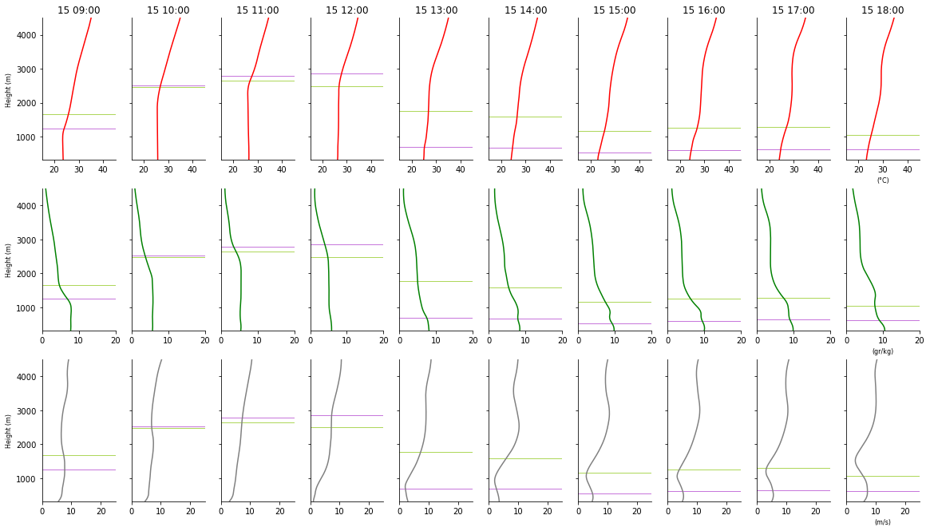
a.-Tivissa Fire 2014 Pyroconvective regime. PyroCb at 15:42
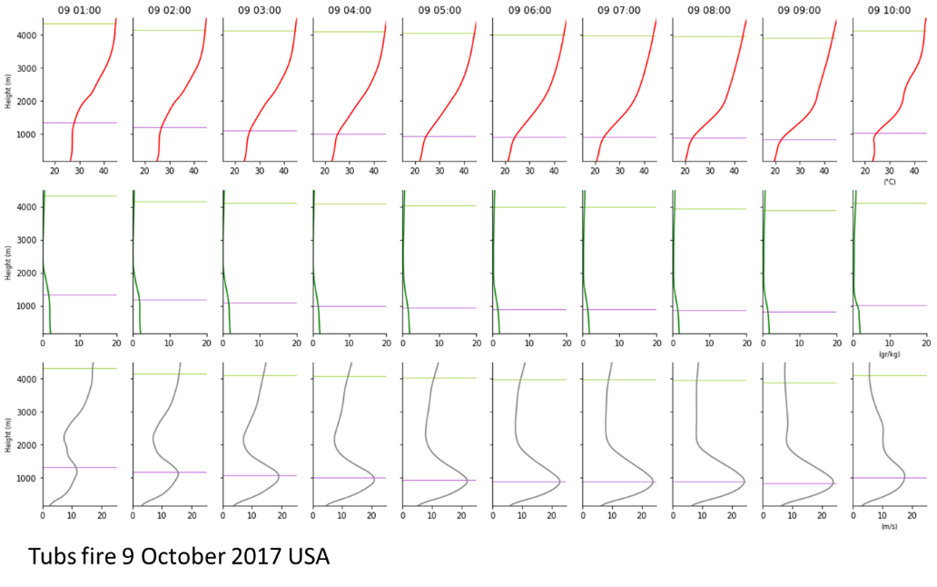
b.-Tubs fire 2017, California. USA: It is an example of wind-driven fire in the shallow pyroconvective regime.
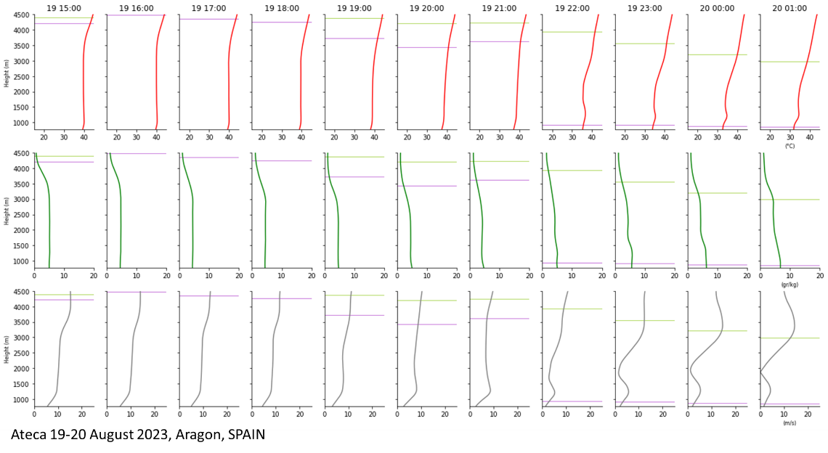
c.-Ateca fire 2022, Aragon, SPAIN. Example of deep pyroconvection regime. . The fire creates a PyroCb at 23:12
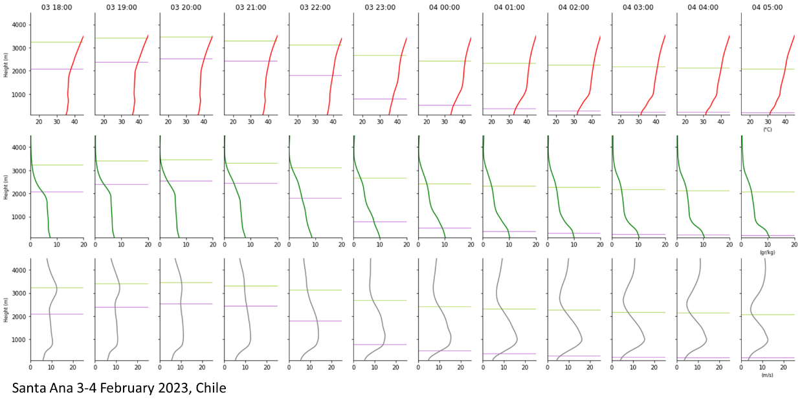
d.-Santa Ana Fire 2023, Bio Bio, CHILE. Example of deep pyroconvective regime. PyroCb at 01:00 am
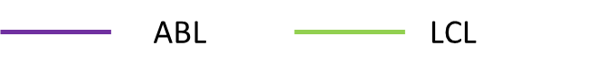
Figure S1.- Hourly evolution of the vertical profile (ERA5) for different fires representing the stability regimes identified in the correlation of ROSb and pyrocloud type with stability in the lower and free troposphere (Figure 1). Vertical profiles for θ (k), q (g·kg-1), and u (m·s⁻¹) are shown. A) Pyroconvective regime. The fire created a pyroCu that shortly transitioned into a PyroCb at 15:42 with the arrival of a moist sea breeze. This is the classic example of pyro-convection in the afternoon using deep and unstable ABL? B) Shallow pyroconvection regime, with nocturnal Tubbs fire (California, USA. 2017). The mechanical turbulence maintains ABL height at night in catabatic winds. C) Deep pyroconvection regime. Ateca fire (Aragon, SPAIN. 2022) and Santa Ana fire (BioBio, CHILE. 2023). Ateca Is a fire that went from burning 5000 ha during the day to more than 11000 ha during the DtN and night timeframes. Santa Ana fire did a change on ROS to 12 km/h in DtN and the first 3 hours into the night.

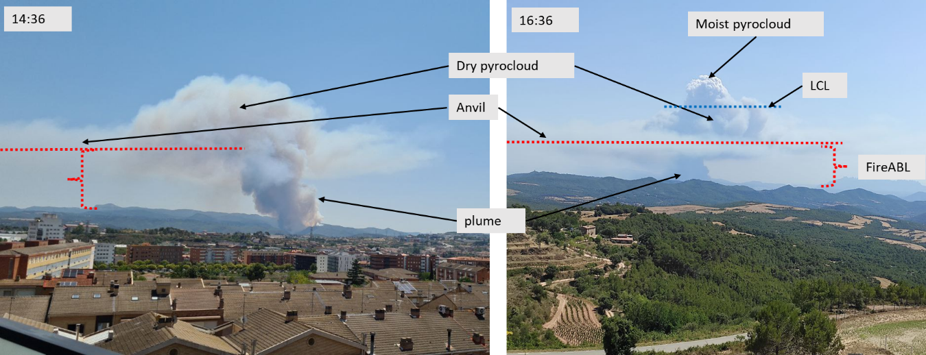
Figure S2.- Plume and Pyrocloud characteristics detail. A) The deepening into the free atmosphere is turbulent, creating overshooting linked to an intense heat flux from fire spread. Free atmosphere stability regulates the penetration process. If the heat flux pulse is strong enough, the plume can reach LCL level and create a moist pyrocloud. B) The turbulent dry pyrocloud forms a cloud umbrella that resembles a stratocumulus. Below the umbrella, the dry pyrocloud-enhanced entrainment creates a fireABL or fire-induced ABL. Pont de Vilomara fire. Catalonia, SPAIN. 2022.

Figure S3 (Video).- Dry Pyrocloud formation (https://doi.org/10.5281/zenodo.10799438). Plume during the first hour of Pont de Vilomara Fire, Catalonia (Spain) 2022. The plume reaches the ABL top and penetrates the transition layer on top. The stability of the day allows for a deep, dry pyrocloud penetration without transition to a moist pyrocloud. We can observe how the dry pyrocloud turbulence starts to entrain hot and dry air into ABL. The pyrocloud-induced modification of ABL creates a visible deeper fireABL.

Figure S4 (Video).- Dry pyrocloud enhanced increase of plume injection height. (https://doi.org/10.5281/zenodo.10799438) Lake fire, California (USA) 2020. Following the process explained in Figure S4, the plume starts to deepen on top of the ABL. The dry pyrocloud gradually facilitates the modification of ABL into fireABL. Step by step, the fireABL changes consolidate an injection height that allows the fire to increase intensity and gradually raise fireABL to a new injection height. FireABL gains height with the fire intensity pulses. We can observe how the plume forms a moist pyrocloud that further enhances entrainment and facilitates a new deeper injection height.

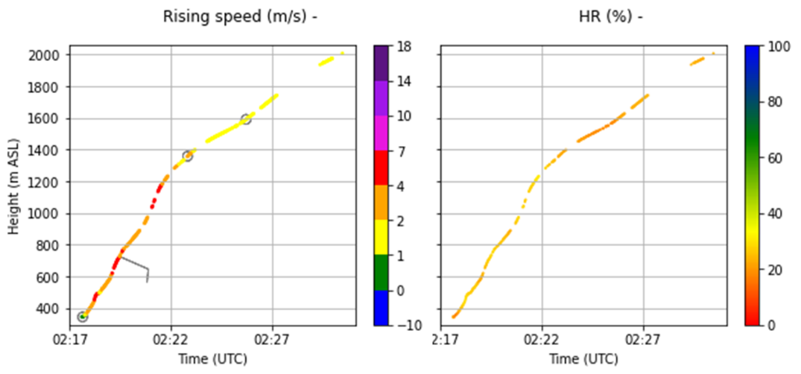
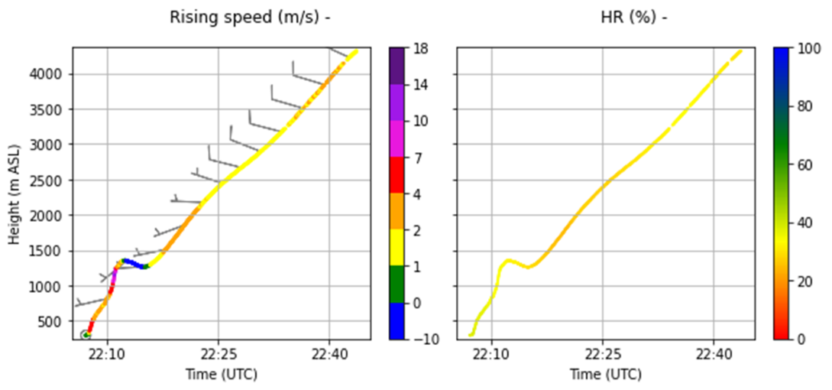
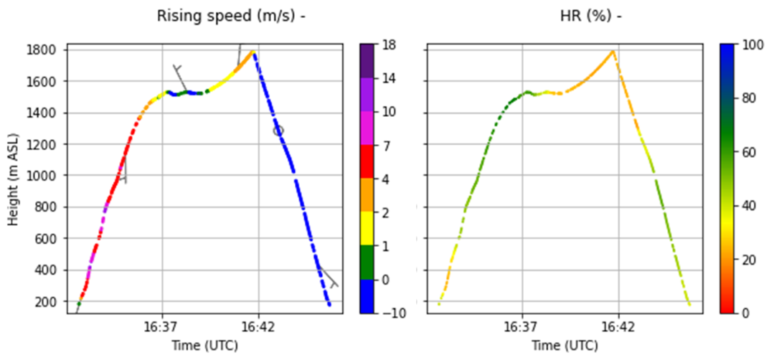
Figure S5. In-plume sounding measurements of the state variables. The measured profile of of rising speed (m.s⁻¹) and RH (%) are presented. We present different radiosonde measurements to show that the dry pyrocumulus turbulence is common in all types of fire behavior that produces a plume arriving at ABL top, despite its intensity. a) plume that fades inside ABL. b) plume on a fire with a heat flux of 9 kW·m². b) plume on a fire of 87 kW·m². Turbulence identified by descending air on top of plumes is observed on all cases when plume has the capacity to reach the ABL top. In those case the plume forms a dry pyrocloud, that evolve to an umbrella that resembles a stratocumulus. We call it pyrostratocumulus (pyroStrCu).

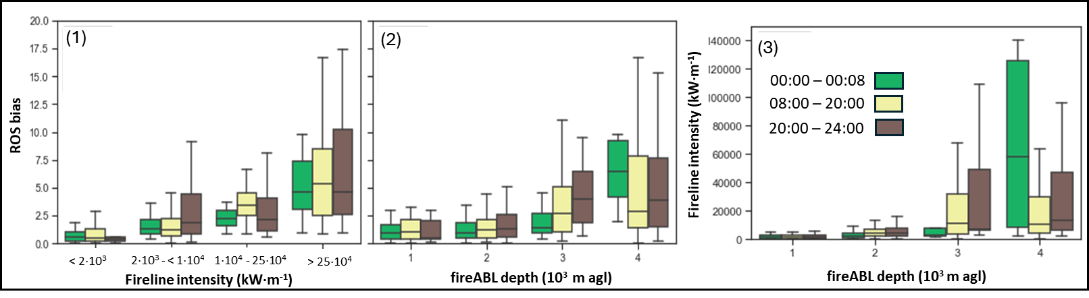
Figure S6.- B) Impact by the timeframe of FLI and fireABL coupling processes on ROSb. b1) ROSb correlation with fireline intensity (kW·m-1). b2) ROSb correlation with modeled fireABL height (m) classes. b3) Fireline intensity (kW·m-1) correlation with modeled fireABL height (m). The ROSb increases following the fireline intensity (1) between 06:00 and 18:00 LT, as expected from the pyroconvection enhancement. However, the FLI vs. ROSb dependence is also significant at the DtN and night timeframes for the highest FLI class. The ROSb and deep fireABL (2) also show a positive trend for fireABL > 2000 m, independently of the timeframe. Our findings indicate that the ROSb is primarly influenced by the FLI and fireABL depth during the daytime. At DtN and night, the higher ROSb is better explained by our hypothesis. In short, the maintenance of the formed fire ABL during the day-to-night transition. Figure 3 corroborates our hypothesis showing the extreme FLI (> 2·104 K·m2·s-1) correlation with the fireABL depth >2000 m during the DtN and night timeframes.

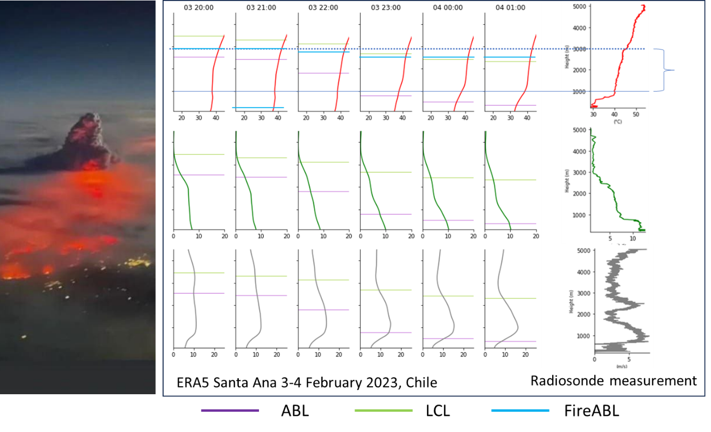
Figura S7.- FireABL measured by a radiosonde in Chile, 3-02-2023. We present the ERA5 profile for the radiosonde measurement at 23:52 LT. The fire had been active at midday and, at night, blew up unexpectedly, forming deep pyroconvection, as observed in the picture from an airplane on the left. Although not directly on the plume, we launched the radiosonde measure in the fire area under the pyroStratoCu. We can observe how the Tª profile (upper graph with a red profile) is showing an ABL (violet level) shrinking but a fireABL (blue level) that maintains a height like that of the radiosonde measurement residual layer.

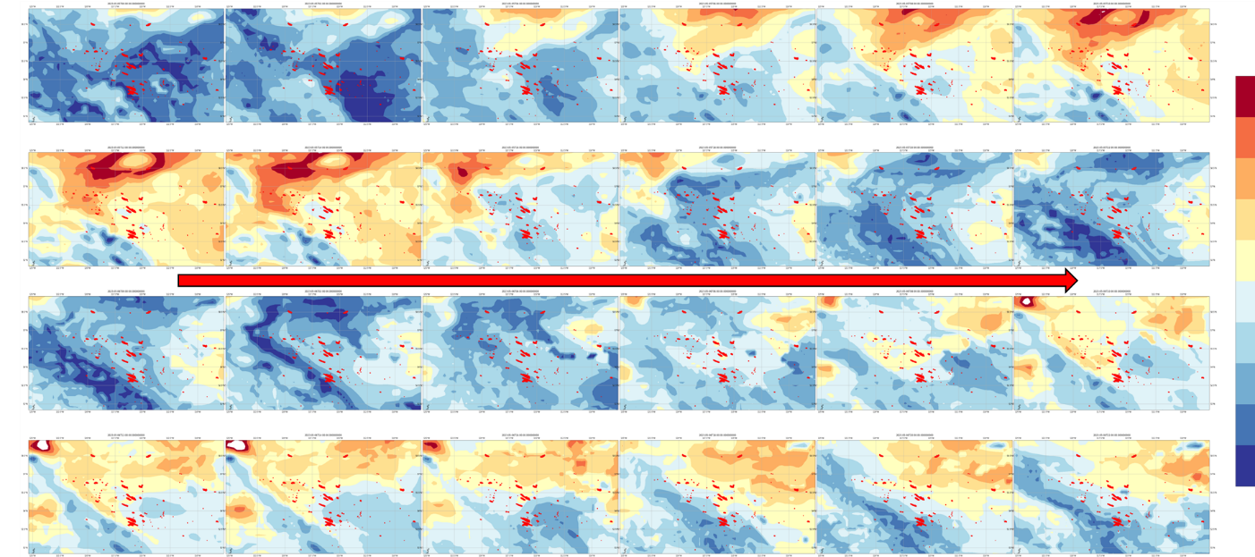
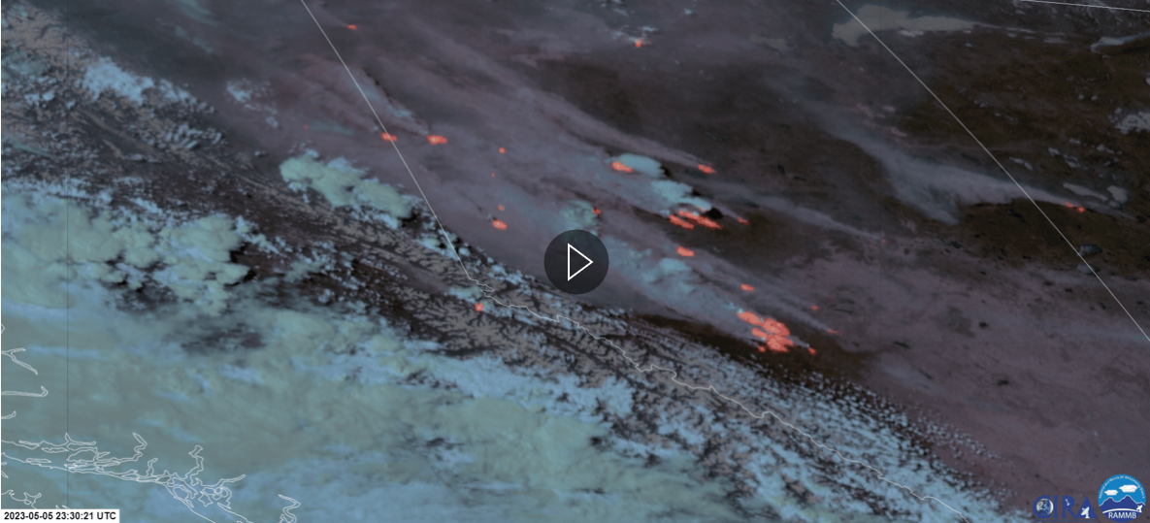
Figure S8.- Free Troposphere stability dynamics importance on governing pyroconvection. a) Alberta (Canada) firestorm on May 5th 2023. Concatenation of extreme wind-driven events with formed fireABL under dry pyrocloud (pyroStraCu). We can observe PyroCb forming during the late afternoon and DtN facilitated. Free atmosphere instability advection (red arrow in panel A) facilitated the transition of a shallow pyroconvective regime with a capped fireABL to a deep pyroconvection regime and a sudden blow-up. The result is an extraordinary, long-lasting extreme wildfire event where free atmosphere stability dynamics govern the pyroconvective characteristics of the group of fires.

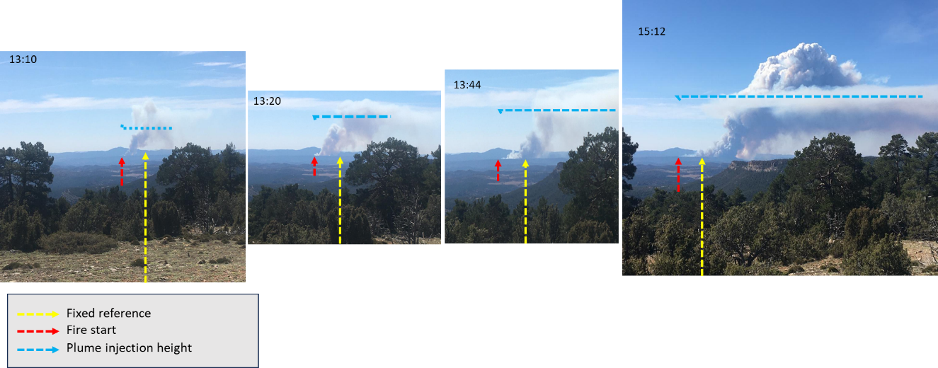

Figure S9. Les Usseres fire, 2023, Comunitat Valenciana. SPAIN. View from the distance of plume evolution at les Usseres fire between 13:10 and 15:12 the afternoon the fire started. To facilitate the reading of the plume spread in the landscape, we add a reference position (yellow arrow) to the pictures and mark the initial starting point (red arrow). The blue line represents the plume injection height that can be assumed to represent the fireABL top. We can observe how the fireABL gradually increases by the dry pyrocloud and forms a pyrostratoCu. Such pyrostratoCu and fireABL below the plume injection height are already visible at 13:20, being well formed at 13:44 and with visible top-down mixing from the pyrocloud at 15:12. It is important to observe how the plume deepens using the fireABL previously created by the fire.

