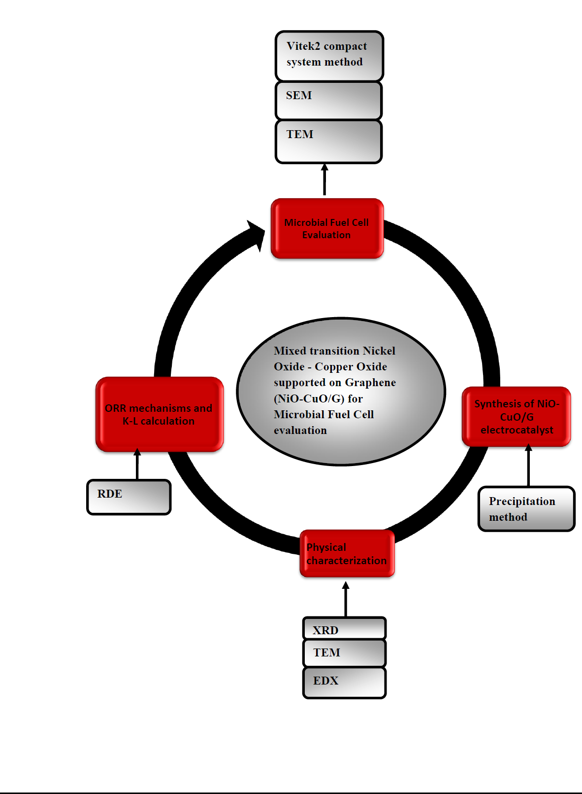
Figure S1. Illustrating the synthesis of NiO-CuO/G electrocatalysts by precipitation of metal salts precursors and its techniques for the ORR in neutral PBS and its application in ACSCMFC.

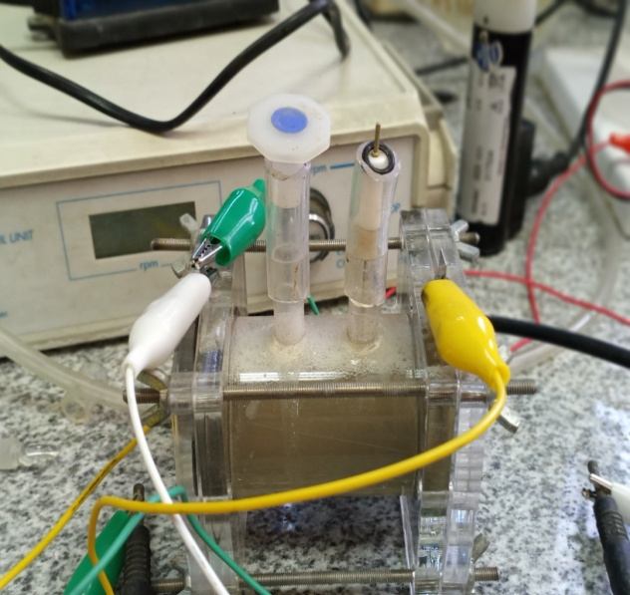
Figure S2 ACSCMFC configuration.

a) | b)
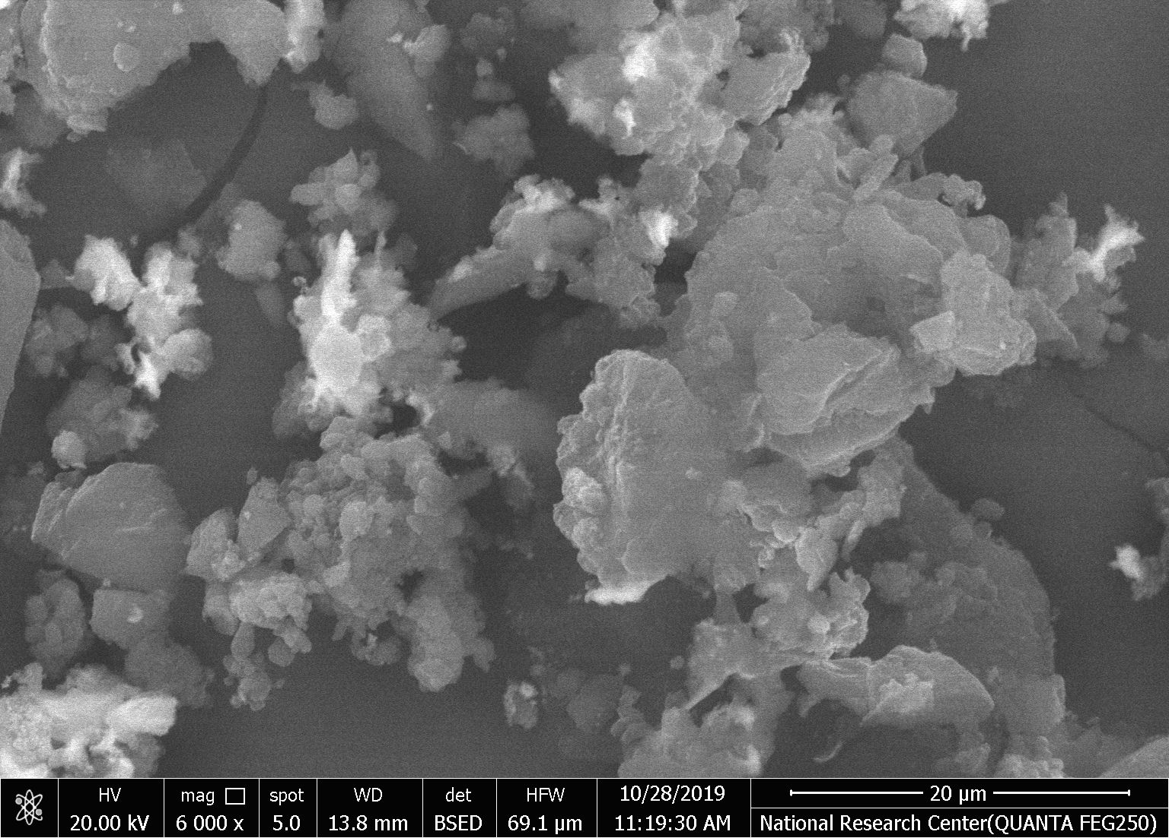 | 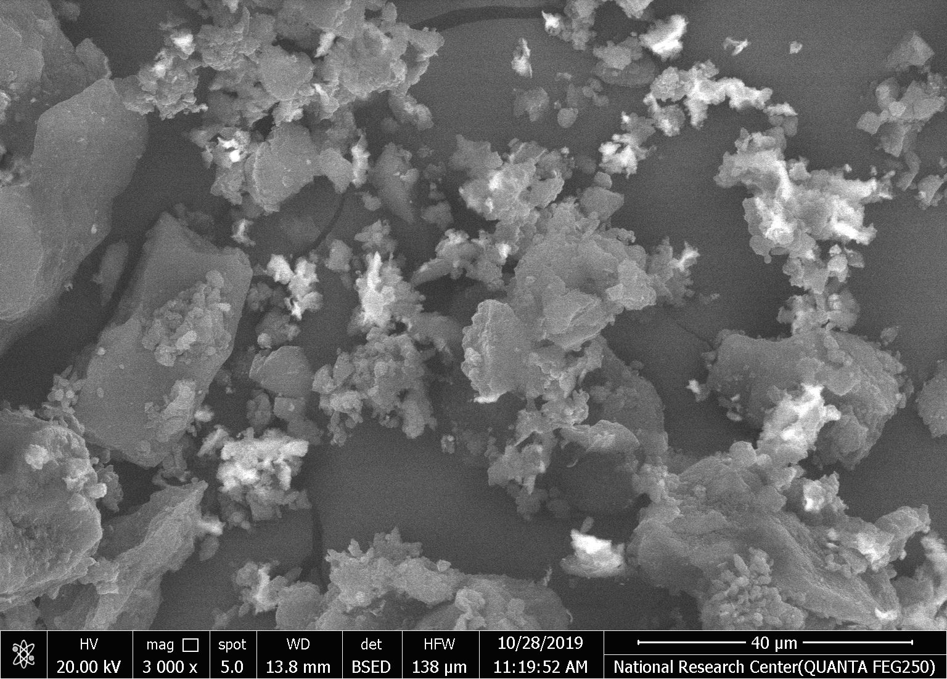

Figure S3 SEM images of 30 wt % NiO-CuO/G composite: (a) high-magnification image and (b) low-magnification image.

a) | b)
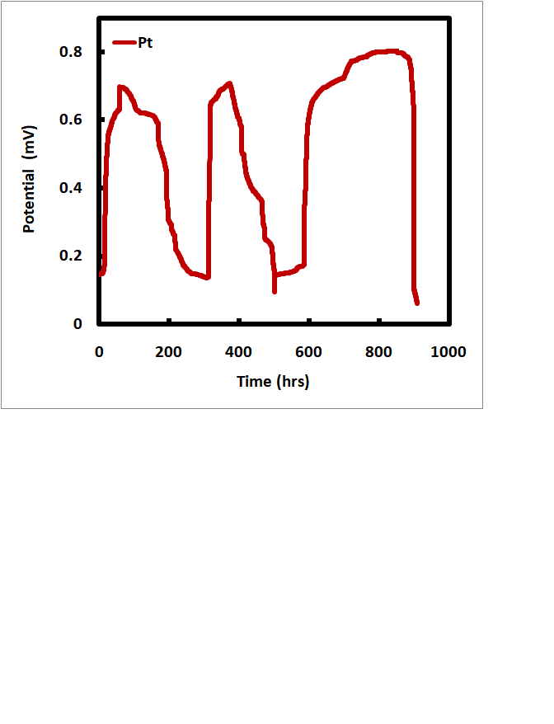 | 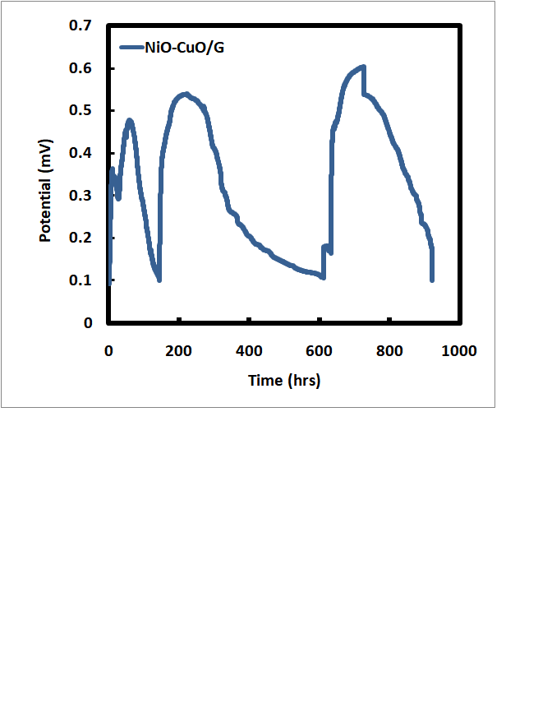

Figure S4 Open circuit potential for a) Pt/C and b) NiO-CuO/G ACSCMFCs over the long-term operation using 2 g/l sodium acetate.

a) | b)  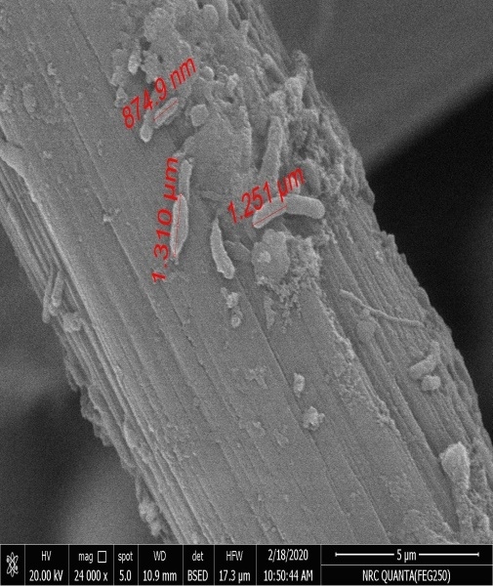
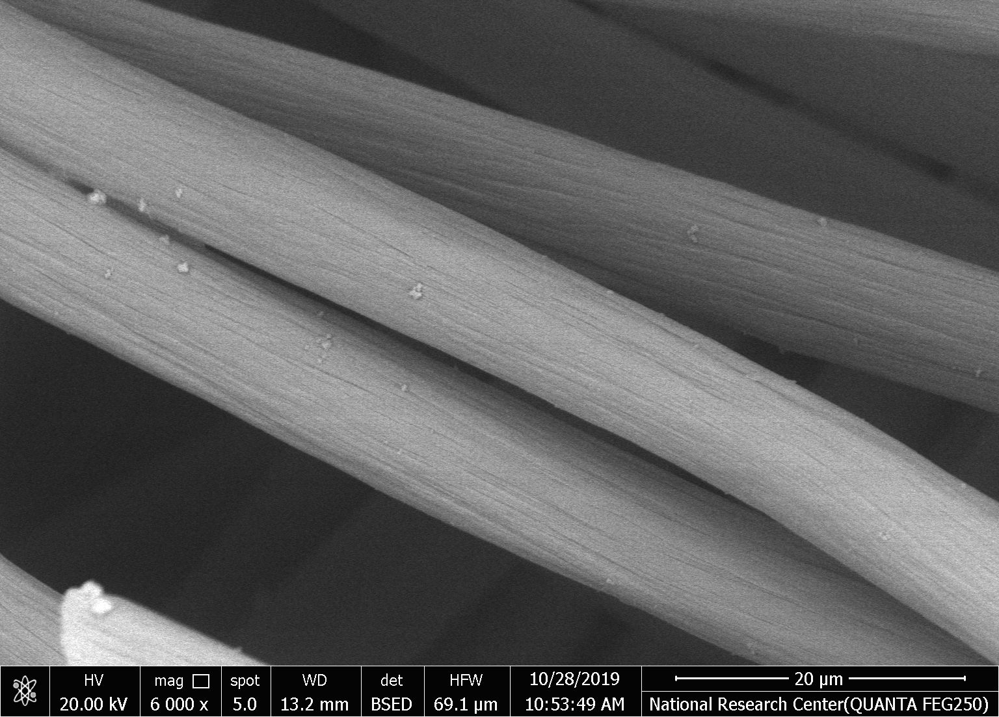

Figure S5 SEM images for bare carbon felt anode before adding microbial community (a) and (b) bacterial growth after 90 days operation at anode electrode surface.

Table S1. Weight and Atomic percentages of elements forming NiO-CuO/G electrocatalyst
Element | Weight% | Atomic%
C K | 77.51 | 84.18
O K | 18.31 | 14.93
NiK | 2 | 0.44
CuK | 2.17 | 0.45

