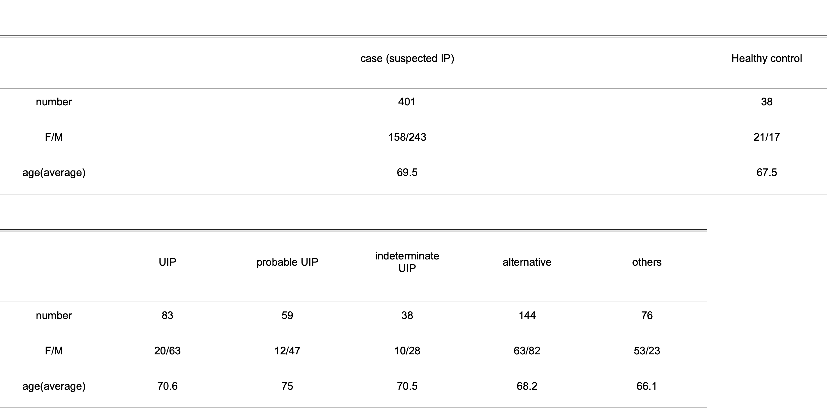
Table I patient basic characteristics

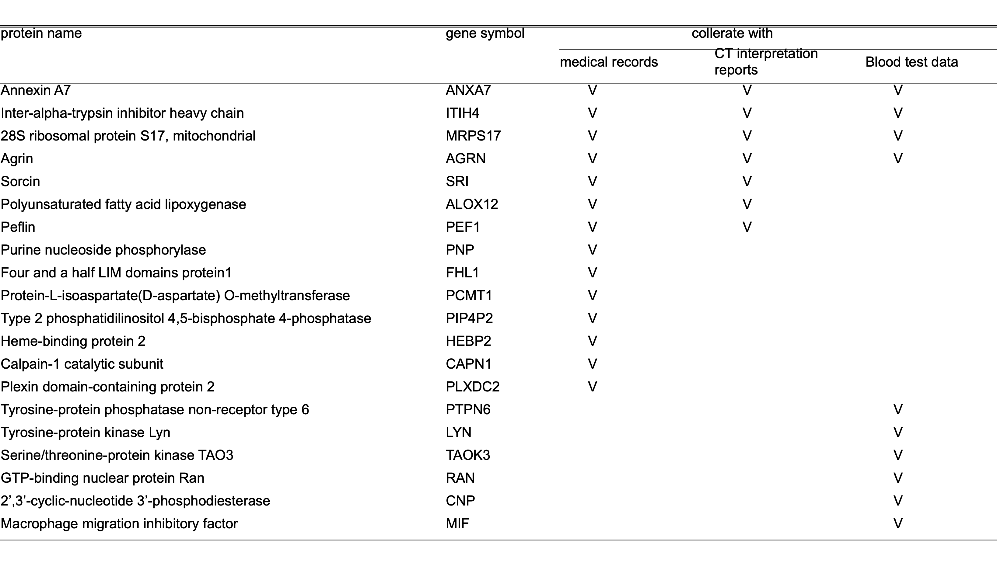
Table II List of proteins co-occurring with medical information with IPF characteristics

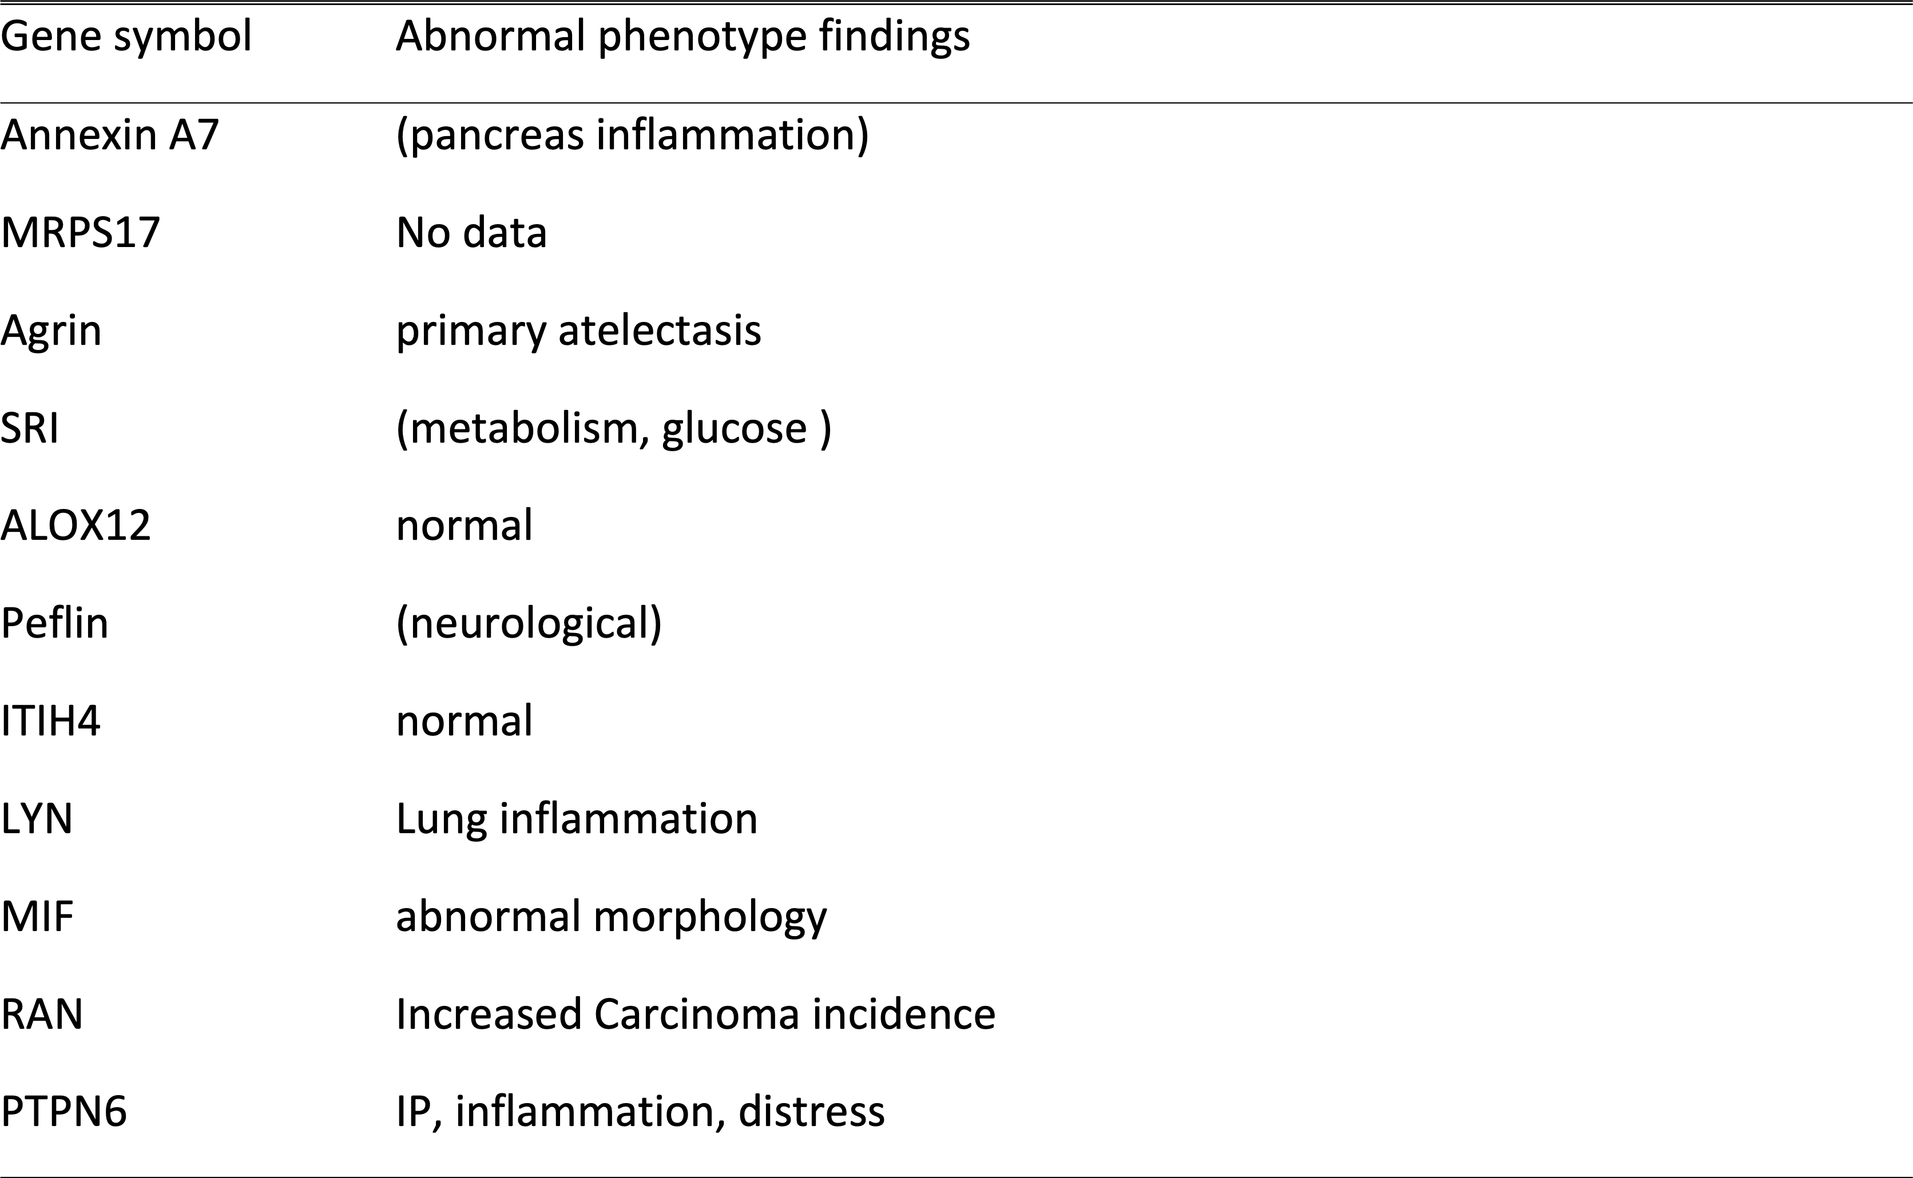
Table III Phenotype list of KO mice for proteins found in subset binding

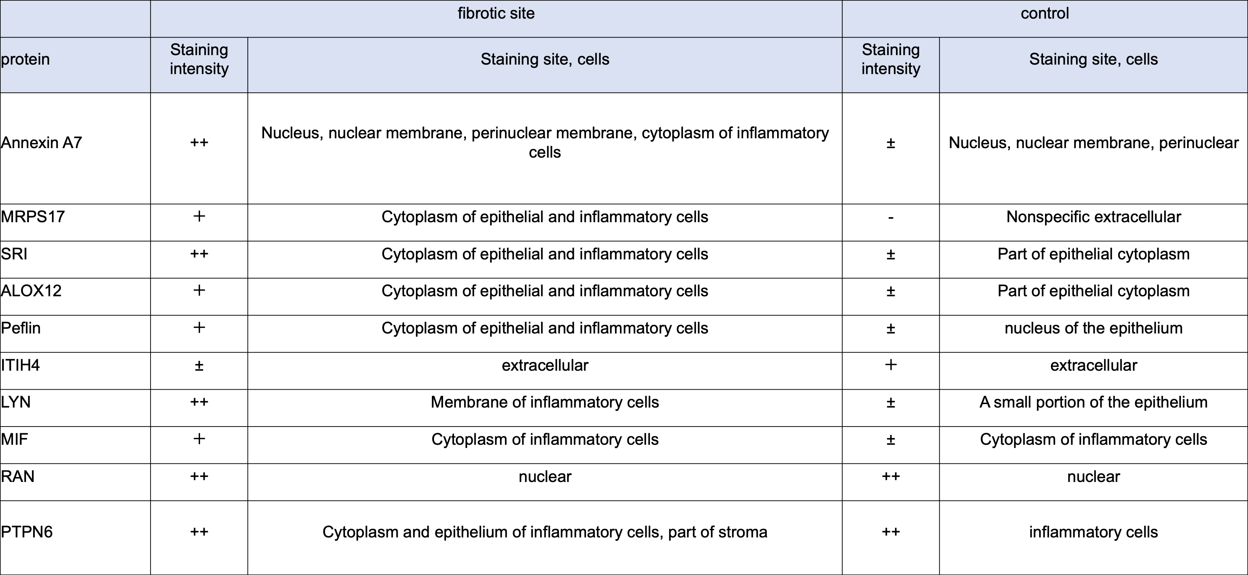
Table IV Summary of the results of immunohistochemical staining.

