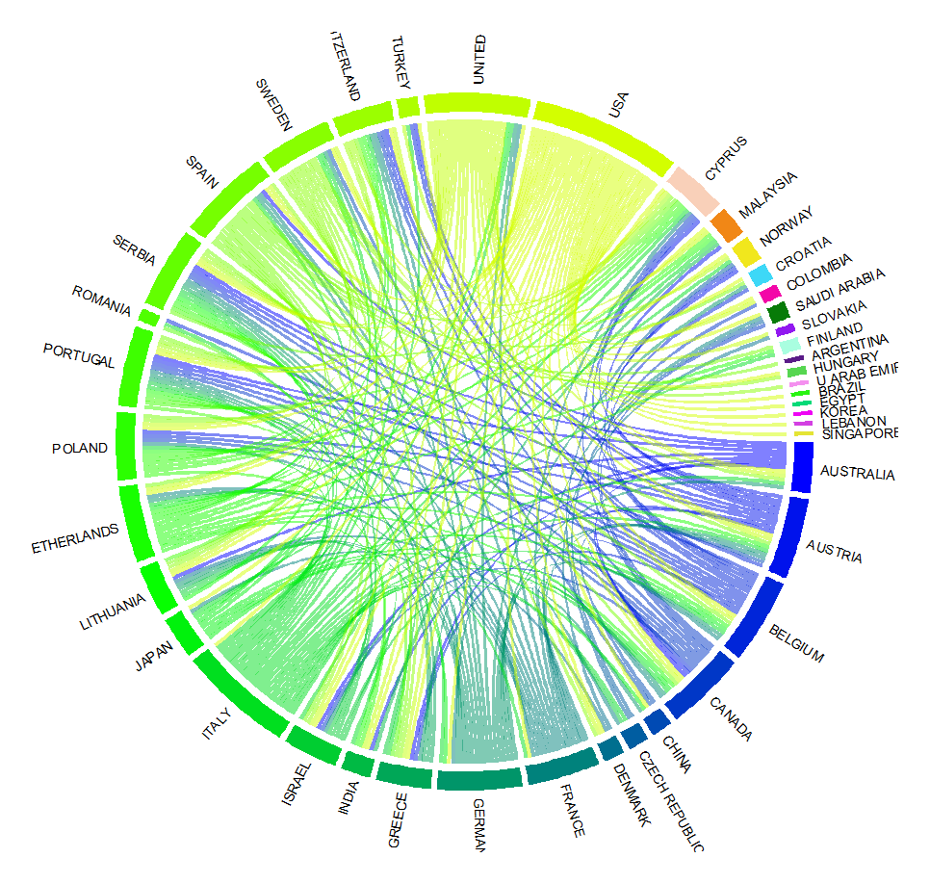
Fig S1. International collaboration analysis based on CA on echocardiography publications
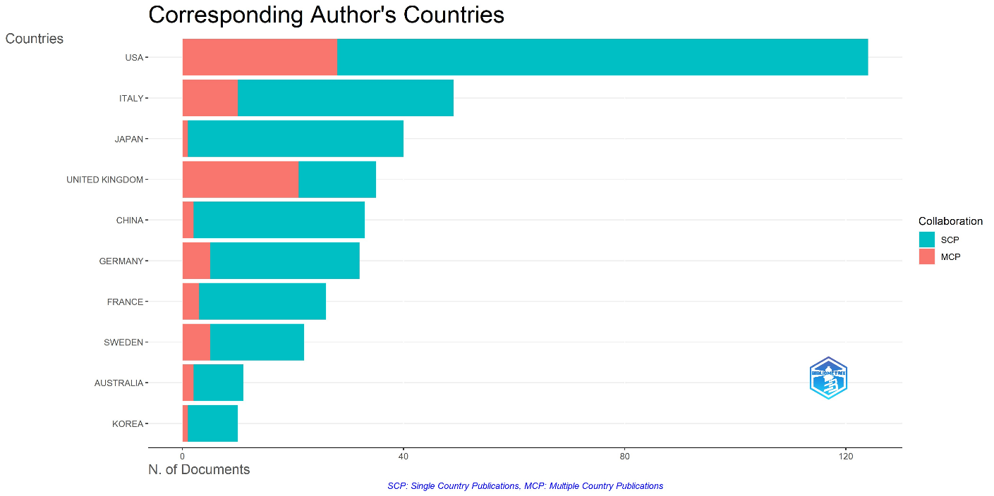
Fig S2. International collaboration analysis based on CA on echocardiography publications

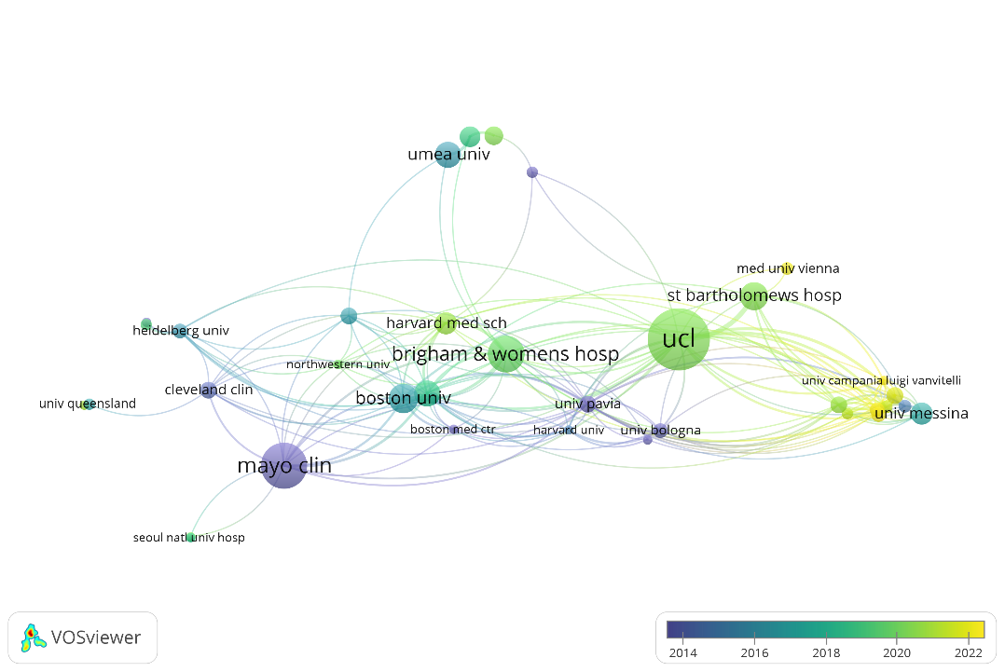

Fig S3. Overlay visualization map of worldwide institutions co-authorship analysis

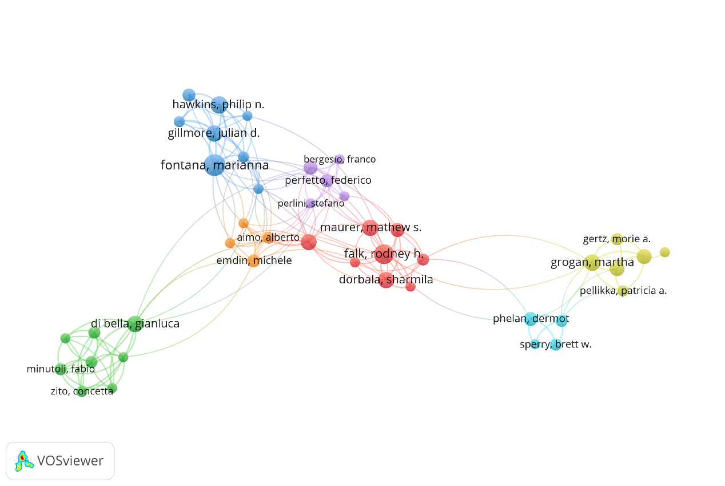
Fig S4. Network visualization map of author co-authorship analysis

