Supplementary Figure 1: Distribution of DMD exon skip amenability by race and ethnicity in 78 DMD patients. Several patients had genotypes that were amenable to skipping more than one exon. NR, not reported.
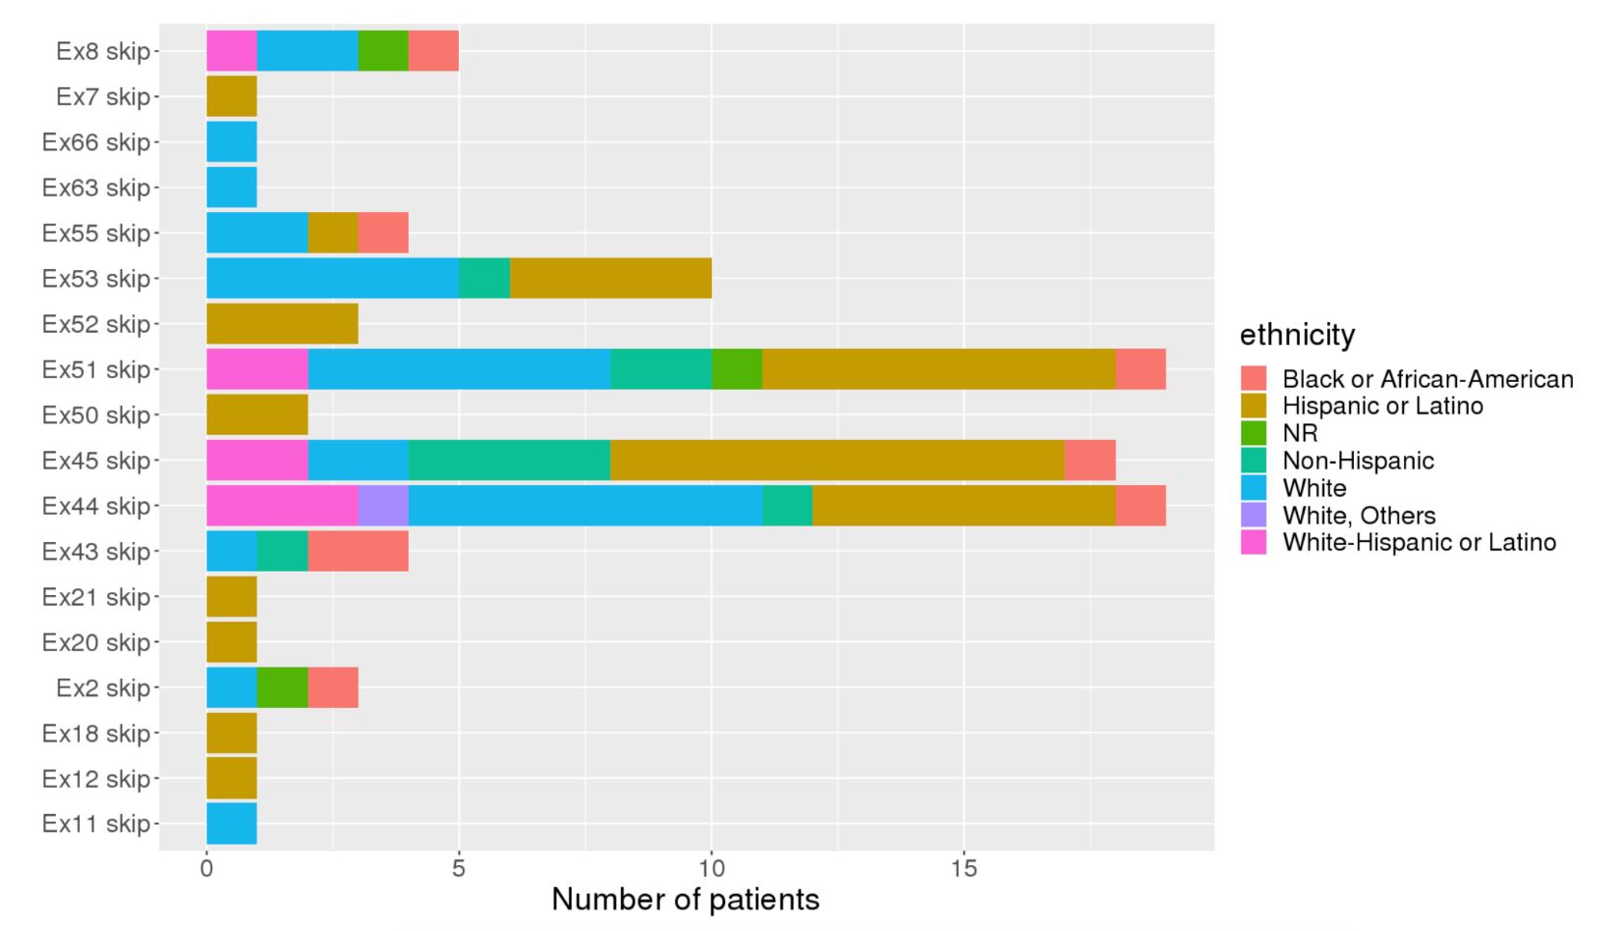
Supplementary Figure 2: Distribution of DMD exon skip amenability by race and ethnicity in 78 DMD patients. Several patients had genotypes that were amenable to skipping more than one exon. NR, not reported.
Race and ethnicity
Race and ethnicity
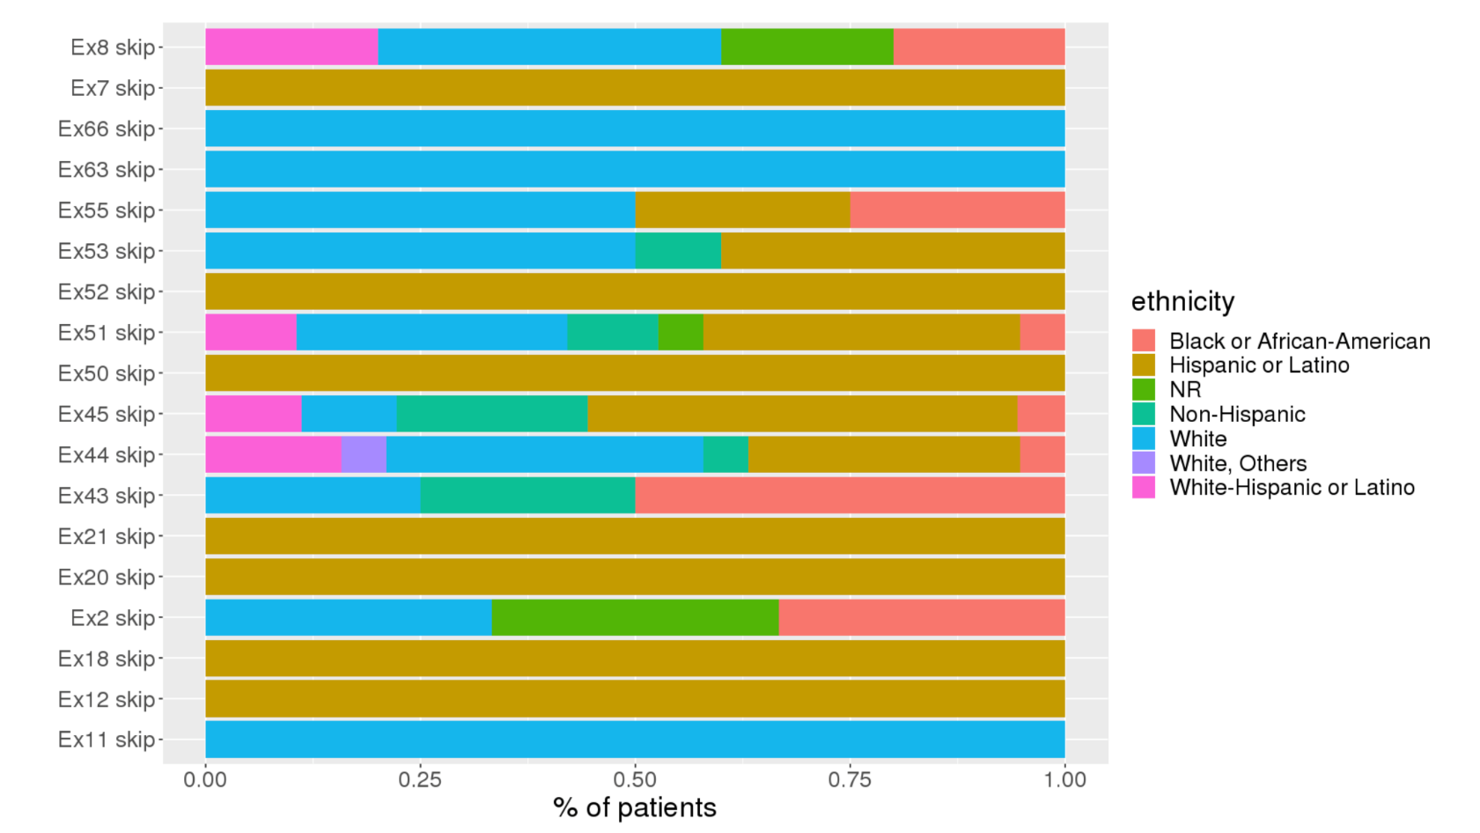
Race and ethnicity

Supplementary Figure 3: Plot of FVC% with time since symptom onset in 111 boys with DMD. Colored lines represent individual patients. The broad black line represents the average value and grey shaded area the standard deviation.
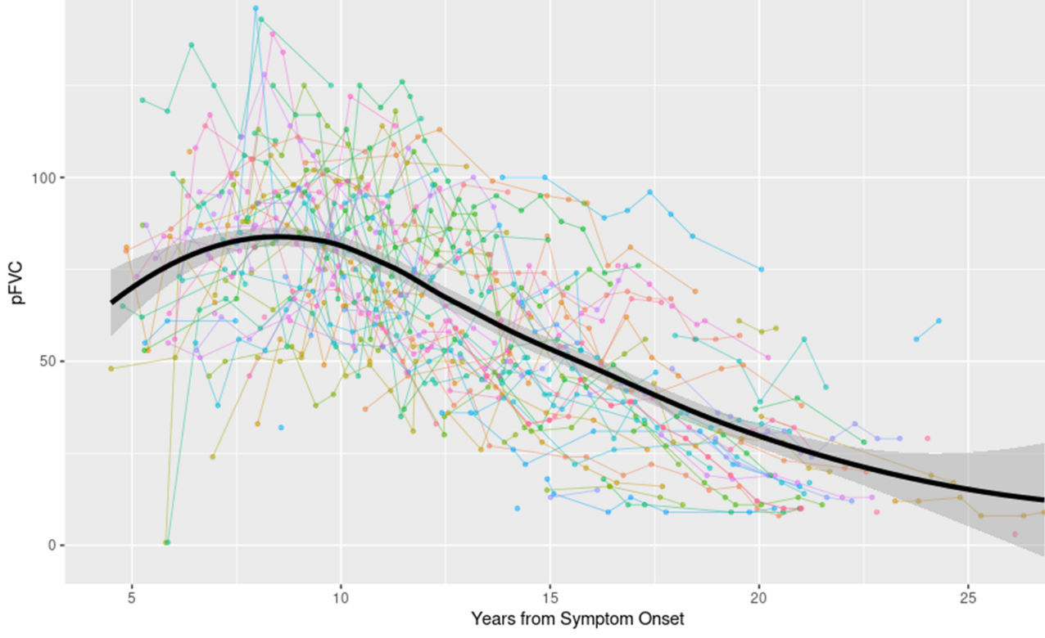
Supplementary Figure 4: Plot of FVC% with time since DMD diagnosis in 111 boys. Colored lines represent individual patients. The broad black line represents the average value and grey shaded area the standard deviation.
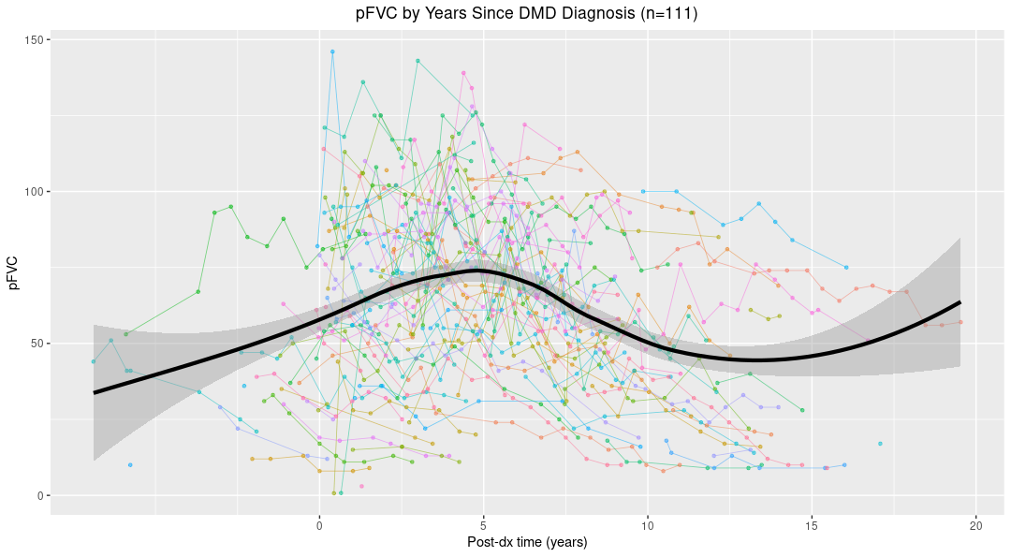

Supplementary Figure 5: Plot of FVC% with time in 111 boys with DMD who received steroid therapy (green, 78 patients, 534 data points) or did not receive steroid therapy (purple, 33 patients, 231 data points). Fine lines represent individual patients. Broad lines represent average values. The upward curve at 17 to 22 years from symptom onset was attributable to two outlier patients (Figure S3).
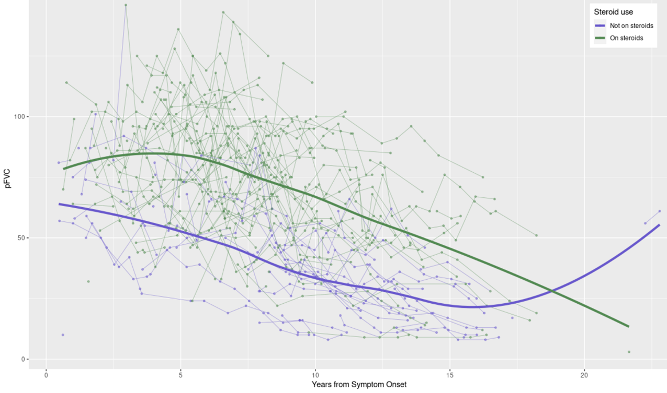
Supplementary Table 1: Differences in disease onset and treatment between Hispanic and non-Hispanic boys with DMD. *Statistically significant (p<.05). SD, standard deviation.
 | Hispanic | Non-Hispanic | p-value
Total number | 54 | 56
Mean age (years) at first symptom (SD) | 4.7 (3.2) | 5.2 (3.7) | 0.517
Median age (years) at first symptom (range) | 4.4 (0-17.5) | 5.0 (0.3-20.5) | 0.649
Ever used steroids (n, %) | 39, 72.2% | 41, 73.2% | 0.907
Mean age (years) at first steroid use | 8.5 | 7.7 | 0.430
Median age (years) at first steroid use | 7.0 | 6.7 | 0.923
Mean age (years) at first RCHHC visit (SD) | 3.9 (3.7) | 5.5 (4.3) | 0.041*
Median age (years) at first RCHHC visit (range) | 2.8 (0-11.2) | 5.42 (0-16.4) | 0.064

Supplementary Figure 6: Plot of FVC% with time in 104 boys with DMD who had (blue) and had not (red) DMD exon skip amenable molecular lesions. Fine lines represent individual patients. Broad lines represent average values.
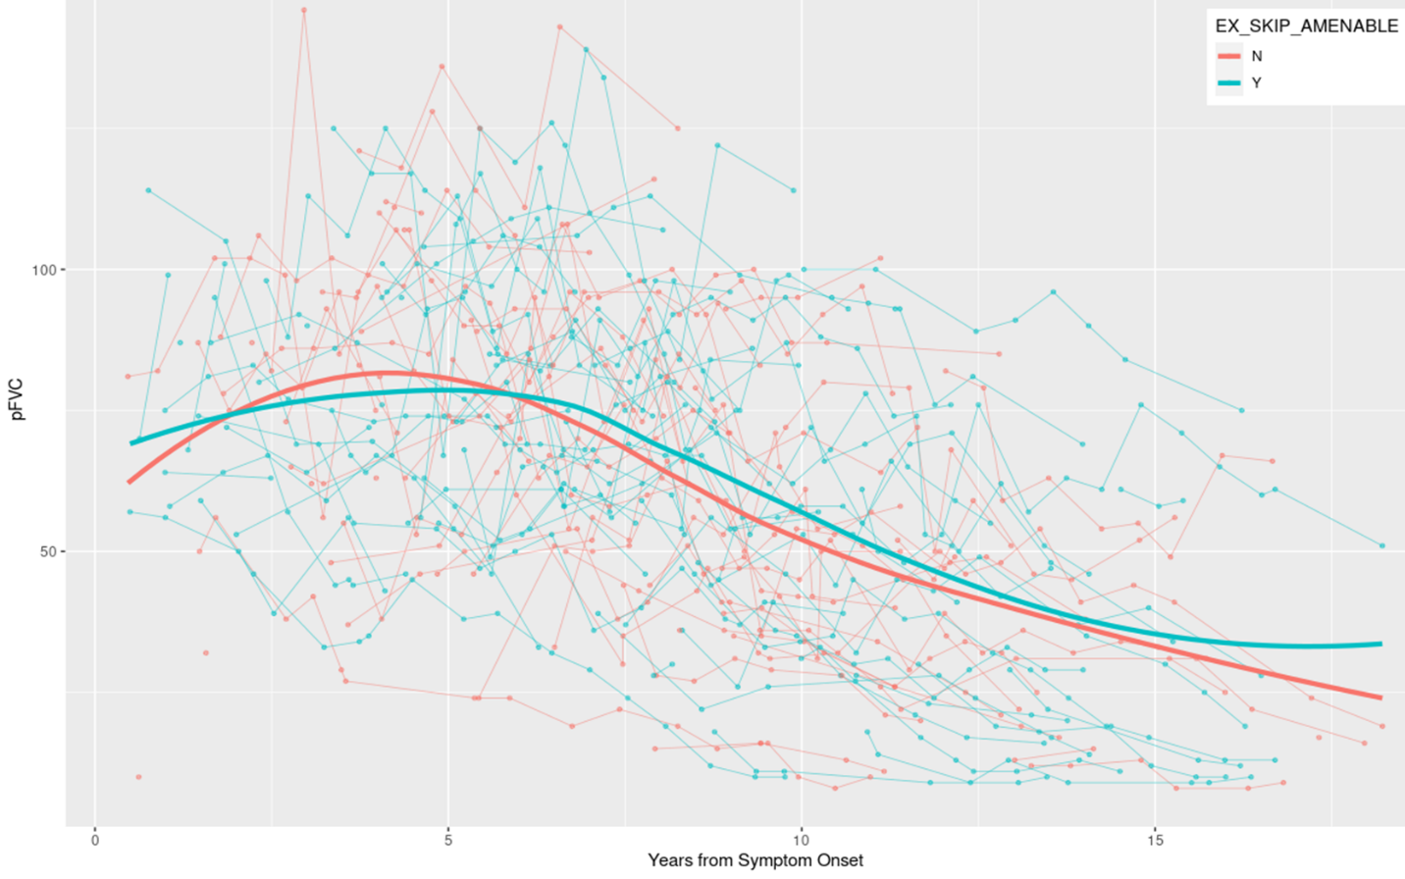

Supplementary Figure 7: Plot of FVC% with time in 19 boys with DMD exon 51 skip amenable lesions (light green), 19 boys with DMD exon 44 skip amenability (dark green), 10 that were exon 53 skip amenable (blue), 1 with DMD exon 18 skip amenability (red), and 43 who were not DMD exon 51, 44, 18, or 53 skip amenable. Fine lines represent individual patients. Broad lines represent average values.
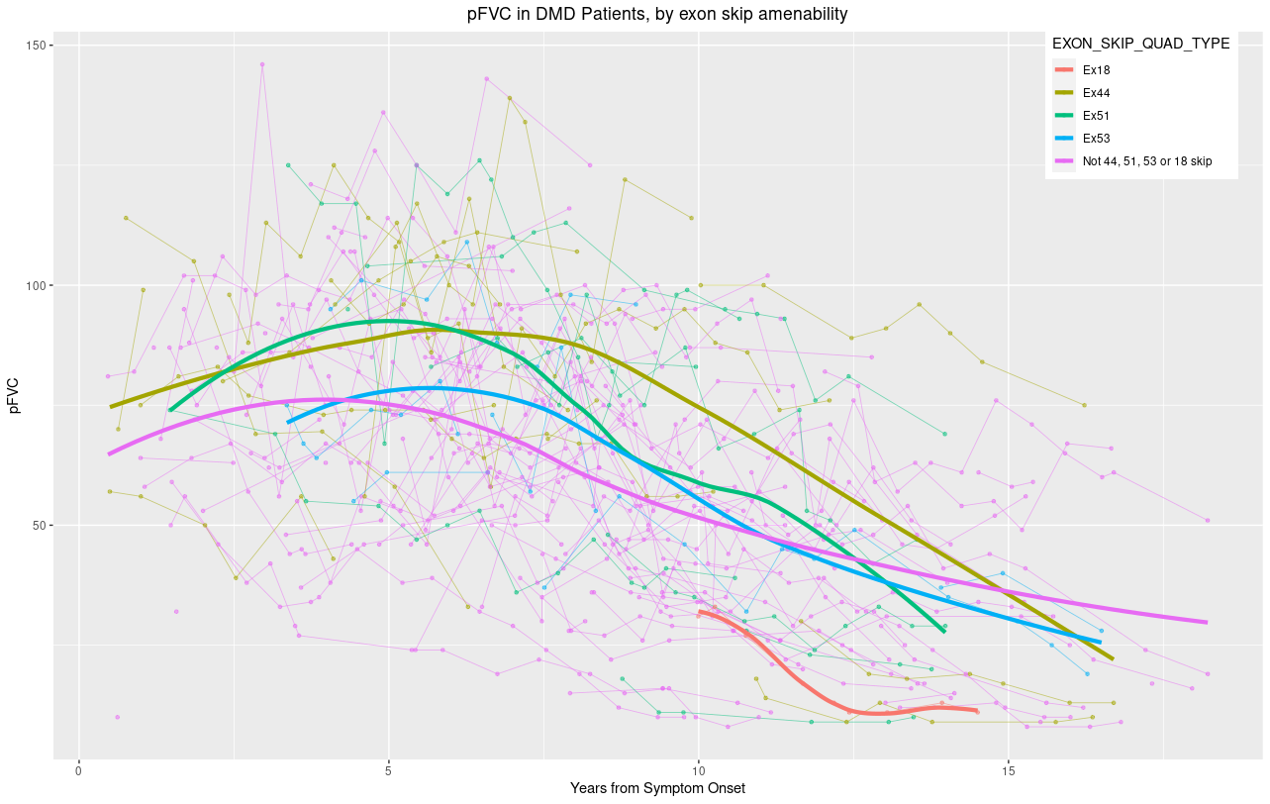

Supplementary Figure 8: Plot of FVC% with time in 104 boys with DMD who did not receive ASO therapy (blue, 712 data points) and 7 boys who did receive ASO therapy (red, 50 data points). Fine lines represent individual patients. Broad lines represent average values.
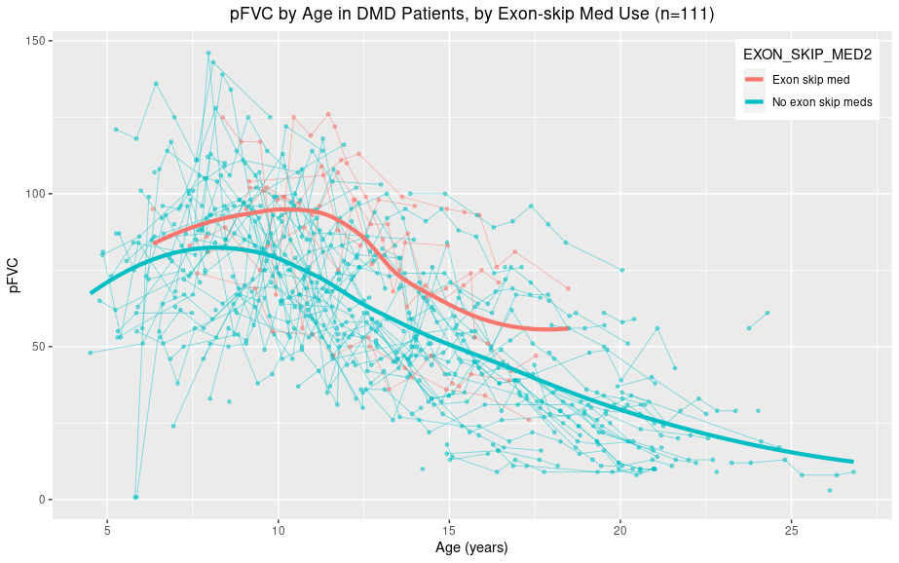
Supplementary Figure 9: Plot of FVC% with time in 104 boys with DMD who did not receive ASO therapy (black, 712 data points) and 7 boys who did receive ASO therapy (red, 50 data points). Fine lines represent individual patients. Broad lines represent average values.
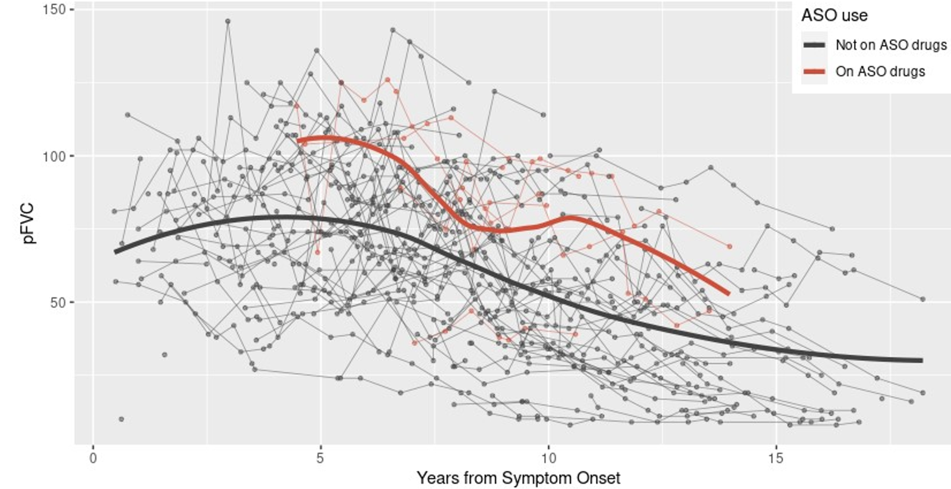

Supplementary Table 2: Associations with FVC% in 113 boys with DMD between 2009 and May 2023.
Characteristic | Number (%) | Unadjusted Odds Ratio (95% CI) | p-value
Sex
Male | 113 (100%)
Ethnicity |  |  | 0.010
Non-Hispanic | 56 (49.6%) | Reference
Hispanic | 57 (50.4%) | -13.59 (-23.88 — -3.28)
Race |  |  | 0.001
White | 49 (43.4%) | Reference.
Non-white | 64 (56.6%) | -16.94 (-27.17 — -6.70)
Age first seen at RCHHC, years |  |  | 0.003
Mean (SD) | 4.5 (4.1) | -1.95 (-3.20 — -0.70)
Median (range) | 4.1 (0-16.4)
Age at molecular diagnosis, years |  |  | <0.001
Mean (SD) | 8.2 (5.8) | -2.90 (-3.67 — -2.12)
Median (range) | 6.5 (0-25.3)
Age at symptom onset, years |  |  | <0.001
Mean (SD) | 4.9 (3.4) | -3.73 (-5.18 — -2.28)
Median (range) | 4.5 (0-20.5)
Exon skip amenable |  |  | 0.969
No | 53 (46.9%) | Reference.
Yes | 60 (53.1%) | -0.21 (-10.86 — 10.45)
Exon 44 skip amenable |  |  | 0.034
No | 99 (87.6%) | Reference.
Yes | 14 (12.4%) | 17.07 (1.39 — 32.77)
Age at steroid start |  |  | <0.001
Never started | 29 (25.7%) | Reference.
<10 years | 67 (59.3%) | 43.20 (34.13 — 52.29)
>=10 years | 17 (15.0%) | 8.58 (-4.03 — 21.14)
Used ASO drug |  |  | 0.028
No | 103 (91.2%) | Reference.
Yes | 10 (8.8%) | 20.50 (2.33 — 38.71)
Years from symptom onset |  |  | <0.001
Mean (SD) | 5.8 (4.0) | -2.59 (-2.91 — -2.27)
Median (range) | 4.7 (0.5-21.6)

Supplementary Figure 10: Plot of LVEF with time since symptom onset in 113 boys with DMD. Colored lines represent individual patients. The broad black line represents the average value and grey shaded area the standard deviation. Average values above 20 years since symptom onset should be disregarded since they reflect only two patients and two data points.
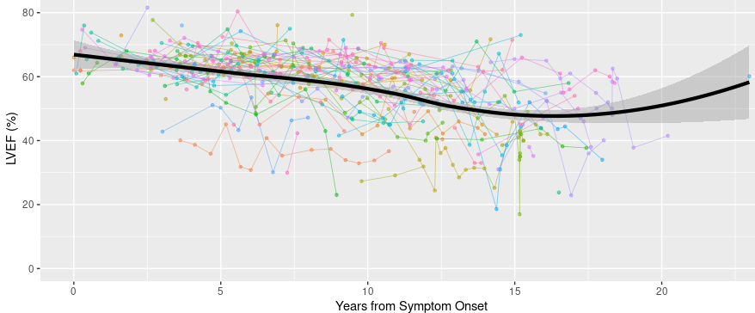
Supplementary Figure 11: Plot of LVEF with time since symptom onset in 56 Hispanic (red) and 56 non-Hispanic (blue) boys with DMD. Fine lines represent individual patients. Broad lines represent average values. Average values above 20 years since symptom onset should be disregarded since they reflect only two patients and two data points.
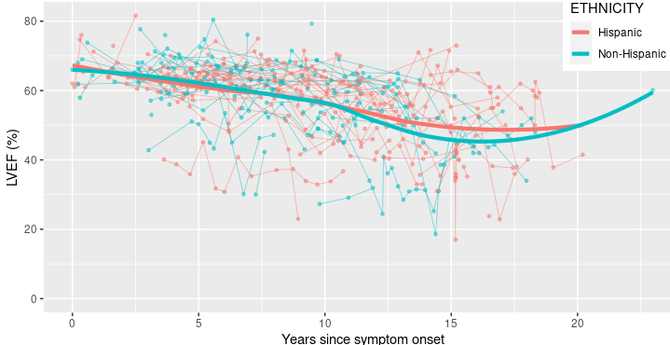

Supplementary Figure 12: Plot of LVEF with time from symptom onset in 113 boys with DMD who did not receive ASO therapy (black) and 7 boys who did receive ASO therapy (red). Fine lines represent individual patients. Broad lines represent average values. Average values above 20 years since symptom onset should be disregarded since they reflect only two patients and two data points.
