Efficacy and safety of antithrombotic therapy with non-vitamin K antagonist oral anticoagulants after transcatheter aortic valve replacement: a systematic review and meta-analysis

SUPPLEMENTAL MATERIAL （Cardiovascular Drugs and Therapy）

Qing An¹, Shuwen Su^{1,2,3}, Yan Tu¹, Lingfeng Gao^{1,2,3}, Gaopeng Xian^{1,2,3}, Yujia Bai^{1,2,3}, Qiong Zhan^{1,2,3}, Xingbo Xu⁴, Dingli Xu^{1,2,3*}, Qingchun Zeng^{1,2,3*}
1. State Key Laboratory of Organ Failure Research, Department of Cardiology, Nanfang Hospital, First Clinical Medical College, Southern Medical University, 510515, Guangzhou, China
2. Guangdong Provincial Key Laboratory of Shock and Microcirculation, Southern Medical University, 510515, Guangzhou, China
3. Bioland Laboratory (Guangzhou Regenerative Medicine and Health Guangdong Laboratory), 510005, Guangzhou, China
4. Department of Cardiology and Pneumology, University Medical Center of Göttingen, Georg-August-University, Göttingen, Germany
* Correspondence:
Qingchun Zeng, M.D., Ph.D., Dingli Xu, M.D.,
Department of Cardiology, Nanfang Hospital, Southern Medical University, 1838 Northern Guangzhou Ave, Guangzhou, 510515, China.
Fax: +86-020-61360416. Tel.: +86-020-61641493.
E-mail: qingchunzeng@smu.edu.cn; dinglixu@fimmu.com.

Supplementary Table 1. CHA₂DS₂VASc scoring system[1].
The variables | Points awarded
Congestive heart failure | 1
Hypertension | 1
Age ≥ 75 years | 2
Diabetes mellitus  (both type1 and type 2) | 1
Stroke/transient ischaemic attack (TIA) or thromboembolism | 2
Vascular disease | 1
Age 65-74 years | 1
Sex (female) | 1

Supplementary Table 2. Search strategies (Take the search strategies of PubMed for example).
Search | Details of the query
#1 | “Transcatheter Aortic Valve Replacement” [Mesh]
#2 | ((transapical[All Fields] OR transventricular[All Fields] OR percutaneous[All Fields] OR transcatheter*[All Fields]) AND (valve*[All Fields] OR prosthe*[All Fields] OR bioprosthe*[All Fields]))
#3 | (TAVI[All Fields] OR PAVR[All Fields] OR TAVR[All Fields])
#4 | #1 OR #2 OR #3
#5 | "Factor Xa Inhibitors"[Mesh]
#6 | ((factor Xa[All Fields] OR factor 10a[All Fields] OR factor 10[All Fields] OR factor X[All Fields] OR fXa[All Fields] OR autoprothrombin c[All Fields] OR thrombokinase[All Fields] OR FX[All Fields] OR FXa[All Fields]) AND (antag*[All Fields] OR inhib*[All Fields] OR block*[All Fields]))
#7 | xabans[All Fields]
#8 | (rivaroxaban[All Fields] OR Xarelto[All Fields] OR Bay‐597939[All Fields] OR Bay597939[All Fields])
#9 | (betrixaban[All Fields] OR PRT‐054021[All Fields] OR PRT054021[All Fields])
#10 | (apixaban[All Fields] OR BMS‐562247[All Fields] OR BMS562247[All Fields] OR ELIQUIS[All Fields])
#11 | (edoxaban[All Fields] OR lixiana[All Fields] OR DU‐176b[All Fields] OR DU176*[All Fields])
#12 | (darexaban[All Fields] OR YM150[All Fields] OR YM‐150[All Fields] OR LY517717[All Fields] OR LY‐517717[All Fields])
#13 | (antistasin[All Fields] OR eribaxaban[All Fields] OR fondaparin*[All Fields] OR idraparinux[All Fields] OR razaxaban[All Fields] OR yagin[All Fields] OR SSR126517E[All Fields] OR Arixtra[All Fields] OR Otamixaban[All Fields] OR vaso flux*[All Fields] OR Dx 9065*[All Fields] OR GW813893[All Fields] OR "Tak 442"[All Fields] OR TAK442[All Fields] OR PD0348292[All Fields])
#14 | #5 OR #6 OR #7 OR #8 OR #9 OR #10 OR #11 OR #12 OR #13
#15 | (Antithrombins[Mesh] OR “Hirudin Therapy” [Mesh] OR Hirudins[Mesh])
#16 | ((thrombin[All Fields] AND inhib*[All Fields]) OR DTI[All Fields])
#17 | ((dabigatran*[All Fields] OR Pradaxa[All Fields] OR Rendix[All Fields]) OR (BIBR‐953*[All Fields] OR BIBR953*[All Fields] OR BIBR‐1048[All Fields] OR BIBR1048[All Fields])）
#18 | ((ximelagatran*[All Fields] OR Exanta[All Fields] OR melagatran*[All Fields]) OR (AZD0837[All Fields] OR AZD‐0837[All Fields]) OR S35972[All Fields])
#19 | (argatroban[All Fields] OR MD805[All Fields] OR MD‐805[All Fields] OR efegatran[All Fields] OR flovagatran[All Fields] OR inogatran[All Fields] OR napsagatran[All Fields] OR bivalirud*[All Fields] OR lepirudin[All Fields] OR desirudin[All Fields] OR desulfatohirudin[All Fields] OR hirudin*[All Fields] OR hirugen[All Fields] OR hirulog[All Fields] OR bothrojaracin[All Fields] OR odiparcil[All Fields])
#20 | #15 OR #16 OR #17 OR #18 OR #19
#21 | ((novel[All Fields] OR new[All Fields]) AND anticoagulant*[All Fields])
#22 | ((non‐vitamin K[All Fields] OR direct[All Fields]) AND anticoagulant*[All Fields])
#23 | (NOAC*[All Fields] OR DOAC*[All Fields])
#24 | #21 OR #22 OR #23
#25 | #14 OR #20 OR #24
#26 | #4 AND #25

Supplementary Table 3. HAS-BLED scoring system[2].
The variables | Points awarded
Hypertension | 1
Abnormal renal/liver function (1 point each) | 1 or 2
Stroke | 1
Bleeding history or predisposition | 1
Labile international normalized ratio (INR) | 1
Elderly (＞65 years or extreme frailty) | 1
Drugs or alcohol (1 point each) | 1 or 2

Supplementary Table 4. Quality evaluation of one CCT.

study | A clearly stated aim | Inclusion of consecutive patients | Prospective collection of data | Endpoints appropriate to the aim of the study | Unbiased assessment of the study endpoint | Follow‐up period appropriate to the aim of the study | Loss to follow up less than 5% | Prospective calculation of the study size | An adequate control group | Contemporary groups | Baseline equivalence of groups | Adequate statistical analyses | Total Score
Seeger  2017 | 2 | 2 | 2 | 2 | 0 | 2 | 2 | 1 | 1 | 1 | 2 | 2 | 19

Supplementary Table 5. Quality evaluation of nine observational studies (cohort studies).

Study | Selection（score） |  |  |  | Comparability（score） |  | Outcome（score） |  |  | Total Score
Study | representativeness of the exposed cohort | Selection of the non-exposed cohort | Ascertainment of exposure | Demonstration that outcome of interest was not present at start of study | select the most important factor | any additional factor | Assessment of outcome | Follow-up period | Adequacy of follow up of cohorts | Total Score
Geis,2018 | 1 | 1 | 1 | 1 | 1 | 1 | 1 | 1 | 1 | 9
Mangner,2019 | 1 | 1 | 1 | 1 | 1 | 0 | 1 | 1 | 0 | 7
Butt,2019 | 1 | 1 | 1 | 1 | 1 | 1 | 1 | 1 | 0 | 8
Jochheim,2019 | 1 | 1 | 1 | 1 | 1 | 0 | 1 | 1 | 0 | 7
Kosmidou,2019 | 1 | 1 | 1 | 1 | 1 | 1 | 1 | 1 | 1 | 9
Tang,2019 | 1 | 1 | 1 | 1 | 0 | 0 | 0 | 1 | 1 | 6
Yanagisawa,2019 | 1 | 1 | 1 | 1 | 0 | 0 | 1 | 0 | 1 | 6
Kalogeras,2020 | 1 | 1 | 1 | 1 | 1 | 1 | 1 | 1 | 0 | 8
Kawashima,2020 | 1 | 1 | 1 | 1 | 1 | 0 | 0 | 1 | 1 | 7

Supplementary Table 6. Characteristics of patients.
Variable | Butt,2019 |  | Dangas,2020 |  | De Backer O,2020 |  | Geis,2018 |  | Jochheim,2019 |  | Kalogeras,2020 |  | Kawashima,2020 |  | Kosmidou,2019 |  | Mangner,2019 |  | Seeger,2017 |  | Tang,2019 |  |  | Yanagisawa,2019
Established indications for OAC | yes |  | no |  | no |  | yes |  | yes |  | yes |  | yes |  | yes |  | yes |  | yes |  | N/A |  |  | N/A
Group | NOACs | VKAs | rivaroxaban | aspirin | rivaroxaban | aspirin | NOACs | VKAs | NOACs | VKAs | NOACs | VKAs | NOACs | VKAs | NOACs | VKAs | NOACs | VKAs | apixaban | VKAs | NOACs | VKAs | APT | NOACs | VKAs | APT
Sample size | 219 | 516 | 826 | 818 | 115 | 116 | 154 | 172 | 326 | 636 | 115 | 102 | 227 | 176 | 933 | 933 | 182 | 117 | 141 | 131 | 287 |  |  | 485
Age (year） | 83 (78–85) | 82 (77–85) | 80.4±7.1 | 80.8±6.0 | 79.7±7.3 | 80.5±6.2 | 83.1 ± 5.3 | 83.0 ± 4.9 | 81.6 ± 6.7 | 81.1 ± 6.1 | 81.9 ± 6.3 | 82.5 ± 5.8 | 84.4 ± 4.7 | 84.3 ± 4.9 | 82.8 ± 6.7 | 82.8 ± 6.7 | 80 (77; 84) | 80 (77; 83) | 82.1±5.3 | 80.5±6.3 | 81.1 ± 8.1 |  |  | 85
Female (%) | 46.1 | 46.3 | 48.4 | 50.5 | 35.7 | 36.2 | 51 | 55 | 52.1 | 52.7 | 40.9 | 42.2 | 69.6 | 63.1 | 34.4 | 34.4 | 51.1 | 52.1 | 50.4 | 48.1 | 47.4 |  |  | 69.7
BMI | N/A | N/A | 28.1±5.5 | 28.2±5.7 | 27.7±6.5 | 27.8±5.1 | 26.6 ± 5.3 | 27.0 ± 5.3 | 26.3 ± 5.2 | 26.6 ± 4.9 | 27.3 ± 5.8 | 25.9 ± 5.8 | 22.6 ± 3.8 | 21.7 ± 3.7 | 28.4 ± 6.1 | 28.4 ± 6.1 | 27.7 (24.5; 31.6) | 27.8 (24.2; 31.2) | 27.2±4.2 | 27.4±5.1 | 29.9 ± 7.8 |  |  | 1.4
Hypertension (%) | 87.2 | 88.6 | 87.2 | 85.2 | 85.2 | 81.9 | 95 | 92 | 89.9 | 89.5 | N/A | N/A | 75.8 | 76.7 | 91.7 | 91.7 | 96.2 | 99.1 | N/A | N/A | 83.3 |  |  | N/A
Diabetes Mellitus (%) | 17.8 | 24.2 | 28.6 | 28.7 | 18.3 | 23.3 | 31 | 33 | 28.8 | 34.1 | 24.3 | 26.8 | 24.2 | 24.4 | 35.3 | 35.3 | 42.3 | 42.2 | 32.6 | 32.1 | 31.4 |  |  | 26.8
EuroSCORE II | N/A | N/A | 4.1±3.9 | 4.1±3.7 | N/A | N/A | 20.4±11.4 | 20.5 ± 11.9 | N/A | N/A | 15 ± 10 | 23.9 ± 13.2 | N/A | N/A | N/A | N/A | N/A | N/A | 18.9±14.5 | 14.6±13.9 | N/A |  |  | N/A
STS risk score | N/A | N/A | 4.0±3.2 | 4.3±3.5 | 2.8±1.5 | 3.0±2.1 | 4.1 ± 1.9 | 4.4 ± 2.4 | 4.5 (3.0–7.4) | 4.5 (3.0–7.3) | N/A | N/A | 7.7 ± 5.1 | 9.5 ± 9.5 | 8.2 ± 4.2 | 8.2 ± 4.2 | 5.9 (3.6; 9.5) | 6.7 (4.4; 10.8) | 7.5±5.2 | 7.9±6.3 | 4.4 ± 2.6 |  |  | N/A
Congestive heart failure (%) | 47.5 | 47.3 | 47.7 | 46.5 | 45.2 | 44.8 | N/A | N/A | N/A | N/A | N/A | N/A | N/A | N/A | 89.6 | 89.6 | N/A | N/A | N/A | N/A | N/A |  |  | N/A
NYHA class III or IV (%) | N/A | N/A | 30.3 | 27.1 | N/A | N/A | N/A | N/A | 85.6 | 74.5 | 78.3 | 85.3 | 51.5 | 63.6 | N/A | N/A | 72.2 | 78.2 | N/A | N/A | 79.4 |  |  | N/A
Coronary artery disease (%) | 54.3 | 54.5 | 39.3 | 37.3 | 36.5 | 31.0 | 52 | 51 | 56.9 | 55.4 | N/A | N/A | 26.0 | 35.2 | 76.3 | 76.3 | 39.2 | 47.0 | 66.0 | 58.8 | 53.7 |  |  | N/A
Previous stroke or intracerebral bleeding (%) | 34.7 | 25.2 | 6.2 | 4.3 | 9.6 | 5.2 | 16 | 15 | N/A | N/A | N/A | N/A | 10.6 | 19.3 | 22.0 | 22.0 | 14.3 | 18.8 | 11.3 | 14.5 | 14.6 |  |  | 8.5
Peripheral or cerebral vascular disease (%) | 10.1 | 8.9 | 10.0 | 10.0 | 8.7 | 8.6 | N/A | N/A | 22.4 | 28.0 | N/A | N/A | 15.0 | 18.8 | 52.2 | 52.2 | 14.3 | 12.8 | 82.9 | 88.5 | 18.1 |  |  | N/A
Previous venous thromboembolism or arterial thromboembolism (%) | 33.8 | 24.2 | 2.2 | 1.8 | 0.9 | 0.9 | N/A | N/A | N/A | N/A | 31.3 | 40.2 | N/A | N/A | N/A | N/A | 6.6 | 12.8 | N/A | N/A | 2.1 |  |  | N/A
Permanent pacemaker (%) | N/A | N/A | 9.7 | 9.8 | 12.2 | 12.1 | N/A | N/A | N/A | N/A | 32.3 | 45.1 | 8.4 | 10.2 | N/A | N/A | N/A | N/A | 16.3 | 13.7 | 11.1 |  |  | N/A
COPD (%) | 21.0 | 16.9 | 13.3 | 10.8 | 16.5 | 13.8 | N/A | N/A | 20.6 | 21.9 | N/A | N/A | 13.2 | 19.3 | 45.9 | 45.9 | 14.3 | 17.9 | N/A | N/A | 11.8 |  |  | N/A
Chronic renal failure (%) | 5.9 | 14.2 | N/A | N/A | N/A | N/A | N/A | N/A | 53.3 | 44.3 | 0.9 | 0.0 | 74.4 | 77.8 | 8.9 | 8.9 | 27.6 | 38.8 | 44.7 | 48.9 | N/A |  |  | 61.4
GFR (ml/min/1.73 m²) | N/A | N/A | 73.4±23.8 | 73.2±23.2 | 73.6±19.2 | 76.6±19.4 | 50.3 ± 18.7 | 47.9 ± 20.6 | N/A | N/A | N/A | N/A | N/A | N/A | N/A | N/A | 56 (43; 71) | 52 (37; 72) | N/A | N/A | 63.4 ± 18.8 |  |  | N/A
Aortic valve area (cm²) | N/A | N/A | 1.8±0.6 | 1.9±0.5 | 1.8±0.5 | 1.8±0.5 | 0.7 ± 0.2 | 0.7 ± 0.2 | 0.7 ± 0.2 | 0.7 ± 0.2 | 0.68 ± 0.30 | 0.67 ± 0.29 | N/A | N/A | N/A | N/A | 0.7 (0.6; 0.9) | 0.7 (0.6; 0.8) | N/A | N/A | N/A |  |  | N/A
Mean aortic valve gradient (mm Hg) | N/A | N/A | 10.0±4.7 | 10.1±4.6 | 11±5 | 11±4 | 34.1 ± 13.0 | 36.1 ± 14.4 | N/A | N/A | 41.3 ± 17.7 | 42.4 ± 16.8 | N/A | N/A | N/A | N/A | 38 (29; 48) | 36 (27; 43) | N/A | N/A | N/A |  |  | N/A
LVEF (%) | N/A | N/A | 57.4±10.9 | 58.2±11.2 | 55±11 | 56±10 | 50.6 ± 11.4 | 49.0 ± 13.6 | N/A | N/A | N/A | N/A | 57.4 ± 12.5 | 56.8 ± 14.4 | 52.8 ± 13.8 | 52.8 ± 13.8 | 55 (43; 64) | 56 (44; 64) | N/A | N/A | N/A |  |  | N/A
HAS-BLED score ª | 3.4±0.9 | 3.3±1.0 | N/A | N/A | N/A | N/A | 2.7 ± 0.8 | 2.9 ± 0.8 | N/A | N/A | N/A | N/A | 2.6 ± 0.8 | 2.9 ± 0.9 | N/A | N/A | 3 (3; 4) | 3 (3; 4) | 3.2±1.1 | 3.1±1.1 | N/A |  |  | N/A
CHA2DS2-VASc Score ^{b} | 5.0±1.4 | 4.9±1.3 | N/A | N/A | N/A | N/A | 4.6 ± 1.2 | 4.8 ± 1.3 | N/A | N/A | N/A | N/A | 5.1 ± 1.0 | 5.2 ± 1.1 | 5.6 ± 1.3 | 5.6 ± 1.3 | 5 (5; 6) | 5 (5; 6) | 5.0±1.2 | 4.9±1.1 | N/A |  |  | N/A
Paravalvular aortic regurgitation (%) | N/A | N/A | 20.2 | 21.8 | 18.2 | 17.2 | N/A | N/A | 2.5 | 5.8 | N/A | N/A | N/A | N/A | N/A | N/A | 16.6 | 14.5 | N/A | N/A | N/A |  |  | N/A
a The HAS-BLED score was calculated by hypertension (1point), abnormal renal/liver function (1point each), stroke (1point), bleeding history or predisposition (1point), labile international normalized ratio (1point), age >65years or extreme frailty (1point), and drugs or alcohol (1point)[2].
b The CHA2DS2-VASc score was calculated by congestive heart failure (1 point), hypertension (1 point), age ≥ 75 years (2 points), diabetes mellitus (both type1 and type 2, 1point), stroke/transient ischaemic attack (TIA) or thromboembolism (2 points), vascular disease (1 point), age 65-74years (1 point), and female sex (1point)[1].
BMI = body mass index; COPD = chronic obstructive lung disease; GFR = glomerular filtration rate; LVEF = left ventricular ejection fraction; OAC = oral anticoagulation.

Supplementary Table 7. Characteristics of studies.

Variable | Butt,2019 |  |  | Dangas,2020 |  |  | De Backer O,2020 |  |  | Geis,2018 |  |  | Jochheim,2019 |  |  | Kalogeras,2020 |  |  | Kawashima,2020 |  |  | Kosmidou,2019 |  |  | Mangner,2019 |  |  | Seeger,2017 |  |  | Tang,2019 |  |  | Yanagisawa,2019
Study design | cohort study |  |  | RCT |  |  | RCT |  |  | cohort study |  |  | cohort study |  |  | cohort study |  |  | cohort study |  |  | cohort study |  |  | cohort study |  |  | CCT |  |  | cohort study |  |  | cohort study
Methodological description | regression-adjusted |  |  | N/A |  |  | N/A |  |  | unadjusted |  |  | IPTW-adjusted |  |  | unadjusted |  |  | unadjusted |  |  | unadjusted |  |  | unadjusted |  |  | unadjusted |  |  | unadjusted |  |  | unadjusted
Group | duration/m | NOACs | VKAs | duration/m | rivaroxaban | aspirin | duration/m | rivaroxaban | aspirin | duration/m | NOACs  (monotherapy) | VKAs  (monotherapy) | duration/m | NOACs | VKAs | duration/m | NOACs | VKAs | duration/m | NOACs | VKAs | duration/m | NOACs | VKAs | duration/m | NOACs | VKAs | duration/m | apixaban | VKAs | duration/m | NOACs | VKAs | duration/m | NOACs | VKAs
All-cause mortality | 12 | 15  (219) | 54  (516) | 17 | 56  (711) | 35  (702) | 17 | 8  (115) | 3  (116) | 6 | 12  (154) | 11  (172) | 12 | 54  (326) | 78  (636) | 24 | 13  (115) | 16  (102) | 19 | 23  (227) | 41  (176) | 24 | 33  (155) | 207  (778) | 12 | 16  (182) | 16  (117) | 12 | 19  (81) | 6  (50) | N/A | N/A | N/A | N/A | N/A | N/A
All-stroke | 12 | 8  (219) | 14  (516) | 17 | 24  (711) | 23  (702) | 17 | 6  (115) | 2  (116) | 6 | 5  (154) | 2  (172) | 12 | 13  (326) | 18  (636) | N/A | N/A | N/A | 19 | 4  (227) | 8  (176) | 24 | 12  (155) | 41  (778) | 1 | 4  (182) | 4  (115) | 12 | 1  (81) | 1  (50) | N/A | N/A | N/A | N/A | N/A | N/A
Valve thrombosis ª | N/A | N/A | N/A | N/A | N/A | N/A | 3 | 14  (97) | 44  (101) | N/A | N/A | N/A | 12 | 1  (326) | 4  (636) | N/A | N/A | N/A | N/A | N/A | N/A | N/A | N/A | N/A | N/A | N/A | N/A | N/A | N/A | N/A | 3 | 0  (21) | 9  (83) | 3d | 4  (53) | 5  (62)
A composite endpoint ^{b} | N/A | N/A | N/A | 17 | 91  (711) | 73  (702) | 17 | 14  (115) | 5  (116) | 6 | 17  (154) | 14  (172) | 12 | 69  (326) | 95  (636) | N/A | N/A | N/A | N/A | N/A | N/A | 24 | 39  (155) | 234  (778) | 1 | 24  (182) | 23  (117) | 12 | 20  (81) | 7  (50) | N/A | N/A | N/A | N/A | N/A | N/A
Major/ life-threatening bleeding | 12 | 11  (219) | 28  (516) | 17 | 42  (711) | 30  (702) | 17 | 4  (115) | 1  (116) | 6 | 3  (154) | 3  (172) | 12 | 67  (326) | 143  (636) | 12 | 9  (115) | 6  (102) | 19 | 8  (227) | 11  (176) | 24 | 8  (155) | 43  (778) | 1 | 25  (182) | 19  (116) | 12 | 4  (81) | 3  (50) | N/A | N/A | N/A | N/A | N/A | N/A
a Valve thrombosis was defined as reduced leaflet motion (≥50% reduction) or the presence of hypoattenuated leaﬂet thickening (HALT).
b A composite endpoint was defined as the composite of death, stork or thromboembolic events.
Occurrence number (Total number).
CCT = controlled (non-randomized) clinical trials; d = day; m = month; NOACs = non-vitamin K antagonist oral anticoagulants; RCT = randomized controlled trials; VKAs = vitamin K antagonists.
IPTW = inverse probability of treatment weighting

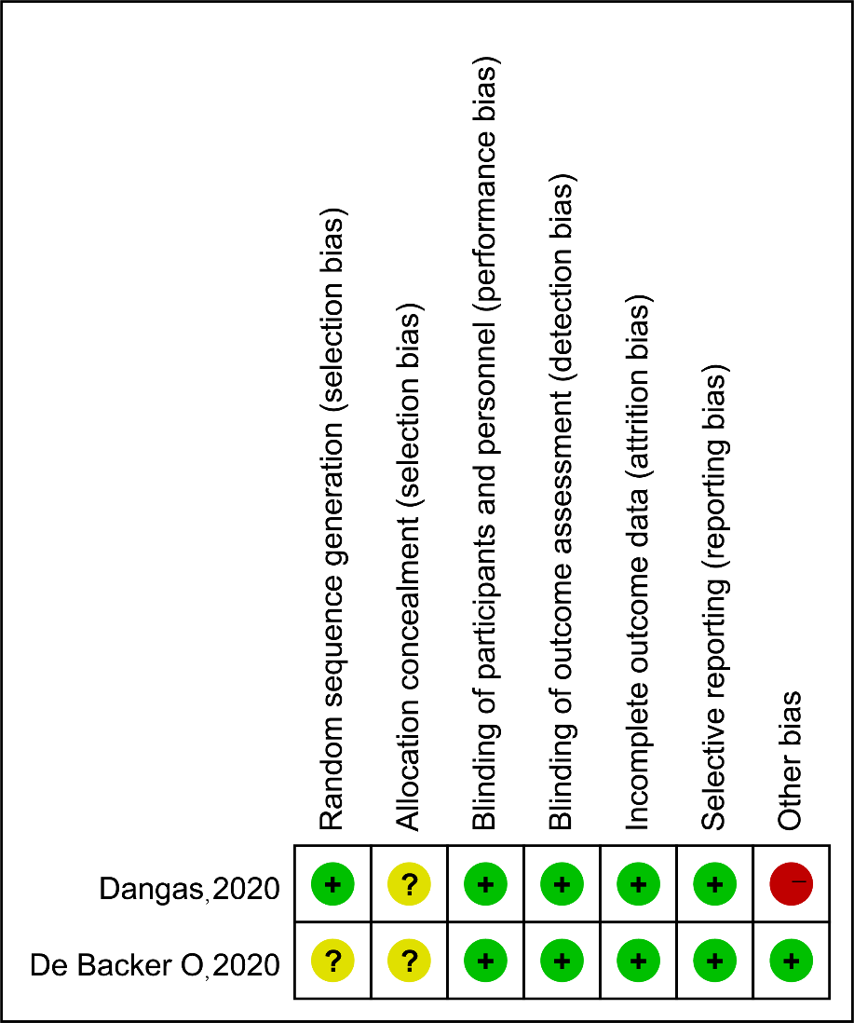
Supplementary Fig. 1 Risk of bias summary and quality evaluation of two randomized controlled trials

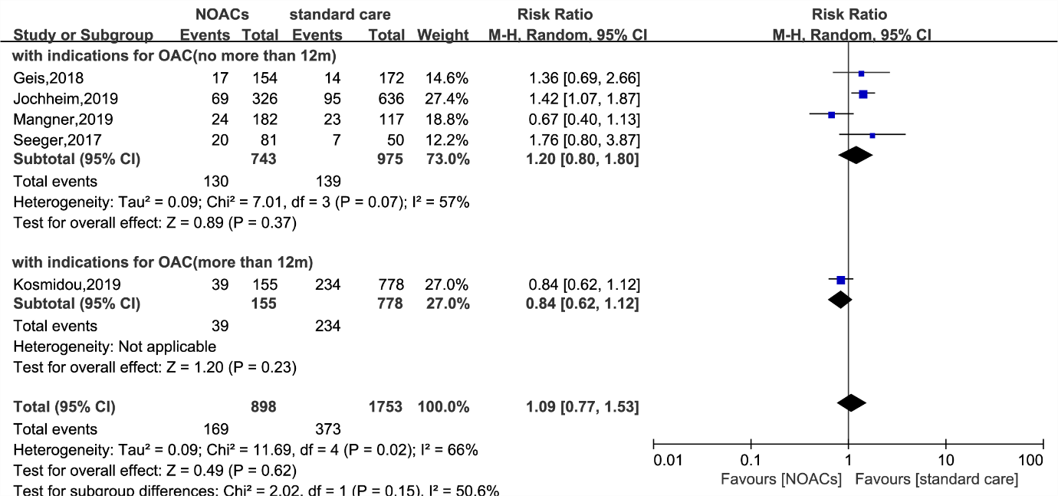
Supplementary Fig. 2 Subgroup analysis of a composite endpoint according to follow-up time
CI (confidence intervals), NOACs (non-vitamin K antagonist oral anticoagulants), OAC (oral anticoagulation)

Supplementary Fig. 3 Baujat plot. The study of Butt et al. provided the highest contribution to heterogeneity of all-cause mortality (with indications for OAC and no more than 12m follow-up) (a); The study of Jochheim et al. provided the highest contribution to heterogeneity of a composite endpoint (with indications for OAC) (b)

Supplementary Fig. 4 Analysis of all-cause mortality (with indications for OAC and no more than 12m follow-up) after excluded the study of Butt et al. (a); analysis of a composite endpoint (with indications for OAC) after excluded the study of Jochheim et al. (b)
CI (confidence intervals), NOACs (non-vitamin K antagonist oral anticoagulants) OAC (oral anticoagulation)

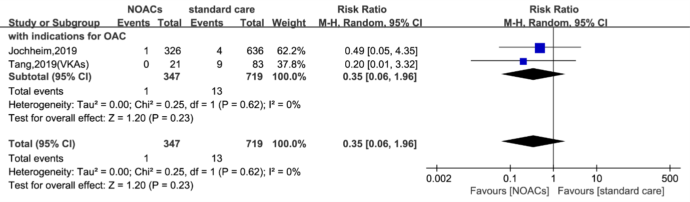
Supplementary Fig. 5 Analysis of the valve thrombosis after excluded the study of Yanagisawa et al.
CI (confidence intervals), NOACs (non-vitamin K antagonist oral anticoagulants) OAC (oral anticoagulation)

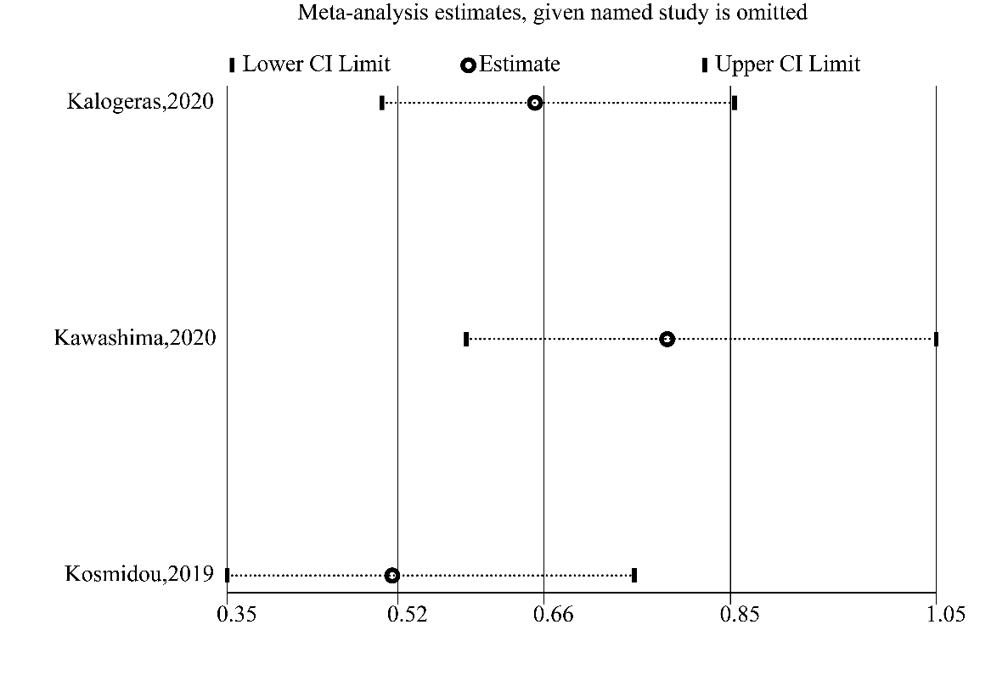
Supplementary Fig. 6 Sensitivity analysis of all-cause mortality (with indications for OAC and more than 12m follow-up)
CI = confidence intervals

Supplementary Fig. 7 Cumulative analyses with O’Brien-Fleming sequential monitoring boundaries in all-cause mortality (with follow-up time more than 12m)
TSA (Trial Sequential Analysis)

References:
1. Sulzgruber P, Wassmann S, Semb AG, et al. Oral anticoagulation in patients with non-valvular atrial fibrillation and a CHA2DS2-VASc score of 1: a current opinion of the European Society of Cardiology Working Group on Cardiovascular Pharmacotherapy and European Society of Cardiology Council on Stroke. Eur Heart J Cardiovasc Pharmacother. 2019; https://doi.org/10.1093/ehjcvp/pvz016.
2. Pisters R, Lane DA, Nieuwlaat R, de Vos CB, Crijns HJ, Lip GY. A novel user-friendly score (HAS-BLED) to assess 1-year risk of major bleeding in patients with atrial fibrillation: the Euro Heart Survey. Chest. 2010; https://doi.org/10.1378/chest.10-0134.

