Supplementary materials

Fitting curves of the relationship between androgen levels and other ovarian stimulation outcomes
We plotted three fitting curves to depict the association of androgen levels and other ovarian stimulation outcomes apart from numbers of retrieved oocytes at the three-time points (T0, T1, T2), including numbers of metaphase II(MII) oocytes, numbers of top quality embryos (TQEs), numbers of blastocyst-stage embryos, TQE formation rate and blastocyst formation rate. (Figure S1-5). The fitting curves presented similar trend with that of T levels and oocytes retrieved with corresponding inflection points, except for that of T levels and TQE formation rate (Table S1).

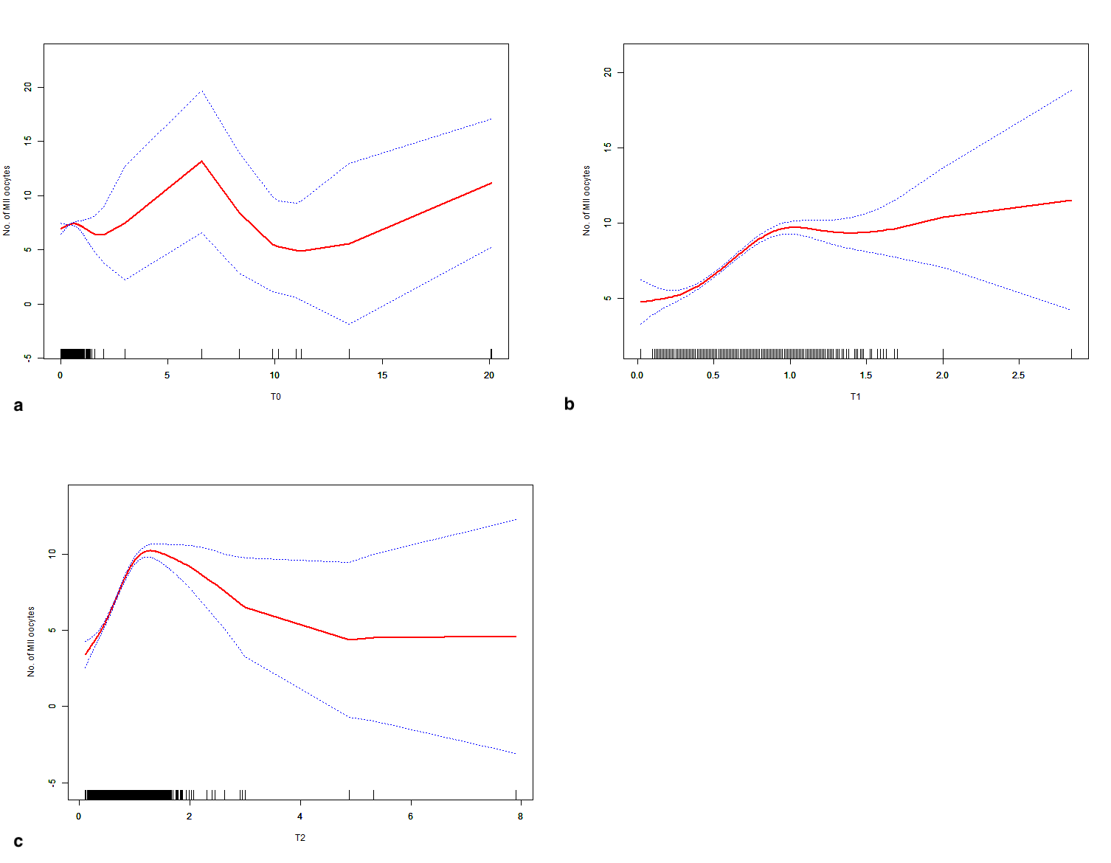
Figure S1. The fitting curves showing the relationship of the testosterone levels and the numbers of metaphase II (MII) oocyets. (a. T0, B. T1, C. T2)
T0: basal levels, T1: T levels on the trigger day, T2: T levels on the next day of the trigger day
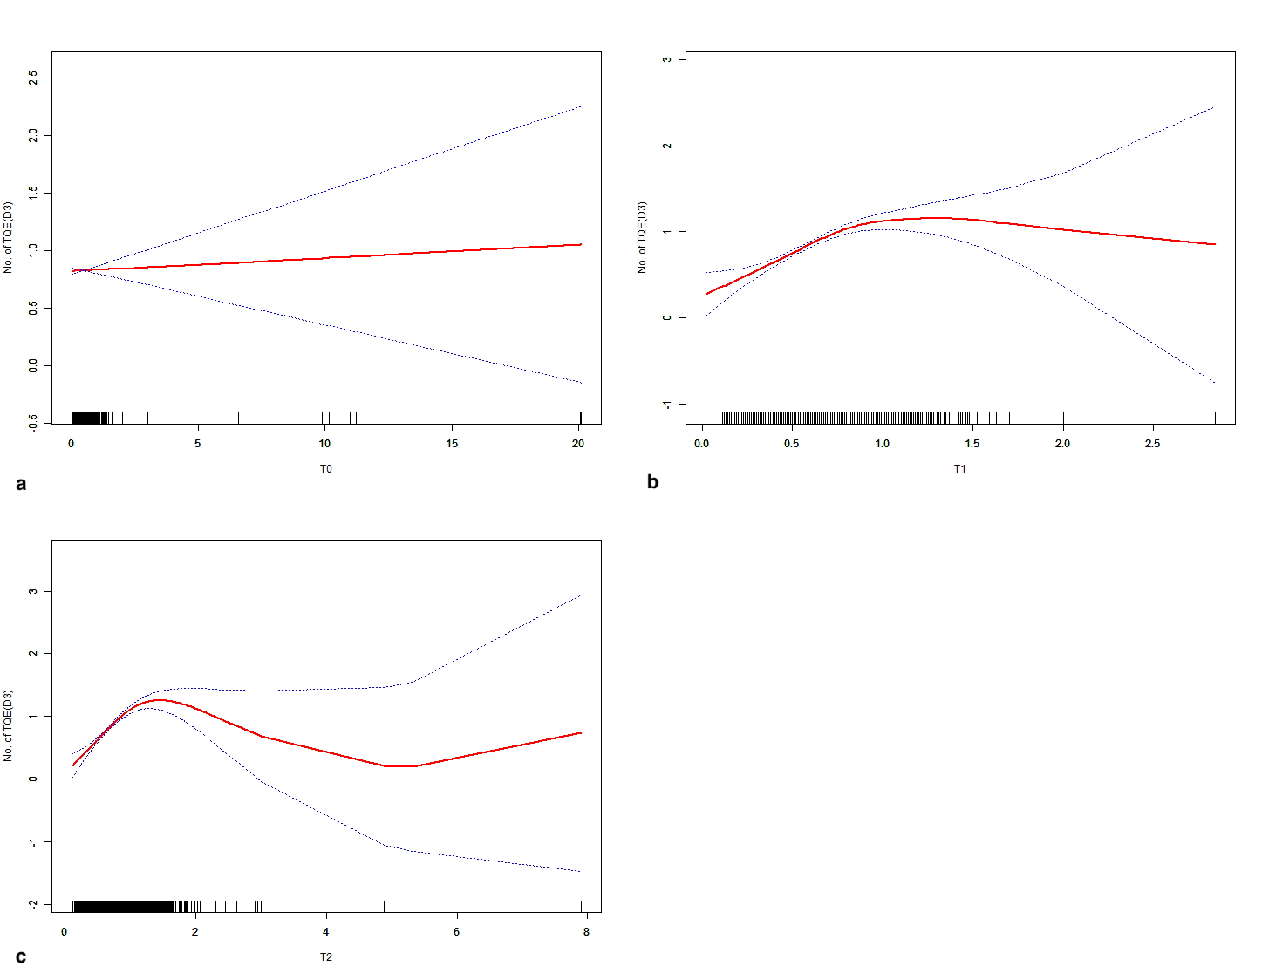
Figure S2. The fitting curves showing the relationship of the testosterone levels and the numbers of top-quality embryos at Day 3 (TQE[D3]). (a. T0, B. T1, C. T2)
T0: basal levels, T1: T levels on the trigger day, T2: T levels on the next day of the trigger day
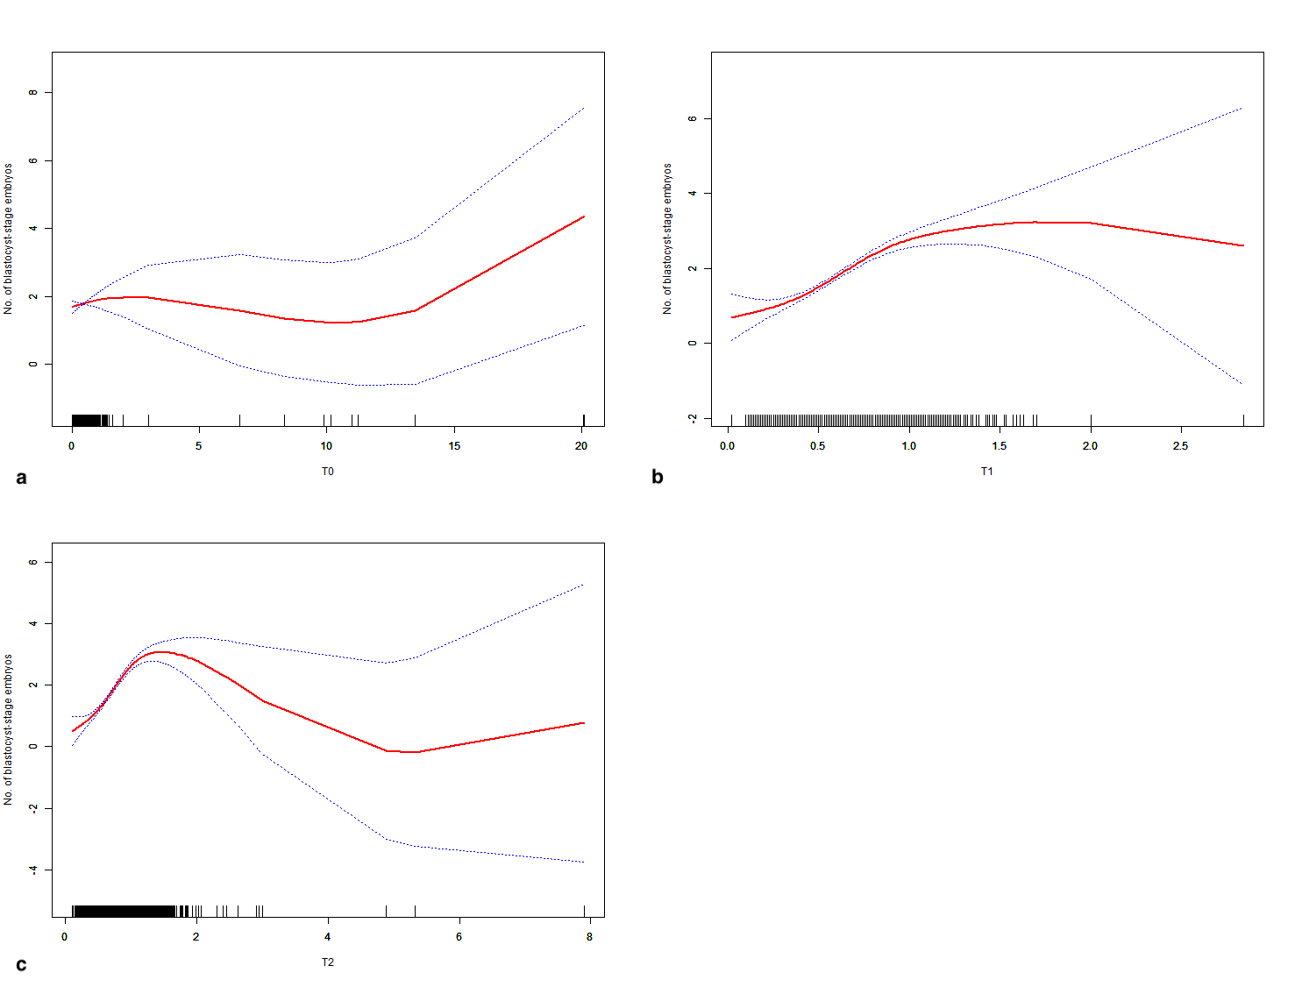
Figure S3. The fitting curves showing the relationship of the testosterone levels and the numbers of blastocyst-stage embryos. (a. T0, B. T1, C. T2)
T0: basal levels, T1: T levels on the trigger day, T2: T levels on the next day of the trigger day
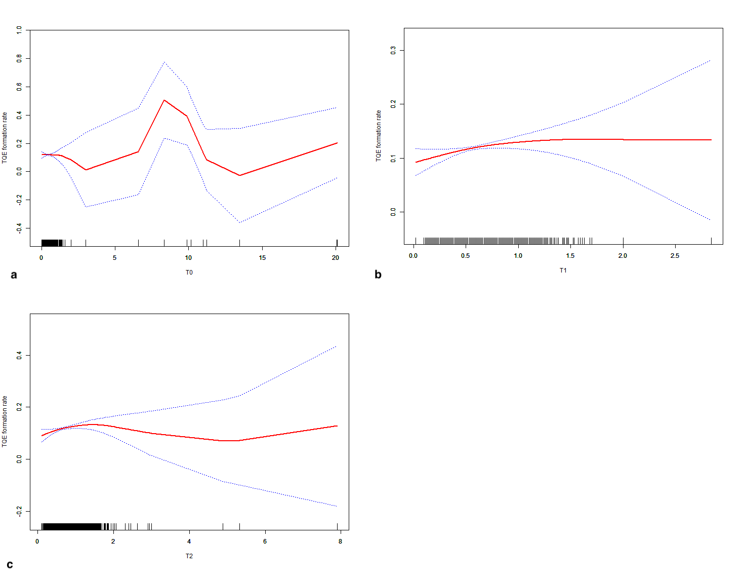
Figure S4. The fitting curves showing the relationship of the testosterone levels and the numbers of top-quality embryos (TQE) formation rate. (a. T0, B. T1, C. T2)
T0: basal levels, T1: T levels on the trigger day, T2: T levels on the next day of the trigger day
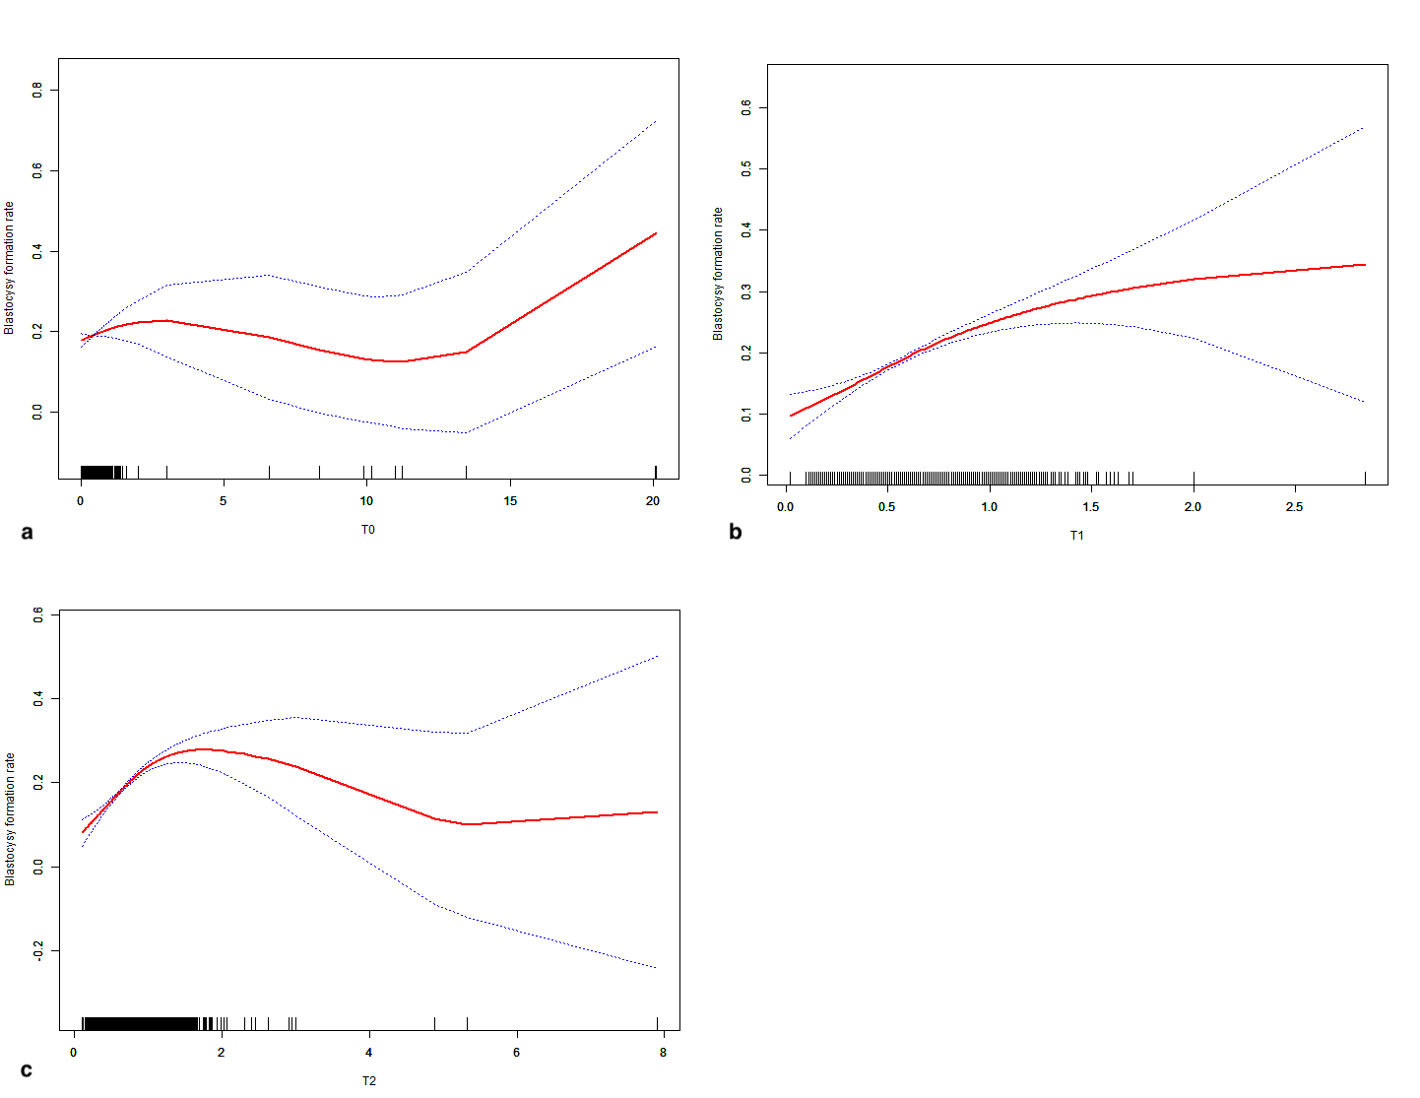
Figure S3. The fitting curves showing the relationship of the testosterone levels and the numbers of blastocyst formation rate. (a. T0, B. T1, C. T2)
T0: basal levels, T1: T levels on the trigger day, T2: T levels on the next day of the trigger day

Table S1. The analysis of the inflection points and the effect sizes of the curves reflecting the association of T levels and the secondary pregnancy outcomes
T levels and numbers of MII oocytes
 | T0 | T1 | T2
Inflection point (K) (ng/mL) | 0.46 | 0.89 | 1.09
β1 (95%CI) <k* | 0.87 (-0.77, 2.50) | 7.20 (6.22,8.13) | 7.76 (7.03, 8.49)
P (β1) | 0.2977 | <0.0001 | <0.0001
β2 (95%CI) >k** | 0.04 (-0.15, 0.24) | 0.07 (-1.96, 2.11) | -1.26 (-1.84, -0.68)
P (β2) | 0.6672 | 0.9446 | <0.0001
Difference for (β2-β1) | -0.82 (-2.49, 0.84) | -7.13 (-9.63, -4.63) | -9.02 (-10.05, -8.00)
P (β2-β1) | 0.3316 | <0.0001 | <0.0001
 | T levels and numbers of TQE
 |  |  | T0 |  | T1 |  | T2
 | Inflection point (K) (ng/mL) |  | 0.28 |  | 0.87 |  | 1.03
 | β1 (95%CI) <k* |  | 0.48 (-0.57, 1.53) |  | 1.09 (0.84, 1.34) |  | 1.12 (0.91, 1.34)
 | P (β1) |  | 0.3713 |  | <0.0001 |  | <0.0001
 | β2 (95%CI) >k** |  | 0.01 (-0.06, 0.07) |  | -0.25 (-0.78, 0.29) |  | -0.16 (-0.34, -0.02)
 | P (β2) |  | 0.8266 |  | 0.3666 |  | 0.078
 | Difference for (β2-β1) |  | -0.47 (-1.53, 0.59) |  | -1.33 (-2.00, -0.67) |  | -1.29 (-1.59, -0.98)
 | P (β2-β1) |  | 0.3830 |  | <0.0001 |  | <0.0001
 | T levels and numbers of blastocyst-stage embryos
 |  |  | T0 |  | T1 |  | T2
 | Inflection point (K) (ng/mL) |  | 0.74 |  | 0.94 |  | 1.16
 | β1 (95%CI) <k* |  | 0.45 (-0.13, 1.03) |  | 2.72 (2.23, 3.21) |  | 2.74 (2.34, 3.14)
 | P (β1) |  | 0.1269 |  | <0.0001 |  | <0.0001
 | β2 (95%CI) >k** |  | 0.03 (-0.11, 0.17) |  | 0.40 (-1.01, 1.82) |  | -0.54 (-0.90, -0.18)
 | P (β2) |  | 0.7101 |  | 0.5758 |  | 0.0031
 | Difference for (β2-β1) |  | -0.42 (-1.04, 0.19) |  | -2.31 (-3.95, -0.68) |  | -3.28 (-3.87, -2.69)
 | P (β2-β1) |  | 0.1790 |  | 0.0054 |  | <0.0001
T levels and TQE formation rate
 |  | T0 |  | T1 |  | T2
Inflection point (K) (ng/mL) |  | 0.22 |  | 0.32 |  | 0.36
β1 (95%CI) <k* |  | 0.22 (-0.02, 0.47) |  | 0.30 (0.08, 0.52) |  | 0.38 (0.17, 0.60)
P (β1) |  | 0.0780 |  | 0.0067 |  | 0.0005
β2 (95%CI) >k** |  | 0.00 (-0.01, 0.02) |  | 0.01 (-0.02, 0.05) |  | 0.01 (-0.01, 0.02)
P (β2) |  | 0.4594 |  | 0.3573 |  | 0.4872
Difference for (β2-β1) |  | -0.22 (-0.47, 0.03) |  | -0.29 (-0.52, -0.06) |  | -0.38 (-0.59, -0.16)
P (β2-β1) |  | 0.0865 |  | 0.0140 |  | 0.0007
T levels and blastocyst formation rate
 |  | T0 |  | T1 |  | T2
Inflection point (K) (ng/mL) |  | 0.78 |  | 0.86 |  | 1.26
β1 (95%CI) <k* |  | 0.04 (-0.01, 0.09) |  | 0.18 (0.13, 0.23) |  | 0.17 (0.14, 0.20)
P (β1) |  | 0.1120 |  | <0.0001 |  | <0.0001
β2 (95%CI) >k** |  | 0.00 (-0.01, 0.01) |  | 0.05 (-0.04, 0.14) |  | -0.04 (-0.08, 0.00)
P (β2) |  | 0.5930 |  | 0.3010 |  | 0.0796
Difference for (β2-β1) |  | -0.04 (-0.09, 0.02) |  | -0.13 (-0.25, -0.01) |  | -0.21 (-0.27, -0.15)
P (β2-β1) |  | 0.1692 |  | 0.0323 |  | <0.0001
*: β coefficient of the section before the inflection point
**: β coefficient of the section after the inflection point
T: testosterone
MII: Metaphase II
TQE: top quality embryo

