g Steps in discovery cohort
g Validation
g Assessment of profile associations

Supplementary Figure 1. Analysis pipeline

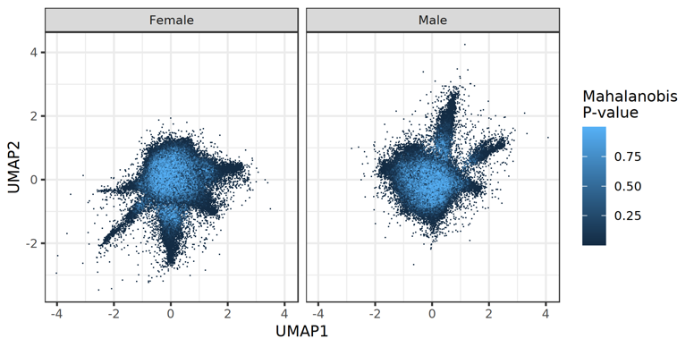
Supplementary Figure 2. UMAP projection and distance from a multivariate normal distribution of residuals derived the BMI model.

A  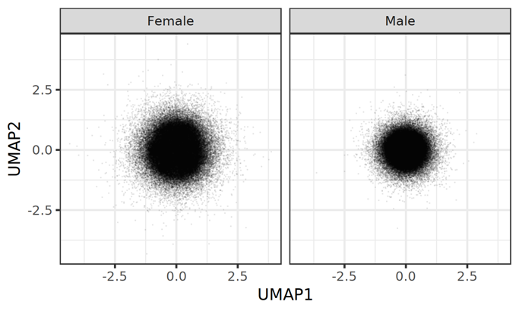 | B  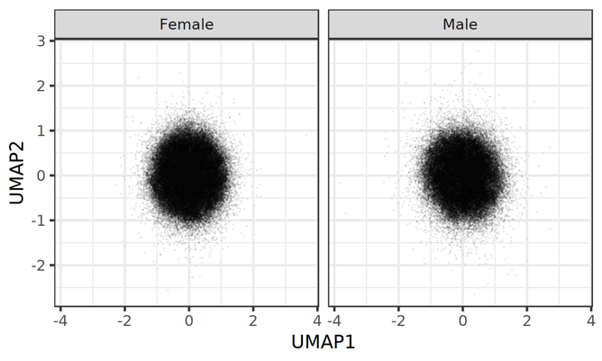
Supplementary Figure 3. UMAP projections of randomly generated multivariate normal distribution of residuals of the same size as the UK Biobank dataset used in the analysis. A: Assuming no correlation between biomarker residuals. B. With the same covariance structure as the residuals obtained in UK Biobank.

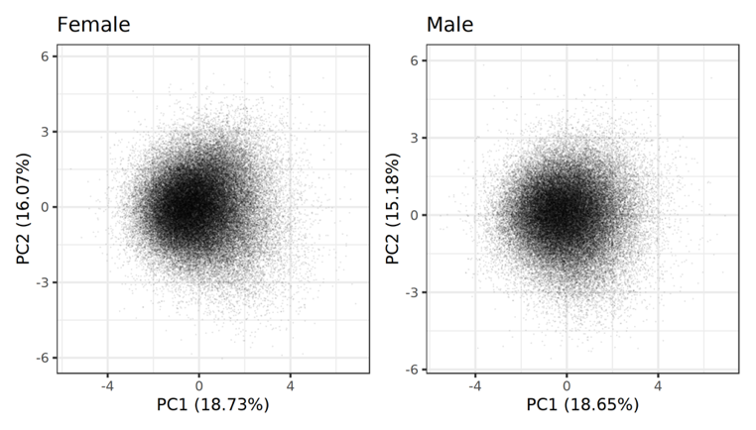
Supplementary Figure 4. Linear dimensionality reduction of deviations from biomarkers from BMI-based expectations using principal component analysis.

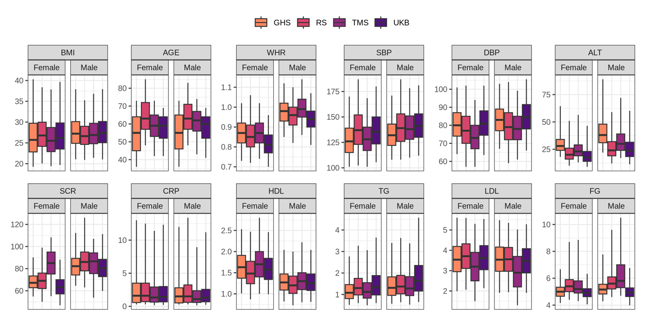
Supplementary Figure 5. Distribution of BMI and biomarkers per cohort. WHR: waist-to-hip ratio. SBP: systolic blood pressure. DBP: diastolic blood pressure. ALT: alanine transaminase. SCR: serum creatinine. CRP: C-reactive protein. HDL: high-density lipoprotein. TG: triglycerides. LDL: low-density lipoprotein. FG: fasting glucose.

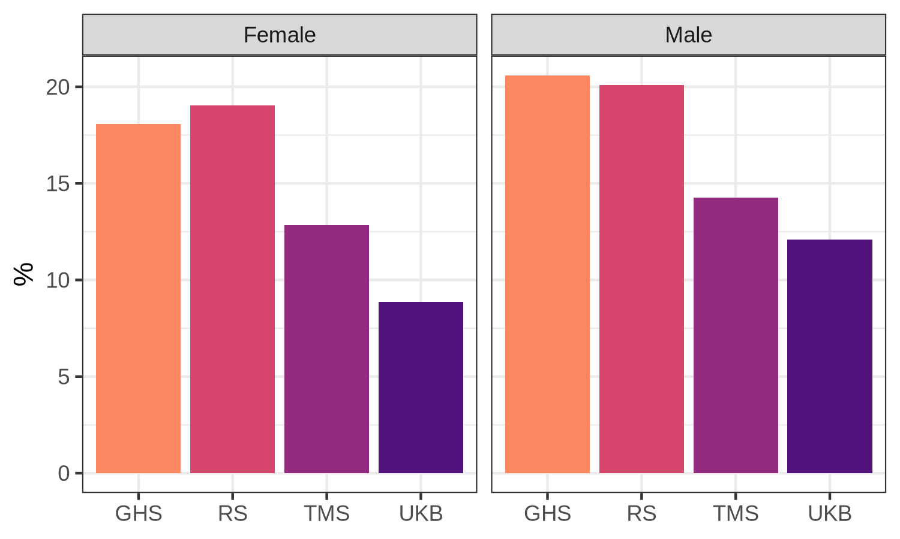
Supplementary Figure 6. Proportion of current smokers in each cohort. GHS: Gutenberg Health Study, TMS: Maastricht Study, RS: Rotterdam Study, UKB: UK Biobank

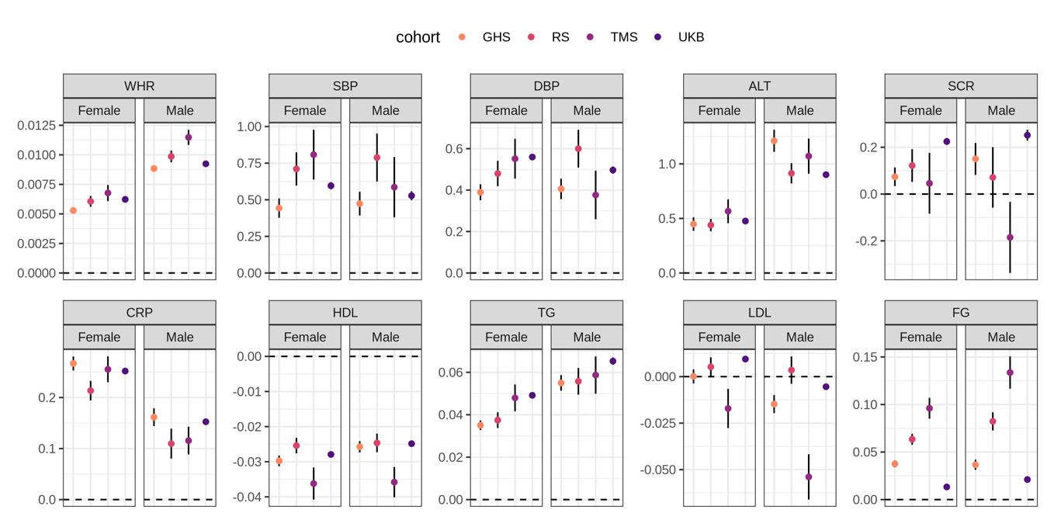
Supplementary Figure 7. Age and current smoking adjusted effect of BMI on biomarkers across cohorts. GHS: Gutenberg Health Study, TMS: Maastricht Study, RS: Rotterdam Study, UKB: UK Biobank. WHR: waist-to-hip ratio. SBP: systolic blood pressure. DBP: diastolic blood pressure. ALT: alanine transaminase. SCR: serum creatinine. CRP: C-reactive protein. HDL: high-density lipoprotein. TG: triglycerides. LDL: low-density lipoprotein. FG: fasting glucose.

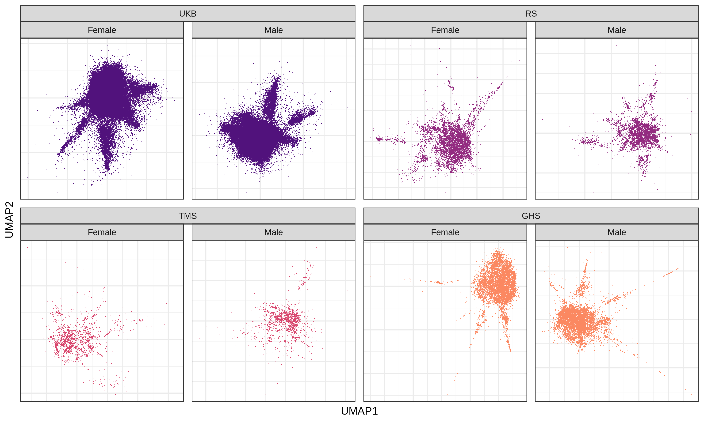
Supplementary Figure 8. UMAP projections. GHS: Gutenberg Health Study, TMS: Maastricht Study, RS: Rotterdam Study, UKB: UK Biobank.

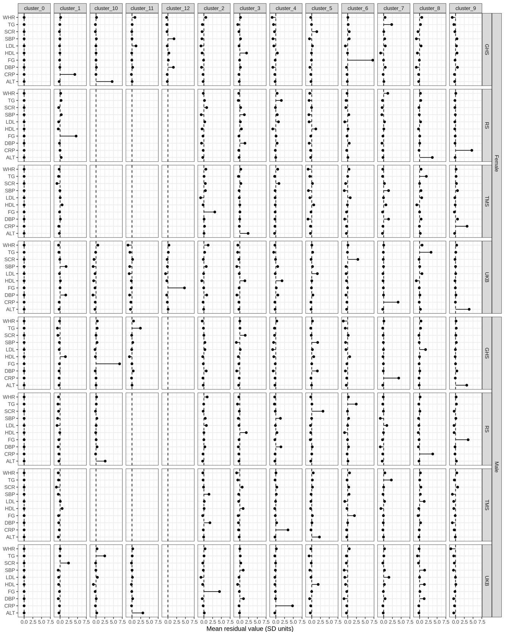
Supplementary Figure 9. Profile centres obtained by running the clustering approach on the 4 cohorts separately. WHR: waist-to-hip ratio. TG: triglycerides. SCR: serum creatinine. SBP: systolic blood pressure. LDL: low-density lipoprotein. HDL: high-density lipoprotein. FG: fasting glucose. DBP: diastolic blood pressure. CRP: C-reactive protein. ALT: alanine transaminase.

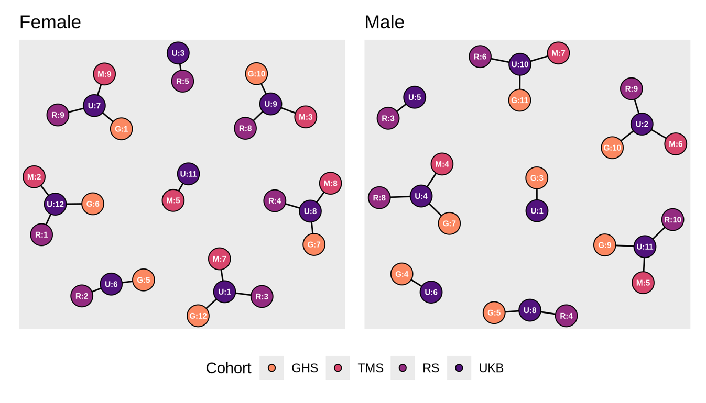
Supplementary Figure 10. Validation of discordant profiles identified in UK Biobank across 3 independent cohorts. GHS: Gutenberg Health Study, TMS: Maastricht Study, RS: Rotterdam Study, UKB: UK Biobank.

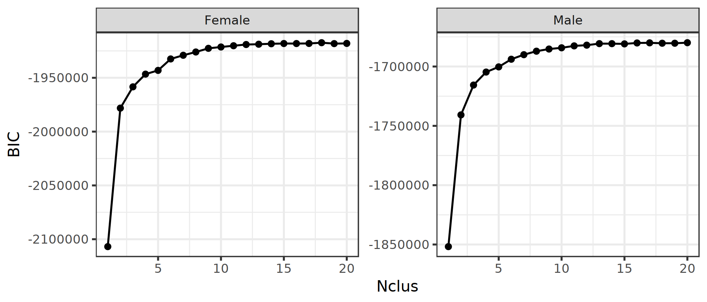
Supplementary Figure 11. Finding the best partition of a Gaussian mixture model applied on the deviation data. We considered an elbow at 6 clusters for both sexes, after which the Bayesian information criterion (BIC) improvement flattens.

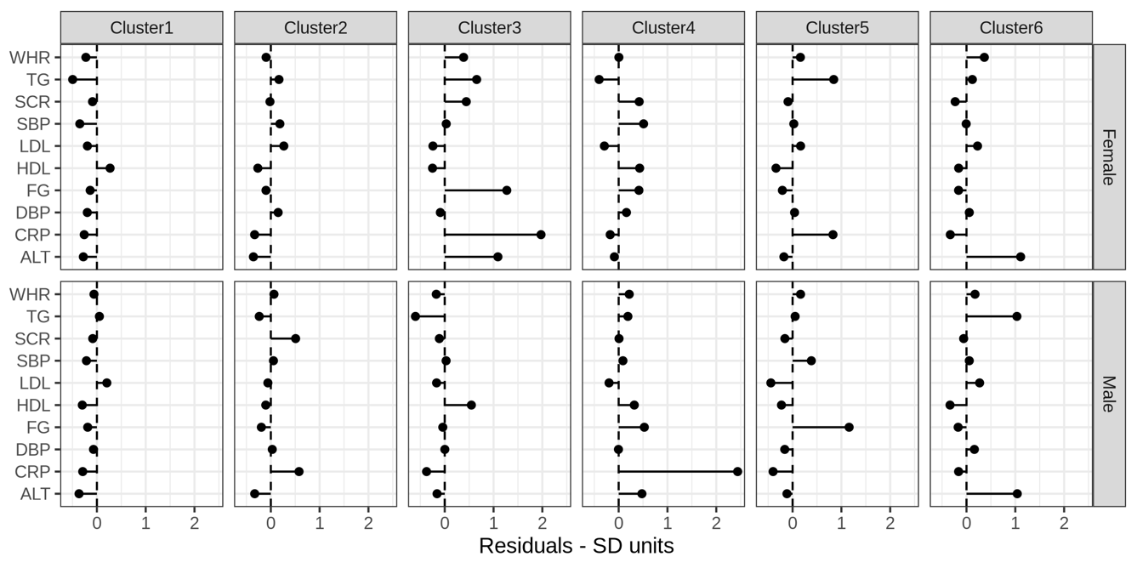
Supplementary Figure 12. Cluster centres of best partitions from the Gaussian mixture modelling. WHR: waist-to-hip ratio. TG: triglycerides. SCR: serum creatinine. SBP: systolic blood pressure. LDL: low-density lipoprotein. HDL: high-density lipoprotein. FG: fasting glucose. DBP: diastolic blood pressure. CRP: C-reactive protein. ALT: alanine transaminase.

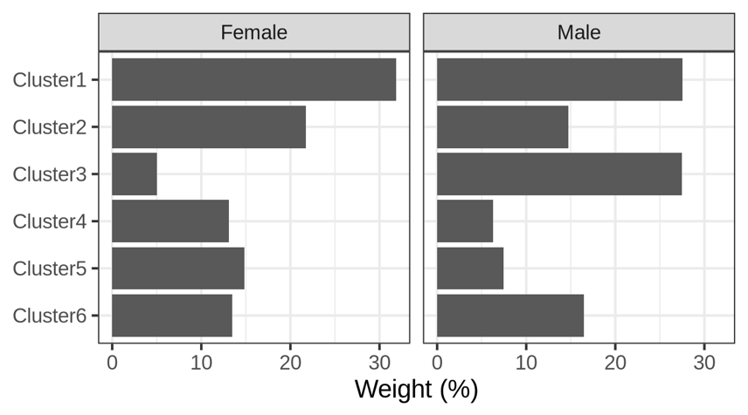
Supplementary Figure 13. Cluster weights of best partitions from the Gaussian mixture modelling.

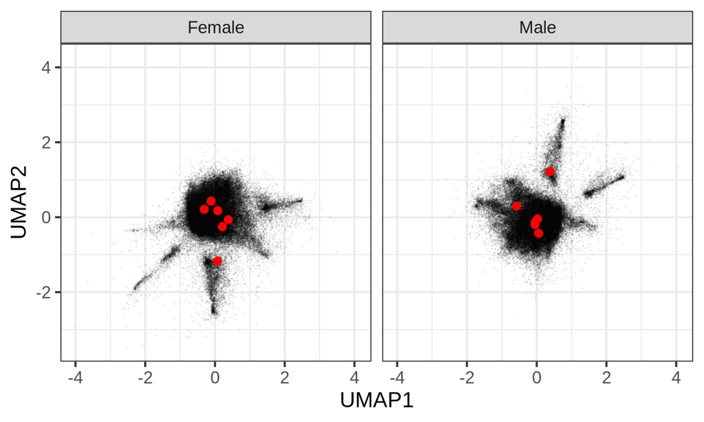
Supplementary Figure 14. Overlaying cluster centres of best partitions from the Gaussian mixture modelling onto the UMAP projection

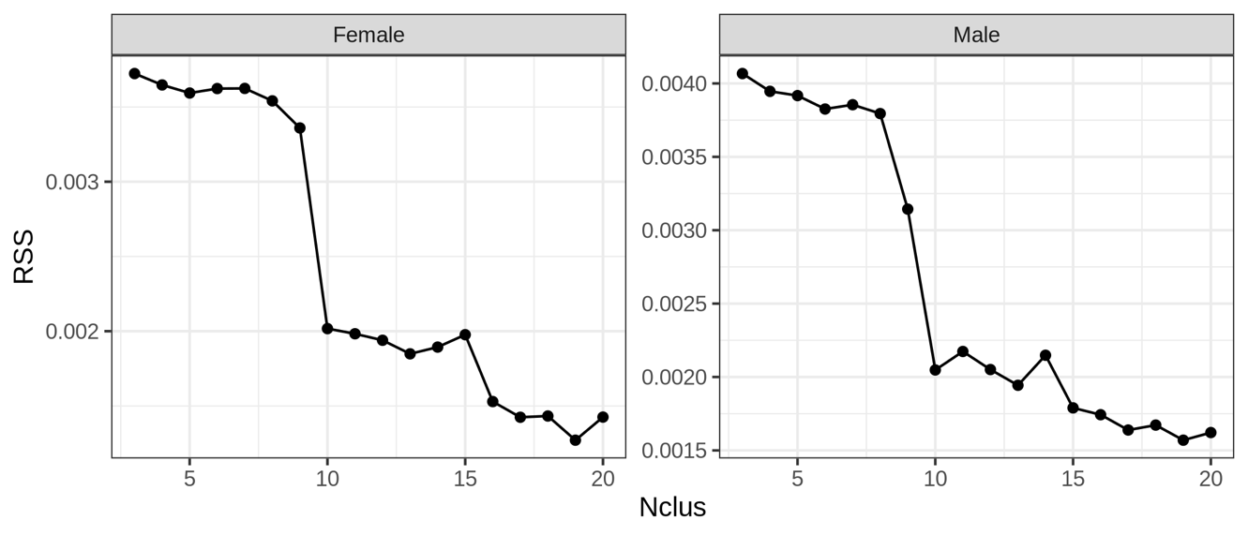
Supplementary Figure 15. Finding the best partition of an archetypal model applied on the deviation data. We considered an elbow at 11 clusters for both sexes, after which the residual sum of squares (RSS) change stalls.

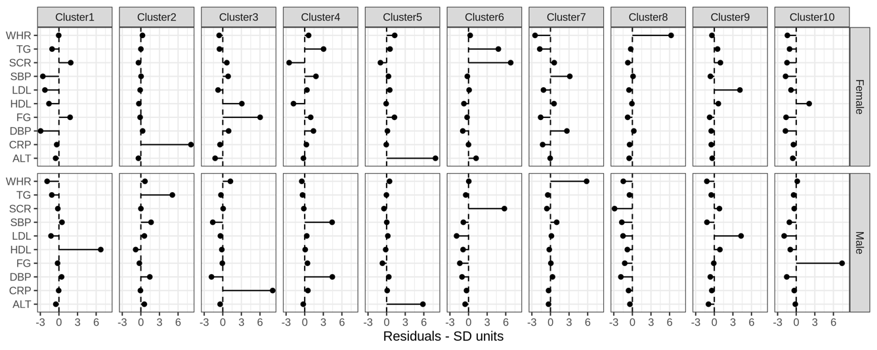
Supplementary Figure 16. Cluster centres of best partitions from archetypal modelling. WHR: waist-to-hip ratio. TG: triglycerides. SCR: serum creatinine. SBP: systolic blood pressure. LDL: low-density lipoprotein. HDL: high-density lipoprotein. FG: fasting glucose. DBP: diastolic blood pressure. CRP: C-reactive protein. ALT: alanine transaminase.

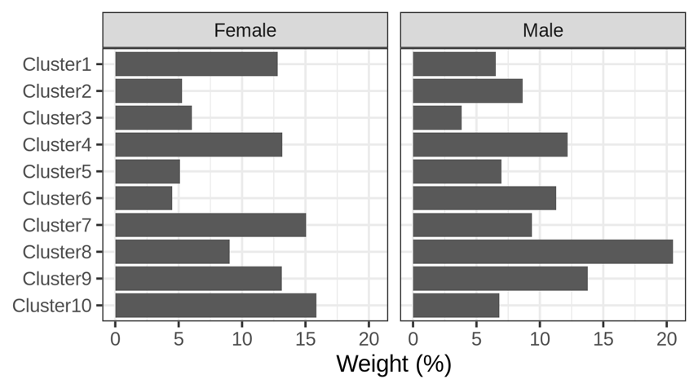
Supplementary Figure 17. Cluster weights of best partitions from archetypal modelling.

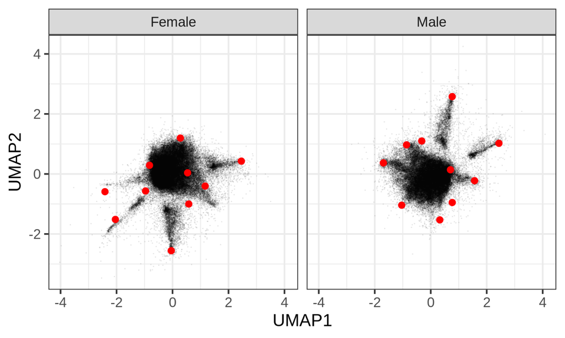
Supplementary Figure 18. Overlaying cluster centres of best partitions from the archetypal modelling onto the UMAP projection.

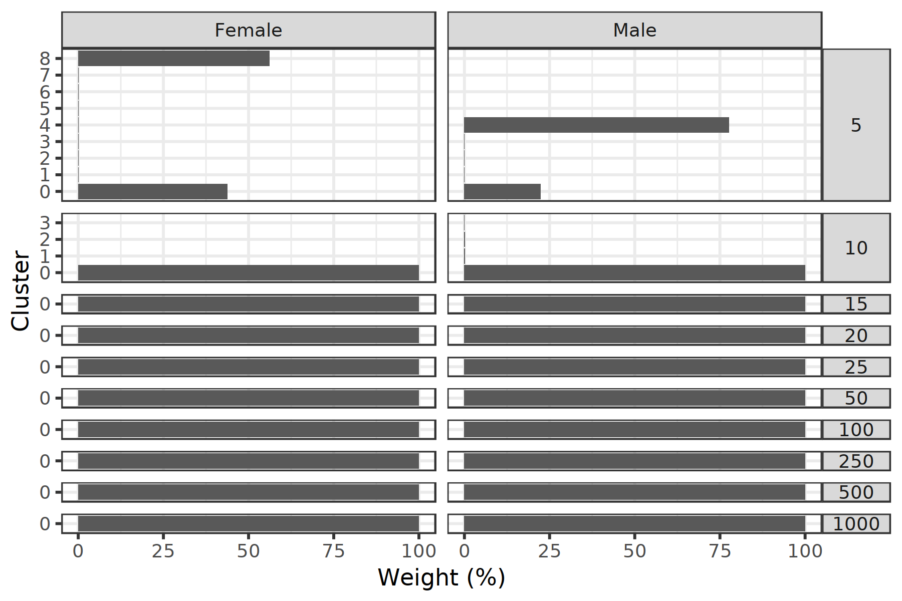
Supplementary Figure 19. Number of clusters and cluster weights for each run of HDBSCAN applied on the deviation data using different values of the minPts argument.

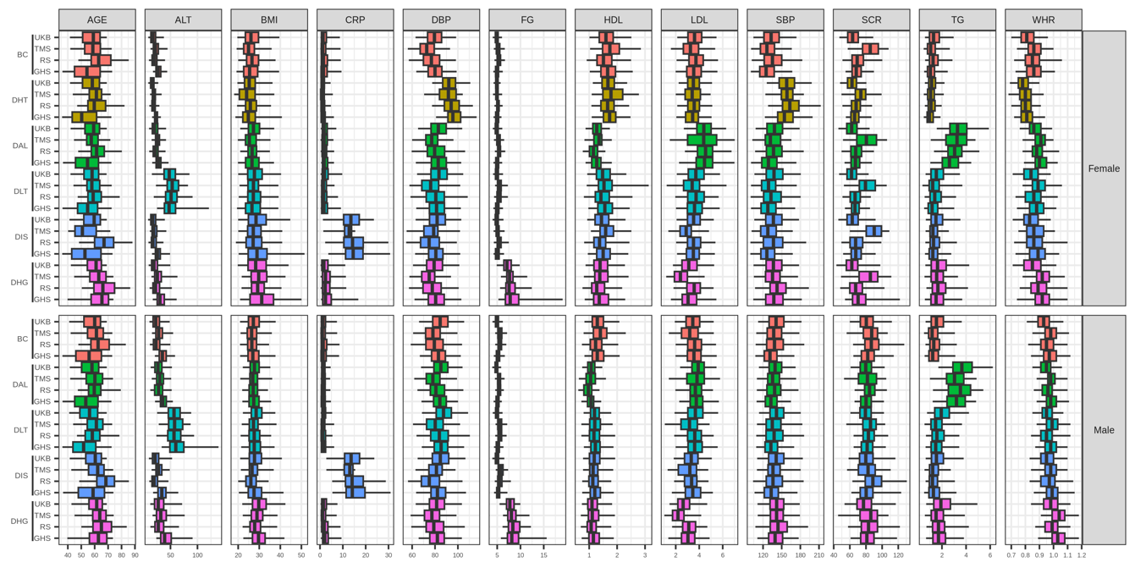
Supplementary Figure 20. Distribution of biomarkers per profile. GHS: Gutenberg Health Study, TMS: Maastricht Study, RS: Rotterdam Study, UKB: UK Biobank. BC: Baseline concordant profile. DHT: discordant hypertensive profile. DAL: discordant adverse lipid profile. DLT: discordant liver transaminases profile. DIS: discordant inflammatory state profile. DHG: discordant hyperglycaemic profile. ALT: alanine transaminase. CRP: C-reactive protein. DBP: diastolic blood pressure. FG: fasting glucose. HDL: high-density lipoprotein. LDL: low-density lipoprotein. SBP: systolic blood pressure. SCR: serum creatinine. TG: triglycerides. WHR: waist-to-hip ratio.

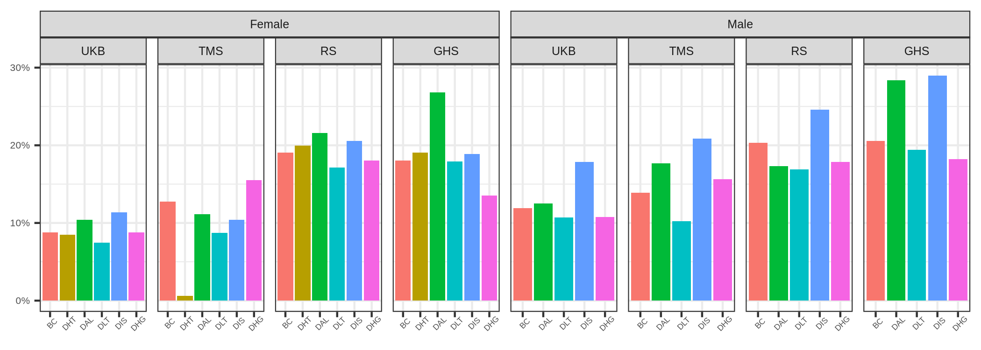
Supplementary Figure 21. Proportion of current smokers per profile. GHS: Gutenberg Health Study, TMS: Maastricht Study, RS: Rotterdam Study, UKB: UK Biobank.

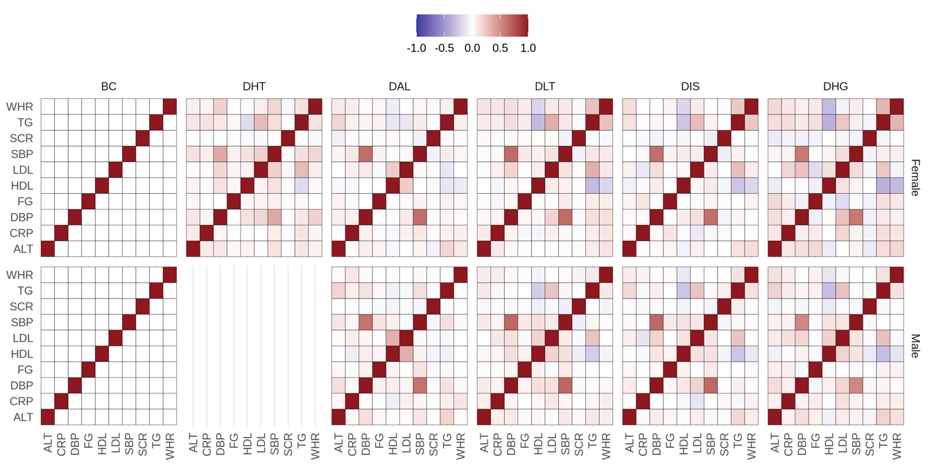
Supplementary Figure 22. Profile-specific correlation matrices of biomarker deviations from the expected for the BMI. BC: Baseline concordant profile. DHT: discordant hypertensive profile. DAL: discordant adverse lipid profile. DLT: discordant liver transaminases profile. DIS: discordant inflammatory state profile. DHG: discordant hyperglycaemic profile. ALT: alanine transaminase. CRP: C-reactive protein. DBP: diastolic blood pressure. FG: fasting glucose. HDL: high-density lipoprotein. LDL: low-density lipoprotein. SBP: systolic blood pressure. SCR: serum creatinine. TG: triglycerides. WHR: waist-to-hip ratio.

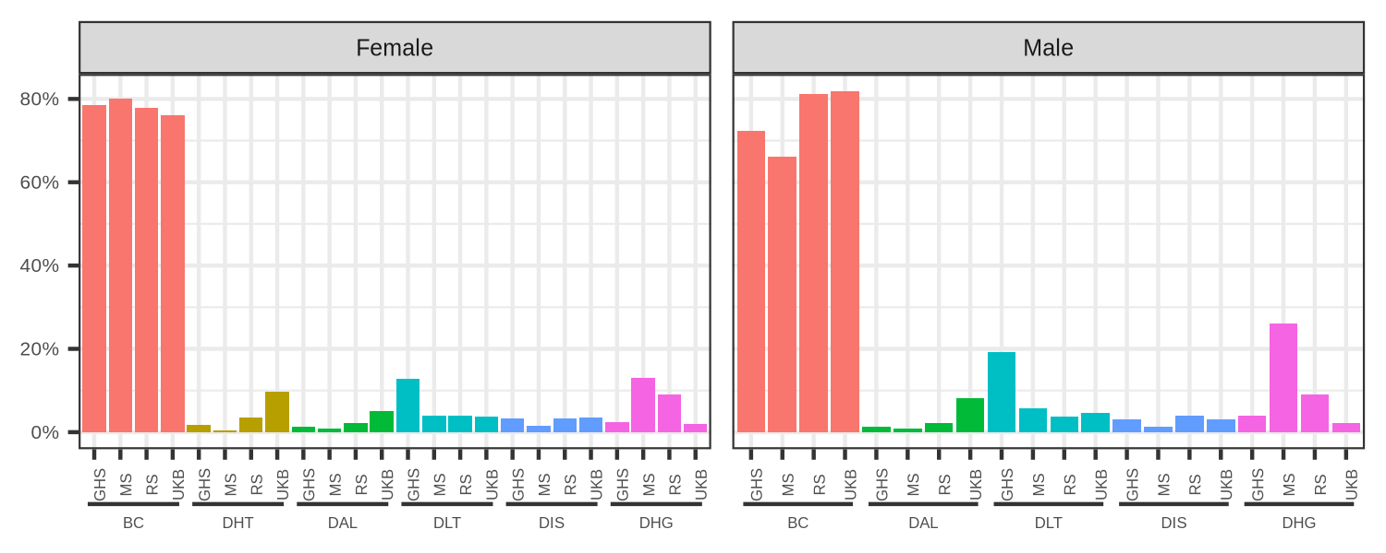
Supplementary Figure 23. Weighted proportions per profile. BC: Baseline concordant profile. DHT: discordant hypertensive profile. DAL: discordant adverse lipid profile. DLT: discordant liver transaminases profile. DIS: discordant inflammatory state profile. DHG: discordant hyperglycaemic profile. GHS: Gutenberg Health Study, TMS: Maastricht Study, RS: Rotterdam Study, UKB: UK Biobank.

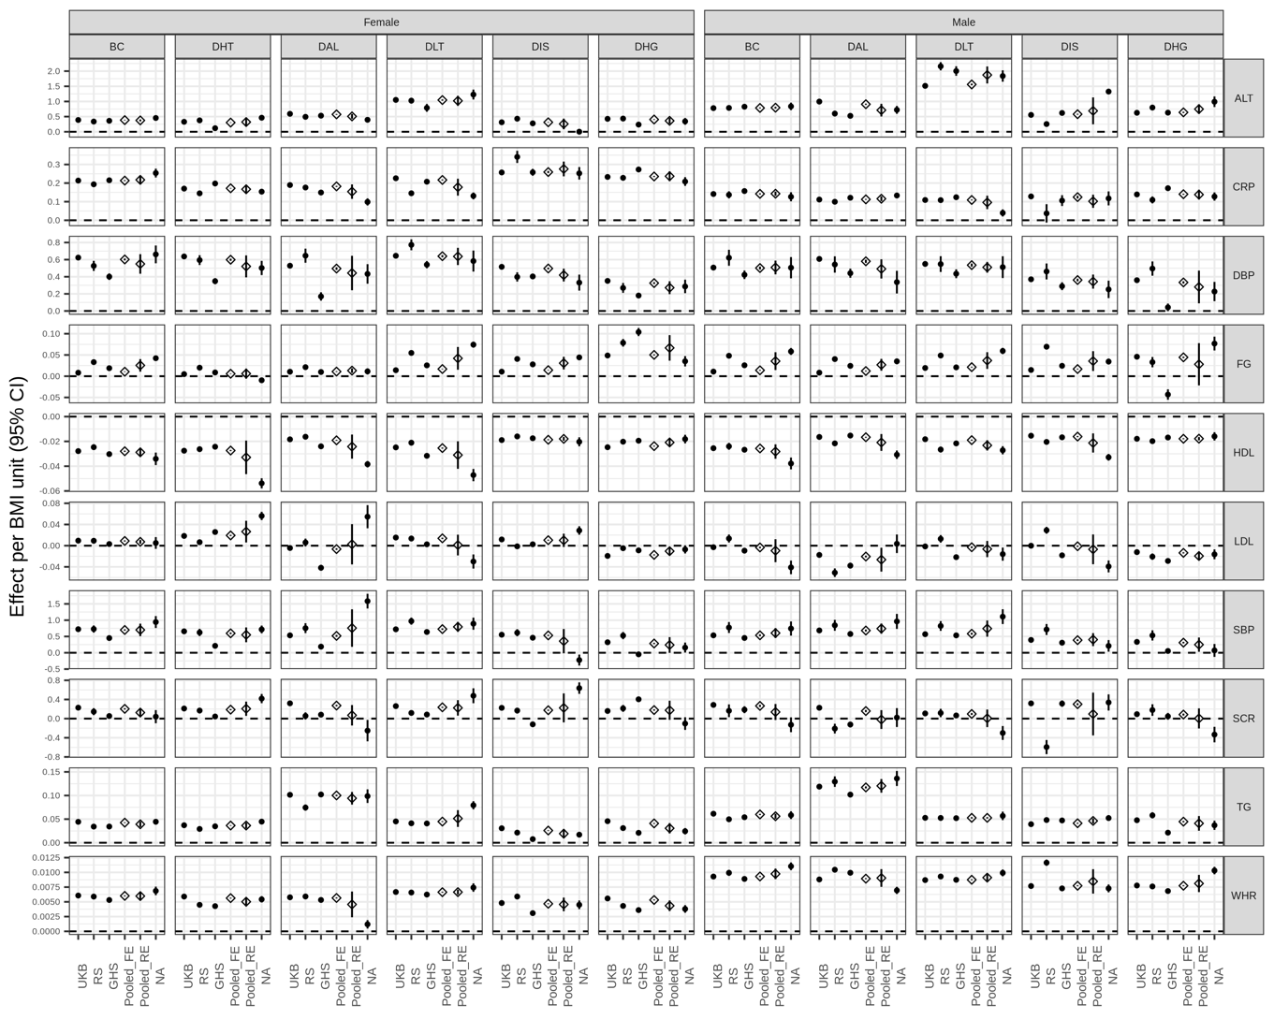
Supplementary Figure 24. Effect of BMI on biomarkers across profiles. GHS: Gutenberg Health Study, TMS: Maastricht Study, RS: Rotterdam Study, UKB: UK Biobank. BC: Baseline concordant profile. DHT: discordant hypertensive profile. DAL: discordant adverse lipid profile. DLT: discordant liver transaminases profile. DIS: discordant inflammatory state profile. DHG: discordant hyperglycaemic profile. ALT: alanine transaminase. CRP: C-reactive protein. DBP: diastolic blood pressure. FG: fasting glucose. HDL: high-density lipoprotein. LDL: low-density lipoprotein. SBP: systolic blood pressure. SCR: serum creatinine. TG: triglycerides. WHR: waist-to-hip ratio.

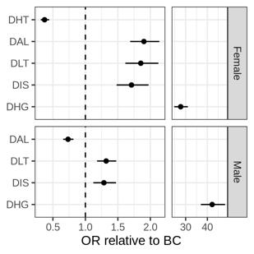
Supplementary Figure 25. Odds ratio of the metabolic syndrome in discordant profiles relative to the concordant profile. BC: Baseline concordant profile. DHT: discordant hypertensive profile. DAL: discordant adverse lipid profile. DLT: discordant liver transaminases profile. DIS: discordant inflammatory state profile. DHG: discordant hyperglycaemic profile. OR: odds ratio.

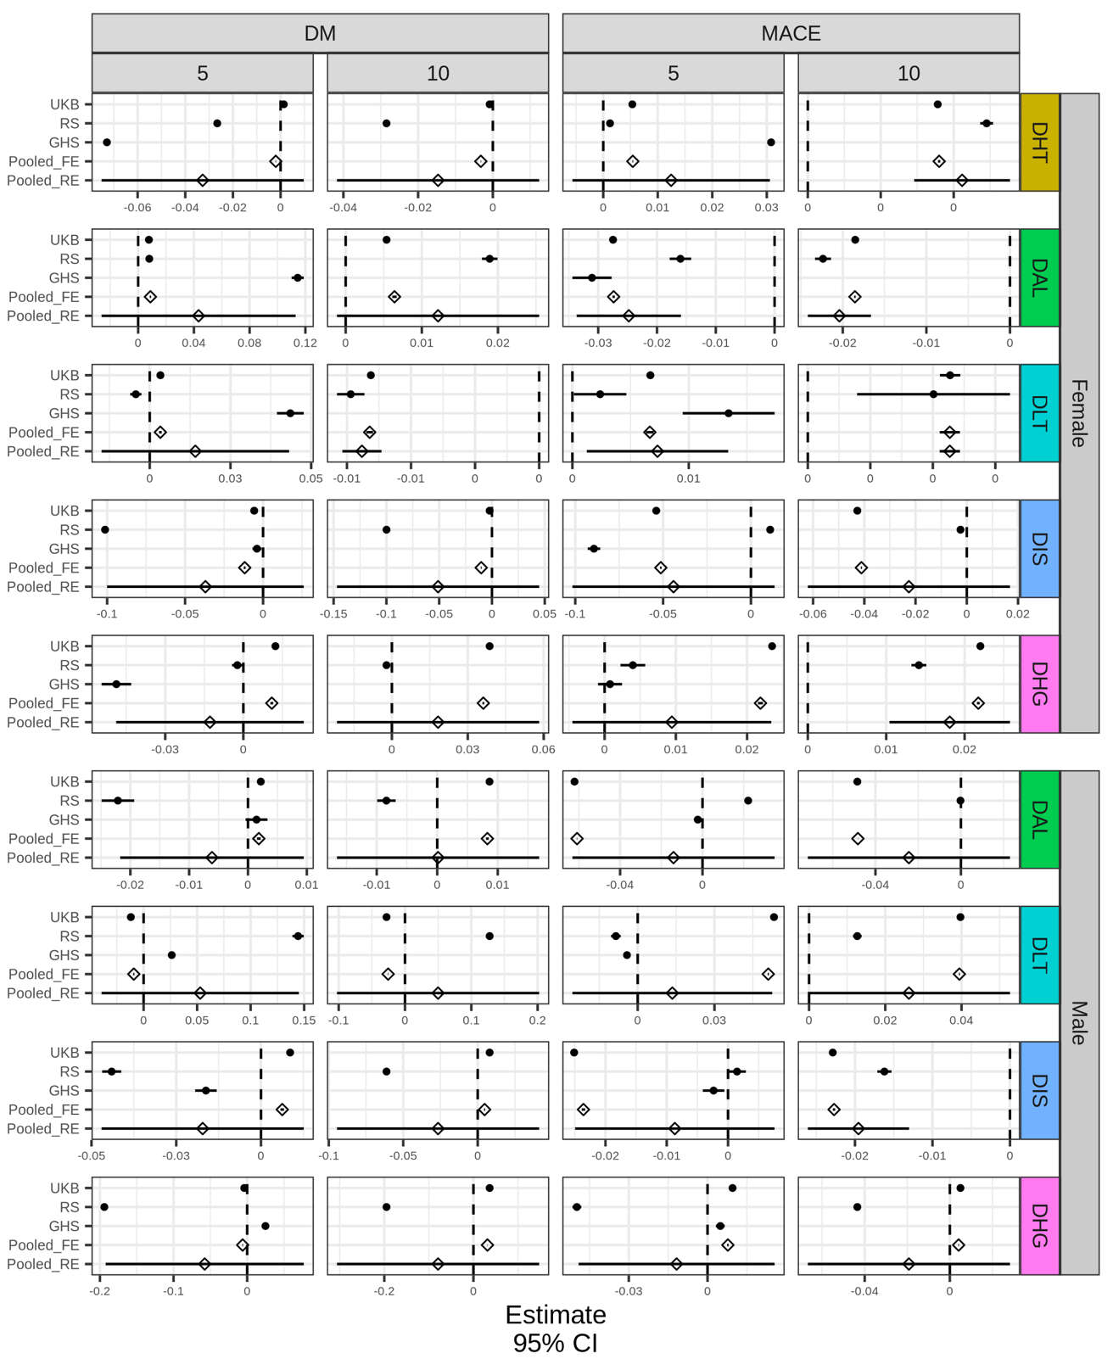
Supplementary Figure 26. Study-specific and pooled discordant log-ratio estimates derived from the Cox regressions. DM: Diabetes Mellitus. MACE: Major Adverse Cardiovascular Event. UKB: UK Biobank, RS: Rotterdam Study, GHS: Gutenberg Health Study. BC: Baseline concordant profile. DLT: discordant liver transaminases profile. DIS: discordant inflammatory state profile. DHT: discordant hypertensive profile. DHG: discordant hyperglycaemic profile. DAL: discordant adverse lipid profile. Pooled_FE: pooled fixed effects. Pooled_RE: pooled random effects. BC: Baseline concordant profile. DHT: discordant hypertensive profile. DAL: discordant adverse lipid profile. DLT: discordant liver transaminases profile. DIS: discordant inflammatory state profile. DHG: discordant hyperglycaemic profile.

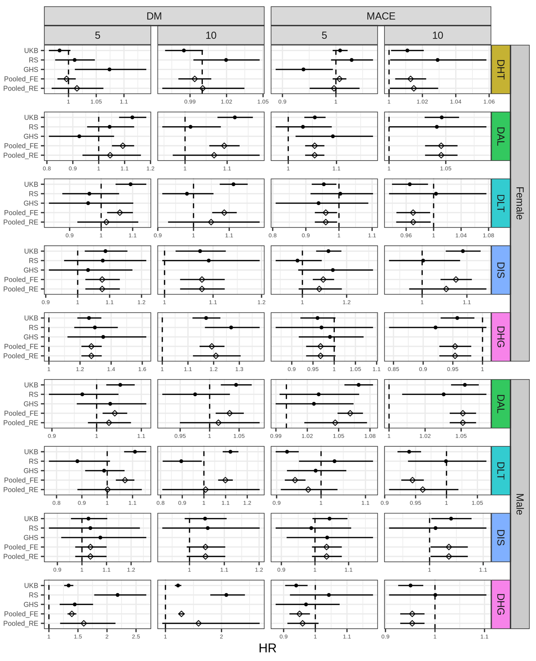
Supplementary Figure 27. Study-specific and pooled estimates of a 10% shift from the concordant to each discordant profile. UKB: UK Biobank, RS: Rotterdam Study, GHS: Gutenberg Health Study. DHT: discordant hypertensive profile. DAL: discordant adverse lipid profile. DLT: discordant liver transaminases profile. DIS: discordant inflammatory state profile. DHG: discordant hyperglycaemic profile. Pooled_FE: pooled fixed effects. Pooled_RE: pooled random effects.

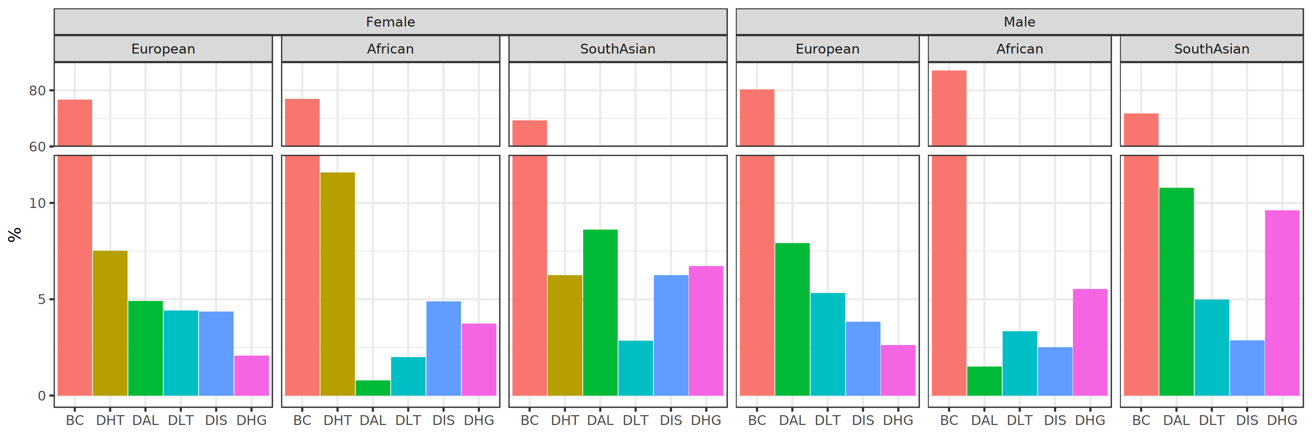
Supplementary Figure 28. Profile proportions in European, African and South Asian populations in UK Biobank. BC: Baseline concordant profile. DHT: discordant hypertensive profile. DAL: discordant adverse lipid profile. DLT: discordant liver transaminases profile. DIS: discordant inflammatory state profile. DHG: discordant hyperglycaemic profile.

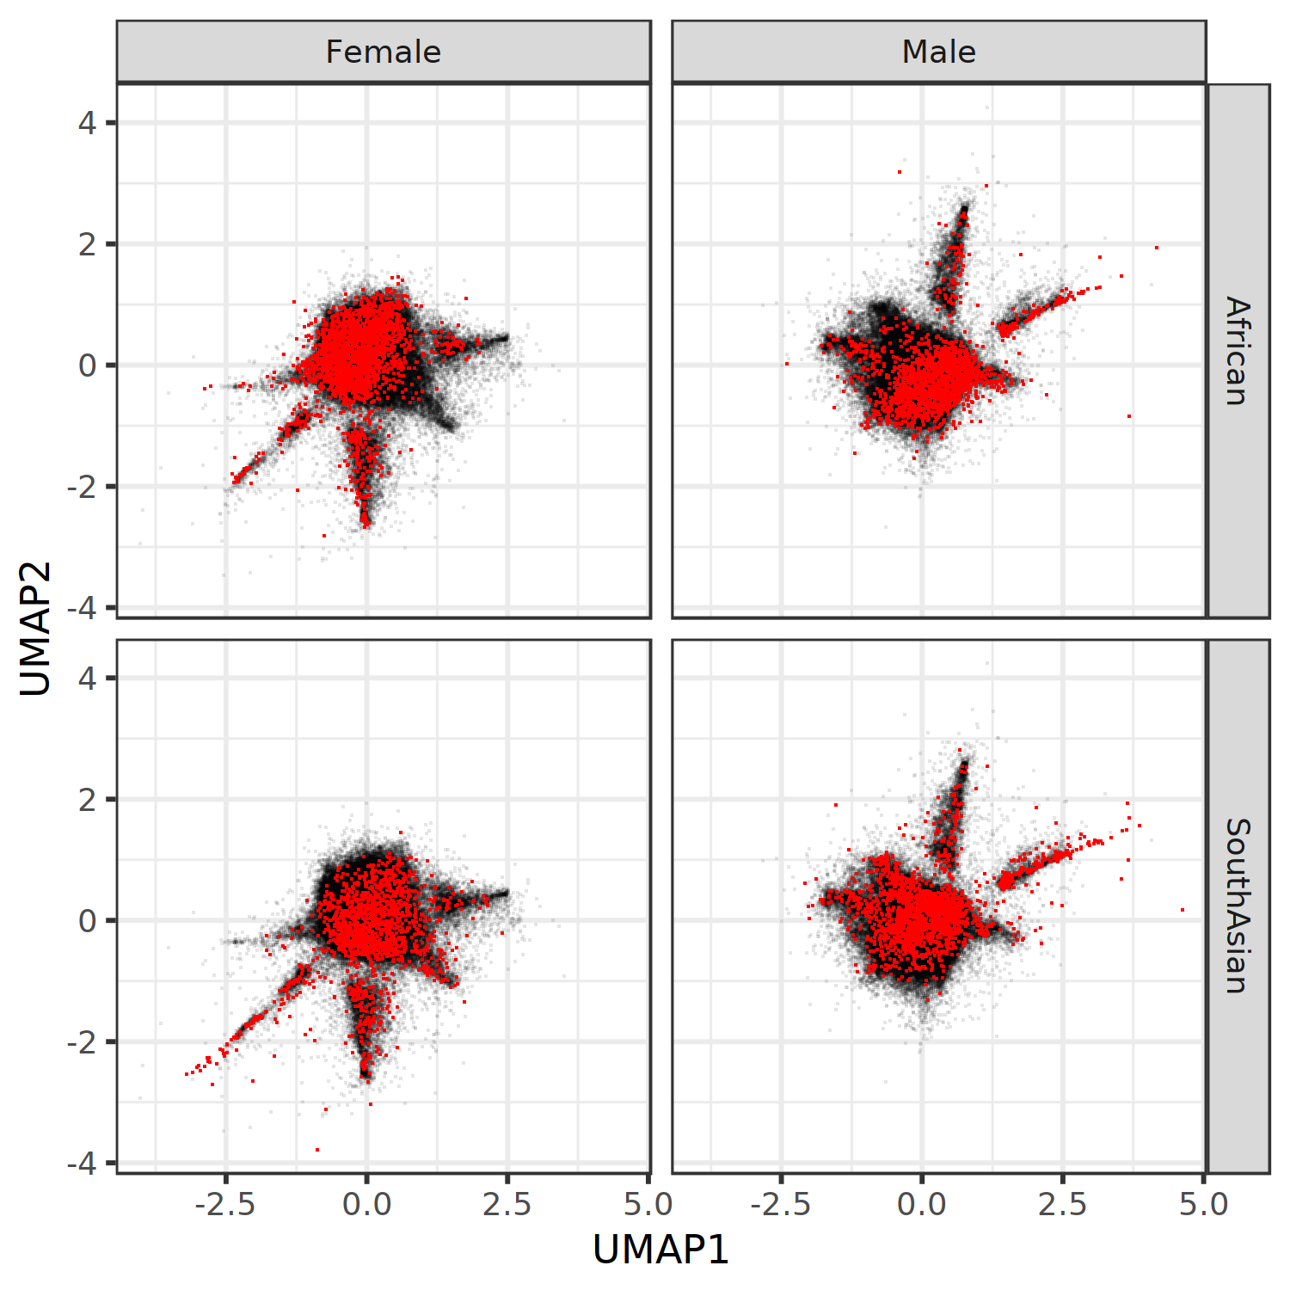
Supplementary Figure 29. Projection of African and South Asian populations from the UK Biobank on the European BMI-discordance projection.

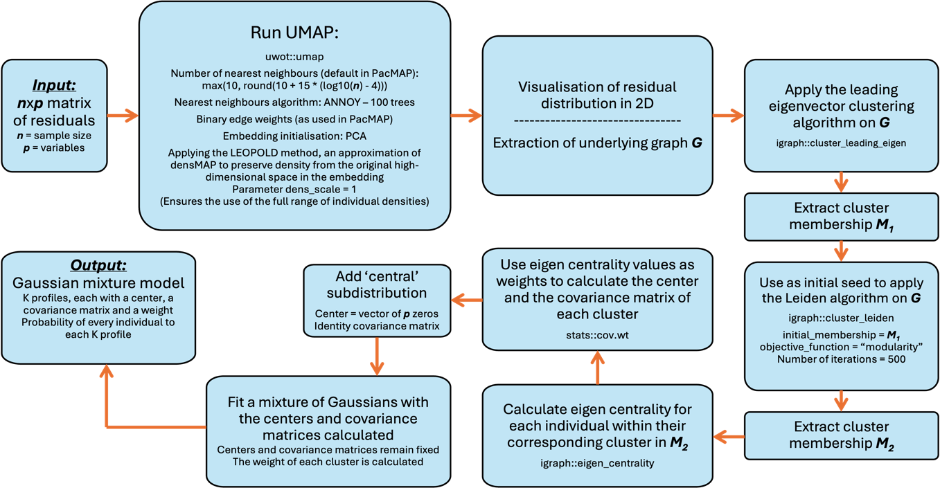
Supplementary Figure 30. Steps to identify discordant profiles.

