The multi integrated DNA Bioinspired hydrogel with synergic effect of MB and AuNP with conductive, self-healing and antibacterial properties as wearable skin-like sensor

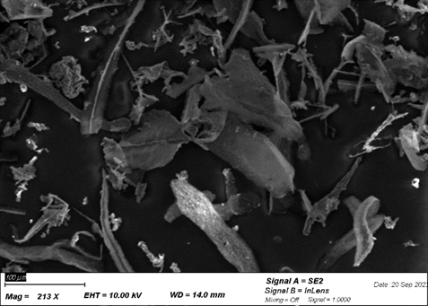
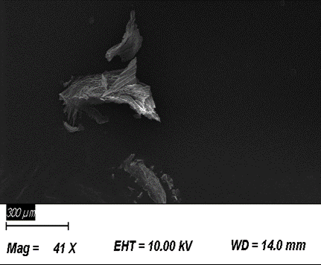
b)
a)

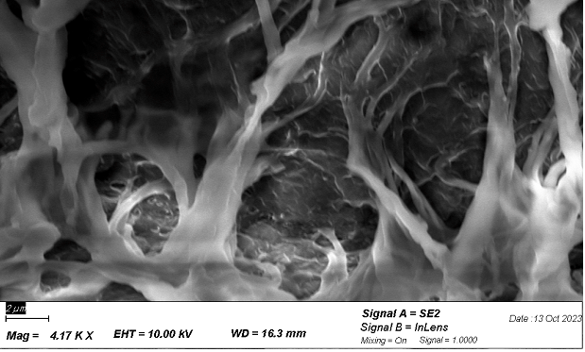
d)
c)

Fig 1S. a,b) The SEM image of the MXene multilayer synthesized via modified hydrofluoric-acid (HF) by freeze drying of suspension of MXene to MXene nanosheets. C,d) PDMM-borax, PM-borax

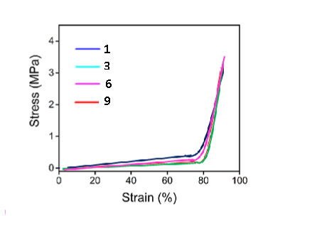

Fig 2S. 9 successive cyclic compressive tests of the PADMM-borax hydrogel hydrogel at 90% strain.

