Gene expression biomarkers differentiate overall survival of colorectal cancer upon targeted therapies
Akram Yazdani*, Azam Yazdani, Raul Mendez-Giraldez, Gianluigi Pillonetto, Esmat Samiei, Reza Hadi, Heinz-Josef Lenz, Alan P Venook, Ahmad Samiei, Andrew B Nixon, Joseph A Lucci 3rd, Scott Kopetz, Monica M Bertagnolli, Charles M Perou, Federico Innocenti

Supplementary
Supplementary figures
Figure S1. Consort chart for RNA-seq data

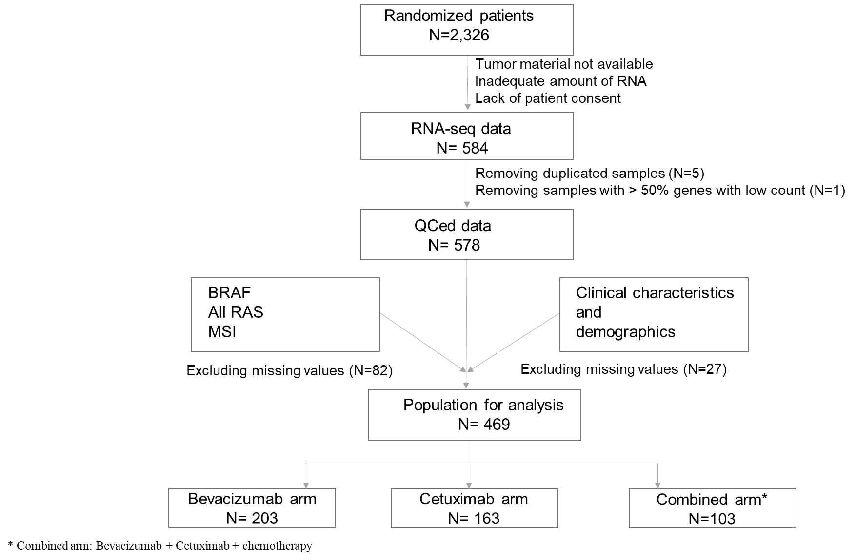
*Combined arm: Bevacizumab + Cetuximab + chemotherapy

Figure S2. Consort chart for germline genotype data
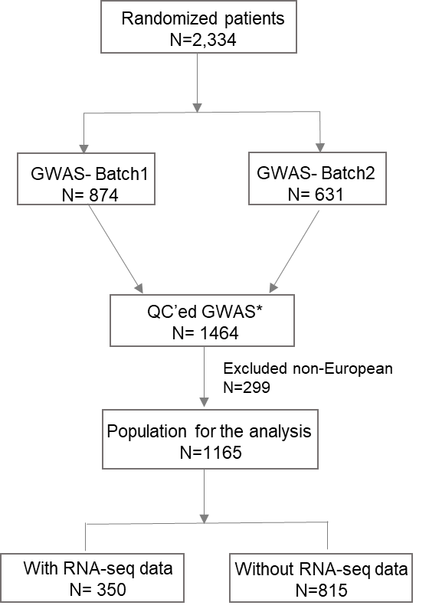

Figure S3. Comparison of the data from CALGB-80405 and TCGA in terms of distribution of OS and events.

Figure S4. Assessing the pleiotropy of cis-eQTLs to find valid IVs for MR analysis. Left panel: The Manhattan plot shows that cis-eQTLs do not significantly affect OS. Right panel: The histogram shows how the p-values corresponding to IVs are distributed.

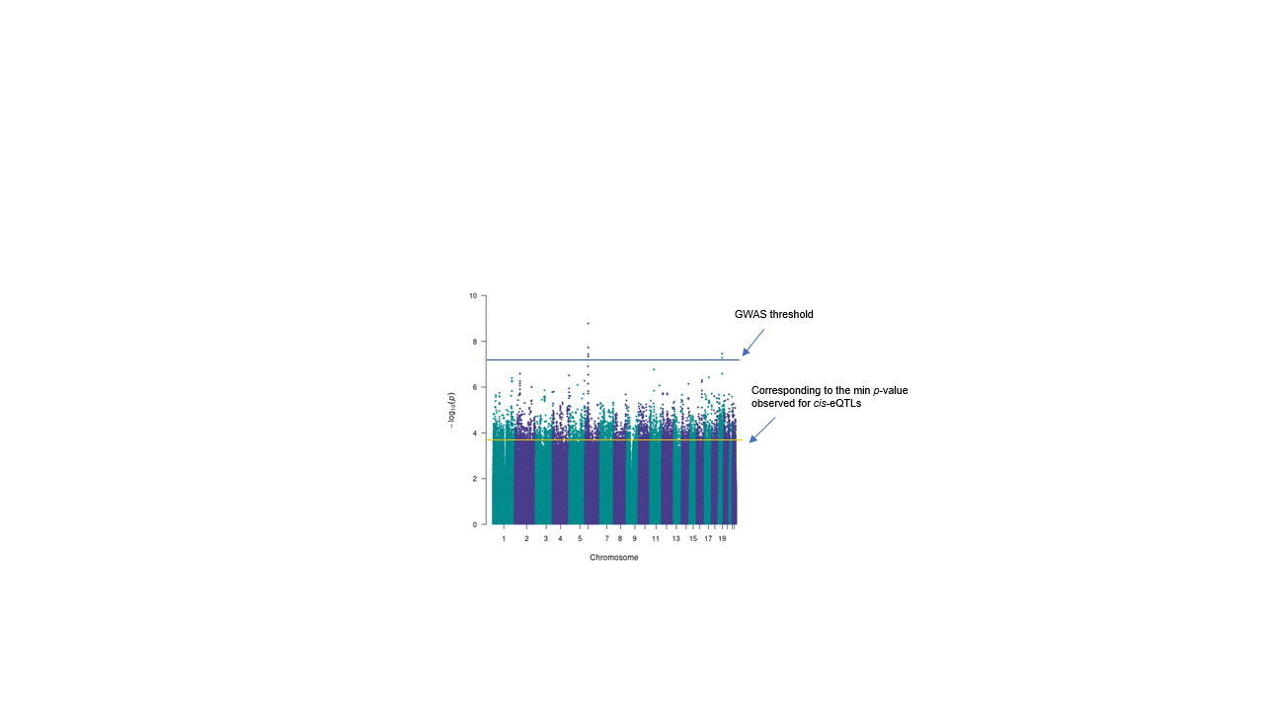

Figure S5. Principal component analysis to assess presents of batch effect on RNA-seq

Figure S6. Gender verification using k means clustering of samples based on expression of genes in chromosome Y.

Figure S7. Histogram of the distance of each cis-eQTL from TSS of the gene
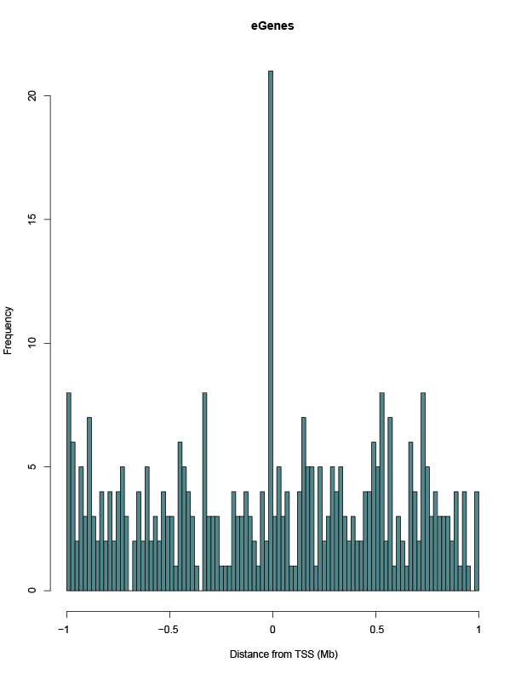

Figure S8. P-values of cis-eQTL vs the distance from TSS of the gene
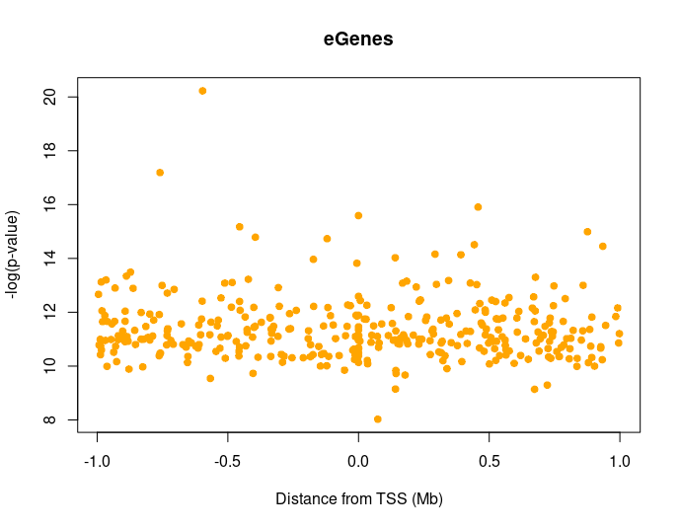

Figure S10. The correlation of first principal components of genotyped data with other covariates

Supplemantery Tables
Table S1. Summary result of additive hazard model for samples under bevacizumab treatment.
Gene Symbol | Ensembl ID | Chr | Z-score | p-value | TCGA  p-value
AC009948.2 | ENSG00000270277 | 2 | -1.677 | 0.0936 | ---
AL022100.1 | ENSG00000227722 | 1 | 1.794 | 0.073 | ---
AP005018.2 | ENSG00000254851 | 11 | -1.715 | 0.086 | ---
APIP | ENSG00000149089 | 11 | -1.879 | 0.060 | 0.05
BMS1P2 | ENSG00000251079 | 10 | 2.935 | 0.003 | ---
CLHC1 | ENSG00000162994 | 2 | 1.722 | 0.085 | 0.034
CMBL | ENSG00000164237 | 5 | -2.372 | 0.018 | 0.0081
COLGALT2 | ENSG00000198756 | 1 | -2.825 | 0.005 | 0.00006
CPT1C | ENSG00000169169 | 19 | -1.780 | 0.0750 | 0.010
DBP | ENSG00000105516 | 19 | 1.842 | 0.065 | 0.0022
EFR3B | ENSG00000084710 | 2 | 2.088 | 0.037 | 0.21
ELOVL6 | ENSG00000170522 | 4 | -1.698 | 0.089 | 0.00067
FTH1P11 | ENSG00000237264 | 8 | -1.786 | 0.074 | ---
GFPT2 | ENSG00000131459 | 5 | 2.086 | 0.036 | 0.019
GNB5 | ENSG00000069966 | 15 | -1.817 | 0.069 | 0.0020
HAAO | ENSG00000162882 | 2 | 2.089 | 0.037 | 0.016
HIST1H1C | ENSG00000187837 | 6 | -1.821 | 0.069 | 0.013
IKZF3 | ENSG00000161405 | 17 | 2.564 | 0.010 | 0.061
IL12RB1 | ENSG00000096996 | 19 | 2.360 | 0.018 | 0.0091
ISM1 | ENSG00000101230 | 20 | 2.287 | 0.022 | 0.0044
KLK11 | ENSG00000167757 | 19 | 1.711 | 0.087 | 0.13
LIPH | ENSG00000163898 | 3 | 2.165 | 0.030 | 0.14
LTF | ENSG00000012223 | 3 | -2.207 | 0.027 | 0.059
MCU | ENSG00000156026 | 10 | 2.051 | 0.040 | 0.030
MITF | ENSG00000187098 | 3 | -2.187 | 0.029 | 0.030
MMP7 | ENSG00000137673 | 11 | 1.782 | 0.075 | 0.042
NCAPH | ENSG00000121152 | 2 | 1.686 | 0.092 | 0.029
NDRG1 | ENSG00000104419 | 8 | 3.227 | 0.001 | 0.085
NEBL | ENSG00000078114 | 10 | -2.069 | 0.039 | 0.034
NPM1 | ENSG00000181163 | 5 | 1.788 | 0.074 | 0.022
NWD1 | ENSG00000188039 | 19 | -1.671 | 0.095 | 0.031
OSBPL1A | ENSG00000141447 | 18 | 1.803 | 0.071 | 0.0098
OXER1 | ENSG00000162881 | 2 | -2.306 | 0.021 | 0.031
PLA2G10 | ENSG00000069764 | 16 | -2.108 | 0.035 | 0.067
RNF122 | ENSG00000133874 | 8 | 2.652 | 0.008 | 0.021
RNF144B | ENSG00000137393 | 6 | -1.917 | 0.055 | 0.16
SCD5 | ENSG00000145284 | 4 | -2.035 | 0.042 | 0.29
SEMA6C | ENSG00000143434 | 1 | -2.047 | 0.041 | 0.0016
SLC40A1 | ENSG00000138449 | 2 | -2.435 | 0.015 | 0.094
SMN1 | ENSG00000172062 | 5 | 1.892 | 0.058 | 0.32
SYN3 | ENSG00000185666 | 22 | 2.120 | 0.034 | 0.0022
TNFAIP2 | ENSG00000185215 | 14 | 1.811 | 0.070 | 0.0016
TTN | ENSG00000155657 | 2 | -1.888 | 0.059 | 0.18
ZNF135 | ENSG00000176293 | 19 | -1.977 | 0.048 | 0.065
ZNF322 | ENSG00000181315 | 6 | -2.068 | 0.039 | 0.052
ZNF345 | ENSG00000251247 | 19 | 1.820 | 0.069 | 0.22
ZNF772 | ENSG00000197128 | 19 | 1.957 | 0.050 | 0.11

Table S2. Summary result of additive hazard model for samples under cetuximab treatment.
Gene Symbol | Ensembl ID | Chr | Z-score | p-value | TCGA  p-value
ABRACL | ENSG00000146386 | 6 | -1.843 | 0.065 | 0.093
ALDH4A1 | ENSG00000159423 | 1 | 2.228 | 0.026 | 0.014
CMBL | ENSG00000164237 | 5 | -1.682 | 0.093 | 0.0081
DSPP | ENSG00000152591 | 4 | 2.317 | 0.021 | ---
DTNA | ENSG00000134769 | 18 | -1.883 | 0.060 | 0.0031
DUSP6 | ENSG00000139318 | 12 | 2.483 | 0.013 | 0.058
FAM86B1 | ENSG00000186523 | 8 | -2.851 | 0.004 | 0.28
GNB5 | ENSG00000069966 | 15 | 2.070 | 0.038 | 0.0020
HAAO | ENSG00000162882 | 2 | -1.753 | 0.080 | 0.016
HLA-DRB6 | ENSG00000229391 | 6 | -2.273 | 0.023 | ---
IL2RA | ENSG00000134460 | 10 | -1.772 | 0.076 | 0.017
MCU | ENSG00000156026 | 10 | 1.801 | 0.072 | 0.030
MUC3A | ENSG00000169894 | 7 | 2.175 | 0.030 | 0.17
MYO1G | ENSG00000136286 | 7 | -2.512 | 0.012 | 0.0052
NPDC1 | ENSG00000107281 | 9 | 1.858 | 0.063 | 0.000020
OSBPL1A | ENSG00000141447 | 18 | 2.471 | 0.013 | 0. 0098
PCDHB17P | ENSG00000255622 | 5 | 1.872 | 0.061 | ---
PCP4 | ENSG00000183036 | 21 | -1.950 | 0.051 | 0.053
POMP | ENSG00000132963 | 13 | 2.472 | 0.013 | 0.23
RAE1 | ENSG00000101146 | 20 | -1.819 | 0.069 | 0.045
RCOR2 | ENSG00000167771 | 11 | 1.746 | 0.081 | 0.041
RIOK3 | ENSG00000101782 | 18 | 1.817 | 0.069 | 0.24
SELENOP | ENSG00000250722 | 5 | -2.477 | 0.013 | 0.0043
SLC45A2 | ENSG00000164175 | 5 | -2.405 | 0.016 | 0.35
SUSD4 | ENSG00000143502 | 1 | 2.065 | 0.039 | 0.0013
TCEA3 | ENSG00000204219 | 1 | 2.103 | 0.035 | 0.092
TG | ENSG00000042832 | 8 | -2.307 | 0.021 | 0.00074
TSPAN13 | ENSG00000106537 | 7 | 2.541 | 0.011 | 0.15
WDR62 | ENSG00000075702 | 19 | 1.777 | 0.076 | 0.032
ZNF493 | ENSG00000196268 | 19 | -1.650 | 0.099 | 0.13
ZNF841 | ENSG00000197608 | 19 | 2.850 | 0.004 | 0.036
ZNF99 | ENSG00000213973 | 19 | -2.257 | 0.024 | 0.042

Table 3. Replication of one-sample MR findings using two-sample MR techniques, determined by hazard ratio.
Gene Symbol | Ensembl ID | Chr | Bevacizumab |  | Cetuximab
Gene Symbol | Ensembl ID | Chr | Z-score | p-value | Z-score | p-value
OSBPL1A | ENSG00000141447 | 18 | -1.226 | 0.22 | 1.23 | 0.218
SEMA6C | ENSG00000143434 | 1 | 1.28 | 0.201 | 0.537 | 0.591
SCD5 | ENSG00000145284 | 4 | -1.781 | 0.075 | -0.2 | 0.841
WDR62 | ENSG00000075702 | 19 | -1.42 | 0.156 | 2.646 | 0.008
TCEA3 | ENSG00000204219 | 1 | -0.398 | 0.69 | 0.099 | 0.921

Table S4. Patient clinical demographics and characteristics in CALGB-80405 trial. Comparisons are between the population with the RNA-seq data and the population without it.
 |  | Population without  RNAseq  (N=1748) | Population with RNAseq  (N=578) | Total  (N=2326) | P value
Age (years) |  |  |  |  | 0.01¹
Median |  | 58.91 | 60.36 | 59.14
Range |  | (20.77-89.51) | (23.99-83.45) | (20.77-89.51)
Arm |  |  |  |  | 0.49²
Bevacizumab+chemotherapy |  | 662 (37.9%) | 235 (40.6%) | 897 (38.6%)
Cetuximab+chemotherapy |  | 681 (39.0%) | 216 (37.4%) | 897 (38.6%)
Bevacizumab/cetuximab+chemotherapy |  | 405 (23.1%) | 127 (22.0%) | 532 (22.8%)
Chemotherapy |  |  |  |  | 0.275²
FOLFOX |  | 1359 (77.7%) | 436 (75.4%) | 1795 (76.2%)
FOLFIRI |  | 389 (22.3%) | 142 (24.5%) | 531 (22.1%)
Prior Adjuvant Chemotherapy |  |  |  |  | 0.123²
No |  | 1486 (85.0%) | 507 (87.7%) | 1993 (85.7%)
Yes |  | 262 (15.0%) | 71 (12.3%) | 333 (14.3%)
Gender |  |  |  |  | 0.08²
Male |  | 1000 (57.2%) | 355 (61.4%) | 1355 (58.3%)
Female |  | 748 (42.8%) | 223 (38.6%) | 971 (41.7%)
Race |  |  |  |  | <0.0001²
Unknown |  | 51 (2.9%) | 3 (0.5%) | 54 (2.3%)
White |  | 1396 (79.9%) | 500 (86.5%) | 1896 (81.7%)
African American |  | 225 (12.9%) | 53 (9.2%) | 278 (12.0%)
Asian |  | 60 (3.4%) | 13 (2.2%) | 73 (3.1%)
Native Hawaiian or Pacific Islander |  | 7 (0.4%) | 0 (0.0%) | 7 (0.3%)
American Indian or Alaska Native |  | 8 (0.5%) | 3 (0.005%) | 11 (0.5%)
More than one race |  | 1 (0.1%) | 5 (0.8%) | 6 (0.3%)
ECOG Performance Status |  |  |  |  | 0.461²
0 |  | 1030 (58.9%) | 331 (57.2%) | 1361 (58.5%)
1 |  | 715 (40.9%) | 247 (42.7%) | 962 (41.4%)
2 |  | 3 (0.2%) | 0 (0.0%) | 3 (0.1%)
Overall Survival (months) |  |  |  |  | 0.04³
Median (95% CI) |  | 24.5 (23.6-25.8) | 27.5 (25.6-30.2) | 25.4 (24.4-26.4)
Progression-Free Survival (months) |  |  |  |  | 0.005³
Median (95% CI) |  | 9.66 (9.35-10.1) | 10.6 (9.59-11.3) | 9.82 (9.49-10.2)
¹Kruskal Wallis ²Chi-Square ³Log-rank

