Interactions between the gut microbiome, associated metabolites and the manifestation and progression of heart failure with preserved ejection fraction in ZSF1 rats

Salmina J. Guivala, Konrad A Bode, Jürgen G Okun, Ece Kartal, Luca Valentina Pohl, Sarah Werner, Sandra Erbs, Holger Thiele, Petra Büttner

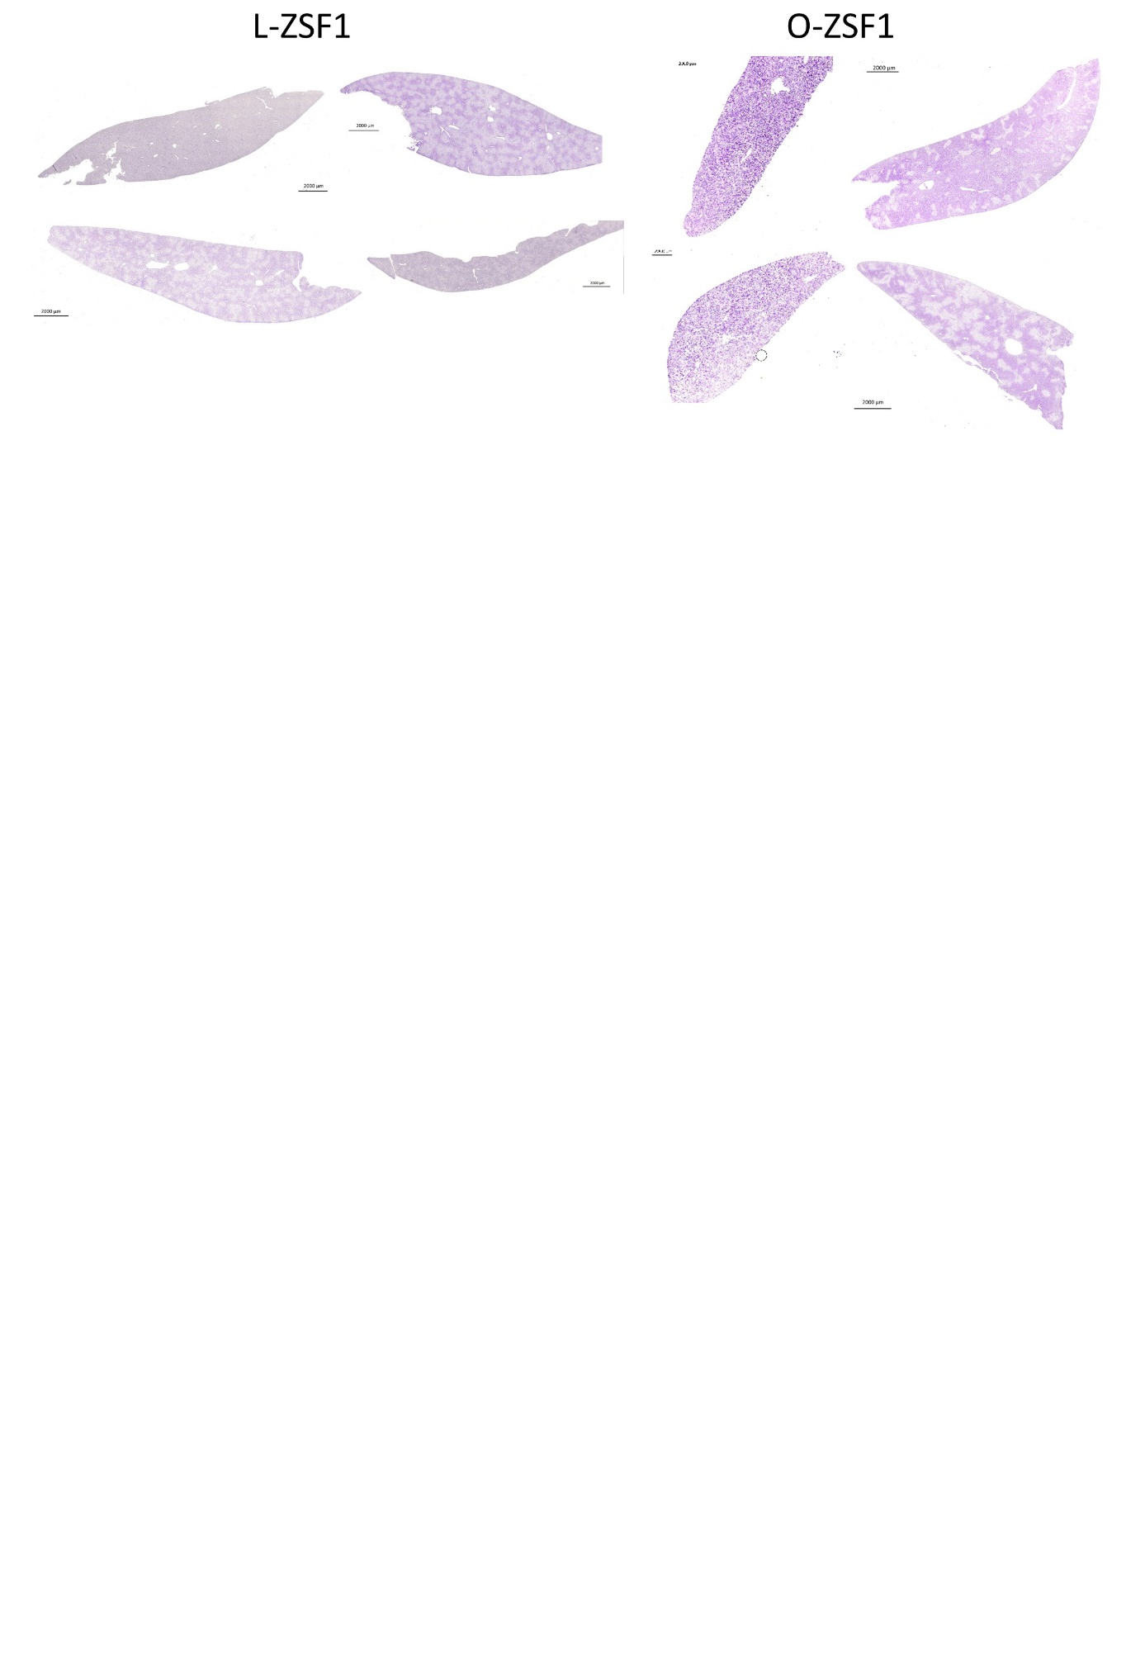

Supplementary figure 1: Histological analysis of ZSF1 liver glycogen content using periodic acid shift (PAS) staining. Four exemplarily individual liver stains per experimental group are presented. The PAS stains glycogen blue to violet. This was more pronounced in O-ZSF1 rats, indicating higher glycogen level.

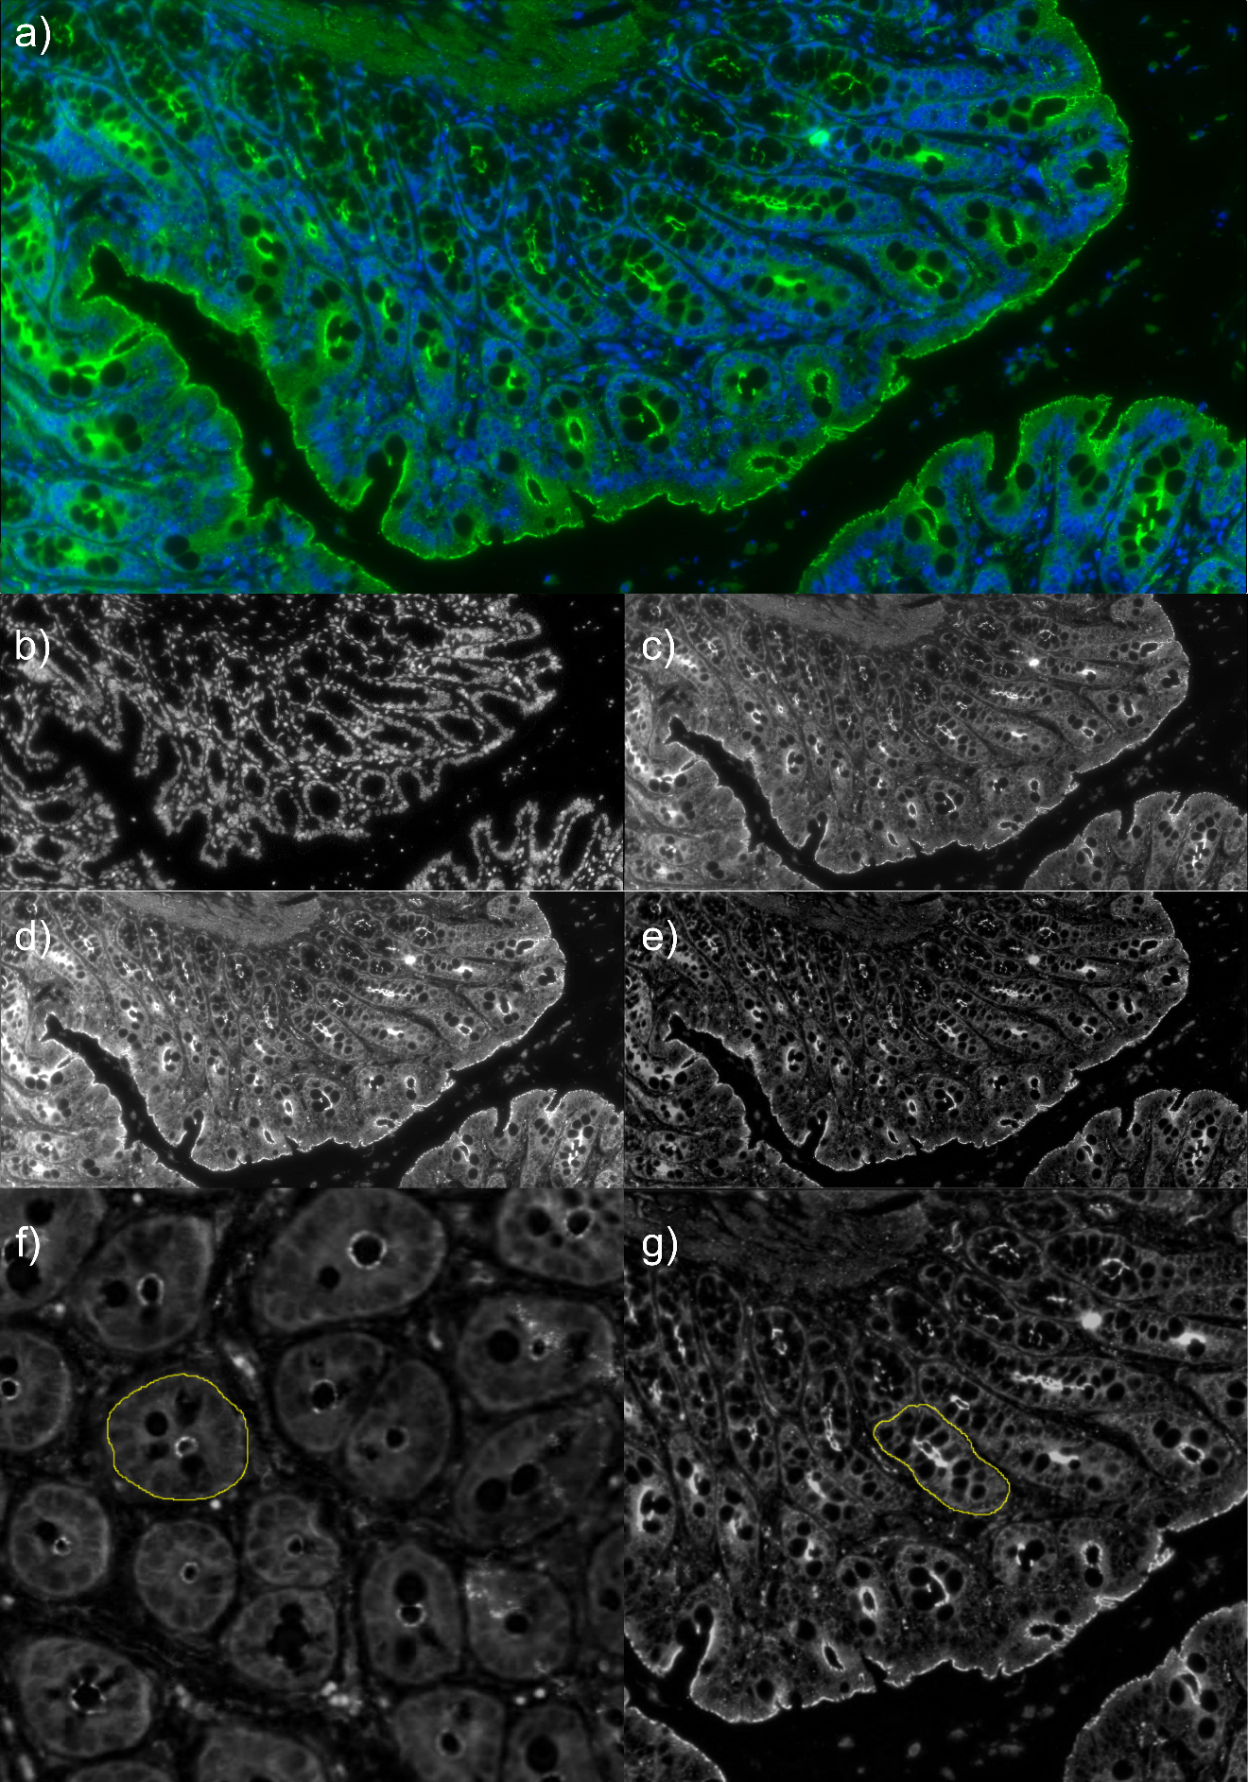Supplementary figure 2: Image Processing and Analysis of ZO1-antibody-staining images using Image J / Fiji. a) Immunohistochemistry image stained with ZO1-antibodies in a colon sample of a lean ZSF1 rat, b) 8-bit image of the blue channel and c) 8-bit image of the green changel after splitting channels, d) green channel image after automatically adjusting brightness & contrast, e) the same image after subtracting background noise using a rolling ball radius of 50 pixel, f) and g) adjusted images showing colon crypts circled as regions of interest

Supplementary Figure 4: Upper panels - Phylum-level core microbiome composition for individual samples over time in lean (L-ZSF1) and obese (O-ZSF1) animals determined at eight (baseline), 13 and 20 weeks using relative abundance of phylae. Taxa were aggregated on the phylum-level using a detection threshold of 0.001 and a prevalence threshold of 0.1. Lower panels - Family-level core microbiome composition for individual samples over time in lean and obese animals at eight, 13 and 20 weeks using relative abundance of families and portraying the top five most prevalent families. Taxa were aggregated on the family-level using a detection threshold of 0.01 and a prevalence threshold of 0.5.
Supplementary Table 1: Differential Abundance Level at 20 weeks of age. Phylum: F=Firmicutes, B=Bacteroidetes, FC=fold change, Genus [species] – when the species was identified the information is given as an extension of the genus in brackets. Padj – P-value adjusted for multiple testing.

Phylum | Class | Order | Family | Genus [species] | log2FC | padj
F | Clostridia | Clostridiales | Ruminococcaceae | Ruminococcus | -2.4 | 0.000
F | Clostridia | Clostridiales |  |  | . | 0.000
B | Bacteroidia | Bacteroidales | S24-7 |  | -3.1 | 0.004
F | Clostridia | Clostridiales | Ruminococcaceae |  | 7.3 | 0.004
F | Clostridia | Clostridiales | Lachnospiraceae |  | 4. | 0.00
F | Clostridia | Clostridiales |  |  | .4 | 0.00
F | Clostridia | Clostridiales |  |  | 3.7 | 0.006
F | Clostridia | Clostridiales | Ruminococcaceae | Oscillospira | .9 | 0.006
F | Clostridia | Clostridiales | Lachnospiraceae | Ruminococcus [gnavus] | -4.0 | 0.008
F | Clostridia | Clostridiales |  |  | 7.0 | 0.008
F | Bacilli | Lactobacillales | Lactobacillaceae | Lactobacillus | -3.7 | 0.008
F | Clostridia | Clostridiales |  |  | -8.7 | 0.009
F | Erysipelotrichi | Erysipelotrichales | Erysipelotrichaceae | Allobaculum | -4.2 | 0.009
F | Clostridia | Clostridiales | Ruminococcaceae | Ruminococcus | . | 0.011
F | Clostridia | Clostridiales |  |  | -4.8 | 0.014
F | Clostridia | Clostridiales |  |  | 8.7 | 0.014
F | Clostridia | Clostridiales | Lachnospiraceae |  | -3.9 | 0.014
F | Clostridia | Clostridiales |  |  | 3.9 | 0.01
F | Clostridia | Clostridiales | Lachnospiraceae | Ruminococcus [gnavus] | 2.4 | 0.01
F | Bacilli | Lactobacillales | Lactobacillaceae | Lactobacillus | -3.9 | 0.01
F | Clostridia | Clostridiales |  |  | -4.9 | 0.01
F | Clostridia | Clostridiales | Lachnospiraceae | Coprococcus | -.9 | 0.018
F | Clostridia | Clostridiales | Ruminococcaceae | Oscillospira | 3. | 0.020
B | Bacteroidia | Bacteroidales | S24-7 |  | -2.8 | 0.020
F | Clostridia | Clostridiales |  |  | 8.2 | 0.020
F | Clostridia | Clostridiales | Lachnospiraceae | Blautia | -6.6 | 0.021
F | Clostridia | Clostridiales |  |  | -4. | 0.021
F | Clostridia | Clostridiales |  |  | -6.3 | 0.021
F | Bacilli | Lactobacillales | Lactobacillaceae | Lactobacillus | -2.7 | 0.02
F | Clostridia | Clostridiales |  |  | 4.1 | 0.028
F | Clostridia | Clostridiales |  |  | 3.4 | 0.029
F | Clostridia | Clostridiales | Ruminococcaceae | Oscillospira | 4.0 | 0.029
F | Clostridia | Clostridiales |  |  | -.0 | 0.029
F | Clostridia | Clostridiales | Lachnospiraceae |  | 3.6 | 0.029
F | Clostridia | Clostridiales |  |  | 3. | 0.029
F | Bacilli | Lactobacillales | Lactobacillaceae | Lactobacillus | -2.0 | 0.030
F | Clostridia | Clostridiales |  |  | 3.4 | 0.030
F | Clostridia | Clostridiales | Ruminococcaceae | Ruminococcus | 3.9 | 0.033
F | Clostridia | Clostridiales |  |  | -6.4 | 0.034
F | Clostridia | Clostridiales | Ruminococcaceae | Oscillospira | 3.6 | 0.034
F | Clostridia | Clostridiales |  |  | 2.0 | 0.034
F | Clostridia | Clostridiales |  |  | -4.9 | 0.03
F | Clostridia | Clostridiales | Lachnospiraceae | Ruminococcus [gnavus] | -3.7 | 0.03
F | Bacilli | Lactobacillales | Lactobacillaceae | Lactobacillus [reuteri] | -1.4 | 0.039
F | Clostridia | Clostridiales | Lachnospiraceae |  | 3.6 | 0.039
F | Clostridia | Clostridiales |  |  | -7.6 | 0.039
B | Bacteroidia | Bacteroidales | Rikenellaceae |  | -2.1 | 0.041
F | Clostridia | Clostridiales |  |  | 3.2 | 0.041
F | Clostridia | Clostridiales | Lachnospiraceae | Coprococcus | -6.6 | 0.04
F | Clostridia | Clostridiales | Ruminococcaceae | Oscillospira | 2.6 | 0.047
F | Clostridia | Clostridiales | Lachnospiraceae |  | 4.1 | 0.048
F | Clostridia | Clostridiales |  |  | 3.6 | 0.048
F | Clostridia | Clostridiales | Ruminococcaceae | Ruminococcus | 4.0 | 0.048

Supplementary information on the R-Packages that were used in this study

“cowplot” - Wilke C (2020). _cowplot: Streamlined Plot Theme and Plot Annotations for 'ggplot2'_. R package version 1.1.1, <https://CRAN.R-project.org/package=cowplot>.

“DESeq2” - Love, Michael I.; Huber, Wolfgang; Anders, Simon (2014): Moderated estimation of fold change and dispersion for RNA-seq data with DESeq2. In: Genome biology 1 (12), S. 0. DOI: 10.1186/s1309-014-00-8.

“ggplot2” - Wickham, Hadley (2016): ggplot2. Elegant Graphics for Data Analysis. 2nd ed. 2016. Cham: Springer International Publishing; Imprint: Springer (Use R!).

“gridExtra” - Auguie B (2017). _gridExtra: Miscellaneous Functions for "Grid" Graphics_. R package version 2.3, <https://CRAN.R-project.org/package=gridExtra>.

“microbiome” - Leo Lahti et al. (2012-2019): microbiome R package. <https://microbiome.github.io>

“phyloseq” - McMurdie, Paul J.; Holmes, Susan (2013): phyloseq: an R package for reproducible interactive analysis and graphics of microbiome census data. In: PloS one 8 (4), e61217. DOI: 10.1371/journal.pone.0061217.

“vegan” - Oksanen J, Simpson G, Blanchet F et al. (2022): _vegan: Community Ecology Package_. R package version 2.6-4, <https://CRAN.R-project.org/package=vegan>

