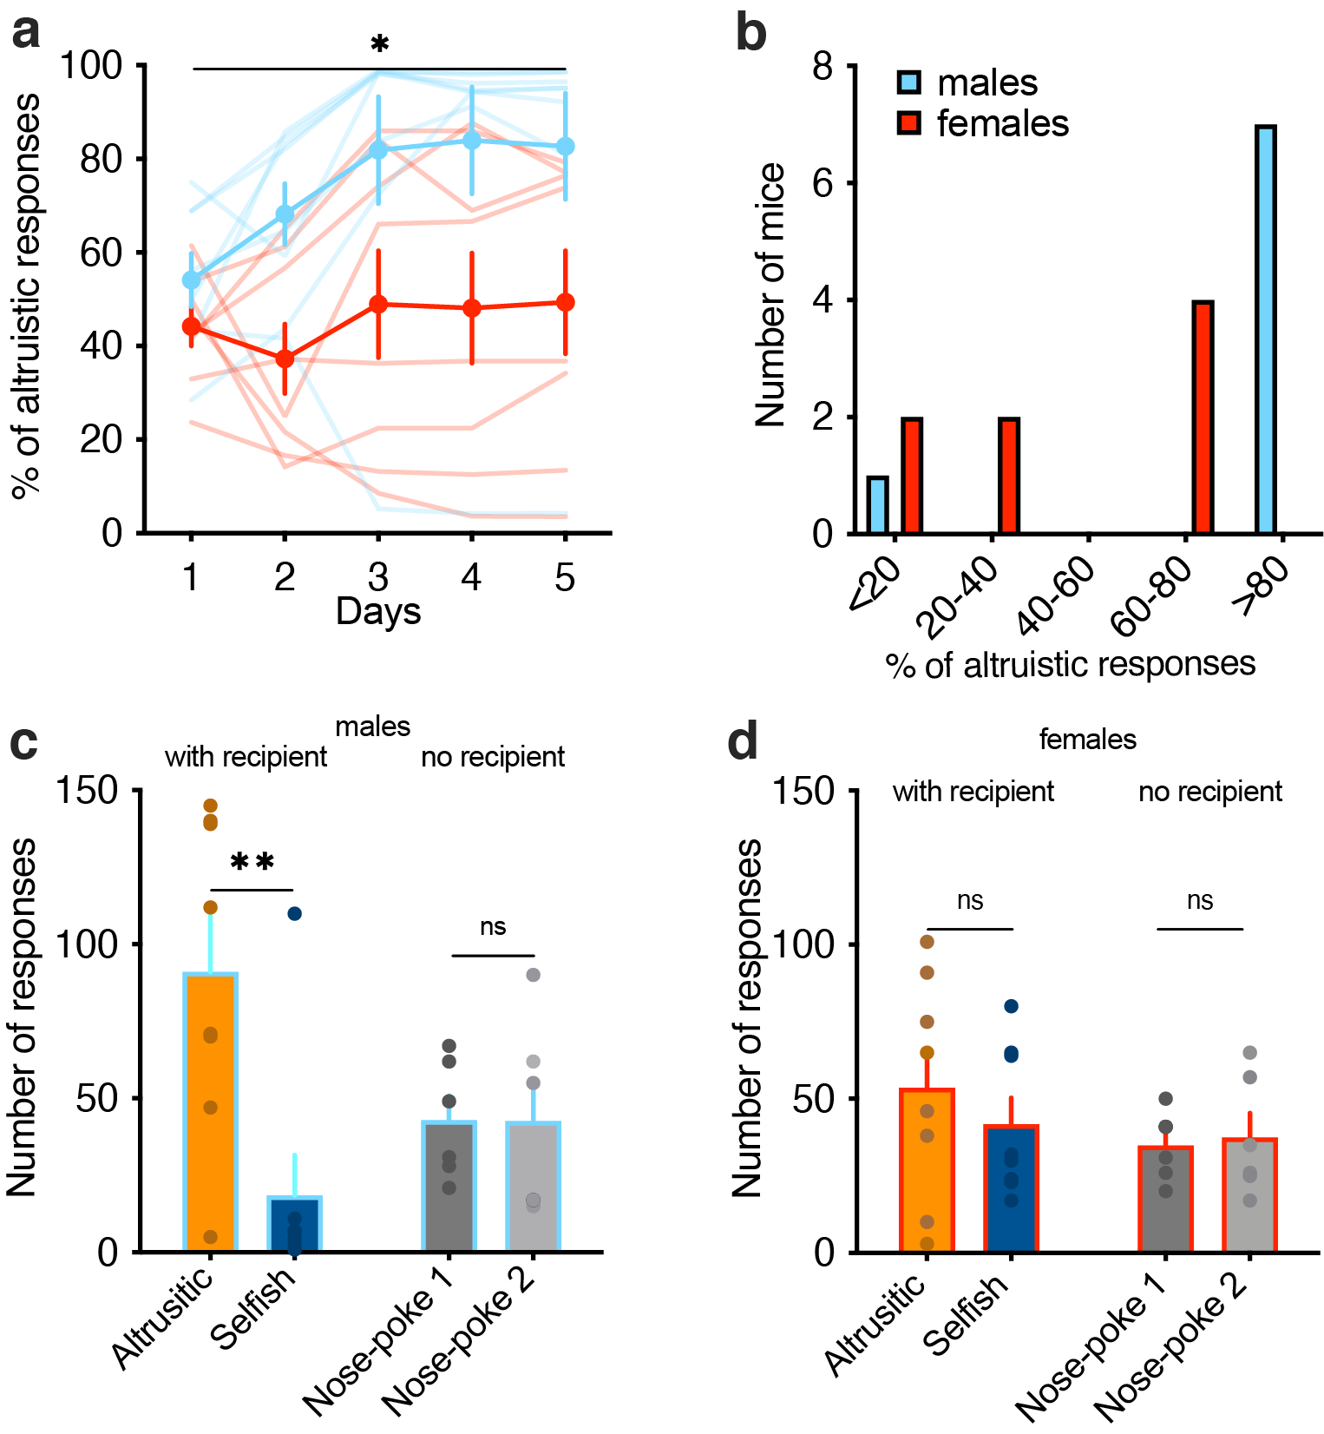
Supplementary Figure 1. Males make more altruistic responses than females. a, altruistic responses in males and females across five days of testing in the SDM (two-way RM ANOVA, gender, F_{(1, 14)}=5.90, p=0.0292; time (days 1-5), F_{(4, 56)}=4.59, p=0.0028). b, number of tested mice grouped by gender and by percentage of altruistic responses. c, number of nose pokes responses in male mice tested in the conditions with recipient, altruistic (orange) and selfish (blue), and no recipient, nose-poke 1 (dark grey) and nose-poke 2 (light grey), on day five of the SDM (two-way ANOVA, group (with recipient, no recipient) x response (nose-poke 1, nose-poke 2), F_{(1, 24)}=6.2, p=0.0199). d, number of nose pokes responses in female mice tested in the conditions with recipient and no recipient, nose-poke 1 (two-way ANOVA, group (with recipient, no recipient), F_{(1, 12)}=4.1, p=0.0630). *p<0.05, **p<0.01, n.s., not significant.

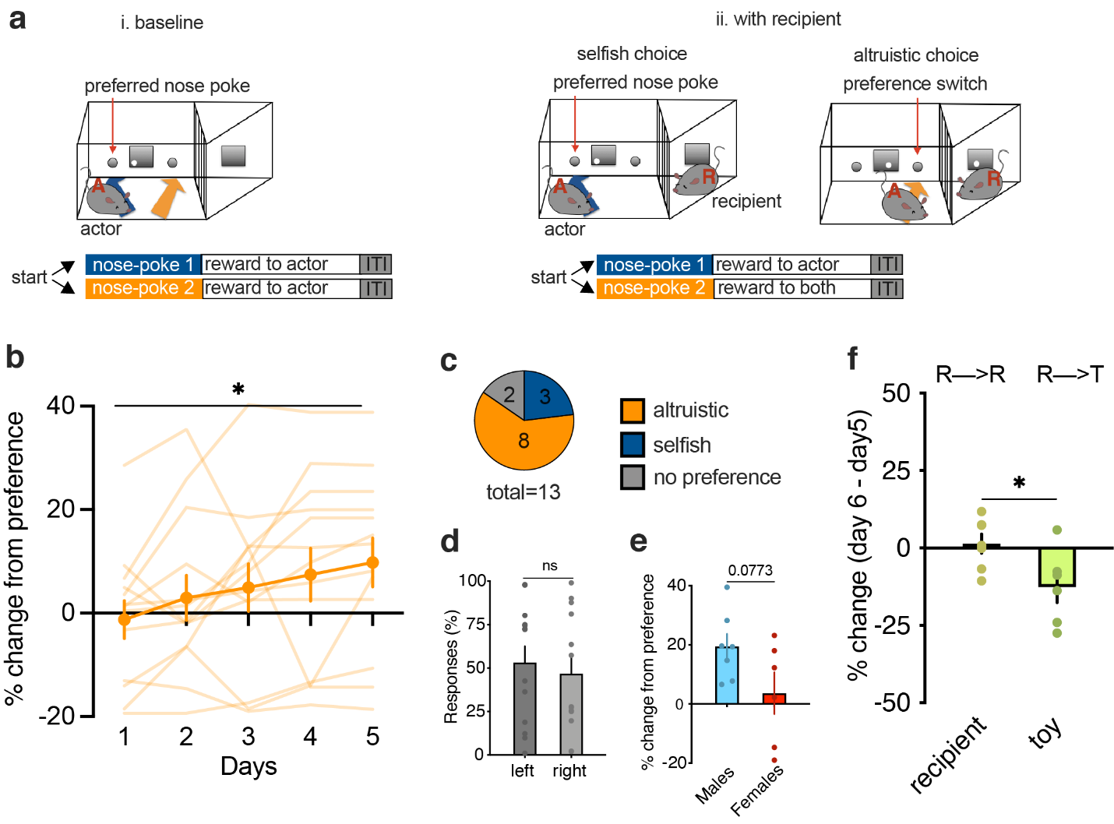
Supplementary Figure 2. Mice change their responses to share food rewards with their conspecifics. a, experimental design of the SDM. Actor mice were trained on a two-choice decision paradigm where nose pokes resulted in food rewards. In the condition i.‘with recipient’ (orange) one nose poke resulted in food reward to actor (selfish choice) and the other nose poke in food reward both to the actor and to the recipient, in the adjacent compartment (altruistic choice). After an inter-trial interval of 5 seconds (ITI), a new trial started and actor could make their choice. The location of the two responses were counterbalanced between left and right nose-pokes. In the condition ii. ‘no recipient’ (grey) the structure of the task was identical, but the adjacent compartment was empty. iii. In the condition ‘with toy’, the recipient was replaced. b, change of preference (in percentage) to altruistic responses during the SDM with recipient compared to the baseline (one-sample t-test, t=2.36, d.f.=64, p=0.0211, n=13). c, number of tested mice grouped by preference. d, nose poke responses (in percentage) during baseline training in the right and left nose-poke were not different at the group level (two-tailed paired t-test: t=0.47, d.f.=24, p=0.6423). d, change of preference (in percentage) to altruistic responses during the last session of SDM in males compared to females (two-tailed paired t-test: t=1.94, d.f.=11, p=0.0773). f, change of preference when animals were tested one additional day with their recipient (RR) or with an inanimate object (toy, RT) (two-tailed unpaired t-test, t=2.49, d.f.=11, p=0.0296). *p<0.05. Values are expressed as mean ± s.e.m.
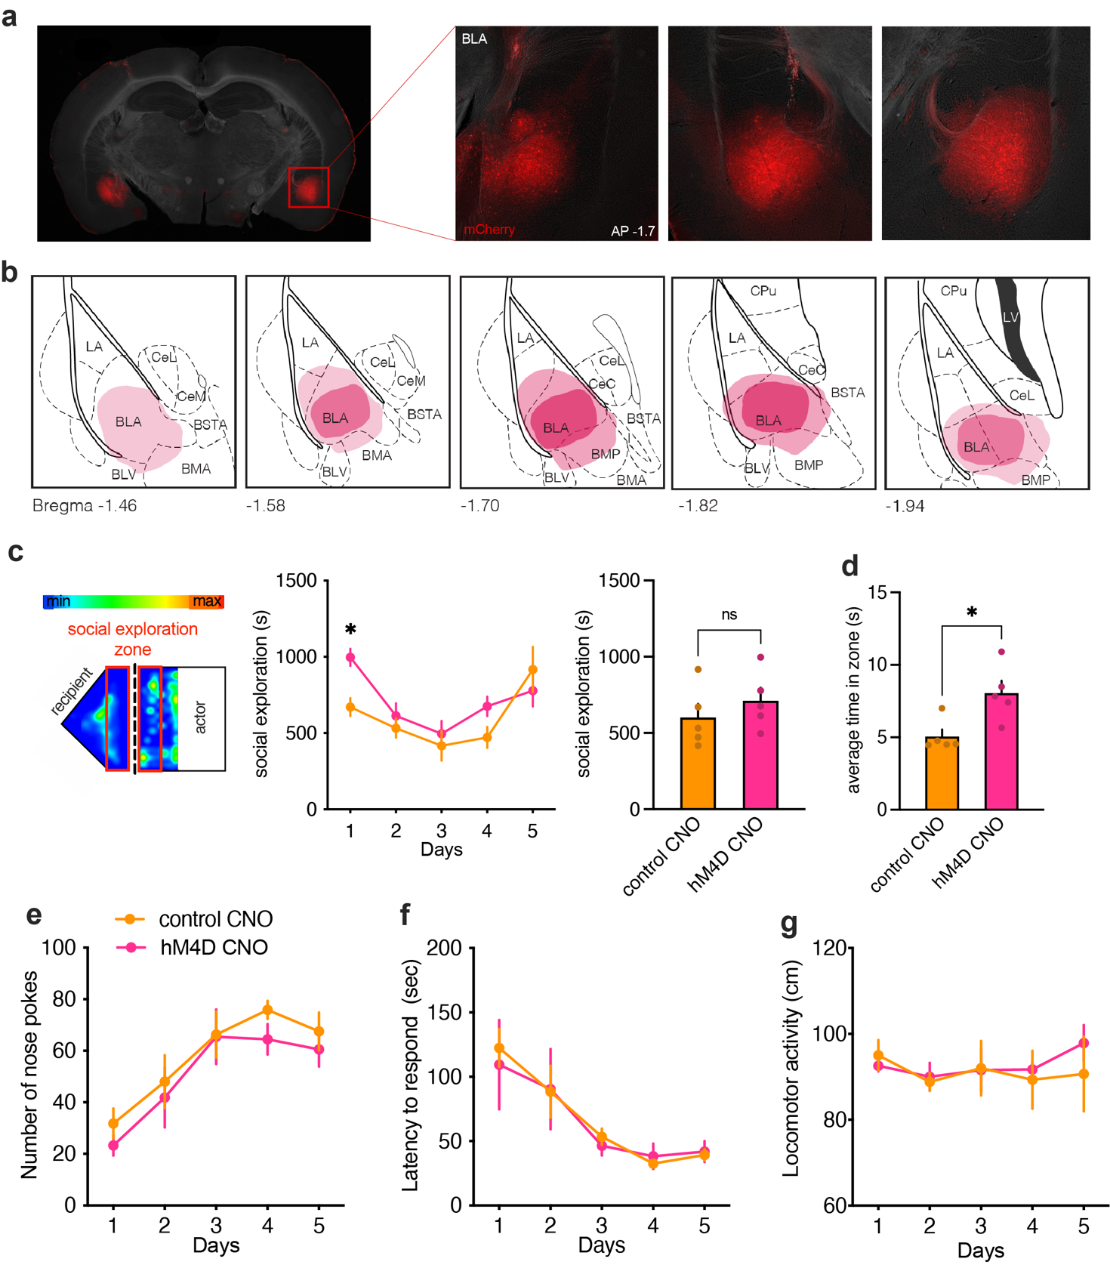
Supplementary Figure 3. BLA neuronal silencing do not affect social exploration and learning. a, representative images of viral expression in the BLA after injection with AAV-CamKIIa-hM4D-mCherry. b, reconstruction of viral expression. Red areas represent viral expression (higher expression = darker color). c, left, schematic illustration of the actor-recipient testing chambers with graphical representation of the amount of time mice spent in different parts of the chambers (with blue as the shortest and red as the longest time). Social exploration was measured in the area highlighted in red) and social exploration (in seconds) of control CNO and hM4D CNO mice towards their recipients during the SDM task (two-way ANOVA, group (control CNO, hM4D CNO), F_{(1, 11)}=1.66, p=0.22; n=6/7 each group). Right, average social exploration across days in control CNO and hM4D CNO mice (two-tailed paired t-test: t=0.89, d.f.=8, p=0.3968). e, average time spent in the social exploration zone during each visit in control CNO and hM4D CNO (two-tailed paired t-test: t=3.05, d.f.=8, p=0.0156). f, number of nose pokes (two-way ANOVA, group (control CNO, hM4D CNO), F_{(1, 13)}=0.54, p=0.4721; n=6/7 each group), g, latency to respond (two-way ANOVA, group (control CNO, hM4D CNO), F_{(1, 11)}=0.02, p=0.8777; n=6/7 each group), and h, locomotor activity (two-way ANOVA, group (control CNO, hM4D CNO), F_{(1, 11)}=0.10, p=0.7566; n=6/7 each group), during the five days of testing in the SDM task in control CNO and hM4D CNO mice. *p<0.05. n.s. not significant. Values are expressed as mean ± s.e.m.
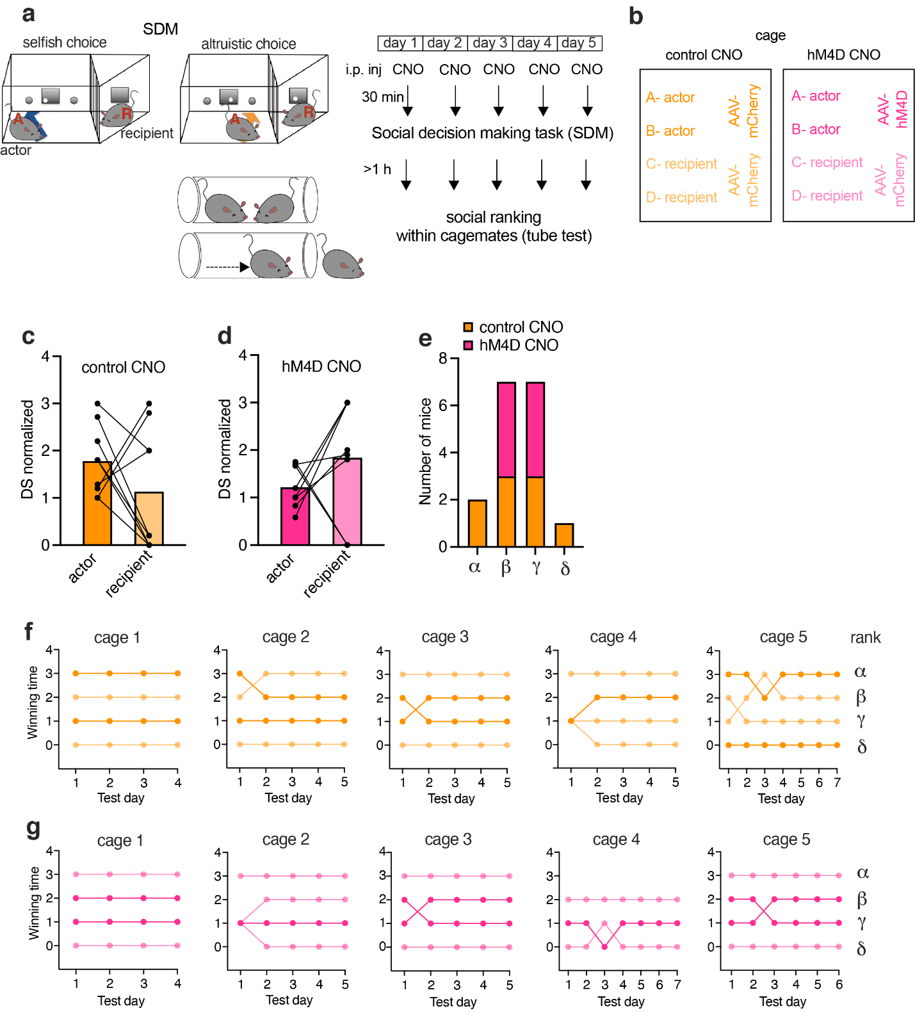

Supplementary Figure 4. BLA neuronal silencing reduces dominance. a, control CNO and hM4D CNO mice were injected with CNO (3mg/kg) 30 minutes before the SDM task. At least 1 hour after daily session, mice were tested in the tube test for assessment of social ranking within cagemates. b, cage composition. Each cage hosted 2 actor-recipient pairs. Actor mice received hM4D or control virus. All the recipients received the control virus. (c-d), social dominance (normalized David’s Score) quantified based on the number and directionality of interactions in the tube test in (c) control CNO (two-tailed paired t-test: t=1.30, d.f.=16, p=0.2120) and (d) hM4D CNO actor mice (two-tailed paired t-test: t=1.331, d.f.=14, p=0.2045). e, number of mice grouped by social rank (alpha, beta, gamma, delta) assessed using the tube test in control CNO and hM4D CNO mice. (f-g), rank positions of (f) control CNO and (g) hM4D CNO mice in each cage over testing days.

