Graphical Abstract

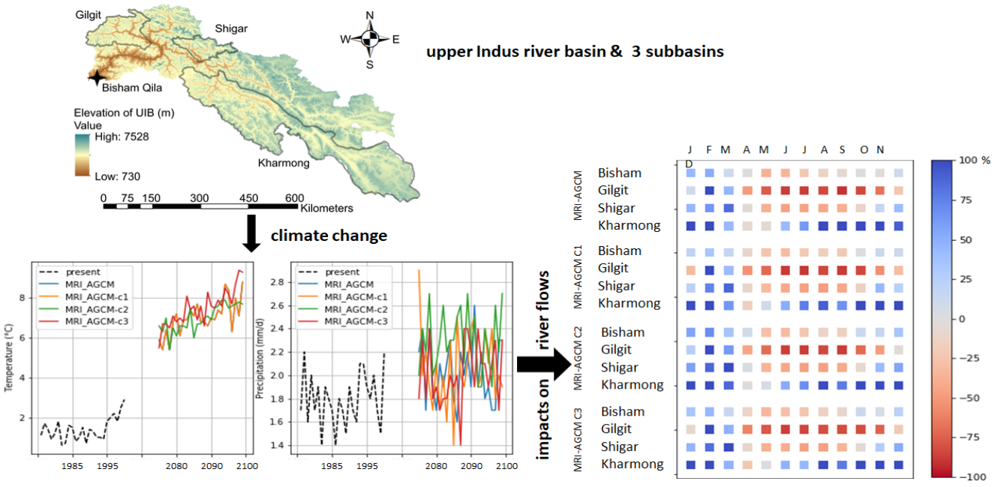
D
changes in the climate and their impacts on the river flows (%) of UIB and subbasins

