Ex. Fig. 1 | Expression of Clcf1 across different cancer types. CLCF1 expression: the y-axis represents various diseases, with lung cancer distinctly highlighted in red. The x-axis displays each sample's expression as a dot, scaled to log2(TPM + 1). A blue line demarcates the 95th percentile across all samples. Any samples beyond this range are consider high expression. All TPM normalized counts are sourced from UCSC Treehouse (v11), representing a total of 12,499 samples from 49 different diseases.

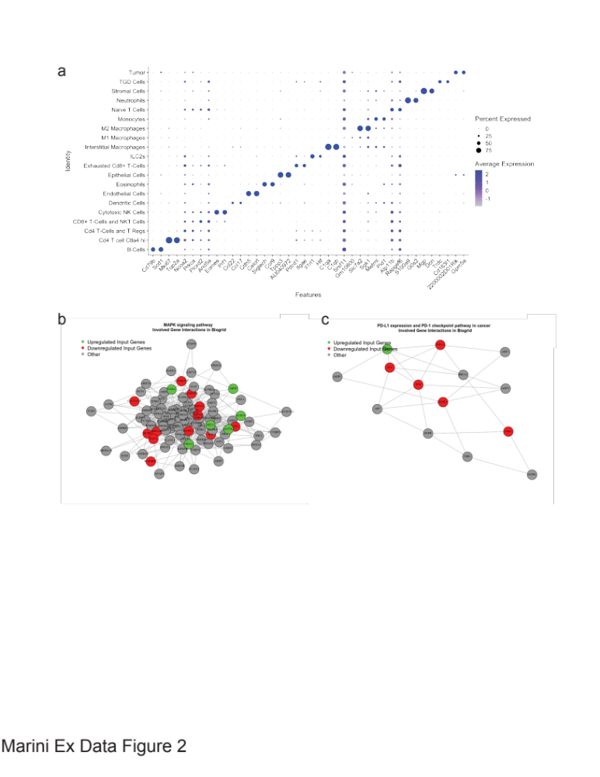
Ex. Fig. 2 | Clustering of lung cells from single cell analysis. a. The dotplot shows the percentage of cells expressing the respective selected marker gene using dot size and the average expression level of that gene based on unique molecular identiﬁer (UMI) counts. Rows represent distinct clustered cell types. b-c. Network depicting pathway analyses for MAPK (b) and PD-L1/PD-1 checkpoint in cancer (c) where grey is no change, green is upregulation and red is downregulation of gene expression.

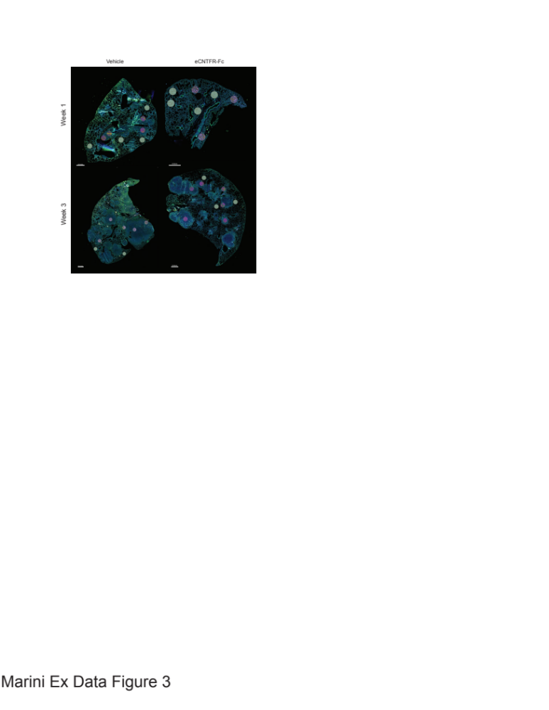
Ex. Fig. 3 | Spatially resolved, multiplexed protein characterization of geometric regions on FFPE tissue. Protein profiling of lung tissue. One lobe for vehicle and eCNTFR-Fc treated was imaged using three-color fluorescence of CD45 (Yellow), PanCK (Green) and DNA (Blue) to establish overall tissue morphology. Circular ROIs of 300 µm in diameter were selected for detailed molecular profiling with a 43-plex oligonucleotide–antibody cocktail. Segmented ROIs are overlayed as Purple (CD45-) or orange (CD45+).

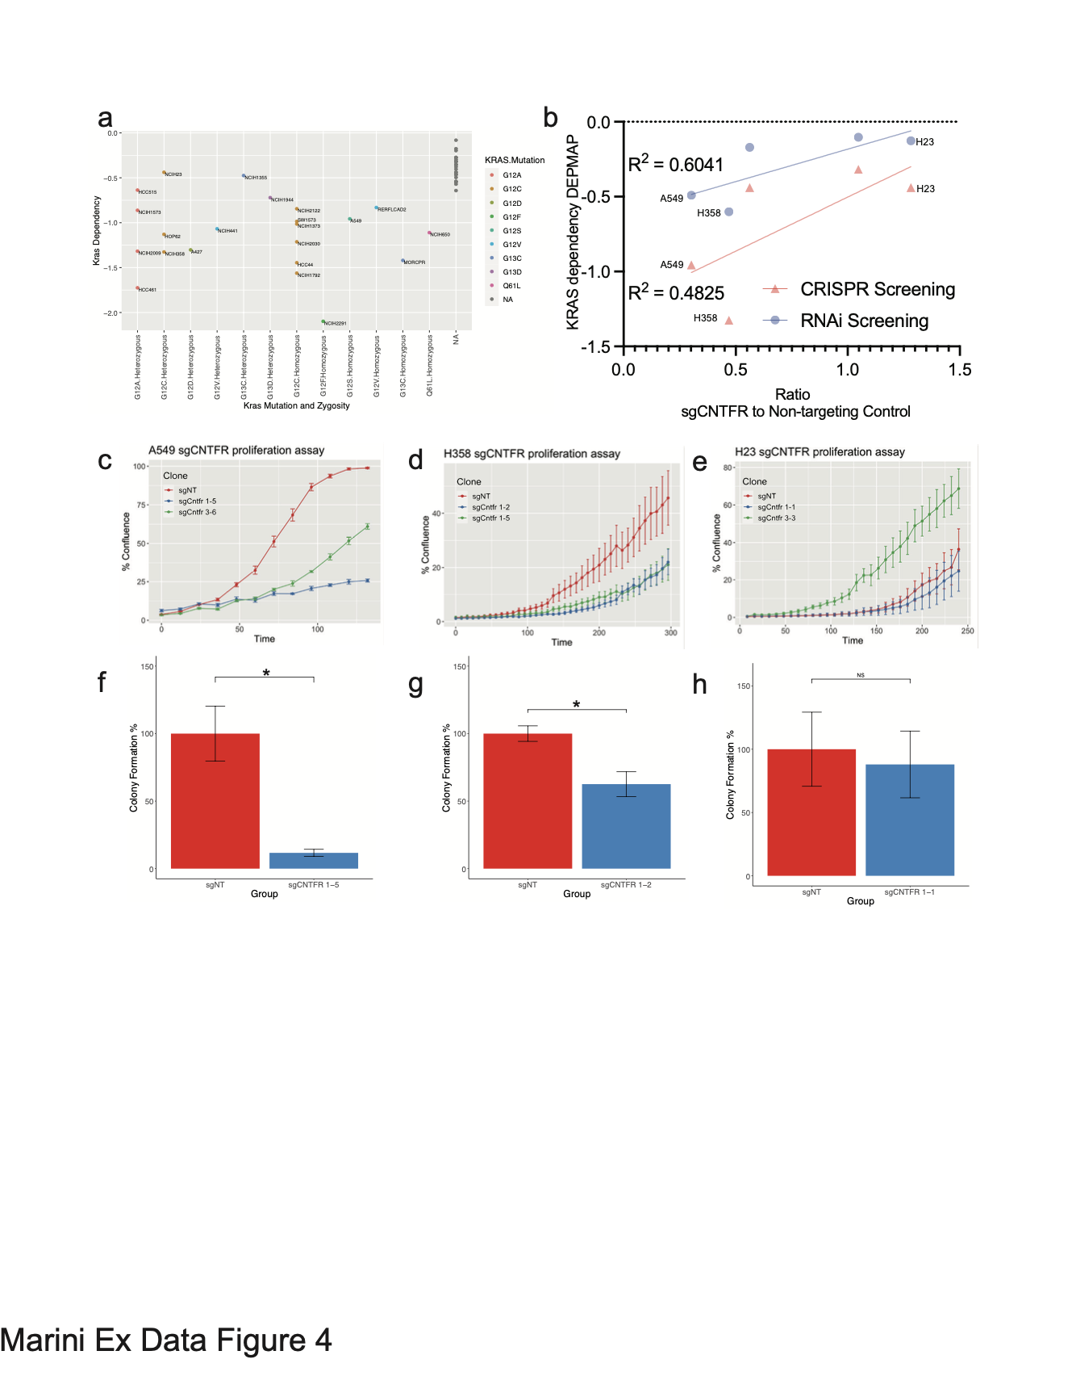
Ex. Fig. 4 | KRAS dependency is correlated with CNTFR dependency. a. KRAS dependency of LUAD cell lines from DEPMAP project Achilleas separated by KRAS mutation and zygosity of mutation. b. correlation plot of KRAS dependency, based on CRISPR screening (Red) or RNAi screening (blue) and CNTFR dependency determined by growth analysis. c-f. Growth curves of sgNT vs sgCNTFR clones in indicated cell lines, n = 4. c. A549. d. H358. e. H23. f-h. Graphs for colony formation assays in indicated LUAD cell lines, where cells, n ≥ 3, p < 0.05 f. A549 g. H358. h. H23.

Ex. Fig. 5 | Biochemical analysis of CNTFR knockout cells.
a. Densitometry of cytokine arrays showing that the CNTFR knockout cells seem to have less cytokine expression generally and show significant decreases in IL-6 family members (IL-6 and IL-11). b, d, f. Western blots of A549 (b), H23 (d) and H358 (f) under serum starved and stimulated conditions. c, e, g, Densitometry analysis of p-ERK for A549 (c), H23 (e) and H358 (g).

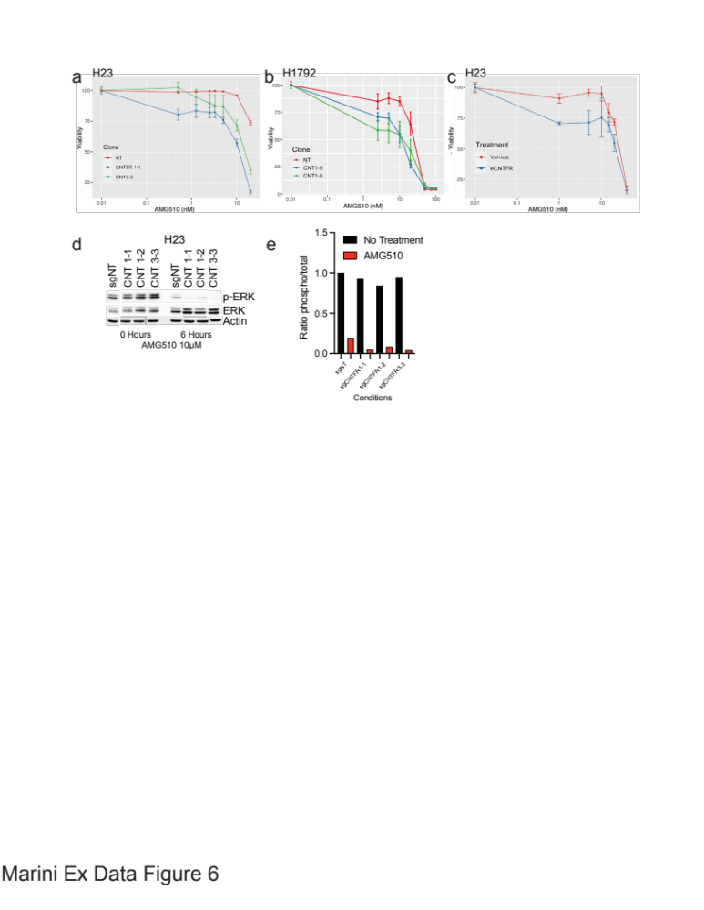
Ex. Fig. 6 | Sensitization of KRAS inhibition resistant cell lines with CNTFR knockout in LUAD. a. Viability curves of the H23 cell lines where Non-targeting and CNTFR knockout clones were treated with KRAS inhibitor AMG510. Knockout clones have increased sensitivity to KRAS inhibition in H23 where cells are intrinsically resistant to KRAS inhibition. b. Viability curves of the H1792 cell lines where Non-targeting and CNTFR knockout clones were treated with KRAS inhibitor AMG510. Consistent with H23, H1792 Knockout clones have increased sensitivity to KRAS inhibition. c. H23 cells are also sensitized to KRAS inhibition using eCNTFR-Fc. d. Western blot of phosphorylation of ERK at baseline and 6 Hours of AMG510 treatment. e. Densitometry of western blot from (d).

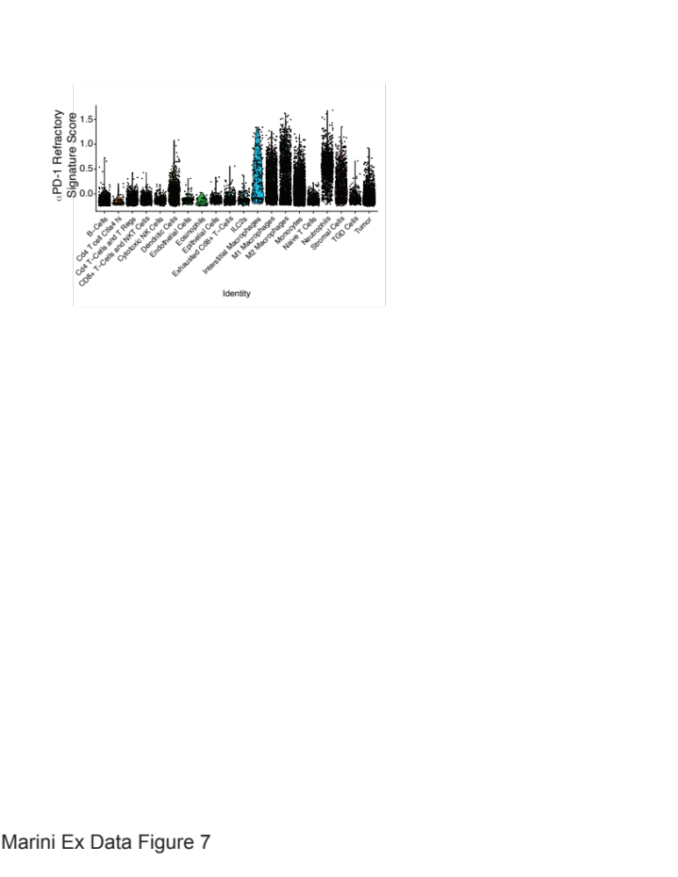
Ex. Fig. 7 | αPD-1 refractory score by cell population. Violin plot of the module score for refractory to αPD-1 gene signature for each of the different populations identified by the single cell analysis.

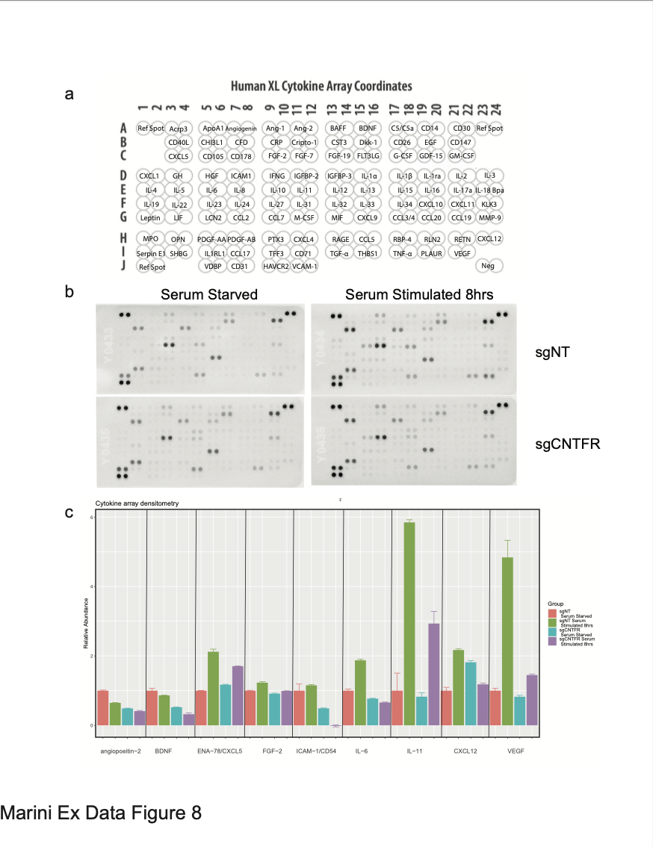
Ex. Fig. 8 | Cytokine array of CNTFR knockout cells. a. Schematic of the locations of cytokines on the array. b. Immunoblot of cytokine array for control or CNTFR knockout cells pre and post serum stimulation. b. Densitometry of cytokine arrays showing that the CNTFR knockout cells seem to have less cytokine expression generally and show significant decreases in IL-6 family members (IL-6 and IL-11).

