Supplementary information for
Condensate Halos in Condensation Frosting
Songyuan Zhen^{1†}, Haoyan Feng^{1†}, Shiji Lin², Yakang Jin¹, Zhigang Li², Xu Deng³, Elmar Bonaccurso^{4*} and Longquan Chen^{1*}
¹School of Physics, University of Electronic Science and Technology of China, Chengdu, Sichuan 611731, China
²Department of Mechanical and Aerospace Engineering, The Hong Kong University of Science and Technology, Clear Water Bay, Kowloon, Hong Kong
³Institute of Fundamental and Frontier Sciences, University of Electronic Science and Technology of China, Chengdu 610054, China
⁴AIRBUS Central R & T, Materials X, Munich 81663, Germany
†These authors contributed equally to this work. *e-mail: elmar.bonaccurso@airbus.com, lqchen@uestc.edu.cn

CONTENTS
Supplementary Section 1. Experimental setup and procedures 2
Supplementary Section 2. Light reflection from a solid surface covered by a sessile drop 4
Supplementary Section 3. Drop freezing modes in condensation frosting 6
Supplementary Section 4. Observation of condensate halos on different solid surfaces 7
Supplementary Section 5. Halo dynamics and the associated temperature evolution in the ice-bridge-triggered drop freezing 9
Supplementary Section 6. Detection of gas temperature and humidity around freezing drops on solid surfaces of different thermal conductivities 10
Supplementary Section 7. Evolution of the established vapor field during the bottom-to-top (B-T) drop freezing 13
Supplementary Tables 15
Supplementary Movies 18
References 19

Supplementary Section 1. Experimental setup and procedures
We experimentally investigated condensation frosting phenomena on solid surfaces with different thermal conductivities and wetting properties (Table S1). The experimental setup is schematically illustrated in Fig. S1. The environmental chamber (with inner dimensions of $10 cm×10 cm×4 cm$) was made of double walls of acrylic materials, which were mounted and sealed on a semiconductor cooling plate. This double-wall design can minimize the heat loss to the surroundings and maintain the bulk environment (locations far away from the cooling plate) in the chamber at a temperature of $20±1℃$ during the experimental measurements. We controlled and modulated the relative humidity ($χ$) inside the chamber by flushing it with humid nitrogen, which was produced by mixing the streams of pure nitrogen and that of nitrogen saturated with water vapor. By adjusting the mixing ratio of these two steams (by using mass flow controllers, Fig. S1), relative humidity in the range of $30\%-70\%$ has been achieved (Table S2). In the experiment, the temperature of the cooling surface was monitored by a thermocouple while a hygrometer (consisting of relative humidity & temperature sensors) was employed to detect the environmental temperature and humidity in real-time. The condensation and frosting phenomena occurring on diverse cooling surfaces were recorded with a CCD camera (U3-3060CP-M-GL, IDS Scheer, Germany) at a frame rate of $100-400 fps$ and a resolution of $1.4 μm/$pixel, wherein a cold light source was used for the vertical illumination. Meanwhile, the heat transfer process in the multiphase transition phenomena was monitored with an infrared camera (A655sc, FILR, USA) at a frame rate of $100 fps$ and a resolution of $33 μm/$pixel. To combine the optical and thermal imaging systems, a single crystal germanium (SCG) lens, which has good reflexivity for visible light (70 %) and also owns a high infrared transmittance (approximately $95\%$ in the wavelength range of $9-12 μm$), was exploited in the light path (Fig. S1).
Fig. S1| Sketch of the experimental setup.
The procedures of the condensation frosting experiment are as follows. A solid substrate was placed on the cooling plate in the environmental chamber, and humid nitrogen of desired gas ratio was then introduced through the inlet hole. After the temperature and relative humidity inside the chamber become stable, which generally takes $\sim 30$ minutes, we began to cool the solid surface through two stages. In the first cooling stage, the temperature of the solid surface ($T_{s}$) was lowered from the environmental temperature ($T_{0}≈20±1℃$) to a value below the dew point ($T_{d}=2-14℃$, depending on the relative humidity¹) but above the freezing point of water ($0 ℃$), which allows for heterogeneous vapor condensation. As shown in Fig. 1 of the manuscript, massive water drops nucleated and grew on the surface, and the sizes of condensate drops can be tuned by controlling the duration of surface cooling. When condensate drops of desired sizes were generated, the second cooling stage was then implemented by decreasing $T_{s}$ to the freezing temperature below $0 ℃$ ($T_{f}=-2℃--25℃$), during which condensate drops become supercooled. We generally observed the freezing of condensate drops within 30 minutes after $T_{f}$ was reached.

Supplementary Section 2. Light reflection from a solid surface covered by a sessile drop
Because of their hemispherical geometry and optical transparency, condensate water drops can behave as Plano-convex lenses, which reflect and refract incident light, eventually appearing as solid black circles with a white spot at their center in the acquired optical images, as shown in Fig. S2a. To get more insight into these optical effects, we numerically calculated the reflection of an incident parallel light illuminating on a solid surface covered by a water drop with $θ_{eq}=120°$, corresponding to the condensate drop in Fig. S2a. Due to the symmetry of the sessile drop, two-dimensional calculation has been performed. As sketched in Fig. S2b, a parallel light beam is illuminated on the drop-covered surface. While the incident light rays on the drop surface would be partially reflected back to the space and partially refracted into drop, which subsequently undergoes the reflection at the solid-liquid interface back to the drop and the refraction at the liquid-air interface back into the air, light rays vertically incident on the solid surface should be directly reflected back. In the calculation, the reflection law and Snell's Law were used to define the directions of the reflected and refracted light rays, whereas the Fresnel formula was employed to calculate their intensities.
In Fig. S2c, we comparatively show the axial distribution of the relative pixel intensity value $I(x/R_{d})/I_{c}$ of the acquired drop image in the experiment (i.e. along the dotted line in Fig. S2a) and of the relative light intensity $I_{r}(x/R_{d})/I_{rc}$ of the resultant reflected light from the drop-covered surface in the numerical calculation (i.e. along the dotted line in Fig. S2b). Here $I(x/R_{d})$ and $I_{c}$ denote the pixel intensity values at the relative position $x/R_{d}$ and drop center ($x/R_{d}=0$) in Fig. S2a, while $I_{r}(x/R_{d})$ and $I_{rc}$ denote the reflected light intensities at the relative position $x/R_{d}$ and drop center ($x/R_{d}=0$) in Fig. S2b, where $x$ is the distance to the drop center and $R_{d}$ is the drop radius. Obviously, a good agreement between the experimental data and numerical calculation has been reached. Employing the calculated spatial light intensity distribution in Fig. S2c, we further reproduced a two-dimensional image of the sessile drop in Fig. S2d, which indeed matches the observed drop in the experiment (Fig. S2a).

Fig. S2. a, Snapshot of a condensate drop sitting the Teflon-coated glass substrate ($θ_{eq}=120°$), which was acquired using the optical imaging system in Fig. S1. b, Illustration of light ray behaviors after the parallel incidence to a drop-covered surface. c, Plot of the relative pixel intensity value ($I/I_{c}$) along the dashed line in a and the relative light intensity ($I_{r}/I_{rc}$) along the dashed line in b as a function of the relative location $x/R_{d}$. d, Reproduced image of a two-dimensional drop (top view) based on the calculated spatial light intensity distribution in c.

Supplementary Section 3. Drop freezing modes in condensation frosting
In the condensation frosting experiments, we have identified two distinct modes of drop freezing: spontaneous freezing and ice-bridge-triggered freezing. While the former represents the occurrence of ice nucleation on an arbitrary drop among massive condensate drops², as shown in Fig. 1 of the manuscript and Fig. S3a below, the latter refers to the freezing of a condensate drop triggered by connecting a growing ice bridge from a nearby frozen drop^{3,4}, as displayed in Fig. S3b. Fig. S3c shows the zoom-in view of the growth of an ice bridge that reaches a neighboring drop and initiates the freezing in Fig. S3b.
Fig. S3| a, Selected snapshots of spontaneous drop freezing on the Teflon-coated glass substrate. b, Selected snapshots of ice-bridge-triggered drop freezing on the Teflon-coated glass substrate. c, Zoom-in view of the growth of an ice bridge from a frozen drop towards a supercooled drop marked in b. d, Plot of the statistical probability of the two drop freezing modes as a function of the freezing temperature $T_{f}$ in condensation frosting experiments on the Teflon-coated glass substrate.
A statistical analysis of the probability of observing these two freezing modes in the condensation frosting experiments on Teflon-coated glass substrates ($k≈0.9 W/mK$ and $θ_{eq}≈120°$) has been performed and the results at different freezing temperatures ($T_{f}$) are summarized in Fig. S3d. Evidently, the ice-bridge-triggered freezing is always the dominant freezing mode in condensation frosting, regardless of the freezing temperature; yet, its occurrence probability slightly decreases with increasing $T_{f}$. By contrast, the spontaneous drop freezing was only observed at $T_{f}≲-10 ℃$, and the lower the freezing temperature, the higher occurrence possibility would be.

Supplementary Section 4. Observation of condensate halos on different solid surfaces
We have identified three levels of strength for condensate halos during the freezing of supercooled drops on solid substrates with different thermal conductivities and wetting properties. By analyzing the variation of the average pixel intensity value ($\overline{I}$) in a surface area of $7 μm×7 μm$ (5 pixel $×$ 5 pixel) adjacent to the supercooled drop ($\sim 7 μm$ to the drop surface) during its freezing, one can find that the maximum value of the average pixel intensity ${\overline{I}}_{max}$ appears before drop freezing, while the average pixel intensity reaches a minimum value ${\overline{I}}_{min}$ when the condensate halo is completely developed. Therefore, the ratio of the minimum and maximum pixel intensity values ${\overline{I}}_{min}$/${\overline{I}}_{max}$ stands for the contrast of the halo pattern, and thus can be used to define the strength of the halo phenomenon.
In this work, the strong halo phenomena were identified for ${\overline{I}}_{min}$/${\overline{I}}_{max}≲0.7$, for which the formation and evolution of the halo pattern can be clearly observed and analyzed via image processing, as shown in Fig. S4a. Weak halo phenomena were defined by $0.7≲{\overline{I}}_{min}$/${\overline{I}}_{max}≲0.9$, exhibiting poor visibility and detail ― though they can still be recognized, as shown in Fig. S4b. For freezing drops with ${\overline{I}}_{min}$/${\overline{I}}_{max}≳0.9$, the variation of the pixel intensity value in their nearby region was very small during drop freezing (Fig. S4c), and thus they are classified as "no halo". Fig. S4d summarizes the experimental conditions for the appearance of these three classes of condensate halos in condensation frosting. It is obvious that condensate halos can only be observed on solid substrates with sufficiently low thermal conductivities ($k≲10 W/mK$) and surface wetting properties (${60°≲θ}_{eq}≲150°$), and the more hydrophobic the surface, the clearer the halo pattern is.

Fig. S4| a, Selected snapshots of strong halo phenomena. b, Selected snapshots of weak halo phenomena. c, Selected snapshots of freezing drops without condensate halos. d, Phase diagram of condensate halos in condensation frosting on solid surfaces with diverse thermal conductivities and wetting properties.

Supplementary Section 5. Halo dynamics and the associated temperature evolution in the ice-bridge-triggered drop freezing
Fig. S5a displays a sequence of halo dynamics and the associated temperature evolution in the ice-bridge-triggered freezing of a supercooled condensate drop on the Teflon-coated glass substrate at $T_{f}=-14.5 ℃$ and $χ≈60 \%$. Similar to that in the spontaneous drop freezing, condensate halo consisting of tiny drops instantly forms at its full size on the solid surface in the short-time recalescent freezing, which is identified by the decrease of the pixel intensity values in the optical images and the increase of surface temperature in the thermographic images on the drop and its nearby region, as shown in Fig. S5b. In the subsequent bottom-to-top drop freezing, the continuous existence of the warm vapor around the partially-frozen drop results in further vapor condensation on the solid surface, and the as-formed condensate drops grow in their sizes, making the halo pattern darker. This halo growth stage ends when the whole drop was frozen, along with the decay of the warm vapor filed. Then, the frozen drop starts to harvest water vapor that evaporates from condensate drops in the halo fence region, and the halo pattern completely disappears within a few seconds.
Fig. S5| a, Selected optical and thermographic images showing the ice-bridge-triggered drop freezing process on the Teflon-coated hydrophobic surface at $T_{f}≈-14.5 ℃$. b, Temporal evolution of the pixel intensity value $I$ and surface temperature $T_{S}$ at the center of the freezing drop and two nearby locations denoted in a. The right figures are zoom-in view of the initial halo formation stage.

Supplementary Section 6. Detection of gas temperature and humidity around freezing drops on solid surfaces of different thermal conductivities
To get more insight into the effect of substrate thermal conductivity on the formation of condensation halos, we simultaneously measured the temperature ($T$) and humidity ($χ^{'}$) in the surrounding gas during the freezing of millimeter-sized supercooled water drops (with a volume of $4.2 μL$) at $T_{f}=-16 ℃$ on glass ($k=0.93 W∙m^{-1}∙K^{-1}$), steel ($k=10 W∙m^{-1}∙K^{-1}$), silicon ($k=160 W∙m^{-1}∙K^{-1}$), and copper ($k=400 W∙m^{-1}∙K^{-1}$) substrates with similar wetting property ($θ_{eq}=110±5°$). Note that condensate halos can only be observed on the glass (strong) and steel (weak) substrate while no halos would form on the silicon and copper substrates during drop freezing (Fig. S4d). As sketched in Fig. S6a, the gas humidity was detected by a humidity sensor locating at $\sim 1.2 mm$ from the drop surface, while the temperature field around the drop was monitored by an infrared camera. The initial temperature and relative humidity were respectively set at $20±1℃$ and of $55±3\%$, which are in the parameter range of our condensation frosting experiments.
In Fig. S6c, we comparatively show selected thermographic images of freezing drops on these four substrates, while the corresponding variations of the relative humidity $χ^{'}/χ_{0}^{'}$ are displayed in Fig. S6d, where $χ_{0}^{'}$ is the initial humidity before freezing. Upon recalescent freezing, a significant increase of the drop temperature from the supercooling value ($\sim -16 ℃$) to the melting point of ice ($\sim 0 ℃$) has been identified on all drops, and simultaneously $χ^{'}/χ_{0}^{'}$ starts to increase. This finding suggests that the sudden temperature rise causes the explosive drop evaporation, which sends out water vapor to the surroundings. Despite the water vapor field was established around all drops throughout their whole freezing process, condensate halos only form on substrates with low thermal conductivities, i.e. $k≲10 W∙m^{-1}∙K^{-1}$. A detailed comparison of the acquired thermographic images reveals that along with the sudden rise of drop temperature, there is also a rise of the temperature of the surrounding gas. This phenomenon can be more clearly seen from the temporal variation of the temperature difference ($∆T$) before and during the drop freezing in Fig. S6c, where representative thermographic images are also displayed. However, on the glass and steel substrates, the temperature rise of the surrounding gas of freezing drops on glass and steel substrates (where condensate halos can form during drop freezing) are much higher than that on silicon and copper substrates (where halo patterns cannot form); similar behaviors are also identified for the variation of the relative humidity during the freezing. Based on the above findings, we can explicitly draw a conclusion that, apart from the buildup of the vapor field by the freezing-induced vapor diffusion, establishing a “high” temperature field is the other crucial condition to trigger the halo formation in drop freezing.
Now, an obvious question to ask is the following: What causes the different temperature rise in the surrounding gas of diverse freezing drops. Given the fact that the only different condition for the above drop freezing experiments is the substrate thermal conductivity, we would explain it as the result of distinct heat transfer process on these substrates. Upon recalescence, the released latent heat from the liquid solidification is partly adsorbed by the drop, causing its temperature rise, and partly would be transferred to the underlying cooling stage through the substrate. However, due to the finite thermal conductivity of solid materials, the rate of heat transfer is limited; in other words, the heat transfer through the solid substrates is insufficient to remove all the released latent apart from that absorbed by the drop. As a result, some heat would be taken away by the surrounding gas, rising its temperature. Because the recalescent freezing takes very short period [$O(10 ms)$], it is impossible to detect this transient heat transfer process. Nevertheless, we have managed to probe the heat transfer in the drop during the bottom-to-top freezing, which lasts for several hundreds of milliseconds. As illustrated in Fig. S7a, a thermocouple temperature sensor was inserted into the drop to measure the temperature variation in the liquid during the freezing. Meanwhile, the infrared camera was still employed to monitor the temperature variation on drop surface, and selected snapshots are shown in Fig. S7b. Fig. S7c reports the temporal variation of water temperature inside freezing drops on the glass and silicon substrates. Evidently, the decrease of the liquid temperature is much slower on the glass substrate than that on the silicon substrate, which demonstrates the limited heat transfer on low thermal conductive substrates and thus indirectly confirms our hypothesis.
Fig. S6| a, Sketch of the experimental setup to simultaneously measure the temperature and relative humidity around freezing water drops (left) on four hydrophobic substrates with similar wetting property but different thermal conductivity, and a snapshot showing the drop in the experiment (right). b, Selected thermographic images showing the drop freezing processes on four different solid substrates. c, Plot of the temperature rise $∆T$ in the surrounding gas close to the drop as a function of the freezing time $t$ (left), and thermographic images (right) showing the temperature difference field around the freezing drop at the time of reaching the maximum $∆T$ as indicated in the top figure. d, Temporal evolution of the humidity ratio $χ^{'}/χ_{0}^{'}$ during freezing.
Fig. S7| a, Sketch of the experimental setup to simultaneously measure the temperature inside and outside freezing water drops (left). b, Selected optical and thermographic images showing the drop freezing processes on the glass substrate. c, Selected optical and thermographic images showing the drop freezing processes on the silicon substrate. d, Temporal evolution of the water temperature inside the drop during freezing.

Supplementary Section 7. Evolution of the established vapor field during the bottom-to-top (B-T) drop freezing
Since the B-T freezing time or equivalently the halo growth time $t_{g}$ is much longer than the characteristic vapor diffusion time $τ_{D}$ (e.g., for the freezing drop with radius $R_{d}≈150 μm$ in Fig. 2 of the manuscript, $t_{g}≈0.5 s$ while $τ_{D}=R_{d}^{2}/D_{v}≈1.2×{10}^{-3} ms$), a quasistatic approximation can thus be employed to describe the vapor concentration. That is, at any given time of the freezing, the vapor diffusion would be modeled using the following equations,
$J=-D_{v}∇C$ (1)
$∇J=0$ (2)
where $J$, $D_{v}$, and $C$ are the evaporation flux, vapor diffusion coefficient, and vapor concentration, respectively. By solving the above equations with the commercial software — COMSOL Multiphysics 5.4, we can obtain the vapor concentration field around a freezing drop and further estimate the size of the halo pattern.
As an example, we calculated the vapor field evolution during the B-T freezing of an individual $0.4 mm$-radius water drop on the Teflon-coated glass substrate at $T_{f}=-17 ℃$, which was experimentally observed using the high-speed camera. Given that condensate drops would harvest all water molecules condensed from the environmental chamber above the cooling surface⁵, the humidity in the vicinity of the freezing drop should be very low, and we set it to be zero in our calculation (i.e., $χ=0$). Before freezing, the vapor concentration at the droplet surface and in the far field (i.e. the location at a distance of $5R_{d}$ from the droplet) are defined as $C_{s}$ and $C_{s}∙χ$, respectively, as illustrated in Fig. S8a, where $C_{s}$ represents the saturation concentration of vapor at the ambient temperature. The vapor diffusion coefficient $D_{v}$ is also set as the value at ambient temperature. Upon freezing, the temperature at the droplet surface instantaneously increases to $0 ℃$, and in principle its vapor concentration should be adjusted to the saturation concentration of vapor at $0 ℃$, which we denote as $C_{s}^{'}$. Nevertheless, previous work has demonstrated that by defining the vapor concentration as $0.78C_{s}^{'}$⁶, a good agreement between the theoretical calculation and experimental result can be achieved; therefore, this concentration value was used in the following calculation. With the ongoing of B-T freezing, the height of ice $H_{ice}$ would increase with time (Fig. S8b), and the unfrozen evaporative drop decreases. To calculate the vapor field around the drop during its freezing, the temporal evolution of the ice front, which was determined in the experiment, must be given (the black line in Fig. S8d).
In Fig. S8c, we show the calculated vapor concentration fields around the supercooled drop before and during its freezing ($t=0-1.0 s$). Clearly, the vapor concentration field around a supercooled drop is very weak because of its low temperature, though the relative humidity in its surrounding gas is rather low. However, once the freezing is triggered, a strong vapor filed would be established due to the increase of the drop temperature, and the vapor field gradually shrinks with the propagation of the icing front from drop bottom to top. Making a reasonable assumption that condensate halo forms on the solid surface region, above which the vapor concentration is equal or higher than the saturation concentration at the supercooled temperature, the halo radial extent $R_{hm}$ was calculated. As shown in Fig. S8c and Fig. S8d, a decrease of $R_{hm}$ with the freezing time would be expected.
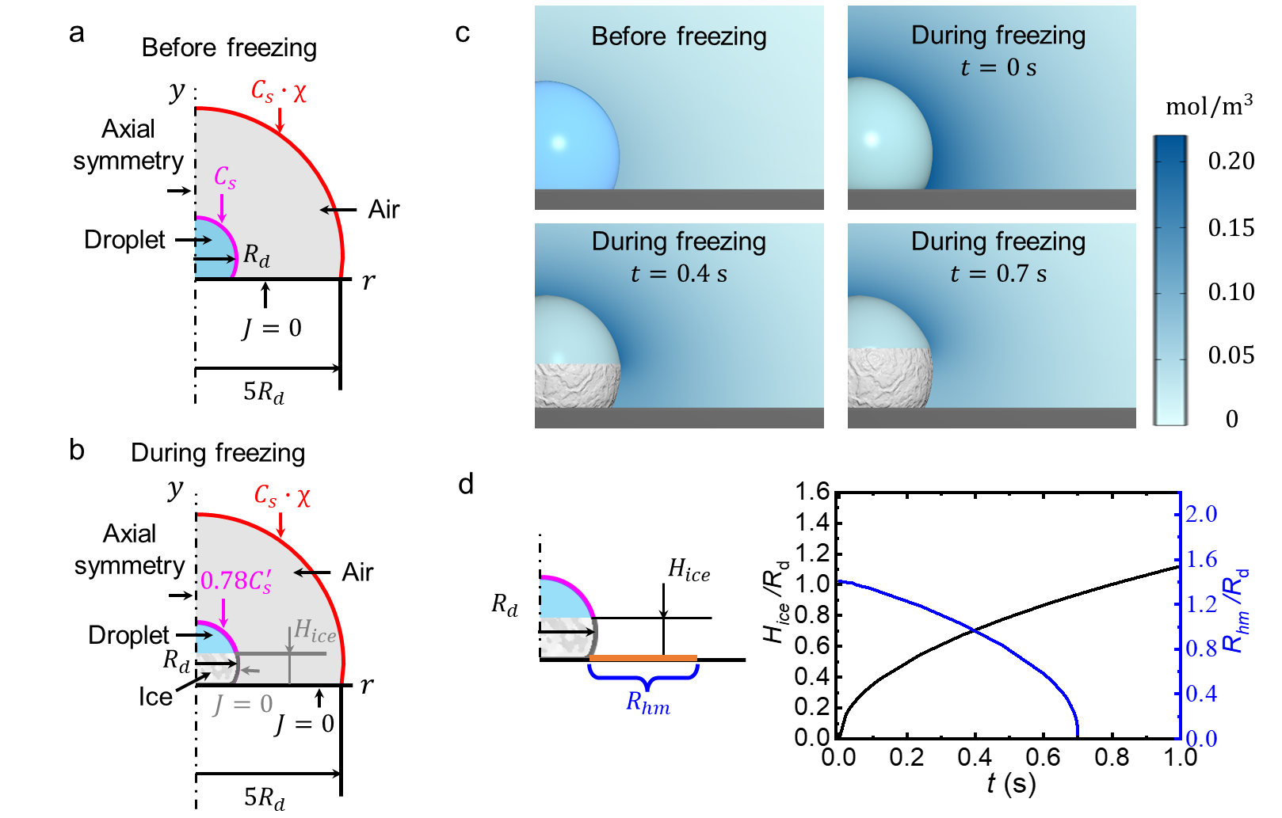
Fig. S8| a, Sketch of the supercooled drop before freezing. b, Sketch of the freezing drop. c, Vapor concentration fields around the supercooled drop before and during its freezing. d, Temporal evolution of the normalized height ($H_{ice}/R_{d}$, the black line) of the freezing front on the drop in the experiment, and the normalized radial extent ($R_{hm}/R_{d}$, the blue line) of the condensate halo in the calculation.

Supplementary Tables

Table S1| Stream rates of pure nitrogen and water vapor saturated nitrogen to achieve different relative humidity in the environmental chamber in Fig. S1.
Stream rate of pure nitrogen (${cm}^{3}/min⁡)$ | Stream rate of water vapor saturated nitrogen (${cm}^{3}/min⁡)$ | The resultant relative humidity in the environmental chamber (%)
0 | 350 | 74
0 | 90 | 68
0 | 0 | 62
145 | 0 | 50
400 | 0 | 38

Table S2| Thermal and wetting properties of diverse substrates used in the experiments.
Substrate number | Material | Thermal  Conductivity $k$ ($W/mK$) | Equilibrium contact angle of $4 μL$ water drop $θ_{eq}$ ($°$)
1 | Pure glass | 0.93 | $$31±4°$$
2 | Glass silanized by 3-aminopropyltriethoxysilane | 0.93 | $$62±3°$$
3 | Glass silanized by 1,1,1,3,3,3-Hexamethyldisilazane | 0.93 | $$88±1°$$
4 | Glass silanized by 1H,1H,2H,2H-perfluorodecyltriethoxysilane | 0.93 | $$117±2°$$
5 | Glass covered by Teflon | 0.93 | $$120±1°$$
6 | Glass covered by hydrophobic nanoparticles | 0.93 | $$151±1°$$
7 | Pure steel | 10 | $$80±1°$$
8 | Steel silanized by 1,1,1,3,3,3-Hexamethyldisilazane | 10 | $$88±1°$$
9 | Steel silanized by 1H,1H,2H,2H-perfluorodecyltriethoxysilane | 10 | $$106±1°$$
10 | Steel covered by hydrophobic nanoparticles | 10 | $$152±1°$$
11 | Pure silicon | 160 | $$60±2°$$
12 | Silicon silanized by 1,1,1,3,3,3-Hexamethyldisilazane | 160 | $$87±1°$$
13 | Silicon silanized by 1H,1H,2H,2H-perfluorodecyltriethoxysilane | 160 | $$113±1°$$
14 | Silicon covered by hydrophobic nanoparticles | 160 | $$150±1°$$
15 | Pure copper | 400 | $$76±2°$$
16 | Copper silanized by 3-aminopropyltriethoxysilane |  | $$61±5°$$
17 | Copper silanized by 1H,1H,2H,2H-perfluorodecyltriethoxysilane | 400 | $$103±1°$$
18 | Copper covered by hydrophobic nanoparticles | 400 | $$151±1°$$

Table S3| Roughness of diverse solid substrates.
Substrates | Roughness (nm) | Topographic AFM images
Pure glass substrates and silanized glass substrates (i.e., substrates 1-5 in Table S2) | 0.64$±$0.03 | 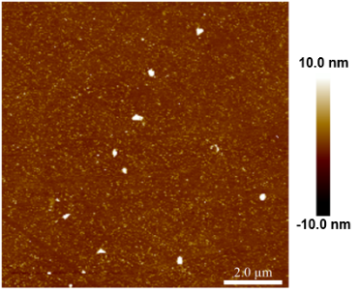
Pure steel substrates and silanized steel substrates (i.e., substrates 7-9 in Table S2) | 2.15$±$0.92 | 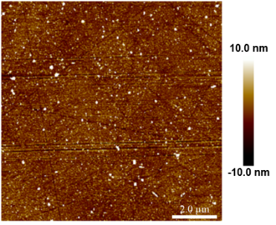
Pure silicon substrates and silanized silicon substrates (i.e., substrates 11-13 in Table S2) | 0.17$±$0.01 | 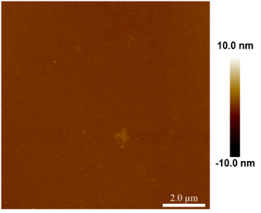
Pure copper substrates and silanized copper substrates (i.e., substrates 15-17 in Table S2) | 45.93$±$19.83 | 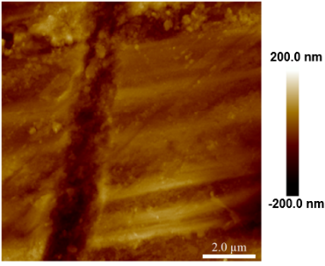
Substrates covered by hydrophobic nanoparticles (i.e., substrates 6, 10, 14 and 18 in Table S2) | 58.53$±$27.59 | 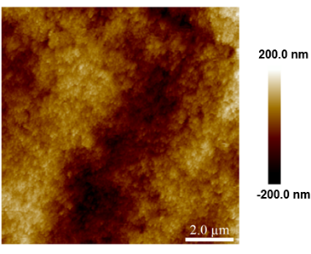

Supplementary Movies
Supplementary Movie 1| A representative condensation frosting process on a glass substrate coated with a $1 μm$-thickness Teflon. The thermal conductivity ($k$) of the substrate is $0.9 Wm^{-1}K^{-1}$ and the equilibrium contact angle ($θ_{eq}$) of $4 μL$ water drops on the surface is $120°$. The movie was recorded at 20 fps.
Supplementary Movie 2| Freezing of condensate water drops on a Teflon-coated glass substrate with $k ≈0.9 Wm^{-1}K^{-1}$ and $θ_{eq}≈120°$ at $T_{f}=-13.1 ℃$. The initial relative humidity ($χ$) for the condensate frosting experiment was $60 \%$. The optical and thermographic movies were recorded at 100 fps.
Supplementary Movie 3| Spontaneous freezing of a condensate water drop on a Teflon-coated glass substrate with $k ≈0.9 Wm^{-1}K^{-1}$ and $θ_{eq}≈120°$ at $T_{f}=-14.5 ℃$. The initial relative humidity ($χ$) for the condensate frosting experiment was $60 \%$. The optical and thermographic movies were recorded at 100 fps.
Supplementary Movie 4| Ice-bridge triggered freezing of a condensate water drop on a Teflon-coated glass substrate with $k ≈0.9 Wm^{-1}K^{-1}$ and $θ_{eq}≈120°$ at $T_{f}=-15.1 ℃$. The initial relative humidity ($χ$) for the condensate frosting experiment was $60 \%$. The optical and thermographic movies were recorded at 100 fps.
Supplementary Movie 5| Recalescent freezing of a $3.3 μL$ water drop on a Teflon-coated glass substrate with $k ≈0.9 Wm^{-1}K^{-1}$ and $θ_{eq}≈120°$ at $T_{f}=-13.2 ℃$ and $χ=55 \%$. The movie was recorded at 5000 fps.
Supplementary Movie 6| A representative frost propagation among four supercooled condensate drops on a Teflon-coated glass substrate with at $T_{f}=-14.4 ℃$ and $χ=65\%$. The movie was recorded at 100 fps.

References
1. Lawrence, M. G. The relationship between relative humidity and the dewpoint temperature in moist air - A simple conversion and applications. Bull. Am. Meteorol. Soc. 86, 225-234 (2005).
2. Gurganus, C., Kostinski, A. B. & Shaw, R. A. Fast Imaging of Freezing Drops: No Preference for Nucleation at the Contact Line. J. Phys. Chem. Lett. 2, 1449-1454 (2011).
3. Guadarrama-Cetina, J., Mongruel, A., Gonzalez-Vinas, W. & Beysens, D. Percolation-induced frost formation. Europhys. Lett. 101 (2013).
4. Petit, J. & Bonaccurso, E. General Frost Growth Mechanism on Solid Substrates with Different Stiffness. Langmuir 30, 1160-1168 (2014).
5. Viovy, Beysens & Knobler. Scaling description for the growth of condensation patterns on surfaces. Phys. Rev. A 37, 4965-4970 (1988).
6. Jung, S., Tiwari, M. K. & Poulikakos, D. Frost halos from supercooled water droplets. Proc. Natl. Acad. Sci. USA 109, 16073-16078 (2012).

