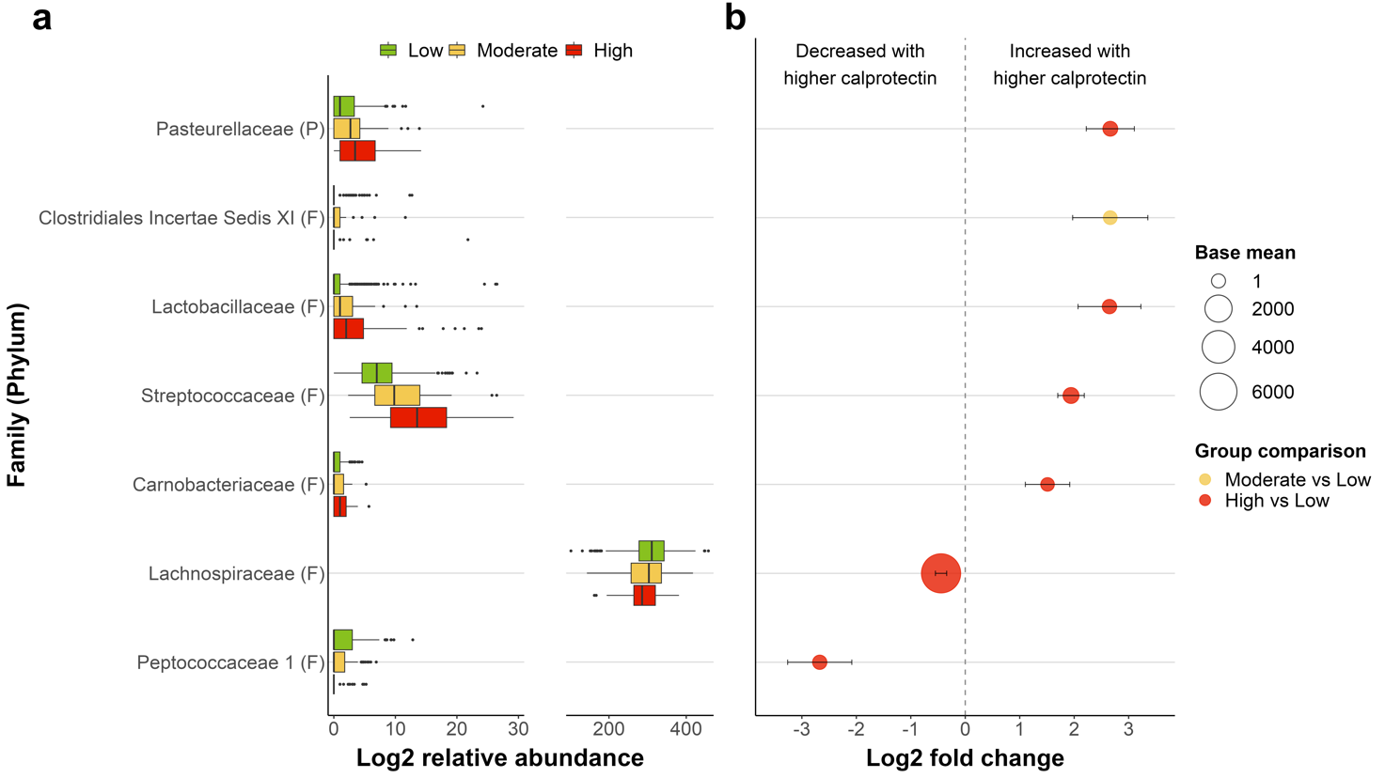
Supplementary Figure 1. Family-level differential abundance analysis. (A) Group-wise boxplots of the relative abundance (log2) of families that show significant differences in group contrasts. (B) Significant (FDR-corrected, covariate-adjusted) findings of differential abundance of gut microbial families for comparisons between low (≤50 μg/g) and moderate (>50-100 μg/g) or high (>100 μg/g) calprotectin groups. The size of the markers corresponds to the base mean value, i.e., the mean of normalized counts of all samples, and the markers are colour-coded based on group comparison. Bars indicate the standard error of log2-fold change. The phylum of the families is indicated in brackets. Abbreviations: F, Firmicutes; P, Proteobacteria.

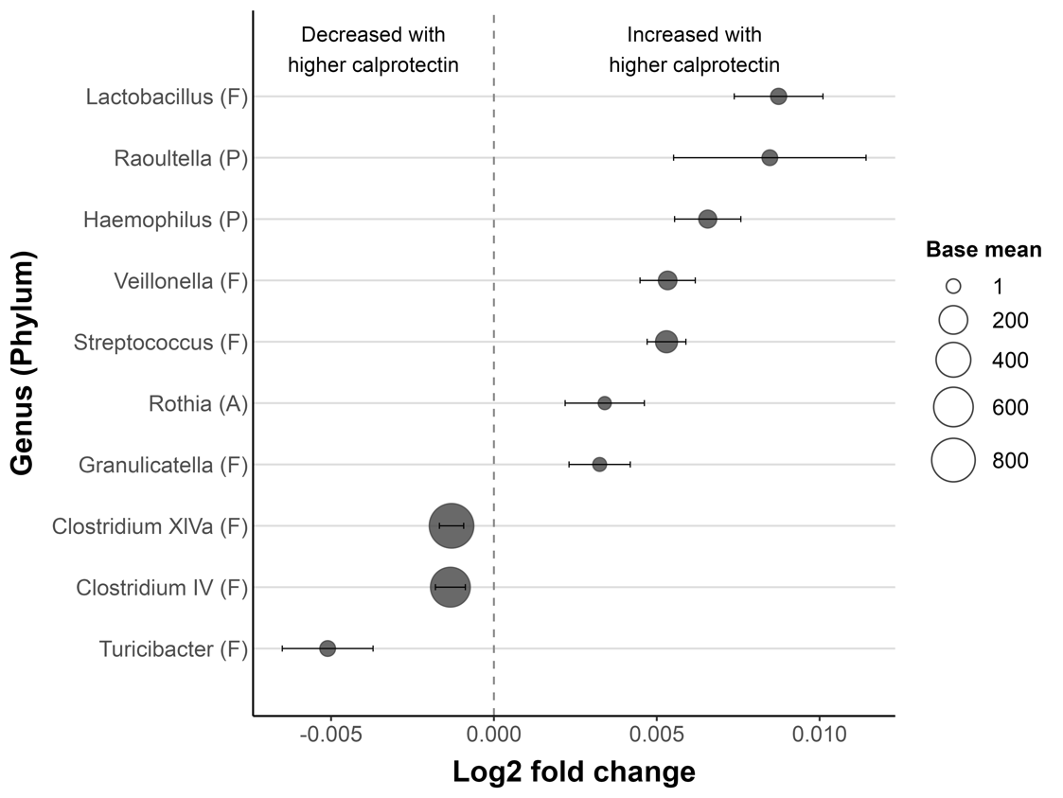
Supplementary Figure 2. Genus-level differential abundance analysis using fecal calprotectin as a continuous variable (n=735). The size of the markers corresponds to the base mean value, i.e., the mean of normalized counts of all samples, and bars indicate the standard error of log2-fold change. Phylum abbreviations: F, Firmicutes; P, Proteobacteria; A, Actinobacteria.

