Supplementary Results
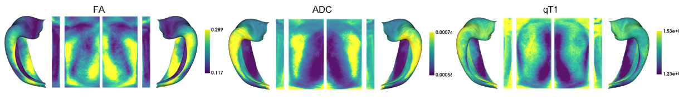
Figure S1. Replication of a subset of structural MRI features from Figure 3 in an independent, 3T scanned cohort (n=82).

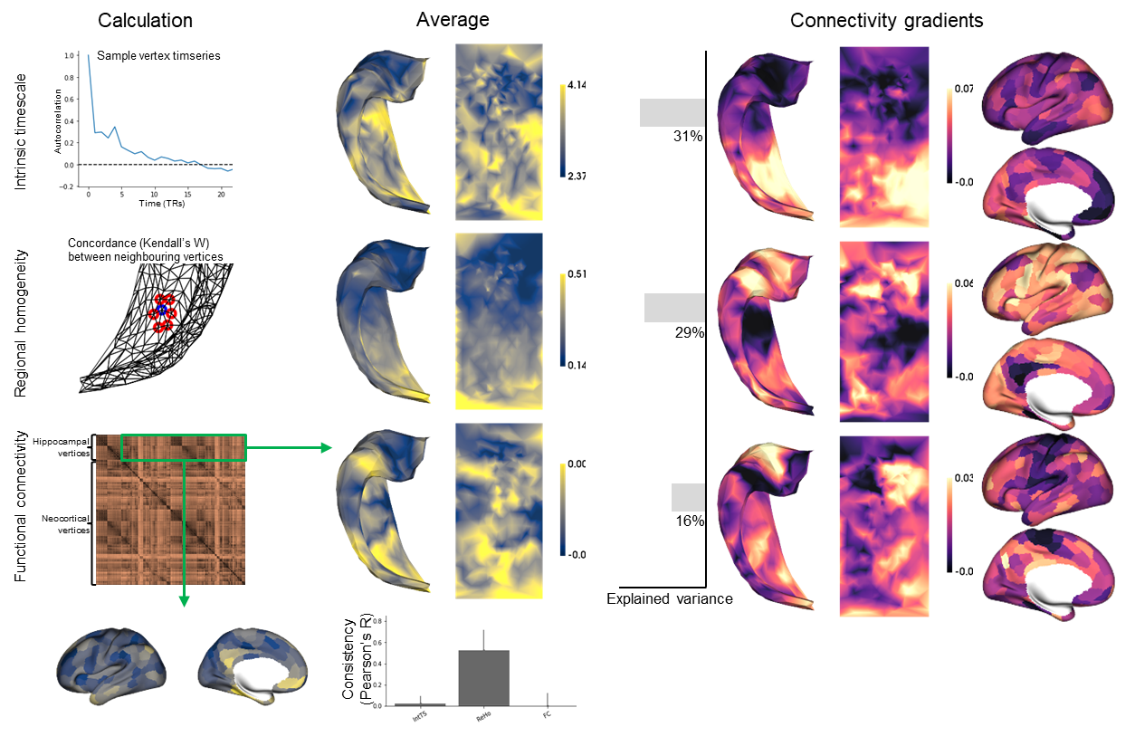
Figure S2. Replication of functional MRI properties from Figure 4 in an independent 7T cohort (n=10).

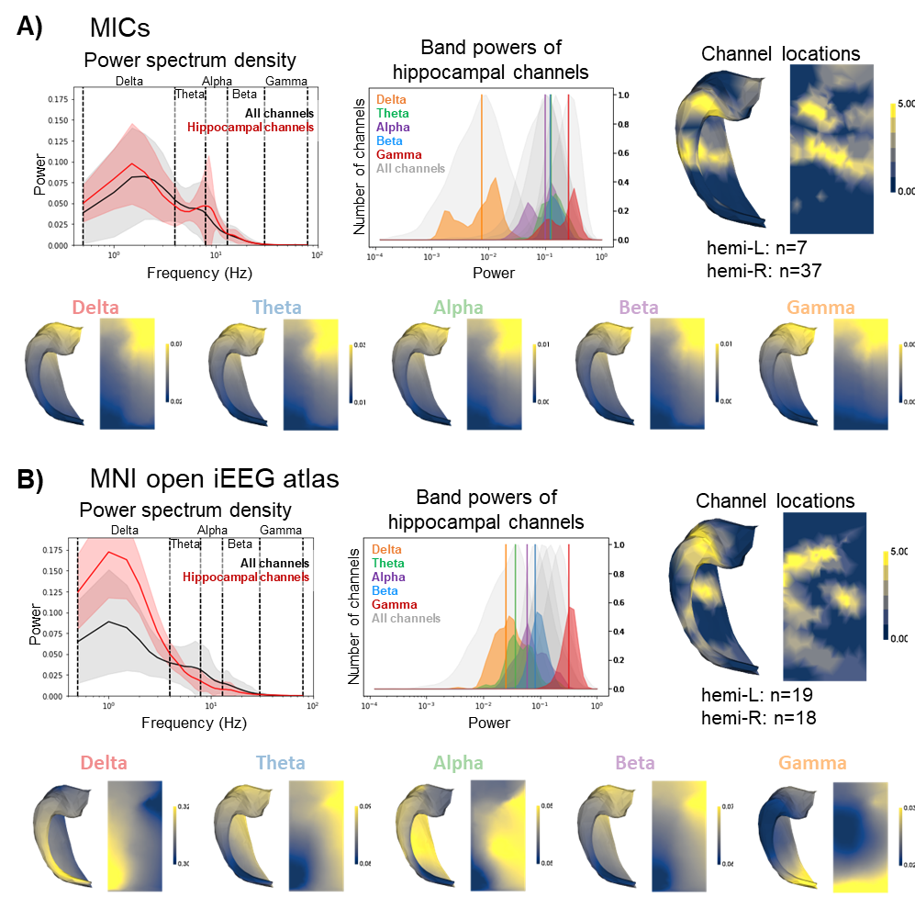
Figure S3. Separation of iEEG properties in Figure 5 into component datasets for replication. A) Locally collected iEEG, resampled to 200Hz to match the Frauscher et al. (2018) open source dataset. B) Open source dataset analysis based on Frauscher et al.

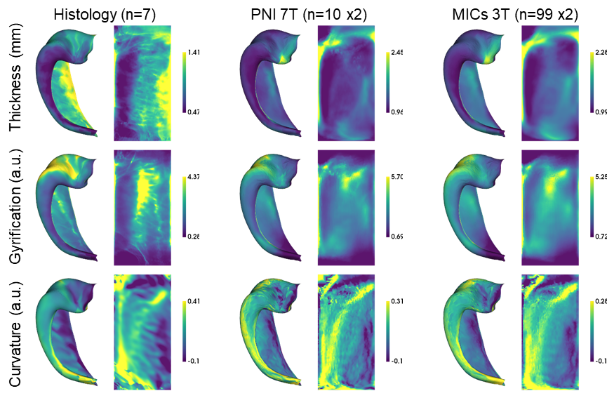
Figure S4. Morphometric thickness, gyrification, and curvature across datasets.

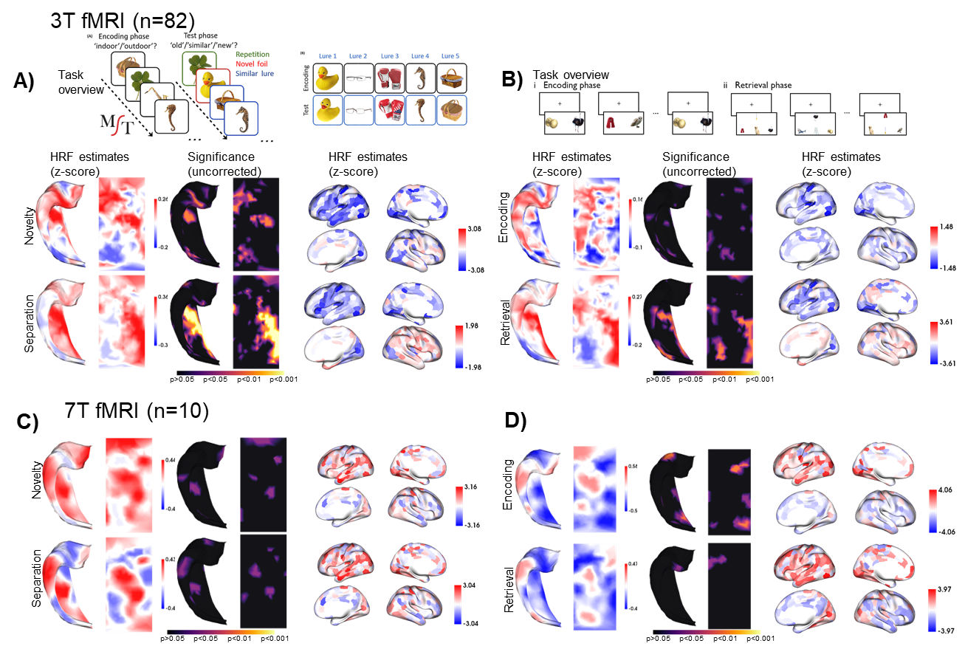
Figure S5. Replication of task fMRI analyses from Figure 7B at 3T and 7T, and across the MST task and a common object pairing study-test paradigm. A) Same data as shown in Figure 7B, but with significance testing. B) Successfully trials during episodic encoding (subsequent memory paradigm) and retrieval. C) and D) same as A) and B), but performed with 7T fMRI and a smaller cohort.

