Supplementary information

Supplementary Methods

Reverse transcription-quantitative real-time PCR (RT-qPCR)
Total RNA was extracted from HSCs, primary MSCs, using the RNeasy Mini Kit (Qiagen SpA, Hilden, Germany), according to the manufacturer’s protocol. RNA concentration and purity were assessed spectrophotometrically by measuring the absorbance at 260 and 280 nm. RNA was reverse transcribed using the Qiagen QuantiTect Reverse Transcription Kit (Qiagen SpA, Hilden, Germany) following the manufacturer’s protocol. For relative mRNA quantification, RT-PCR was performed using Rotor Gene® Q software (v.2.3.1.49; Qiagen SpA). The relative abundance of mRNA transcripts was calculated using the Δ^{CT} method and normalized to glyceraldehyde-3-phosphate dehydrogenase (GAPDH) levels.

Protein extraction and western immunoblot assay
Cells were collected and homogenized in RIPA buffer [NaCl (150 mM), Tris-base (50 mM), EGTA (5 mM), Triton X-100 (1%), sodium deoxycholate (0.5%), sodium dodecyl sulfate (0.1%)] containing dithiothreitol (1 mM) and complete protease inhibitor cocktail. Lysates were centrifuged at 1800 x g at 4 °C for 10 min. The protein concentration in the supernatants was determined using a BCA protein assay (Thermo Fisher Scientific). Samples containing equal amounts of proteins (30 μg) were then separated by NuPAGE 4%–12% Bis-Tris gel electrophoresis (Life Technologies, Carlsbad, CA, USA), and the proteins were transferred to nitrocellulose (Bio-Rad, Hercules, CA, USA). Membranes were incubated with dry milk (5%) in Tris buffer [TBST; Tris (20 mM) at pH 7.5, NaCl (150 mM)] containing Tween 20 (0.1%) for 1 h at room temperature, and incubated with the following primary antibodies: C5ar1 (#orb393229, rabbit polyclonal, Biorbyt Ltd, 1:500) and β-actin (#ab6276, mouse monoclonal, Abcam, 1:5000, RRID:AB_2223210) at 4°C overnight. The membranes were then probed with goat anti-mouse or donkey anti-rabbit IgG conjugated with horseradish peroxidase (#A90-516P, RRID:AB_10631212 and #A120-208P, RRID:AB_66770, Bethyl Laboratories Inc, 1:10,000) for 2 h at RT. Finally, membranes were washed three times with TBST, and bound antibodies were detected using chemiluminescence reagents (Pierce™ ECL; Thermo Fisher Scientific) and revealed using an imaging system (ChemiDoc; Bio-Rad, RRID:SCR_019037). The density of specific bands was measured using ImageJ (v.1.54f; National Institutes of Health, Bethesda, MD, USA) and normalized to β-actin.

Immunofluorescence
Mice were anesthetized, transcardially perfused with PBS (phosphate buffer saline), and then tissues (trigeminal nerve and sciatic nerve) were collected. The collected tissues from perfused mice were placed overnight at 4 °C in 10% formalin, transferred to 30% sucrose overnight, frozen, and cryosectioned at 10 μm. Blocking was performed using normal donkey serum (NDS, 5%) for 1 h and incubated with the following primary antibodies: F4/80 ([#MA516624, rat monoclonal (Cl:A3-1), Thermo Fisher Scientific, 1:50, RRID:AB_253820), C5ar1 (#orb393229, rabbit polyclonal, Biorbyt Ltd, 1:100), NLRP3 (#MA5-32255, rabbit monoclonal, Thermo Fisher Scientific, 1:100, RRID:AB_2809541), NLRP1 (#12256-1-AP, rabbit polyclonal, Proteintech, 1:50, RRID:AB_2298504) and IL-1β (#NB600-633, rabbit polyclonal, Novus Biological, 1:100, RRID:AB_10001060) for 1 h at room temperature and O/N at 4 °C with SOX10 (#AF2864, goat polyclonal, R&D Systems, 1:200, RRID:AB_442208). Sections were then incubated for 2 h in the dark with the following with fluorescent secondary antibodies: Alexa Fluor 488 (#A32790, donkey anti-rabbit polyclonal, Thermo Fisher Scientific, 1:600, RRID:AB_2762833), Alexa Fluor 488 (#A21208, donkey anti-rat polyclonal, Thermo Fisher Scientific, 1:600, RRID:AB_2535794) and Alexa Fluor 594 (#A11058, donkey anti-goat polyclonal, Thermo Fisher Scientific, 1:600, RRID:AB_2534105). Sections were coverslipped using a water-based mounting medium containing DAPI (#ab104139; Abcam). All slides were visualized and analyzed using a Zeiss Axio Imager 2 microscope with Z-stacks in the Apotome mode (ZEISS). The number of F4/80⁺ cells was counted in 4.5x10⁵ µm² boxes in the sciatic nerve trunk and trigeminal nerve. Pearson correlation (Rcoloc) value in the colocalization analysis were calculated using the colocalization Plugin of the ImageJ (v.1.54f; National Institutes of Health, Bethesda, MD, USA).

AAV production and cell lysis
AAVPro-HEK293T cells were cultured in DMEM supplemented with heat-inactivated FBS (10 %), Pen/Strep (1%), and L-glutamine (2%) and sodium pyruvate (1%). Three days before transfection, cells were seeded in a CellBIND Polystyrene CellSTACK 2 Chamber (#3310, Corning, Corning, NY, USA) for 48 h to reach 80% confluence. Cells were washed with PBS, detached with trypsin-EDTA 0.05% (EuroClone, Milan, Italy). Finally, 250 million cells were seeded in a and CellBIND Polystyrene CellSTACK 5 Chamber (#3311; Corning) for 24 h, until 80% of confluence. Each chamber was transfected with 2.5 mg of DNA containing the three plasmids (packaging, helper and GOI plasmids) in a 1:1:1 molar ratio. Total DNA was diluted in 176 ml of OptiMEM (Thermo Fisher Scientific) and combined with PEI (1:3 DNA to PEI ratio). After 15 min of incubation, 350 mL of DMEM supplemented with FBS (2%) was added to the OptiMEM/DNA/PEI mix and used to replace the complete medium in each chamber. Cells were left at 37°C for 72 h, before AAV particles were started to be collected. Cells were harvested and transferred into 50 mL conical tubes and centrifuged at 1000 × g for 10 min at 4 °C. The supernatant was filtered through 0.45-μm PES membranes, before that 25 mL of PEG solution (400 g of 40% polyethylene glycol + 24 g of NaCl in ddH2O to a final volume of 1.000 mL) was added to every 100 mL of supernatant. The total solution was slowly stirred at 4 °C for 1 h and then, kept for 3 h without stirring at 4°C to allow full precipitation of particles. The solution was then centrifuged at 2.800 × g for 15 min at 4 °C, the supernatant was discarded, and the virus was resuspended in a10 ml of PBS/pluronic F68 (0.001%)/NaCl (200 mM) solution. Virus producing cell pellet was directly resuspended in 10 mL of PBS/Pluronic F68 (0.001%)/NaCl (200 mM) solution and cells were lysed by 4 cycles of freezing/thaw. Each cycle included a step of 30 min at -80°C, followed by a quick thaw at 37°C for 10 min. Sample was then centrifuged at 3.200 × g for 15 min at 4 °C and supernatant, containing the AAV particles was collected, while cell debris were discarded. Samples obtained by medium treatment and cell lyses, containing the AAV particles, were finally mixed, incubated with benzonase (50 UI/mL) at 37 °C for 45 min to digest residual plasmids and residual genomic DNA / cellular RNA. Then, sample was centrifuged at 2.400 × g for 10 min at 4°C. The clarified supernatant was transferred to new tubes and was kept overnight at 4 °C before purification.

Iodixanol-based purification protocol
Purification using a gradient of iodixanol was prepared as previously described ⁵⁵ with a few modifications. Starting with a 60% iodixanol solution (OptiPrep; STEMCELL Technologies, Vancouver, Canada), a gradient was prepared with a 15% solution [4.5 mL of iodixanol (60%) + 13.5 mL of NaCl/PBS-MK buffer (1M)], a 25% solution [5 mL of iodixanol (60%) + 7 mL of PBS-MK buffer (1×) + 30 μL of phenol red], a 40% solution [6.7 mL of iodixanol (60%) + 3.3 mL of PBS-MK buffer (1×)], and a 60% solution [10 mL of iodixanol (60%) + 45 μL of phenol red]. Each solution was added into a 39-mL Quick-Seal tube (Beckman Coulter, Brea, CA, USA) using a syringe equipped with an 18 G needle in the following order: 8 mL of the iodixanol solution (15%), 6 mL of the iodixanol solution (25%), 5 mL of the iodixanol solution (40%), and 5 mL of the iodixanol solution (60%). Finally, tubes were filled with the sample, sealed and, centrifuged in a Type 70 Ti rotor (Beckman Coulter) at 350.000 x g at 10°C for 90 min and then pierced with a 16 G needle on top and an 18 G needle at the interface between the 60% and 40% iodixanol gradients. Viral particles contained in the 40% iodixanol layer were fractioned in 1.5 mL microcentrifuge tubes and concentrated using Amicon Ultra-15 centrifugal filter units (molecular weight cut-off, 100 kDa; Merck Millipore). Before the concentration step, membranes were covered with 15 mL of 0.1% Pluronic F68 in PBS solution that were discarded and replaced with 15 mL of 0.01% Pluronic F68 in PBS solution. The tubes were centrifuged at 3.000 rpm for 5 min at 4 °C. The supernatant was discarded, and 15 mL of 0.001% Pluronic F68 in PBS + NaCl 200mM solution was added and centrifuged at 3.000 rpm for 5 min at 4 °C. The sample was then added and centrifuged at 3.500 rpm for 8 min at 4 °C and flowthrough was discarded. During concentration process, formulation buffer (0.001% Pluronic F68 in PBS) was also added to the sample after few centrifugation steps to replace iodixanol and to avoid toxicity in animals after AAV injection. The viral titer was quantified using RT-qPCR.

Supplementary Figures

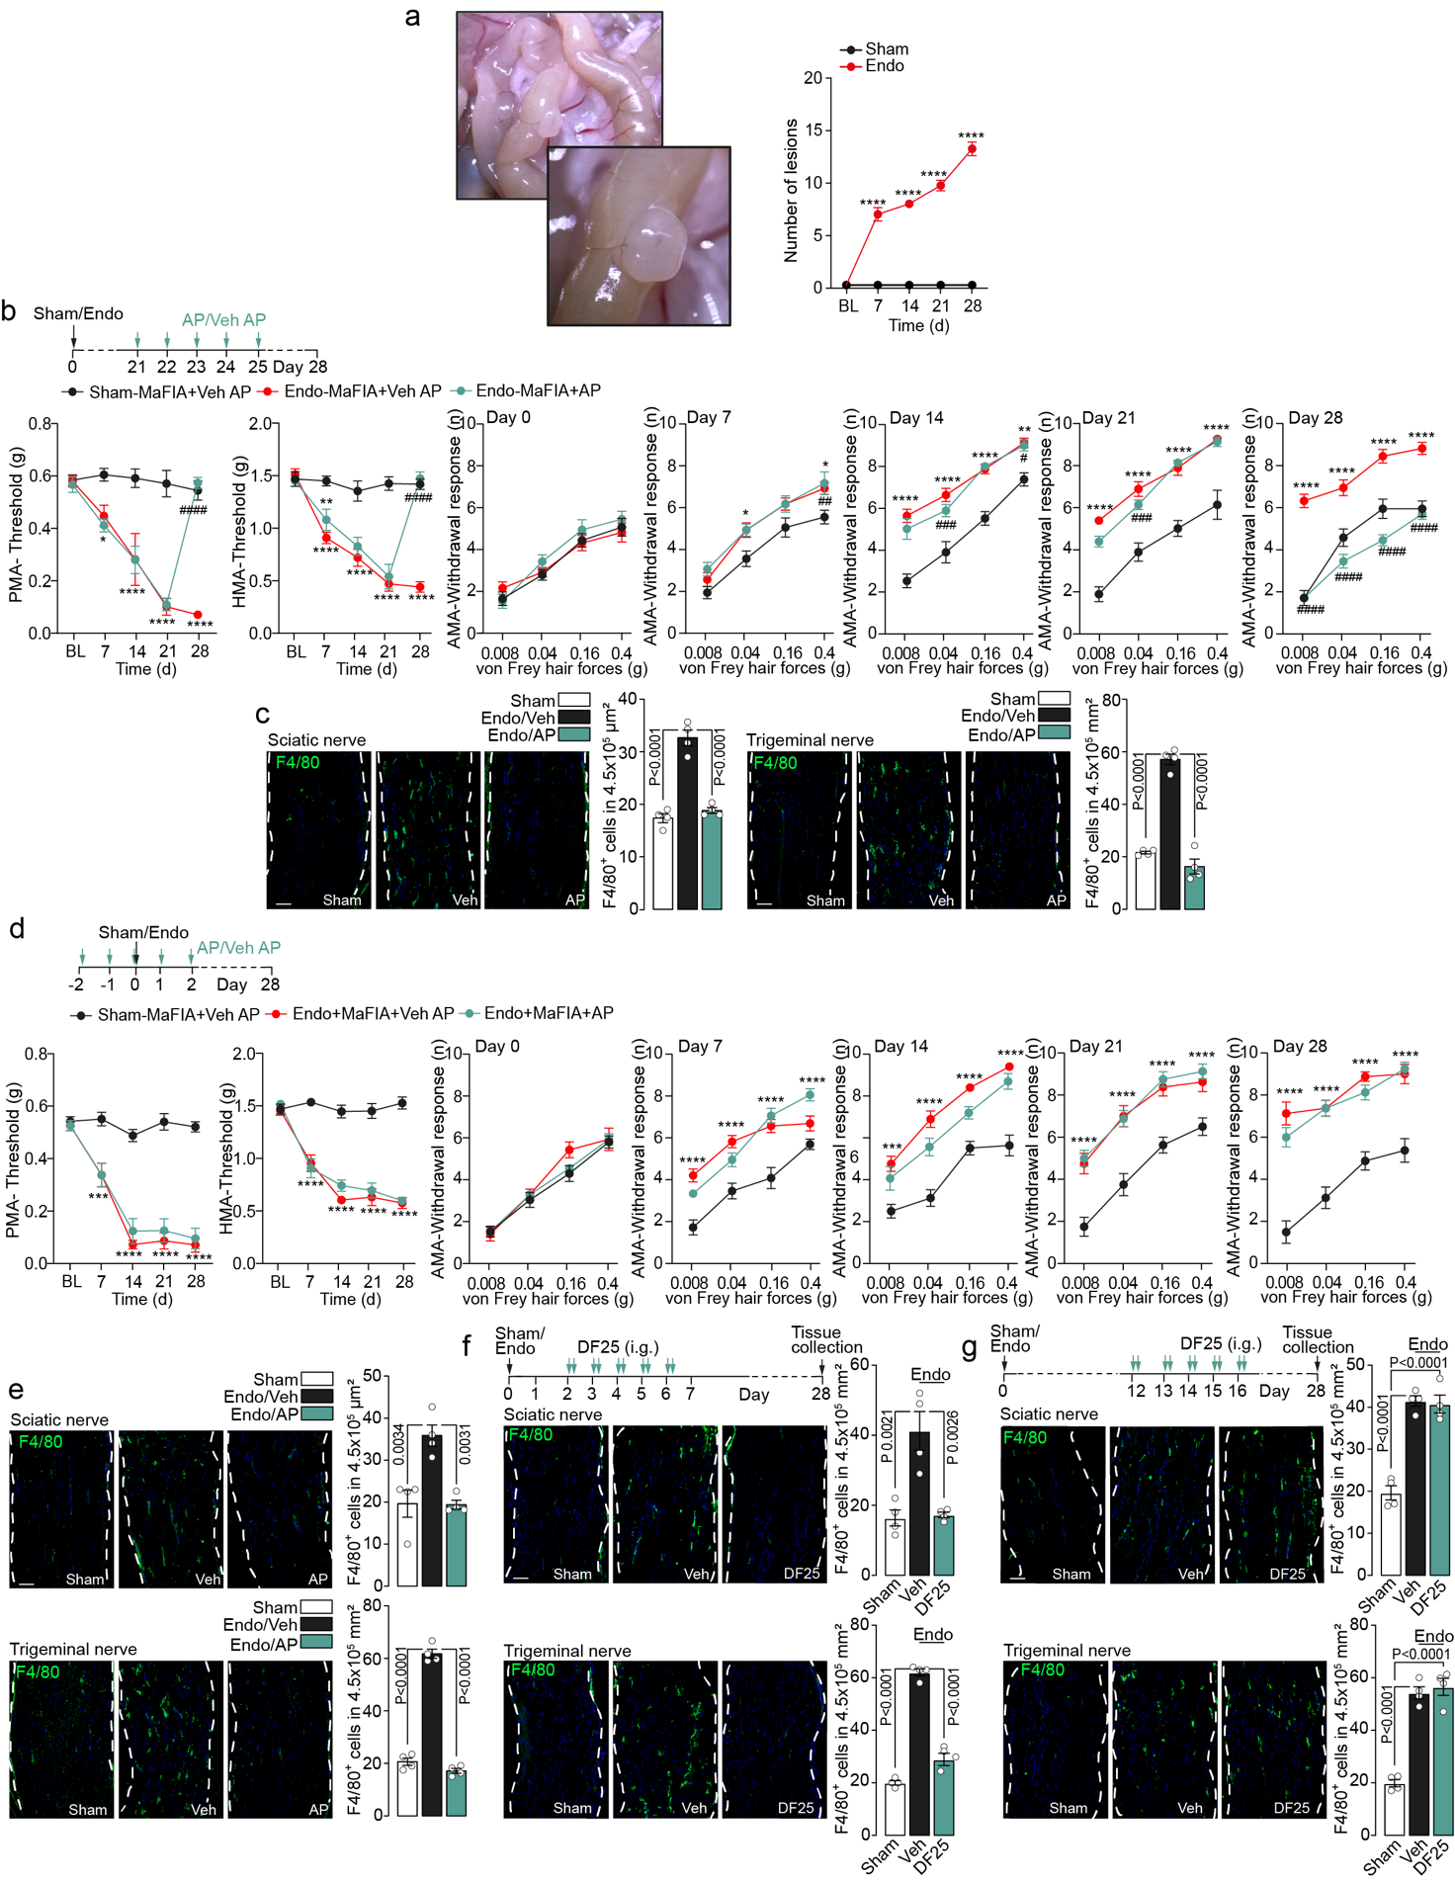
Supplementary Fig. 1 (a) Representative photographs and cumulative data of endometriotic lesions in endometriotic (endo) C57BL/6J female (B6) and Sham mice. (b) Timeline of the AP20187 (AP) treatment schedule and time-dependent periorbital (PMA), hindpaw (HMA) and abdominal (AMA) mechanical allodynia in endo and Sham MaFIA mice after intraperitoneal (i.p.) injection of AP or vehicle (Veh) (n=8 mice per group). (c) Representative images and cumulative data of F4/80⁺ cells in sciatic and trigeminal nerve tissue of endo B6 after AP or Veh and Sham mice (n=4 independent experiments). (d) Timeline of the AP treatment schedule and time-dependent PMA, HMA and AMA in endo and Sham MaFIA mice after i.p. injection of AP or Veh (n=8 mice per group). (e) Representative images and cumulative data of F4/80⁺ cells in sciatic and trigeminal nerve tissue of endo B6 mice after AP or Veh and Sham mice. (f,g) Timeline of the DF2593A (DF25) treatments, and representative images and cumulative data of F4/80⁺ cells in sciatic and trigeminal nerve tissue in endo and Sham B6 mice after intagastric (i.g.) administration of DF25 (1 mg/kg) or vehicle (Veh) and Sham mice (Scale bar, 50 μm, dashed lines, perineurium). Data are mean ± s.e.m. a, b,d 2-way ANOVA, c, e, f, g, 1-way ANOVA, Bonferroni correction. *P<0.05, **P<0.01, ***P<0.001, ****P<0.0001 vs. Sham #P<0.05, ###P<0.001 ####P<0.0001 vs. Endo-MaFIA+ Veh AP.

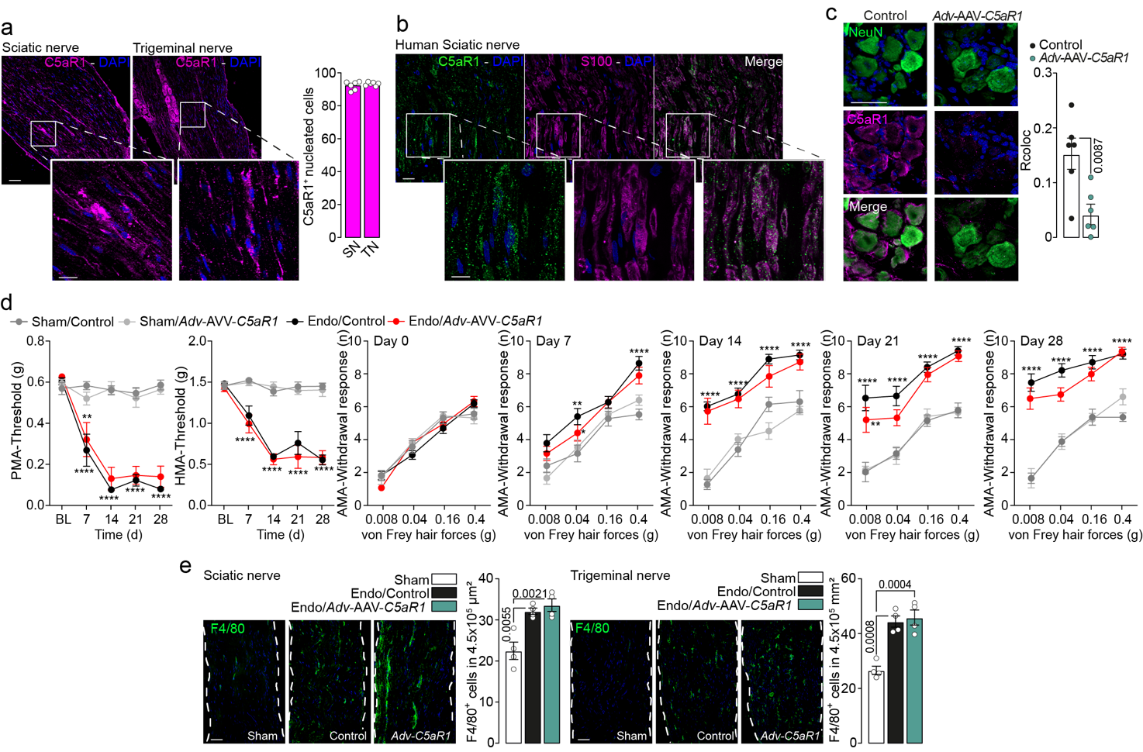
Supplementary Fig. 2 (a) Representative images and cumulative data of C5aR1+ nucleated cells in sciatic (SN) and trigeminal (TN) nerves from C57BL/6J female (B6) mice (Scale bar, 50 μm; inset, 20 μm) (n=6 independent experiments). (b) representative images of C5aR1 and S100 co-expression in human sciatic nerve tissues (Scale bar, 50 μm; inset, 20 μm). (c) Representative images and cumulative data (Rcoloc) of NeuN and C5aR1 co-expression in dorsal root ganglia tissues of Adv-AAV-C5aR1 and Control mice (Scale bar, 50 μm) (n=6 independent experiments). (d) Time-dependent periorbital (PMA), hindpaw (HMA) and abdominal (AMA) mechanical allodynia in endometriotic (endo) or Sham Adv-AAV-C5aR1 and Control mice (n=8 mice per group). (e) Representative images and cumulative data of F4/80⁺ cells in sciatic and trigeminal nerve tissue of endo and Sham Adv-AAV-C5aR1 and Control mice (n=4 independent experiments) (Scale bar, 50 μm, dashed lines, perineurium). Data are mean ± s.e.m. c, Student’s t test, d, 2-way ANOVA, e, 1-way ANOVA, Bonferroni correction. **P<0.01, ****P<0.0001 vs Sham.

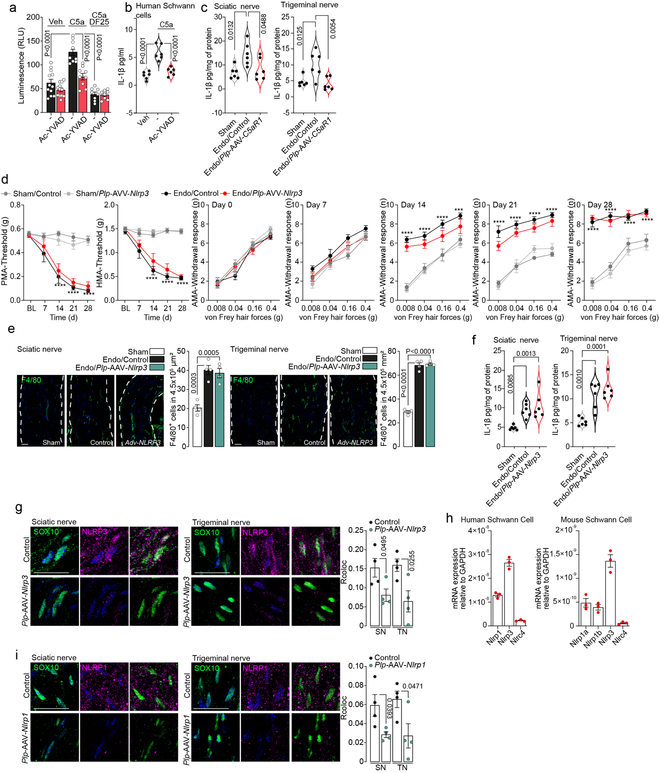
Supplementary Fig. 3 (a) Caspase-Glo 1 inflammasome assay in human Schwann cells stimulated with C5a or vehicle (Veh) and in the presence of DF2593A (DF25), Ac-YVAD or Veh (number of replicates: C5a= 9, Veh/C5a=12, Veh/ Ac-YVAD=12, C5a/ Ac-YVAD=9, C5a/ DF25=8 and C5a/Veh DF25=8) . (b) IL-1β assay in human Schwann cell conditioned medium after stimulation with C5a or Veh and in the presence of Ac-YVAD or Veh (n=6 independent experiments). (c) IL-1β assay in sciatic and trigeminal nerve tissue homogenates in endometriotic (endo) or Sham Plp-AAV-C5aR1 and Control mice (n=6 independent experiments). (d) Time-dependent periorbital (PMA), hindpaw (HMA) and abdominal (AMA) mechanical allodynia in endo and Sham Plp-AAV-Nlrp3 and Control mice (n=8 mice per group). (e) Representative images and cumulative data of F4/80⁺ cells in sciatic and trigeminal nerve of endo or Sham Plp-AAV-Nlrp3 and Control mice (n=4 independent experiments) (Scale bar, 50 μm, dashed lines, perineurium). (f) IL-1β assay in sciatic and trigeminal nerve tissue homogenates in endo or Sham Plp-AAV-Nlrp3 and Control mice (n=6 independent experiments). (g) Representative images and cumulative data (Rcoloc) of SOX10 and NLRP3 co-expression in sciatic and trigeminal nerves of Plp-AAV-Nlrp3 and Control mice (n=4 independent experiments) (Scale bar, 20 μm). (h) Nlrp1, Nlrp3 and Nlrc4 mRNA relative expression in primary mouse and human Schwann cells. (i) Representative images and cumulative data (Rcoloc) of SOX10 and NLRP1 co-expression in sciatic and trigeminal nerves of Plp-AAV-Nlrp1 and Control mice (n=4 independent experiments) (Scale bar, 20 μm). Data are mean ± s.e.m. a, b, c, e, f, 1-way ANOVA, b, 2-way ANOVA, Bonferroni correction. d, Student’s t test. ***P<0.001, ****P<0.0001 vs Sham.

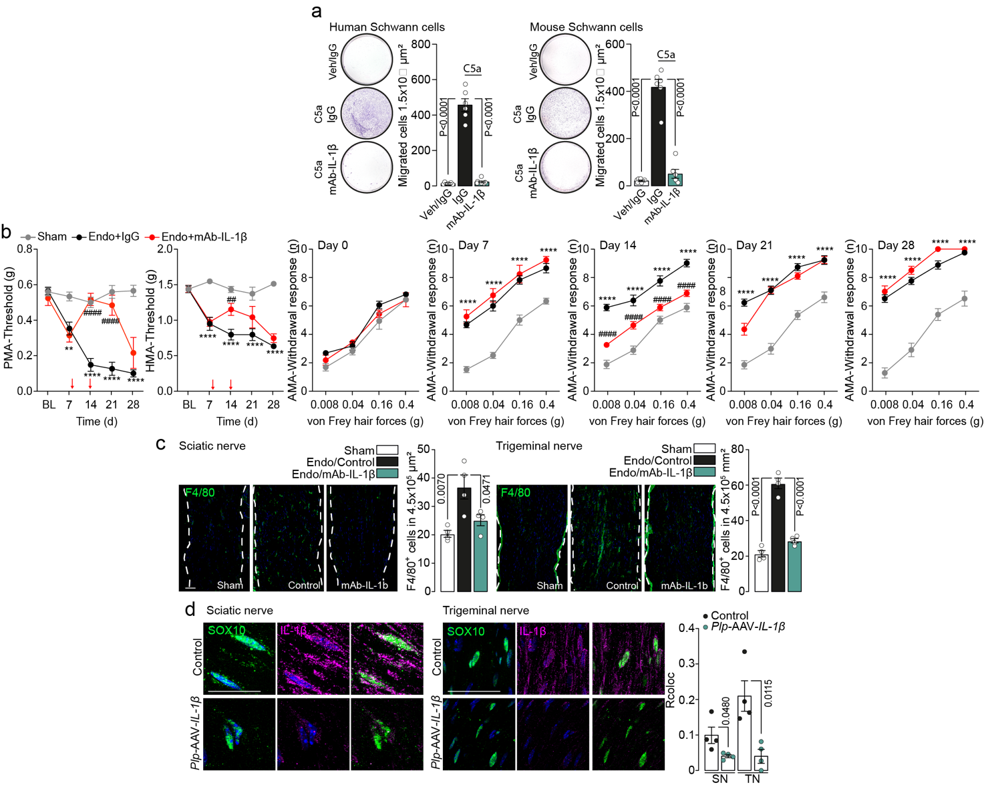
Supplementary Fig. 4 (a) Representative images and cumulative data of transmigrated macrophages after stimulation of human and mouse Schwann cells with C5a or Veh, in the presence with mAb-IL-1β or IgG (n=6 independent experiments). (b) Time-dependent periorbital (PMA), hindpaw (HMA) and abdominal (AMA) mechanical allodynia in endometriotic (endo) or Sham C57BL/6J female (B6) mice treated with mAb-IL-1β or IgG. (n=8 mice per group). (c) Representative images and cumulative data of F4/80⁺ cells in sciatic and trigeminal nerve tissue of endo or Sham B6 mice treated with mAb-IL-1β or IgG (n=4 independent experiments) (Scale bar, 50 μm, dashed lines, perineurium). (d) Representative images and cumulative data (Rcoloc) of SOX10 and IL-1β co-expression in sciatic and trigeminal nerves in Plp-AAV-IL-1β and Control mice (n=4 independent experiments) (Scale bar, 20 μm). Data are mean ± s.e.m. a, c, 1-way ANOVA, d, 2-way ANOVA, Bonferroni correction. g, i, Student’s t test. **P<0.01, ****P<0.0001 vs Sham, ##P<0.01, ####P<0.0001 vs Sham.

Supplermentary tables

Supplermentary table S1. Primers for plasmid construction

Primer | Primer sequence (5’ to 3’)
P1 | CATCTGTGGCTTCACTAAAATAAGAGGTTCTCTCCTGGGCGCTCACTGTCAACAGCAATA
P2 | GTGAAGCCACAGATGTAAAATAAGAGGTTCTCTCCTGGTTGCCTACTGCCTCGGACTTCA
P3 | GAGTACCGGTCACGCGTACGCAAG
P4 | ACTAGTGCTATCGATGTTGAGC
P5 | GCTTCACTAAATAAATAGGTAAGTGGTTGCTCGCTCACTGTCAACAGCAATATACCTTC
P6 | CACAGATGTAAATAAATAGGTAAGTGGTTGCCTGCCTACTGCCTCGGACTTCAAG

Supplermentary table S2. Human and mouse primers for RT-qPCR

 | Sequence (5’ to 3’)
Human GAPDH (NM_002046) | F: ACATCGCTCAGACACCATG  R: TGTAGTTGAGGTCAATGAAGGG
Human C5aR1 (NM_001736) | F: GAGATCATGCAAACTCAACACA  R: GTCAATATCCTGGTATGAGACTAC
Human Il-1β (NM_000576 | F: CAGCCAATCTTCATTGCTCAAG  R: GAACAAGTCATCCTCATTGCC
Human NLRP3 (NM_001079821) | F: GAATGCCTTGGGAGACTCAG  R: AGATTCTGATTAGTGCTGAGTACC
Human NLRC4 (NM_021209) | F: GACTGAGAGAACACATCTGCTG  R: CCAAATGGAAAGGTCAAAGGTG
Human NLRP1 (NM_033007) | F: ACTGCTCCATTCGGAAGG  R: CCCACACCAGAGTCTCATCT
Mouse GAPDH (NM_008084) | F: AATGGTGAAGGTCGGTGTG  R: GTGGAGTCATACTGGAACATGTAG
Mouse C5aR1 (NM_001173550) | F: GTTACCACAGAACCCAGGAG  R: GCCATCCGCAGGTATGTTAG
Mouse Il-1β (NM_008361) | F: GACCTGTTCTTTGAAGTTGACG  R: CTCTTGTTGATGTGCTGCTG
Mouse NLRP3 (NM_145827) | F: CACTCATGTTGCCTGTTCTTC  R: CGGTTGGTGCTTAGACTTGA
Mouse NLRC4 (NM_001033367) | F:AGTTCTAGCACAGAATCTTCACA  R: AGCATCAATGTAGTGAGCTCTC
Mouse NLRP1a (NM_001004142) | F: GTGATGGTCCCTACGATGAAC  R: CCCAGAACTCATCTTCAGTCC
Mouse NLRP1b (NM_001040696) | F: GAGTCTTCGGGTGAACATGA  R: CAACTGGCATTAGTGATTGGG

