Supplemental materials

Table S1 Components, retention time and their quantitative ions and qualitative ions
Number | Compound name | Retention time (min) | Quantitative ion (m/z) | Qualitative ion (m/z)
1 | Acetone | 2.43 | 43 | 58
2 | Dichloromethane | 3.035 | 49 | 84.00-86.00
3 | trans-1,2-Dichloroethylene | 3.315 | 61 | 96.00-98.00
4 | Hexane | 3.42 | 57 | 41.00-86.00
5 | 1,1, -dichloroethane | 3.755 | 63 | 65.00-83.00
6 | cis-1,2-Dichloroethylene | 4.37 | 61 | 96.00-98.00
7 | Chlorform | 4.745 | 83 | 85
8 | 1,1,1-trichloroethane | 4.935 | 97 | 99.00-61.00
9 | Carbon tetrachloride | 5.11 | 117 | 119.00-121.00
10 | 1,2-dichloroethane | 5.435 | 62 | 98
11 | Benzene | 5.38 | 78 | 77
12 | Trichloroethylene | 6.235 | 95 | 132.00-130.00
13 | 1,2-dichloropropane | 6.565 | 63 | 62.00-41.00
14 | Bromodichloromethane | 6.95 | 83 | 85.00-127.00
15 | Toluene | 8.06 | 91 | 92
16 | 1,1,2-trichloroethane | 8.765 | 97 | 83.00-85.00
17 | Tetrachloroethylene | 8.875 | 166 | 129.00-164.00
18 | Dibromochloromethane | 9.445 | 129 | 127
19 | 1,2-dibromoethane | 9.635 | 107 | 109.00-188.00
20 | N, N-dimethylformamide | 10.3 | 73 | 44.00-58.00
21 | Chlorobenzene | 10.775 | 112 | 77.00-114.00
22 | 1,1,1,2-tetrachloroethane | 11.045 | 131 | 133.00-119.00
23 | Ethylbenzene | 11.08 | 91 | 106
24 | m,p-xylene | 11.48 | 91 | 106
25 | o-xylene | 12.64 | 91 | 106
26 | Styrene | 12.72 | 104 | 78
27 | Bromoform | 13.205 | 173 | 254.00-175.00
28 | N, N-dimethylacetamide | 13.68 | 87 | 72.00-44.00
29 | 1,1,2,2-Tetrachloroethylene | 14.96 | 83 | 85.00-131.00
30 | 1,2,3-trichloropropane | 15.04 | 75 | 77
31 | 1,3,5-trimethylbenzene | 15.83 | 105 | 120
32 | 1,2,4-Trimethylbenzene | 16.915 | 105 | 120
33 | 1,3-dichlorobenzene | 17.585 | 146 | 148.00-111.00
34 | 1,4-dichlorobenzene | 17.945 | 146 | 148.00-111.00
35 | 1,2-dichlorobenzene | 18.91 | 146 | 148.00-111.00
36 | 1,2,4-Trichlorobenzene | 23.545 | 182 | 180.00-145.00
37 | Hexachlorobutadiene | 24.055 | 225 | 227.00-223.00

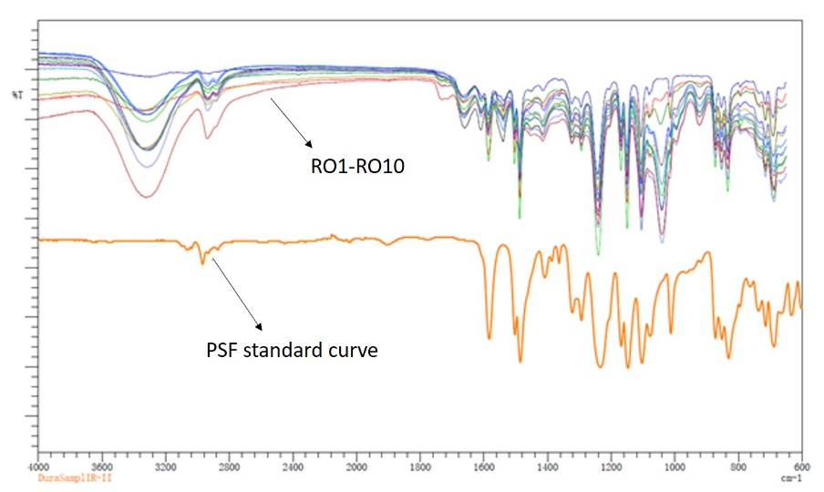
Figure S1 Infrared red spectra of different RO membranes
Figure S2 Example of the concentration of various VOCs in effluent water as a function of inflow volume, a) acetone, b) dichloromethane, c) hexane, d) chloroform, e) 1,2-dichloroeyhane, f) benzene, g) toluene, h) N,N- dimethylformamide, i) chlorobenzene, j) ethyl benzene, k) xylene, l) styrene. Total flow rate = 0.5 L/min, ratio of purified water and waste water = 0.9 – 1.2.

Figure S3 Liner fitting equations and correlation coefficients of a) DCM, b) TCM, c) DCA and d) Tol. Results in effluent with VOC concentrations lower than their maximum detection limits were not showed.

