APPENDICES
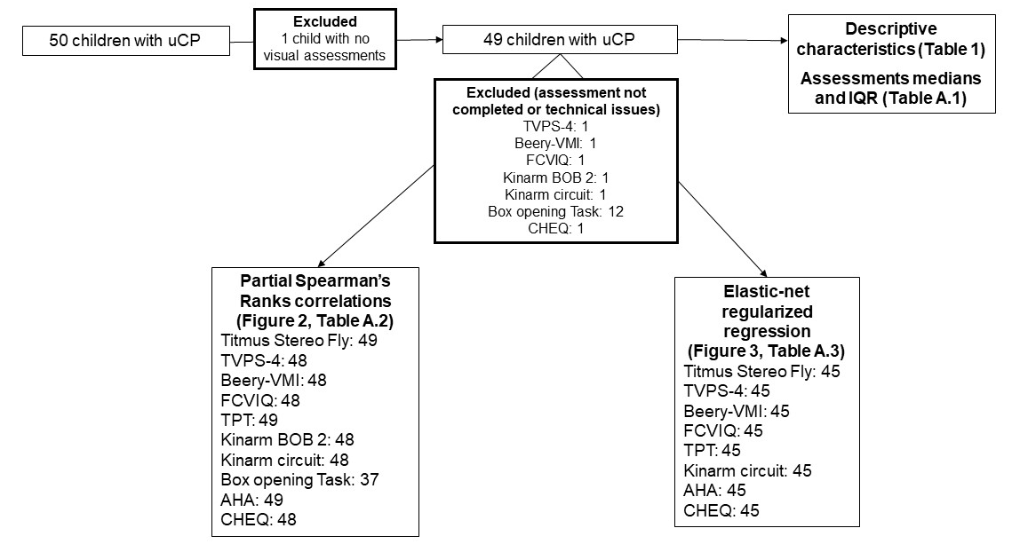
Figure A.1. Flow chart describing the study cohort.

TVPS-4: Test of Visual Perceptual Skills, Fourth edition; Beery: Beery Buktenica Test of Visual-Motor Integration; BOB: Ball-on-bar; FCVIQ: Flemish cerebral visual impairment questionnaire; TPT: Tyneside Pegboard Test; AHA: Assisting Hand Assessment; CHEQ: Children's Hand-use Experience Questionnaire.
Table A.1. Median and interquartile ranges of the visual functions, functional vision, and bimanual function assessments.
 | Assessment | Median (IQR) |  | uCP (N = 49), n (%)
Visual assessments | ªTitmus Stereo Fly ↑ | 8.00 | (3.00-9.00) |  | 49 | (100)
Visual assessments | ^{b}TVPS-Visual Discrimination ↑ | -0.33 | (-1.50-0.33) |  | 48 | (98)
Visual assessments | ^{b}TVPS-Spatial Relationships ↑ | 0.00 | (-1.00-0.67) |  | 48 | (98)
Visual assessments | ^{b}TVPS-Form Constancy ↑ | -0.33 | (-1.00-0.67) |  | 48 | (98)
Visual assessments | ^{b}TVPS-Visual Figure-Ground ↑ | -0.50 | (-1.33-0.17) |  | 48 | (98)
Visual assessments | ^{b}TVPS-Visual Closure ↑ | -0.67 | (-1.33-0.17) |  | 48 | (98)
Visual assessments | ^{b}Beery-Visuomotor Integration ↑ | -1.17 | (-2.20-(-0.67)) |  | 48 | (98)
Visual assessments | ^{c}FCVIQ total score ↓ | 4.00 | (1.00-7.50) |  | 48 | (98)
Bimanual function assessments | ^{d}TPT NDH-DH ↓ | 22.42 | (17.45-31.35) |  | 49 | (100)
Bimanual function assessments | ^{d}TPT DH-NDH ↓ | 27.81 | (19.10-41.17) |  | 49 | (100)
Bimanual function assessments | ^{e}Kinarm circuit task ↑ | 0.26 | (0.24-0.29) |  | 48 | (98)
Bimanual function assessments | ^{f}Kinarm BOB 2 bar tilt SD ↓ | 0.07 | (0.06-0.09) |  | 48 | (98)
Bimanual function assessments | ^{g}Kinarm BOB 2 hand speed difference ↓ | 46.41 | (39.76-58.97) |  | 48 | (98)
Bimanual function assessments | ^{h}Kinarm BOB 2 hand path length bias ↓ | 0.02 | (-0.02-0.04) |  | 48 | (98)
Bimanual function assessments | ^{i}Box opening task goal synchronization ↓ | 0.10 | (0.06-0.16) |  | 37 | (76)
Bimanual function assessments | ^{d}Box opening task total movement time ↓ | 1.72 | (1.55-2.33) |  | 37 | (76)
Bimanual function assessments | ^{l}AHA ↑ | 75.00 | (57.00-84.00) |  | 49 | (100)
Bimanual function assessments | ^{l}CHEQ-grip ↑ | 52.50 | (39.00-66.50) |  | 48 | (98)
Bimanual function assessments | ^{l}CHEQ-time ↑ | 50.50 | (42.50-61.50) |  | 48 | (98)
Bimanual function assessments | ^{l}CHEQ-feeling ↑ | 52.50 | (42.50-63.50) |  | 48 | (98)
Percentages are calculated out of the total sample of children with uCP included in the analysis (N=49).
ªResults report the last circle identified or the fly test. ^{b}Results are reported in z-scores. ^{c}Results calculated as the sum of the ‘yes’ items (1: the child presents the characteristic described in the item). ^{d}Results calculated in sec. ^{e}Results calculated according to the formula $\frac{min(│Vx│,│Vy│) }{\sqrt{(V^{2}x }+V^{2}y) }$ with V_{x/y} = absolute value of the horizontal/vertical hand velocity (Yeganeh Doost et al., 2017). ^{f}Results calculated in Radius. ^{g}Results calculated in %. ^{h}Results calculated in cm/cm. ^{i}Results calculated in sec/sec. ^{l}Results calculated in logit [0-100] (Krumlinde-Sundholm & Eliasson, 2009; Sköld et al., 2011). ↑: higher values indicate a better performance.↓: lower values indicate a better performance. IQR: interquartile ranges calculated with Tukey’s Hinges; n: number of children; TVPS: Test of Visual Perceptual Skills, Fourth edition; Beery: Beery Buktenica Test of Visual-Motor Integration; FCVIQ: Flemish cerebral visual impairment questionnaire; BOB: Ball-on-bar; SD: standard deviation; TPT: Tyneside Pegboard Test; NDH: non dominant hand; DH: dominant hand; AHA: Assisting Hand Assessment; CHEQ: Children's Hand-use Experience Questionnaire.
 |  | Tyneside Pegboard Test |  | Kinarm exoskeleton robot |  |  |  | Box opening task |  | AHA |  | CHEQ
 |  | NDH-DH | DH-NDH | BOB 2 bar tilt SD | BOB 2 hand speed difference | BOB 2 hand path length bias | Kinarm circuit task | Total movement time | Goal synchronization | AHA | CHEQ-grip | CHEQ-time | CHEQ-feeling
Titmus Stereo Fly | r_{s} | -0.404 | -0.236 | -0.283 | -0.211 | -0.108 | 0.204 | -0.049 | -0.031 | 0.117 | 0.082 | 0.278 | 0.253
Titmus Stereo Fly | p | 0.028 | 0.195 | 0.133 | 0.256 | 0.509 | 0.265 | 0.803 | 0.876 | 0.482 | 0.609 | 0.137 | 0.176
TVPS-Visual Discrimination | r_{s} | -0.347 | -0.427* | -0.155 | -0.289 | -0.108 | 0.331 | -0.223 | -0.175 | 0.275 | 0.329 | 0.313 | 0.380*
TVPS-Visual Discrimination | p | 0.07 | 0.022 | 0.373 | 0.133 | 0.509 | 0.087 | 0.281 | 0.373 | 0.141 | 0.087 | 0.104 | 0.042
TVPS-Spatial Relationships | r_{s} | -0.447* | -0.483* | -0.201 | -0.215 | -0.205 | 0.410* | -0.303 | -0.216 | 0.245 | 0.312 | 0.341 | 0.395*
TVPS-Spatial Relationships | p | 0.02 | 0.01 | 0.27 | 0.253 | 0.265 | 0.028 | 0.155 | 0.287 | 0.185 | 0.104 | 0.081 | 0.033
TVPS-Form Constancy | r_{s} | -0.333 | -0.331 | -0.153 | -0.108 | -0.159 | 0.436* | -0.205 | -0.221 | 0.19 | 0.191 | 0.156 | 0.284
TVPS-Form Constancy | p | 0.085 | 0.085 | 0.373 | 0.509 | 0.373 | 0.022 | 0.315 | 0.285 | 0.287 | 0.287 | 0.373 | 0.133
TVPS-Visual Figure-Ground | r_{s} | -0.519** | -0.620*** | -0.323 | -0.309 | -0.204 | 0.407* | -0.129 | -0.143 | 0.409* | 0.485** | 0.516** | 0.533**
TVPS-Visual Figure-Ground | p | 0.006 | 0.0003 | 0.094 | 0.104 | 0.265 | 0.028 | 0.506 | 0.465 | 0.028 | 0.01 | 0.006 | 0.006
TVPS-Visual Closure | r_{s} | -0.391* | -0.438* | -0.205 | -0.145 | -0.313 | 0.352 | -0.258 | -0.124 | 0.306 | 0.271 | 0.269 | 0.414*
TVPS-Visual Closure | p | 0.033 | 0.021 | 0.265 | 0.399 | 0.104 | 0.07 | 0.22 | 0.509 | 0.104 | 0.153 | 0.153 | 0.028
Beery-Visuomotor Integration | r_{s} | -0.377* | -0.249 | -0.285 | -0.173 | -0.017 | 0.178 | -0.166 | -0.177 | 0.257 | 0.089 | 0.125 | 0.243
Beery-Visuomotor Integration | p | 0.042 | 0.178 | 0.133 | 0.327 | 0.91 | 0.317 | 0.399 | 0.373 | 0.17 | 0.588 | 0.465 | 0.195
FCVIQ total score | r_{s} | 0.228 | 0.231 | 0.212 | 0.3 | 0.166 | -0.178 | 0.291 | 0.02 | -0.229 | -0.306 | -0.441* | -0.458*
FCVIQ total score | p | 0.214 | 0.214 | 0.256 | 0.113 | 0.351 | 0.317 | 0.178 | 0.91 | 0.214 | 0.106 | 0.021 | 0.019
Table A.2. Results of the partial Spearman’s rank correlations after false discovery rate correction between visual and bimanual function assessments in children with unilateral cerebral palsy.
TVPS: Test of Visual Perceptual Skills, Fourth edition; Beery: Beery-Buktenica Test of Visual-Motor Integration; FCVIQ: Flemish cerebral visual impairment questionnaire; BOB: Ball-on-bar task of the Kinarm exoskeleton robot; SD: standard deviation; TPT: Tyneside Pegboard Test; NDH: non-dominant hand; DH: dominant hand; AHA: Assisting Hand Assessment; CHEQ: Children's Hand-use Experience Questionnaire. Significant Spearman’s rank correlation in bold: *p ≤ 0.05, **p ≤ 0.01, ***p ≤ 0.001. Spearman rank’s correlation coefficient, interpreted as no or negligible (<0.30), low (0.30-0.49), moderate (0.50-0.69), high (0.70-0.89), or very high (≥0.90) (Mukaka, 2012).
Table A.3. Results of the elastic-net regularized regression with the effect sizes (Cohen’s d) of each predictor.
Bimanual function outcomes |  |  | Age |  | Titmus Stereo Fly |  | TVPS |  |  |  |  |  |  |  |  |  | Beery |  | FCVIQ |  | R²
 |  |  |  |  |  |  | Visual Discrimination |  | Spatial Relationships |  | Form Constancy |  | Visual Figure-Ground |  | Visual Closure |  | Visuomotor Integration |  | Total score
TPT | NDH-DH | -0.002 |  | -0.002 |  | -0.001 |  | -0.261 |  | 0.000ª |  | -0.089 |  | -0.142 |  | -0.001 |  | 0.000ª |  | 0.115
TPT | DH-NDH | -0.150 |  | 0.090 |  | 0.082 |  | -0.315 |  | 0.030 |  | -0.282 |  | -0.178 |  | -0.060 |  | -0.083 |  | 0.063
KINARM | Circuit task | 0.606 |  | -0.002 |  | 0.004 |  | 0.104 |  | 0.176 |  | 0.066 |  | 0.009 |  | 0.000 |  | 0.000ª |  | 0.356
AHA | AHA | -0.006 |  | -0.084 |  | 0.001 |  | 0.009 |  | 0.000ª |  | 0.279 |  | 0.088 |  | 0.182 |  | 0.001 |  | 0.035
CHEQ | grip | 0.000 |  | -0.002 |  | 0.000 |  | 0.004 |  | 0.000 |  | 0.288 |  | 0.041 |  | 0.000 |  | -0.001 |  | 0.104
CHEQ | time | 0.002 |  | 0.000ª |  | 0.000 |  | 0.002 |  | -0.004 |  | 0.345 |  | 0.001 |  | 0.000 |  | -0.201 |  | 0.210
CHEQ | feeling | 0.000ª |  | 0.000ª |  | 0.001 |  | 0.003 |  | 0.001 |  | 0.260 |  | 0.239 |  | 0.018 |  | -0.113 |  | 0.171

ªThe average estimate is less than 0.001. TVPS: Test of Visual Perceptual Skills, Fourth edition; Beery: Beery Buktenica Test of Visuo-Motor Integration; FCVIQ: Flemish cerebral visual impairment questionnaire; TPT: Tyneside Pegboard Test; NDH: non-dominant hand; DH: dominant hand; AHA: Assisting Hand Assessment; CHEQ: Children's Hand-use Experience Questionnaire (CHEQ). R²: R-squared indicating the power of the model, interpreted as weak (0.02-0.12), moderate (0.13-0.25) in italics, and large (>0.26) in bold (Cohen, 1999). The estimate of each individual predictors was used as effect sizes (Cohen's d) and interpreted as tiny (<0.10) in white, very small (0.10-0.19) in light yellow, small (0.20-0.49) in dark yellow, moderate (0.50-0.79) in orange, large (0.80-1.19), very large (1.20-1.99) and huge (≥2.00) (Sawilowsky, 2009).

