Supporting Information

Integrated Blood Pressure-Chemical Sensing Epidermal Patch

Juliane R. Sempionatto^{1†}, Muyang Lin^{1†}, Lu Yin^{1†}, Ernesto de la Paz¹, Kexin Pei¹, Thitaporn Sonsa-ard¹, Andre N. de Loyola Silva¹, Ahmed A. Khorshed¹, Fangyu Zhang¹, Nicholas Tostado,¹ Sheng Xu¹*, and Joseph Wang¹*

¹Department of Nanoengineering, University of California San Diego, La Jolla, California 92093, USA.
†These authors contributed equally to this work
*e-mail: shengxu@ucsd.edu, josephwang@ucsd.edu

Contents

List of Abbreviations 34
Supplementary Note 1. Sensor Fabrication Protocols: 35
Fabrication of the SEBS substrate 35
Synthesis of the stretchable silver and PB ink 35
Printing of the stretchable electrodes 35
Assembly of the PZT transducers 36
Biosensor Working electrode modification 36
Preparation of the IP hydrogels 37
Supplementary Note 2. Sensor in-vitro characterization: 38
Lactate sensor 38
Glucose sensor 38
Alcohol sensor 38
Caffeine sensor 39
Supplementary Note 3. Calibration of blood pressure waveform: 40
Supplementary References 41
Supplementary Figures 42
Supplementary Video 68

List of Abbreviations
AA Ascorbic acid
AC acetaminophen
AL Alcohol
AOx Alcohol oxidase
BAC Blood alcohol concentration
BP Blood pressure
CA Chronoamperometry
CF Caffeine
DPV Differential pulse voltammetry
ECG Electrocardiogram
EEG Electroencephalogram
EKG Electrocardiogram
EMF Electromotive force
GLU Glucose
GOx Glucose oxidase
HR Heart rate
IP Iontophoresis
ISF Interstitial fluid
LA Lactate
LOx Lactate oxidase
NO Nitric oxide
PB Prussian blue
PZT Piezoelectric lead zirconate titanate
RPM Rotations per minute
SEBS Styrene-ethylene-butylene-styrene block copolymer
SEM Scanning electron microscope
UA Uric acid
US Ultrasound

Supplementary Note 1. Sensor Fabrication Protocols:

Fabrication of the SEBS substrate
A viscus SEBS resin was prepared by dispersing SEBS beads in toluene with a weight ratio of 1: 2. The mixture was left on a linear shaker (Scilogex, SK-L180-E) overnight or until the mixture became transparent and homogeneous. A PET film with non-stick coating was used as the temporary casting substrate, and a doctor blade set at 1 mm height was used to cast the SEBS resin into a sheet on the PET substrate. The cast resin was firstly dried in ambient environment for 1 h, followed by curing in a conventional oven at 80 °C for 1 h to remove the excess solvent. The transparent, uniform SEBS film was peeled off from the PET substrate for subsequent sensor fabrication.

Synthesis of the stretchable silver and PB ink
The formulation of the stretchable silver ink is based on early reports.¹ The ink was synthesized by mixing silver flakes, toluene, and SEBS, in a weight ratio of 4: 2.37: 0.63, in a dual asymmetric centrifugal mixer (Flacktek Speedmixer, DAC 150.1 KV-K) with a speed of 1800 RPM for 10 min or until obtaining a homogeneous ink. The stretchable PB ink was synthesized by mixing super-P carbon black, graphite powder, PB, SEBS and toluene, in a weight ratio of 0.5: 3: 1: 1.26: 4.74, in the mixer at 2150 RPM for 10 min or until the ink was homogeneous.

Printing of the stretchable electrodes
The prepared SEBS sheet was used as the stretchable substrate for the printed electrodes. Firstly, stretchable silver ink was used for printing the interconnections, the IP electrodes and the reference electrodes on the front of the SEBS substrate. Next, the stretchable PB ink was used to print the working and counter electrodes of the biosensors. The SEBS substrate was then turned over and the interconnections for the transducer array were printed, with one extra channel reserved for connecting to the common ground of the transducers. A separate piece of SEBS sheet was used to print the ground wire for the transducers. The printed inks were cured in a conventional oven at 80 °C for 10 min after each printing step. The step-by-step printing of the electrode is illustrated in Supplementary Figure 1.

Assembly of the PZT transducers
The diced PZT transducers can be “solvent soldered” onto the printed current collectors by firstly dissolving the junction regions of the interconnections temporarily with a small volume of toluene, followed by placing the transducers onto the softened trances to physically bond with the composite ink. After placing the transducers onto wetted interconnections, the assembled device was left drying for 2 minutes in ambient temperature. Afterwards, the printed ground wire was carefully aligned with the transducers and solvent soldered to the array in a similar fashion. Lastly, the printed ground was “solvent soldered” to the reserved channel of the interconnection array. The detailed fabrication process is illustrated in Supplementary Figure 2.

Biosensor Working electrode modification
All PBS used in the electrode modification were prepared in 0.1 M with a pH of 7.4. All BSA solution were prepared with a concentration of 10 mg/mL in PBS. The chitosan solution was prepared by dissolving chitosan in 0.1 M acetic acid with concentration of 0.5 wt%. For preparing the lactate biosensor, the chitosan solution was mixed with a LOx (40 mg/mL) in BSA solution, in a ratio of 1: 1 (v/v), followed by drop casting a 2 µL aliquot of the mixture onto the working electrode surface. For preparing the glucose biosensor, GOx (40 mg/mL) in BSA solution, glutaraldehyde in water (5 wt%) and Nafion in water (0.5 wt%) were mixed in a ratio of 1: 1: 0.33 (v/v/v) , and a 1.5 µL aliquot was drop cast onto the working electrode surface. For preparing the alcohol biosensor, AOx (10-40 units/mg), BSA solution and the chitosan solution were mixed in a ratio of 8:1:1 (v/v/v), and a 4 µL aliquot of the mixture was drop cast to the working electrode surface. After drying at room temperature for 1 hr, 2 µL of the chitosan solution was drop cast to the previously modified surface. Upon completing the corresponding modification steps, the resulting biosensors were stored at 4°C overnight before using. For caffeine sensor, a solution of 0.1 mg/mL of MWCNT was dispersed in 50% EtOH (v/v in DI water) in an ultrasound bath for 10 min, and a 2 µL aliquot of the dispersed solution was drop cast onto the working electrode surface. After drying at room temperature for 1 hr, 2 µL of 0.01% v/v of Nafion in water solution was drop cast onto the previously decorated working electrode and dried at room temperature overnight. Schematics representing the modified sensor components and corresponding electrochemical reactions are shown in Supplementary Figure 5.

Preparation of the IP hydrogels
An Ecoflex mold with multiple circular trenches with diameter of 18 mm and thickness of at least 1 mm was prepared for forming the hydrogels. The anode hydrogel solution was prepared by dissolving 120 mg agarose in 3 mL of 0.1 M phosphate-buffered saline solution at 150 °C with stirring until all agarose was dissolved. The cathode hydrogel solution was prepared by dissolving 120 mg agarose in 3 mL DI water, followed by dissolving 60 mg of pilocarpine. 300 µL aliquots of the hot solutions were added into each circular mold to allow them to solidify. After the solution cooled down, the gels were cut into the corresponding cathode and anode geometries and stored in a wet chamber at 4 °C before using. Detailed preparation procedure is illustrated in Supplementary Figure 15.

Supplementary Note 2. Sensor in-vitro characterization:
All PBS used in the in-vitro characterization of the sensors is 0.1 M at pH 7.4, unless otherwise noted.

Lactate sensor
The calibration curve of the lactate sensor was obtained in the environment of 100 µL PBS. The solution was spiked with 1 µL of 0.5 M lactate solution to incrementally increase the concentration of the lactate from 0 to 30 mM with CA at -0.2 V for 60 s after each spiking. The selectivity of the lactate sensor was evaluated by performing CA while spiking the PBS successively with lactate (2 mM), glucose (0.2 mM), ascorbic acid (10 µM), uric acid (60 µM) and acetaminophen (10 µM).² The stability of the lactate sensor was examined by performing 10 repetitive CA measurements of 2 mM lactate and calculating its relative response changes in %. The in-vitro characterization data of the lactate sensor is summarized in Supplementary Figure 6.

Glucose sensor
The calibration curve of the glucose sensor was obtained in the environment of 100 µL PBS. The solution was spiked with 1 µL of 0.1 M glucose solution to incrementally increase the concentration of glucose from 0 to 10 mM with CA at -0.2 V for 60 s after each spiking. The selectivity of the glucose sensor was evaluated by performing CA while spiking the PBS successively with glucose (2 mM), lactate (10 mM), ascorbic acid (10 µM), uric acid (10 µM) and acetaminophen (10 µM).² The stability of the glucose sensor was examined by performing 10 repetitive CA measurements of 2 mM glucose and calculating its relative response changes in %. The in-vitro characterization data of the glucose sensor is summarized in Supplementary Figure 7.

Alcohol sensor
The calibration curve of the alcohol sensor was obtained in the environment of 100 µL PBS. The solution was spiked with 1 µL of 0.8 M ethanol solution to incrementally increase the concentration of alcohol from 0 to 32 mM with CA at -0.2 V for 60 s after each spiking. The selectivity of the alcohol sensor was evaluated by performing CA while spiking the PBS measured successively with ethanol (20 mM), lactate (10 mM), glucose, (0.2 mM), ascorbic acid (10 µM), uric acid (60 µM) and acetaminophen (10 µM).² The stability of the alcohol sensor was evaluated by performing 10 repetitive CA measurements of 2 mM ethanol and calculating its relative response changes in %. The in-vitro characterization data of the alcohol sensor is summarized in Supplementary Figure 8.

Caffeine sensor
DPV was utilized for evaluating the caffeine sensor with the following parameters: accumulation at -1.2 V for 30s; E_{initial}: +0.5 V; E_{final}: +1.5 V; E_{step}: 0.004 V; E_{pulse}: 0.05 V; t_{pulse}: 0.05 s; scan rate: 0.02 V/s. For calibration curve tests, 100 µL of 0.01 M acetate buffer (pH 4.5) were used to cover the sensing area of the device. The background response was recorded repeatedly until the signal was stable. The caffeine DPV response was then recorded after each consecutive addition of 1 µL of 1 mM caffeine in DI water for obtaining 10 µM increments of the caffeine concentration, up to 210 µM. The selectivity of the caffeine sensor was evaluated by performing DPV while spiking the PBS successively with caffeine (20 µM), lactate (10 mM), ascorbic acid (10 µM), uric acid (60 µM) and acetaminophen (10 µM).² The stability of the caffeine sensor was examined by performing 10 repetitive DPV measurements of 20 µM caffeine and calculating its relative peak current changes in %. The in-vitro characterization data of the caffeine sensor is summarized in Supplementary Figure 9.

Supplementary Note 3. Calibration of blood pressure waveform:
The position of the artery walls was represented by the flight time of the echo signals. By continuously tracking the echo shift of the vessel walls, the arterial distension waveform could be recorded (Supplementary Figure 10).³ Then, based on an established model⁴, the arterial distension waveform could be transferred to blood pressure waveforms³.
The arterial blood pressure waveform $p\left(t\right)$ is calculated from the vessel distension waveform $d\left(t\right)$ as follows:
$$A\left(t\right)=\frac{πd^{2}(t)}{4}$$
$$p\left(t\right)={p_{d}·e}^{α(\frac{A\left(t\right)}{A_{d}}-1)}$$
where $A\left(t\right)$ is the cross-sectional area of the artery, and $d\left(t\right)$ is the diameter of the target artery. Here, the artery is assumed to be rotationally symmetrical. $p_{d}$ is the diastolic pressure. $A_{d}$ is the diastolic arterial cross-section, and α is the rigidity coefficient.
α can be calculated by following equation:
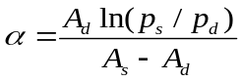
where $A_{s}$ is the systolic arterial cross-section, and $p_{s}$ is the systolic pressure. The $p_{d}$ and $p_{s}$ are measured by the commercial blood pressure cuff from the brachial site. Using the above equations and a brief calibration for α, $p_{d}$, and $p_{s}$ the accurate pressure waveform $p\left(t\right)$ can be obtained.
It is worth noting that we assume that the human blood vessel is elastic with negligible viscoelasticity. For subjects with normal local vascular conditions or with slight local atherosclerosis, the diameter of vessel do not lag behind the pressure waveforms ^{4,5}

Supplementary References
1. Yin, L. et al. From All-Printed 2D Patterns to Free-Standing 3D Structures: Controlled Buckling and Selective Bonding. Adv. Mater. Technol. 3, 1800013 (2018).
2. Kim, J. et al. Simultaneous Monitoring of Sweat and Interstitial Fluid Using a Single Wearable Biosensor Platform. Adv. Sci. (2018). doi:DOI: 10.1002/advs.201800880
3. Wang, C. et al. Monitoring of the central blood pressure waveform via a conformal ultrasonic device. Nat. Biomed. Eng. 2, 687–695 (2018).
4. Arndt, J. O., Klauske, J. & Mersch, F. The diameter of the intact carotid artery in man and its change with pulse pressure. Pflugers Arch. Gesamte Physiol. Menschen Tiere 301, 230–240 (1968).
5. Valdez-Jasso, D. et al. Linear and nonlinear viscoelastic modeling of aorta and carotid pressure-area dynamics under in vivo and ex vivo conditions. Ann. Biomed. Eng. (2011). doi:10.1007/s10439-010-0236-7

Supplementary Figures

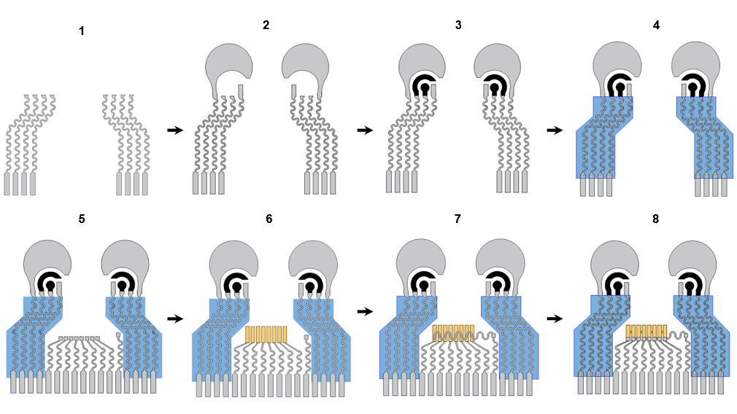
Supplementary Figure 1. Layer-by-layer printing and assembling steps of the integrated sensor. Stretchable silver and PB ink were used to print the pattern over the SEBS substrate. Step 1: Printing the stretchable serpentine interconnection using the silver ink. Step 2: Printing of the IP electrodes and the reference electrodes using the silver ink. Step 3: Printing the the counter (curved) and working electrodes (round) using the PB ink. Step 4: Printing an insulating layer to define the working electrode area and insulate the interconnections using the SEBS resin. Step 5: Flip the SEBS substrate backside up. Print the serpentine interconnects for the transducers and ground using the silver ink. Step 6: Solvent solder the transducer chips onto the silver interconnects. Step 7: Solvent solder the ground to the other side of the transducers and connect it to the reserved ground interconnect. Step 8: Finished. Ready for sensor modifications.

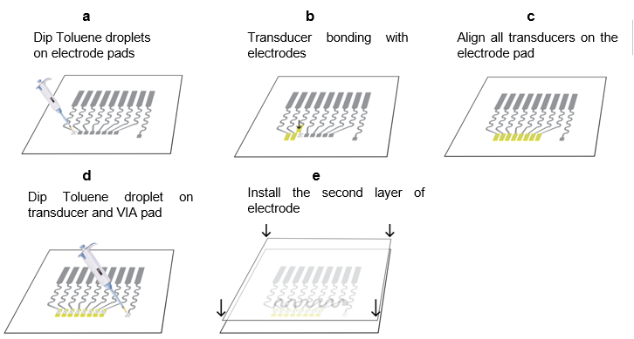
Supplementary Figure 2. Assembly process of ultrasound transducers. a, Dip toluene droplets on the connection pad of the interconnects using a pipette to partially dissolve the silver traces. b, Place the transducer on the softened pad for bonding. c, Repeat steps in a-b and align all the transducers along the pattern. d, Dip toluene droplets on transducers and the ground interconnect pad using a pipette. e, Apply the ground wire to the transducers and connect to the ground interconnect pad.

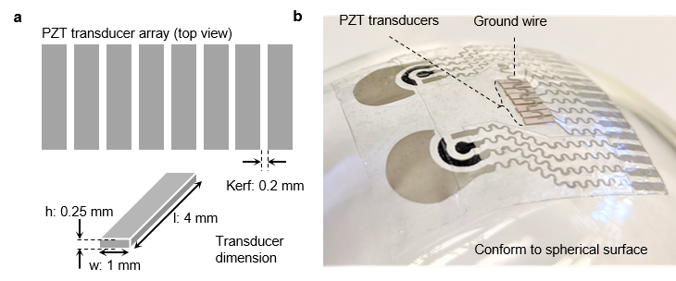
Supplementary Figure 3. Transducer dimensions and conformability. a, Dimensions of the PZT transducer pixel and the transducer array. The aspect ratio of each pixel is controlled to be smaller than 0.3 (w, l > 3h) to ensure that the PZT vibration is in thickness mode with accurate frequency (7 MHz). b, Photo of the device on a spherical surface to demonstrate the conformability of the fabricated transducer array.

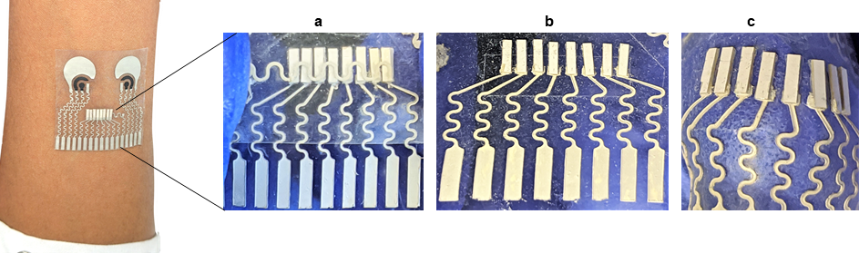
Supplementary Figure 4. Adhesion of the PZT transducers to the substrate. a-c, The photo images of the pristine device before any deformation (a), the device during horizontal stretching (b) and under indentation (c). The PZT transducers remained well attached to the printed silver traces after the deformations.

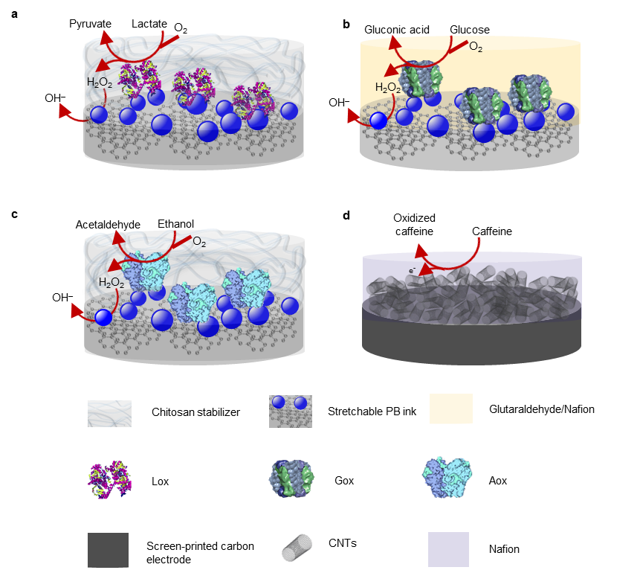
Supplementary Figure 5. Biosensor modifications and reaction mechanisms. a, Lactate sensor modification. LOx reaction with lactate, leading to the formation of hydrogen peroxide and pyruvate. Further, the PB-based electrode transducer transforms the hydrogen peroxide product to hydroxyl ions (OH⁻) for selective lactate detection. b, Glucose sensor modification. The GOx reaction with glucose leads to the formation of hydrogen peroxide and gluconic acid. The PB based electrode transducer offers specific detection of the peroxide product towards selective glucose detection. c, Alcohol sensor modification. The AOx reaction with its ethanol substrate results in the formation of hydrogen peroxide and acetaldehyde. The PB-based electrode transducer offers specific detection of the peroxide product towards selective alcohol detection. d, Caffeine sensor modification. The anodic oxidation of the caffeine analyte results the production of uric acid and electron flow. The DPV peak current corresponds to the caffeine concentrations.
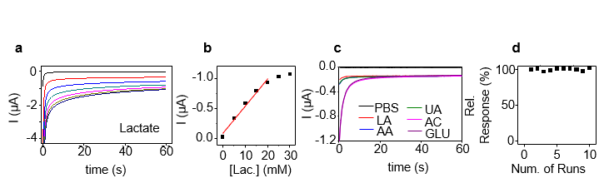
Supplementary Figure 6. In-vitro characterization of the lactate sensor. a, Lactate sensor’s amperometric response to successive additions of 5 mM lactate from 0 to 30 mM. b, Lactate calibration curve based on the data of a. c, Evaluation of the lactate sensor selectivity in the presence of lactate (LA, 2 mM), glucose (GLU, 0.2 mM), ascorbic acid (AA, 10 µM), uric acid (UA, 60 µM) and acetaminophen (AC, 10 µM). (d) Stability of the lactate: 10 repetitive measurements of 2 mM lactate.

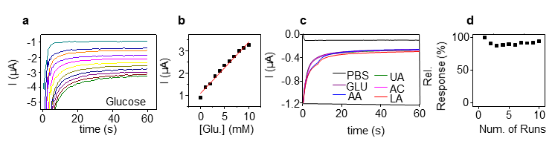
Supplementary Figure 7. In-vitro characterization of the glucose sensor. a, Glucose sensor’s amperometric response to successive 1 mM glucose additions from 0 to 10 mM. b, Glucose calibration curve based on the data of a. c, Evaluation of the glucose sensor selectivity in the presence of GLU (2 mM), LA (10 mM), AA (10 µM), UA (10 µM) and AC (10 µM). d, Stability of the glucose sensor: 10 repetitive measurements of 2 mM glucose.

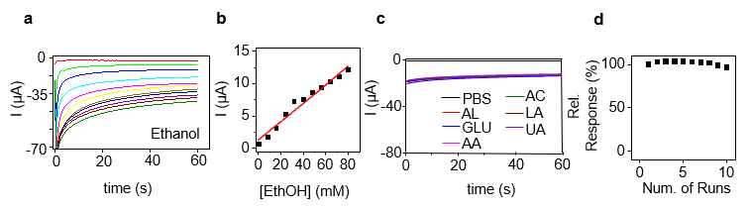
Supplementary Figure 8. In-vitro characterization of the alcohol sensor. a, The glucose sensor’s amperometric response to successive 8mM ethanol increments from 0 to 80 mM. b, Calibration curve of the alcohol sensor based on the data of a. c, Selectivity test in the presence of AL (20 mM), GLU (0.2 mM), AA (10 µM), LA (10 mM), UA (60 µM) and AC (10 µM). d, Stability of the alcohol sensor: 10 repetitive measurements of 20 mM alcohol.

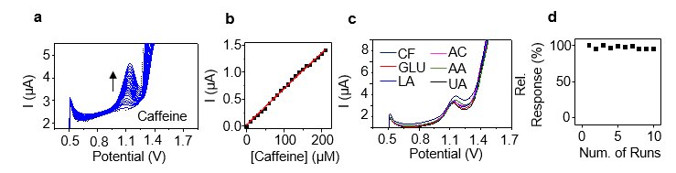
Supplementary Figure 9. In-vitro characterization of the caffeine sensor. a, The caffeine sensor’s DPV response of increasing caffeine additions in 10 µM steps from 0 to 200 µM. b, Corresponding caffeine calibration curve based on the data of a. c, Evaluation of the caffeine sensor selectivity in the presence of CF (20 µM), GLU (0.2 mM), LA (10 mM), AA (10 µM), UA (60 µM) and AC (10 µM). d, Stability of the caffeine sensor: 10 repetitive DPV measurements of 20 µM caffeine.

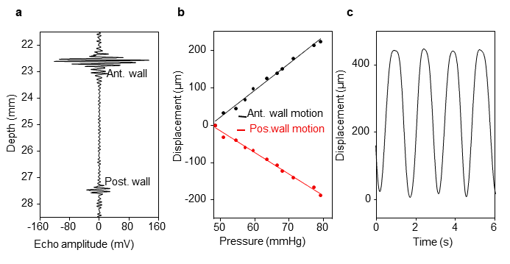
Supplementary Figure 10. Ultrasound transducer characterization on phantom. a, Radio frequency signal showing the anterior wall and posterior wall of the carotid artery phantom. b, Vessel wall displacement with increased intravascular pressure on phantom. c, Periodic vessel distension induced by the inflator.

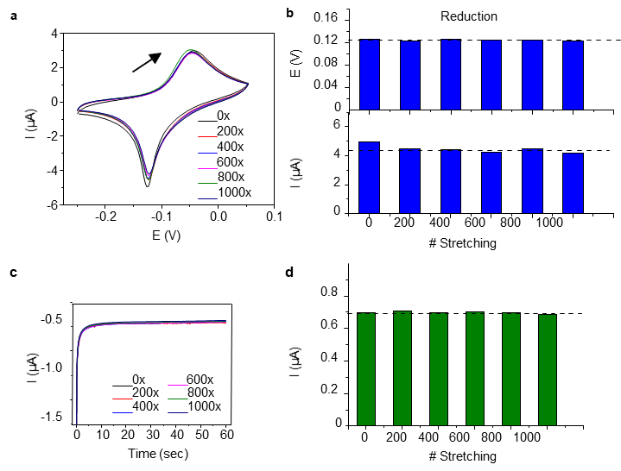
Supplementary Figure 11. Electrode electrochemical stability under repeated stretching tests. a-b, the CV response of the PB electrode every 200 cycles in a 1000-cycle, 20% strain stretching test (a) and the corresponding reduction peak potentials and peak currents. c-d, The CA response at -0.2 V applied anodic potential of the PB electrode every 200 cycles in a 1000-cycle, 20% strain stretching test (a), and the corresponding end-point currents (d). All electrochemical tests were performed in 0.1M PBS with pH 7.4, against an Ag/AgCl reference electrode.

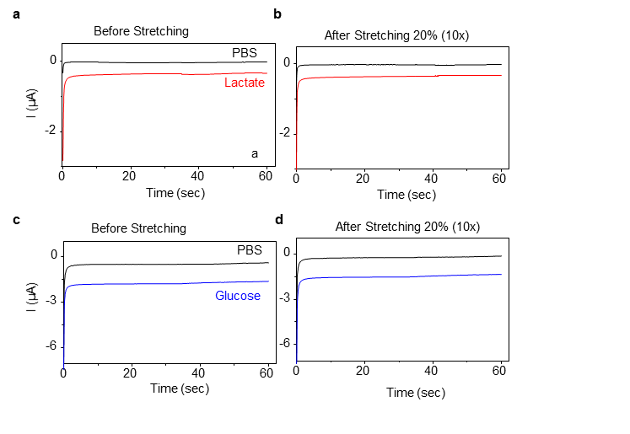
Supplementary Figure 12. Sensor electrochemical stability under repeated stretching tests. a-b, the response of modified lactate sensor to 2 mM lactate before (a) and after (b) 10 cycles of 20% stretching. c-d, the response of modified glucose sensor to 10 mM glucose before (a) and after (b) 10 cycles of 20% stretching. CA was recorded using a potential of -0.2 V in 0.1 M PBS with pH 7.4.

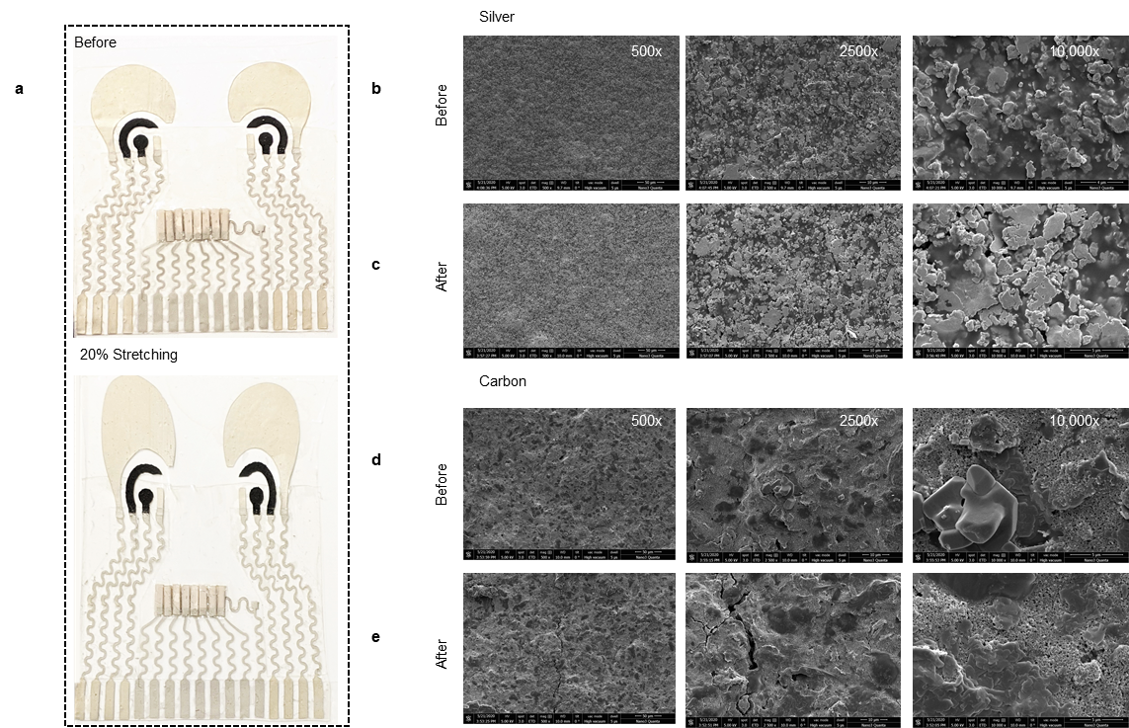
Supplementary Figure 13. Structural integrity of the stretchable silver and PB/carbon ink composites. a, Photo illustration of the device before and after stretched to 120%. b-e, SEM images in different magnifications of the silver trace before (b) and after (c) 1000 cycles of 20% stretching, and of the carbon trace before (d) and after (e) 1000 cycles of 20% stretching.

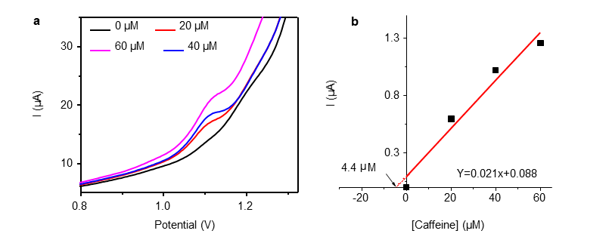
Supplementary Figure 14. Standard additions to determine caffeine concentration in sweat. a, DPV of caffeine in collected sweat (after drinking 114 mg caffeine). Increasing concentrations of caffeine were added to the collected sweat and the respective calibration curve was used to analyze the initial caffeine concentration in sweat b, Calibration curve. The horizontal axis shows the concentration range used in the test. The vertical axis shows the current change after each addition.

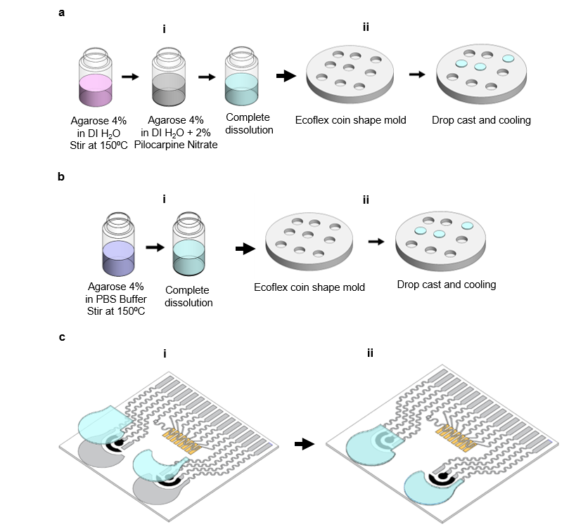
Supplementary Figure 15. Preparation and assembling of the hydrogel layers. a, Anode hydrogel preparation. (i) A mixture of 4% agarose and DI water kept under continuous stirring at 150ºC until complete dissolution. Next, the addition of 2% pilocarpine nitrate under stirring. (ii) 300 µL of the solution were then dropcasted in the Ecoflex molds. After cooling, the viscous solution on the mold became a solid coin shape hydrogel. b, Cathode hydrogel preparation: (i) The mixture of 4% agarose and 0.1 M PBS (pH 7.4) buffer was kept at continuous stirring at 150ºC until observing complete agarose dissolution. (ii) 300 µL of the solution were then dropcasted in Ecoflex molds. After cooling, the viscous solution on the mold became a solid coin shape hydrogel. c, Hydrogel assembly: (i) A coin shape anode and cathode hydrogel disks were cut with the shape of the screen-printed pattern of the anode and cathode respectively. (ii) After the shape was provided, the anode hydrogel was placed on the left side and the cathode hydrogel was placed in the right side.
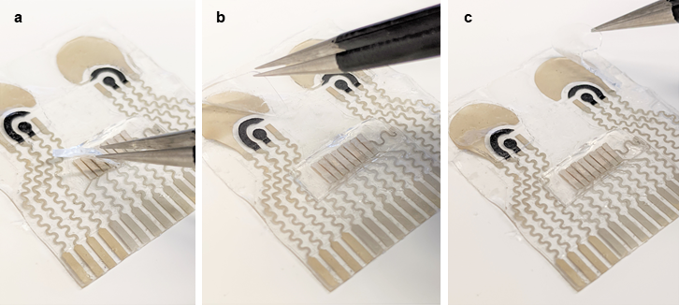
Supplementary Figure 16. Assembly of the iontophoretic and US hydrogels. a, The commercial solid gel pad for ultrasound inspection integrated on device. The picture shows a freestanding cut piece of solid gel. The hydrogels for cathode and anode were cut into the shape of the IP electrodes. b, After the shape was provided, c, the anode hydrogel was placed on the left side and the cathode hydrogel was placed in the right side.

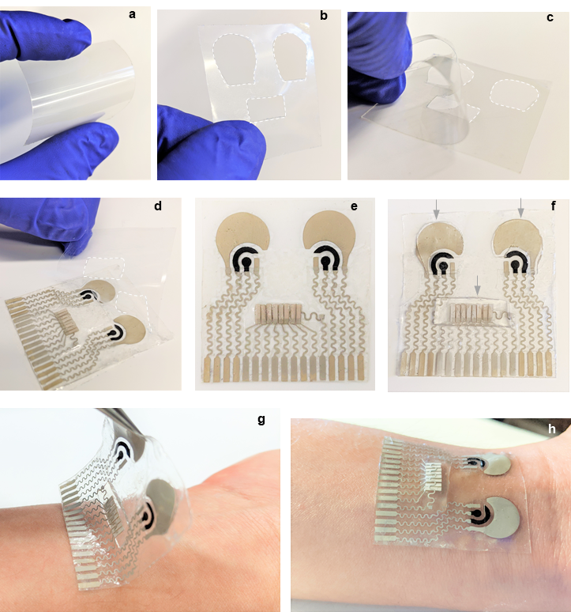
Supplementary Figure 17. Transfer process of the patch. a, Double-sided tattoo adhesive. b, Opening for the sensing areas, c, removing the first protective layer from the double-sided tattoo adhesive with opening for the sensing areas, and d, applying adhesive to the tattoo; e, after removing the second protective layer from the applied adhesive, f, placing the hydrogels and US gel and g-h, transferring to the body.

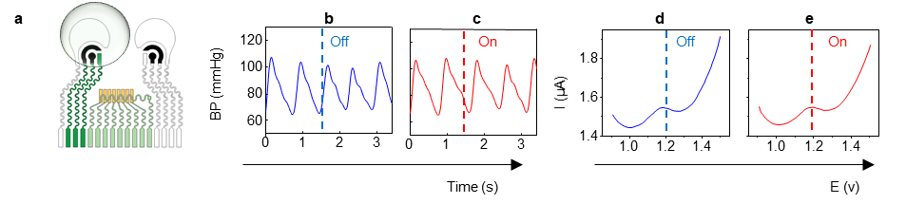
Supplementary Figure 18. Characterization of multimodal wearable sensor. a, Signal interference study between the sweat caffeine electrochemical sensor (left side) and the BP transducer, including b, BP signal recording while initially sweeping the potential for caffeine detection followed by terminating the sweeping (off), and c, BP signal recording while the potential sweeping for caffeine detection is off followed by initiating the sweeping (on). The effect of the BP signal on the caffeine detection was also investigated. d, DPV was recording for caffeine detection while the BP was active, following by terminating the BP signal acquisition (off), and e, DPV recording for caffeine detection while the BP was inactive, following by initiating the BP signal acquisition (on).
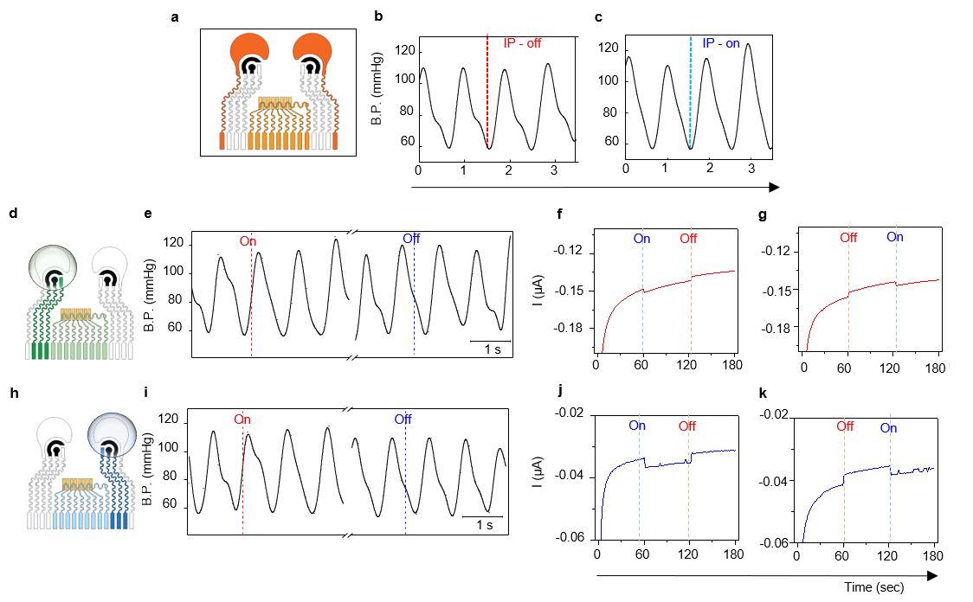
Supplementary Figure 19. On body cross-talking evaluation of multimodal wearable sensor. a, Signal interference study between iontophoretic current (0.3 mA/cm²) applied between cathode and anode (dark orange color) and blood pressure device (light orange color). b, Blood pressure wave form recorded when the IP current was initially on, and next turned off. c, Blood pressure waveform recorded when the IP current was initially off and then turned on. d, Cross talking study between detection potential for glucose (dark green) and the blood pressure ultrasound device (light green). e, BP signal recorded while the detection potential was initially off, followed by turning the detection potential (-0.2V) on (red dotted line) and off (blue dotted line). f-g, Glucose signal recording while applying an on/off ultrasound cycle every 60 seconds during 3 min. h, Cross talking study between the lactate detection potential (dark blue) and the blood pressure ultrasound device (light blue). i, BP signal recorded while the detection potential was initially off, followed by turning the detection potential -0.2V on (red dotted line) and off (blue dotted line). j, Lactate signal recording while applying the ultrasound cycle on/off every 60 seconds during 3 min. k, Lactate signal recording while applying the ultrasound cycle off/on every 60 seconds during 3 min.

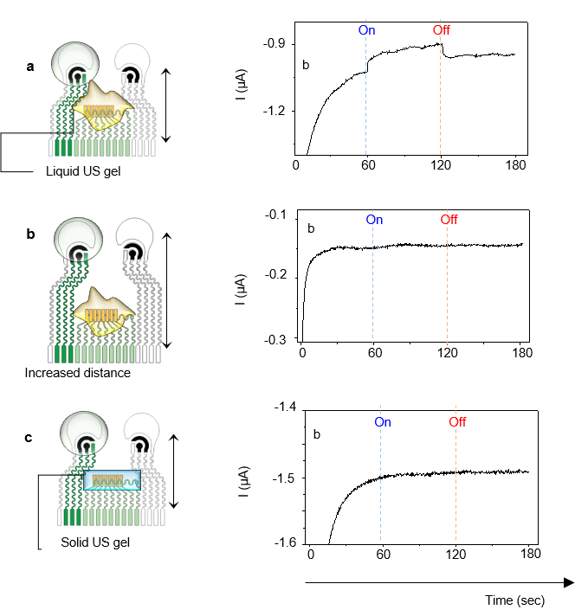
Supplementary Figure 20. In-vitro cross-talking evaluation of multimodal wearable sensor. In vitro measurements were performed using the agarose-PBS hydrogel and the ultrasound gel placed over the blood pressure transducers. a, The PBS hydrogel and ultrasound gel were in contact while the ultrasound pulse was turned on and off (right), respectively. A decreasing (more positive current) was observed when the gels were in contact. b, A different design with increased distance between the gels were used in vitro with the same amount of ultrasound gel, due to the physical distance, no cross talking was observed (right). c, The same design (with shorter distance between the blood pressure and chemical sensors) was used with a solid hydrogel and no apparent cross talking was observed (right).

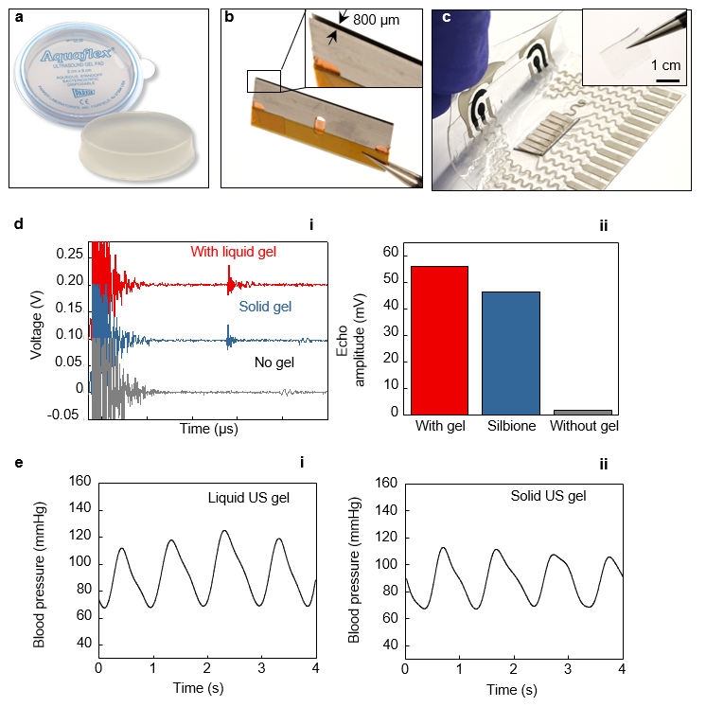
Supplementary Figure 21. Preparation and test of solid ultrasound gel. a, The commercial solid gel pad for ultrasound inspection. b, The razor blades used to cut thin slice of solid ultrasound gel; the insert shows the gap between the blades are 800 μm. c, Integrated solid gel on device. The insert shows a freestanding cut piece of solid gel. d, Ultrasound penetration intensity test with a pulse-echo test is performed in (i) using a phantom Ecoflex with the liquid and solid ultrasound gel and in the absence of the gel. The respective echo amplitude is compared in (ii). e, On body experiment comparing the BP waveform measured with (i) liquid and (ii) solid ultrasound gel.

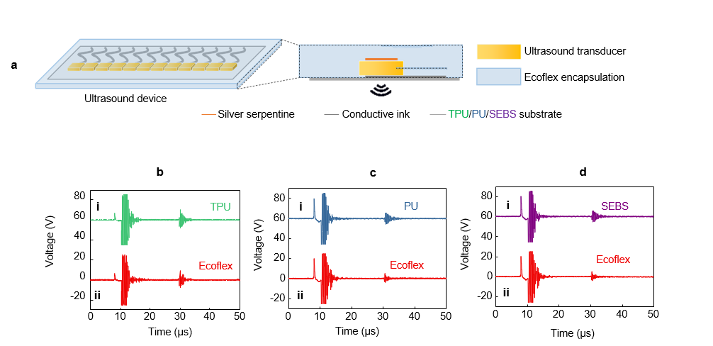
Supplementary Figure 22. Effect of substrate on the ultrasound transmission. The substrates with certain ultrasound impedance will result in a different ultrasound penetration intensity. a, Illustration of the fabrication process. A pulse-echo test is performed on different materials as substrates, including b-i, TPU, c-i, PU, d-i, SEBS, and (ii) Ecoflex. The echo signal intensity is directly compared for the ultrasound penetration.

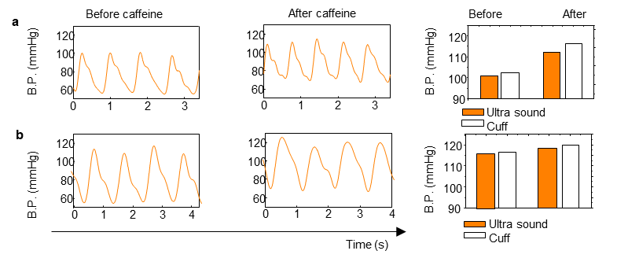
Supplementary Figure 23. On body evaluation for caffeine intake. a, On body evaluation of BP changes for a volunteer with no habitual caffeine intake (caffeine intolerant). Before and after caffeine sugar free beverage consumption (Right). Bar graphics represent the sensor validation using a commercial cuff (white) and BP readings obtained with ultrasound transducer (orange). b, On body evaluation of BP changes for a volunteer with regular caffeine intake habits (caffeine tolerant). Before and after caffeine sugar free beverage consumption (Right). Bar graphics represent the sensor validation using a commercial cuff (white) and BP readings obtained with ultrasound transducer (orange).

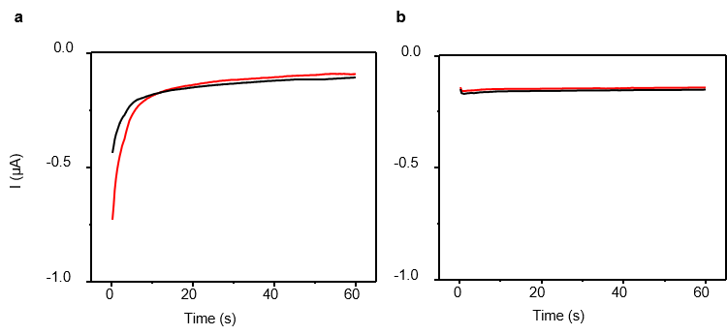
Supplementary Figure 24. Control experiment: Electrochemical sensors without the sensing recognition layer. a, Cathode sensor signal recorded after the first ISF extraction (red line) and after the second ISF extraction (black line). b, Anode sensor signal recorded in the first sweat stimulation (red line) and during the second sweat stimulation (black line). Applied potential, -0.2 V.

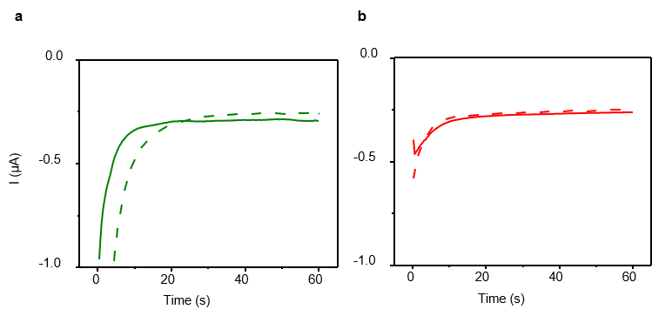
Supplementary Figure 25. Control experiments: Response for lactate and glucose recording without exercise and food ingestion. a, The lactate sensor response after the first sweat stimulation (green dash line) and second sweat stimulation (green solid line). b, The glucose sensor response after the first ISF extraction (red dash line) and second ISF extraction (red solid line). Applied potential, -0.2 V.

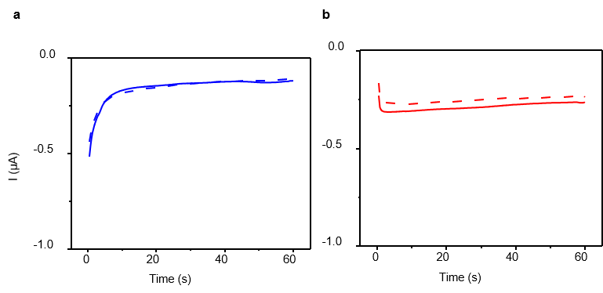
Supplementary Figure 26. Control experiments: Response for alcohol and glucose recording without alcohol and food ingestion. a, The alcohol the first sweat stimulation (blue dash line) and second sweat stimulation (blue solid line). b, Response of the glucose sensor after the first ISF extraction (red dash line) and second ISF extraction (red solid line). Applied potential, -0.2 V.

Supplementary Video
Video S1. Application of hydrogels on the device

