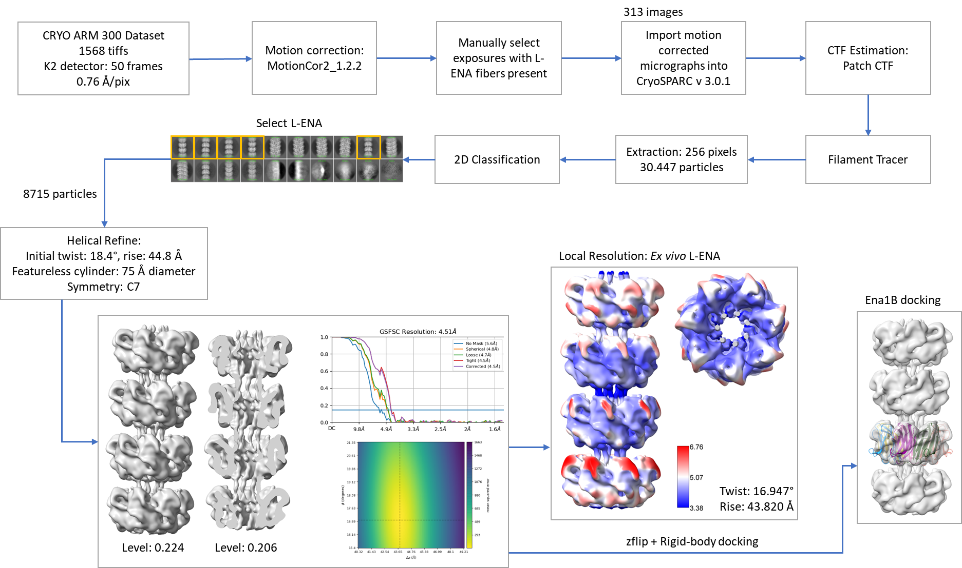
Supporting Figure 1: CryoEM workflow for the ex vivo L-ENA fibers
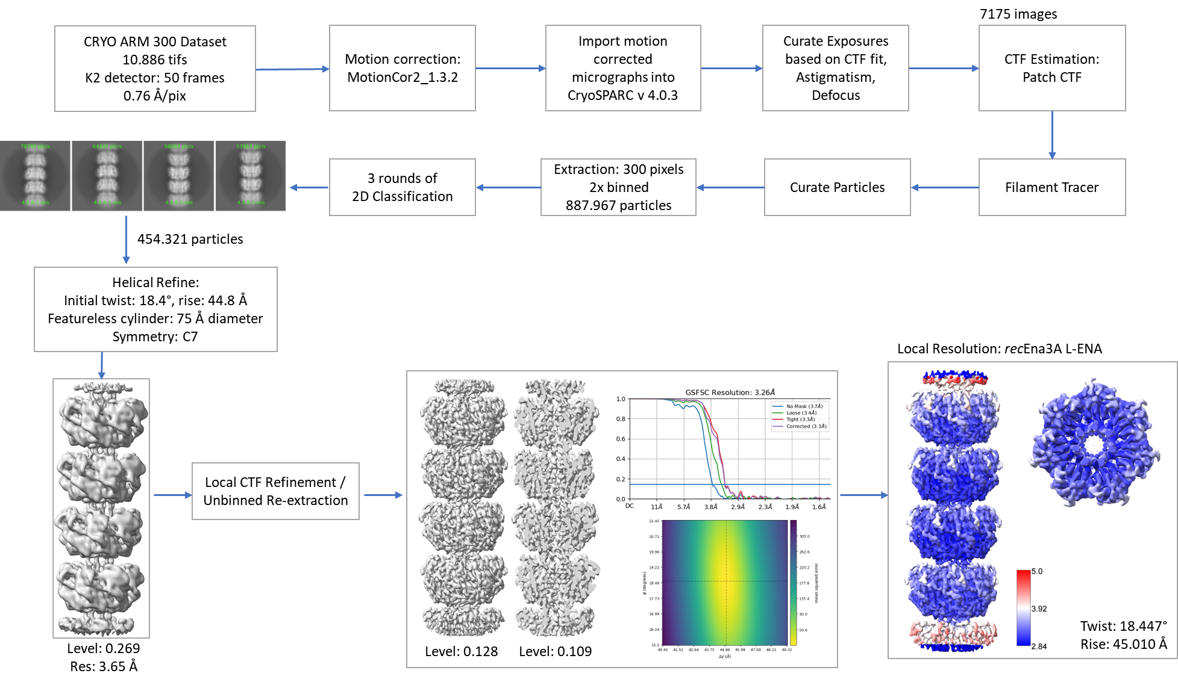
Supporting Figure 2: CryoEM workflow for the recEna3A L-ENA fibers

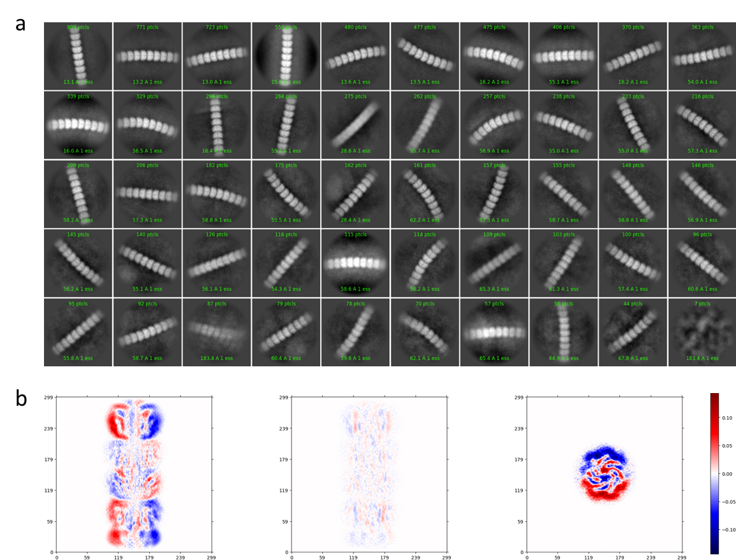
Supporting Figure 3: Flexibility of recEna3A L-ENA fibers: (a) CryoSPARC 2D class averages of L-ENA using a particle box size of 600x600pixels (0.76Å/pixel) after manual picking of high curvature L-ENA segments, (b) Cryosparc output for the mode 1 of the 3D variability analysis job on L-ENA (see Supporting Movie 1 for a representation of the corresponding volume series).
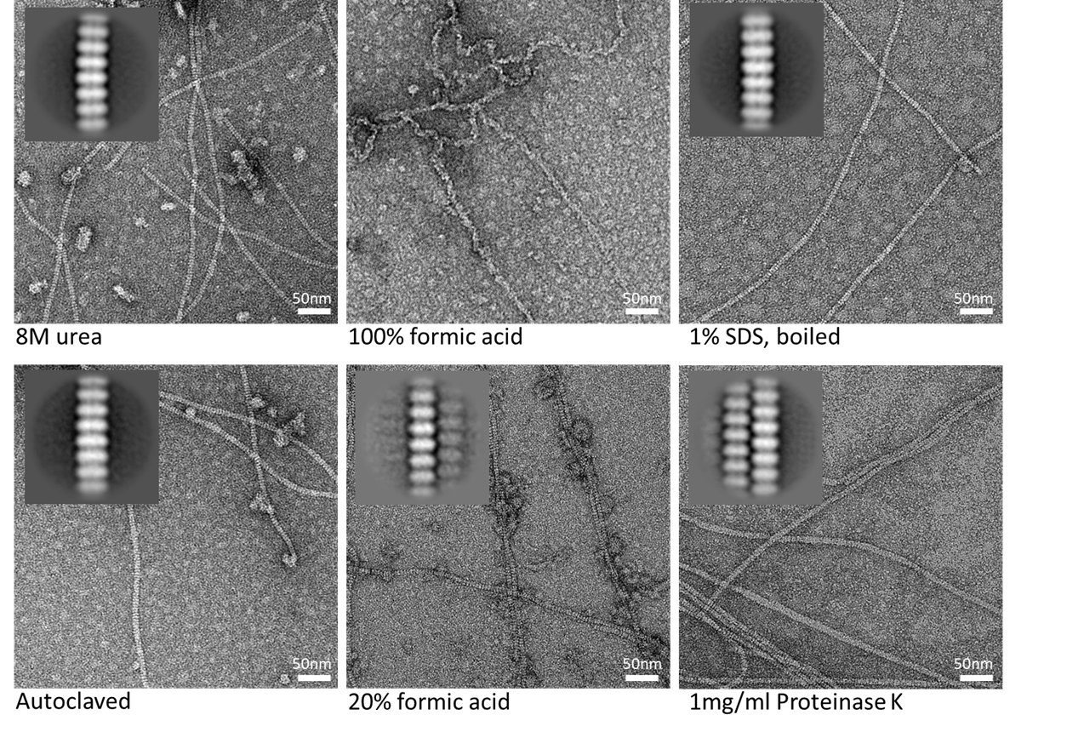
Supporting Figure 4: Stability assay for recEna3A fibers: recombinant Ena3A fibers were incubated for 1h in 8M urea, 20% or 100% (v/v) formic acid, or boiled in 1% (w/v) SDS, autoclaved (121C° for 18min) in miliQ, or incubated in 1 mg.mL⁻¹ proteinase K in 33.3mM Hepes pH 7.5, 1mM CaCl₂ for 24h.
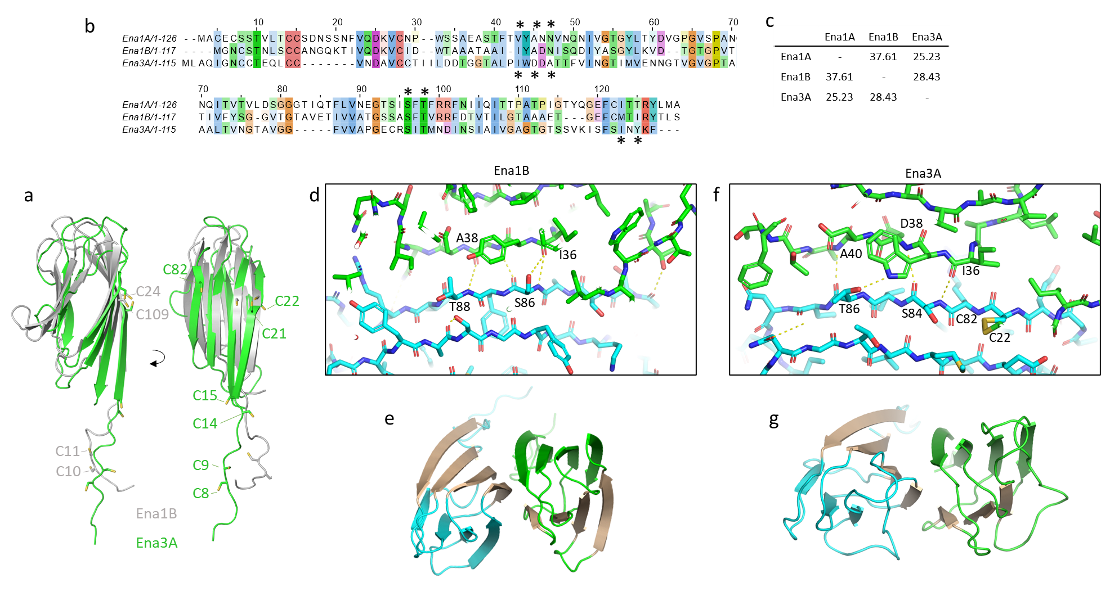
Supporting Figure 5: Multiple sequence alignment of the S-ENA subunits (Ena1A and Ena1B) and the L-ENA subunit (Ena3A). Residues involved in lateral contacts are highlighted with a star (above: S-ENA contact; below: L-ENA contacts), (b) percent identity matrix for Ena1A, Ena1B and Ena3A, (c) and (e) comparison between the β-sheet augmentation contacts at the Ena1B dimer interface (PDB: 7A02), and (d) and (f) the β-sheet augmentation at the Ena3A dimer interface. Inter-molecular hydrogen bonds (determined in PyMol 2.5.2 using “Find Polar between Chains”) shown in yellow, dashed lines.
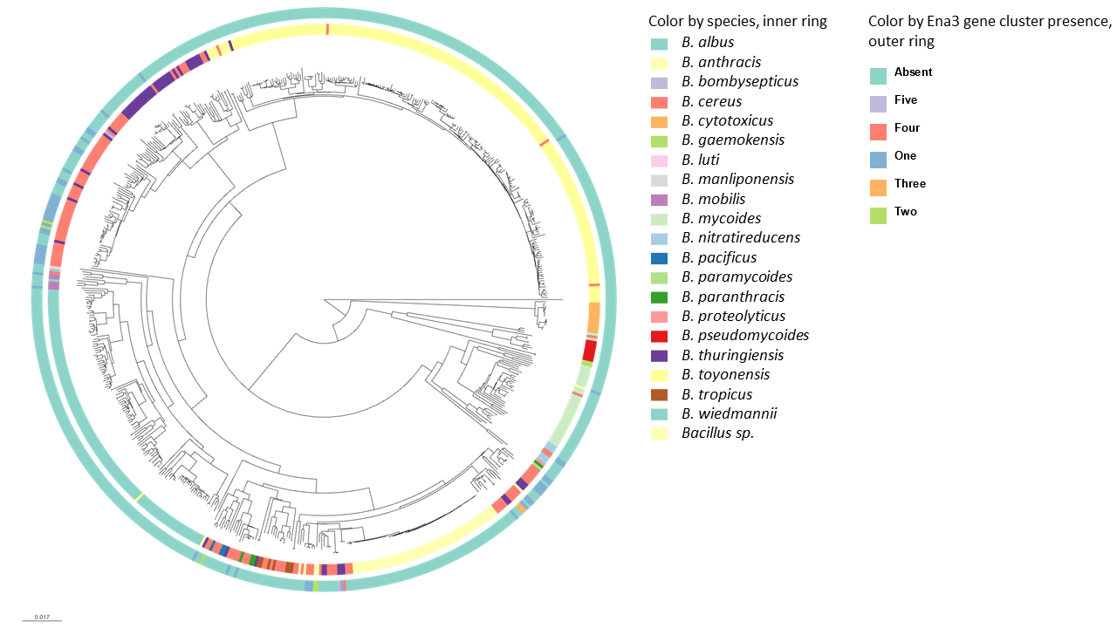
Supporting Figure 6: Phylogenetic analysis of L-ENA occurrence. Clustering of 656 B. cereus s.l. genomes (B. subtilis is excluded from tree). Rings are colored according to designated species (inner ring) and presence and copy-number of ena3A gene cluster (outer ring). Tree is made using Mashtree, vizualised using Microreact, and available at https://microreact.org/project/uzm4JFrrsCPZeRnMpRqvvf-supplementary-figure-9-ena3-paper .
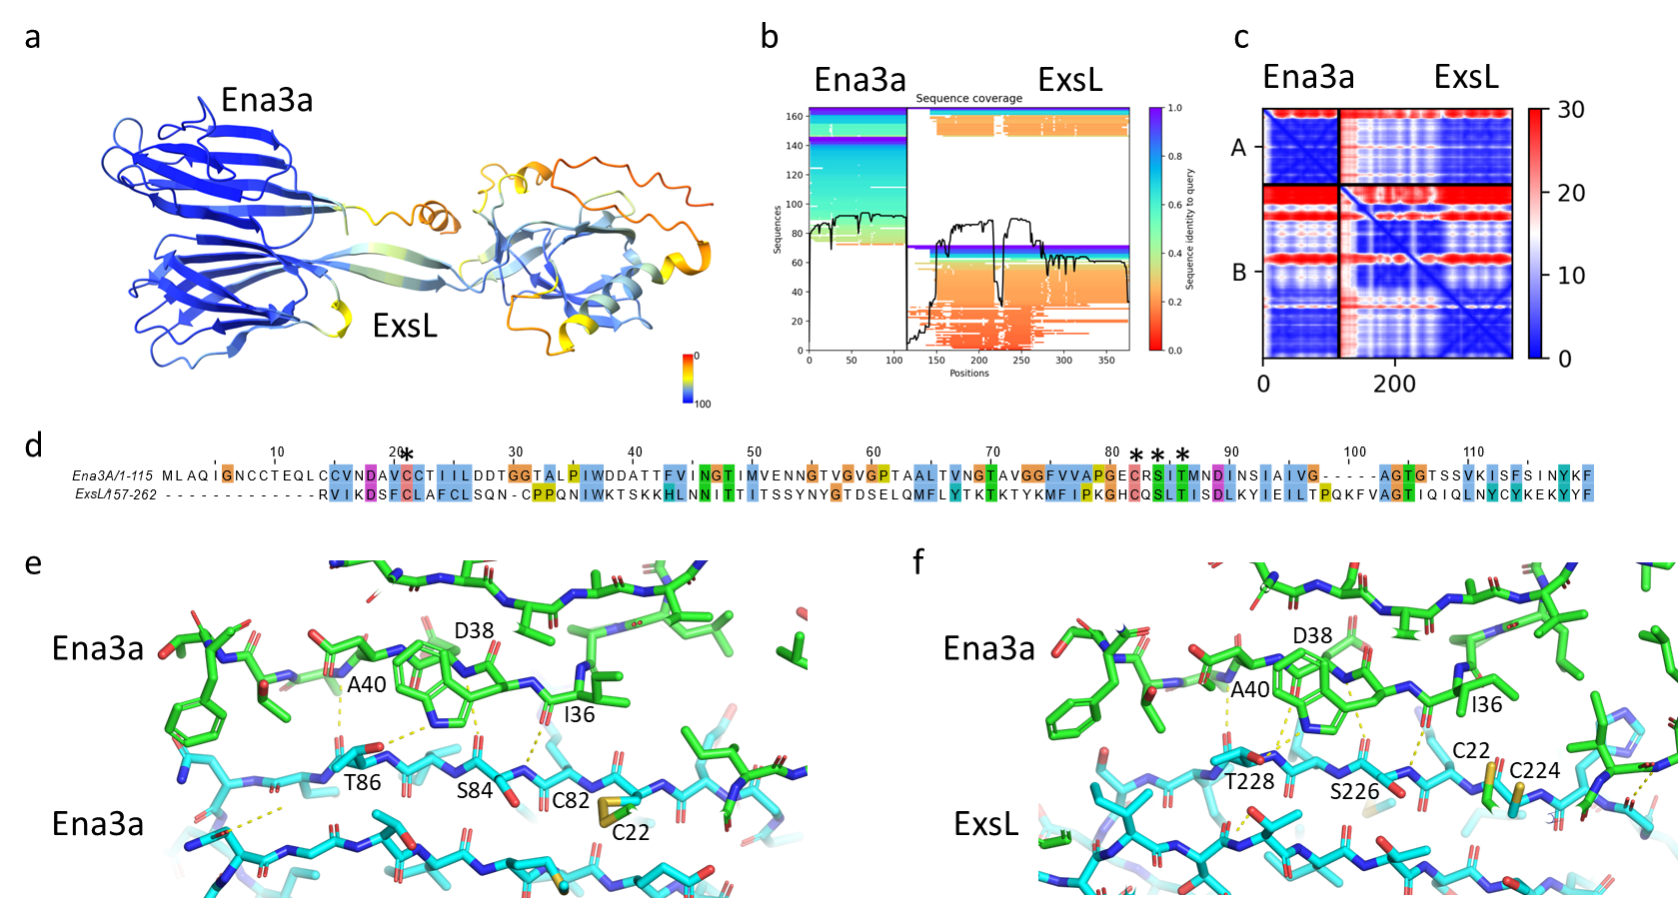
Supporting Figure 7: Alphafold2 prediction of the ExsL-Ena3A dimeric complex: (a) Alphafold-multimer 1.2 ExsL-Ena3A dimer (pLDDT=82.6; ptmscore=0.73) colour coded according to pLDDT-score, (b) Sequence coverage of the corresponding ExsL-Ena3A multiple sequence alignment, (c) Predicted aligned error map of the predicted ExsL-Ena3A dimer, (d) Pairwise sequence alignment (17.4% sequence identity) of Ena3A and the C-terminal Ena-core domain of ExsL (157-262). Residues involved in lateral Ena3A-Ena3A contacts (highlighted with a star) are conserved in ExsL, (e) β-sheet augmentation at the Ena3A dimer interface (determined via cryoEM), (f) Predicted β-sheet augmentation at the ExsL-Ena3A heterodimer interface (predicted using AF2 multimer). Inter-molecular hydrogen bonds (determined in PyMol 2.5.2 using “Find Polar between Chains”) shown in yellow, dashed lines.

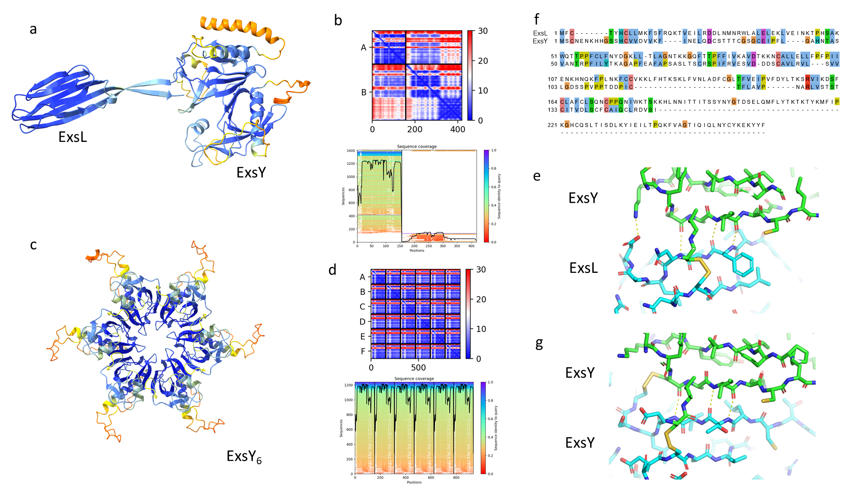
Supporting Figure 8 : (a) Alphafold-multimer 1.2 ExsL-ExsY dimer (pLDDT=80.2; ptmscore=0.71) colour coded according to pLDDT-score, (b) Predicted aligned error map and sequence coverage of the multiple sequence alignment, (c) Alphafold-multimer 1.2 ExsY hexamer (pLDDT=81.3; ptmscore=0.86) colour coded according to pLDDT-score, (d) Predicted aligned error map and sequence coverage of the multiple sequence alignment, (e) Pairwise-sequence alignment between ExsL and ExsY (30.8% sequence identity), comparison of the AF2, (f) and (g) comparison of the putative ExsL/ExsY and ExsY/ExsY dimeric interfaces. Inter-molecular hydrogen bonds (determined in PyMol 2.5.2 using “Find Polar between Chains”) shown in yellow, dashed lines.
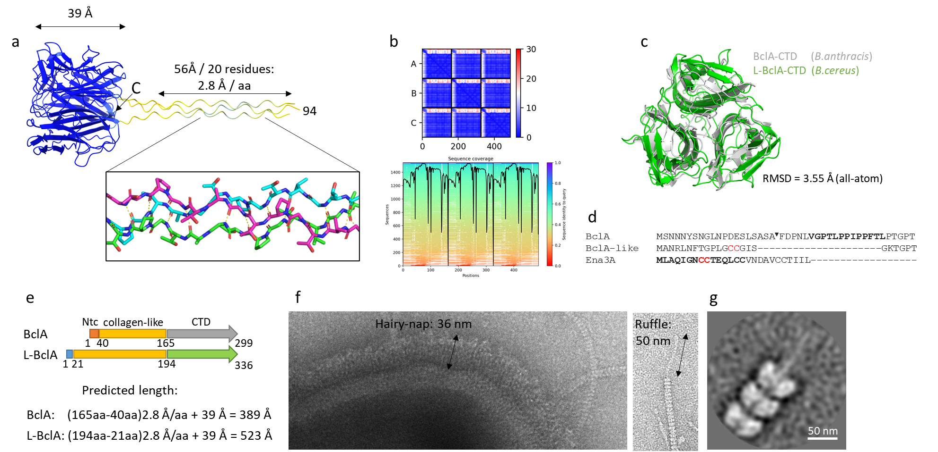
Supporting Figure 9: Structural analysis of L-BclA: (a) Alphafold-multimer v 1.2 prediction of an L-BclA₉₄₋₂₆₇ trimer (pLDDT=94, ptmscore=0.9) colour coded according to pLDDT-score (N-terminus omitted); collagen-like stalk region shown in stick representation with putative H-bonds shown in dashed lines, (b) Corresponding predicted aligned error map and sequence coverage of the multiple sequence alignment of the AF2 L-BclA₉₄₋₂₆₇ trimer, (c) superposition (all-atom RMSD = 3.55Å; sequence identity = 22.1%) of the AF2 L-BclA₉₄₋₂₆₇ trimer with the crystal structure of BclA-CTD of the hairy nap layer of B.anthracis (PDB: 1WCK), (d) N-terminal sequence of BclA, L-BclA and Ena3A: letters in bold for BclA correspond to the exosporium leader sequence, and the arrow marker indicates the proteolytic cleavage site. L-BclA has no identifiable exosporium leader sequence, nor any notable sequence homology to the N-terminal connector (shown in bold) of Ena3A apart from a single CC-motif, (e) Domain organization of BclA (Q81JD7) and L-BclA and the corresponding theoretical lengths in fully extended state, (f) Comparison of the thickness of the hairy nap layer to the length of the L-ENA ruffles, (g) 2D class average of L-ENA fiber termini.

Table S1 CryoEM model and data statistics

 | Ex vivo L-Ena  EMD-17579 | recENA3A  EMD-17627; PDB: 8PDZ
Data collection and processing | CryoARM300, BECM | CryoARM300, BECM
Magnification | 60.000 | 60.000
Voltage (kV) | 300 | 300
Electron exposure (e–/Å2) | 61.8 | 63.2
Defocus range (μm) | -0.5 to -3.5 | -0.5 to -3.5
Pixel size (Å) | 0.766 | 0.764
Symmetry imposed | Helical  Rise = 43.820 Å  Twist = 17.041° | Helical  Rise = 44.970 Å  Twist = 18.547°
Number of segments used | 8715 | 454321
Map resolution (Å)  FSC threshold | 5.77¹  0.143 | 3.32¹  0.143
Local resolution (Å) (min, 25th percentile, median, 75th percentile, max) | 2.63, 4.23, 5.08, 6.66, 11.49 | 2.84, 3.19, 3.71, 4.96, 8.28
Refinement  Initial model used | NA | AlphaFold2
Model resolution (Å)  FSC threshold | NA  NA | 3.3  0.143
Model composition  Non-hydrogen atoms  Protein residues | NA  NA | 22288  3164
B factor (Å2) | NA | 84.18
R.m.s. deviations  Bond lengths (Å)  Bond angles (°) | NA  NA | 0.004  0.997
Validation  MolProbity score  Clashscore  Poor rotamers (%) | NA  NA  NA | 1.47  8.74  0
Ramachandran plot  Favored (%)  Allowed (%)  Disallowed (%) | NA  NA  NA | 98.20%  1.80%  0%
Correlation coefficient  CC (mask)  CC (box)  CC (peaks)  CC (volume) | NA  NA  NA  NA | 0.72  0.84  0.70  0.71
1 Numbers reflect the unsharpened map

Table S2. Plasmid constructs

Name | Details | Reference
pMAD-I-SceI | Shuttle vector for making deletion mutant, carries I-SceI restriction site | (Lindbäck et al., 2012)
pMAD-I-SceI Δena3A | pMAD-I-SceI carrying homology sequences flanking ena3A | this study
pMAD-I-SceI Δl-bclA | pMAD-I-SceI carrying homology sequences flanking l-bclA | this study
pMAD-I-SceI ΔexsL | pMAD-I-SceI carrying homology sequences flanking exsL | this study
pBKJ233 | Expresses I-SceI enzyme (promotes second cross over) | (Janes and Stibitz, 2006)
pHT315 | Low-copy number plasmid for complementation | (Arantes and Lereclus, 1991)
pena3A | pHT315::ena3A (complementation of B. cereus Δena3A | this study
pl-bclA | pHT315::l-bclA (complementation of B. cereus Δl-bclA) | this study
pexsL | pHT315::exsL (complementation of B. cereus ΔexsL) | this study

Table S3. Overview of gene knockout mutants/complementation constructs

Name | Genetic background | Reference
Wild type | NVH0075-95 | (Pradhan et al., 2021)
ΔexsL | NVH0075-95 | this study
Δl-bclA | NVH0075-95 | this study
Δena3A | NVH0075-95 | this study
Δena1ABC |  | (Pradhan et al., 2021)
Δena1ABC/Δena3A | NVH0075-95 Δena1ABC | this study
ΔexsL::pexsL | NVH0075-95 ΔexsL | this study
ΔbclA::pl-bclA | NVH0075-95 Δl-bclA | this study
Δena3A::pena3A | NVH0075-95 Δena3A | this study
ΔenaABC/Δena3A::pena3A | NVH0075-95 Δena1ABC/Δena3A | this study

Table S4. List of primers

Primer code | Sequence (5'-3') | Gene
Quantitative RT-PCR
2116/2117 | AAGTGCGTCTAATCAACAAGGAAA/ GGGAAATCTCCCATGAACACA | rpoB
2410/2411 | TGGCAAACTACGCCACCTT/ AATTGGCCTTTCTTAGTGTTACCTG | exsL
2428/2429 | GCAGTAGGTATTGGTGCTGGT/ AAGCGGATACACTTAGAGCTGG | l-bclA
2414/2415 | CGCAAATAGGAAATTGCTGCAC/ CGGTACCGCCAGTATCATCTAA | ena3A
Determining operon
2311/2312 | TGCTGACTTTTGTGGTTTGACT/GGGGCCTGTTTTCCCACTAA | exsL→l-bclA
2314/2315 | ACAGTGCCTCAATCAGGGAG/CAGCTGTTGGTCCAACTCCA | l-bclA→ena3A
Colony PCR screening of mutants and Sanger sequencing
2241/2242 | GGTTGGAGCTGCCTTAACAA/ TGAGGGGTCACCATATCAAAA | ena3A
2311/2313 | TGCTGACTTTTGTGGTTTGACT/ATCCTCCAACAGCTGTTCCG | l-bclA
2363/2364 | TTCTTTGGTGGGGATGGGATT/ ACATCCAAGTGGTCCAGTGA | exsL
Complementation |  | Plasmid
2374/2375 | ACTATGAATTCATGTTTTTATATACTAAAACCAAAACTTATAAAATGTTTATCCCGAA/  GTCAGTGAATTCTTACGAAACCCTAATGATTGTTAAGGCAGC | pHT315-pl-bclA

