Electronic Supplementary Information (ESI)
Cellulose Nanofiber-templated Carbon Dot Composite for Metal-free Photocatalyst
Jungbin Ahn, Sewon pak, and Hyungsup Kim*

Department of Organic and Nano System Engineering, Konkuk University, Seoul, 05029, Republic of
*iconclast@konkuk.ac.kr

Figure S1. FT-IR spectra of precursors

Figure S2. High resolution N1s and S2p spectra of (a) CDs and (b) CDCNFs
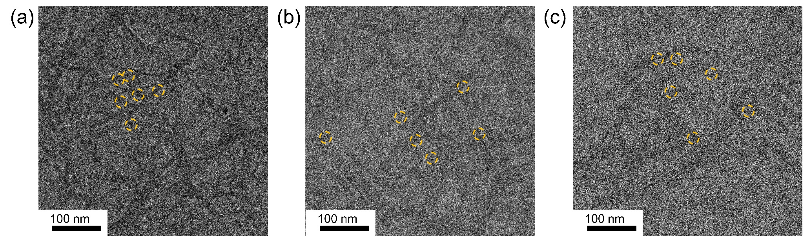
Figure. S3. Survey spectra of (a) CDs and (b) CDCNFs, high resolution C1s and O1s spectra of (c) CDs and (d) CDCNFs

Figure. S4. TEM images of CDCNFs in high magnification

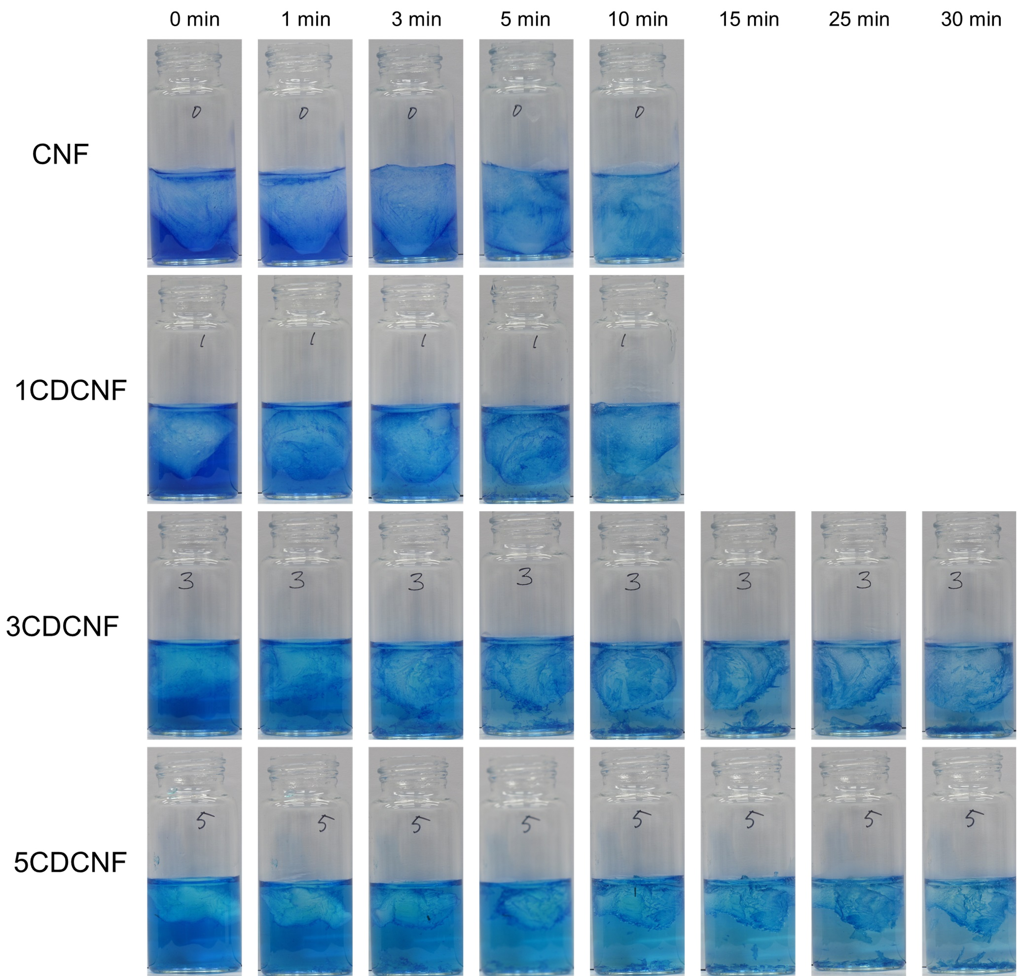
Figure S5. Digital images of MB/aerogel solutions after irradiation of UV light.
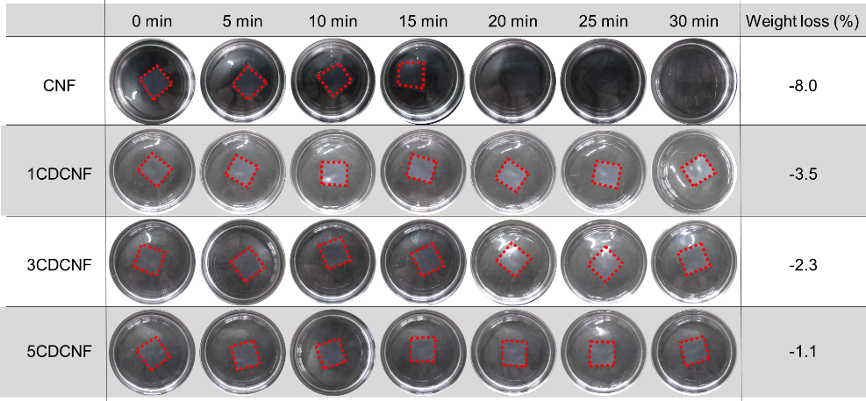
Under the aqueous solution, CNF film was highly swelled in 20 min and totally lost its shape in 30 min. Moreover, self-degradation of CNF occurred and decreased the film weight to 8%. On the other hand, CDCNF composite films maintained their shape even after 30 min. The weight loss ratios were 3.5, 2.3 and 1.1%, respectively. The decrease of weight loss in composite was originated from two factors: suppressed swelling behavior and inhibited decomposition of cellulose. As discussed in the previous study of ours, CD could reduce the swelling property of CNF by blocking the repulsive force between the carboxylate groups. As well, CD acted as protective layer for radical degradation of CNF. With higher swelling ratio, CNF had higher possibility of UV attack. Meanwhile, CD suppressed the swelling behavior of CNF as well as absorbed the given light energy. This inhibited the self-degradation of CNF. 5CDCNF had the highest light absorption among the composite and resulted in the lowest weight loss. Compared to the film state, aerogel had more room to absorb water owing to the higher specific surface area. This would result in faster degradation of the aerogels, as shown in the manuscript. Still, 5CDCNF aerogel could retain its shape and was reusable.
Figure S6. Digital images of films in DW under UV irradiation along time and weight loss ratio after 30 min.
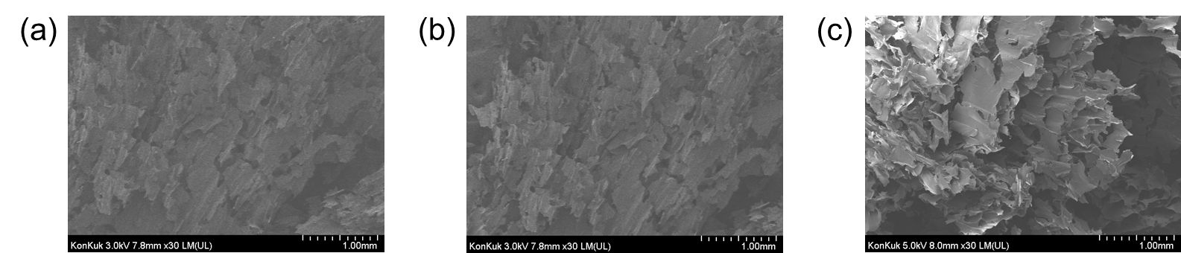
Figure S7. SEM images of the aerogels (a) 1CDCNF (b) 3CDCNF and (c) 5CDCNF.
In the SEM image, the significant difference was not observed between the samples because the CNF concentration was kept constant in the study. The CNF was the main frame to construct the aerogel structure. As a result, the effect of the precursor concentration (glutathione and citric acid) was negligible on the morphology. The CD size was much smaller than CNF and showed no significant influence on the aerogel morphology.

