Electronic Supplementary Information (ESI)
Cellulose Nanofiber-templated Carbon Dot Composite for Metal-free Photocatalyst
Jungbin Ahn, Sewon pak, and Hyungsup Kim*

Department of Organic and Nano System Engineering, Konkuk University, Seoul, 05029, Republic of
*iconclast@konkuk.ac.kr

Figure S1. FT-IR spectra of precursors

Figure S2. High resolution N1s and S2p spectra of (a) CDs and (b) CDCNFs
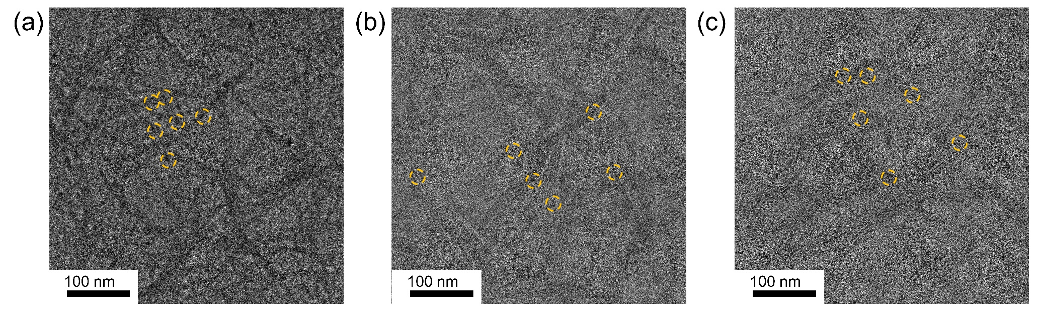
Figure. S3. Survey spectra of (a) CDs and (b) CDCNFs, high resolution C1s and O1s spectra of (c) CDs and (d) CDCNFs

Figure. S4. TEM images of CDCNFs in high magnification

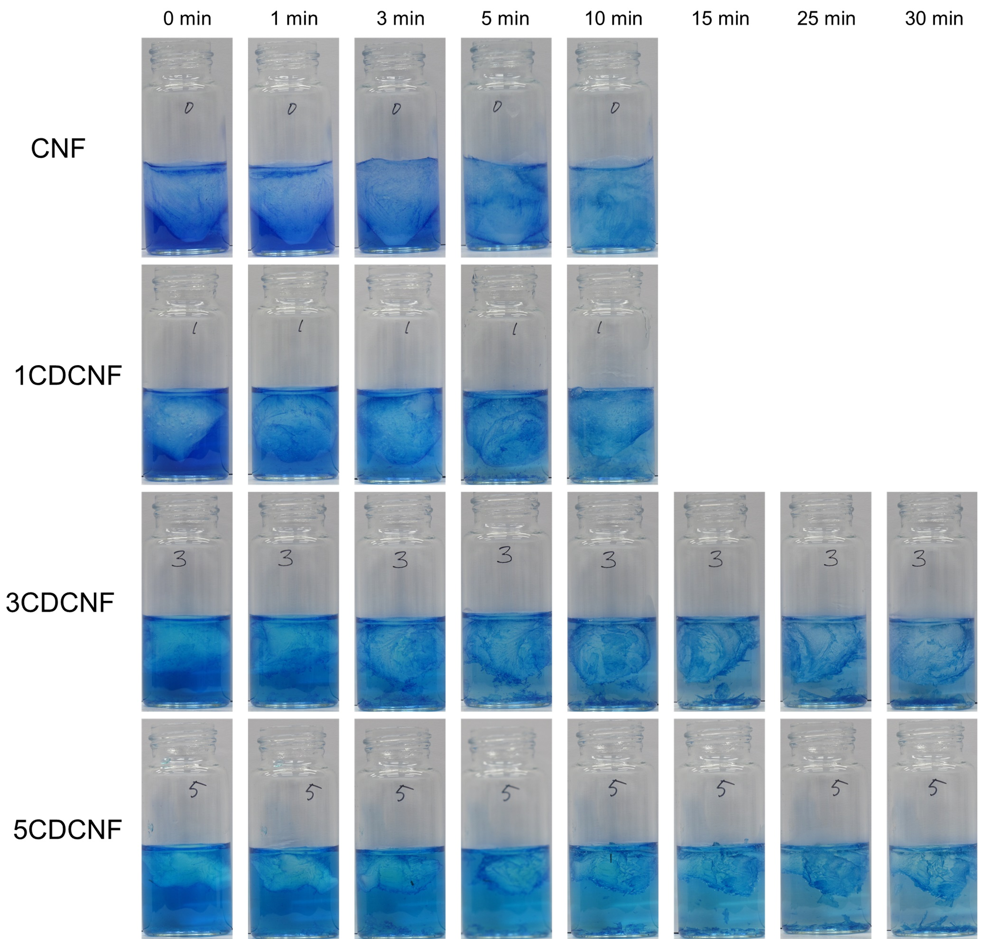
Figure S5. Digital images of MB/aerogel solutions after irradiation of UV light.

