Extended Data Figures
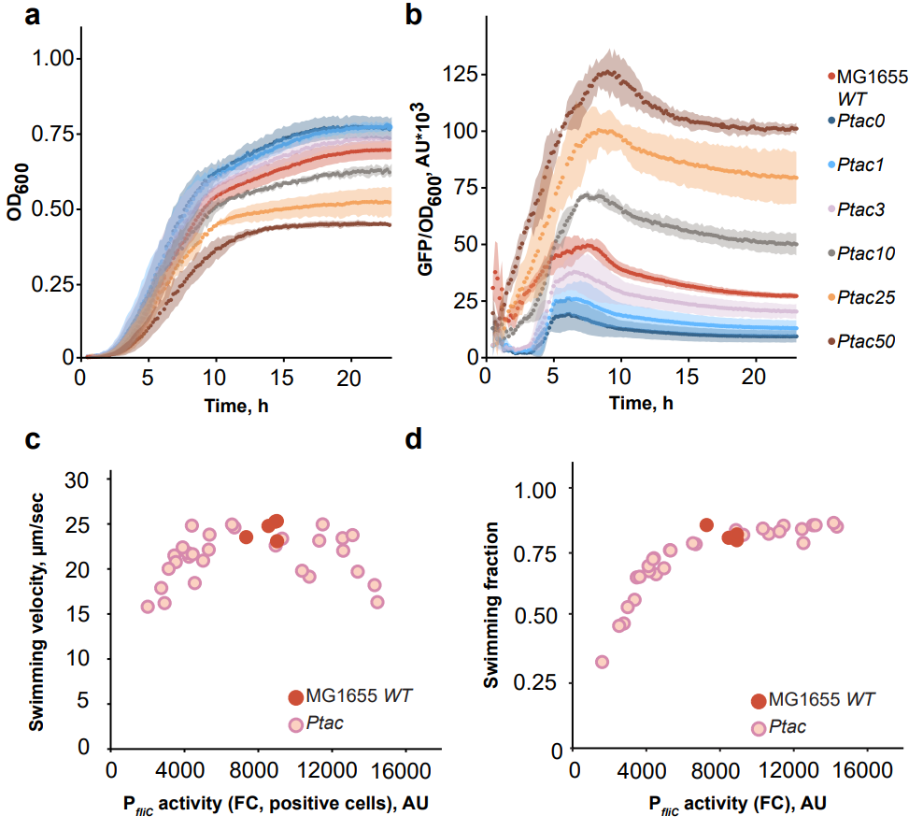
Extended Data Fig. 1 | The effect of flagellar gene expression on growth and motility of MG1655 WT and Ptac strains in nutrient-rich medium (TB). Cell growth (a) and P_{fliC} reporter activity (GFP/OD₆₀₀) (b) were monitored in the indicated cultures for 24 h by measuring absorbance (OD₆₀₀) and GFP fluorescence every 10 min in the plate reader. Numbers represent the corresponding IPTG concentration for the Ptac strain. Standard deviation is shown by the shaded area around the curves (n = 3 biological replicates, mean ± s.d.). Changes in the swimming velocity of motile cells (c) and swimming fraction (d) as a function of reporter activity measured by flow cytometry (FC). P_{fliC} activity was determined as median GFP intensity only in GFP-positive cells (see Methods for details) (c) or in the whole population (d). Each point represents a single replicate culture.
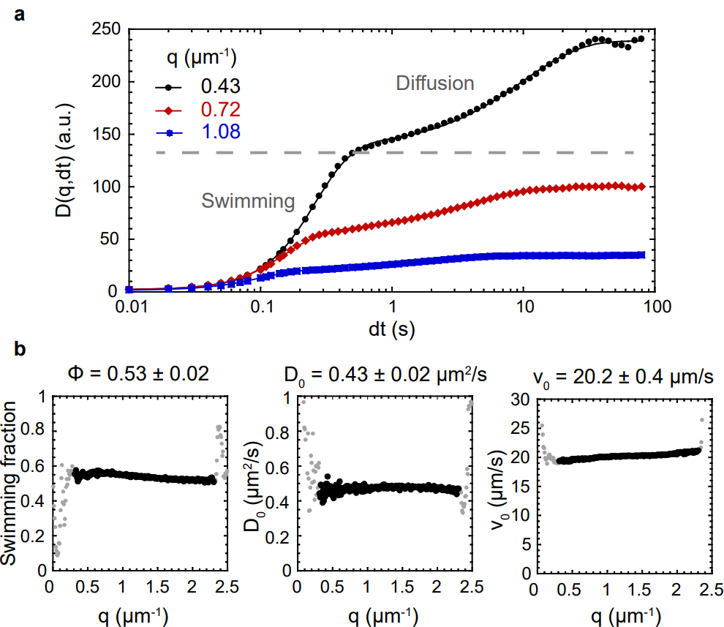

Extended Data Fig. 2 | Differential dynamics microscopy analysis of cell motility. Shown is an example measurement for the Ptac strain at 0 µM IPTG induction. a, Differential intensity correlation functions (DICF) as a function of the lag time dt, for different values of the wave number q. The dashed gray line indicates the separation between the contribution of swimming (short times) and diffusion (long times) to the increase of the DICF. Points are experimental data and lines are fits by the (swimming + diffusion of non-swimmers) model (see Supplementary Note 1). b, Resulting fit parameters (fraction of swimmers, diffusion coefficient, and average velocity) as a function of q. Dark dots indicate successful fits and gray dots are the ones that fail due to either lack of full decorrelation (small q) or low signal over noise (large q). Consistent fit parameter values over the valid range of q validate the model. The mean and standard deviation of the fit parameter values over the valid range are indicated.

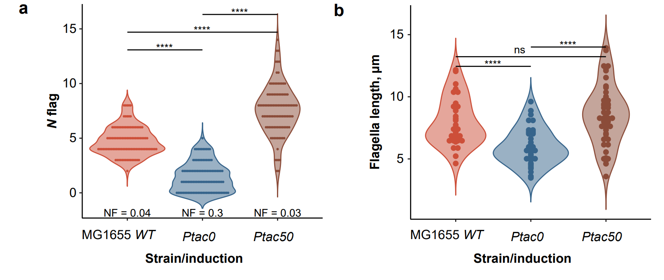
Extended Data Fig. 3 | Distributions of flagella number and length in the population of MG1655 WT and Ptac strains (0, 50 μM IPTG). Each point on the violin plot is a single-cell measurement of flagella number (a, n = 100 randomly selected cells) or length (b, n = 35-50 flagellar filaments in n = 10-20 cells) for the indicated condition. Normality of means was tested by the Shapiro-Wilk test (P ≤ 0.05 (a), and P ≥ 0.05 (b)). Due to the large sample size (n > 20), a two-sided t-test was used for both (a) and (b) to compare the differences between the population means. Since the hypothesis of equal variances was rejected (Levene’s test, P ≤ 0.05), we used Welch’s t-test followed by the Holm-Bonferroni method to correct for multiple testing, and the adjusted P values (****P ≤ 0.0001) are shown on both panels. NF on (a) indicates the fraction of non-flagellated cells for each condition.

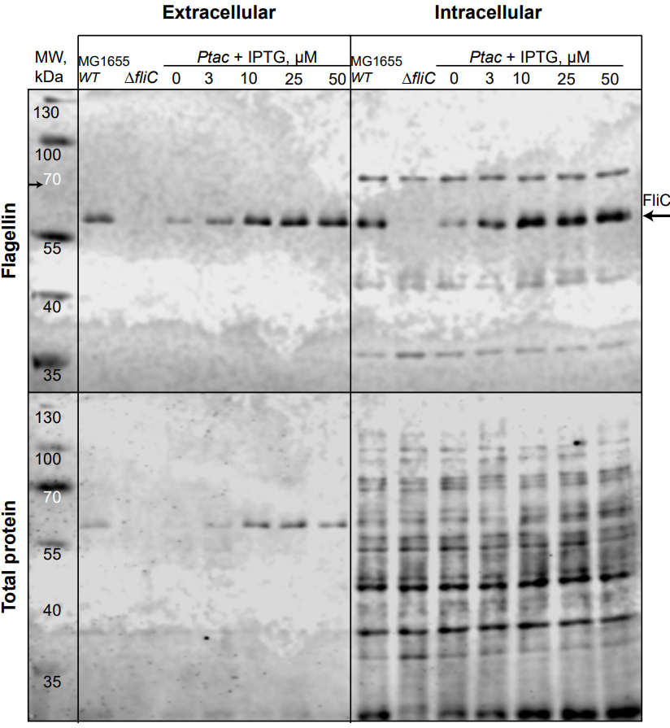
Extended Data Fig. 4 | The amount of intra- and extracellular flagellin increases as a function of motility gene expression. Immunoblotting analysis of flagellin (FliC, indicated by black arrow) in intra- and extracellular fractions of MG1655 WT, Ptac and ΔfliC (negative control) cells. Sample volumes were adjusted by OD₆₀₀ normalization prior to loading. Membrane staining for total protein was used as a loading control (bottom). MW, kDa – band profile of the prestained protein ladder. See Methods for details.
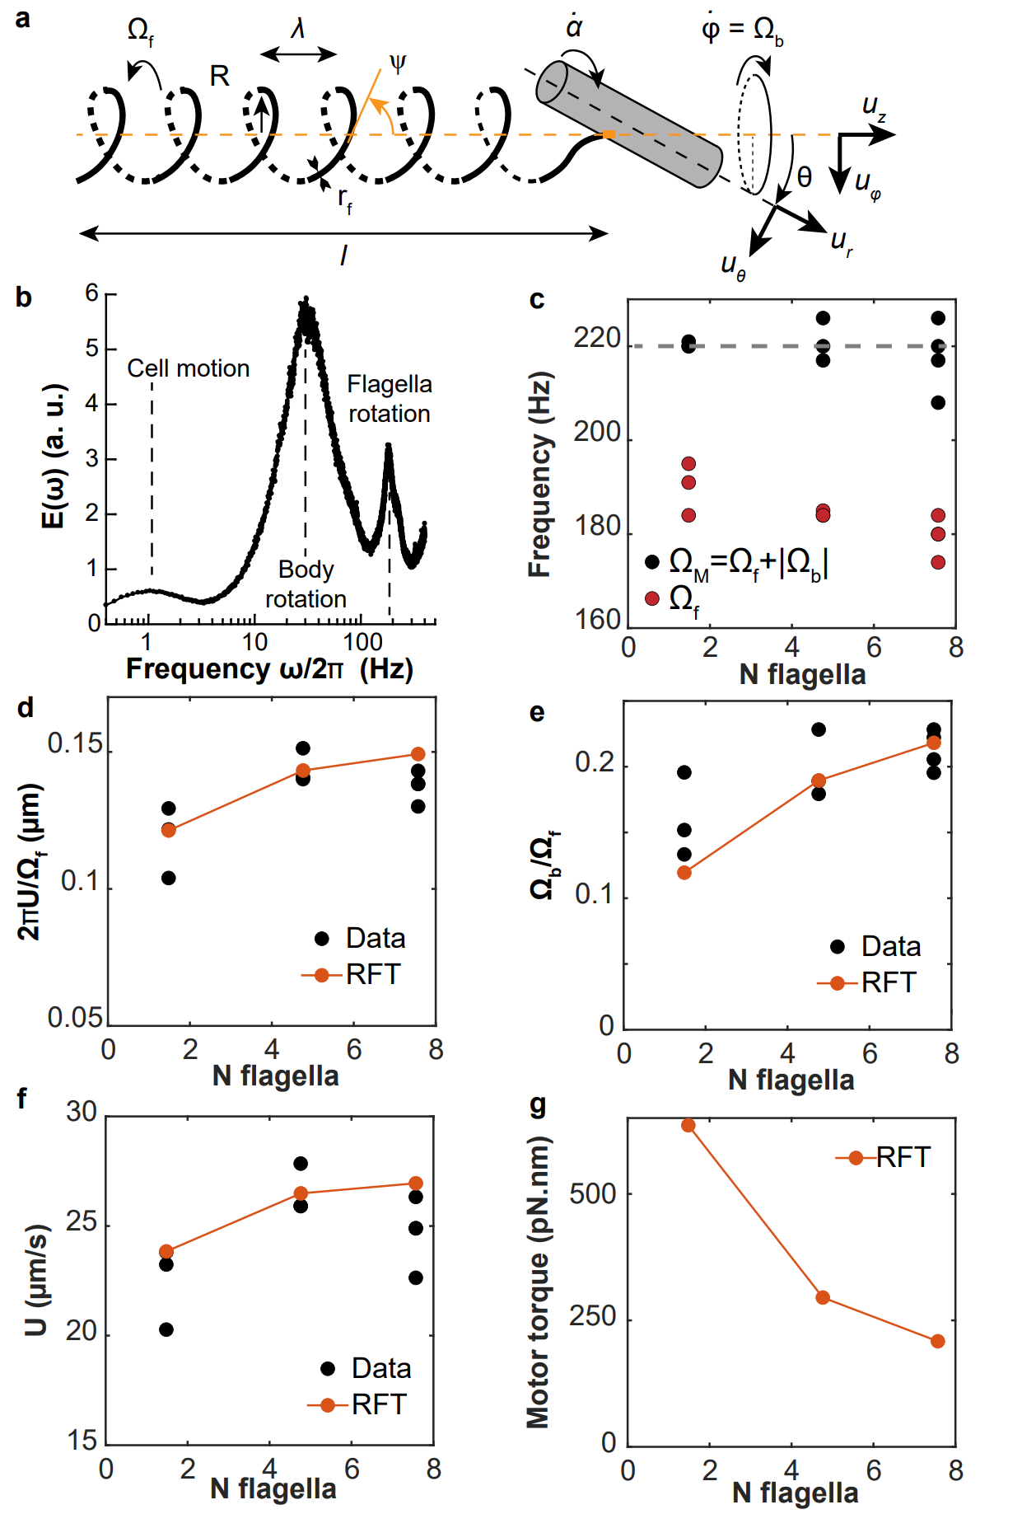
Extended Data Fig. 5 | Model of flagellar propulsion. a, Scheme of the model of flagellar propulsion, featuring a tightly wrapped bundle rotated by N flagellar motors and a counter-rotating cell body. Geometric parameters as well as swimming speed (U), and body ($Ω_{b}$) and flagellar ($Ω_{f}$) rotation speeds are indicated. b, Example of normalized power spectrum $E\left(ω\right)$ obtained by dark field flicker microscopy (DFFM) for MG1655 WT cells. The second and third peaks measure the rotation frequencies of the cell body and flagellum, respectively. c, Measured rotation frequencies. The black points are motor frequencies (sum of flagellum and cell body rotation rates), and the red points are flagellar frequencies. The gray dotted line is the motor frequency used in the model (220 Hz). d-f, Resistive force theory predictions (RFT, Supplementary Note 2, Eqs. 2.8 (d), 2.9 (e), and 2.5-2.6 (f)) compared to experimental measurements (Data) for Ptac0, MG1655 WT and Ptac50 strains (from left to right) using DDM and DFFM (see Supplementary Note 1). In f, the motor rotation speed is set to 220 Hz, consistent with the experimental value found in c. g, Predicted flagellar motor torque (Supplementary Note 2, Eq. 2.11) for the three same strains using RFT. (c-g) The strains are indexed by the measured average number of flagella they harbor. (c-g) Each experimental data point is a biological replicate.
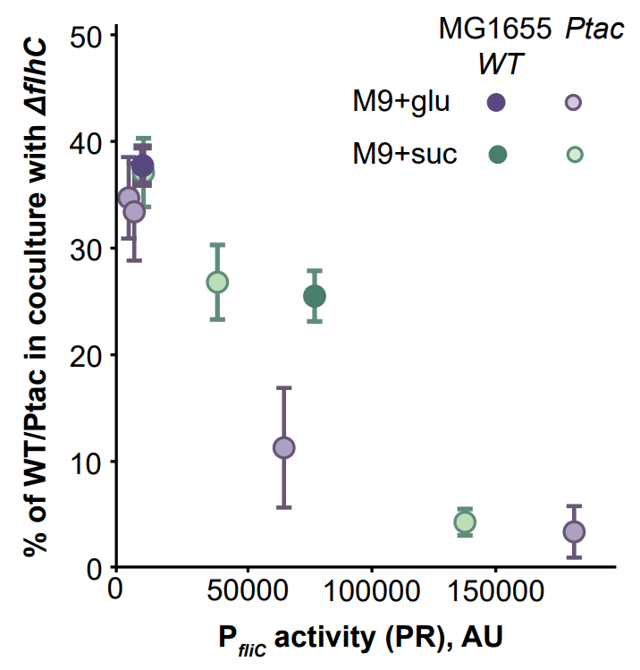
Extended Data Fig. 6 | Growth fitness cost of flagellar gene expression in minimal medium. Strains were initially co-inoculated in a 1:1 ratio, and fitness cost was determined as the percentage of either MG1655 WT or Ptac strain (induced by different concentrations of IPTG) in the co-cultures with the non-flagellated ΔflhC strain after 72 h of incubation with shaking (200 rpm). P_{fliC} activity measured in the plate reader (PR) was used to plot the data. The mean ± s.d. values (n = 3 biological replicates) are shown.
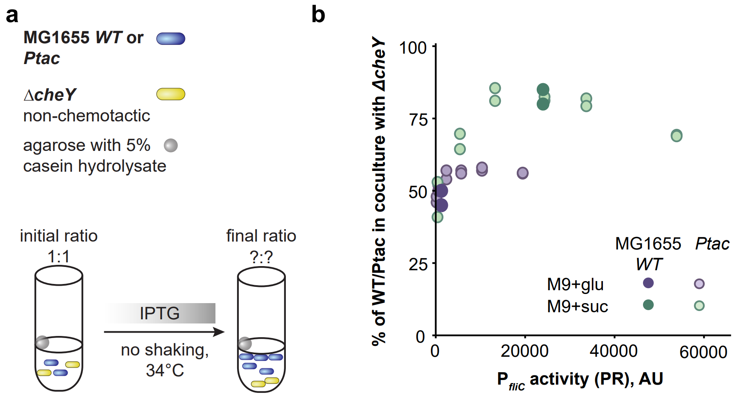
Extended Data Fig. 7 | Growth fitness benefit of flagellar gene expression in minimal medium. Schematic overview (a) and results (b) of pairwise growth competition between chemotactic MG1655 WT or Ptac strain (induced by different concentrations of IPTG) and non-chemotactic ΔcheY grown in the presence of localized nutrient source (agarose beads containing 5% casein hydrolysate) for 72 h without shaking. Strains were initially co-inoculated in a 1:1 ratio, and fitness benefit was quantified as the percentage of MG1655 WT or Ptac strain in the mixed population at the end of the experiment (n = 2 biological replicates). P_{fliC} activity measured in the plate reader (PR) was used to plot the data (n = 1). Note that a different plate reader was used in these experiments, for consistency with a previous publication²¹ (see Methods).

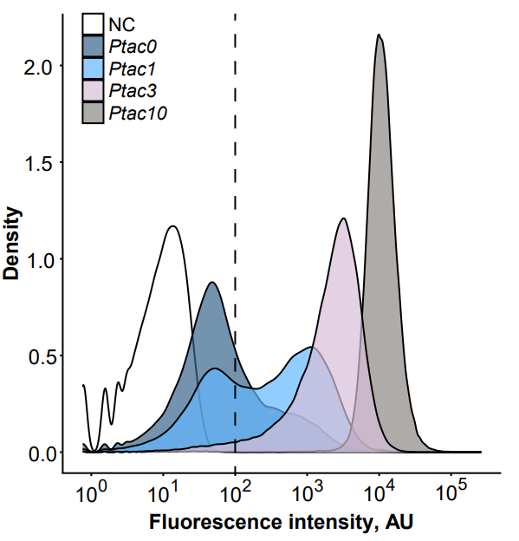
Extended Data Fig. 8 | Flow cytometry measurements of P_{fliC}-GFP reporter activity in the Ptac strain population grown in M9 succinate. Flagellar gene expression was induced by different concentrations of IPTG (indicated by numbers); the Ptac strain lacking the reporter plasmid served as negative control (NC). The vertical dashed line indicates the gate used to distinguish GFP-positive from GFP-negative cells.
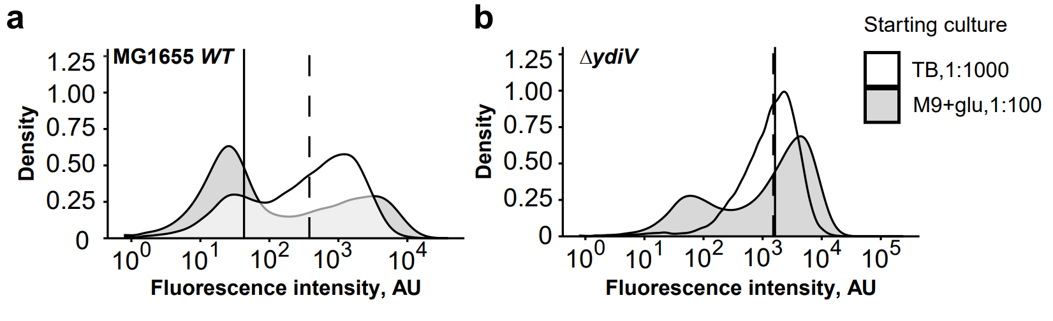
Extended Data Fig. 9 | Flow cytometry analysis of P_{fliC}-GFP reporter activity in the populations of MG1655 WT and ΔydiV strains. Cells were subjected to prolonged incubation under catabolite repression in M9 glucose either by using a higher dilution of the overnight culture (TB, 1:1000) or by pre-growing the overnight culture in M9 glucose (M9+glu, 1:100). The vertical line indicates median P_{fliC} activity (solid for M9+glu, 1:100; dashed for TB, 1:1000). Representative data from one replicate are shown.
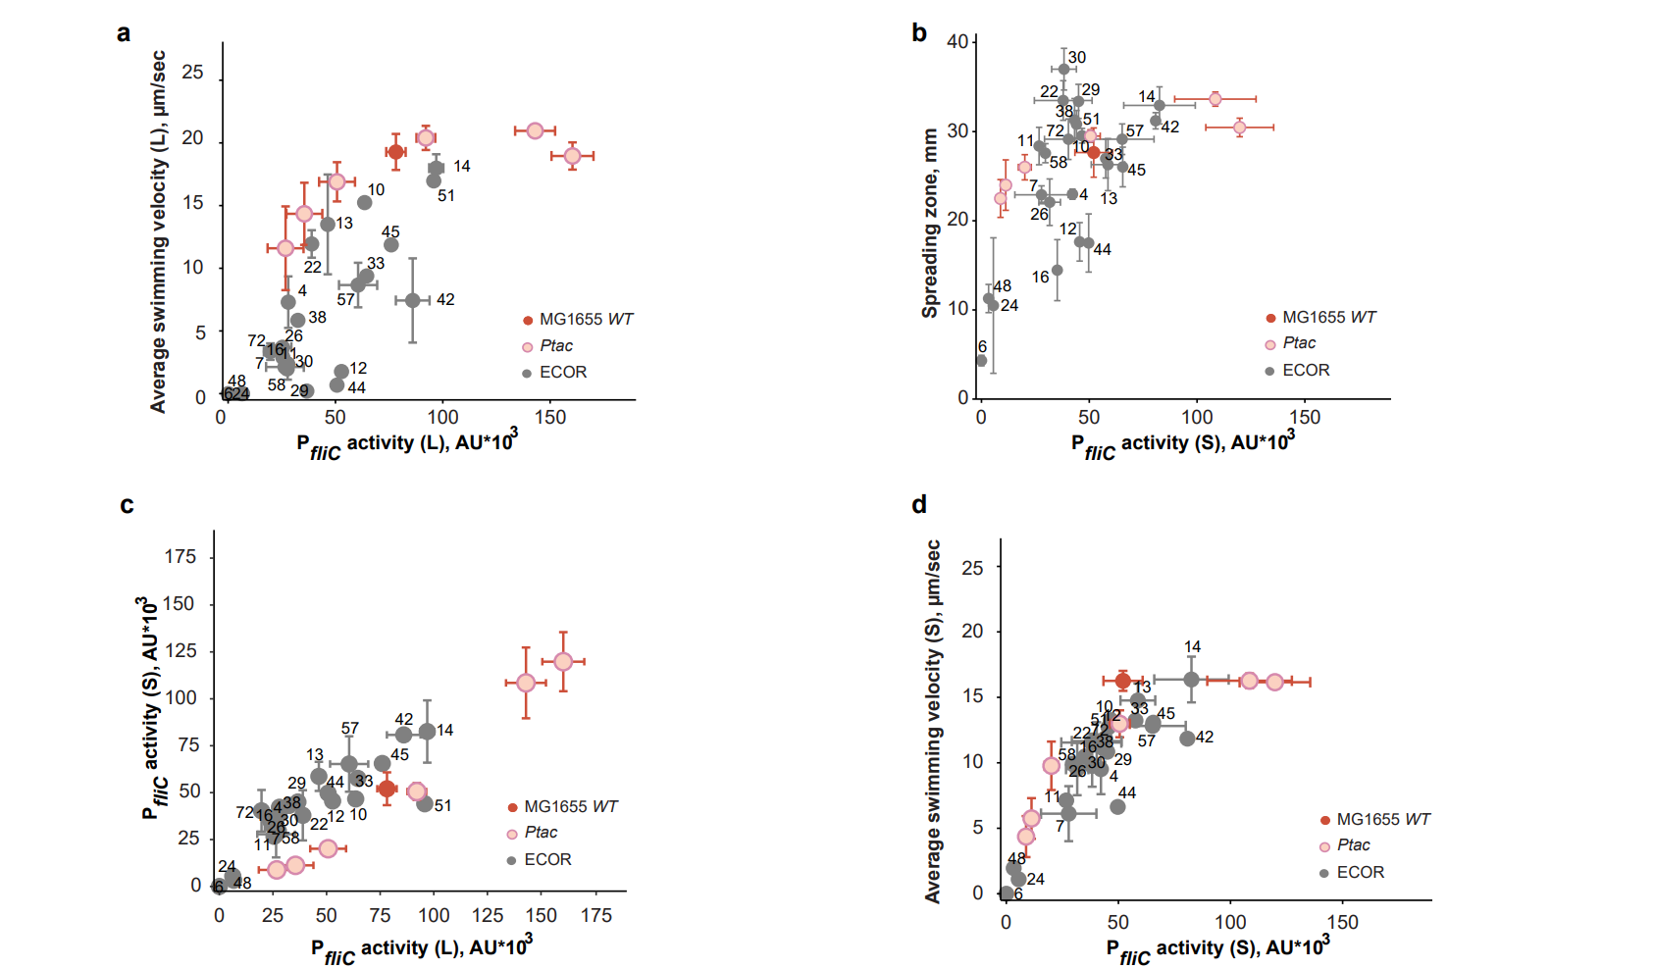
Extended Data Fig. 10 | Relations between P_{fliC} reporter activity, swimming and spreading for MG1655 WT, Ptac and the cohort of 24 natural E. coli isolates. Panels (a, c-d) contain the same data as panels (a, c-d) in Fig. 4 (n = 3 biological replicates for 10 ECOR strains, mean ± s.d.) supplemented by the non-replicate measurements for the remaining 14 strains. b, Dependence of spreading zone diameter (in mm) in porous 0.27% TB agar (data from Fig. 4b) on P_{fliC} reporter activity in E. coli strains grown on semi-solid (S) 0.5% TB agar (data from (c)).

