Supplementary Information

Imputed and Raw Data

As one of the first choices that must be made is between Raw chip data (directly genotyped calls) and Imputed data, we first explain a bit about the differences. Raw chip data - genotype calls directly from the Affymetrix chip’s ThermoFisher calling software. The array consists of 736,145 probes for 655,973 markers. In addition to the core GWAS markers (about 500,000a), it also contains 116,402 coding variants enriched in Finland, 10,800 specific markers for the HLA/KIR region, 14,900 ClinVar variants, 4,600 pharmacogenomic variants, and 57,000 selected markers that were of special interest for the partners. The rare Finnish coding variants are often only available in the chip data. For release 10, there was a total of 412,181 samples. Imputed genotypes were 430,897, individuals with endpoints were 429,207, and individual with detailed longitudinal data were 429,861. This resulted in the inclusion of 21,311,942 variants in the association analysis.”

Fig. S1: Venn diagram for cases of chronic secretory otitis media and chronic mucous otitis media in FinnGen

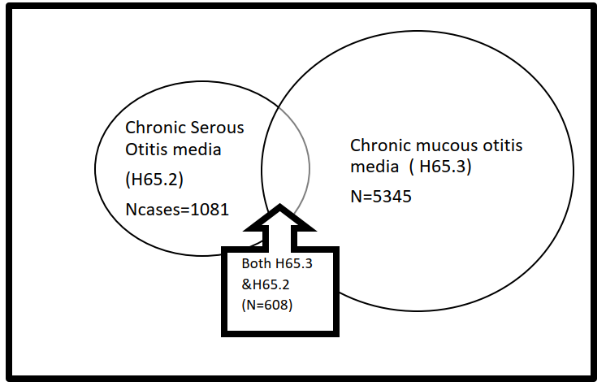

Fig. S2 : Immunohistochemistry for annexin A13 in murine upper airway

Immunohistochemistry revealed abundant expression of annexin A13 in the nasopharynx (triangle), the epithelium of the eustachian tube (black star), and the epithelial glands (arrows). (Magnification x20)

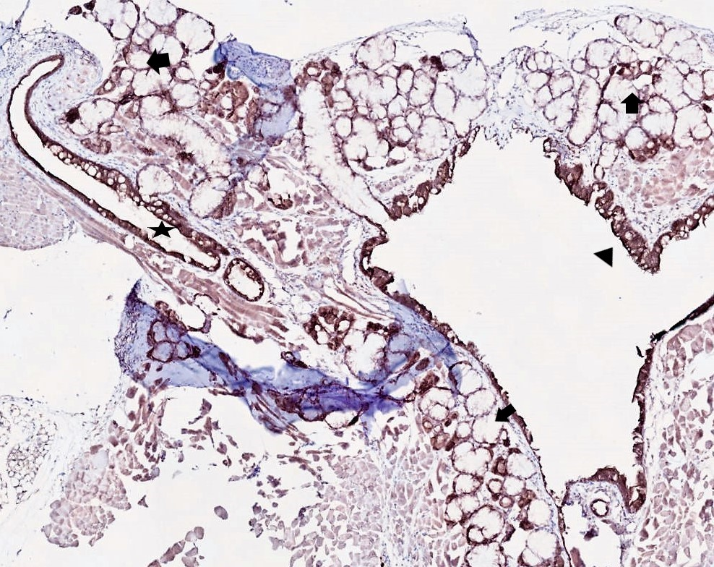

Fig. S3 (a-d): Locus plots for all reported variants

- Locus plot for the rs3779980 (intron) and the rs2294013 (missense) variants

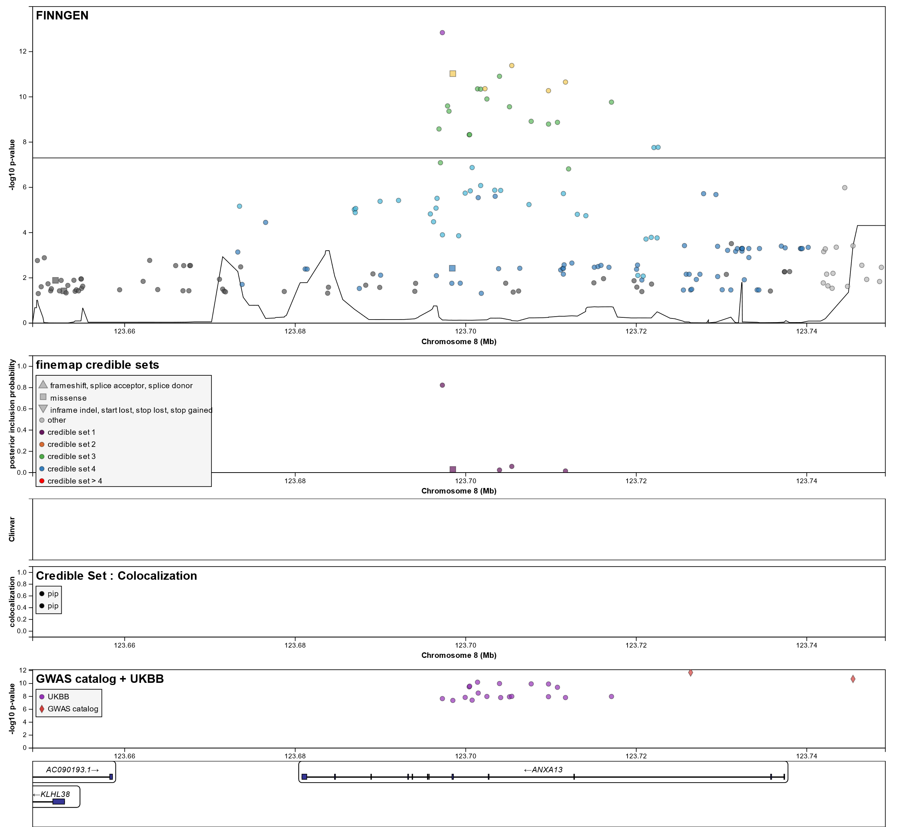

Locus zoom for the rs72553883 missense variant
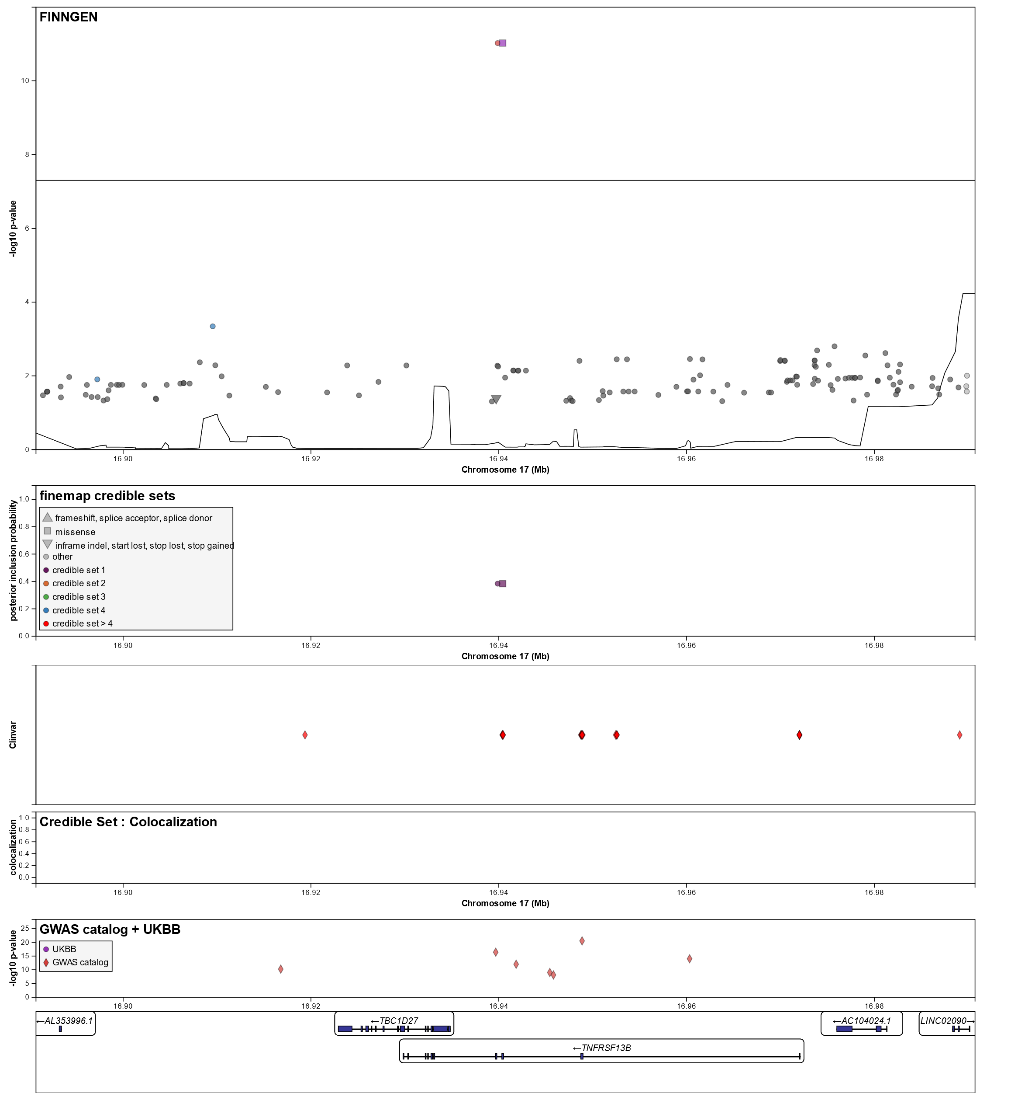

- Locus zoom for the rs3744374 missense variant

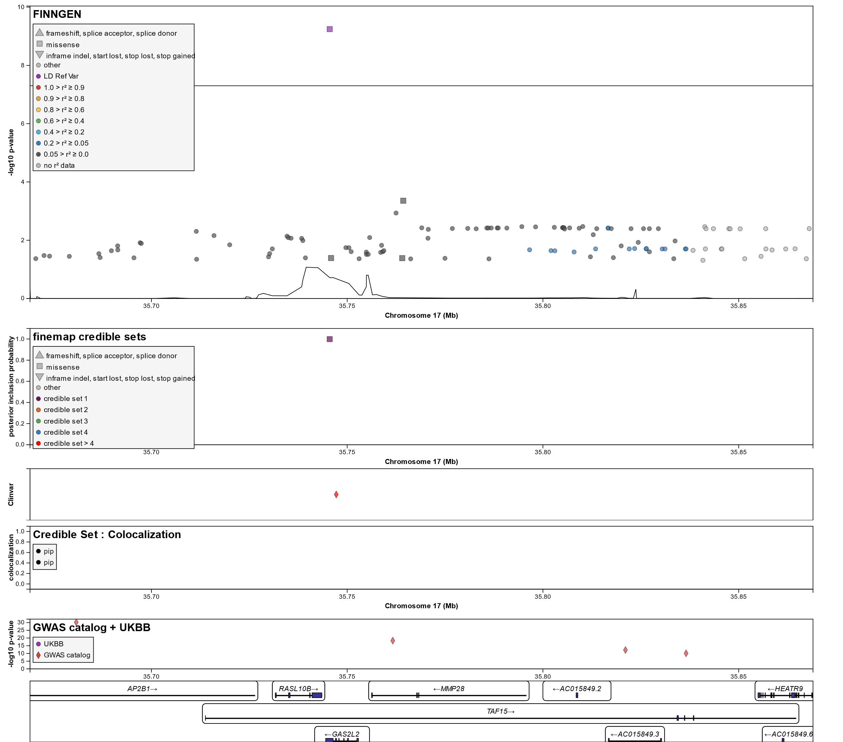

- Locus zoom for the rs1978060 (intron) and the rs72646967 (missense) variants

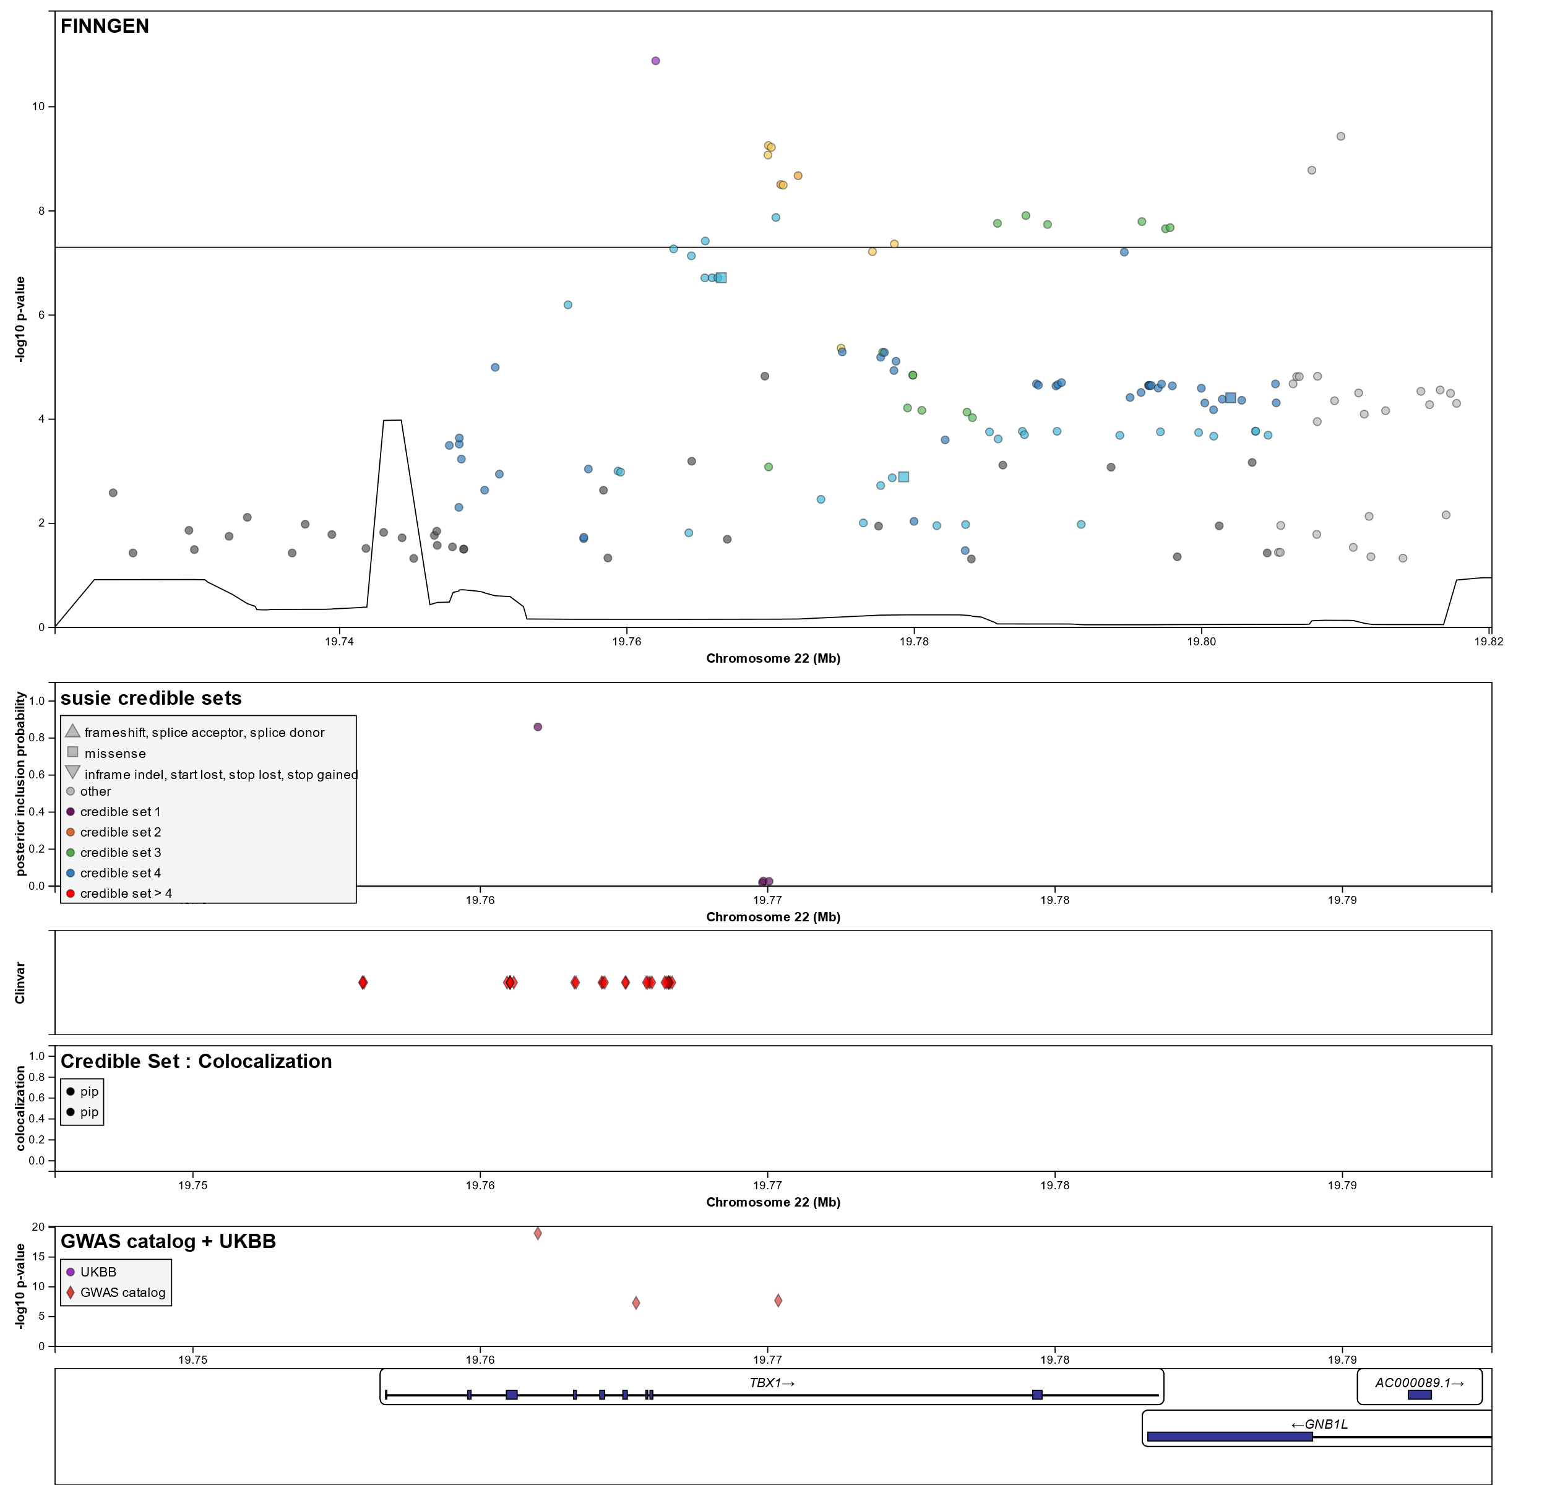

Table S1: Other associations of reported variants in the Finnish population
Significant co-associations of the variants identified for chronic non-suppurative otitis media are shown based on a phenome-wide association study in FinnGen

Chr:Pos (hg38) | Rsid | AF | EA | NEA | Gene | Phenotype | OR | 95%CI | p-value
8:123697261 | rs3779980 | 0.530 | G | A | ANXA13 | Nonsuppurative otitis media | 0.94 | 0.91-0.97 | 3.73x10⁻⁵
8:123698489 | rs2294013 | 0.350 | C | T | ANXA13 | Nonsuppurative otitis media | 1.08 | 1.05-1.12 | 2.53x10⁻⁷
17:16940415 | rs72553883 | 0.025 | G | T | TNFRSF13B | Chronic diseases of tonsils and adenoids | 1.35 | 1.29-1.41 | 1.31x10⁻⁶
17:16940415 | rs72553883 | 0.025 | G | T | TNFRSF13B | Tonsillectomy and adenotomy | 1.34 | 1.27-1.41 | 4.45x10⁻⁷
17:16940415 | rs72553883 | 0.025 | G | T | TNFRSF13B | Other diseases of upper respiratory tract | 1.17 | 1.14-1.21 | 2.77x10⁻⁴¹
17:16940415 | rs72553883 | 0.025 | G | T | TNFRSF13B | Diseases of middle ear and mastoid | 1.21 | 1.14-1.27 | 6.02x10⁻²⁷
17:16940415 | rs72553883 | 0.025 | G | T | TNFRSF13B | Nonsuppurative otitis media | 1.31 | 1.20-1.43 | 2.23x10⁻²²
17:16940415 | rs72553883 | 0.024 | G | T | TNFRSF13B | Eustachian salpingitis and obstruction | 1.58 | 1.36-1.84 | 4.22x10⁻¹¹
17:16940415 | rs72553883 | 0.024 | G | T | TNFRSF13B | Peritonsillar abscess | 1.28 | 1.17-1.41 | 4.50x10⁻⁹
17:35745536 | rs3744374 | 0.230 | G | A | GAS2L2 | Chronic sinusitis | 0.92 | 0.89-0.94 | 4.92x10⁻⁹
17:35745536 | rs3744374 | 0.229 | G | A | GAS2L2 | Diseases of middle ear and mastoid | 0.93 | 0.91-0.95 | 3.06x10⁻⁷
17:35745536 | rs3744374 | 0.229 | G | A | GAS2L2 | Nonsuppurative otitis media | 0.90 | 0.87-0.94 | 4.82x10⁻¹¹
17:35745536 | rs3744374 | 0.229 | G | A | GAS2L2 | Other diseases of upper respiratory tract | 0.97 | 0.96-0.98 | 5.28x10⁻¹¹
22:19762002 | rs1978060 | 0.641 | A | G | TBX1 | Nonsuppurative otitis media | 1.13 | 1.10-1.18 | 2.35x10⁻⁸
22:19762002 | rs1978060 | 0.642 | A | G | TBX1 | Diseases of middle ear and mastoid | 1.07 | 1.05-1.09 | 5.48x10⁻⁸
22:19762002 | rs1978060 | 0.641 | A | G | TBX1 | Nasal polyp | 1.10 | 1.06-1.14 | 6.16x10-¹⁵
22:19762002 | rs1978060 | 0.641 | A | G | TBX1 | Suppurative and unspecified otitis media | 1.07 | 1.04-1.09 | 3.65x10-¹³
22:19766568 | rs72646967 | 0.170 | A | C | TBX1 | Nonsuppurative otitis media | 0.89 | 0.85-0.92 | 2.15x10⁻⁷
22:19766568 | rs72646967 | 0.170 | A | C | TBX1 | Diseases of middle ear and mastoid | 0.93 | 0.90-0.97 | 2.59x10⁻⁷

Table S2: Loci associated with otitis media and eustachian disorders in the UKBB

Chr. chromosome; Pos. position; EA. effect allele; NEA. non-effect allele; CI. confidence interval; EAF. effect allele frequency
UK biobank
Chr:Pos (hg38) | Rsid | AF | EA | NEA | Gene | Phenotype | Beta (95% CI) | OR | p-value
8:123697261 | rs3779980 | 0.55 | G | A | ANXA13 | Otitis media | -0.21 | 0.8106 | 5.1x-10^{–10}
8:123697261 | rs3779980 | 0.55 | G | A | ANXA13 | OM & ED | -0.17 | 0.8437 | 2.2x10⁻⁸
22:19762002 | rs1978060 | 0.62 | A | G | TBX1 | Nasal polyps | 0.13 | 1.1388 | 5.8x10⁻⁷

Table S3: Estimation of variant pathogenicity

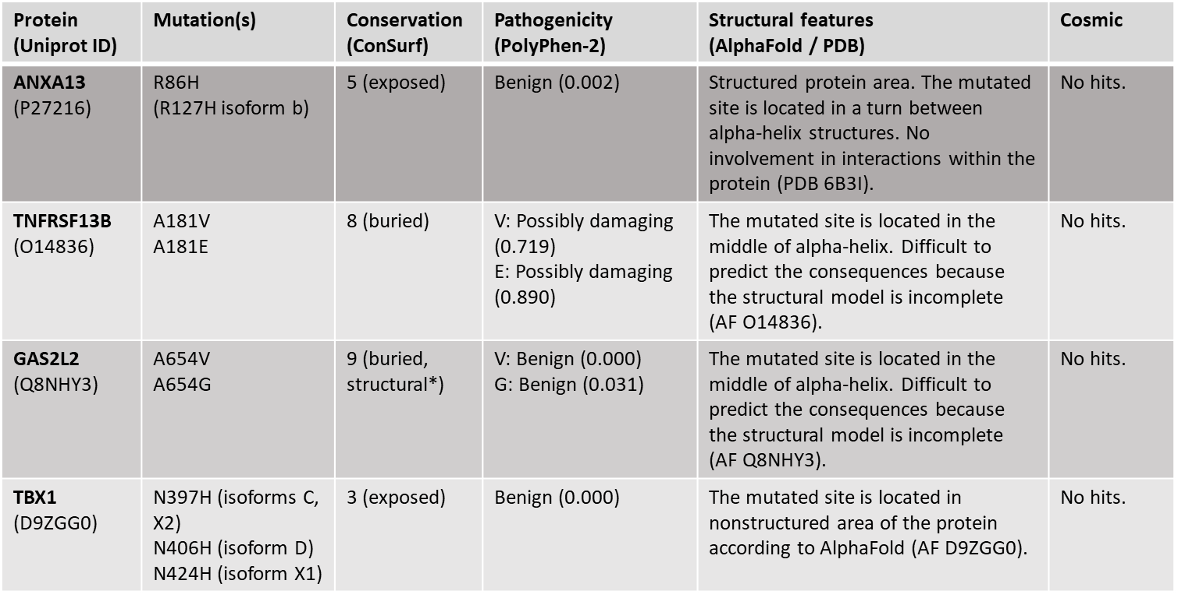

*A predicted structural residue (highly conserved and buried)

Supplementary Data S4: Contributors of Finngen

Steering Committee
Aarno Palotie | Institute for Molecular Medicine Finland (FIMM), HiLIFE, University of Helsinki, Helsinki, Finland; Broad Institute of MIT and Harvard; Massachusetts General Hospital
Mark Daly | Institute for Molecular Medicine Finland (FIMM), HiLIFE, University of Helsinki, Helsinki, Finland; Broad Institute of MIT and Harvard; Massachusetts General Hospital
Bridget Riley-Gills | Abbvie, Chicago, IL, United States
Howard Jacob | Abbvie, Chicago, IL, United States
Dirk Paul | Astra Zeneca, Cambridge, United Kingdom
Slavé Petrovski | Astra Zeneca, Cambridge, United Kingdom
Heiko Runz | Biogen, Cambridge, MA, United States
Sally John | Biogen, Cambridge, MA, United States
George Okafo | Boehringer Ingelheim, Ingelheim am Rhein, Germany
Nathan Lawless | Boehringer Ingelheim, Ingelheim am Rhein, Germany
Heli Salminen-Mankonen | Boehringer Ingelheim, Ingelheim am Rhein, Germany
Robert Plenge | Bristol Myers Squibb, New York, NY, United States
Joseph Maranville | Bristol Myers Squibb, New York, NY, United States
Mark McCarthy | Genentech, San Francisco, CA, United States
Margaret G. Ehm | GlaxoSmithKline, Collegeville, PA, United States
Kirsi Auro | GlaxoSmithKline, Espoo, Finland
Simonne Longerich | Merck, Kenilworth, NJ, United States
Anders Mälarstig | Pfizer, New York, NY, United States
Katherine Klinger | Translational Sciences, Sanofi R&D, Framingham, MA, USA
Clement Chatelain | Translational Sciences, Sanofi R&D, Framingham, MA, USA
Matthias Gossel | Translational Sciences, Sanofi R&D, Framingham, MA, USA
Karol Estrada | Maze Therapeutics, San Francisco, CA, United States
Robert Graham | Maze Therapeutics, San Francisco, CA, United States
Robert Yang | Janssen Biotech, Beerse, Belgium
Chris O´Donnell | Novartis Institutes for BioMedical Research, Cambridge, MA, United States
Tomi P. Mäkelä | HiLIFE, University of Helsinki, Finland, Finland
Jaakko Kaprio | Institute for Molecular Medicine Finland (FIMM), HiLIFE, University of Helsinki, Helsinki, Finland
Petri Virolainen | Auria Biobank / University of Turku / Hospital District of Southwest Finland, Turku, Finland
Antti Hakanen | Auria Biobank / University of Turku / Hospital District of Southwest Finland, Turku, Finland
Terhi Kilpi | THL Biobank / Finnish Institute for Health and Welfare (THL), Helsinki, Finland
Markus Perola | THL Biobank / Finnish Institute for Health and Welfare (THL), Helsinki, Finland
Jukka Partanen | Finnish Red Cross Blood Service / Finnish Hematology Registry and Clinical Biobank, Helsinki, Finland
Anne Pitkäranta | Helsinki Biobank / Helsinki University and Hospital District of Helsinki and Uusimaa, Helsinki
Taneli Raivio | Helsinki Biobank / Helsinki University and Hospital District of Helsinki and Uusimaa, Helsinki
Jani Tikkanen | Northern Finland Biobank Borealis / University of Oulu / Northern Ostrobothnia Hospital District, Oulu, Finland
Raisa Serpi | Northern Finland Biobank Borealis / University of Oulu / Northern Ostrobothnia Hospital District, Oulu, Finland
Tarja Laitinen | Finnish Clinical Biobank Tampere / University of Tampere / Pirkanmaa Hospital District, Tampere, Finland
Veli-Matti Kosma | Biobank of Eastern Finland / University of Eastern Finland / Northern Savo Hospital District, Kuopio, Finland
Jari Laukkanen | Central Finland Biobank / University of Jyväskylä / Central Finland Health Care District, Jyväskylä, Finland
Marco Hautalahti | FINBB - Finnish biobank cooperative
Outi Tuovila | Business Finland, Helsinki, Finland
Raimo Pakkanen | Business Finland, Helsinki, Finland

Scientific Committee
Jeffrey Waring | Abbvie, Chicago, IL, United States
Bridget Riley-Gillis | Abbvie, Chicago, IL, United States
Fedik Rahimov | Abbvie, Chicago, IL, United States
Ioanna Tachmazidou | Astra Zeneca, Cambridge, United Kingdom
Chia-Yen Chen | Biogen, Cambridge, MA, United States
Heiko Runz | Biogen, Cambridge, MA, United States
Zhihao Ding | Boehringer Ingelheim, Ingelheim am Rhein, Germany
Marc Jung | Boehringer Ingelheim, Ingelheim am Rhein, Germany
Shameek Biswas | Bristol Myers Squibb, New York, NY, United States
Rion Pendergrass | Genentech, San Francisco, CA, United States
Margaret G. Ehm | GlaxoSmithKline, Collegeville, PA, United States
David Pulford | GlaxoSmithKline, Stevenage, United Kingdom
Neha Raghavan | Merck, Kenilworth, NJ, United States
Adriana Huertas-Vazquez | Merck, Kenilworth, NJ, United States
Jae-Hoon Sul | Merck, Kenilworth, NJ, United States
Anders Mälarstig | Pfizer, New York, NY, United States
Xinli Hu | Pfizer, New York, NY, United States
Åsa Hedman | Pfizer, New York, NY, United States
Katherine Klinger | Translational Sciences, Sanofi R&D, Framingham, MA, USA
Robert Graham | Maze Therapeutics, San Francisco, CA, United States
Manuel Rivas | Maze Therapeutics, San Francisco, CA, United States
Dawn Waterworth | Janssen Research & Development, LLC, Spring House, PA, United States
Nicole Renaud | Novartis Institutes for BioMedical Research, Cambridge, MA, United States
Ma´en Obeidat | Novartis Institutes for BioMedical Research, Cambridge, MA, United States
Samuli Ripatti | Institute for Molecular Medicine Finland (FIMM), HiLIFE, University of Helsinki, Helsinki, Finland
Johanna Schleutker | Auria Biobank / Univ. of Turku / Hospital District of Southwest Finland, Turku, Finland
Markus Perola | THL Biobank / Finnish Institute for Health and Welfare (THL), Helsinki, Finland
Mikko Arvas | Finnish Red Cross Blood Service / Finnish Hematology Registry and Clinical Biobank,  Helsinki, Finland
Olli Carpén | Helsinki Biobank / Helsinki University and Hospital District of Helsinki and Uusimaa, Helsinki
Reetta Hinttala | Northern Finland Biobank Borealis / University of Oulu /  Northern Ostrobothnia Hospital District, Oulu, Finland
Johannes Kettunen | Northern Finland Biobank Borealis / University of Oulu /  Northern Ostrobothnia Hospital District, Oulu, Finland
Arto Mannermaa | Biobank of Eastern Finland / University of Eastern Finland /  Northern Savo Hospital District, Kuopio, Finland
Katriina Aalto-Setälä | Faculty of Medicine and Health Technology, Tampere University, Tampere, Finland
Mika Kähönen | Finnish Clinical Biobank Tampere / University of Tampere / Pirkanmaa Hospital District,  Tampere, Finland
Jari Laukkanen | Central Finland Biobank / University of Jyväskylä / Central Finland Health Care District,  Jyväskylä, Finland
Johanna Mäkelä | FINBB - Finnish biobank cooperative

Clinical Groups
Reetta Kälviäinen | Northern Savo Hospital District, Kuopio, Finland
Valtteri Julkunen | Northern Savo Hospital District, Kuopio, Finland
Hilkka Soininen | Northern Savo Hospital District, Kuopio, Finland
Anne Remes | Northern Ostrobothnia Hospital District, Oulu, Finland
Mikko Hiltunen | University of Eastern Finland, Kuopio, Finland
Jukka Peltola | Pirkanmaa Hospital District, Tampere, Finland
Minna Raivio | Hospital District of Helsinki and Uusimaa, Helsinki, Finland
Pentti Tienari | Hospital District of Helsinki and Uusimaa, Helsinki, Finland
Juha Rinne | Hospital District of Southwest Finland, Turku, Finland
Roosa Kallionpää | Hospital District of Southwest Finland, Turku, Finland
Juulia Partanen | Institute for Molecular Medicine Finland, HiLIFE, University of Helsinki, Finland
Ali Abbasi | Abbvie, Chicago, IL, United States
Adam Ziemann | Abbvie, Chicago, IL, United States
Nizar Smaoui | Abbvie, Chicago, IL, United States
Anne Lehtonen | Abbvie, Chicago, IL, United States
Susan Eaton | Biogen, Cambridge, MA, United States
Heiko Runz | Biogen, Cambridge, MA, United States
Sanni Lahdenperä | Biogen, Cambridge, MA, United States
Shameek Biswas | Bristol Myers Squibb, New York, NY, United States
Natalie Bowers | Genentech, San Francisco, CA, United States
Edmond Teng | Genentech, San Francisco, CA, United States
Rion Pendergrass | Genentech, San Francisco, CA, United States
Fanli Xu | GlaxoSmithKline, Brentford, United Kingdom
David Pulford | GlaxoSmithKline, Stevenage, United Kingdom
Kirsi Auro | GlaxoSmithKline, Espoo, Finland
Laura Addis | GlaxoSmithKline, Brentford, United Kingdom
John Eicher | GlaxoSmithKline, Brentford, United Kingdom
Qingqin S Li | Janssen Research & Development, LLC, Titusville, NJ 08560, United States
Karen He | Janssen Research & Development, LLC, Spring House, PA, United States
Ekaterina Khramtsova | Janssen Research & Development, LLC, Spring House, PA, United States
Neha Raghavan | Merck, Kenilworth, NJ, United States
Martti Färkkilä | Hospital District of Helsinki and Uusimaa, Helsinki, Finland
Jukka Koskela | Hospital District of Helsinki and Uusimaa, Helsinki, Finland
Sampsa Pikkarainen | Hospital District of Helsinki and Uusimaa, Helsinki, Finland
Airi Jussila | Pirkanmaa Hospital District, Tampere, Finland
Katri Kaukinen | Pirkanmaa Hospital District, Tampere, Finland
Timo Blomster | Northern Ostrobothnia Hospital District, Oulu, Finland
Mikko Kiviniemi | Northern Savo Hospital District, Kuopio, Finland
Markku Voutilainen | Hospital District of Southwest Finland, Turku, Finland
Mark Daly | Institute for Molecular Medicine, Finland (FIMM), HiLIFE, University of Helsinki, Helsinki, Finland; Broad Institute of MIT and Harvard; Massachusetts General Hospital
Ali Abbasi | Abbvie, Chicago, IL, United States
Jeffrey Waring | Abbvie, Chicago, IL, United States
Nizar Smaoui | Abbvie, Chicago, IL, United States
Fedik Rahimov | Abbvie, Chicago, IL, United States
Anne Lehtonen | Abbvie, Chicago, IL, United States
Tim Lu | Genentech, San Francisco, CA, United States
Natalie Bowers | Genentech, San Francisco, CA, United States
Rion Pendergrass | Genentech, San Francisco, CA, United States
Linda McCarthy | GlaxoSmithKline, Brentford, United Kingdom
Amy Hart | Janssen Research & Development, LLC, Spring House, PA, United States
Meijian Guan | Janssen Research & Development, LLC, Spring House, PA, United States
Jason Miller | Merck, Kenilworth, NJ, United States
Kirsi Kalpala | Pfizer, New York, NY, United States
Melissa Miller | Pfizer, New York, NY, United States
Xinli Hu | Pfizer, New York, NY, United States
Kari Eklund | Hospital District of Helsinki and Uusimaa, Helsinki, Finland
Antti Palomäki | Hospital District of Southwest Finland, Turku, Finland
Pia Isomäki | Pirkanmaa Hospital District, Tampere, Finland
Laura Pirilä | Hospital District of Southwest Finland, Turku, Finland
Oili Kaipiainen-Seppänen | Northern Savo Hospital District, Kuopio, Finland
Johanna Huhtakangas | Northern Ostrobothnia Hospital District, Oulu, Finland
Nina Mars | Institute for Molecular Medicine Finland (FIMM), HiLIFE, University of Helsinki, Helsinki, Finland
Ali Abbasi | Abbvie, Chicago, IL, United States
Jeffrey Waring | Abbvie, Chicago, IL, United States
Fedik Rahimov | Abbvie, Chicago, IL, United States
Apinya Lertratanakul | Abbvie, Chicago, IL, United States
Nizar Smaoui | Abbvie, Chicago, IL, United States
Anne Lehtonen | Abbvie, Chicago, IL, United States
Coralie Viollet | AstraZeneca, Cambridge, United Kingdom
Marla Hochfeld | Bristol Myers Squibb, New York, NY, United States
Natalie Bowers | Genentech, San Francisco, CA, United States
Rion Pendergrass | Genentech, San Francisco, CA, United States
Jorge Esparza Gordillo | GlaxoSmithKline, Brentford, United Kingdom
Kirsi Auro | GlaxoSmithKline, Espoo, Finland
Dawn Waterworth | Janssen Research & Development, LLC, Spring House, PA, United States
Fabiana Farias | Merck, Kenilworth, NJ, United States
Kirsi Kalpala | Pfizer, New York, NY, United States
Nan Bing | Pfizer, New York, NY, United States
Xinli Hu | Pfizer, New York, NY, United States
Tarja Laitinen | Pirkanmaa Hospital District, Tampere, Finland
Margit Pelkonen | Northern Savo Hospital District, Kuopio, Finland
Paula Kauppi | Hospital District of Helsinki and Uusimaa, Helsinki, Finland
Hannu Kankaanranta | University of Gothenburg, Gothenburg, Sweden/ Seinäjoki Central Hospital, Seinäjoki,  Finland/ Tampere University, Tampere, Finland
Terttu Harju | Northern Ostrobothnia Hospital District, Oulu, Finland
Riitta Lahesmaa | Hospital District of Southwest Finland, Turku, Finland
Nizar Smaoui | Abbvie, Chicago, IL, United States
Coralie Viollet | AstraZeneca, Cambridge, United Kingdom
Susan Eaton | Biogen, Cambridge, MA, United States
Hubert Chen | Genentech, San Francisco, CA, United States
Rion Pendergrass | Genentech, San Francisco, CA, United States
Natalie Bowers | Genentech, San Francisco, CA, United States
Joanna Betts | GlaxoSmithKline, Brentford, United Kingdom
Kirsi Auro | GlaxoSmithKline, Espoo, Finland
Rajashree Mishra | GlaxoSmithKline, Brentford, United Kingdom
Majd Mouded | Novartis, Basel, Switzerland
Debby Ngo | Novartis, Basel, Switzerland
Teemu Niiranen | Finnish Institute for Health and Welfare (THL), Helsinki, Finland
Felix Vaura | Finnish Institute for Health and Welfare (THL), Helsinki, Finland
Veikko Salomaa | Finnish Institute for Health and Welfare (THL), Helsinki, Finland
Kaj Metsärinne | Hospital District of Southwest Finland, Turku, Finland
Jenni Aittokallio | Hospital District of Southwest Finland, Turku, Finland
Mika Kähönen | Pirkanmaa Hospital District, Tampere, Finland
Jussi Hernesniemi | Pirkanmaa Hospital District, Tampere, Finland
Daniel Gordin | Hospital District of Helsinki and Uusimaa, Helsinki, Finland
Juha Sinisalo | Hospital District of Helsinki and Uusimaa, Helsinki, Finland
Marja-Riitta Taskinen | Hospital District of Helsinki and Uusimaa, Helsinki, Finland
Tiinamaija Tuomi | Hospital District of Helsinki and Uusimaa, Helsinki, Finland
Timo Hiltunen | Hospital District of Helsinki and Uusimaa, Helsinki, Finland
Jari Laukkanen | Central Finland Health Care District, Jyväskylä, Finland
Amanda Elliott | Institute for Molecular Medicine Finland (FIMM), HiLIFE, University of Helsinki,  Helsinki, Finland; Broad Institute, Cambridge, MA,  USA and Massachusetts General Hospital, Boston, MA, USA
Mary Pat Reeve | Institute for Molecular Medicine Finland (FIMM), HiLIFE, University of Helsinki, Helsinki, Finland
Sanni Ruotsalainen | Institute for Molecular Medicine Finland (FIMM), HiLIFE, University of Helsinki, Helsinki, Finland
Dirk Paul | Astra Zeneca, Cambridge, United Kingdom
Natalie Bowers | Genentech, San Francisco, CA, United States
Rion Pendergrass | Genentech, San Francisco, CA, United States
Audrey Chu | GlaxoSmithKline, Brentford, United Kingdom
Kirsi Auro | GlaxoSmithKline, Espoo, Finland
Dermot Reilly | Janssen Research & Development, LLC, Boston, MA, United States
Mike Mendelson | Novartis, Boston, MA, United States
Jaakko Parkkinen | Pfizer, New York, NY, United States
Melissa Miller | Pfizer, New York, NY, United States
Tuomo Meretoja | Hospital District of Helsinki and Uusimaa, Helsinki, Finland
Heikki Joensuu | Hospital District of Helsinki and Uusimaa, Helsinki, Finland
Olli Carpén | Hospital District of Helsinki and Uusimaa, Helsinki, Finland
Johanna Mattson | Hospital District of Helsinki and Uusimaa, Helsinki, Finland
Eveliina Salminen | Hospital District of Helsinki and Uusimaa, Helsinki, Finland
Annika Auranen | Pirkanmaa Hospital District , Tampere, Finland
Peeter Karihtala | Northern Ostrobothnia Hospital District, Oulu, Finland
Päivi Auvinen | Northern Savo Hospital District, Kuopio, Finland
Klaus Elenius | Hospital District of Southwest Finland, Turku, Finland
Johanna Schleutker | Hospital District of Southwest Finland, Turku, Finland
Esa Pitkänen | Institute for Molecular Medicine Finland (FIMM), HiLIFE, University of Helsinki,  Helsinki, Finland
Nina Mars | Institute for Molecular Medicine Finland (FIMM), HiLIFE, University of Helsinki,  Helsinki, Finland
Mark Daly | Institute for Molecular Medicine Finland (FIMM), HiLIFE, University of Helsinki,  Helsinki, Finland; Broad Institute of MIT and Harvard; Massachusetts General Hospital
Relja Popovic | Abbvie, Chicago, IL, United States
Jeffrey Waring | Abbvie, Chicago, IL, United States
Bridget Riley-Gillis | Abbvie, Chicago, IL, United States
Anne Lehtonen | Abbvie, Chicago, IL, United States
Margarete Fabre | AstraZeneca, Cambridge, United Kingdom
Jennifer Schutzman | Genentech, San Francisco, CA, United States
Natalie Bowers | Genentech, San Francisco, CA, United States
Rion Pendergrass | Genentech, San Francisco, CA, United States
Diptee Kulkarni | GlaxoSmithKline, Brentford, United Kingdom
Kirsi Auro | GlaxoSmithKline, Espoo, Finland
Alessandro Porello | Janssen Research & Development, LLC, Spring House, PA, United States
Andrey Loboda | Merck, Kenilworth, NJ, United States
Heli Lehtonen | Pfizer, New York, NY, United States
Stefan McDonough | Pfizer, New York, NY, United States
Sauli Vuoti | Janssen-Cilag Oy, Espoo, Finland
Kai Kaarniranta | Northern Savo Hospital District, Kuopio, Finland; Department of Molecular Genetics,  University of Lodz, Lodz, Poland
Joni A Turunen | Helsinki University Hospital and University of Helsinki, Helsinki, Finland; Eye Genetics Group,  Folkhälsan Research Center, Helsinki, Finland
Terhi Ollila | Hospital District of Helsinki and Uusimaa, Helsinki, Finland
Hannu Uusitalo | Pirkanmaa Hospital District, Tampere, Finland
Juha Karjalainen | Institute for Molecular Medicine Finland (FIMM), HiLIFE, University of Helsinki, Helsinki, Finland
Esa Pitkänen | Institute for Molecular Medicine Finland (FIMM), HiLIFE, University of Helsinki, Helsinki, Finland
Mengzhen Liu | Abbvie, Chicago, IL, United States
Heiko Runz | Biogen, Cambridge, MA, United States
Stephanie Loomis | Biogen, Cambridge, MA, United States
Erich Strauss | Genentech, San Francisco, CA, United States
Natalie Bowers | Genentech, San Francisco, CA, United States
Hao Chen | Genentech, San Francisco, CA, United States
Rion Pendergrass | Genentech, San Francisco, CA, United States
Kaisa Tasanen | Northern Ostrobothnia Hospital District, Oulu, Finland
Laura Huilaja | Northern Ostrobothnia Hospital District, Oulu, Finland
Katariina Hannula-Jouppi | Hospital District of Helsinki and Uusimaa, Helsinki, Finland
Teea Salmi | Pirkanmaa Hospital District, Tampere, Finland
Sirkku Peltonen | Hospital District of Southwest Finland, Turku, Finland
Leena Koulu | Hospital District of Southwest Finland, Turku, Finland
Nizar Smaoui | Abbvie, Chicago, IL, United States
Fedik Rahimov | Abbvie, Chicago, IL, United States
Anne Lehtonen | Abbvie, Chicago, IL, United States
David Choy | Genentech, San Francisco, CA, United States
Rion Pendergrass | Genentech, San Francisco, CA, United States
Dawn Waterworth | Janssen Research & Development, LLC, Spring House, PA, United States
Kirsi Kalpala | Pfizer, New York, NY, United States
Ying Wu | Pfizer, New York, NY, United States
Pirkko Pussinen | Hospital District of Helsinki and Uusimaa, Helsinki, Finland
Aino Salminen | Hospital District of Helsinki and Uusimaa, Helsinki, Finland
Tuula Salo | Hospital District of Helsinki and Uusimaa, Helsinki, Finland
David Rice | Hospital District of Helsinki and Uusimaa, Helsinki, Finland
Pekka Nieminen | Hospital District of Helsinki and Uusimaa, Helsinki, Finland
Ulla Palotie | Hospital District of Helsinki and Uusimaa, Helsinki, Finland
Maria Siponen | Northern Savo Hospital District, Kuopio, Finland
Liisa Suominen | Northern Savo Hospital District, Kuopio, Finland
Päivi Mäntylä | Northern Savo Hospital District, Kuopio, Finland
Ulvi Gursoy | Hospital District of Southwest Finland, Turku, Finland
Vuokko Anttonen | Northern Ostrobothnia Hospital District, Oulu, Finland
Kirsi Sipilä | Research Unit of Oral Health Sciences Faculty of Medicine,  University of Oulu, Oulu, Finland; Medical Research Center,  Oulu, Oulu University Hospital and University of Oulu, Oulu, Finland
Rion Pendergrass | Genentech, San Francisco, CA, United States
Hannele Laivuori | Institute for Molecular Medicine Finland (FIMM), HiLIFE, University of Helsinki, Helsinki, Finland
Venla Kurra | Pirkanmaa Hospital District, Tampere, Finland
Laura Kotaniemi-Talonen | Pirkanmaa Hospital District, Tampere, Finland
Oskari Heikinheimo | Hospital District of Helsinki and Uusimaa, Helsinki, Finland
Ilkka Kalliala | Hospital District of Helsinki and Uusimaa, Helsinki, Finland
Lauri Aaltonen | Hospital District of Helsinki and Uusimaa, Helsinki, Finland
Varpu Jokimaa | Hospital District of Southwest Finland, Turku, Finland
Johannes Kettunen | Northern Ostrobothnia Hospital District, Oulu, Finland
Marja Vääräsmäki | Northern Ostrobothnia Hospital District, Oulu, Finland
Outi Uimari | Northern Ostrobothnia Hospital District, Oulu, Finland
Laure Morin-Papunen | Northern Ostrobothnia Hospital District, Oulu, Finland
Maarit Niinimäki | Northern Ostrobothnia Hospital District, Oulu, Finland
Terhi Piltonen | Northern Ostrobothnia Hospital District, Oulu, Finland
Katja Kivinen | Institute for Molecular Medicine Finland (FIMM), HiLIFE,  University of Helsinki, Helsinki, Finland
Elisabeth Widen | Institute for Molecular Medicine Finland (FIMM), HiLIFE,  University of Helsinki, Helsinki, Finland
Taru Tukiainen | Institute for Molecular Medicine Finland (FIMM), HiLIFE,  University of Helsinki, Helsinki, Finland
Mary Pat Reeve | Institute for Molecular Medicine Finland (FIMM), HiLIFE,  University of Helsinki, Helsinki, Finland
Mark Daly | Institute for Molecular Medicine Finland (FIMM), HiLIFE,  University of Helsinki, Helsinki, Finland;  Broad Institute of MIT and Harvard; Massachusetts General Hospital
Niko Välimäki | University of Helsinki, Helsinki, Finland
Eija Laakkonen | University of Jyväskylä, Jyväskylä, Finland
Jaakko Tyrmi | University of Oulu, Oulu, Finland / University of Tampere, Tampere, Finland
Heidi Silven | University of Oulu, Oulu, Finland
Eeva Sliz | University of Oulu, Oulu, Finland
Riikka Arffman | University of Oulu, Oulu, Finland
Susanna Savukoski | University of Oulu, Oulu, Finland
Triin Laisk | Estonian biobank, Tartu, Estonia
Natalia Pujol | Estonian biobank, Tartu, Estonia
Mengzhen Liu | Abbvie, Chicago, IL, United States
Bridget Riley-Gillis | Abbvie, Chicago, IL, United States
Rion Pendergrass | Genentech, San Francisco, CA, United States
Janet Kumar | GlaxoSmithKline, Collegeville, PA, United States
Kirsi Auro | GlaxoSmithKline, Espoo, Finland
Iiris Hovatta | University of Helsinki, Finland
Chia-Yen Chen | Biogen, Cambridge, MA, United States
Erkki Isometsä | Hospital District of Helsinki and Uusimaa, Helsinki, Finland
Hanna Ollila | Institute for Molecular Medicine Finland (FIMM), HiLIFE, University of Helsinki, Helsinki, Finland
Jaana Suvisaari | Finnish Institute for Health and Welfare (THL), Helsinki, Finland
Thomas Damm Als | Aarhus University, Denmark
Antti Mäkitie | Department of Otorhinolaryngology - Head and Neck Surgery, University of Helsinki and Helsinki University Hospital, Helsinki, Finland
Argyro Bizaki-Vallaskangas | Pirkanmaa Hospital District, Tampere, Finland
Sanna Toppila-Salmi | University of Helsinki, Finland
Tytti Willberg | Hospital District of Southwest Finland, Turku, Finland
Elmo Saarentaus | Institute for Molecular Medicine Finland (FIMM), HiLIFE, University of Helsinki, Helsinki, Finland
Antti Aarnisalo | Hospital District of Helsinki and Uusimaa, Helsinki, Finland
Eveliina Salminen | Hospital District of Helsinki and Uusimaa, Helsinki, Finland
Elisa Rahikkala | Northern Ostrobothnia Hospital District, Oulu, Finland
Johannes Kettunen | Northern Ostrobothnia Hospital District, Oulu, Finland
Kristiina Aittomäki | Department of Medical Genetics, Helsinki University Central Hospital, Helsinki, Finland
Fredrik Åberg | Transplantation and Liver Surgery Clinic, Helsinki University Hospital, Helsinki University,  Helsinki, Finland

Finngen Analysis Working Group
Mitja Kurki | Institute for Molecular Medicine Finland (FIMM), HiLIFE,  University of Helsinki, Helsinki, Finland; Broad Institute, Cambridge, MA, United States
Samuli Ripatti | Institute for Molecular Medicine Finland (FIMM), HiLIFE,  University of Helsinki, Helsinki, Finland
Mark Daly | Institute for Molecular Medicine, Finland (FIMM), HiLIFE,  University of Helsinki, Helsinki, Finland; Broad Institute of MIT and Harvard;  Massachusetts General Hospital
Juha Karjalainen | Institute for Molecular Medicine Finland (FIMM), HiLIFE,  University of Helsinki, Helsinki, Finland
Aki Havulinna | Institute for Molecular Medicine Finland (FIMM), HiLIFE,  University of Helsinki, Helsinki, Finland; Finnish Institute for Health and Welfare (THL),  Helsinki, Finland
Juha Mehtonen | Institute for Molecular Medicine Finland (FIMM), HiLIFE,  University of Helsinki, Helsinki, Finland
Priit Palta | Institute for Molecular Medicine Finland (FIMM), HiLIFE,  University of Helsinki, Helsinki, Finland
Shabbeer Hassan | Institute for Molecular Medicine Finland (FIMM), HiLIFE, University of Helsinki, Helsinki, Finland
Pietro Della Briotta Parolo | Institute for Molecular Medicine Finland (FIMM), HiLIFE, University of Helsinki, Helsinki, Finland
Wei Zhou | Broad Institute, Cambridge, MA, United States
Mutaamba Maasha | Broad Institute, Cambridge, MA, United States
Shabbeer Hassan | Institute for Molecular Medicine Finland (FIMM), HiLIFE, University of Helsinki, Helsinki, Finland
Susanna Lemmelä | Institute for Molecular Medicine Finland (FIMM), HiLIFE, University of Helsinki, Helsinki, Finland
Manuel Rivas | University of Stanford, Stanford, CA, United States
Aarno Palotie | Institute for Molecular Medicine Finland (FIMM), HiLIFE, University of Helsinki, Helsinki, Finland
Aoxing Liu | Institute for Molecular Medicine Finland (FIMM), HiLIFE, University of Helsinki, Helsinki, Finland
Arto Lehisto | Institute for Molecular Medicine Finland (FIMM), HiLIFE, University of Helsinki, Helsinki, Finland
Andrea Ganna | Institute for Molecular Medicine Finland (FIMM), HiLIFE, University of Helsinki, Helsinki, Finland
Vincent Llorens | Institute for Molecular Medicine Finland (FIMM), HiLIFE, University of Helsinki, Helsinki, Finland
Hannele Laivuori | Institute for Molecular Medicine Finland (FIMM), HiLIFE, University of Helsinki, Helsinki, Finland
Taru Tukiainen | Institute for Molecular Medicine Finland (FIMM), HiLIFE, University of Helsinki, Helsinki, Finland
Mary Pat Reeve | Institute for Molecular Medicine Finland (FIMM), HiLIFE, University of Helsinki, Helsinki, Finland
Henrike Heyne | Institute for Molecular Medicine Finland (FIMM), HiLIFE, University of Helsinki, Helsinki, Finland
Nina Mars | Institute for Molecular Medicine Finland (FIMM), HiLIFE, University of Helsinki, Helsinki, Finland
Joel Rämö | Institute for Molecular Medicine Finland (FIMM), HiLIFE, University of Helsinki, Helsinki, Finland
Elmo Saarentaus | Institute for Molecular Medicine Finland (FIMM), HiLIFE, University of Helsinki, Helsinki, Finland
Hanna Ollila | Institute for Molecular Medicine Finland (FIMM), HiLIFE, University of Helsinki, Helsinki, Finland
Rodos Rodosthenous | Institute for Molecular Medicine Finland (FIMM), HiLIFE, University of Helsinki, Helsinki, Finland
Satu Strausz | Institute for Molecular Medicine Finland (FIMM), HiLIFE, University of Helsinki, Helsinki, Finland
Tuula Palotie | University of Helsinki and Hospital District of Helsinki and Uusimaa, Helsinki, Finland
Kimmo Palin | University of Helsinki, Helsinki, Finland
Javier Garcia-Tabuenca | University of Tampere, Tampere, Finland
Harri Siirtola | University of Tampere, Tampere, Finland
Tuomo Kiiskinen | Institute for Molecular Medicine Finland (FIMM),  HiLIFE, University of Helsinki, Helsinki, Finland
Jiwoo Lee | Institute for Molecular Medicine Finland (FIMM),  HiLIFE, University of Helsinki, Helsinki, Finland;  Broad Institute, Cambridge, MA, United States
Kristin Tsuo | Institute for Molecular Medicine Finland (FIMM),  HiLIFE, University of Helsinki, Helsinki, Finland; Broad Institute, Cambridge, MA, United States
Amanda Elliott | Institute for Molecular Medicine Finland (FIMM), HiLIFE, University of Helsinki, Helsinki, Finland;  Broad Institute, Cambridge, MA, USA and Massachusetts General Hospital, Boston, MA, USA
Kati Kristiansson | THL Biobank / Finnish Institute for Health and Welfare (THL), Helsinki, Finland
Mikko Arvas | Finnish Red Cross Blood Service /  Finnish Hematology Registry and Clinical Biobank, Helsinki, Finland
Kati Hyvärinen | Finnish Red Cross Blood Service, Helsinki, Finland
Jarmo Ritari | Finnish Red Cross Blood Service, Helsinki, Finland
Olli Carpén | Helsinki Biobank / Helsinki University and Hospital District of Helsinki and Uusimaa, Helsinki
Johannes Kettunen | Northern Finland Biobank Borealis / University of Oulu /  Northern Ostrobothnia Hospital District, Oulu, Finland
Katri Pylkäs | University of Oulu, Oulu, Finland
Eeva Sliz | University of Oulu, Oulu, Finland
Minna Karjalainen | University of Oulu, Oulu, Finland
Tuomo Mantere | Northern Finland Biobank Borealis / University of Oulu /  Northern Ostrobothnia Hospital District, Oulu, Finland
Eeva Kangasniemi | Finnish Clinical Biobank Tampere / University of Tampere /  Pirkanmaa Hospital District, Tampere, Finland
Sami Heikkinen | University of Eastern Finland, Kuopio, Finland
Arto Mannermaa | Biobank of Eastern Finland / University of Eastern Finland /  Northern Savo Hospital District, Kuopio, Finland
Eija Laakkonen | University of Jyväskylä, Jyväskylä, Finland
Nina Pitkänen | Auria Biobank / University of Turku / Hospital District of Southwest Finland, Turku, Finland
Samuel Lessard | Translational Sciences, Sanofi R&D, Framingham, MA, USA
Clément Chatelain | Translational Sciences, Sanofi R&D, Framingham, MA, USA

Biobank Directors
Lila Kallio | Auria Biobank / University of Turku / Hospital District of Southwest Finland, Turku, Finland
Tiina Wahlfors | THL Biobank / Finnish Institute for Health and Welfare (THL), Helsinki, Finland
Jukka Partanen | Finnish Red Cross Blood Service / Finnish Hematology Registry and Clinical Biobank, Helsinki, Finland
Eero Punkka | Helsinki Biobank / Helsinki University and Hospital District of Helsinki and Uusimaa, Helsinki
Raisa Serpi | Northern Finland Biobank Borealis / University of Oulu / Northern Ostrobothnia Hospital District, Oulu, Finland
Sanna Siltanen | Finnish Clinical Biobank Tampere / University of Tampere / Pirkanmaa Hospital District, Tampere, Finland
Veli-Matti Kosma | Biobank of Eastern Finland / University of Eastern Finland / Northern Savo Hospital District, Kuopio, Finland
Teijo Kuopio | Central Finland Biobank / University of Jyväskylä / Central Finland Health Care District, Jyväskylä, Finland

Finngen teams
Anu Jalanko | Institute for Molecular Medicine Finland (FIMM), HiLIFE, University of Helsinki, Helsinki, Finland
Huei-Yi Shen | Institute for Molecular Medicine Finland (FIMM), HiLIFE, University of Helsinki, Helsinki, Finland
Risto Kajanne | Institute for Molecular Medicine Finland (FIMM), HiLIFE, University of Helsinki, Helsinki, Finland
Mervi Aavikko | Institute for Molecular Medicine Finland (FIMM), HiLIFE, University of Helsinki, Helsinki, Finland
Helen Cooper | Institute for Molecular Medicine Finland (FIMM), HiLIFE, University of Helsinki, Helsinki, Finland
Denise Öller | Institute for Molecular Medicine Finland (FIMM), HiLIFE, University of Helsinki, Helsinki, Finland
Rasko Leinonen | Institute for Molecular Medicine Finland (FIMM), HiLIFE, University of Helsinki, Helsinki, Finland;  European Molecular Biology Laboratory, European Bioinformatics Institute, Cambridge, UK
Henna Palin | Finnish Clinical Biobank Tampere / University of Tampere /  Pirkanmaa Hospital District, Tampere, Finland
Malla-Maria Linna | Helsinki Biobank / Helsinki University and Hospital District of Helsinki and Uusimaa, Helsinki
Mitja Kurki | Institute for Molecular Medicine Finland (FIMM), HiLIFE, University of Helsinki, Helsinki, Finland;  Broad Institute, Cambridge, MA, United States
Juha Karjalainen | Institute for Molecular Medicine Finland (FIMM), HiLIFE, University of Helsinki, Helsinki, Finland
Pietro Della Briotta Parolo | Institute for Molecular Medicine Finland (FIMM), HiLIFE, University of Helsinki, Helsinki, Finland
Arto Lehisto | Institute for Molecular Medicine Finland (FIMM), HiLIFE, University of Helsinki, Helsinki, Finland
Juha Mehtonen | Institute for Molecular Medicine Finland (FIMM), HiLIFE, University of Helsinki, Helsinki, Finland
Wei Zhou | Broad Institute, Cambridge, MA, United States
Masahiro Kanai | Broad Institute, Cambridge, MA, United States
Mutaamba Maasha | Broad Institute, Cambridge, MA, United States
Zhili Zheng | Broad Institute, Cambridge, MA, United States
Hannele Laivuori | Institute for Molecular Medicine Finland (FIMM), HiLIFE, University of Helsinki, Helsinki, Finland
Aki Havulinna | Institute for Molecular Medicine Finland (FIMM), HiLIFE, University of Helsinki, Helsinki, Finland;  Finnish Institute for Health and Welfare (THL), Helsinki, Finland
Susanna Lemmelä | Institute for Molecular Medicine Finland (FIMM), HiLIFE, University of Helsinki, Helsinki, Finland
Tuomo Kiiskinen | Institute for Molecular Medicine Finland (FIMM), HiLIFE, University of Helsinki, Helsinki, Finland
L. Elisa Lahtela | Institute for Molecular Medicine Finland (FIMM), HiLIFE, University of Helsinki, Helsinki, Finland
Mari Kaunisto | Institute for Molecular Medicine Finland (FIMM), HiLIFE, University of Helsinki, Helsinki, Finland
Elina Kilpeläinen | Institute for Molecular Medicine Finland (FIMM), HiLIFE, University of Helsinki, Helsinki, Finland
Timo P. Sipilä | Institute for Molecular Medicine Finland (FIMM), HiLIFE, University of Helsinki, Helsinki, Finland
Oluwaseun Alexander Dada | Institute for Molecular Medicine Finland (FIMM), HiLIFE, University of Helsinki, Helsinki, Finland
Awaisa Ghazal | Institute for Molecular Medicine Finland (FIMM), HiLIFE, University of Helsinki, Helsinki, Finland
Anastasia Kytölä | Institute for Molecular Medicine Finland (FIMM), HiLIFE, University of Helsinki, Helsinki, Finland
Rigbe Weldatsadik | Institute for Molecular Medicine Finland (FIMM), HiLIFE, University of Helsinki, Helsinki, Finland
Sanni Ruotsalainen | Institute for Molecular Medicine Finland (FIMM), HiLIFE, University of Helsinki, Helsinki, Finland
Kati Donner | Institute for Molecular Medicine Finland (FIMM), HiLIFE, University of Helsinki, Helsinki, Finland
Timo P. Sipilä | Institute for Molecular Medicine Finland (FIMM), HiLIFE, University of Helsinki, Helsinki, Finland
Anu Loukola | Helsinki Biobank / Helsinki University and Hospital District of Helsinki and Uusimaa, Helsinki
Päivi Laiho | THL Biobank / Finnish Institute for Health and Welfare (THL), Helsinki, Finland
Tuuli Sistonen | THL Biobank / Finnish Institute for Health and Welfare (THL), Helsinki, Finland
Essi Kaiharju | THL Biobank / Finnish Institute for Health and Welfare (THL), Helsinki, Finland
Markku Laukkanen | THL Biobank / Finnish Institute for Health and Welfare (THL), Helsinki, Finland
Elina Järvensivu | THL Biobank / Finnish Institute for Health and Welfare (THL), Helsinki, Finland
Sini Lähteenmäki | THL Biobank / Finnish Institute for Health and Welfare (THL), Helsinki, Finland
Lotta Männikkö | THL Biobank / Finnish Institute for Health and Welfare (THL), Helsinki, Finland
Regis Wong | THL Biobank / Finnish Institute for Health and Welfare (THL), Helsinki, Finland
Auli Toivola | THL Biobank / Finnish Institute for Health and Welfare (THL), Helsinki, Finland
Minna Brunfeldt | THL Biobank / Finnish Institute for Health and Welfare (THL), Helsinki, Finland
Hannele Mattsson | THL Biobank / Finnish Institute for Health and Welfare (THL), Helsinki, Finland
Kati Kristiansson | THL Biobank / Finnish Institute for Health and Welfare (THL), Helsinki, Finland
Susanna Lemmelä | Institute for Molecular Medicine Finland (FIMM), HiLIFE, University of Helsinki, Helsinki, Finland
Sami Koskelainen | THL Biobank / Finnish Institute for Health and Welfare (THL), Helsinki, Finland
Tero Hiekkalinna | THL Biobank / Finnish Institute for Health and Welfare (THL), Helsinki, Finland
Teemu Paajanen | THL Biobank / Finnish Institute for Health and Welfare (THL), Helsinki, Finland
Priit Palta | Institute for Molecular Medicine Finland (FIMM), HiLIFE, University of Helsinki, Helsinki, Finland
Kalle Pärn | Institute for Molecular Medicine Finland (FIMM), HiLIFE, University of Helsinki, Helsinki, Finland
Mart Kals | Institute for Molecular Medicine Finland (FIMM), HiLIFE, University of Helsinki, Helsinki, Finland
Shuang Luo | Institute for Molecular Medicine Finland (FIMM), HiLIFE, University of Helsinki, Helsinki, Finland
Tarja Laitinen | Pirkanmaa Hospital District, Tampere, Finland
Mary Pat Reeve | Institute for Molecular Medicine Finland (FIMM), HiLIFE, University of Helsinki, Helsinki, Finland
Shanmukha Sampath Padmanabhuni | Institute for Molecular Medicine Finland (FIMM), HiLIFE, University of Helsinki, Helsinki, Finland
Marianna Niemi | University of Tampere, Tampere, Finland
Harri Siirtola | University of Tampere, Tampere, Finland
Javier Gracia-Tabuenca | University of Tampere, Tampere, Finland
Mika Helminen | University of Tampere, Tampere, Finland
Tiina Luukkaala | University of Tampere, Tampere, Finland
Iida Vähätalo | University of Tampere, Tampere, Finland
Jyrki Tammerluoto | Institute for Molecular Medicine Finland (FIMM), HiLIFE, University of Helsinki, Helsinki, Finland
Marco Hautalahti | Finnish Biobank Cooperative - FINBB
Johanna Mäkelä | Finnish Biobank Cooperative - FINBB
Sarah Smith | Finnish Biobank Cooperative - FINBB
Tom Southerington | Finnish Biobank Cooperative - FINBB
Petri Lehto | Finnish Biobank Cooperative - FINBB

