SUPPLEMENTARY MATERIAL

Table S1. Morphometric data on the sampled fishes.

* Straight fork length, except for Tetrapturus albidus which was lower-jaw fork length.

Species | Specimen | Length (cm)* | Total weight (g) | Sampling date
Auxis sp. | 1 | 35.9 | 671.5 | September 2019
Auxis sp. | 2 | 29.6 | 346.5 | September 2019
Auxis sp. | 3 | 40.1 | 1093 | September 2019
Coryphaena hippurus | 1 | 64.8 | 2620.5 | August 2019
Coryphaena hippuurs | 2 | 120.5 | 22000 | August 2019
Euthynnus alletteratus | 1 | 51.6 | 1849 | August 2019
Euthynnus alletteratus | 2 | 49.5 | 1790 | August 2019
Euthynnus alletteratus | 3 | 52.5 | 2227.5 | September 2019
Sarda sarda | 1 | 37.7 | 635.5 | June 2019
Sarda sarda | 2 | 41.6 | 900.5 | June 2019
Sarda sarda | 3 | 39.5 | 1791.5 | June 2019
Tetrapturus albidus | 1 | 194 | 40400 | September 2019
Tetrapturus albidus | 2 | 181 | 33000 | September 2019
Tetrapturus albidus | 3 | 163.5 | 24200 | September 2019

Table S2. Number of 16S rRNA gene copy numbers based on the rrnDB database*, of the important bacterial genera found in the gills and skin tissues in each of five pelagic fishes from the Atlantic Ocean (accessed on 07 Dec. 2023).

Genus | Average ± standard deviation of the 16S rRNA gene copy number | No. of genomes
Acinetobacter | 6.2 ± 0.5 | 652
Corynebacterium | 4.3 ± 0.8 | 351
Cutibacterium  Propionibacterium | 3.0 ± 0.5  2.0 + 0.0 | 38  20
Massilia | 6.6 ± 1.7 | 23
Paracococcus | 2.7 ± 0.5 | 27
Psychrobacter | 4.4 ± 0.9 | 18
Staphylococcus | 5.7 ± 0.7 | 1161
Xanthomonas | 2.0 ± 0.1 | 354

* Stoddard SF, Smith BJ, Hein R, Roller BRK, Schmidt TM (2014) rrnDB: improved tools for interpreting rRNA gene abundance in bacteria and archaea and a new foundation for future development. Nucleic Acids Research 43:D593-D598

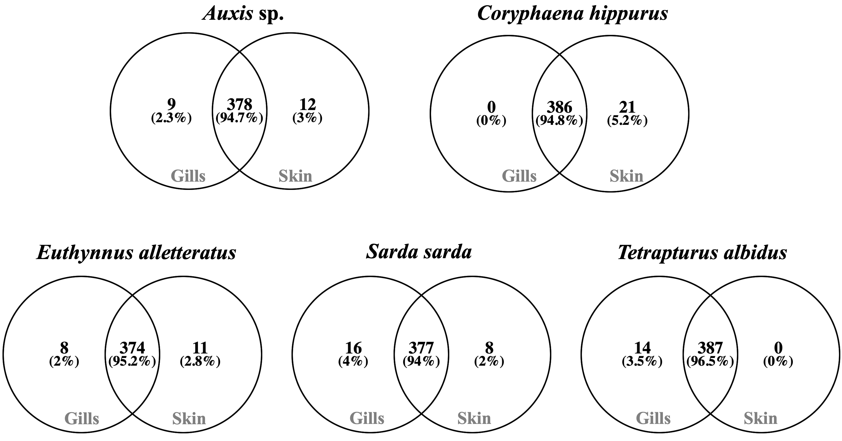

Figure S1. Overlap of the inferred bacterial metabolic pathways between the gills and skin tissues in each of five pelagic fishes from the Atlantic Ocean.

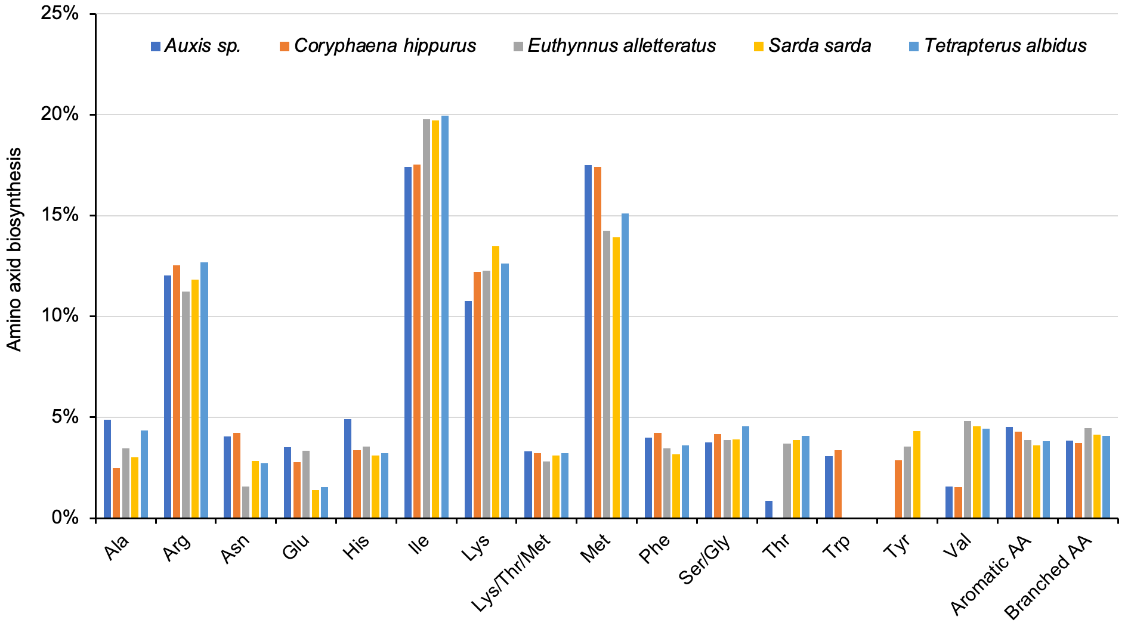

Figure S2. Relative contribution of the bacterial amino acid biosynthesis in the gills of five pelagic fishes from the Atlantic Ocean.

