Efficacy and Safety of Inclisiran, Alirocumab, Evolocumab, and Evinacumab in Lipid-Lowering: A Network Meta-Analysis
CARDIOVASCULAR DRUGS AND THERAPY
Lin Zhang, Bin Li, Wei Chen, Wei Li, Huayun Yang, Diguang Pan
Corresponding Author: Diguang Pan; Department of Cardiology, Guilin People’s Hospital, 12 Wenming Road, Guilin, Guangxi, China
E-mail: diguangpan1028@163.com

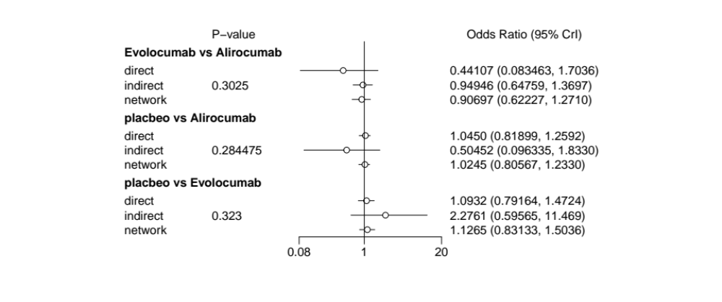
Fig. S1 Local inconsistency test

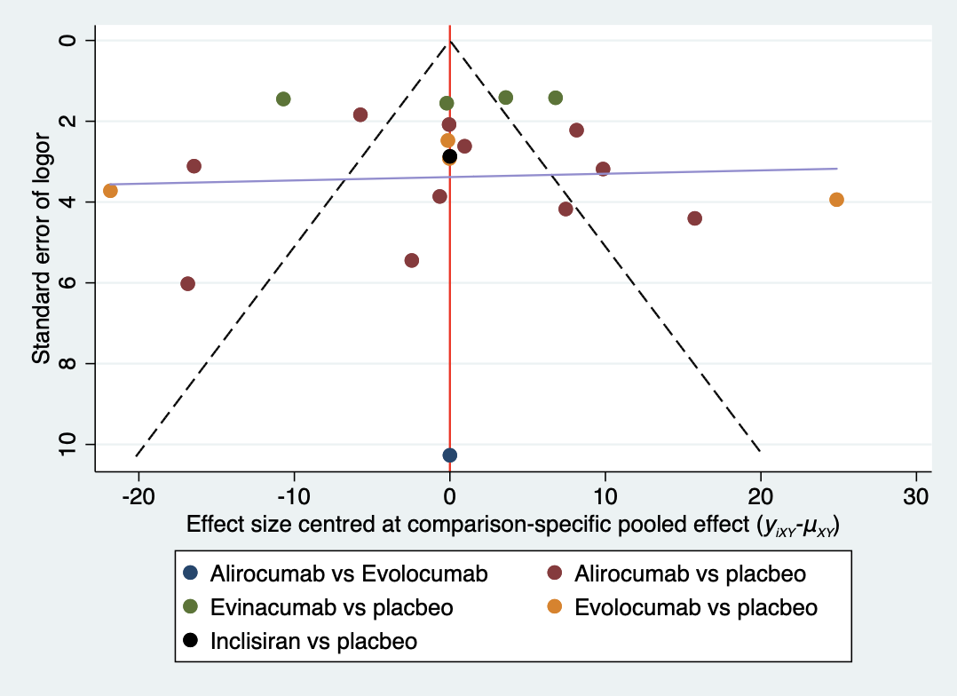
Fig. S2 Egger test of LDL-C

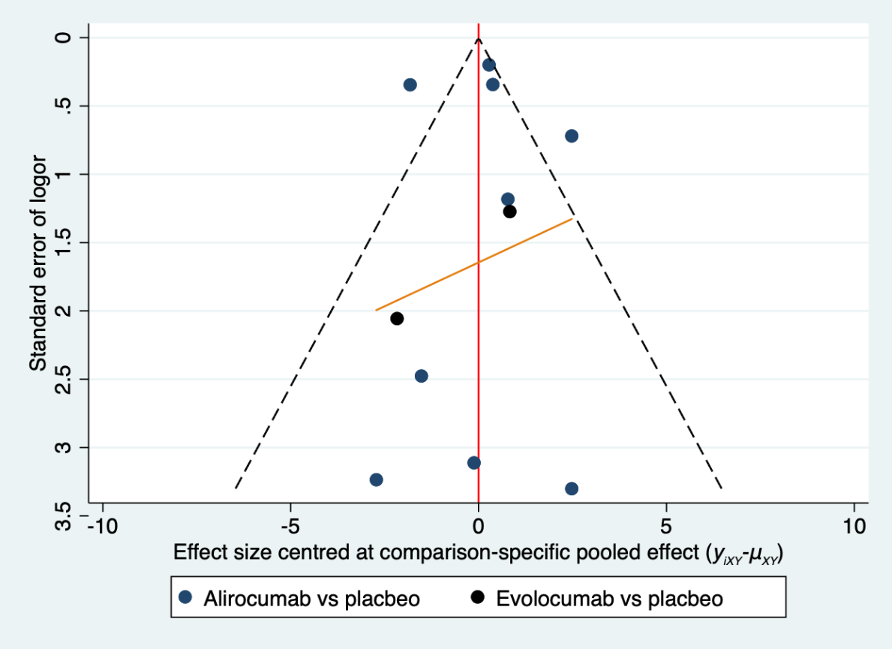
Fig. S3 Egger test of HDL-C

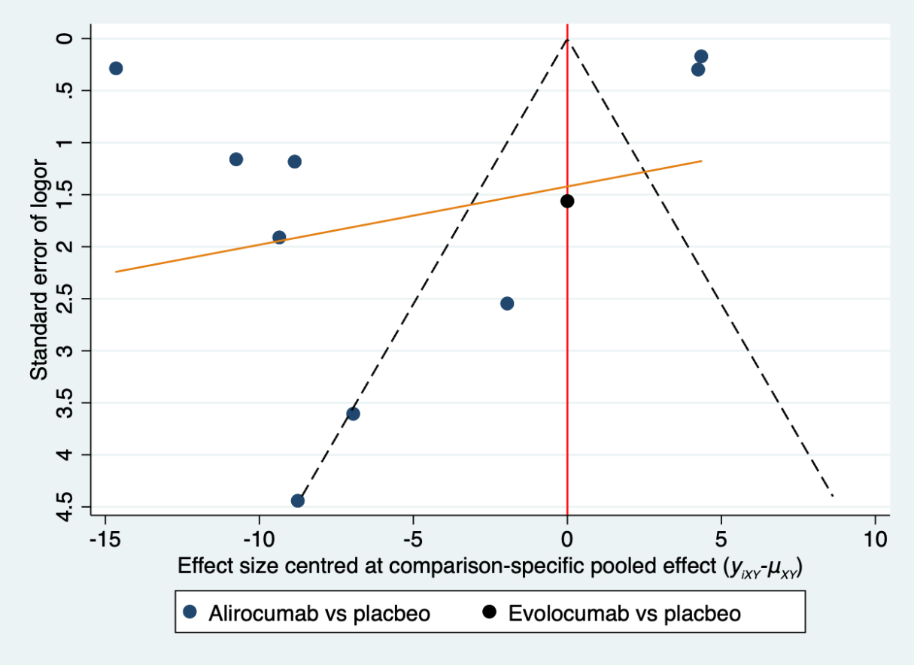
Fig. S4 Egger test of total cholesterol

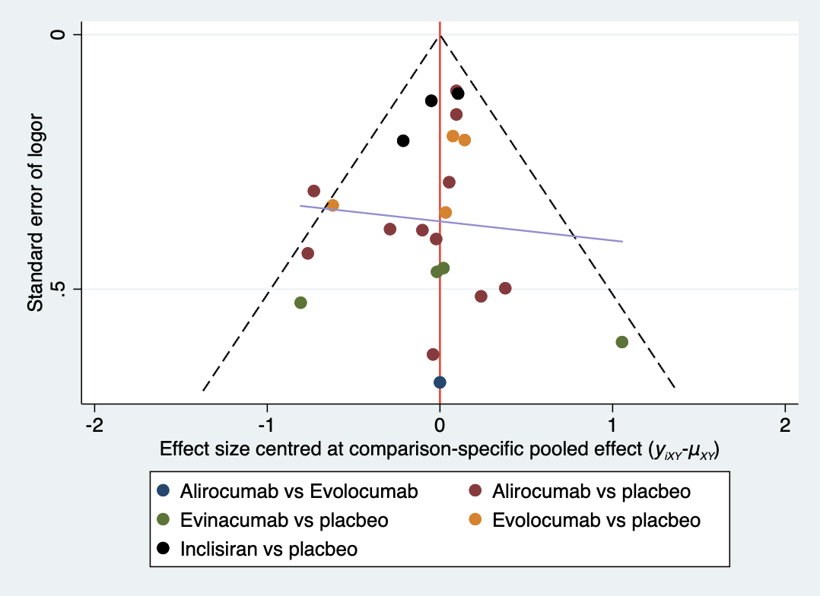
Fig. S5 Egger test of adverse event

