Annex II: The parameters used for sample size calculation under the nationally representative TB survey, China (Jan-June 2017)
We calculated sample size using the formula below.
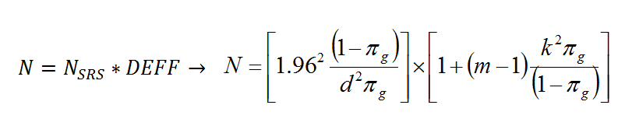
Parameter | Meaning | Value estimated in this study
 | Number of people included in the patient survey | 960
NSRS | Simple Random Sampling size | 220
DEFF | Design effect | 4.36
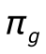 | “Prior guess” of the true proportion of patients experiencing diagnosis delay (expressed as a proportion) | 30%
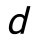 | Relative precision (expressed as a proportion). Recommended 0.20 or 0.25 | 0.2
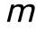 | Cluster size (=number of targeted individuals), assumed to be constant across clusters | 50
 | Coefficient of between-cluster variation. Recommended to assume is in the range 0.4 – 0.6 | 0.4

