BMC Biotechnology – Open Access
Supplemental Materials
Research Article:
Characterizing the Biopotency of Truncated Transgene Variants in rAAV viral vectors: Essential Considerations for Gene Therapy Applications
Christian Fiedler¹, Johannes Lengler², Bernadette Gruber², Marcus Scheindel¹, Carsten Büngener³, Dominik, Mittergradnegger¹, Marian Bendik², Barbara Kraus² and Juan A. Hernandez Bort²
¹Biotherapeutics Process Development Europe, Baxalta Innovations GmbH, a part of Takeda companies, Industriestrasse 131, 1221 Vienna, Austria
²Gene Therapy Process Development, Baxalta Innovations GmbH, a part of Takeda companies, Uferstraße 15, 2304 Orth an der Donau, Austria
³Analytical Development Europe, Baxalta Innovations GmbH, a part of Takeda companies, Benatzkygasse 2-8, 1221 Vienna, Austria

*Corresponding author: juan.hernandezbort@takeda.com

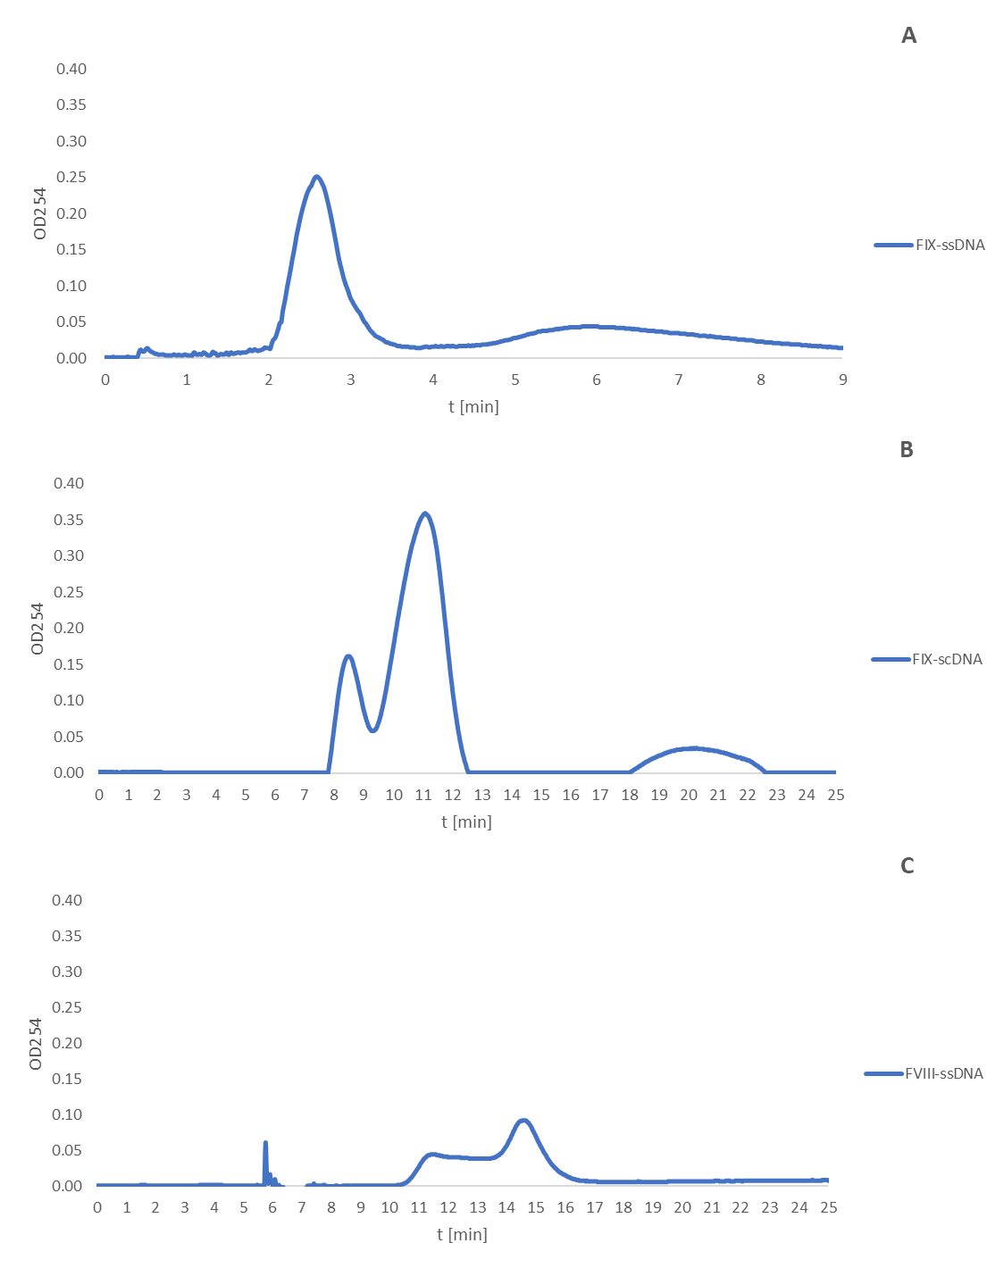
Suppl. Figure 1: Complete Elution Profile via Ultracentrifugation of rAAV8 Containing Various DNA Constructs: (a) FIX-ssDNA, (b) FIX-scDNA, and (c) FVIII-ssDNA. The elution characteristics were influenced by the specific DNA transgene configuration. The absorption at OD254 varied based on the quantity of material subjected to ultracentrifugation.

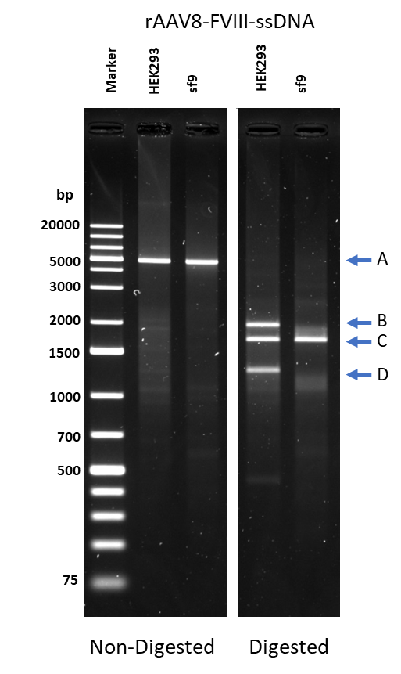
Suppl. Figure 2: Comparative Analysis of rAAV8-FVIII-ssDNA Produced in HEK293 Human Cells vs. Sf9 Baculovirus Insect Cells. The image illustrates an agarose gel with lanes displaying the molecular profiles of non-digested and restriction enzyme-digested samples.: The arrows represent: A - Genomic DNA, B - DNA containing 3' ITR, C - DNA containing transgene, D - DNA containing 5' ITR.

