Supporting Information
Oil well produced water pollutants photodegradation using an innovative double Z-scheme ternary heterostructure of MIL-101(Cr)/Fe₃O₄-SiO₂/nanorod-graphitic carbon nitride
Parisa Azmoon¹, Mehrdad Farhadian ^{1*}, Alireza Pendashteh^{2,3}, Shahram Tangestaninejad⁴
¹ Department of Chemical Engineering, Faculty of Engineering, University of Isfahan, Isfahan, Iran
² Department of Chemical Engineering, Faculty of Engineering, University of Guilan, Rasht, Iran
³ Department of Water and Environmental Engineering, Caspian Sea Basin Research Center, University of Guilan, Rasht, Iran
⁴ Department of Chemistry, Catalysis Division, University of Isfahan, Iran

* Corresponding authors:
Tel.: +98 313 793 7032; E-mail address: m.farhadian@eng.ui.ac.ir (Mehrdad Farhadian).

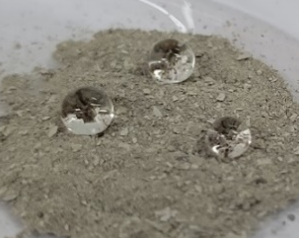
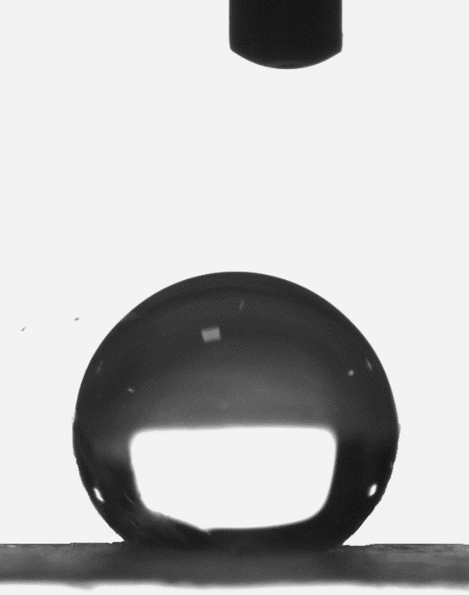
(a)
153.9 °
151.7 °
150.4 °
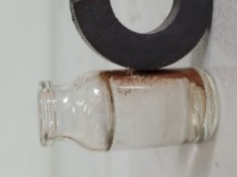
(b)
(c)
5.7
Fig. S1 a wettability of the ternary composite nanoparticles, b magnetic saturation values, and c point of zero charges (pH_{pzc}) of synthesized nanoparticles.

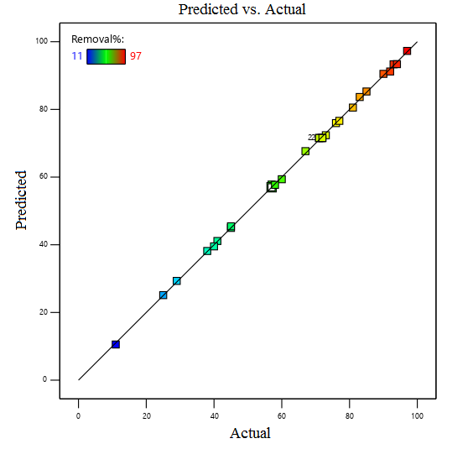  (b) | 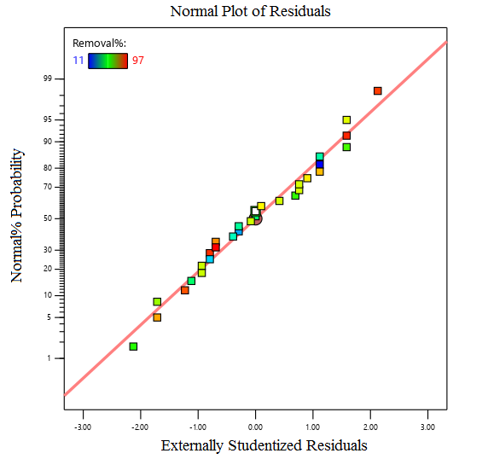  (a)
Fig. S2 Plots of a normal probability vs. residuals, and b predicted vs. actual values.
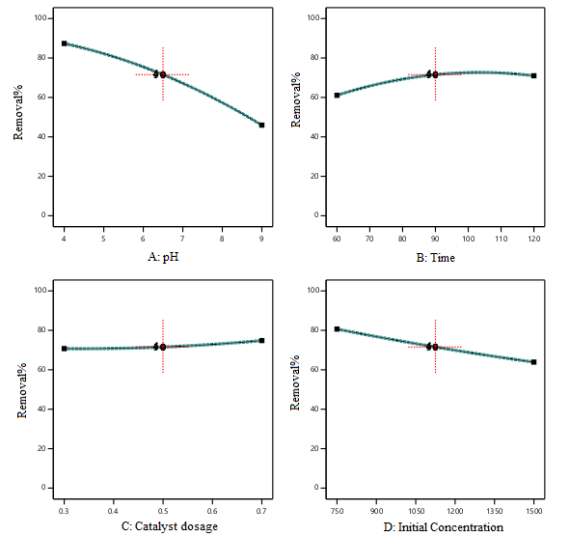
(d)
(c)
(a)
(b)
Fig. S3 2D plots of the effect of a pH, b illumination time, c catalyst dosage, and d pollutant initial concentration on the S-OPW removal efficiency.

Fig. S4 Real oilfield-produced water treatment by synthesized nanoparticles.
(a)
(b)
(c)
Fig. S5 a Pseudo-first-order, b pseudo-second-order, and c intraparticle diffusion kinetic models plots for S-OPW adsorption onto as-prepared nanoparticles.
(b)
(a)
(b) | (a)
Fig. S6 a Langmuir and b Freundlich isotherm plots for S-OPW adsorption onto as-prepared nanoparticles.

Fig. S7 Photocatalytic degradation kinetic of S-OPW by as-prepared nanoparticles.

 | S-OPW (Binak, Bushehr, Iran) (weight percentage) | R-OPW (Sarvak Azar Oilfield, Ilam, Iran) (weight percentage)
Saturated | 49.1 | 43.1
Aromatic | 32.3 | 33.8
Resin | 12.2 | 11.3
Asphaltene | 6.4 | 11.8
Table S1 Characterization of the crude oil in the real and synthetic produce water.

Source | Sum of Squares | df | Mean Square | F-value | p-value
Model | 14310.84 | 14 | 1022.2 | 2489.8 | < 0.0001 | significant
A-pH | 10292.04 | 1 | 10292.04 | 25068.57 | < 0.0001 | significant
B-Time | 590.04 | 1 | 590.04 | 1437.18 | < 0.0001 | significant
C-g | 100.04 | 1 | 100.04 | 243.67 | < 0.0001 | significant
D-C₀ | 1683.38 | 1 | 1683.38 | 4100.24 | < 0.0001 | significant
AB | 22.56 | 1 | 22.56 | 54.96 | < 0.0001 | significant
AC | 22.56 | 1 | 22.56 | 54.96 | < 0.0001 | significant
AD | 5.06 | 1 | 5.06 | 12.33 | 0.0031 | significant
BC | 1.56 | 1 | 1.56 | 3.81 | 0.07 | not significant
BD | 0.0625 | 1 | 0.0625 | 0.1522 | 0.7019 | not significant
CD | 14.06 | 1 | 14.06 | 34.25 | < 0.0001 | significant
A² | 658 | 1 | 658 | 1602.71 | < 0.0001 | significant
B² | 836.64 | 1 | 836.64 | 2037.83 | < 0.0001 | significant
C² | 41.3 | 1 | 41.3 | 100.6 | < 0.0001 | significant
D² | 14.5 | 1 | 14.5 | 35.32 | < 0.0001 | significant
Residual | 6.16 | 15 | 0.4106
Lack of Fit | 5.08 | 10 | 0.5083 | 2.36 | 0.1773 | not significant
Pure Error | 1.07 | 5 | 0.215
Table S2 ANOVA for Quadratic Model response for S-OPW using MIL-Cr/F@S/nr-GCN (20 wt%) ternary heterostructure.

Adsorbent | q_{e,exp} (mg/g) | Pseudo-first-order |  |  | Pseudo-second-order
Adsorbent | q_{e,exp} (mg/g) | q_{e} | k₁ | R² | q_{e} | k₂ | R²
nr-GCN | 904 | 281 | 0.0248 | 0.851 | 909 | 0.0004 | 0.9996
MIL-Cr/F@S-OA (35 wt%) | 1044 | 296 | 0.023 | 0.793 | 1250 | 0.0004 | 0.9998
MIL-Cr/F@S/nr-GCN-OA (20 wt%) | 1388 | 169 | 0.0191 | 0.644 | 1250 | 0.0007 | 0.9998
Table S3 Pseudo-first-order and Pseudo-second-order kinetic model constants for S-OPW adsorption onto as-prepared nanoparticles.

Adsorbent | Intraparticle-diffusion  (part-1) |  |  | Intraparticle-diffusion  (part-2)
Adsorbent | k_{p} | C | R² | k_{p} | C | R²
nr-GCN | 148.4 | 113.2 | 0.9127 | 7.5 | 803.3 | 0.997
MIL-Cr/F@S-OA (35 wt%) | 202.3 | 225.9 | 0.8313 | 8.61 | 1138.9 | 0.9899
MIL-Cr/F@S/nr-GCN-OA (20 wt%) | 200.4 | 324.2 | 0.7031 | 8.17 | 1161.2 | 0.9911
Table S4 Intraparticle-diffusion kinetic model constants for S-OPW adsorption onto as-prepared nanoparticles.

Adsorbent | q_{e,exp} | Langmuir |  |  | Freundlich
Adsorbent | q_{e,exp} | q_{max} | k₁ | R² | 1/n | k_{f} | R²
nr-GCN | 2070 | 2500 | 0.004 | 0.953 | 0.46 | 86.7 | 0.996
MIL-Cr/F@S-OA (35 wt%) | 2634 | 2500 | 0.0127 | 0.992 | 0.304 | 317.9 | 0.997
MIL-Cr/F@S/nr-GCN-OA (20 wt%) | 4220 | 5000 | 0.0116 | 0.931 | 0.407 | 328.9 | 0.979
Table S5 Isotherm study of S-OPW adsorption onto as-prepared nanoparticles.

