Supplementary Material
Non-linear elasticity, earthquake triggerring and seasonal hydrological forcing along the Irpinia fault, Southern Italy

Movie S1
Text 1 – Complete derivation of poroelastic equation [1]
Figure S1 – Velocity model, seismicity & depth sensivity kernel
Figure S2 – Strain sensitivity of velocity variation on raw series

Complete derivation of poroelastic equation [1]

We consider the following Cartesian system: $x=ENE$; $y=WSW$; $z=up$. Extensional stresses are considered positive. We write the poroelastic relations in a mixed-stiffnes formulation ¹:

$$\left[\begin{matrix}σ_{xx}+αP \\ σ_{yy}+αP \\ σ_{zz}+αP\end{matrix}\right]=\frac{E}{\left(1+ν\right)\left(1-2ν\right)}\left[\begin{matrix}1-ν & ν & ν \\ ν & 1-ν & ν \\ ν & ν & 1-ν\end{matrix}\right]\left[\begin{matrix}ε_{xx} \\ ε_{yy} \\ ε_{zz}\end{matrix}\right]$$

where $ν$ is the Poisson's ratio, $E$is the Young's modulus, $α$ is the Biot-Willis coefficient and $P$ is the pore pressure variation. Setting $ε_{yy}= ε_{zz}=0$:

$$σ_{xx}+αP=E\frac{ \left(1-ν\right)}{\left(1+ν\right)\left(1-2ν\right)}ε_{xx}$$

$$σ_{yy}+αP=E\frac{ν }{\left(1+ν\right)\left(1-2ν\right)}ε_{xx}$$

$$σ_{zz}+αP=E\frac{ ν}{\left(1+ν\right)\left(1-2ν\right)}ε_{xx}$$

and

$$ε_{xx}=\frac{ σ_{zz}+αP}{\frac{Eν}{\left(1+ν\right)\left(1-2ν\right)}}$$

Assuming that $σ_{zz}$ (overburden stress) does not change with time and that $P$ corresponds to a $∆h$ change in elevation of the unconfined karst aquifer's water table and a hydraulic head change of $ρ_{w}g∆h$:

$${∆ε}_{xx}=\frac{ αρ_{w}g∆h}{\frac{Eν}{\left(1+ν\right)\left(1-2ν\right)}}$$

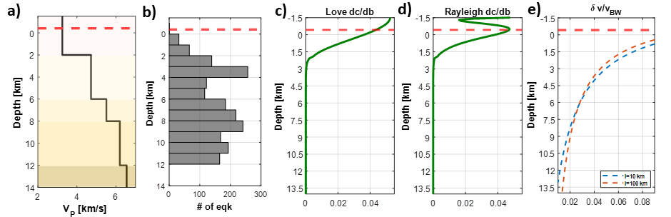
Figure S1 Velocity model, seismicity & depth sensivity kernel: Surface waves sensitivity kernel, dashed line represent the level of Caposele Spring (417 m a.s.l) :a) velocity model ² ; b) histogram of depth of earthquakes; c-d) Surface waves sensitivity kernel ³ ; e) Scattered body waves sensitivity kernel for coda wave time lapse 30 s for two different free paths : 10 km (blue dashed line) and 100 km (red dashed line).
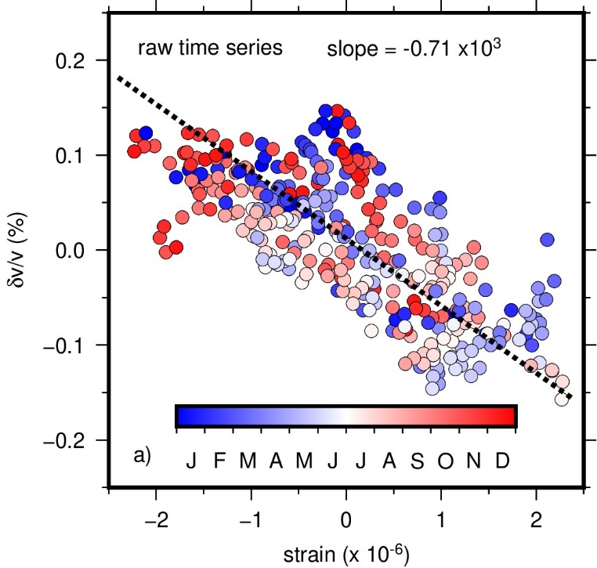
Figure S2: Strain sensitivity of velocity variation on raw series: velocity variations vs strain, color coded for the month, dashed black line represents the fit of the equation [1].

References
1. Wang, H. F. Theory of Linear Poroelasticity—with Applications to Geomechanics and Hydrogeology . (Princeton University Press, 2000).
2. Matrullo, E., De Matteis, R., Satriano, C., Amoroso, O. & Zollo, A. An improved 1-D seismic velocity model for seismological studies in the Campania–Lucania region (Southern Italy). Geophys J Int 195, 460–473 (2013).
3. Herrmann, R. B. Computer Programs in Seismology: An Evolving Tool for Instruction and Research. Seismological Research Letters 84, 1081–1088 (2013).

