Supporting Information
Ligand induced chirality in NEA₂BiBr₅ lead-free perovskite
- Materials: (R)-(+)-α-Methyl-1-naphthalenemethylamine(99%) and (S)-(-)-1-(1-Naphthyl)ethylamine(99%) were purchased from macklin. Hydrobromic acid（48wt%）were purchased from macklin. Bismuth oxide（99%）were purchased from macklin.
- Experimental Section
Synthesis of R/SNEA₂BiBr₅: Single crystals of RNEA₂BiBr₅, SNEA₂BiBr₅ were grown by dissolving a proper amount of Bi₂O₃ in a large excess of 48% wt% aqueous HBr, heating the mixture to 90°C. After the solid dissolution, the stoichiometric amount of the liquid amine R-/S-NEA was added. The crystals formation was obtained by a slow cooling down to room temperature at 5°C h⁻¹.
Morphology and Structural Characterizations: Single crystal X-ray diffraction (SCXRD) data were collected on a Agilent supernova diffractometer with Mo Kα radiation (λ = 0.71073 Å ) at 150 and 197 K. Using Olex2, the structure was solved with the XS structure solution program using Direct Methods and refined with the XL refinement package using Least Squares minimisation. Powder X-ray diffraction (PXRD) patterns were collected by a D/Max2500PC. UV-vis absorbance spectra were registered with a UV-vis spectrophotometer (UV 2600).FTIR spectra were registered with a Nicolet iS10. The linear circular dichroism (CD) spectra were collected using a JASCO J-1500 CD spectrometer in a transmission geometry,and the ratio of sample to KCl is 1:100.TG spectra were registered with a HITACHI STA200.
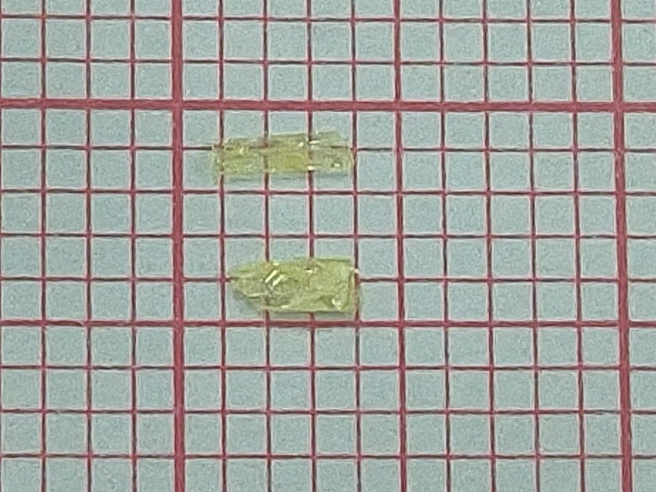
FigureS1.The photos of RNEA₂BiBr₅ andSNEA₂BiBr₅(from top to bottom).
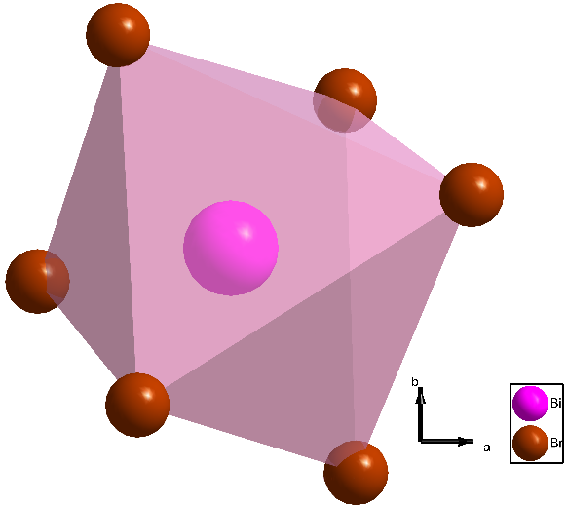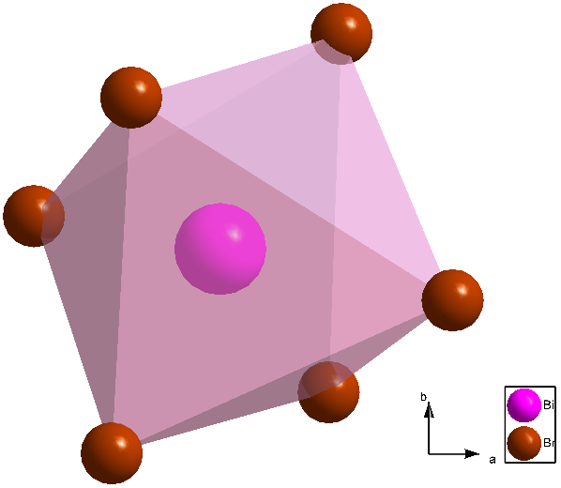\
FigureS2.The distorted [BiBr₆]³⁻ octahedron unit of RNEA₂BiBr₅.(left) and SNEA₂BiBr₅ (right).
RNEA₂BiBr₅ SNEA₂BiBr₅
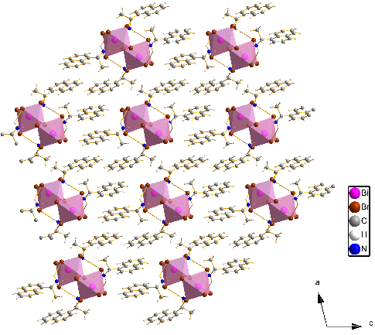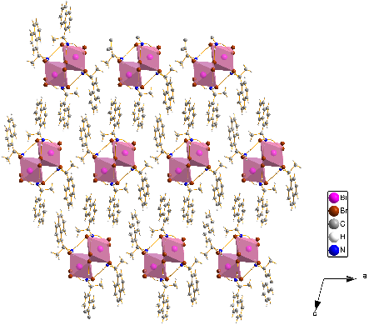
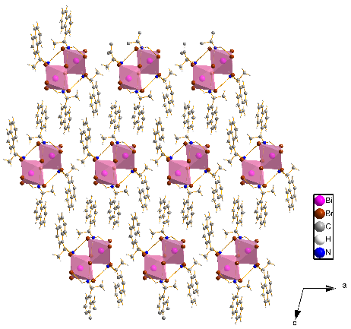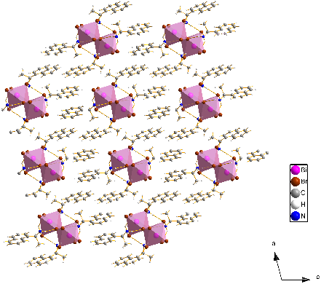
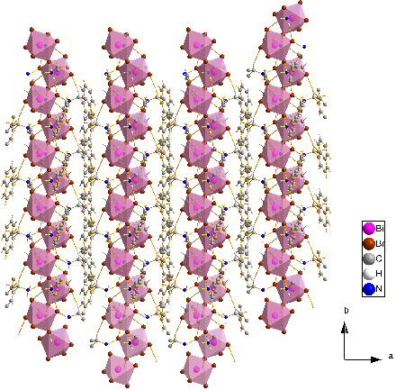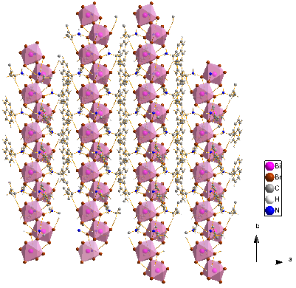
Figure S3. Two crystal structures of R/SNEA2BiBr5 observed from the three axes of abc.
Table 1 Crystal data and structure refinement for RNEA₂BiBr₅.
Identification code | RNEA₂BiBr₅
Empirical formula | C₂₄H₂₈N₂BiBr₅
Formula weight | 953.01
Temperature/K | 150.00(10)
Crystal system | monoclinic
Space group | P2₁
a/Å | 11.8438(5)
b/Å | 7.9001(4)
c/Å | 15.8023(7)
α/° | 90.00
β/° | 104.373(5)
γ/° | 90.00
Volume/Å³ | 1432.30(11)
Z | 2
ρ_{calc}g/cm³ | 2.210
μ/mm⁻¹ | 13.144
F(000) | 888.0
Crystal size/mm³ | 0.37 × 0.1 × 0.08
Radiation | Mo Kα (λ = 0.71073)
2Θ range for data collection/° | 7.1 to 51.34
Index ranges | -14 ≤ h ≤ 14, -9 ≤ k ≤ 9, -19 ≤ l ≤ 19
Reflections collected | 10434
Independent reflections | 5214 [R_{int} = 0.0393, R_{sigma} = 0.0608]
Data/restraints/parameters | 5214/1/293
Goodness-of-fit on F² | 1.014
Final R indexes [I>=2σ (I)] | R₁ = 0.0346, wR₂ = 0.0684
Final R indexes [all data] | R₁ = 0.0404, wR₂ = 0.0714
Largest diff. peak/hole / e Å⁻³ | 1.68/-1.38
Flack parameter | -0.040(8)

Table 2 Fractional Atomic Coordinates (×10⁴) and Equivalent Isotropic Displacement Parameters (Å²×10³) for RNEA₂BiBr₅. U_{eq} is defined as 1/3 of the trace of the orthogonalised U_{IJ} tensor.
Atom | x | y | z | U(eq)
Bi1 | 3891.2(3) | 1942.6(5) | 931.6(2) | 19.95(8)
Br1 | 3027.7(9) | -166.9(11) | 1940.8(7) | 32.1(2)
Br2 | 5051.2(8) | -1075.1(12) | 380.7(6) | 31.6(2)
Br3 | 6121.8(8) | 2657.9(11) | 2214.8(6) | 27.2(2)
Br4 | 2847.1(8) | 4802.1(11) | 1374.6(6) | 28.9(2)
Br5 | 2101.2(8) | 1494.9(12) | -530.7(7) | 35.6(3)
C1 | 6586(8) | 8546(11) | 4599(6) | 28(2)
C2 | 6925(8) | 10203(12) | 4460(6) | 32(2)
C3 | 7279(9) | 11291(13) | 5166(8) | 46(3)
C4 | 7343(10) | 10764(16) | 6018(8) | 54(3)
C5 | 7008(10) | 9143(15) | 6160(7) | 50(3)
C6 | 6644(8) | 7986(13) | 5463(6) | 32(2)
C7 | 6298(8) | 6336(13) | 5610(7) | 39(3)
C8 | 5927(8) | 5253(13) | 4924(7) | 36(2)
C9 | 5867(8) | 5782(12) | 4067(7) | 31(2)
C10 | 6205(7) | 7355(10) | 3886(6) | 22(2)
C11 | 6181(8) | 7942(12) | 2975(6) | 28(2)
C12 | 7401(8) | 7852(13) | 2783(7) | 38(2)
C13 | 9700(6) | 2010(14) | 2720(5) | 25.3(18)
C14 | 9435(8) | 3674(12) | 2892(6) | 31(2)
C15 | 9733(9) | 4314(14) | 3723(7) | 41(3)
C16 | 10318(9) | 3308(13) | 4431(7) | 40(3)
C17 | 10592(8) | 1671(14) | 4293(6) | 35(2)
C18 | 10287(8) | 976(12) | 3448(6) | 30(2)
C19 | 10576(8) | -709(12) | 3292(7) | 35(2)
C20 | 10311(8) | -1393(12) | 2477(8) | 43(3)
C21 | 9749(9) | -377(12) | 1770(7) | 37(2)
C22 | 9447(7) | 1241(11) | 1874(6) | 28(2)
C23 | 8853(7) | 2262(15) | 1080(6) | 35(3)
C24 | 9457(8) | 2269(15) | 343(7) | 45(3)
N1 | 7632(6) | 1642(16) | 725(5) | 58(3)
N2 | 5389(6) | 6856(12) | 2305(5) | 33.4(17)

Table 3 Anisotropic Displacement Parameters (Å²×10³) for RNEA₂BiBr₅. The Anisotropic displacement factor exponent takes the form: -2π²[h²a*²U₁₁+2hka*b*U₁₂+…].
Atom | U₁₁ | U₂₂ | U₃₃ | U₂₃ | U₁₃ | U₁₂
Bi1 | 19.66(15) | 24.80(16) | 16.12(16) | 0.68(16) | 5.80(11) | 0.46(16)
Br1 | 38.0(6) | 33.2(5) | 30.1(6) | 2.7(4) | 17.8(5) | -4.8(4)
Br2 | 36.3(6) | 37.4(6) | 21.4(5) | -2.5(4) | 8.0(4) | 12.6(5)
Br3 | 25.9(5) | 33.5(5) | 19.6(5) | -0.4(4) | 0.6(4) | -0.4(4)
Br4 | 31.2(5) | 29.5(5) | 26.5(6) | -1.4(4) | 8.3(4) | 6.2(4)
Br5 | 25.8(5) | 51.2(7) | 25.1(6) | -1.5(4) | -2.6(4) | -1.6(4)
C1 | 22(5) | 34(6) | 27(6) | -4(4) | 5(4) | 4(4)
C2 | 28(5) | 38(6) | 24(6) | -3(4) | -3(4) | 0(4)
C3 | 49(7) | 42(6) | 42(8) | -10(5) | 2(6) | -1(5)
C4 | 42(7) | 77(9) | 38(8) | -30(7) | 0(6) | -5(6)
C5 | 48(7) | 77(9) | 23(6) | -12(6) | 9(5) | -5(6)
C6 | 26(5) | 48(7) | 21(6) | -1(5) | 3(4) | 3(5)
C7 | 29(6) | 67(8) | 24(6) | 19(5) | 12(5) | 3(5)
C8 | 30(6) | 40(6) | 40(7) | 14(5) | 13(5) | -2(5)
C9 | 34(6) | 26(6) | 34(6) | -4(4) | 9(5) | -7(4)
C10 | 16(4) | 24(6) | 23(5) | -1(4) | 2(4) | 5(4)
C11 | 35(5) | 29(5) | 16(5) | -5(4) | -4(4) | -5(4)
C12 | 27(5) | 57(6) | 31(6) | 8(5) | 11(5) | -4(5)
C13 | 11(4) | 40(5) | 24(5) | 1(5) | 3(3) | -7(5)
C14 | 35(6) | 38(6) | 20(6) | 3(4) | 5(4) | 4(5)
C15 | 39(6) | 54(7) | 27(6) | -4(5) | 1(5) | 5(5)
C16 | 33(6) | 64(8) | 18(6) | -4(5) | -1(4) | -5(5)
C17 | 26(5) | 52(7) | 27(6) | 9(5) | 5(4) | 5(5)
C18 | 19(5) | 42(6) | 26(6) | 14(5) | 2(4) | -6(4)
C19 | 25(5) | 35(6) | 48(7) | 14(5) | 12(5) | 3(4)
C20 | 32(6) | 25(5) | 73(9) | 5(6) | 14(6) | 6(5)
C21 | 36(6) | 40(6) | 36(7) | -9(5) | 9(5) | -3(5)
C22 | 16(4) | 38(6) | 30(6) | 0(4) | 3(4) | -6(4)
C23 | 27(5) | 52(8) | 21(5) | 0(4) | -4(4) | 6(5)
C24 | 40(6) | 64(8) | 31(6) | 3(5) | 11(5) | 2(6)
N1 | 25(4) | 122(10) | 26(5) | -6(6) | 5(4) | 12(6)
N2 | 39(4) | 30(4) | 26(4) | 7(4) | -2(3) | 0(5)

Table 4 Bond Lengths for RNEA₂BiBr₅.
Atom | Atom | Length/Å |  | Atom | Atom | Length/Å
Bi1 | Br1 | 2.6788(9) |  | C10 | C11 | 1.507(12)
Bi1 | Br2¹ | 3.1002(9) |  | C11 | C12 | 1.550(12)
Bi1 | Br2 | 2.9871(9) |  | C11 | N2 | 1.497(11)
Bi1 | Br3 | 2.9582(10) |  | C13 | C14 | 1.394(14)
Bi1 | Br4 | 2.7481(9) |  | C13 | C18 | 1.441(12)
Bi1 | Br5 | 2.7435(10) |  | C13 | C22 | 1.431(12)
Br2 | Bi1² | 3.1002(9) |  | C14 | C15 | 1.368(13)
C1 | C2 | 1.403(13) |  | C15 | C16 | 1.406(13)
C1 | C6 | 1.421(13) |  | C16 | C17 | 1.364(14)
C1 | C10 | 1.451(12) |  | C17 | C18 | 1.407(13)
C2 | C3 | 1.388(13) |  | C18 | C19 | 1.411(13)
C3 | C4 | 1.394(16) |  | C19 | C20 | 1.360(14)
C4 | C5 | 1.375(16) |  | C20 | C21 | 1.402(14)
C5 | C6 | 1.413(14) |  | C21 | C22 | 1.349(12)
C6 | C7 | 1.403(13) |  | C22 | C23 | 1.510(13)
C7 | C8 | 1.365(14) |  | C23 | C24 | 1.510(12)
C8 | C9 | 1.403(13) |  | C23 | N1 | 1.498(11)
C9 | C10 | 1.357(13)
¹1-X,1/2+Y,-Z; ²1-X,-1/2+Y,-Z

Table 5 Bond Angles for RNEA₂BiBr₅.
Atom | Atom | Atom | Angle/˚ |  | Atom | Atom | Atom | Angle/˚
Br1 | Bi1 | Br2¹ | 171.81(3) |  | C7 | C8 | C9 | 120.6(9)
Br1 | Bi1 | Br2 | 87.03(3) |  | C10 | C9 | C8 | 121.9(10)
Br1 | Bi1 | Br3 | 96.82(3) |  | C1 | C10 | C11 | 118.1(8)
Br1 | Bi1 | Br4 | 95.59(3) |  | C9 | C10 | C1 | 118.8(8)
Br1 | Bi1 | Br5 | 95.27(3) |  | C9 | C10 | C11 | 123.1(8)
Br2 | Bi1 | Br2¹ | 85.225(11) |  | C10 | C11 | C12 | 112.0(7)
Br3 | Bi1 | Br2¹ | 85.50(3) |  | N2 | C11 | C10 | 111.1(7)
Br3 | Bi1 | Br2 | 87.43(3) |  | N2 | C11 | C12 | 106.7(8)
Br4 | Bi1 | Br2¹ | 92.13(3) |  | C14 | C13 | C18 | 117.8(8)
Br4 | Bi1 | Br2 | 177.31(3) |  | C14 | C13 | C22 | 125.3(9)
Br4 | Bi1 | Br3 | 92.87(3) |  | C22 | C13 | C18 | 116.9(10)
Br5 | Bi1 | Br2¹ | 81.82(3) |  | C15 | C14 | C13 | 121.3(9)
Br5 | Bi1 | Br2 | 88.10(3) |  | C14 | C15 | C16 | 120.9(10)
Br5 | Bi1 | Br3 | 166.87(3) |  | C17 | C16 | C15 | 119.9(10)
Br5 | Bi1 | Br4 | 91.03(3) |  | C16 | C17 | C18 | 120.4(9)
Bi1 | Br2 | Bi1² | 152.82(4) |  | C17 | C18 | C13 | 119.7(9)
C2 | C1 | C6 | 119.6(9) |  | C17 | C18 | C19 | 121.2(9)
C2 | C1 | C10 | 122.0(9) |  | C19 | C18 | C13 | 119.1(10)
C6 | C1 | C10 | 118.4(9) |  | C20 | C19 | C18 | 122.1(10)
C3 | C2 | C1 | 119.5(10) |  | C19 | C20 | C21 | 118.7(9)
C2 | C3 | C4 | 121.6(10) |  | C22 | C21 | C20 | 122.2(10)
C5 | C4 | C3 | 119.1(10) |  | C13 | C22 | C23 | 119.7(9)
C4 | C5 | C6 | 121.3(11) |  | C21 | C22 | C13 | 121.1(9)
C5 | C6 | C1 | 118.7(10) |  | C21 | C22 | C23 | 119.2(9)
C7 | C6 | C1 | 120.2(10) |  | C24 | C23 | C22 | 115.5(8)
C7 | C6 | C5 | 121.1(10) |  | N1 | C23 | C22 | 110.1(8)
C8 | C7 | C6 | 120.0(9) |  | N1 | C23 | C24 | 108.1(8)
¹1-X,1/2+Y,-Z; ²1-X,-1/2+Y,-Z

Table 6 Hydrogen Bonds for RNEA₂BiBr₅.
D | H | A | d(D-H)/Å | d(H-A)/Å | d(D-A)/Å | D-H-A/°
N1 | H1B | Br3 | 0.91 | 2.50 | 3.387(8) | 166.6
N2 | H2A | Br3 | 0.91 | 2.54 | 3.440(9) | 169.1

Table 7 Torsion Angles for RNEA₂BiBr₅.
A | B | C | D | Angle/˚ |  | A | B | C | D | Angle/˚
Br1 | Bi1 | Br2 | Bi1¹ | 153.24(9) |  | C10 | C1 | C6 | C5 | -179.7(8)
Br2² | Bi1 | Br2 | Bi1¹ | -24.09(7) |  | C10 | C1 | C6 | C7 | -2.3(14)
Br3 | Bi1 | Br2 | Bi1¹ | -109.79(8) |  | C13 | C14 | C15 | C16 | 0.0(15)
Br4 | Bi1 | Br2 | Bi1¹ | -13.3(7) |  | C13 | C18 | C19 | C20 | -0.4(13)
Br5 | Bi1 | Br2 | Bi1¹ | 57.86(8) |  | C13 | C22 | C23 | C24 | 127.4(9)
C1 | C2 | C3 | C4 | 2.1(16) |  | C13 | C22 | C23 | N1 | -109.8(9)
C1 | C6 | C7 | C8 | 1.4(14) |  | C14 | C13 | C18 | C17 | -1.2(12)
C1 | C10 | C11 | C12 | 81.5(10) |  | C14 | C13 | C18 | C19 | -179.4(8)
C1 | C10 | C11 | N2 | -159.3(7) |  | C14 | C13 | C22 | C21 | 179.3(9)
C2 | C1 | C6 | C5 | 2.1(14) |  | C14 | C13 | C22 | C23 | 0.4(12)
C2 | C1 | C6 | C7 | 179.5(9) |  | C14 | C15 | C16 | C17 | -0.2(16)
C2 | C1 | C10 | C9 | -178.7(8) |  | C15 | C16 | C17 | C18 | -0.4(15)
C2 | C1 | C10 | C11 | 0.0(13) |  | C16 | C17 | C18 | C13 | 1.1(13)
C2 | C3 | C4 | C5 | -2.3(17) |  | C16 | C17 | C18 | C19 | 179.2(9)
C3 | C4 | C5 | C6 | 2.5(17) |  | C17 | C18 | C19 | C20 | -178.6(9)
C4 | C5 | C6 | C1 | -2.4(16) |  | C18 | C13 | C14 | C15 | 0.7(13)
C4 | C5 | C6 | C7 | -179.7(10) |  | C18 | C13 | C22 | C21 | 0.0(12)
C5 | C6 | C7 | C8 | 178.7(10) |  | C18 | C13 | C22 | C23 | -178.8(7)
C6 | C1 | C2 | C3 | -2.0(14) |  | C18 | C19 | C20 | C21 | 1.0(14)
C6 | C1 | C10 | C9 | 3.2(13) |  | C19 | C20 | C21 | C22 | -1.1(15)
C6 | C1 | C10 | C11 | -178.2(8) |  | C20 | C21 | C22 | C13 | 0.6(14)
C6 | C7 | C8 | C9 | -1.2(15) |  | C20 | C21 | C22 | C23 | 179.4(8)
C7 | C8 | C9 | C10 | 2.2(15) |  | C21 | C22 | C23 | C24 | -51.4(12)
C8 | C9 | C10 | C1 | -3.1(13) |  | C21 | C22 | C23 | N1 | 71.3(11)
C8 | C9 | C10 | C11 | 178.3(9) |  | C22 | C13 | C14 | C15 | -178.5(9)
C9 | C10 | C11 | C12 | -99.9(10) |  | C22 | C13 | C18 | C17 | 178.1(8)
C9 | C10 | C11 | N2 | 19.3(12) |  | C22 | C13 | C18 | C19 | -0.1(11)
C10 | C1 | C2 | C3 | 179.9(8)
¹1-X,-1/2+Y,-Z; ²1-X,1/2+Y,-Z

Table 8 Hydrogen Atom Coordinates (Å×10⁴) and Isotropic Displacement Parameters (Å²×10³) for RNEA₂BiBr₅.
Atom | x | y | z | U(eq)
H2 | 6912 | 10578 | 3886 | 38
H3 | 7484 | 12423 | 5065 | 55
H4 | 7615 | 11514 | 6495 | 65
H5 | 7021 | 8794 | 6737 | 59
H7 | 6322 | 5972 | 6188 | 47
H8 | 5708 | 4130 | 5029 | 43
H9 | 5580 | 5017 | 3599 | 37
H11 | 5895 | 9137 | 2902 | 34
H12A | 7684 | 6683 | 2850 | 57
H12B | 7943 | 8583 | 3194 | 57
H12C | 7346 | 8235 | 2185 | 57
H14 | 9040 | 4377 | 2424 | 38
H15 | 9543 | 5452 | 3822 | 50
H16 | 10522 | 3769 | 5004 | 48
H17 | 10991 | 996 | 4772 | 42
H19 | 10968 | -1386 | 3772 | 43
H20 | 10502 | -2536 | 2389 | 52
H21 | 9574 | -846 | 1198 | 45
H23 | 8807 | 3461 | 1272 | 42
H24A | 9454 | 1121 | 107 | 67
H24B | 10262 | 2655 | 563 | 67
H24C | 9044 | 3034 | -119 | 67
H1A | 7274 | 2284 | 258 | 87
H1B | 7232 | 1722 | 1147 | 87
H1C | 7648 | 543 | 556 | 87
H2A | 5676 | 5783 | 2339 | 50
H2B | 5344 | 7283 | 1763 | 50
H2C | 4666 | 6843 | 2408 | 50

Table S9 Crystal data and structure refinement for SNEA₂BiBr₅
Identification code | SNEA₂BiBr₅
Empirical formula | C₂₄H₂₈N₂BiBr₅
Formula weight | 953.01
Temperature/K | 197(30)
Crystal system | monoclinic
Space group | P2₁
a/Å | 11.8780(4)
b/Å | 7.9257(2)
c/Å | 15.8128(5)
α/° | 90.00
β/° | 104.541(3)
γ/° | 90.00
Volume/Å³ | 1440.96(8)
Z | 2
ρ_{calc}mg/mm³ | 2.196
m/mm⁻¹ | 13.065
F(000) | 888.0
Crystal size/mm³ | 0.41 × 0.1 × 0.08
2Θ range for data collection | 6.92 to 51.36°
Index ranges | -14 ≤ h ≤ 14, -9 ≤ k ≤ 9, -19 ≤ l ≤ 18
Reflections collected | 9561
Independent reflections | 4897[R(int) = 0.0460]
Data/restraints/parameters | 4897/1/293
Goodness-of-fit on F² | 1.027
Final R indexes [I>=2σ (I)] | R₁ = 0.0585, wR₂ = 0.1417
Final R indexes [all data] | R₁ = 0.0637, wR₂ = 0.1482
Largest diff. peak/hole / e Å⁻³ | 2.30/-2.66
Flack parameter | -0.067(13)

Table S10 Fractional Atomic Coordinates (×10⁴) and Equivalent Isotropic Displacement Parameters (Å²×10³) for SNEA₂BiBr₅. U_{eq} is defined as 1/3 of of the trace of the orthogonalised U_{IJ} tensor.
Atom | x | y | z | U(eq)
Bi1 | 3896.8(2) | 2383.6(4) | 930.46(15) | 19.19(6)
Br2 | 2853.3(8) | -466.4(10) | 1373.4(5) | 29.8(2)
Br5 | 6129.4(7) | 1667.4(11) | 2215.3(5) | 27.7(2)
Br1 | 3040.5(8) | 4496.5(11) | 1938.6(6) | 33.6(2)
Br4 | 4938.2(8) | 385.4(11) | -378.5(5) | 32.5(2)
Br3 | 2104.9(7) | 2842.4(12) | -536.2(6) | 37.3(3)
C19 | -577(7) | 10046(12) | 6709(6) | 36(2)
C17 | -590(7) | 7649(13) | 5710(6) | 39(3)
C6 | 6197(6) | 6960(10) | 3883(5) | 22(2)
C16 | -326(9) | 6059(13) | 5566(5) | 41(3)
C9 | 6928(8) | 4108(12) | 4473(5) | 35(3)
C23 | 1128(6) | 7034(11) | 8926(5) | 31(3)
C24 | 527(8) | 7069(17) | 9658(6) | 56(3)
C12 | 7012(8) | 5219(14) | 6174(6) | 43(3)
C22 | 551(7) | 8095(11) | 8143(6) | 28(2)
C18 | -282(7) | 8384(11) | 6563(6) | 30(2)
C14 | 579(8) | 5675(12) | 7112(6) | 36(2)
C10 | 7295(9) | 3040(13) | 5179(7) | 47(3)
C4 | 6644(8) | 6364(13) | 5474(6) | 37(3)
C20 | -314(8) | 10746(13) | 7510(7) | 46(3)
C5 | 6571(7) | 5795(12) | 4589(5) | 28(2)
N1 | 2361(6) | 7639(16) | 9256(5) | 63(3)
C8 | 7412(7) | 6452(13) | 2800(5) | 35(2)
C21 | 230(7) | 9730(12) | 8249(6) | 36(2)
C15 | 262(9) | 5045(15) | 6250(6) | 45(3)
C11 | 7332(9) | 3619(16) | 6034(7) | 59(3)
C1 | 5865(8) | 8530(12) | 4071(5) | 32(2)
N2 | 5399(6) | 7484(11) | 2294(4) | 38(2)
C13 | 283(6) | 7353(13) | 7274(5) | 24.8(18)
C7 | 6193(7) | 6398(10) | 2970(5) | 25(2)
C2 | 5921(9) | 9088(14) | 4920(6) | 44(3)
C3 | 6278(8) | 7995(14) | 5594(6) | 47(3)

Table S11 Anisotropic Displacement Parameters (Å²×10³) for SNEA₂BiBr₅. The Anisotropic displacement factor exponent takes the form: -2π²[h²a*²U₁₁+...+2hka×b×U₁₂]
Atom | U₁₁ | U₂₂ | U₃₃ | U₂₃ | U₁₃ | U₁₂
Bi1 | 20.81(11) | 22.09(12) | 16.32(11) | -0.77(11) | 7.76(9) | -0.60(12)
Br2 | 35.7(4) | 26.6(4) | 28.9(4) | 1.8(3) | 11.3(3) | -8.7(3)
Br5 | 28.0(4) | 33.2(4) | 19.9(3) | 0.4(3) | 2.4(3) | -0.3(3)
Br1 | 42.6(4) | 32.0(4) | 32.4(4) | -4.6(3) | 20.8(3) | 6.2(4)
Br4 | 40.3(4) | 36.1(5) | 22.5(4) | -4.3(3) | 10.6(3) | 13.3(4)
Br3 | 27.4(4) | 52.1(6) | 28.1(4) | 1.2(4) | -0.9(3) | 2.3(4)
C19 | 30(4) | 31(5) | 52(5) | 23(4) | 19(4) | 11(4)
C17 | 36(4) | 50(6) | 32(4) | 19(4) | 11(3) | 5(4)
C6 | 14(3) | 26(5) | 25(3) | 2(3) | 2(3) | 9(3)
C16 | 47(5) | 62(6) | 12(4) | -9(4) | 4(4) | -6(5)
C9 | 38(5) | 46(5) | 18(4) | 3(4) | -1(4) | -10(4)
C23 | 22(4) | 31(6) | 35(4) | -5(3) | -1(3) | 8(3)
C24 | 45(5) | 94(9) | 33(4) | 4(6) | 14(4) | -17(6)
C12 | 41(5) | 64(7) | 26(4) | 10(4) | 12(4) | 11(5)
C22 | 18(3) | 34(4) | 34(4) | -8(4) | 6(3) | -5(3)
C18 | 17(3) | 41(5) | 35(4) | 19(4) | 11(3) | -3(4)
C14 | 32(4) | 35(5) | 38(5) | -10(4) | 5(4) | 5(4)
C10 | 50(6) | 29(5) | 57(6) | 11(4) | 5(5) | 7(4)
C4 | 34(4) | 48(6) | 31(4) | 4(4) | 11(4) | 1(4)
C20 | 35(5) | 28(5) | 73(7) | 6(5) | 9(5) | 9(4)
C5 | 20(4) | 36(5) | 28(4) | 2(4) | 5(3) | -10(3)
N1 | 20(3) | 141(9) | 26(4) | -27(5) | 4(3) | -8(5)
C8 | 36(4) | 50(6) | 24(4) | 3(4) | 16(3) | 5(4)
C21 | 24(4) | 40(5) | 48(5) | -19(4) | 16(4) | -9(4)
C15 | 48(6) | 53(6) | 31(5) | -8(4) | 3(4) | 1(5)
C11 | 45(6) | 90(8) | 39(5) | 38(5) | 7(5) | 13(6)
C1 | 30(4) | 43(5) | 19(4) | 2(3) | 2(3) | 9(4)
N2 | 49(4) | 34(4) | 30(3) | -3(4) | 5(3) | 5(4)
C13 | 15(3) | 32(4) | 28(3) | 0(4) | 5(3) | -4(4)
C7 | 31(4) | 17(4) | 26(4) | 6(3) | 5(3) | 1(3)
C2 | 60(6) | 45(5) | 32(4) | -7(4) | 21(4) | 9(5)
C3 | 40(5) | 79(8) | 27(4) | -15(4) | 18(4) | 11(5)

Table S12 Bond Lengths for SNEA₂BiBr₅.
Atom | Atom | Length/Å |  | Atom | Atom | Length/Å
Bi1 | Br2 | 2.7505(9) |  | C23 | C22 | 1.512(12)
Bi1 | Br5 | 2.9626(8) |  | C23 | N1 | 1.504(10)
Bi1 | Br1 | 2.6823(10) |  | C12 | C4 | 1.413(13)
Bi1 | Br4¹ | 2.9906(9) |  | C12 | C11 | 1.357(17)
Bi1 | Br4 | 3.0996(9) |  | C22 | C21 | 1.373(12)
Bi1 | Br3 | 2.7500(8) |  | C22 | C13 | 1.454(11)
Br4 | Bi1² | 2.9906(9) |  | C18 | C13 | 1.415(11)
C19 | C18 | 1.397(13) |  | C14 | C15 | 1.411(13)
C19 | C20 | 1.346(14) |  | C14 | C13 | 1.416(14)
C17 | C16 | 1.332(14) |  | C10 | C11 | 1.418(16)
C17 | C18 | 1.430(12) |  | C4 | C5 | 1.452(13)
C6 | C5 | 1.431(11) |  | C4 | C3 | 1.392(15)
C6 | C1 | 1.361(12) |  | C20 | C21 | 1.433(14)
C6 | C7 | 1.509(12) |  | C8 | C7 | 1.538(13)
C16 | C15 | 1.387(13) |  | C1 | C2 | 1.399(13)
C9 | C10 | 1.381(14) |  | N2 | C7 | 1.506(10)
C9 | C5 | 1.429(14) |  | C2 | C3 | 1.356(14)
C23 | C24 | 1.505(13)
¹1-X,1/2+Y,-Z; ²1-X,-1/2+Y,-Z

Table S13 Bond Angles for SNEA₂BiBr₅.
Atom | Atom | Atom | Angle/˚ |  | Atom | Atom | Atom | Angle/˚
Br2 | Bi1 | Br5 | 92.92(2) |  | C21 | C22 | C23 | 120.5(8)
Br2 | Bi1 | Br4 | 91.80(3) |  | C21 | C22 | C13 | 119.7(8)
Br2 | Bi1 | Br4¹ | 177.18(3) |  | C13 | C22 | C23 | 119.8(8)
Br5 | Bi1 | Br4 | 85.50(2) |  | C19 | C18 | C17 | 121.6(8)
Br5 | Bi1 | Br4¹ | 87.28(2) |  | C19 | C18 | C13 | 120.1(8)
Br1 | Bi1 | Br2 | 95.68(3) |  | C13 | C18 | C17 | 118.2(8)
Br1 | Bi1 | Br5 | 96.88(3) |  | C15 | C14 | C13 | 119.3(8)
Br1 | Bi1 | Br4 | 172.02(3) |  | C9 | C10 | C11 | 120.0(10)
Br1 | Bi1 | Br4¹ | 87.08(3) |  | C12 | C4 | C5 | 119.2(9)
Br1 | Bi1 | Br3 | 95.16(3) |  | C3 | C4 | C12 | 122.3(9)
Br4¹ | Bi1 | Br4 | 85.418(10) |  | C3 | C4 | C5 | 118.4(8)
Br3 | Bi1 | Br2 | 91.18(3) |  | C19 | C20 | C21 | 119.1(9)
Br3 | Bi1 | Br5 | 166.83(3) |  | C6 | C5 | C4 | 118.9(8)
Br3 | Bi1 | Br4 | 81.87(3) |  | C9 | C5 | C6 | 123.3(8)
Br3 | Bi1 | Br4¹ | 88.03(3) |  | C9 | C5 | C4 | 117.8(8)
Bi1² | Br4 | Bi1 | 153.23(3) |  | C22 | C21 | C20 | 120.9(9)
C20 | C19 | C18 | 122.4(8) |  | C16 | C15 | C14 | 120.5(10)
C16 | C17 | C18 | 122.1(8) |  | C12 | C11 | C10 | 121.0(10)
C5 | C6 | C7 | 118.8(7) |  | C6 | C1 | C2 | 123.6(8)
C1 | C6 | C5 | 118.0(8) |  | C18 | C13 | C22 | 117.7(9)
C1 | C6 | C7 | 123.2(7) |  | C18 | C13 | C14 | 119.2(8)
C17 | C16 | C15 | 120.6(8) |  | C14 | C13 | C22 | 123.1(7)
C10 | C9 | C5 | 120.9(9) |  | C6 | C7 | C8 | 112.5(6)
C24 | C23 | C22 | 114.5(7) |  | N2 | C7 | C6 | 111.2(7)
N1 | C23 | C24 | 109.7(7) |  | N2 | C7 | C8 | 108.0(7)
N1 | C23 | C22 | 108.0(8) |  | C3 | C2 | C1 | 118.8(10)
C11 | C12 | C4 | 121.1(9) |  | C2 | C3 | C4 | 122.2(9)
¹1-X,1/2+Y,-Z; ²1-X,-1/2+Y,-Z

Table S14 Torsion Angles for SNEA₂BiBr₅.
A | B | C | D | Angle/˚ |  | A | B | C | D | Angle/˚
Br2 | Bi1 | Br4 | Bi1¹ | -41.75(7) |  | C20 | C19 | C18 | C17 | 178.6(9)
Br5 | Bi1 | Br4 | Bi1¹ | 51.05(7) |  | C20 | C19 | C18 | C13 | 1.9(14)
Br1 | Bi1 | Br4 | Bi1¹ | 158.70(15) |  | C5 | C6 | C1 | C2 | 3.1(13)
Br4² | Bi1 | Br4 | Bi1¹ | 138.67(8) |  | C5 | C6 | C7 | C8 | -79.3(9)
Br3 | Bi1 | Br4 | Bi1¹ | -132.68(7) |  | C5 | C6 | C7 | N2 | 159.5(7)
C19 | C18 | C13 | C22 | -0.8(12) |  | C5 | C9 | C10 | C11 | -0.6(15)
C19 | C18 | C13 | C14 | -179.7(8) |  | C5 | C4 | C3 | C2 | -3.8(15)
C19 | C20 | C21 | C22 | 4.1(15) |  | N1 | C23 | C22 | C21 | -74.1(10)
C17 | C16 | C15 | C14 | 0.7(16) |  | N1 | C23 | C22 | C13 | 108.8(9)
C17 | C18 | C13 | C22 | -177.7(8) |  | C21 | C22 | C13 | C18 | 1.5(12)
C17 | C18 | C13 | C14 | 3.5(12) |  | C21 | C22 | C13 | C14 | -179.7(8)
C6 | C1 | C2 | C3 | -2.9(16) |  | C15 | C14 | C13 | C22 | 178.6(9)
C16 | C17 | C18 | C19 | -179.2(9) |  | C15 | C14 | C13 | C18 | -2.6(13)
C16 | C17 | C18 | C13 | -2.4(13) |  | C11 | C12 | C4 | C5 | 2.0(15)
C9 | C10 | C11 | C12 | -0.1(17) |  | C11 | C12 | C4 | C3 | 178.0(10)
C23 | C22 | C21 | C20 | 179.8(8) |  | C1 | C6 | C5 | C9 | 179.3(8)
C23 | C22 | C13 | C18 | 178.6(7) |  | C1 | C6 | C5 | C4 | -3.5(12)
C23 | C22 | C13 | C14 | -2.6(12) |  | C1 | C6 | C7 | C8 | 100.5(9)
C24 | C23 | C22 | C21 | 48.3(11) |  | C1 | C6 | C7 | N2 | -20.8(11)
C24 | C23 | C22 | C13 | -128.7(9) |  | C1 | C2 | C3 | C4 | 3.2(16)
C12 | C4 | C5 | C6 | 180.0(8) |  | C13 | C22 | C21 | C20 | -3.1(13)
C12 | C4 | C5 | C9 | -2.7(13) |  | C13 | C14 | C15 | C16 | 0.5(15)
C12 | C4 | C3 | C2 | -179.8(10) |  | C7 | C6 | C5 | C9 | -0.9(12)
C18 | C19 | C20 | C21 | -3.5(15) |  | C7 | C6 | C5 | C4 | 176.3(7)
C18 | C17 | C16 | C15 | 0.3(15) |  | C7 | C6 | C1 | C2 | -176.7(9)
C10 | C9 | C5 | C6 | 179.2(9) |  | C3 | C4 | C5 | C6 | 3.9(13)
C10 | C9 | C5 | C4 | 2.0(13) |  | C3 | C4 | C5 | C9 | -178.8(9)
C4 | C12 | C11 | C10 | -0.6(16)
¹1-X,-1/2+Y,-Z; ²1-X,1/2+Y,-Z

Table S15 Hydrogen Atom Coordinates (Å×10⁴) and Isotropic Displacement Parameters (Å²×10³) for SNEA₂BiBr₅.
Atom | x | y | z | U(eq)
H19 | -977 | 10706 | 6225 | 44
H17 | -996 | 8316 | 5231 | 47
H16 | -542 | 5615 | 4989 | 50
H9 | 6914 | 3714 | 3903 | 42
H23 | 1149 | 5839 | 8728 | 37
H24A | 931 | 6313 | 10126 | 85
H24B | -280 | 6697 | 9438 | 85
H24C | 540 | 8221 | 9885 | 85
H12 | 7037 | 5576 | 6752 | 52
H14 | 988 | 4980 | 7578 | 43
H10 | 7523 | 1918 | 5092 | 56
H20 | -488 | 11899 | 7584 | 55
H1A | 2363 | 8772 | 9349 | 94
H1B | 2766 | 7408 | 8852 | 94
H1C | 2699 | 7104 | 9765 | 94
H8A | 7364 | 6084 | 2200 | 53
H8B | 7933 | 5698 | 3211 | 53
H8C | 7714 | 7607 | 2880 | 53
H21 | 372 | 10194 | 8820 | 43
H15 | 453 | 3917 | 6137 | 54
H11 | 7583 | 2877 | 6517 | 70
H1 | 5580 | 9288 | 3601 | 38
H2A | 4654 | 7365 | 2339 | 57
H2B | 5445 | 7161 | 1752 | 57
H2C | 5618 | 8583 | 2383 | 57
H7 | 5902 | 5210 | 2892 | 30
H2 | 5713 | 10213 | 5023 | 53
H3 | 6278 | 8354 | 6168 | 56

