Supplementary Material
Integrative Analysis of Prognostic Value and Immune Infiltration of ELOVL Gene Family in Lung Adenocarcinoma
Jindong Li,¹ Yan Zhang,¹ Chengyan Jin,¹ Bin Wang,¹ Jianxiong Kang,¹ Peiyan Hua^{1,*}

*Correspondence:
Dr. Peiyan Hua (E-mail: huapeiyan@ jlu.edu.cn)

Figure Legends
Supplementary Figure 1
Expression pattern of ELOVLs in various cancer types and normal tissues. (A) HOXC1, (B) HOXC2, (C) HOXC3, (D) HOXC4, (E) HOXC5, (F) HOXC6, (G) HOXC7. The red rectangle box indicate gene expression levels in tumor tissues and the blue rectangle box indicate normal control tissues. * P < 0.05, ** P < 0.01, and *** P < 0.001.
Supplementary Figure 2
Representative images of ELOVL6 immunohistochemical staining of paired LUAD and adjacent normal tissues. The scale bar in above images was 500um, and in below images was 100um.
Supplementary Figure 3
Relationship of ELOVLs expression with RNAss, DNAss, StromalScore, ImmuneScore, ESTIMATEScore, and TumorPurity in pan-cancer, R represents correlation value, positive number represents positive correlation, negative number represents negative correlation.
Supplementary Figure 4
ELOVLs differential expression across pan-cancer and correlation analysis between ELOVLs expression. (A) The heatmap of ELOVLs differential expression in pan-cancer. The red boxes represent that ELOVLs expression is high and the blue boxes represent that ELOVLs expression is low. (B) Boxplot demonstrated expression of ELOVLs in pan-cancer samples. (C) The correlation analysis of ELOVLs expression in pan-cancer. The blue and red dots illustrated that expression of ELOVLs had a positive and negative correlation, respectively.

Supplementary Figure 1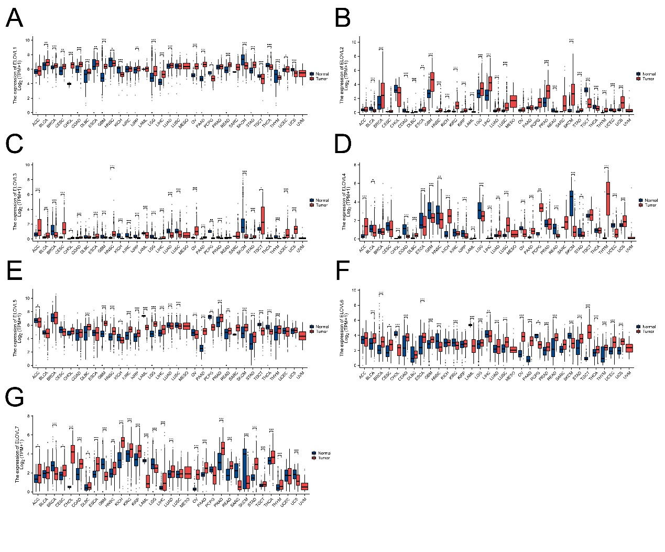

Supplementary Figure 2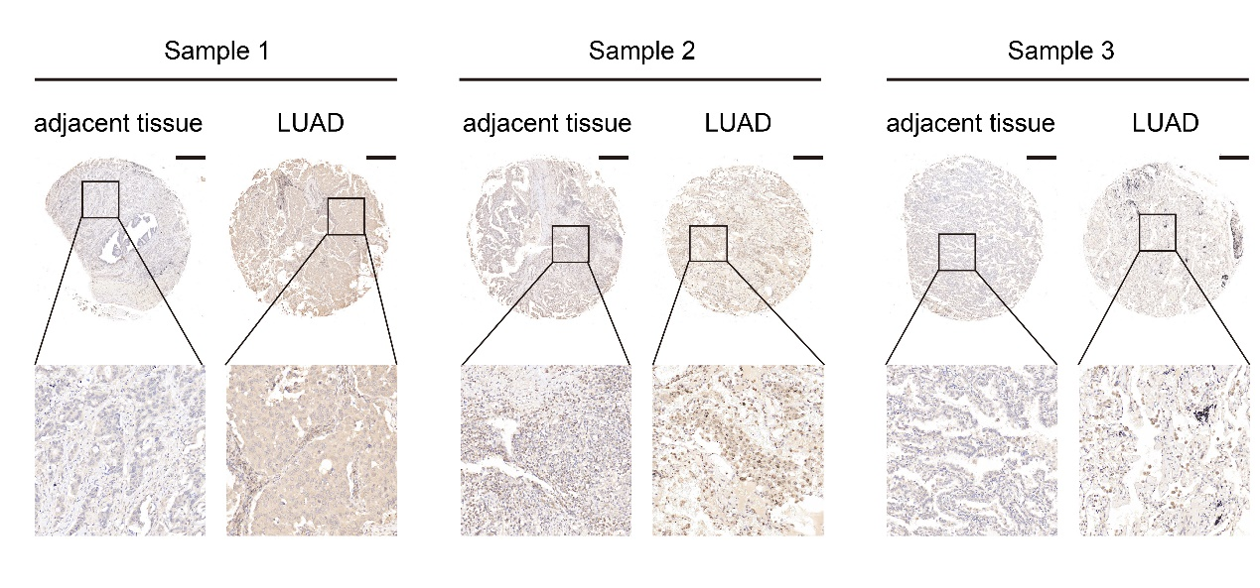

Supplementary Figure 3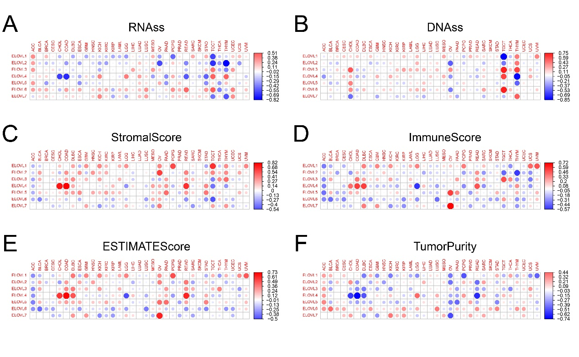

Supplementary Figure 4